UNIVERSITY OF WALES:  TRINITY SAINT DAVID |  |  | PRIFYSGOL CYMRU:  Y DRINDOD DEWI SANT
LOCATION: LAMPETER |  | LLEOLIAD: LLAMBED
LEVEL 6 |  | LEFEL 6
October 2019 |  | Hydref 2019

HPAH6037
Murder, Mayhem and Megalomania: The Life and Times of the Emperor Nero

QUIZ 1

Write your name here:
Write your Student number here:

TIME: 20 minutes

ATTEMPT TO ANSWER ALL OF THE FOLLOWING 20 QUESTIONS:

In the case of multiple-choice questions indicate your answer by circling either A, B, C or D (as you think is correct). Giving more than one answer to a question will result in a zero mark (if you wish to change your answer make this clear). For other questions write your answer.

1) Which of these is not a Flavian era historian who wrote about Nero?
A – Cluvius Rufus
B – Cassius Dio
C – Fabius Rusticus
D – Pliny the Elder

2) In what year was Agrippina banished from Rome by the Emperor Caligula?
A – 37 CE
B – 38 CE
C – 39 CE
D – 40 CE

3) A fairly prevalent view holds that the Apocolocyntosis was first composed by Seneca the Younger in the year 54 CE. At what religious festival is it assumed that it may have been first performed?
. .

4) In what year did Nero marry Octavia (daughter of Claudius)?
A – 50 CE
B – 51 CE
C – 52 CE
D – 53 CE

5) Which emperor is being represented on the obverse of this aureus?
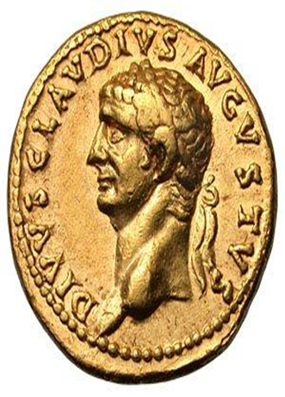
. .

6) The Apocolocyntosis is a difficult work to categories, but to which genre is this work commonly associated?
. .

7) Which of these works of Tacitus is the latest in composition (i.e. latest written)?
A – Histories
B – Annals
C – Dialogus de oratoribus
D – Germania

8) From which work does the following (translated) passage come from?
“Some of the men are said to have hesitated, looking back and inquiring:— "Where was Britannicus?" Then, as no lead to the contrary was forthcoming, they acquiesced in the choice presented to them: Nero was carried into the camp; and, after a few introductory words suited to the occasion, promised a donative on the same generous scale as that of his father, and was saluted as Imperator.”
. .

9)
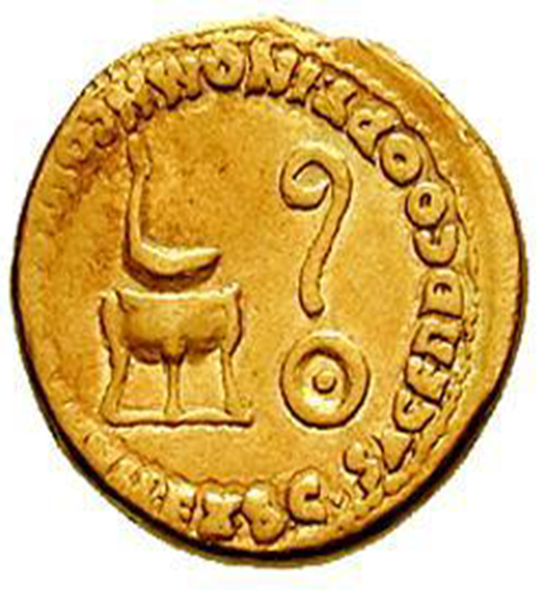
Give the name of the religious symbol – pointed to by the arrow – that appears on this Nero as Caesar aureus (minted during the last few years of Claudius’ reign).
A – Simpulum
B – Litus
C – Tripod
D – Patera

10) Name the author of this passage?
“Thus publicly proclaiming himself as the first among God's principal enemies, he was led on to slaughter the apostles. It is, therefore, recorded that Paul was beheaded in Rome itself, and that Peter likewise was crucified under Nero.”
. .

11) Name the author of this passage?
“Body, soul, intelligence: to the body belong sensations, to the soul appetites, to the intelligence principles. To receive the impressions of forms by means of appearances belongs even to animals; to be pulled by the strings of desire belongs both to wild beasts and to men who have made themselves into women, and to a Phalaris and a Nero…”
. .

12) Name the individual who appears on the obverse of this Sestertius (struck 50-54 CE).
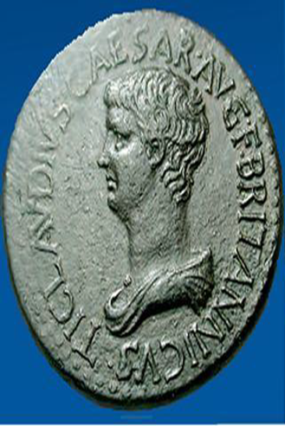
.

13) Which historical figure is being referred to in this passage of Tacitus’ Annals?
“His sisters, Antonia and Octavia, she similarly detained. She had barred all avenues of approach with pickets, and ever and anon she issued notices that the emperor's indisposition was turning favourably: all to keep the troops in good hope, and to allow time for the advent of the auspicious moment insisted upon by the astrologers.”
. .

14) From which Greek city in Caria (Anatolia) does this relief of Agrippina crowning Nero derive?
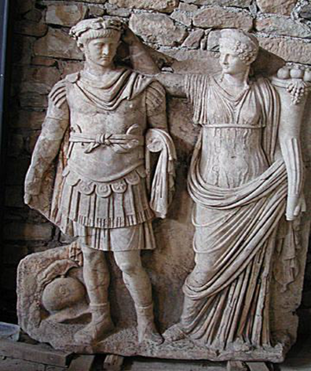
. .

15) From what province does was this papyrus document found?
“… of the remaining two (honours) your temple I decline because to gods alone is this honour to be granted rightly by men, and the gold crown I released to be sent back to you, not wishing at the beginning of my principate to burden you. Whatever (privileges)… you have received from the emperors before me [I wish to be securely yours,]…” (P. Med. Inv. 70, 01)
. .

16) What is the name Nero’s Praetorian Prefect (you can just give the cognomen) from 54-62 CE (he held the office from 50 CE, i.e. initially served in the role under Claudius)?
. .

17) Who is the author of this passage?
“Agrippina… fearing that Nero would marry the woman [Poppaea Sabina]… ventured upon a most unholy course…. she had used her blandishments and immodest looks and kisses to enslave even Nero in similar fashion. Whether this actually occurred, now, or whether it was invented to fit their character, I am not sure; but I state as a fact what is admitted by all, that Nero had a mistress resembling Agrippina of whom he was especially fond… and when he toyed with the girl herself or displayed her charms to others, he would say that he was wont to have intercourse with his mother.”
A – Suetonius
B – Tacitus
C – Cassius Dio
D – Seneca the Younger

18) In what year was this aureus most likely minted?
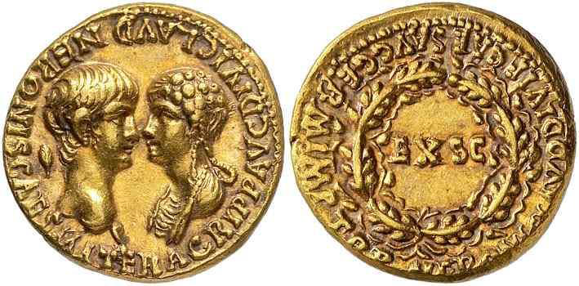
. .

19) In what year was this aureus most likely minted?
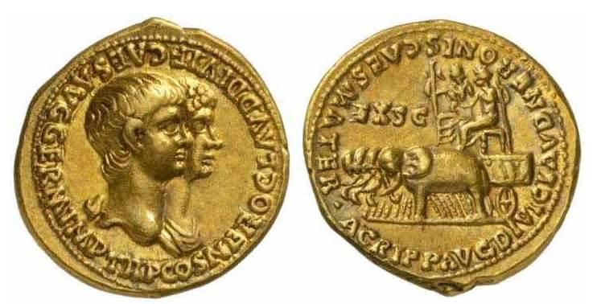
. .

20) In what year did Britannicus die (he was purportedly murdered)?
. .

