The Application of an Engineering Design Methodology-
Dry Sump Pan and Oil Pick Up Adaptor Design.

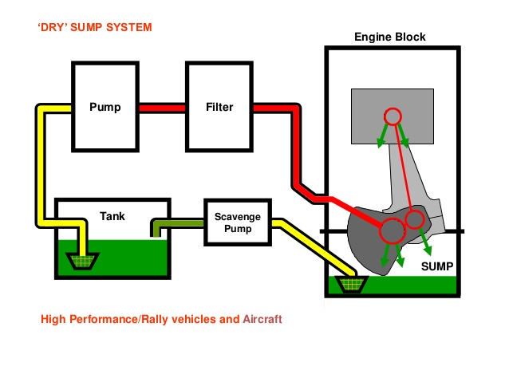

Fig 1. Dry Sump System Operation
(Image Source - https://i.stack.imgur.com/37JHb.jpg)

By: Daniel Davies.

Student Number: 1801345.

Date: 1st March 2019.

Design Assignment.

Section 1. Problem Investigation.
1.1. Introduction.
1.2 Problem identification, understanding the need.
Fig 1. Dry Sump System Operation.

Section 2. Product Design Specification.
2.1. Market requirements.
2.2 Analysis of Market Requirements that influences Product Design.
2.3 Product Design Specification Table.
2.4. Production requirements.
2.5 Conformance requirements.
Fig 2. Example of a Ford Zetec Dry Sump Pan.

Section 3. Concept Designs.
Section 4. Design Isolation.
Section 5. Design Development / Final Design.
Section 6. References

Section 1. Problem Investigation.
1.1 Introduction.
In order to fully understand the problem that needs to be addressed it is important to consider the following factors.
An engine’s lubricating system reduces wear and tear by reducing friction between the internal moving parts. It also absorbs heat and helps to create a better seal between components such as the piston rings and cylinder wall. The lubricant is circulated inside the engine either by a wet-sump or dry sump system.
In a wet sump system, oil is stored in the sump pan and a ‘splash type’ lubrication process takes place where the crank journals and big end bearing dip into the oil as the engine revs. Oil is also picked up, filtered and pumped through strategically drilled holes and galleries to other areas such as the cam lobes. It then drips or is recirculated and in some systems cooled before returning to the sump for it to be reused.
A dry sump system offers more efficient lubrication where the oil is kept in a separate reservoir outside the engine. A scavenger pump collects the oil which is then cooled and directly pumped under pressure around the engine to the lubrication points, before draining down to the sump pan for it to be collected and recycled. In order to regulate the crankcase pressure, high revving engines are often fitted with a pressure relief valve to ensures that the seals do not fail inwards.
(Source of info https;//www.torquecars.com/tuning/dry-sumps.php)

High performance motor racing is a challenging environment and the lack of sufficient lubrication in an engine would cause catastrophic damage. In a conventional wet sump engine, the continual acceleration, braking and ‘turning in’ and high cornering loads cause the lubricant to be splashed and tossed around in all directions. Racetrack conditions can result in loss of oil pressure when the lubricant sloshes away from the pickup tube. The introduction of sump baffles may slightly reduce this effect but do not eradicate it.
A dry-sump system is a complex and successful solution to the problem in that it is able to provide an uninterrupted supply of oil that is not affected by the high g-forces experienced during racing. The main features of a dry-sump system are the sump/oil pan, scavenger pump, lubrication reservoir and plumbing. The sump becomes a ‘collection pan’ where the oil is scavenged and sent to the reservoir which becomes the ‘sump’ and provides a constant feed to the main oil pressure pump. Another advantage with dry sump systems is that they can be fitted in situations where there may not be enough room for conventional wet sump engines. This was pioneered by Bruce McLaren ‘who wanted to lower the engine in an early Can Am race car chassis, where he found there wouldn’t be enough room for a wet sump oil pan.’
Info source https://nasaspeed.news/tech/engine/under-pressure-an-inside-look-at-oiling-systems/
A dry sump lubrication system can also provide an increase in engine power. The additional crankcase vacuum created by the dry sump/scavenge pump results in improved piston-ring seal. While the crank/big end assembly is kept free of ‘windage’ and oil splash which allows it to ‘spin freely’ making the engine ‘rev’ better. As the oil is not stored in the sump, it can be smaller, shallower in depth and lower in weight. Other advantages are increased
lubricant capacity, the possibility of mounting remote oil coolers and adjustable and consistent oil pressure.
1.2 Problem identification, understanding the need.
I) Oil Starvation. For normal production passenger car applications, a standard wet sump system provides adequate lubrication and cooling. However, dry sump type lubrication systems are often an essential requirement when an engine is used for high performance motorsport applications in order to overcome the problems experienced by wet sump systems. The successful design option should eradicate the major problem with wet sump lubrication systems where engine oil starvation caused by the lateral movement as a result of the forces acting on the race car.

‘’In a racing application, high engine RPM's and increased G-forces become very detrimental to how a wet sump operates. The crankshaft acts as a windmill within the crankcase, whipping oil up from the sump, while G-forces caused by acceleration, turns or braking further complicate system issues. This is particularly a problem in race applications that are subject to left and right turns, hard acceleration and severe braking. The pickup can become uncovered and ingest air, quickly starving the bearings for oil.’’
(https://www.laneautomotive.com/wetsump.htm)

ii) Size and positioning. Engines used for motorsport application such as track competitions are usually mounted low in a racing chassis with minimal ground clearance in order to keep the centre of gravity as low as possible. Therefore, it is important to consider the size of the sump pan when designing and locating the type and nature of the pick-up assembly. Consideration should always be given when locating a scavenge pump or pipes underneath the sump pan. The design should comply and fit with the tolerances of the existing Zetec power unit.

iii) Adequate and sufficient amount of lubrication. The additional pressures on a race car engine as a result of increased rpm require a consistent oil pressure without the possibility of any interruptions that could result from race conditions. The collector within the pan will need to recycle a sufficient rate of lubricant to cope with these needs.

iv) To reduce drag and therefore increase engine power; The crankshaft in a normal road going wet sump engine continually splashes into the oil in the sump, especially at high revs. Reducing the oil level would therefore reduce drag on the engine and provide a slight increase in power.
Depending on the application, the resulting reduction in internal crankcase windage and drag may increase the engine’s power output 5 to 15 hp or more. (But to realise these gains, the dry sump oil system has to pull at least 8 to 10 inches Hg or more of vacuum).
(https://www.enginebuildermag.com/2012/11/dry-sump-oiling-systems/

v) Compatibility; The dry sump pan and pick up adaptor must be compatible with the Zetec engine. The mounting holes and the oil pick up adaptor must align and work effectively together for them to be easily installed. The pan should allow easy and fast access for necessary servicing and maintenance. The pan should be designed such that the lubricant would be collected or ‘scavenged’ by the external oil pump. No oil should accumulate in the pan.

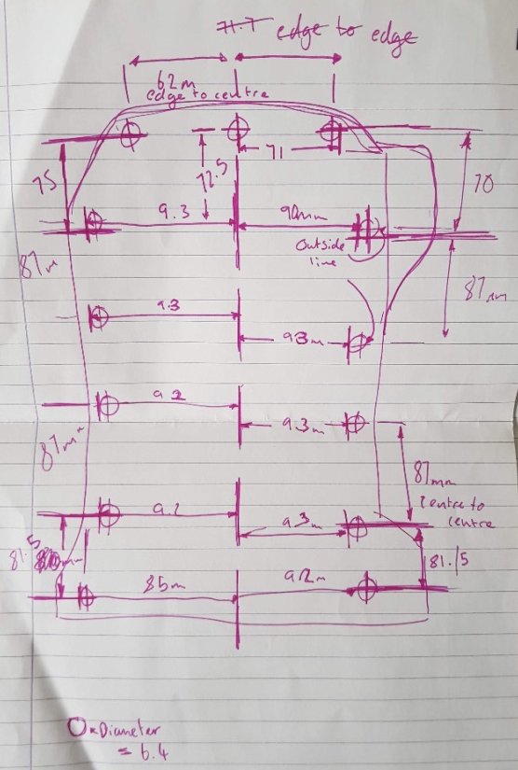
Drawing of the wet sump of the ford zetec that was taken in drawn in the workshop.

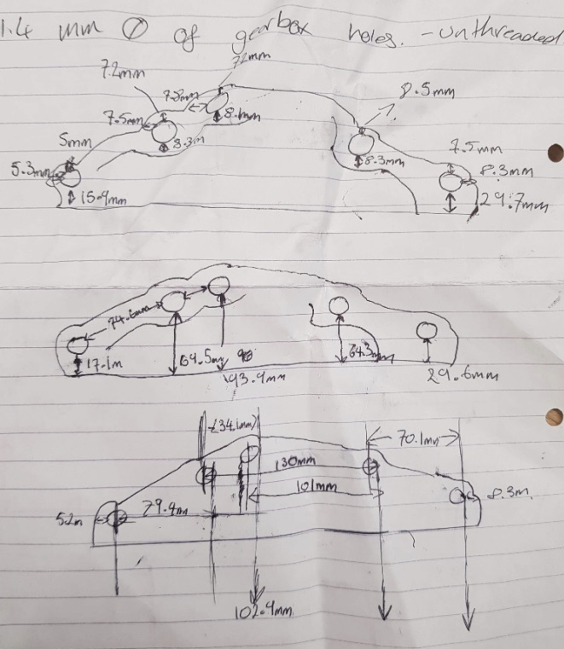

Drawing of the gearbox mounting of the sump, that will be used to create the design on solid works

Section 2. Product Design Specification.
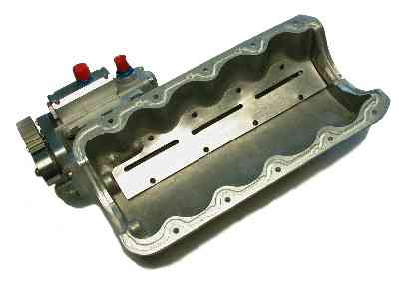

Fig 2.
Example of a
Ford Zetec Dry Sump Pan.
Image Source
https://www.drysump.com/images/FordPans/1050c1.jpg

2.1. Market requirements.

When considering the product design specification, it is important to consider the customer requirements as already identified because of the initial market research.
Customer Requirements. | Importance rating (out of 10)
In the event of a roll-over, the engine should not be flooded with lubricant. | 9
The product should be lightweight. | 8
The product should be low cost. | 7
The product should allow easy/fast access for servicing / maintenance. | 7
The product should be easy to install (initial set-up) | 5
(Information sourced from Task Description doc.)

2.2 Analysis of Market Requirements that influences Product Design.

In order to try to attempt to satisfy the above customer requirements, consideration should be given to the following factors in the design specifications.

- To prevent the engine from being flooded with lubricant, the sump pan should be designed in such a way that it holds the minimum amount of lubricant at all times. Any pipe outlets should be at the sufficient level for the external scavenge pump to collect it and return it to the remote oil reservoir /tank. The design depth of the sump pan does not necessarily have to be the same as the standard sump as it will hold the same amount of lubricant. However, it will need to allow sufficient space for the movement of the crank/big end assembly.

- Consideration should be made to construct the pan from aluminium alloy. This would not only save weight but provide the strength and durability. The oil pick up adaptor could be made from either from alloy or another suitable compatible material.

- Utilising the current existing mounting holes, seals and gaskets on the Zetec engine would not only keep the cost as low as possible but would mean that the pan would be easy to initially install and set up and also allow easy fast access for servicing/maintenance.

- In order to allow ease of installation and easy/fast access for servicing, the oil outlet hole should be mounted/attached in such a way as to provide easy access.

2.3 Product Design Specification Table.

Performance Requirements. | Design Requirements. | Design Specification.
To scavenge /collect oil from sump pan successfully under race conditions. | Compatible with Ford Zetec engine existing mounting points. | Size must fit within Ford Zetec sump pan mounting points.
To deliver smooth, constant, consistent oil pressure without possibility of interruption or oil starvation under race conditions. | The product should be easy to install (initial set-up) | The product should be low cost.
In the event of a roll-over, the engine should not be flooded with lubricant. | The product should be lightweight. | Maximum weight.
The product should allow easy/fast access for servicing / maintenance. | Durable material. | Maximum cost.
Minimum force. | Low cost.

Life in service requirements.
The requirements should be sufficient to ensure that the sump pan/pick up adaptor will work effectively for the duration of its life in service requirement. As it is not a consumable part, it’s life expectancy would be anticipated as being long term and in excess of 5 years.
- Operating environment; Both sump and adaptor should be heat resistant, oil resistant and be of the correct material to be durable.
- Maintenance requirements; Access for maintenance would be provided by utilising the existing mounting points. It should be a direct replacement fit for the standard sump and will provide the same access for maintenance.
- Replaceable components; Both the pan and the adaptor should be replaceable in the event of damage or failure.
- Reliability/durability targets; Both the pan and the adaptor should be as reliable as the original sump and perform to the same level of durability.

2.4 Production requirements.
In order to ensure that the product can be made, many production requirements should be fulfilled.
- Target cost to manufacture; When considering possible materials, manufacturing processes and assembly methods, both the sump and adaptor should have targeted manufacture costs within the marketplace in order to be economically viable. One cost factor is that aluminium is approximately 50% more expensive than steel. Also, how the pan is fabricated can also influence the final target cost. One other cost factor is that aluminium generally requires more care and skill to weld and fabricate due to it being a softer metal to work with. Low grade aluminium can sometimes give problems with being porous. Info source; (http://blog.cantonracingproducts.com/blog/steel-vs-aluminum)

- Product size and weight targets; Whilst considering size and weight of the materials for the product. A typical aluminium sump pan will be lighter in weight compared to a steel sump pan gaining around a 30% weight saving. For competition purposes this has added value as any weight saving is usually good practice. Info source; (http://blog.cantonracingproducts.com/blog/steel-vs-aluminum)

- Bought-in vs Manufactured in House; With many specialist race preparation companies in existence today and with the advances in engineering available. It may be beneficial to source manufacturing outside rather than develop production in-house. Therefore, saving on raw material costs and storage. However, the advantage with in-house production is that it may be possible to manufacture the sump and adaptor in a quicker lead time, offering better availability to the customer.

2.4. Conformance requirements.

In order to ensure that the product will comply with all legal and commercial obligations, there are many conformance requirements that need to be fulfilled.
- Product Compatibility; When considering the product size and weight, it should be compatible with the current Zetec engine and operate within the requirements of size and fitment. The size of the sump pan will need to provide sufficient clearance for the crank/big end assembly to rotate
- Safety/product liability requirements; The design should be such that lubricant should not remain in the pan and in the event of a roll-over lubricant should not flood the engine.
- Industry standards; The finished product should be produced to operate to same industry standards as the manufacturers own.

Section 3. Concept Designs.

Design A
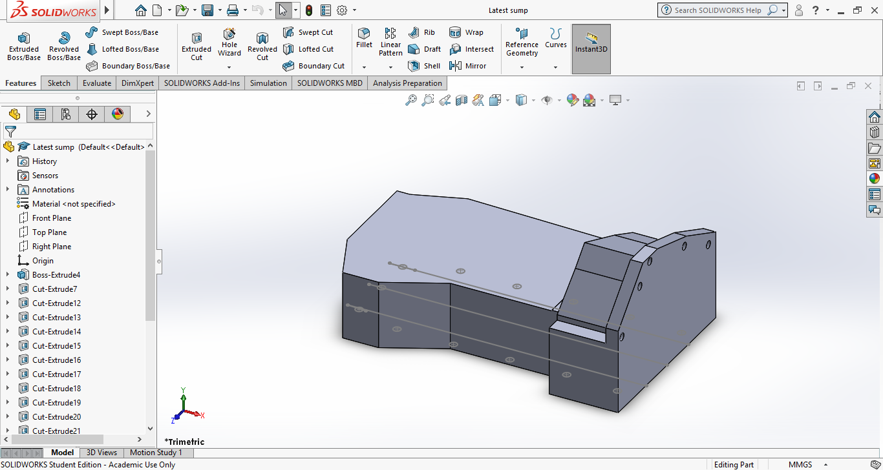

The first design of the sump is a rough idea following the measurements from section A. Basic skills and techniques was carried out in the first part of the design. Made from aluminium, so it is lightweight which is needed in a performance car. This design could be made better by making it thinner to ensure there is a lot less of unnecessary weight.

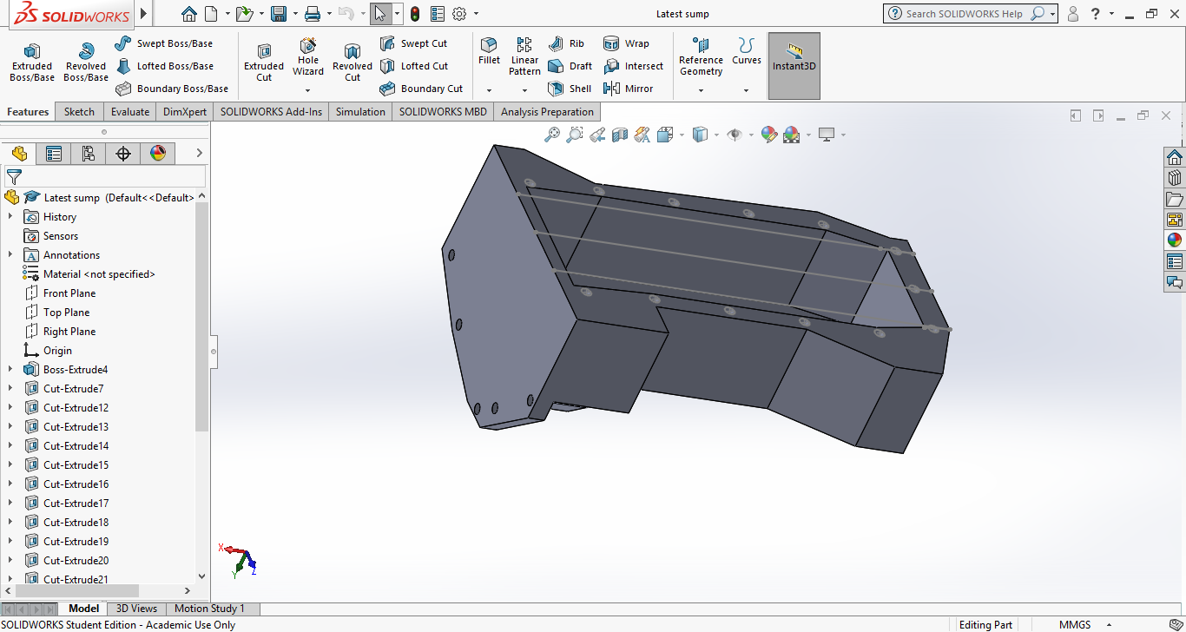

Design B
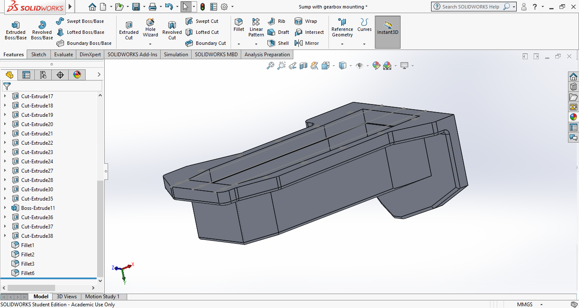

In design B it is much more advanced than design A, using different techniques to get a better result. Also it is made the material is slightly thinner than the first one. Also the fit of the B would much better than A resulting in a better serviceability.

Design C

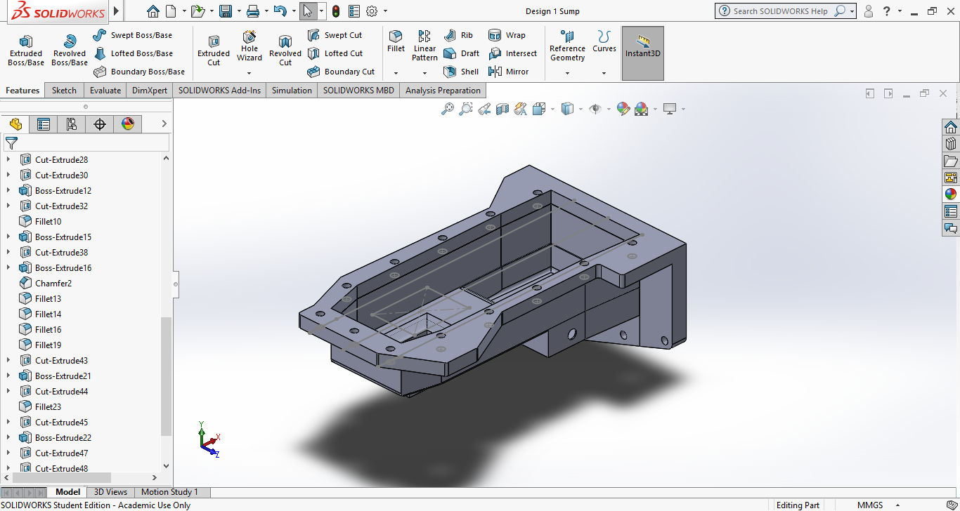

Design C is the most advanced out the 3 designs. The design is more thought about and including key factors that make a dry sump operate for example the pick-up and scavenge pump.

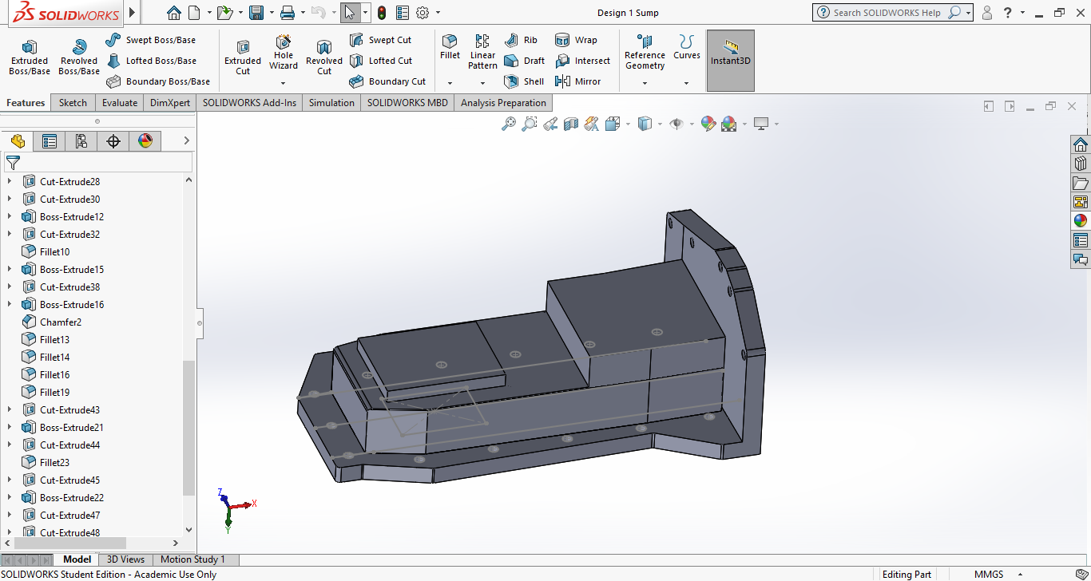
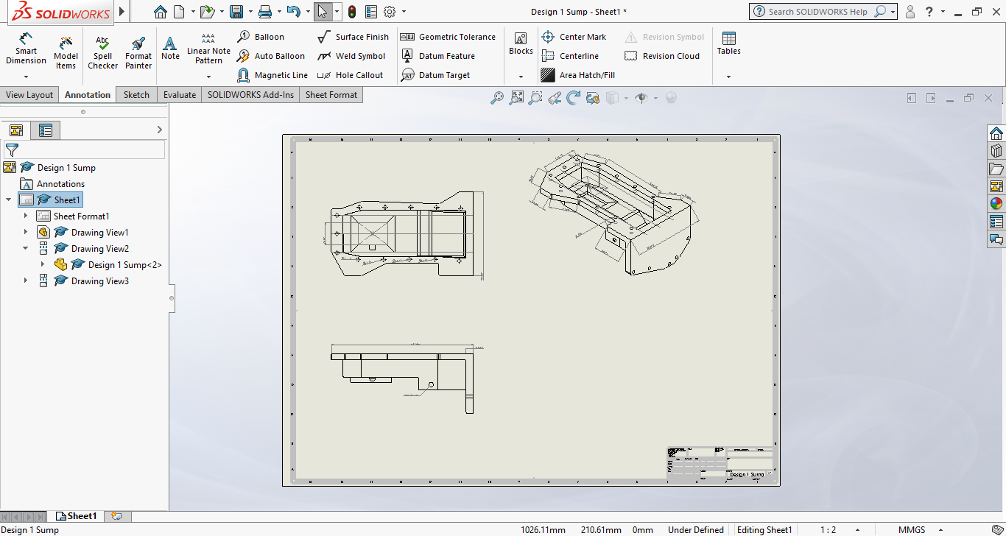
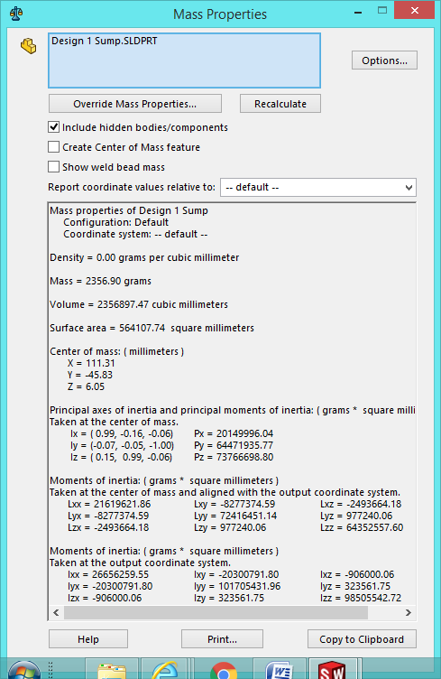

Picture from Solid works showing the mass property of Design 1 (C)

Section 4. Design Isolation.

Feature | Design A | Design B | Design C
Fulfilment of function | 7 | 8 | 10
Reliability | 5 | 7 | 9
Serviceability | 3 | 6 | 8
Life | 7 | 6 | 6
Ease of maintenance | 4 | 6 | 7
Ease of manufacture | 8 | 7 | 5
Efficiency of operation | 3 | 6 | 8
Simplicity of layout | 8 | 6 | 5
Cost | 6 | 7 | 9

A = 51
B = 59
C =67

By looking at the pugh matrix table the design that comes out on top is design C this means this is the better design compared to design A and B in a manufacturing process, this would help the company/manufacture to decide on what design to go with if there is any uncertainty. If the manufacture is looking for a way to still get some sort of quality out of the product they could go with design B which is slightly less costly but there is still some expectation of quality. Design A is very poor in serviceability and efficiency of manufacture. Further down the line with more research design could be the better option do to it to be close to design C.

Section 5. Design Development / Final Design.

The final Design is design C. This is the best design out of the 3 which has been made. It shows a better quality and design. Although further improvements could be taken place down the line, e.g. Increased use of complexed techniques, further research into the pick-up.
When manufacturing this design the, the steps to be taken (machining) might need further study. For example, when machining the area where the gearbox mount is, the operation should be taken out carefully.
A typical aluminium sump pan will be lighter in weight compared to a steel sump pan gaining around a 30% weight saving. An aluminium material would be best for the dry sump to be made from. For a dry sump aluminium, has added value as any weight saving is usually good practice, which is essential.

https://uowtsd-my.sharepoint.com/:u:/g/personal/1801345_student_uwtsd_ac_uk/Ee0tF5z5FOJDgMZa1UKeugcBMyY4Niyql1xyfDID1yM5Qw?e=xV2wwQ

Section 6. References
Sources of information.
Fig 1. Dry Sump System Operation. Image Source - Davies, D. (2019). [online] I.stack.imgur.com. Available at: https://i.stack.imgur.com/37JHb.jpg [Accessed 7 Jan. 2019].

Fig 2. Example of a Ford Zetec Dry Sump Pan. Image Source
Davies, D. (2019). [online] Drysump.com. Available at: https://www.drysump.com/images/FordPans/1050c1.jpg [Accessed 14 Jan. 2019].

Davies, D. (2019). Dry sumps. [online] TorqueCars. Available at: https://www.torquecars.com/tuning/dry-sumps.php [Accessed 21 Jan. 2019].

Engine Lubrication system.

Davies, D. (2019). lubrication system-petroil, splash, pressure, semi-pressure, dry & wet sump. [online] Engramritkumar. Available at: https://engramritkumar.com/lubrication-system/ [Accessed 7 Feb. 2019].

Introduction to wet sump systems.
Davies, D. (2019). Under Pressure – an Inside Look at Oiling Systems | NASA Speed News Magazine. [online] NASA Speed News Magazine. Available at: https://nasaspeed.news/tech/engine/under-pressure-an-inside-look-at-oiling-systems/ [Accessed 8 Feb. 2019].

Increase in engine power as a result of dry sump system can also provide an
Davies, D. (2019). Oil System Differences: Wet vs. Dry Sump. [online] Know Your Parts. Available at: https://www.knowyourparts.com/technical-resources/engine/oil-system-differences/ [Accessed 16 Feb. 2019].

Problems with wet sump applications for motorsports. Davies, D. (2019). Wet Sump Oiling Systems. [online] Laneautomotive.com. Available at: https://www.laneautomotive.com/wetsump.htm [Accessed 27 Feb. 2019].

Dry sump reduces internal crankcase windage and drag.
Davies, D. (2019). Dry Sump Oiling Systems - Engine Builder Magazine. [online] Engine Builder Magazine. Available at: https://www.enginebuildermag.com/2012/11/dry-sump-oiling-systems/ [Accessed 5 Mar. 2019].

Pge 3. Image Source https://www.drysump.com/images/FordPans/1050c1.jpg(http://blog.cantonracingproducts.com/blog/steel-vs-aluminum)

Material cost and weight factors.
Davies, D. (2019). The Showdown: Steel VS Aluminum Oil Pans. [online] Blog.cantonracingproducts.com. Available at: http://blog.cantonracingproducts.com/blog/steel-vs-aluminum [Accessed 10 Mar. 2019].

