Week ? – Peripheral
Knee Anatomy and Injuries Worksheet
Questions:

- Name the 3 compartments of the knee joint (3)

- What type of joint is the knee? (1)

- Which is the main weightbearing bone of the lower leg? (1)

- What is the closed packed position of the knee? (1)

- Name 4 of the factors which improve the stability of the knee joint (4)

- What is the main function of the cruciates? (1)

- Which is stronger the ACL or PCL? (1)

- Name four functions of the menisci.(4)

- Name four types of meniscal tear. (4)

- Name 4 sporting movement scenarios where the ACL is vulnerable (4)

Complete the labelling overleaf…

Labelling:
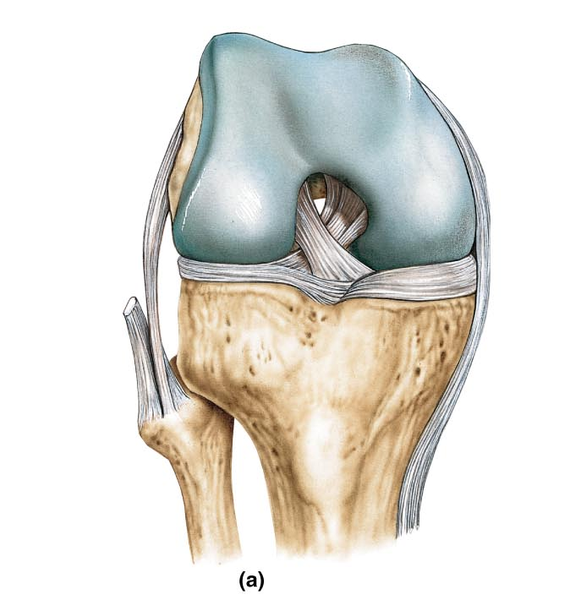
Medial meniscus Medial femoral condyle Lateral femoral condyle
Lateral meniscus Anterior cruciate ligament Posterior cruciate ligament
Lateral collateral ligament Medial collateral ligament

