

Changemakers: Creativity and Value Creation
Professions (BMHP5014)

Student name: Rafat Ibrahim
Student number: 2428544
Component 1
Lecturer’s name: Mr Soban Sadiq

Table of Contents
Introduction 3
Task 1 Explaining Essential Concepts in Practice 3
1.1 Innovation 3
1.2 Creativity 3
1.3 Value Creation 4
1.4 Change 4
Task 3 – Self-Reflection 6
3.1 Group Discussion in class based on Gibbs' Reflective Cycle (Gibbs,1988). 6
Task 4 – Case Study Analysis of a UK Revolution 7
Task 5 – Research Task 8
Task 6 – Exploring Digital Innovation in Health and Social Care 9
6.1 Wearable Health Technologies 9
6.2 Electronic Health Records 9
6.3 Preventative Care and Health Promotion 10
Task 7 – Recognising the NHS Leadership Structure 11
7.1 Outline of the NHS Leadership Framework 11
7.2 Leadership Behaviour and Leading with Care 11
7.3 Reflective Journal Entry 12
Task 8 – Self-Reflection Journal Entry 13
Reference List 14

Introduction
Health and social care services are changing in response to growing patient need, staff pressures, high technological and adjustment needs in public health. Whilst professionals must be able to think innovatively, accept transformation and take on board a creative mind to upgrade the standard and efficacy of care. Creativity is no longer restricted to inventive ability, supports specialists using practical solutions to difficult problems. Innovation changes original ideas into upgrading that establish value for patients, service users, organisations and broader society (NHS England, 2023).

Task 1 Explaining Essential Concepts in Practice

1.1 Innovation
Innovation means launching new or upgraded ideas, services or processes that create value and improve outcomes. In health and social care, innovation assists organisations to respond to high demand, workforce shortages and changing patient needs by improving productivity and excellence of care (West et al, 2022). Rogers' Diffusion of Innovation Theory explains, improvements are embraced over time depending how beneficial plus simple for people to benefit (Rogers, 2003). A practical example is the establishment of NHS virtual wards, this decreased avoidable hospital admissions while bettering patient experience (NHS England, 2023).

1.2 Creativity
Creativity is the capacity to bring original and constructive ideas that resolve problems or upgrade existing practice. In health and social care, creativity aids professionals to foster patient-centred services, enhance communication and widen innovative methods to difficult medical conditions (Rogers, 2023). Amabile's Componential Theory aims that creativeness improves when human being link knowledge, creative thinking skills and essential motivation (Amabile, 1996). An illustration is the use of adapted digital care plans that let patients with long-term illnesses to join actively in controlling their own health, adjusting arrangement and conduct observance.

1.3 Value Creation
Porter (2010) mentioned, value creation refers to improving outcomes that matter to patients. Whilst making effective use of available resources, through the value- based system focusing on increasing the quality of care and reducing costs, to maximise patient outcomes. Porter argues that healthcare organisations create value when better clinical outcomes are achieved (Porter, 2010). An example is electronic ordering arrangements, which helps to reduce medication oversights and increase efficiency in patient safety across healthcare services.

1.4 Change
Change is the planned process of improving organisational practices to meet new challenges or opportunities. Continuous change is essential within health and social care because services must respond to new technologies. Lewin's Change Management Model explains that successful organisational change involves unfreezing present practice, applying alteration and refreezing another technique of working (Burnes, 2017). The widespread implementation of Electronic Health Records (EHRs) across the NHS demonstrates planned organisational change, improving communication, continuity of care and patient safety through better information sharing.

Task 2
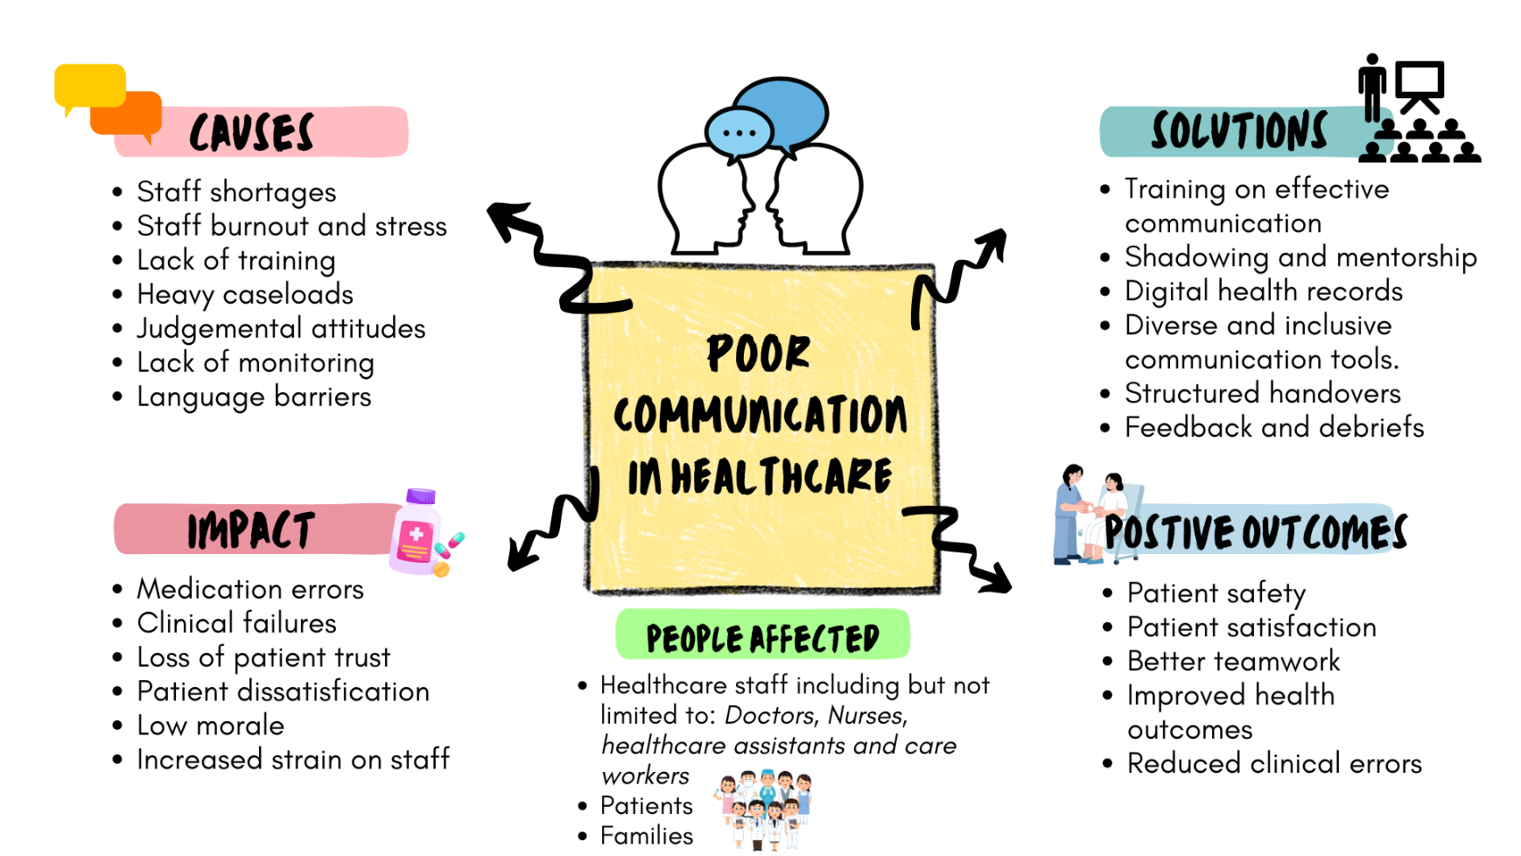
Figure 1. Mind Map Model on Poor Communication in Health and Social Care (Meadows, 2008).

Poor communication in healthcare has been caused by various factors as summarised in Figure 1. Communication problems are major concerns in health and social care which can be due to staff unavailability, poor shift transfers, wrong information systems and heavy tasks. These influences could result in administering medication wrongly, late treatment and decrease patient happiness, having impact on patients, families and healthcare professionals. Mind map establishes these issues are connected instead of a single factor. A holistic system recommends, when communication is improved, it coordinates better teamwork across the healthcare organisation and technology (Meadows, 2008). Initiating electronic health records, using designed communication tools and staff training can improve multidisciplinary partnership and enhanced patient outcomes (NHS England, 2023).

Task 3 – Self-Reflection

3.1 Group Discussion in class based on Gibbs' Reflective Cycle (Gibbs,1988).
During the classroom discussion, my group discovered using convergent and divergent ideas to elaborate resolutions for communication within health and social care. Divergent thinking aided us to produce a wider scope of ideas with no critique, whereas convergent thinking enabled us to evaluate these ideas logically and select the most practical solution (Cropley, 2021).
Initially, I found convergent thinking more comfortable because I prefer structured decision making. However, during the brainstorming I realised that allowing everyone to contribute freely produced more creative ideas than I expected. I suggested creating a simple list of advantages and disadvantages for each option, enabling the group to reach agreement together.
Reflecting on the activity, I recognised that creativity is strengthened when individuals feel confident to share ideas without fear of criticism. I also learned that effective teamwork depends upon active listening, respectful communication and valuing different perspectives. Gibbs (1988) supports continuous professional learning by helping individuals to look back and identify future improvements.
I would contribute my ideas earlier and encourage quieter members of the group to participate more actively, if I need to do this again creating a more inclusive discussion.

Task 4 – Case Study Analysis of a UK Revolution
The positive revolution in the NHS is the beginning of virtual wards. This initiative was developed to address increasing hospital admissions, bed shortages and rising demand for healthcare services. Virtual wards allow sick patients to receive treatment and care safely in their houses using remote supervising devices supported by multidisciplinary healthcare teams (NHS England, 2023).
Creativity contributed to this innovation by Davis (1989) combining digital technology with new models of patient centred care. Instead of relying solely on traditional hospital admission, healthcare professionals redesigned care pathways to support patients remotely while maintaining clinical safety. This shows creative problem solving through the incorporation of technology, teamwork and service reform (Davis, 1989).
The inventiveness has been meaningful for patients care and NHS services. Patients benefit from remaining in familiar surroundings, reducing the risk of getting hospital infections and improving overall experience (NHS, 2023). Meanwhile the NHS benefits from improved resource utilisation and reduced pressure on acute services.
Rogers' Diffusion of Innovation Theory suggests, innovations are more readily adopted when they are perceived as beneficial, practical and compatible with existing practice (Rogers, 2003). The increasing adoption of virtual wards across England demonstrates how innovative healthcare solutions can improve patient outcomes while supporting long-term service sustainability

Task 5 – Research Task
One current issue within health and social care is employee’s breakdown, research by West et al. (2020) discovered, emotional exhaustion, and lack of organisational support are major causes of burnout among healthcare professionals. The study explains that burnout negatively affects staff wellbeing, patient safety, and healthcare quality. This article helped me understand how workplace pressure and staffing shortages contribute to stress within healthcare environments.
A second study by Hall et al. (2016) identified poor work-life balance and limited psychological support as additional causes of burnout among healthcare workers. The article also explains that burnout can lead to increased medical errors, staff absence, and reduced patient satisfaction. However, this research suggests good staff welfare brings out better patient results.
Both articles agree that excessive workload and emotional pressure are significant causes of stress in healthcare settings. However, West et al. (2020) focuses more on governance and workplace culture, which is the organisational factors, while Hall et al. (2016) concentrate on patient welfare, highlights psychological wellbeing and emotional support.
Maslach’s Burnout Theory explains that prolonged workplace stress can result in an emotional exhaustion, reduced professional proficiency, efficiency, achievement, and depersonalisation among healthcare staff (Maslach and Leiter, 2021).

Task 6 – Exploring Digital Innovation in Health and Social Care

6.1 Wearable Health Technologies
These technologies, for examples the fitness trackers and smart watches are very useful, so many advantages of wearable health digitals, they monitor the management of persistent health conditions by allowing patients to monitor their health on time. Wearable devices can track heart rate, physical activity, blood pressure, and sleep patterns, helping individuals manage conditions such as diabetes and cardiovascular disease. This also allows the health care specialist to discover any changes earlier, supports preventative care and reduces the risk of serious health complications (WHO, 2021). Wearable technologies also encourage patient independence and self-management.
For example, some smartwatches can detect abnormal heart rhythms and encourage users to seek medical advice early. According to Davis (1989) “The Technology Acceptance Model” will benefit professionals using digital healthcare tools because of the usefulness and suitability.

6.2 Electronic Health Records
Electronic Health Records (EHRs) improve interaction and partnership among healthcare professionals sharing patients’ information quicker and securely across departments and healthcare organisations. EHRs reduce paperwork and improve access to accurate patient information. For example, doctors and nurses can access the same patient records, helping improve treatment decisions and reduce medication errors. EHRs also improve continuity of care because patient histories, allergies, and treatment plans are available during appointments or emergencies (NHS, 2023).
Davis (1989) explained that the Technology Acceptance Models suggests, healthcare specialists can adapt to use of digital system, when they realise the importance and the usefulness of it. Staff training can be one of the challenges but remain a better information sharing support teamwork and improve patient safety by ensuring healthcare professionals have access to updated information when providing care.

6.3 Preventative Care and Health Promotion
Digital technology can help preventive care and health promotion by helping individuals access health communication and monitor healthy behaviours e.g. mobile health products and online platforms can encourage exercise, healthy eating, smoking cessation, and mental wellbeing. For example, the NHS Better Health app provides advice on weight management, programmes, and healthy lifestyle choices. Digital reminders and health tracking systems can motivate individuals to maintain healthier habits and reduce the risk of chronic illness (NHS, 2023).
Technology also improves accessibility because individuals can access support remotely without attending healthcare settings. Preventative digital healthcare brings down the costs of long-term health and improves wider health outcomes (WHO, 2021). The Technology Acceptance Model explains the likelihood of people will engage in using digital health interventions because of the benefits and easy to use (Davies, 1989).

Task 7 – Recognising the NHS Leadership Structure

7.1 Outline of the NHS Leadership Framework
NHS Healthcare Management Model comprises of behaviours, training and qualities that support an active leadership within health and social care settings. The structure encourages leaders to promote safe, compassionate, and high-quality care while supporting teamwork and continuous improvement (NHS, 2023).
The framework includes behaviours with shared purpose, lead with empathy, valuing information, motivation, and training. These behaviours help healthcare professionals build positive workplace cultures and improve patient experiences (Burnes. 2017).
The NHS Leadership Framework, for example the NHS Long Term Workforce Plan (2023) reforms and improves healthcare professional’s communication, staff wellbeing, service quality, and organisational change. Effective leadership supports innovation and encourages healthcare professionals to contribute ideas that improve patient care.
Transformational Leadership Theory suggests leaders inspire staff through encouragement and shared vision, helping teams adopt innovative approaches and improve practice (Bass and Avolio, 1994). Strong leadership is important during periods of organisational change and healthcare pressure.

7.2 Leadership Behaviour and Leading with Care
Lead with care involves supporting staff and patients wellbeing and creating positive workplace relationships. A healthcare leader foster improvement by establishing a workplace culture rooted in mutual respect and confident sharing new ideas (NHS, 2023).
For example, a ward manager who listens to staff concerns and encourages team discussions may improve communication and teamwork. When employees feel valued, they are more likely to contribute innovative ideas that improve patient care.
NHS (2023) stated, “leading with care also reduce workplace stress and burnout”, which improves staff morale and patient experiences. Compassionate leadership supports both employee wellbeing and service quality.

7.3 Reflective Journal Entry
This component has given me a greater insight about creativity and value creation in health and social care. Initially, I believed creativity is related to artistic activities, understanding that creativity involves problem-solving, leadership, and improving healthcare services.
The discussions about digital innovation and teamwork influenced my thinking also learning about virtual wards and wearable technologies showed me how creative ideas can improve patient outcomes and make healthcare more accessible.
The group activities also improved my confidence in sharing ideas and working collaboratively with others. Reflecting on my learning helped me recognise the importance of adaptability and communication within healthcare environments (Gibbs, 1988).

Task 8 – Self-Reflection Journal Entry
Kolb’s Experiential Learning Cycle (1984) was used to assess my learning throughout the module. The module improved my perception of creativity, innovation, and value creation within health and social care setting
One activity that changed my viewpoint was the class grouping conversation on convergent and divergent. Before the session, I viewed innovation mainly as technology-based change. However, I now understand that creativity also involves communication, teamwork, and problem-solving.
The case study on virtual wards has helped me recognise how modernisation can improve patient care and cut pressure on healthcare services. Furthermore, I realised that staff wellbeing and leadership are important influences in a successful innovation.
In future placement roles, I will apply creative thinking by remaining open to new ideas and supporting collaborative teamwork. Kolb (1984) explains that learning develops through reflection on experience, which has helped me become more aware of my professional strengths and areas for improvement.

Reference List
Amabile, T. (1996) Creativity, innovation and leadership in organisations. London: Routledge.
Bass, B. and Avolio, B. (1994) Developing transformational leadership in healthcare organisations. London: Sage.
Burnes, B. (2017) ‘Kurt Lewin and the Harwood studies: The foundations of OD’, Journal of Applied Behavioural Science, 53(3), pp. 213–231.
Cropley, D.H. (2021) Creativity: A Very Short Introduction. Oxford: Oxford University Press.
Davis, F. (1989) Technology acceptance and digital healthcare innovation. Oxford:
Gibbs, G. (1988) Reflective learning in professional practice. London: Sage.
Hall, L.H., Johnson, J., Watt, I., Tsipa, A. and O’Connor, D.B. (2016) ‘Healthcare staff wellbeing, burnout, and patient safety: A systematic review’, BMJ Open, 6(3), e011168. Available at: BMJ Open article – Healthcare staff wellbeing, burnout, and patient safety (Accessed: 20 July 2026).
Kolb, D.A. (1984) Experiential Learning: Experience as the Source of Learning and Development. Englewood Cliffs, NJ: Prentice-Hall.
Maslach, C. and Leiter, M. (2021) The burnout challenge: Managing people’s relationships with their jobs. Cambridge, MA: Harvard University Press.
Meadows, D. (2008) Thinking in systems: A primer. White River Junction, VT: Chelsea Green Publishing.
NHS England (2023) Digital Weight Management Programme. Available at: https://www.england.nhs.uk/ourwork/prevention/obesity/digital-weight-management-programme/ (Accessed: 28 July 2026).
NHS England (2023) Virtual wards including hospital at home. Available at: https://www.england.nhs.uk/long-read/virtual-wards-including-hospital-at-home/ (Accessed: 28 July 2026).
Porter, M. (2021) ‘Value creation in healthcare systems’, International Journal of Healthcare Management, 14(3), pp. 210–218.
Rogers, E. (2003) Diffusion of innovations in healthcare practice. New York: Free Press.
West, M., Coia, D. and Bailey, S. (2020) Caring for doctors, caring for patients: How to transform UK healthcare environments to support doctors and medical students to care for patients. London: General Medical Council. Available at: GMC report – Caring for doctors, caring for patients (Accessed: 20 July 2026).
World Health Organization (2021) Global strategy on digital health 2020–2025. Geneva: World Health Organization. Available at: https://www.who.int/publications/i/item/9789240020924 (Accessed: 28 July 2026).

