Comparison of Existing Steel and Concrete Habitable Buildings.

Callum Griffiths

ACBA4016

28/03/2025

Contents
Introduction 2
Willis Tower- Steel Structure 2
Burj Khalifa- Concrete Structure 4
Case Studies 5
Willis Tower- Environemental Considerations 5
Willis Tower- Impact On Community And Environment 6
Willis Tower- Frames Assembly And The Potential Adaption 7
Burj Khalifa Environemental Considerations 8
Burj Khalifa- Impact On Community And Environment 9
Burj Khalifa- Frames Assembly And The Potential Adaption 10
Comparison Of the Advantages and Disadvantages Of Materials 11
Reference List 12

Introduction
This report will review and compare the differences between steel and concrete framed structures. Using the Willis Tower in Chicago and the Burj Khalifa in Dubai, the report will take a look at the original design of the buildings, the method of construction and analyse the framing materials in different aspects. Starting with a brief introduction to both buildings, the report will then move onto the analysis with each building discussed individually. Finishing off the report will be a table highlighting the advantages and disadvantages of both materials.

Willis Tower- Steel Structure
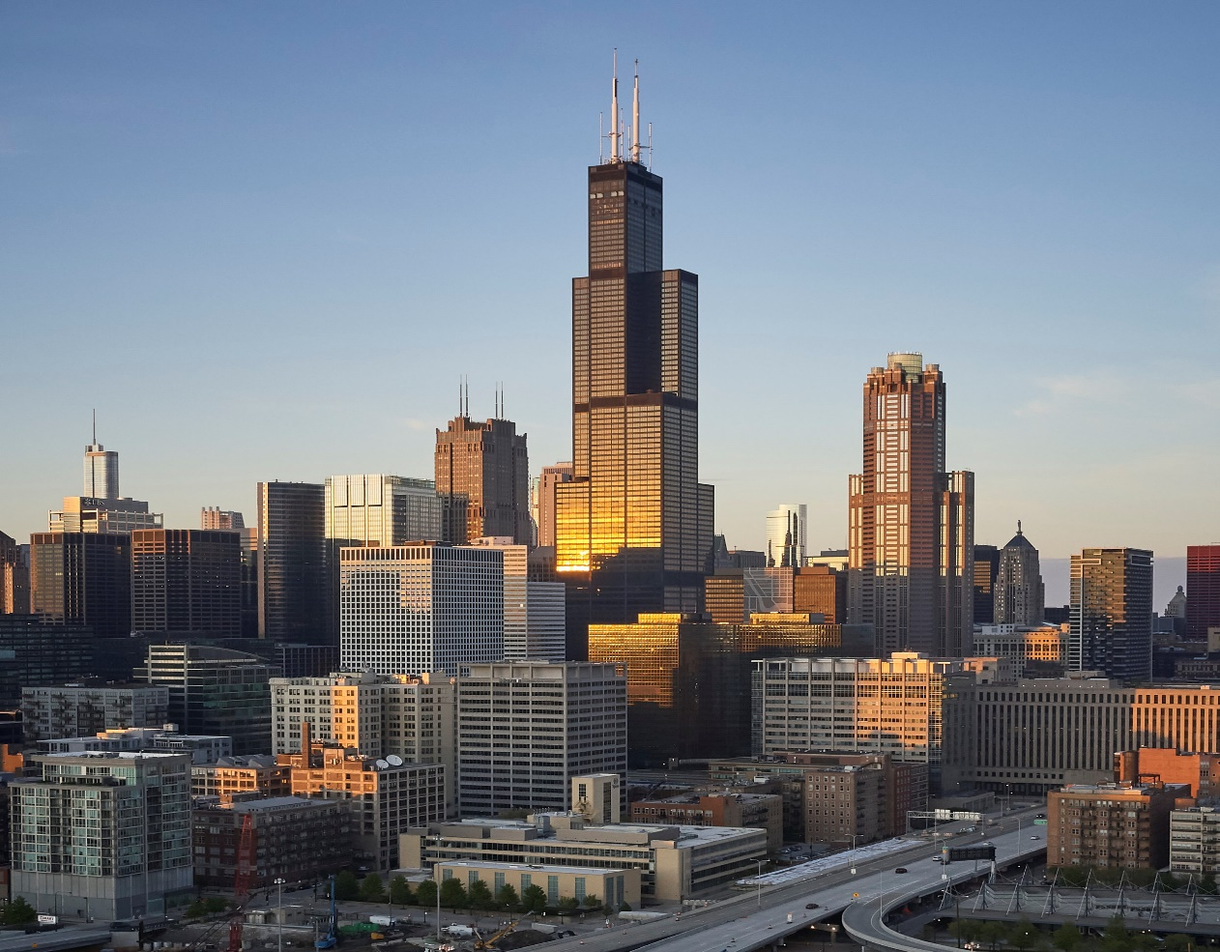
(Skidmore, Owings & Merrill (SOM), n.d.)
The Willis Tower, formerly known as the Sears Tower, is a 110 storey skyscraper in Chicago, USA. The skyscraper stands at 520 metres including the broadcast antennae which was added in 1982 and for 25 years stood as the tallest building in the world. The tower is currently the third tallest building in America and the 25th tallest building in the world. Construction started on the building in 1970 and was completed by 1973. 2000 people worked on the building throughout this period. In 2009, the Wills Tower Skydeck opened on the 103rd floor offering tourists panoramic views of Illinois, Michigan, Indiana and Wisconsin highlighting the adaptability of the tower and new methods to try and improve footfall and tourism (Willis Tower, n.d.).
The Willis Tower was designed with the bundled tube method. This design features nine steel tubes bundled together in a 3x3 grid and tied together to create a strong, rigid structure. Some tubes ended at the 65th floor, others at the 90th, while two continued to the top giving the structure a stepped appearance. This method not only saved money for the client, but it also met one of the main requirements of the specification which was to have large open office floor space (RICS, n.d.).
As mentioned, construction started on the Willis Tower in 1970. Due to the building’s height and weight, a deep foundation was essential. Caissons were sunk over 100 feet into the ground to provide the stability needed for the tower (Chicago Architecture Centre, 2024). Construction on the tower proceeded rapidly. Major works like welding the beams to the columns were done off site which meant the workers were able to finish two floors a week (Megastructures, 2015.).

Burj Khalifa- Concrete Structure
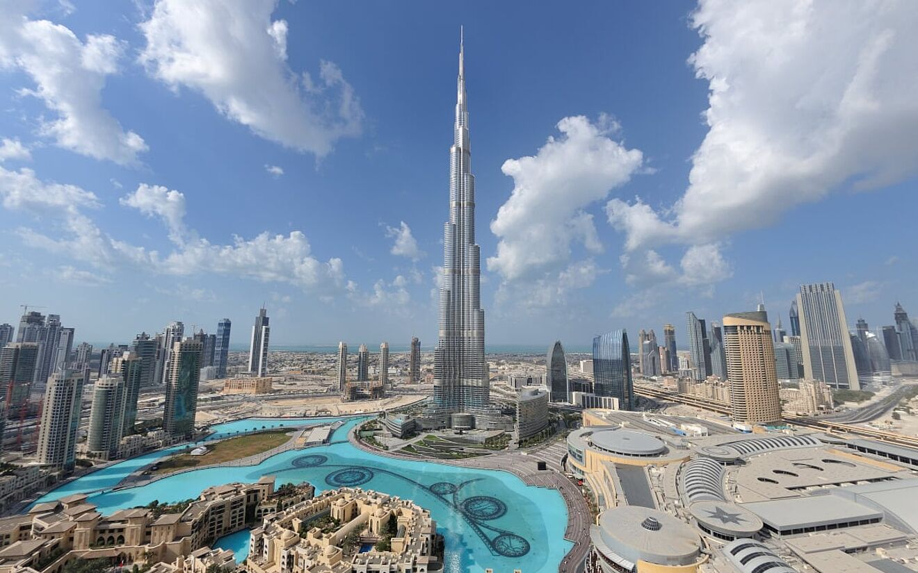
(Allplan Architecture, 2023; Skidmore, Owings & Merrill (SOM), n.d.)
The Burj Khalifa is a 163 storey skyscraper located in Dubai. Officially opening in 2010, it took 6 years to build. Standing at 828 metres high, it is officially the tallest building in the world. Skidmore, Owings, and Merrill (SOM) designed the building and were also the team behind the Willis Tower (The Institution of Civil Engineers, 2016).
The design of the Burj Khalifa was inspired by the Hymenocallis, a regional desert flower which is shown at the base of the tower. A key element of the design is the use of a buttressed core system. The central hexagonal core is the tower’s backbone, preventing it from twisting. The three Y-shaped wings stick out from the core, giving the building extra stability. These wings are made of reinforced concrete and connect to the core in a triangular shape, which helps spread the weight evenly. This provides the strength and stability while also providing resistance to wind force. Similar to the design of the Willis Tower, the Burj Khalifa features a staggered setback to break up the wind flow (Burj Khalifa, 2024).
As highlighted by Guardian Glass who supplied the glass units for the Burj Khalifa, the tower features a number of design elements to try and reduce energy absorption. Features like high efficiency lighting and heating, ventilation and air conditioning systems and also the use of reflective glass which reduces heat absorption (Guardian Glass, 2024).
The construction of the Burj Khalifa started in 2004 with the excavation. The tower is sat on 194 bored piles. The Burj Khalifa is predominantly reinforced concrete, however it does consist of a structural steel spire at the top. The tower required an enormous amount of concrete totalling 330,000 cubic metres of concrete, with the foundation alone requiring 45,000 cubic metres (Baker and Pawlikowski, n.d.).

Case Studies

Willis Tower- Environemental Considerations
The Willis Tower is located in Chicago which has been nicknamed “The Windy City”. Although not originally clear where this nicknamed originated, the most obvious explanation is from the breezes that blow off Lake Michigan (Andrews, n.d.). The Willis Tower will be exposed to frequent high winds as Chicago’s average wind speed is estimated to be at 9.9 mph (Harrington, 2023). Consideration had to be given to this when picking a suitable framing material.
Steel is a flexible material which allows the building to sway slightly in high winds without it breaking. Another environmental factor is the extreme weather conditions Chicago experiences with temperatures changing rapidly during the day. Due to this it was pivotal that the material used was able to expand and contract without cracking. Although steel can expand with heat, the design accounts for this movement and the ventilation helps regulate the heat indoors (Madsen, 2005).
Chicago averages 35-40 inches of snow each year (Choose Chicago, n.d.). Snow accumulation on rooftops can provide unnecessary load which may add stress to the structure. The stepped design of the tower reduces the amount of snow that falls onto the roof as it splits the load between the building.

Willis Tower- Impact On Community And Environment
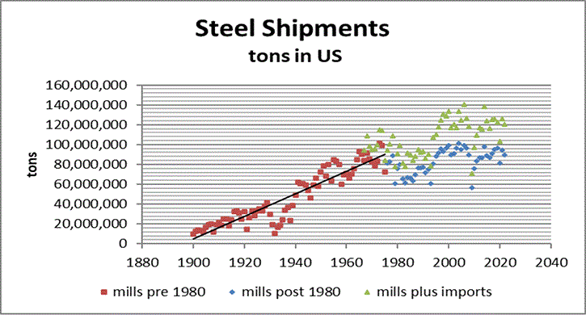
(Figure 1) (National Academy of Engineering, n.d.)
The Willis Tower had a significant impact on the community and the environment. Steel was a major contributor to the U.S economy in the 20th century as shown figure 1 and a city like Chicago relied heavily on these jobs (National Material Company, 2018). The building of the Willis Tower created work for the local community and boosted employment levels. After the construction had completed, large companies and businesses moved into the tower, creating long term employment and regular footfall for local businesses (Willis Tower, n.d.).
Unfortunately, steel production has a major impact on the environment, especially given the time period of construction. Steel used for the Willis Tower will have been produced using blast furnaces. These blast furnaces release a large amount of carbon dioxide into the atmosphere. Figures reveal that the steel industry is one of the biggest contributors to global greenhouse gas emissions. Steel production also requires large quantities of water for the cooling process. Water waste from these processes can contain contaminants which can lead to rivers and lakes becoming polluted. The steel industry is aware of these figures and are taking steps to try and reduce the impact on the environment but as mentioned previously, considering when the Wills Tower was made, the impact of steel manufacturing was not as commonly known. (Conejo, Birat and Dutta, 2020).

Willis Tower- Frames Assembly And The Potential Adaption
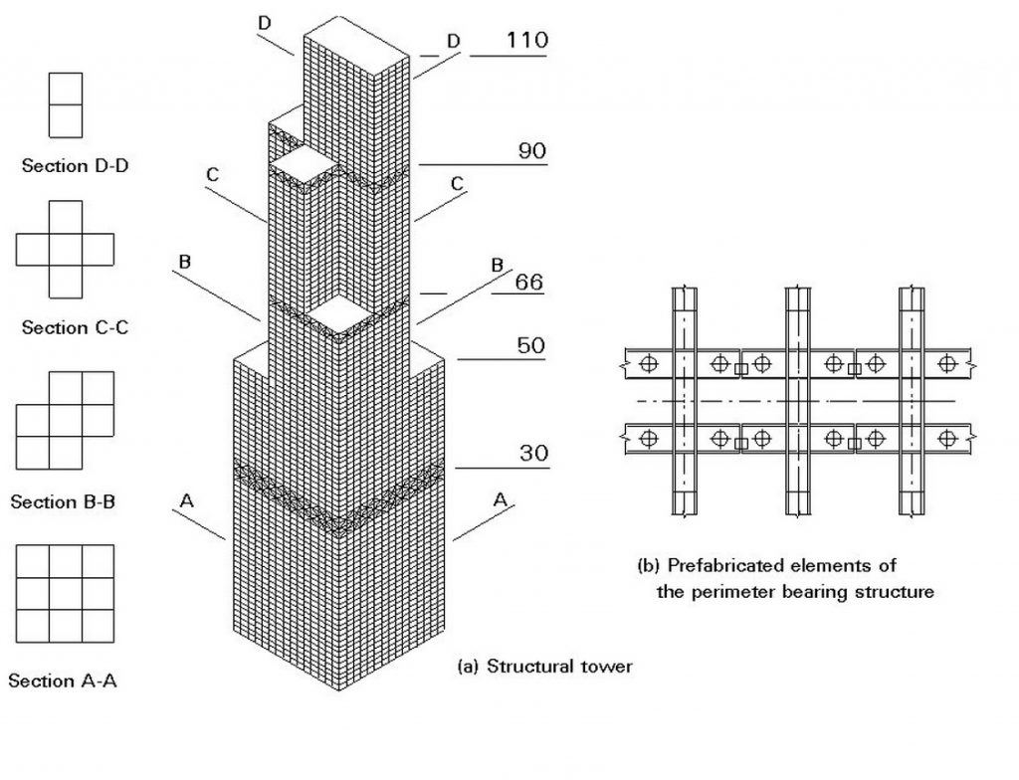
(Figure 2) (Hidden Architecture, 2019)
The Willis Tower steel was prefabricated offsite and transported to Chicago. Figure 2 shows the offset sections as mentioned previously. This allowed for rapid installation. As mentioned previously, workers were able to complete two floor a week, saving the client time and money. As with all large projects, installation speed was a significant worry not only for the client but for the local community. Noise disruption and traffic congestion are a concern with any project, let alone in a busy area of Chicago. The use of prefabricated steel helped the installation move along swiftly and quickly, keeping disruption time down (Willis Tower, n.d.).
Prefabrication offsite allowed for the rapid install as well as good quality control meaning the client will save on waste. Moving forward, steel is very adaptable meaning the bundle tubed system can be modified by simply removing sections without compromising the structure. Steel is 100% recyclable, so in future if the tower gets removed or replaced, the whole structure can be reused. The adaptability of steel increases the potential for conversion, whether this be rentable office space or living areas, the client moving forward has a chance to increase income from the tower however they choose (Megastructures, 2015.).

Burj Khalifa Environemental Considerations
The Burj Khalifa is located in Dubai. Due to the extreme temperatures, a material had to be used that would be able to withstand the heat and humidity as well as sandstorms. Unlike steel which is can be prone to rust in humid weather, reinforced concrete can withstand the humidity and not degrade as quickly (Madsen, 2005).
The concrete used includes cooling additives to control expansion and contraction which reduces thermal stress. As well as the reinforced concrete, the Burj Khalifa also features a corrosion resistant steel reinforced bar at the peak of the tower, this was used to prevent damage from moisture and salt exposure (Commercial Interior Design, 2016).
These extreme temperatures can cause a building to expand and contract. Concrete is extremely fire resistant making it a logical material to use in the tower due to the consistent nature of the heat in Dubai (The Concrete Centre, 2019).

Burj Khalifa- Impact On Community And Environment
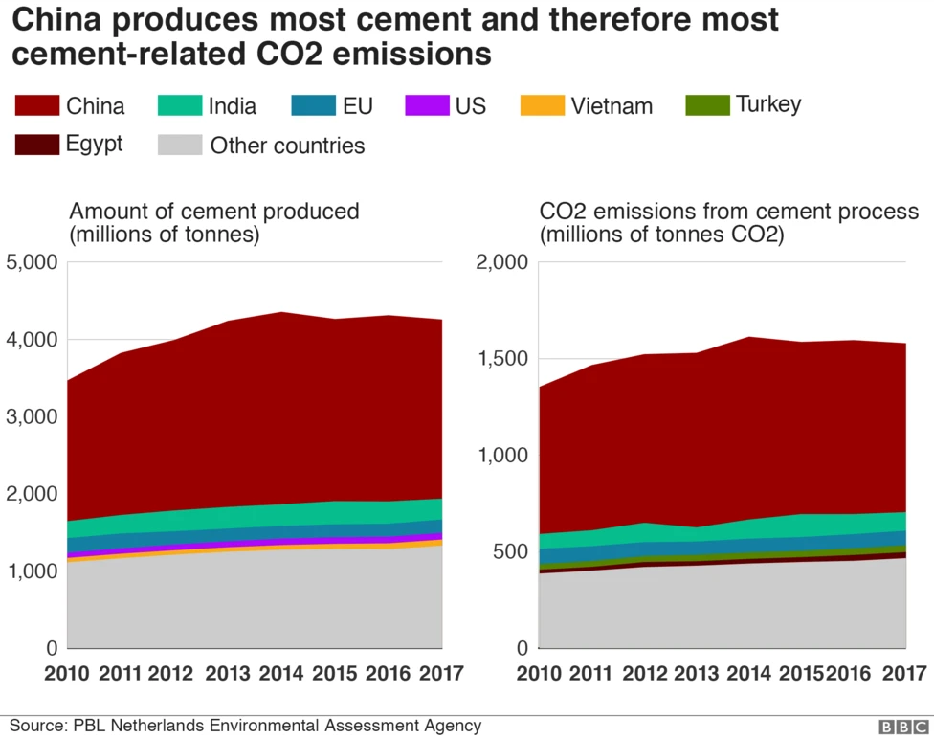
(Figure 3) (Rodgers, 2018)
Much like steel, concrete has a high impact on the environment. As shown in figure 3, concrete production is one of the biggest contributors to CO2 emissions globally due to the high temperatures required to manufacture. Producing concrete involves heating materials in kilns at high temperatures, this process uses large amounts of fossil fuels damaging the environment. The hot climate meant the concrete required water intensive concrete cooling which increases the water consumption (Watts, 2019).
The impact of the Burj Khalifa on the local community and the world was enormous. Jobs were created all over the world to deal with the requirements to build such a substantial tower. Materials were shipped in from many different countries increasing employment levels but also impacting the environment (Commercial Interior Design, 2016).
Unfortunately, the workers working on the tower faced harsh conditions, working in extreme heat for long hours and for low pay. Many safety violations were breached. The exploitation of workers who were brought in from predominantly South and East Asian countries was reported at the time and made widespread news. (Human Rights Watch, 2006)
Workers were housed in labour camps on the outskirts of the city in overcrowded accommodation with poor facilities. When working at the site, the work was often dangerous without suitable equipment and very little breaks. Workers were often not paid on time and when they were paid, the wages were very low. According to a Human Rights Watch report, one worker reported he was paid $10,50 a day for eight hours work and that was more than new employees as he had been with the company for 11 years (Human Rights Watch, 2006).

Burj Khalifa- Frames Assembly And The Potential Adaption
Similar to the Willis Tower, a lot of the structural materials for the Burj Khalifa were prefabricated offsite. This again allowed for higher quality control, reduced wastage and faster assembly on site. The concrete core of the structure was constructed using pumped concrete which allowed work to continue without cranes up to 600 meters high. Along side the pumped concrete, a jump form system was employed which allowed concrete to be poured 24 hours a day. This allows for quicker install time and substantial cost savings (Sabin Civil Engineering, 2025).
Unlike steel, which was used in the Willis Tower, concrete has limited adaptability, making structural modifications challenging. Any changes to the shape or height of the Burj Khalifa would be difficult, though some internal layout adjustments have been made since its opening. Although adaptation will be challenging, concrete can be crushed into aggregate and reused in new concrete, reducing waste and resource consumption (MPA, n.d.)

Comparison Of the Advantages and Disadvantages Of Materials
 | Steel | Concrete
Advantages | Ease of erection. | High durability meaning longer lifetime.
 | Ability to prefabricate. | Fire resistant.
 | Less wastage. | Highly resistant to water damage.
 | 100% recyclable. | Readily available in most places.
 | Good quality control. | Easily moulded so suitable to many designs.
 | Ease in fixing. | Low maintenance.
 | Less demand on site space. | Low transport costs as materials tend to be locally sourced.
 | Adaptability increasing lifecycle of material. | Energy efficient.
 | Erection regardless of weather conditions.
 | High strength to weight ratio.
Disadvantages | Expensive compared to concrete. | Increased construction time and labour costs.
 | Needs fire protection as heat can weaken the material. | Less flexibility in design.
 | Steel is prone to rust and corrosion. | Complex foundations needed as steel is around 50% lighter.
 | Working with steel may incur higher labour costs for skilled workers. | High initial costs for materials.
 | Potentially longer lead times holding up deliveries and projects. | Susceptible to cracking.
 | Extra costs associated with fireproofing. | Low tensile strength.
 | Environmental impact. | Difficult to modify.
 |  | Environmental impact.
(Australian Steel Institute, 2024).
(The Concrete Centre, 2019)
(Empire Engineering, 2023)
(Madsen, 2005).

Reference List
Allplan Architecture (2023). Image of Burj Khalifa. Allplan Architecture. Available at: https://www.allplan.com/blog/burj-khalifa/ [Accessed 24 Mar. 2025].
Andrews, E. (n.d.). Why is Chicago called the ‘Windy City’? [online] HISTORY. Available at: https://www.history.com/news/why-is-chicago-called-the-windy-city [Accessed 17 Mar. 2025].
Australian Steel Institute (2024). Australian Steel Institute - Advantages of Steel Construction. [online] www.steel.org.au. Available at: https://www.steel.org.au/what-we-do/focus-areas/steel-in-architecture/advantages-of-steel-construction/ [Accessed 28 Mar. 2025].
Baker, B. and Pawlikowski, J. (n.d.). The Design and Construction of the World’s Tallest Building: the Burj Khalifa, Dubai. [online] Available at: https://www-tandfonline-com.ezproxy.uwtsd.ac.uk/doi/epdf/10.2749/101686615X14355644770857?needAccess=true [Accessed 17 Mar. 2025].
Burj Khalifa (2024). Architecture & Design. [online] Burj Khalifa. Available at: https://www.burjkhalifa.ae/the-tower/architecture-design/ [Accessed 17 Mar. 2025].
Chicago Architecture Centre (2024). Chicago Architecture Center. [online] Chicago Architecture Center. Available at: https://www.architecture.org/online-resources/architecture-encyclopedia/caisson [Accessed 16 Mar. 2025].
Choose Chicago (n.d.). Chicago Weather Averages. [online] Choose Chicago. Available at: https://www.choosechicago.com/plan-your-trip/chicago-weather/ [Accessed 26 Mar. 2025].
Commercial Interior Design (2016). How the Burj Khalifa was built (including design, foundations, cladding and urban myths). [online] Commercial Interior Design. Available at: https://www.commercialinteriordesign.com/insight/updated-how-the-burj-khalifa-was-built-including-design-foundations-cladding-and-urban-myths [Accessed 27 Mar. 2025].
Conejo, A.N., Birat, J.-P. and Dutta, A. (2020). A review of the current environmental challenges of the steel industry and its value chain. Journal of Environmental Management, [online] 259, p.109782. doi:https://doi.org/10.1016/j.jenvman.2019.109782.
Empire Engineering (2023). Steel Vs Concrete - Empire Engineering. [online] Empireengineering.co.uk. Available at: https://www.empireengineering.co.uk/steel-vs-concrete/ [Accessed 28 Mar. 2025].
Guardian Glass (2024). The Burj Khalifa. [online] Guardian Glass. Available at: https://www.guardianglass.com/gb/en/projects/project-details/the-burj-khalifa [Accessed 26 Mar. 2025].
Harrington, A. (2023). Why is Chicago called the Windy City? [online] Cbsnews.com. Available at: https://www.cbsnews.com/chicago/news/why-chicago-called-windy-city/ [Accessed 26 Mar. 2025].
Hidden Architecture (2019). Willis Tower (formerly Sears Tower). [online] Hidden Architecture. Available at: https://hiddenarchitecture.net/willis-tower-formerly-sears-tower/ [Accessed 27 Mar. 2025].
Human Rights Watch (2006). Building Towers, Cheating Workers | Exploitation of Migrant Construction Workers in the United Arab Emirates. [online] Human Rights Watch. Available at: https://www.hrw.org/report/2006/11/11/building-towers-cheating-workers/exploitation-migrant-construction-workers-united [Accessed 27 Mar. 2025].
Madsen, J.J. (2005). Concrete Vs Steel. Nashville: Endeavor Business Media. [online] Available at: https://www.proquest.com/docview/210228164?accountid=130472&parentSessionId=gX%2FzdXeHSENbueKH%2F5%2B1S6WWdfoxN1MRpvLvBhGs4Hg%3D&pq-origsite=primo&sourcetype=Trade%20Journals [Accessed 26 Mar. 2025].
MPA (n.d.). Five Ways Concrete Is Creating lower-carbon Buildings. [online] This is concrete. Available at: https://thisisukconcrete.co.uk/Tackling-climate-change/Five-ways-concrete-is-creating-lower-carbon-buildi.aspx [Accessed 27 Mar. 2025].
National Academy of Engineering (n.d.). The Rise of the US Steel Industry. [online] NAE Website. Available at: https://www.nae.edu/313347/The-Rise-of-the-US-Steel-Industry [Accessed 27 Mar. 2025].
National Material Company (2018). A Brief History of the American Steel Industry. [online] National Material Company - Steel Processing Facilities. Available at: https://www.nationalmaterial.com/brief-history-american-steel-industry/ [Accessed 26 Mar. 2025].
RICS (n.d.). Buildings that elevated cities: Chicago’s Sears Tower. [online] ww3.rics.org. Available at: https://ww3.rics.org/uk/en/modus/built-environment/commercial-real-estate/buildings-that-elevated-cities--chicago-s-sears-tower.html [Accessed 16 Mar. 2025].
Rodgers, L. (2018). Climate change: The massive CO2 emitter you may not know about. BBC News. [online] 17 Dec. Available at: https://www.bbc.co.uk/news/science-environment-46455844 [Accessed 27 Mar. 2025].
Sabin Civil Engineering (2025). Burj Khalifa | How a Wonder was Constructed? [online] YouTube. Available at: https://www.youtube.com/watch?v=tOjYeqvTfJM [Accessed 27 Mar. 2025].
Skidmore, Owings & Merrill (SOM) (n.d.). Willis Tower Image. Skidmore, Owings & Merrill (SOM). Available at: https://www.som.com/projects/willis-tower-formerly-sears-tower/ [Accessed 24 Mar. 2025].
Structural Community (2020). Advantages & Disadvantages of Steel Construction. [online] Structural Community. Available at: https://structural.community/articles/advantages-of-steel-construction/ [Accessed 27 Mar. 2025].
The Concrete Centre (2019). Fire resistance. [online] www.concretecentre.com. Available at: https://www.concretecentre.com/Performance-Sustainability/Fire-Resistance.aspx [Accessed 26 Mar. 2025].
The Institution of Civil Engineers (2016). Burj Khalifa. [online] Institution of Civil Engineers (ICE). Available at: https://www.ice.org.uk/what-is-civil-engineering/infrastructure-projects/burj-khalifa [Accessed 16 Mar. 2025].
Watts, J. (2019). Concrete: the most destructive material on Earth. [online] The Guardian. Available at: https://www.theguardian.com/cities/2019/feb/25/concrete-the-most-destructive-material-on-earth [Accessed 27 Mar. 2025].
Willis Tower (n.d.). About Willis Tower. [online] www.willistower.com. Available at: https://www.willistower.com/about [Accessed 13 Mar. 2025].
Willis Tower (n.d.). THE HOWS, WHATS AND WOWS OF THE WILLIS TOWER a GUIDE FOR TEACHERS SKYDECK CHICAGO PROPERTY MANAGED BY U.S. EQUITIES ASSET MANAGEMENT LLC. [online] Available at: https://theskydeck.com/wp-content/uploads/2013/08/Teachers-Guide-2014.pdf [Accessed 26 Mar. 2025].
Willis Tower (n.d.). Willis Tower History | Skydeck Chicago History and Story. [online] Skydeck. Available at: https://theskydeck.com/the-experience/tower-history/ [Accessed 26 Mar. 2025].
www.youtube.com. (n.d.). MegaStructures - Willis Tower (Sears Tower) (National Geographic Documentary). [online] Available at: https://www.youtube.com/watch?v=_rm1GiS6Rjc [Accessed 16 Mar. 2025].

