

LOCATION: SWANSEA | LLEOLIAD: ABERTAWE
LEVEL 4 | LEFEL 4
EXAMINATION PERIOD | CYFNOD ARHOLIADAU
2023 | 2023
MODULE CODE: ACCB4017
SOFTWARE DEVELOPMENT (SOLUTIONS)
(IN-CLASS TEST – time to BE ARRANGED BY MODULE LECTURER)
TIME: 2 HOURS
answer all questions

Equipment or materials required. Please select from the following:
Adnoddau neu ddefnyddiau sydd eu hangen.

Cyfrifiannell/Calculator ☐
Llyfr Agored/Open Book ☒
Arall/Other ☐

Nodwch/Please Note: Students will answer the questions below using the programming language they have studied during the module. The questions/solutions shown below refer to the Python language, but some groups may be studying the module using other programming languages (such as C). Therefore the paper will be adapted to reflect this if required.

Additionally, at some delivery locations, where the test is delivered via electronic means such as Moodle, questions may be drawn from a random pool, but will be in the style and of a similar difficulty level to those listed below.

ANSWER ALL QUESTIONS

1. a) Which variable type would be most suitable to store each of the following values?

p ………….string.........…………………………………..…

-41 ………….int.........…………………………………….…

Gemma ………….string .…………………………………….…

2.56 …………..float........…………………………………..…

G5 …………..string........…………………………………..…

34.62 …………..float........…………………………………..…

[1 mark each - 6 marks total]

1 b)

What errors are present in the following code for welcoming a user to a program? Line numbers are included for easy reference

1 print(Welcome to my program") missing quote [1]
2
3 print("Please enter your name: ")
4 myName = int(input()) wrong variable type used [1]
5
6 print("Welcome, " myName) missing comma [1]
7
8 print("I shall say hello to you 10 times: ")
9
10 for counter in range(0, 11) 11 times, plus missing colon [2]
11 print("Hello")

[5 marks]

1 c) How many iterations do the following loops have?

for i in range(2, 6, 1): ……4……..
print("Hello")

for i in range(0, 12, 2): ……6……..
print("Hello")

[4 marks – 2 marks each]

1. d) What is the value of the integer variable total after the following code is executed?

total = 1
for x in range(0, 9, 1):
total = total + x
if x == 5:
total = 0
total = total - 1

……20…… [3 marks]

1 e) Logic

- Given the following values x=5, y=2, z=15 is the statement below true or false?
x<=y
…false…

- Given the following values x=5, y=3, z=12 is the statement below true or false?
x == z/y
…false…

[2 marks total]

[20 marks total for Question 1]

2. Calculating the volume of a cone

The volume of a cone is calculated using the formula shown below:
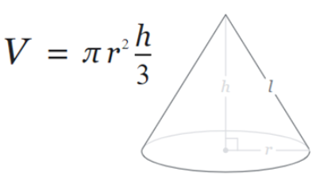

Task:
Write a program to calculate the volume using the above formula.

Allow the user to enter the measurements for r and h. Both r and h should be positive numbers. You can set pi to 3.142

Print the volume on the screen to 2 decimal places
[10 marks total for Question 2]
Solution

Students should present efficient code to accomplish the task. A possible solution is shown below.

pi = 3.142
print("Please enter measurement for r: ")
r = float(input())
while r <= 0:
print("r must be a positive number, please try again")
r = float(input())
print("Please enter measurement for h:")
h = float(input())
while h <= 0:
print("h must be a positive number, please try again")
h = float(input())
volume = (pi * r * r) * (h / 3)
volume = round(volume, 2)
print("The volume of the cone: ", volume)

Required:

Choice of appropriate types [2]
Calculation made and printed out correctly [4]
Validation of user input [4]
3. Using lists (Python) or arrays (C etc)

Task:
Declare an empty list in your program to hold some measurements, for example:

rainfall = [ ]

1. Prompt the user to enter five (valid) rainfall measurements (in millimetres) and store them in a list. (eg 3.3, 5.0, 2.6 etc)
2. Print each of the entered values on the screen using a loop.
3. Calculate the total rainfall (ie add all five measurements)
4. Also calculate the average rainfall and print it on the screen

Sample output:
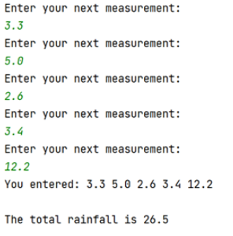
[15 marks total for Question 3]
Solution
Students should present efficient code to accomplish the task. A possible solution is shown below.

rainfall = []
for i in range(0, 5, 1):
rm = float(input("Enter your next measurement: "))
if rm < 0 or rm > 500:
rm = float(input("Sorry out of range. Try again: "))
rainfall.append(rm)
total = sum(rainfall)
average = total / len(rainfall)
print("You entered: ")
for i in range(0, len(rainfall), 1):
print(rainfall[i], end=" ")
print("\nThe total rainfall is: ", round(average, 2))

Required:

Management of list (no overflow, underflow etc) [5]
Use of loops [5]
Calculation correct [3]
Validation of input [2]

4. Using Functions

Task:
Write a function called entermeasurement() which will allow the user to enter a measurement for one side of a parcel and then return it to the main program. The function should also check that the measurement entered is greater than 0.

From the main program, call your entermeasurement() function 3 times - once for each of the length, width and height measurements, and print the measurements returned on the screen.

Also, calculate and print the volume of the parcel (length * width * height) on the screen.

Sample output:

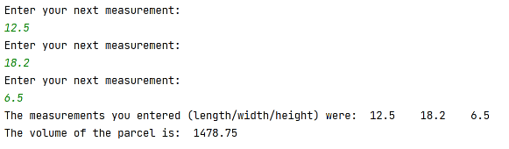
[15 marks total for Question 4]

Solution
Students should present efficient code to accomplish the task. A possible solution is shown below.

def entermeasurement():
print("Enter size: ")
cm = float(input())
while cm<0:
print(“Try again, must not be negative”)
cm=float(input())
return cm
dimensions = []
for i in range(0, 3):
dimensions.append(entermeasurement())
print("\nThe measurements you entered were: ")
for measurements in dimensions:
print(measurements, end=" ")
volume = dimensions[0] * dimensions[1] * dimensions[2]
print("Volume is”, volume)

Required:
General efficiency, use of loops where appropriate [4]
Function and its re-use correct [5]
Variable scope correct [3]
Correct output eg calculation etc [3]

Diwedd/End

