

Student Name: SHUVON MAJHI

Student ID: 2432116

Module Name: international Marketing: Principles and Practices
Module Code: LCMB 7026

Assignment title: International Marketing Principles and Practices
Lecturer’s Name: Tushara Balendran

Words: 5454

Table of Contents
Introduction 4
Brand Overview 5
Company background 5
Netflix in the United Kingdom 5
Netflix in India 6
Comparison of the Socio-Cultural Context- PESTLE Analysis 7
Political and Regulatory Environment 7
Economic Environment 7
Sociocultural Environment 8
Technological Environment 11
Legal Environment 11
Environmental and Sustainability Factors 12
Similarities and differences between the macroenvironment in India and the UK 12
Comparison of STP (Segmentation, Targeting, and Positioning) Strategies 13
Market Segmentation 13
Targeting Strategies 14
Positioning Strategies 15
Similarities and differences of STP strategies 17
Comparison of Marketing Mix (7Ps) 19
Product mix 19
Price 21
Place 23
Promotion 24
People 25
Process 25
Physical Evidence 26
Evaluation of the Performance of Marketing Strategies 27
Performance in the United Kingdom 27
Subscriber Base and Revenue 28
Content and engagement 28
Brand Equity 29
Performance in India 29
Subscriber Growth and Revenue 29
Digital and Social Media Engagement 30
Brand Image and Market Position 30
Evaluation of Marketing Ethics Practice 32
Recommendation 33
Conclusion 34
References 35

Introduction
Within the present competitive digital entertainment industry, Netflix has become a market leader by offering on-demand services on a global platform of feature films, television, and original material. Its success in international markets highlights the paramount role of localised marketing investments in maintaining global success. This report compares the marketing mixes of Netflix in the United Kingdom and India, to understand how socio-cultural, economic and technological conditions influence business operations. Its analysis will use such canonical marketing frameworks as the PESTLE, STP, and the 7Ps in comparison and evaluation of Netflix's strategic approaches in both jurisdictions. Moreover, the paper examines the global management of the brand, product dimension, and ethics. Based on these results, this report suggests recommendations that could help Netflix improve its future international marketing and long-term brand positioning.

Brand Overview

Company background
Netflix was started in 1997 in California by Reed Hastings and Marc Randolph as a DVD-by-mail service and has since shown a radical transformation of the entertainment industry with the advent of streaming. During the year 2007, Netflix introduced its online streaming platform, thus changing the way audiences consume media. At the current moment, Netflix is functioning in over 190 countries, having over 260 million subscribers all over the globe (Barraza, 2025).
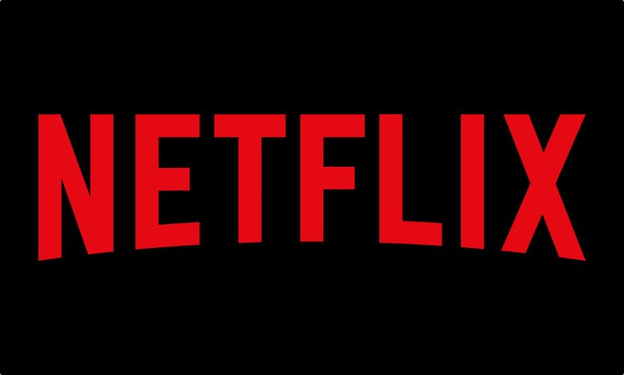
Figure 1: Neflix
Source: (Barraza, 2025)

Netflix in the United Kingdom
In early 2012, Netflix launched in the United Kingdom and quickly scaled up to a leading video-on-demand provider. The UK market is described as mature with a high income and a high degree of digital literacy, under which, streaming services have dominantly replaced traditional television (Yuan, 2023). Furthermore, Netflix has also entered into strategic partnerships with telecommunication companies, such as Sky and Virgin Media, to incorporate its streaming platform into their existing television packages, which gives customers easy and built-in access to it (Fariandi and Ariani, 2023). By 2024, the subscriber base of the platform in the UK reached about 17 million users, which makes it competitive with Amazon Prime Video, Disney+, and BBC iPlayer.

Netflix in India
Netflix launched in India in 2016 into a complex, price-elastic environment dominated by national and regional competitors, including Disney+ Hotstar, Zee5, and SonyLIV. The company focused on a localisation strategy that emphasises regional language options, mobile access, and low-end pricing to appeal to and retain Indian viewers. Furthermore, Netflix has made large investments in original Indian content, such as Sacred Games, Delhi Crime, Rana Naidu, etc., which feature local characters and local stories (Pérez, 2020). The activities of the platform in India also build on its alliances with telecommunication titans like Jio and Airtel, through which streaming subscriptions are combined with data tariffs. Nevertheless,

Comparison of the Socio-Cultural Context- PESTLE Analysis
This part involves a comparative study of the macro-environmental forces that affect the marketing strategies of Netflix in the United Kingdom and India using the PESTLE model.

Political and Regulatory Environment
United Kingdom:
In the United Kingdom, the business environment is favourable to global operations because of a stable political environment. The Office of Communications (Ofcom) and the British Board of Film Classification (BBFC) regulate media and entertainment activities. It helps Netflix by providing a free, liberal regulatory regime requiring a balance between creative freedom and strict rules regarding explicit content, advertising, and consumer protection (Gupta and Madan, 2024).
India:
The political condition in India is favourable for Netflix. However, the political climate of India poses more complicated regulatory hurdles. Media content is controlled by the Ministry of Information and Broadcasting (MIB) and the Central Board of Film Certification (CBFC). The government has, in the recent past, introduced the Information Technology, Intermediary Guidelines and Digital Media Ethics Code, Rules 2021, that necessitate content control and grievance-redress frameworks in the over-the-top (OTT) platforms (Dibra and Braholli, 2024).

Economic Environment
United Kingdom:
The UK has one of the largest and strongest economies in the world, with a GDP of $3.38 trillion in 2023. Besides, the GDP is growing gradually. The inflation rate is low in the UK but above the BoE’s target rate of 2% (Harari, 2025). Disposable income levels are adequate to sustain entertainment subscriptions. Consumers are quite willing to spend on high-quality content and are already accustomed to a variety of subscription services. However, the UK market is also economically mature and creates strong competition between Disney+, Amazon Prime and NOW TV. Given this situation, the economic condition in the UK can be rendered favourable in the UK.
India:
India is one of the fastest-growing economies in the world, with a GDP of $3.9 trillion in 2024 (The World Bank, 2025). The inflation rate is high in India, which is around 4.3%. However, the market is very price sensitive, and consumers tend to demand value propositions. Disposable income and the ability to spend on entertainment in India are significantly less than in the United Kingdom (Jati and Serenade, 2024). The price factor is one of the vital factors, considering that other competitors like Disney+ Hotstar and Zee5 offer cheaper or free-to-air alternatives.

Sociocultural Environment
United Kingdom:
The British consumers are upholding originality, content of narrative, and naturalism in audiovisual information. The national diversity of the population creates demand in both local and foreign programming (Nelsa et al., 2025). Moreover, changing family dynamics and time changes have set a motion towards the on-demand entertainment that has smartened away traditional broadcast television (Gregory, 2021).
India:
The sociocultural environment in India is deeply heterogeneous as it incorporates many religions, languages, and regional customs. Entertainment plays a leading role in everyday life, and authentic cultural representation is key to audience acceptance. Therefore, Indian audiences prefer content that captures native values, feelings, and storytelling tropes (Morris, 2022).
Cultural differences based on Hofstede’s Dimensions
To highlight the cultural disparities that affect streaming choices and marketing tactics of communicating, the chart compares the Hofstede cultural dimension scores of the United Kingdom and India.
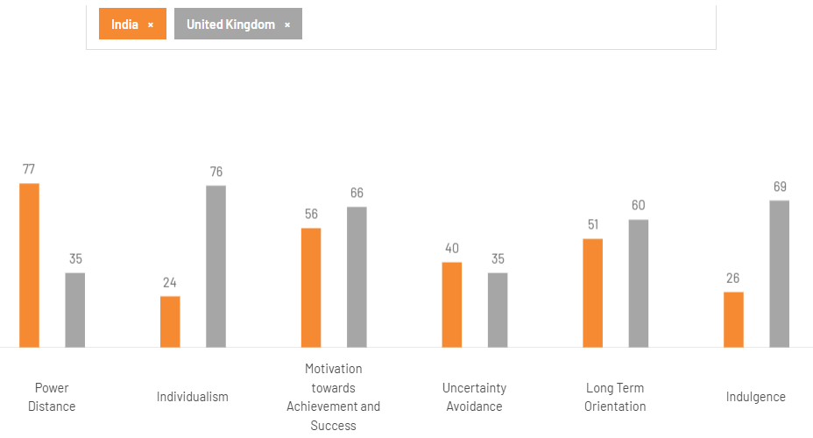
Figure 2: Hofstede cultural dimensions comparison between the UK and India
Source: (Hofstede Insights, 2025)
The score of power distance in India (77) suggests approval of hierarchical systems and might limit user empowerment but enable centralised strategic control, creating a moderately favourable cultural environment towards Netflix (Migliore, 2011). By contrast, power distance in the UK is low (35), which indicates egalitarian ethics and autonomy, which go well with the user-oriented and choice-driven ecosystem of Netflix (Dhaundiyal et al., 2020).
Regarding individualism, the collectivist orientation of India (24) facilitates universal and family-oriented media viewing and produces ambivalent consequences about the customised model (Kuźmińska-Haberla, 2017). On the other hand, UK individualism (76) is very positive and encourages customised content and subscription.
Masculinity in both nations is rather high, with India at 56 and the UK at 66, implying a competitive and achievement-driven culture. This is a positive aspect in the two cases, since inspirational and success-driven stories will appeal to readers (Kuźmińska-Haberla, 2017). The cultural openness to new genres, new formats, and new digital platforms like Netflix is good, as low uncertainty avoidance in India (40) and the UK (35) means the culture is open towards innovation and experimentation (Dhaundiyal et al., 2020).
Regarding long-term orientation, the balanced score (51) of India emphasises moderate future orientation, which provides the development of brand loyalty gradually (Migliore, 2011). The UK score (60) reflects greater long-term planning and perseverance, which is positive in terms of continuing with business models of subscription (Dhaundiyal et al., 2020).
Lastly, there is a significant difference in the indulgence. The controlled leisure spending and strong price sensitivity due to the conservative culture in India (26) mean that the environment is not favourable (Migliore, 2011). Conversely, the culture of indulgence in the UK (68) indicates a tendency towards high consumption of entertainment and leisure activities, which are of great value to Netflix (Dhaundiyal et al., 2020).
Overall Assessment
As a whole, India is a moderately favourable cultural context to Netflix, as it demands a comprehensive localisation and pricing approach, whereas the UK is a highly favourable market, as it conforms to cultural contexts of personalisation, innovation, and non-essential entertainment expenditure (Hsiao, 2024).
Advantages and Disadvantages of Hofstede’s Cultural Dimension Model
Advantages: The model provided by Hofstede has provided a systematic and simple to apply comparison with national cultures. It is also well known in global business studies and can help organisations to develop marketing and entry strategies across boundaries (Hsiao, 2024).
Disadvantages: Nevertheless, the model is most likely to generalise national cultures and disregard national differences within countries. It rests on quite old data and fails to represent cultural dynamism in its entirety, as well as, it does not considering cultural differences at the individual or organisational levels (Hsiao, 2024).

Technological Environment
United Kingdom:
The technological factors in the UK are favourable for Netflix. The United Kingdom is also an advanced technological country, with a high level of broadband coverage, 5G networks, and smart device penetration. These circumstances allow Netflix to streamline 4K content and a customised viewing solution (Onyusheva and Baker, 2021).
India:
The digitalisation of India and low-cost mobile data have sparked an explosion in over-the-top (OTT) services, and the Indian population is now becoming one of the biggest smartphone and internet markets in the world (Ithurbide, 2022). The Jio and Airtel technological alliances made it expand its coverage. Thus, the technological condition in India is favourable for Netflix operations and growth.

Legal Environment
United Kingdom:
The United Kingdom has very strict data protection laws, which are governed by the General Data Protection Regulation (GDPR), which governs user privacy and proper management of data (Rental, 2023). Netflix has to adhere to consumer rights laws, advertising ethics, and anti-piracy laws. Management of copyright is essential, as there are strong creative industries in the country. The regulatory condition, thus, is very rigid for Netflix in the UK.
India:
In 2023, India reportedly introduced the Digital Personal Data Protection Act (DPDP) that made it well-conformed to the privacy of data on a global scale. Netflix must comply with the Information Technology Act on cyber laws and content liability. In addition, the complex tax regime in India, such as the Goods and Services Tax imposed on digital services, greatly affects the pricing strategies of the platform (White and Bucci, 2022). Hence, the legal environment is very demanding and unfavourable for Netflix in India.

Environmental and Sustainability Factors
United Kingdom:
The United Kingdom has a growing environmental sustainability concern that dictates consumer attitudes and corporate responsibility policies. The organisation publishes its carbon footprint and has data-centre projects, which are energy-intensive and are consistent with the national sustainability efforts (Fernández-Manzano et al., 2016). Furthermore, it promotes green production and participates in the Albert Sustainable Production Certification to reduce emissions made during filming. Thus, environmental conditions is demanding and pressing in the UK.
India:
Environmental awareness is on the rise in India, but not dominating the entertainment choices. However, Netflix has embarked on sustainable production and writers on Social responsibility campaigns (Baranidharan and Kulkarni, 2025). The high youth population, reliant on climate change issues, could improve the corporate image of the platform through the integration of environmental messages in the brand communication. Thus, the environmental condition is favourable for Netflix in India.

Similarities and differences between the macroenvironment in India and the UK
The economic factors of both countries are very favourable for Netflix. But UK people have a higher disposable income compared to Indians. Similarly, India’s GDP growth rate is much higher than that of the UK. Another similar factor includes political stability and strict regulatory control of customer rights, privacy and content sensitivity.
Environmental pressure is a differentiating factor. UK people are very aware of the environmental impacts of business operations, whereas in India, environmental awareness is at an initial stage. Enforcement of laws in the UK is more flexible in India compared to the UK.

Comparison of STP (Segmentation, Targeting, and Positioning) Strategies
The pillars of international marketing in Netflix are segmentation, targeting, and positioning (STP). Being a world-pacer in streaming, Netflix has to alter its strategies to fit demographic, psychographic, and behavioural differences in markets.

Figure 3: STP strategies
Source: (Hidayat and Ambarwati, 2024)

Market Segmentation
Segmentation divides a diverse market into small homogeneous consumer groups that have similar needs and behavioural patterns. At Netflix, many segmentation variables are used in order to find its audience and target it accurately (Hidayat and Ambarwati, 2024).
United Kingdom:
Netflix has extensively depended on demographic as well as psychographic segmentation practices (Baschiera and Re, 2018):
Demographic Segmentation: The streaming service aims at consumers of varying age groups, although it focuses mostly on millennials and Gen Z (18 to 40). Moreover, an income-based segmentation strategy will also be relevant. UK families with a higher disposable income level will be more willing to subscribe to several streaming services at the same time (Bobmanuel, 2022).
Psychographic Segmentation: British audiences have a high level of interest in creative content that has realistic and social commentary. High rates of binge-watching habits and a liking to exclusive content are further drivers of platform usage (Advanced Television, 2024).
Behavioural Segmentation: Regularly, UK viewers demonstrate consistent viewing habits, preferring both local and foreign-made productions of high quality. The algorithmic recommendation engine used by Netflix helps to retain more customers by suggesting what to watch based on their viewing history and any preferences they have (Allen, 2020a).
India:
The huge and diverse population of India requires a multi-dimensional segmentation model:
Demographic Segmentation: The main target group is urban young people 18-35 who have high technology capabilities and interact socially (Beckett, 2024). However, Netflix aims to expand into the tier-2 and tier-3 cities where middle-class people are starting to use mobile-based internet solutions.
Geographic Segmentation: Netflix divides its markets regionally, in acknowledgement of the linguistic and cultural plurality of India, such as the Hindi-speaking north, Tamil-speaking south and Bengali-speaking east.
Psychographic Segmentation: Indian viewers often view entertainment as a social, emotional, and culturally based event (Allen, 2020b). Hence, Netflix includes various genres underlining emotional response and social networking, like family-oriented stories, Bollywood, regional dramas and so on.

Targeting Strategies
United Kingdom:
Netflix follows a differentiated strategy and offers various subscription options (BusinessQuant, 2020). Because its aim is to encompass a wide range of customers.
Primary Target Market: The primary target market will be the middle to high-income digitally savvy consumers in need of premium entertainment. These users appreciate the on-demand nature, where there are no ads, and are willing to pay a fee to get exclusivity.
Secondary Target Market: Familiar and older audiences who enjoy a varied repertoire that may be viewed collectively, including productions like The Crown and The Great British Baking Show (Chrislema, 2014).
India:
In India, Netflix practices all-focused targeting, which focuses on individual high-potential segments with progressive expansions. The aim is to balance profitability and market penetration.
Primary Target Market: It focuses on young adults and urban youth aged 18 to 35 who live in metropolis cities like Mumbai, Delhi and Bengaluru. They are English-speaking, aspirational, and exposed to global culture (Farooqui, 2024).
Secondary Target Market: Price-conscious middle-income people and local audiences who want to watch affordable local-language entertainment. This inclusive targeting can be seen in the introduction of Hindi, Tamil, Telugu and Malayalam interfaces (India Today, 2021).

Positioning Strategies
The global brand, Netflix, which ensures Entertainment for everyone, everywhere, also adjusts to the specific needs of the market.
United Kingdom:
In the UK, Netflix markets itself as a digital entertainment service, along with offering ad-free and high-quality content. Its brand positioning includes-
Quality and exclusivity: Netflix has earned a reputation among the British through its originality, cinematic production, and award-winning series such as The Crown and Bridgerton (Khan, 2019).
Personalisation: More sophisticated algorithms can generate personalised recommendations, thereby reinforcing the Netflix image of a smart and customer-focused site.
Convenience: Netflix is easier to use, yet more convenient and innovative, because of the easy cross-platform accessibility of the services in smart televisions, laptops, and smartphones (Richter, 2024).
India:
Netflix uses a global, but local, brand in India to provide inspirational and culturally resonant content at affordable prices.
Affordability and accessibility: The mobile-only plan redefined the value offering of Netflix in India, making this platform a cheap entry to high-quality entertainment in the world (Sagar, 2024).
Cultural relevance: Netflix presents itself as the facilitator of Indian narratives internationally by creating locally-produced content, including Sacred Games, Delhi Crime, and Kota Factory.
Diversity and inclusion: The multilingual library and regional differences contribute to the inclusivity of the platform, thus attracting the culturally diverse Indian topography (Dharmadhikari, 2025).
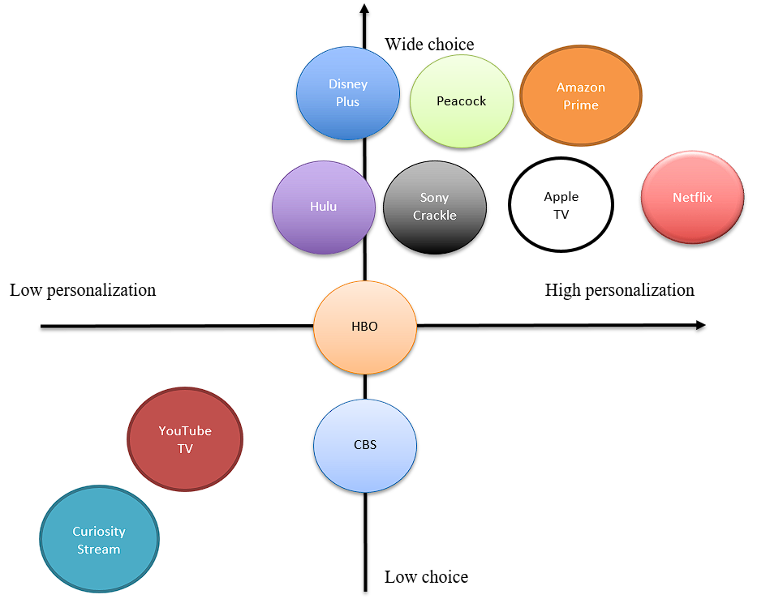
Figure 4: Perceptual Map of Netflix in India
Source: (Gupta, 2021)
Netflix in India is deemed to offer highly personalised content recommendations and services while offering above average content options (Gupta, 2021). The company is striving to offer localised content to increase its content options compared to competitors in the Indian market.

Similarities and differences of STP strategies
Netflix has made use of multi-dimensional segmentation based on demographic, psychographic and behavioural factors in both markets, and substantially digital consumption behaviour (Beckett, 2024). The differentiated strategy embraced by the company also focuses on catering to various groups of viewers and situating itself around the content quality, novelty, and smooth user experience backed by user-oriented personalisation fuelled by algorithms (Allen, 2020a).
The differences in the targeting breadth and positioning are the key ones. In India, Netflix caters to a more specialised, high-income and urban audience, and aims at the premium segment because of price elasticity and unequal buying power (Gupta, 2021). However, in the UK, Netflix addresses a wide pool of potential customers, both in terms of income and age and is defined as a massively popular entertainment service that indicates more indulgence, individualism and a well-developed subscription culture (Khan, 2019).

Comparison of Marketing Mix (7Ps)
The Marketing Mix (7Ps) serves as an analysis tool of paramount importance in evaluating the strategic stance of Netflix in divergent markets (Yuan, 2023).
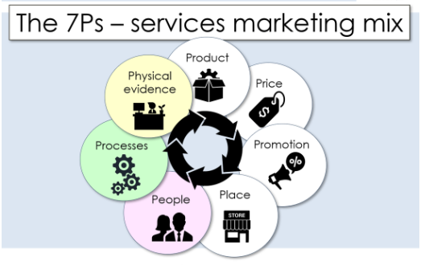
Figure 5: The 7Ps of Marketing Mix
Source: (Sweney, 2025)

Product mix
Product Classification and Dimensions:
Netflix can be considered both as a speciality and as a shopping product. It is an item of daily convenience but intentionally chosen, bringing personalised entertainment experiences (Jati and Serenade, 2024).
Core Product: Netflix provides high-quality on-demand entertainment at the individual user level, which is its core product.
Actual Product (Packaging): It includes a highly accessible interface, a vast content base, premium subscriptions, multilingual support, and better streaming technology (Kramer-Wine, 2023).
Augmented (Auxiliary) Product: Netflix adds value through providing strong customer service, offline downloading experience, an artificial intelligence-based recommender system and alliances with device makers and internet service providers (Chowdhury et al., 2025).
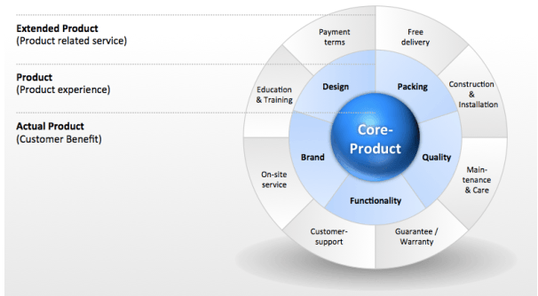
Figure 6: Product dimensions
Source: (Kramer-Wine, 2023)
Product depth and product width:
Product depth has been defined as the availability of a variation of a product category, whereas product width has been defined as the presence of various product types of a firm (Kotler and Armstrong, 2018). The depth of the product, in the case of Netflix, is quite high, as every content group, including drama, comedy, documentaries, and even animation, has numerous sub-genres, localised languages, and even formats, such as films, series, and even originals (Gupta, 2021).
Product width is also somewhat low since Netflix specialises in one main product category, which is, video streaming on the basis of the subscription (Kotler and Armstrong, 2018). Nonetheless, the narrow specialisation makes it strategic, operationally efficient, and a strong brand in the international digital entertainment business.
United Kingdom:
The UK Netflix product strategy focuses on offering high-quality ad-free entertainment, which is accomplished by the use of a range of content that includes global and local content. The UK market, with a high digital maturity and fierce competition, requires high-quality and exclusive selling (Sweney, 2025). Accordingly, the concept of product used by Netflix is not limited to the streaming platform but also includes the user experience, customised recommendation systems, and cross-platform access.
The UK library has both popular international series like Bridgerton and Stranger Things as well as homegrown OC like The Crown and Top Boy. These headings create a cultural resonance and brand loyalty (Kom and Supono, 2022).
India:
Netflix's product strategy in India is localised, approachable, and culturally inclined. The product is adapted to the linguistic diversity of the country, with the habits of mobile-centricity. Sacred Games, Delhi Crime, and Mismatched are Indian originals telling local stories and themes of society, whereas much investment is made in regional language content in Hindi and Tamil, Telugu and Malayalam (Santos, 2025).

Price
United Kingdom:
Netflix uses a value-based pricing model that corresponds to perceived service quality and price in comparison to the competitors. By 2024, the United Kingdom will include tiered plans, including Standard with Ads of £4.99 per month, Standard £10.99 per month and Premium £15.99 per month. British customers who are used to the spread of digital subscriptions are also more tolerant of high prices (Sweney, 2025). The differentiated pricing enables market segmentation on the basis of income and viewing preference, and retaining profitability in the developed industry environment (Nafees et al., 2021).
India:
Netflix uses a market-penetration pricing strategy in India to fit price-sensitive customers. Coupon-based subscription packages (Mobile only) cost ₹149/month, Basic cost ₹199/month, Standard cost ₹499/month and Premium cost ₹649/month. The Indian-exclusive mobile plan was a key innovation that targeted younger users who consume content mostly on smartphones (Dharmadhikari, 2025).
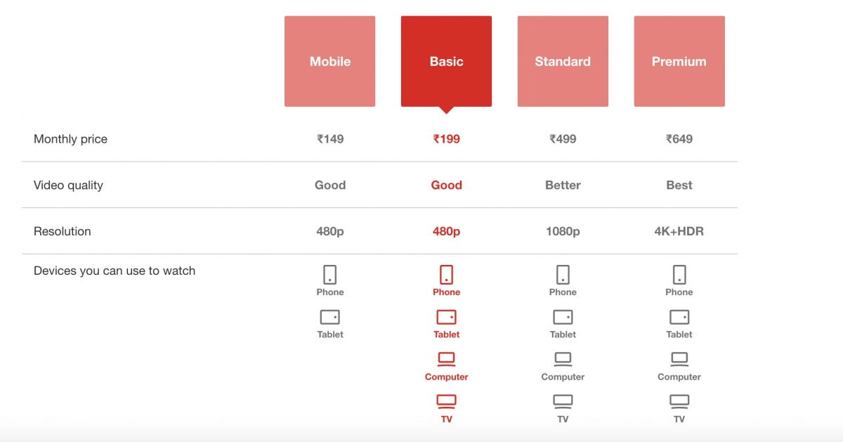
Figure 7: Subscription costs in India
Source: (Dharmadhikari, 2025)
The chart illustrates that Netflix maintains a higher average revenue per user (ARPU) in the UK, in the EMEA region, than in India, in the APAC region, due to better purchasing power and subscription pricing in the UK (Sagar, 2024). Although both regions exhibit increasing growth, the lower and slower ARPU growth indicates that the APAC region is sensitive to prices and the use of low-cost mobile services, as in India.
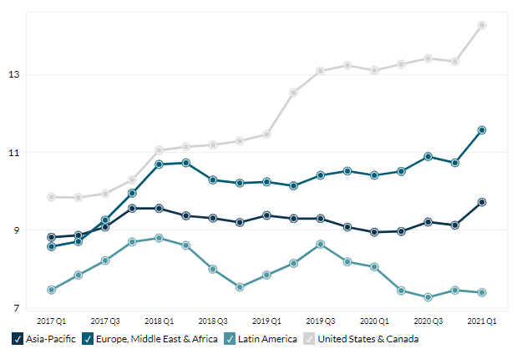
Figure 8: Global ARPU by region showing low ARPU for the Asia Pacific
Source: (Sagar, 2024)

Place
United Kingdom:
In the United Kingdom, the distribution strategy used by Netflix is based on digital availability on various platforms. Through smart televisions, game consoles, smartphones, laptops, and tablets, consumers are able to access content. Collaborating with other broadcasters like Sky, Virgin Media, and BT helps Netflix to be added to broadband and television plans, hence reaching a wide spectrum of households (Richter, 2024).
India:
Netflix in India is engaging in a mobile-based, partnership-driven business model. The mobile platform controls the streaming consumption with more than 750 million smartphone users and one of the lowest mobile data costs in the world. Netflix integrates with the telecom giants-Jio, Airtel and Vodafone Idea to introduce subscriptions in mobile data plans (Khan, 2019). This will increase affordability and make a penetration in the semi-urban and rural areas, thus increasing the geographical coverage of the service.

Promotion
The international brand management strategy of Netflix places stress on global consistency, although it can be adapted locally. The red “N” logo with just a minimum of brightness, the homogeneous interface, and the tagline See What’s Next give the company a good worldwide brand recognition (Barraza, 2025).
United Kingdom:
The promotional strategy of Netflix in the United Kingdom anticipates brand stories and online interactions. Marketing communication uses social media, partnering with influencers and experiences to build a cohesive narrative structure (Sinha et al., 2024).
Advertising: The application of highly visible outdoor and online campaigns, such as the One Storey Away campaign, makes emotional appeal and the diversity of storeys the core interaction drivers (BusinessQuant, 2020).
Public Relations: Sponsorships of movie festivals, film recognitions (BAFTA) and charity activities help to strengthen the image and social responsibility of the corporation.
India:
Netflix promotion is more regionalised, culturally immersive and localised in regard to the context of India.
Influencer Marketing: Bollywood actors and local influencers are used as influencer marketing to achieve relatability and cover the maximum of the target audience (Farooqui, 2024). Local relations with local production homes and community projects increase the acceptability and credibility of the brand in the local market.
Advertising: Regional television, social media promotions, and film trailers, for example, Dekte Reh Jaoge, are created considering regional languages and local humour (India Today, 2021).

People
United Kingdom:
Netflix has remarkably talented artists, data scientists, and customer support agents in the United Kingdom. Human resource practices give focus to innovation, diversity and consumer-based decision-making. British actors and directors as brand ambassadors make it more authentic (Beckett, 2024). Local offices in London liaise with regional production houses to make sure there is culturally resonant content.
India:
Netflix invests in local talent within India through hiring regional content producers, dubbing artists, and marketing experts who have a strong understanding of linguistic and cultural nuances. Partnerships with Indian directors and actors like Anurag Kashyap and Radhika Apte strengthen the trust in the brand (Bobmanuel, 2022). Focus on inclusivity and diversity indicates the interest of Netflix in local hiring and content authenticity.

Process
United Kingdom:
The Netflix process strategy in the United Kingdom focuses on automation, efficiency, and personalisation. The customer experience, such as subscription through consumption, is handled smoothly with the help of artificial intelligence algorithms and data analysis predicting audience tastes. Billing and renewal of subscriptions are automated, thus securing convenience and customer retention (Baschiera and Re, 2018).
India:
Netflix simplifies its operations in India in order to benefit more people. Registration and payment systems include credit cards, UPI, and mobile wallets, hence accommodating consumers with non-traditional banking facilities. The recommendation engine allows finding multilingual content, and the user goes to the various regional libraries with more ease (Hidayat and Ambarwati, 2024).

Physical Evidence
United Kingdom:
Netflix, being a digital service, has intangible evidence in terms of its interface design, branding symbols, and promotional graphics. Brand identity is supported by the iconic red “N” in the logo, minimalist design and the monotonic black-red colours. Visual marketing and joint promotion activities assist in physical brand visibility (Baranidharan and Kulkarni, 2025). The availability of Netflix in both TV shows and streaming services is a tangible proof of its availability and status.
India:
Physical evidence in India is not confined to the digital realm, but it also includes the localisation of branding, local advertisements, and community events. The interface at Netflix incorporates the use of titles and culturally adapted artworks, which are in several languages (Fernández-Manzano et al., 2016). Co-marketing with mobile service providers and smart device producers enhances physical presence in retail outlets.

Evaluation of the Performance of Marketing Strategies
The comparison of the marketing of Netflix in the United Kingdom and India provides information about the effectiveness of its adaptation initiatives under different socio-economic and cultural conditions (Koval, 2019).

Performance in the United Kingdom
The marketing approaches used by Netflix in the United Kingdom have been quite effective, with the firm being a leader in the competitive streaming market in the country.
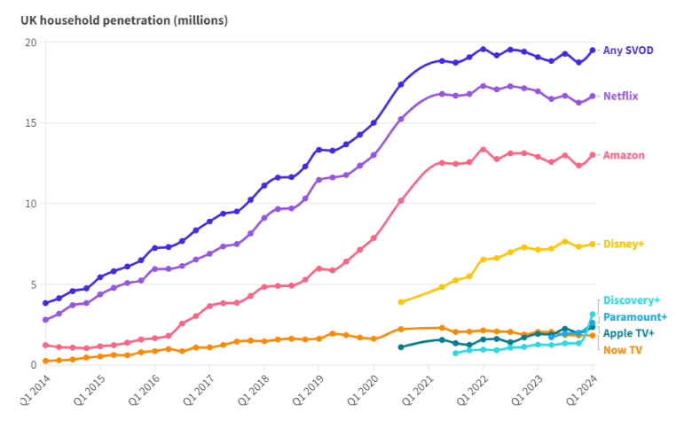
Figure 9: Streaming penetration and market share in the UK
Source: (Advanced Television, 2024)
By 2024, Netflix controlled an estimated share of about 32% in the video-on-demand (VoD) business of the United Kingdom market, overpowering competitors including Disney+, holding 24% as well and Amazon Prime Video holding 22%. This dominance has been as resulted from the strong brand reputation of Netflix, its diversified content, and advanced personalisation technology (Advanced Television, 2024).

Subscriber Base and Revenue
In Europe, the United Kingdom is still among the most profitable markets for Netflix, having an estimated 17 million subscribers. ARPU is comparatively higher than in other locations, which shows that the audience is willing to pay to get premium and ad-free content (Daniel, 2018). In 2023, the launch of an ad-supported option also increased the range of the customer base and aimed at the price-sensitive audience, without reducing profitability.

Content and engagement
Netflix has focused on British narratives since such series as The Crown, Sex Education, and Top Boy have strengthened its cultural affiliation and kept viewers watching. According to social-media analytics, Netflix UK has higher engagement rates on Instagram than its key competitors, which highlights the usefulness of localised digital marketing efforts (White and Bucci, 2022).
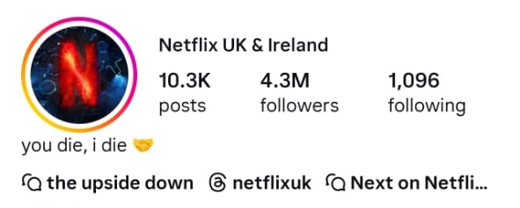
Figure 10: Netflix UK & Ireland Instagram Profile
Source: (Author)
Netflix UK’s Instagram profiles resort to humour and content relatability to help engage younger demographic groups (Chrislema, 2014). The expectation of the releases can be done with trailers or other videos taken behind the scenes on YouTube. Such short clips make the audience more interested.

Brand Equity
Netflix has a remarkably high brand value in the UK, among the ten most visible digital entertainment brands. Channel integration in its marketing mix can be seen through its strategic alliances with telecoms providers, such as Sky and Virgin Media, which have expanded household penetration.

Performance in India
On the other hand, the way Netflix has performed in India has been a bit more slow-paced but with more potential, due to their adaptive marketing strategies, which focus on localisation and pricing (Rental, 2023). Indian streaming is a highly competitive and revered environment, with state-based leaders like Disney+ Hotstar and Zee5, taking the lead partly because of the region-specific content and discounts. However, the strategic initiatives that Netflix has implemented since 2021 have increased its market penetration and perception.

Subscriber Growth and Revenue
In 2024, the subscriber base of Netflix in India was more than 7 million, which was an increase of 25% compared to 2022. The revenue was also increased significantly after attempting localised pricing and a mobile-only plan that costs 149 rupees monthly (Richter, 2024).
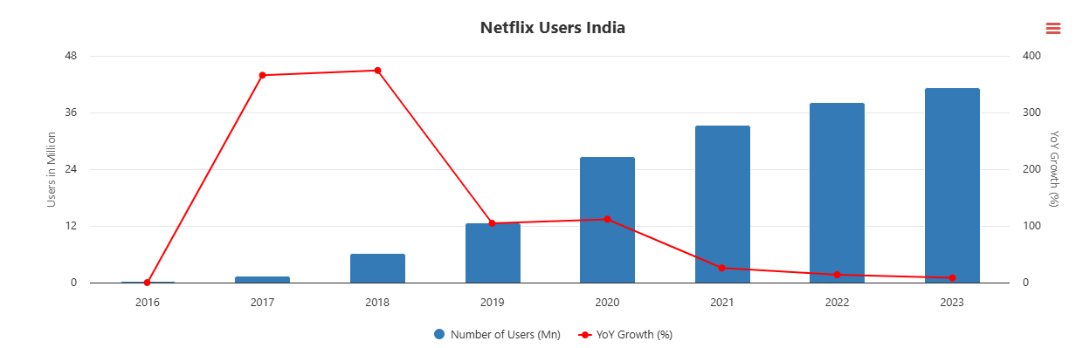
Figure 11: Subscriber growth in India for Netflix
Source: (Farooqui, 2024)
Netflix has made its service more accessible to middle-income customers in India through strategic changes to better fit the current mobile-first consumption culture. The average revenue per user (ARPU) is still lower than in the Western markets, but the growth trend indicates a viable way to sustainable profitability through volume growth (Farooqui, 2024).

Digital and Social Media Engagement
As of 2024, the social-media following of Netflix India had grown exponentially, with the company gathering more than 12 million subscribers to its services on the key platforms. The use of campaigns like Dekhte Reh Jaoge and partnership with Bollywood influence powers has increased the relatability of their culture and strengthened brand recall (Baranidharan and Kulkarni, 2025).
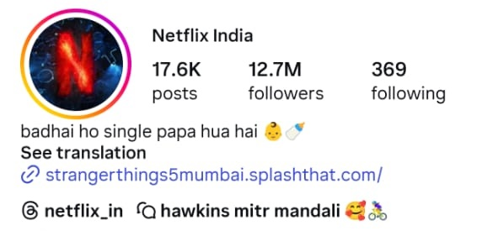
Figure 12: Netflix India Instgram Profile
Source: (Author)
This change from a global-dominating to a more regionalistic and focused communication mode testifies to the effectiveness of the Netflix localisation promotion policy.

Brand Image and Market Position
At the modest market share of about 7%, as compared to 38% of Disney+ Hotstar and 22% of Amazon Prime Video, Netflix has the best brand perception in terms of quality and exclusivity. The service is seen as aspirational and elite and thus plays up to its long-term positioning as a high-quality platform that offers cinematic greatness and narrative variety (Hsiao, 2024).

Evaluation of Marketing Ethics Practice
The marketing strategies used by Netflix in the United Kingdom and India mostly align with the existing ethical standards (Gregory, 2021). However, certain issues that govern the representation of content, transparency in ads, and cultural sensitivity have arisen.
The marketing ethics of Netflix in the United Kingdom are more or less the same as the standards of the market, though the concerns regarding the pricing transparency and the privacy of the information remain (Baranidharan and Kulkarni, 2025). However, Netflix complies with the United Kingdom General Data Protection Regulation (GDPR) on data protection, and it has strict data protection practices. The company reports that it does not sell user data, and publicly claims that customised suggestions are based only on in-platform buyers' performance (Morris, 2022).

Recommendation
The comparison of Netflix's performance in the United Kingdom and its performance in India shows that Netflix's international marketing strategies have been mostly successful, though there is room to be more competitive and establish a greater cultural resonance. To continue, Netflix must invest in more hyper-local content, particularly in the growing regional markets in India. The establishment of deeper partnerships with local cinema makers, production companies and telecommunication companies can be helpful in the cheap access and increasing brand awareness.
In the United Kingdom, Netflix can keep on polishing its premium positioning by increasing high-production-value productions and experience marketing to stand out among the competition, like Disney+ and Amazon Prime Video. In both markets, Netflix should consider more flexible pricing packages, such as student and family plans, to attract cheaper and younger audiences.

Conclusion
Netflix is a globally successful streaming platform with millions of subscribers. The platform has been successful due to its focus on personalisation, cultural accessibility, and accessibility. Netflix has been able to effectively navigate macroenvironmental especially cultural differences between different nations and cater to different markets offering contents specific to their demands. As Netflix continues to invest in localised content, innovative pricing models, and ethical accountability, the company will be able to solidify its competitive edge and continue its long-term growth both in mature and emerging markets.

References
- Advanced Television (2024). Data: Netflix tops UK streaming market in Q3. [online] Advanced-television.com. Available at: https://www.advanced-television.com/2024/10/07/data-netflix-tops-uk-streaming-market-in-q3/.
- Allen, A. (2020a). Finding the right customers with the STP model. [online] Oxford College of Marketing Blog. Available at: https://blog.oxfordcollegeofmarketing.com/2020/06/24/finding-the-right-customers-with-stp-model/.
- Allen, A. (2020b). The 7Ps of The Marketing Mix. [online] Oxford College of Marketing. Available at: https://blog.oxfordcollegeofmarketing.com/2020/10/08/understanding-the-7ps-of-the-marketing-mix/.
- Baranidharan, S., and Kulkarni, S. (2025). Beyond binge-watching: How Netflix can adapt its digital marketing strategy for long-term success. In Cases on Effective Digital Marketing for Competitive Organizations (pp. 43-90). IGI Global Scientific Publishing.
- Barraza, C. (2025). Global Brand, Local Market: A Strategic Analysis of Netflix’s Adaptation Challenges in India.
- Baschiera, S., and Re, V. (2018). National screen productions and global SVoD services: The case of Netflix in the UK and Italy. Comunicazioni sociali: 3, 2018, 395-407.
- Beckett, M. (2024). UK Online Streaming Statistics 2024. [online] Uswitch. Available at: https://www.uswitch.com/broadband/studies/online-streaming-statistics/.
- Bobmanuel, A. A. (2022). THE STRATEGIC ANALYSIS OF NETFLIX, INC. The Virginia University of Lynchburg, 1(1), 1-19.
- BusinessQuant (2020). Netflix’s ARPU by Region (2017-2021). [online] Business Quant. Available at: https://businessquant.com/netflix-average-revenue-per-user-by-segment.
- Chowdhury, N., Balaraman, P., Liu, J., Sirkeci, I., and Wilson, J. A. (2025). B2B Marketing Mix. In Essential B2B Marketing Strategies (pp. 33-49). Palgrave Macmillan, Cham.
- Chrislema (2014). Are you considering all your product dimensions? - Chris Lema | Business Coach. [online] Chris Lema. Available at: https://chrislema.com/product-dimensions/ [Accessed 9 Nov. 2025].
- Daniel, C. O. (2018). Effects of marketing strategies on organizational performance. International journal of business marketing and management, 3(9), 1-9.
- Dharmadhikari, S. (2025). How Netflix Used Market Research to Launch a Global Strategy. [online] Cognitive Market Research. Available at: https://www.cognitivemarketresearch.com/blog/how-netflix-used-market-research-to-launch-a-global-strategy? [Accessed 9 Nov. 2025].
- Dhaundiyal, D., Chakravarty, R. and N. Joshi, A., (2020), November. Hofstede and Hobbitses: Generational Evolution of Power Distance and Masculinity in UK in Popular Literature. In Proceedings of the 11th Indian Conference on Human-Computer Interaction (pp. 1-11).
- Dibra, R., and Braholli, A. (2024). NATIVE DIGITAL ADVERTISING, A PROPER TOOL FOR DIGITAL MARKETING EFFECTIVENESS. NETFLIX BRAND. SUSTAINABLE INTELLIGENCE IN THE DIGITAL LANDSCAPE, 95.
- Fariandi, R., and Ariani, D. W. (2023). The effect of social media marketing activities on brand awareness, brand image and brand loyalty for the Netflix brand. Journal of Management Science (JMAS), 6(3), 359-365.
- Farooqui, J. (2024). Netflix India sees double-digit growth in revenue, profit for FY24. [online] The Economic Times. Available at: https://economictimes.indiatimes.com/industry/media/entertainment/netflix-india-sees-double-digit-growth-in-revenue-profit-for-fy24/articleshow/114860216.cms?
- Fernández-Manzano, E. P., Neira, E., and Clares-Gavilán, J. (2016). Data management in audiovisual business: Netflix as a case study. Profesional de la Información, 25(4), 568-577.
- Gregory, A. (2021). Complete Analysis of Netflix, Inc.
- Gupta, J. (2021). The 10 Biggest Netflix Competitors. [online] Feedough. Available at: https://www.feedough.com/the-10-biggest-netflix-competitors/#google_vignette [Accessed 17 Dec. 2025].
- Gupta, R., and Madan, S. (2024). Digital Marketing: The science and magic of digital marketing can help you become a successful marketing professional. BPB Publications.
- Harari, D. (2025). Inflation: Key Economic Indicators. commonslibrary.parliament.uk. [online] Available at: https://commonslibrary.parliament.uk/research-briefings/sn02792/ [Accessed 17 Dec. 2025].
- Hidayat, R., and Ambarwati, R. (2024). Impact of Digital Marketing Strategies, Brand Image, and Influencers on Netflix Purchase Decisions. Jurnal Pamator: Jurnal Ilmiah Universitas Trunojoyo, 17(1), 125-137.
- Hofstede Insights (2025). Country Comparison Tool. [online] Theculturefactor.com. Available at: https://www.theculturefactor.com/country-comparison-tool?countries=india%2Cunited+kingdom [Accessed 17 Dec. 2025].
- Hsiao, Y. H. (2024). The business strategy analysis of Netflix. Transactions on Social Science, Education and Humanities Research, 11.
- India Today. (2021). Netflix subscription plans get cheaper in India, mobile plan now starts at Rs 149. [online] Available at: https://www.indiatoday.in/technology/news/story/netflix-subscription-plans-get-cheaper-in-india-mobile-plan-now-starts-at-rs-149-1887501-2021-12-14.
- Ithurbide, C. (2022). Netflix in India: Localization strategies of a transnational platform and local reconfigurations. In Annales de géographie (Vol. 743, No. 1, pp. 23-43). Armand Colin.
- Jati, I. M., and Serenade, V. (2024). Netflix's Global Market Entry and Adaptation Strategies Critical Review. Jurnal Informatika Ekonomi Bisnis, 932-936.
- Jati, I. M., and Serenade, V. (2024). Netflix's Global Market Entry and Adaptation Strategies Critical Review. Jurnal Informatika Ekonomi Bisnis, 932-936.
- Khan, A. (2019). Netflix Users In India By Year: 2020 - 2023. [online] Dazeinfo. Available at: https://dazeinfo.com/2019/10/31/netflix-users-in-india-graphfarm/.
- Kom, T. W. C. S., and Supono, R. A. (2022). Consumer Behavior Analysis of Interest in Subscribe to Video Streaming by Implementing 7p's Marketing Strategies Using Quality Function Deployment Method. Engineering and Science, 7(3), 37-46.
- Kotler, P. and Armstrong, G. (2018). Principles of marketing. Singapore: Pearson/Prentice-Hall.
- Koval, Z. O. (2019). Evaluation of efficiency of marketing strategies of enterprises by factor analysis methods. Economic innovations, 21(1 (70)), 64-74.
- Kramer-Wine, J. (2023). Netflix Case Study.
- Kuźmińska-Haberla, A., (2017), December. Poland and India in the Light of Hofstede’s Cultural Dimensions. In Eurasian Economic Perspectives: Proceedings of the 20th Eurasia Business and Economics Society Conference-Vol. 2 (pp. 267-283). Cham: Springer International Publishing.
- Migliore, L.A., (2011). Relation between big five personality traits and Hofstede's cultural dimensions: Samples from the USA and India. Cross Cultural Management: An International Journal, 18(1), pp.38-54.
- Morris, K. L. (2022). Netflix Strategic Business Analysis.
- Nafees, L., Mehdi, M., Gupta, R., Kalia, S., Banerjee, S., and Kapoor, S. (2021). Netflix in India: expanding to success. Emerald Emerging Markets Case Studies, 11(2), 1-31.
- Nelsa, P., Paradita, A. X., Hermawan, F. F., Ghifari, M. Y., and Lubis, M. (2025). Netflix's Digital Transformation Strategy: A Systematic Review of Challenges and Risk Mitigation Approaches. JIPI (Jurnal Ilmiah Penelitian dan Pembelajaran Informatika), 10(2), 1133-1143.
- Onyusheva, I. R. I. N. A., and Baker, A. S. (2021). Netflix: A case study on international business strategy development. The EUrASEANs: journal on global socio-economic dynamics, 6(31), 40-52.
- Pérez, E. P. (2020, May). Next Episode, Next Market: Social Media Marketing for SVOD: The Case Of Netflix. In GLOBAL (Vol. 4, p. 8).
- Rental, D. V. D. (2023). Case Study: Netflix. Strategic International Management, 2022, 153.
- Richter, F. (2024). Infographic: Netflix Added 22M Subs in 2024 So Far, the Most Since 2020. [online] Statista Daily Data. Available at: https://www.statista.com/chart/21465/global-paid-net-subscriber-additions-by-netflix/?
- Sagar, E. (2024). SVOD platforms pin hopes on economic recovery and ad tiers amid UK plateau - The Media Leader. [online] The Media Leader - News analysis, opinion and insight for media and advertising professionals. Available at: https://uk.themedialeader.com/svod-platforms-pin-hopes-on-economic-recovery-and-ad-tiers-amid-uk-plateau/.
- Santos, J. C. D. (2025). Marketing Strategy: Redefining the Marketing Mix. Marketing Strategies for the Internationalization of Businesses and Brands, 23.
- Sinha, P., Mittal, R., and Rishi, B. (2024). Netflix India: The Battle of Trials and Expectations. Asian Case Research Journal, 28(04), 211-227.
- Sweney, M. (2025). UK broadcasters hail rare win over Netflix in battle for streaming ads. [online] the Guardian. Available at: https://www.theguardian.com/media/2025/jun/14/uk-broadcasters-netflix-battle-streaming-ads?
- The World Bank (2025). India | Data. [online] Worldbank.org. Available at: https://data.worldbank.org/country/india [Accessed 17 Dec. 2025].
- White, P. J., and Bucci, J. (2022). Major Case Study: Netflix.
- Yuan, C. (2023). A case study of Netflix’s marketing strategy. BCP Business & Management ICAMM, 2023.

