  Component One:  What are the key skills required when working in the housekeeping team? 750 words (+/- 10%)  Contribution to Overall Module Assessment: 25% | Student No: | Muhsina Miah
 | Module Title: | Operating Hotel Facilities
 | Module Code: | BMIH4006
 | Lecturer: | Laurence Blake
There are many skills required when working in the housekeeping team. Housekeepers often work on their own or they may work as part of a small team of other housekeepers and they all must complete a set number of room cleanings each day within the certain time limit set for them. One of the main key skills required for housekeeping is time management, this skill is very important because it applies and affects both individuals and team’s progress. Managing your time properly will improve your focus and allows you to pace yourself, giving yourself more time to clean the room properly and efficiently.
Housekeepers are responsible for cleaning various areas and surfaces of the hotel rooms. They must have the knowledge of how to clean each surface, they must know the differences between the cleaning products they use, they must have the knowledge of what products to use on what surfaces and how to handle or mange the situation if they use the wrong product of have an accident with it, for examples if accidently they get the cleaning product in their eyes.
The housekeepers must be able to work efficiently individually as well as part of a team.
Another very important key skill required in housekeeping is communications. Communication skills involve speaking, listening, observing and emphasising. These skills are important whether you are speaking face to face, emails, on a video call or through letters, you can also communicate through body language, you might need to communicate ideas, feelings or what’s going around you. Communication skills allow you to understand and be understood by others around you. Developing your communication skills can do much more to help you advance in the workplace. To work as part of a team the housekeepers must have a very good communication skills, this is very important part of the roll as they must communicate with each other of how they are getting on with their daily room jobs, if they are on time of schedule, if not then if they need help to complete it before the customers are checked in. After they have completed their rooms, they must let their manager know so the manager can do a quick check of each room and then let the reception know that its ready for the customers and then the receptionist can locate rooms to customers. The most important skill required for housekeeping or any other job is confidents. You must be confidence of yourself and have confidence in what you’re doing. You must know your strengths and weaknesses to be confident in yourself. Another key skills required for housekeeping is self-discipline, this skill includes concentration and planning, this gives you the ability to stay on track despite obstacles, distractions or simply not feeling like doing your work.

Word Count | 678

Component Two:
Contribution to Overall Module Assessment: 25%
In this scenario – You have just been promoted to team leader for a floor within the hotel. A guest complains that on their arrival, their room had not been properly cleaned. Create an action plan and answer the following questions.

Problem | Why did it happen? | What are you going to do? | How will you prevent this from happening in the future? | What measures would you introduce to improve team effectiveness?
Customer complains room was not cleaned properly on arrival. | Must be a mistake by housekeeping, they must have missed it by accident | Quickly get the housekeeping to clean the room properly and if customer not satisfied then give them a new clean room | Communicate with the housekeeping, ask the housekeeping manager to make sure they check the rooms properly before handing it to the receptionist | Make sure each department communicate with each other to ensure that the room meets the standards required before locating it to a customer.

Component Three:
Contribution to Overall Module Assessment: 50%
Your task is to create and prepare a presentation following the detailed scenario provided below.

As the floor housekeeping manager and given the recent guest complaints you need to put together a basic training presentation for your colleagues within the housekeeping team to get the best out of them, ensure that brand standard is being achieved and that Health and Safety procedures are also being followed.

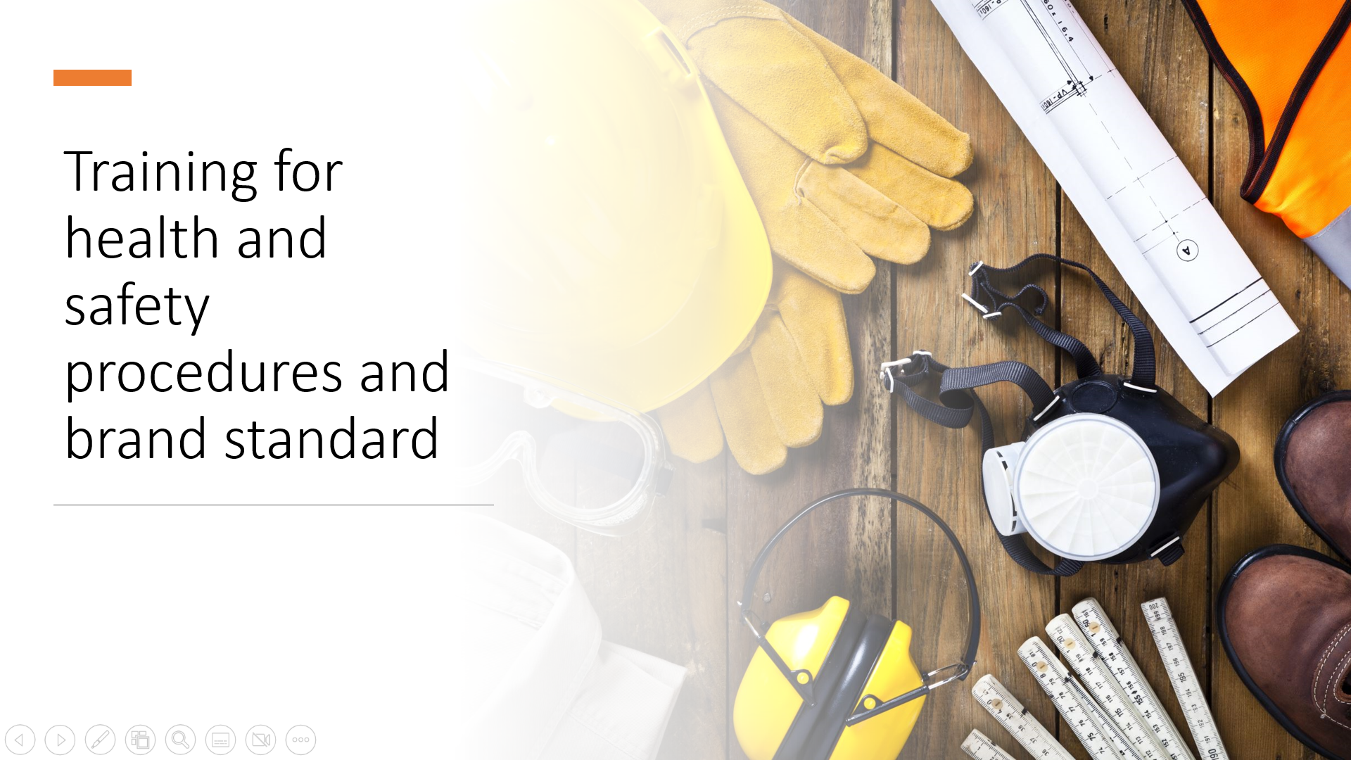

Training Notes: This presentation is about health and safety procedures and brand standard.
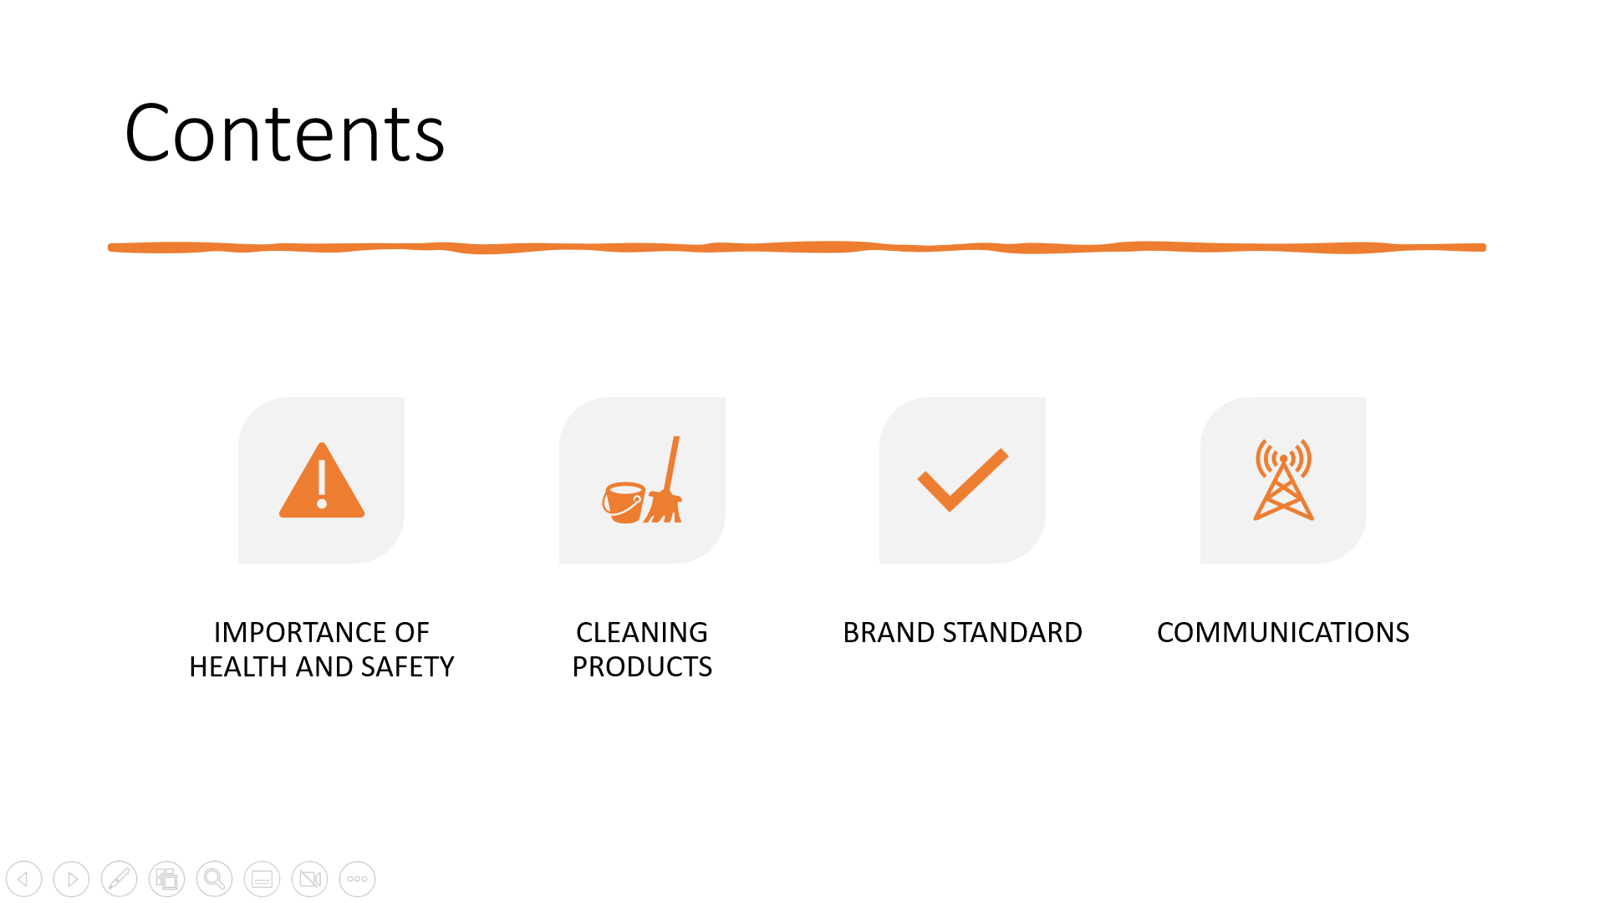

Training Notes: In this presentation we will talk about importance of health and safety, cleaning products, brand standards and communications.
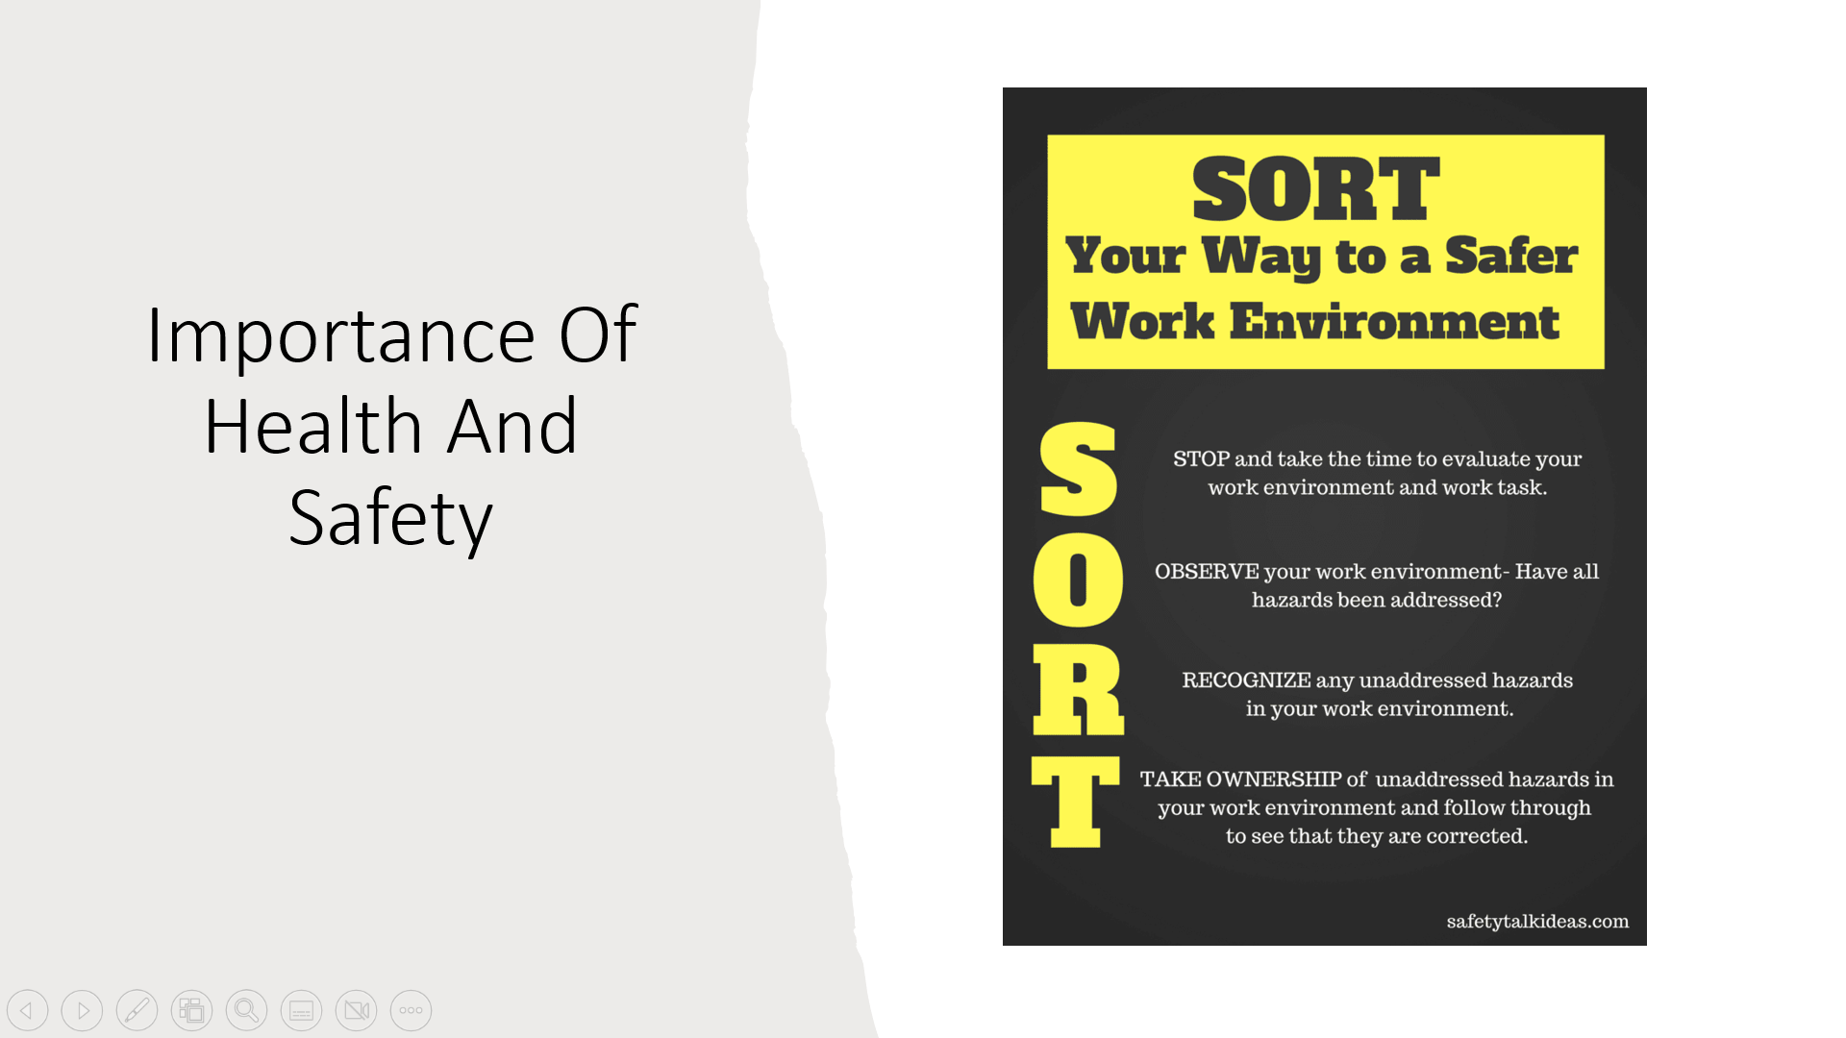

Training Notes: Health and safety regulations are important in any work place, both for staff and any organisation itself. Implementing good health and safety measures lowers the overall risk of accidents, injuries and illnesses in the workplace.
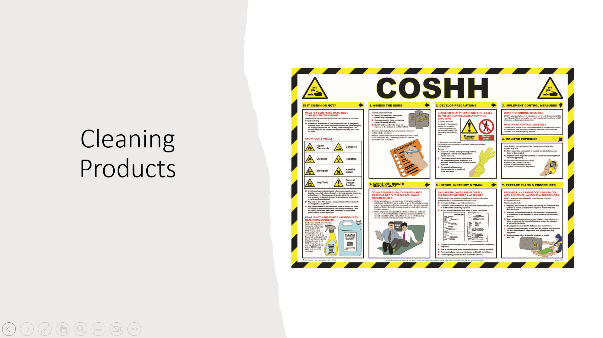

Training Notes: Making sure you know what cleaning products are used for which surfaces, you will also need to know what to do when there is an accident involving cleaning products with harmful chemicals. Please make sure you report it to your managers too even though you have cleaned it and there was no harm on anyone or anything.
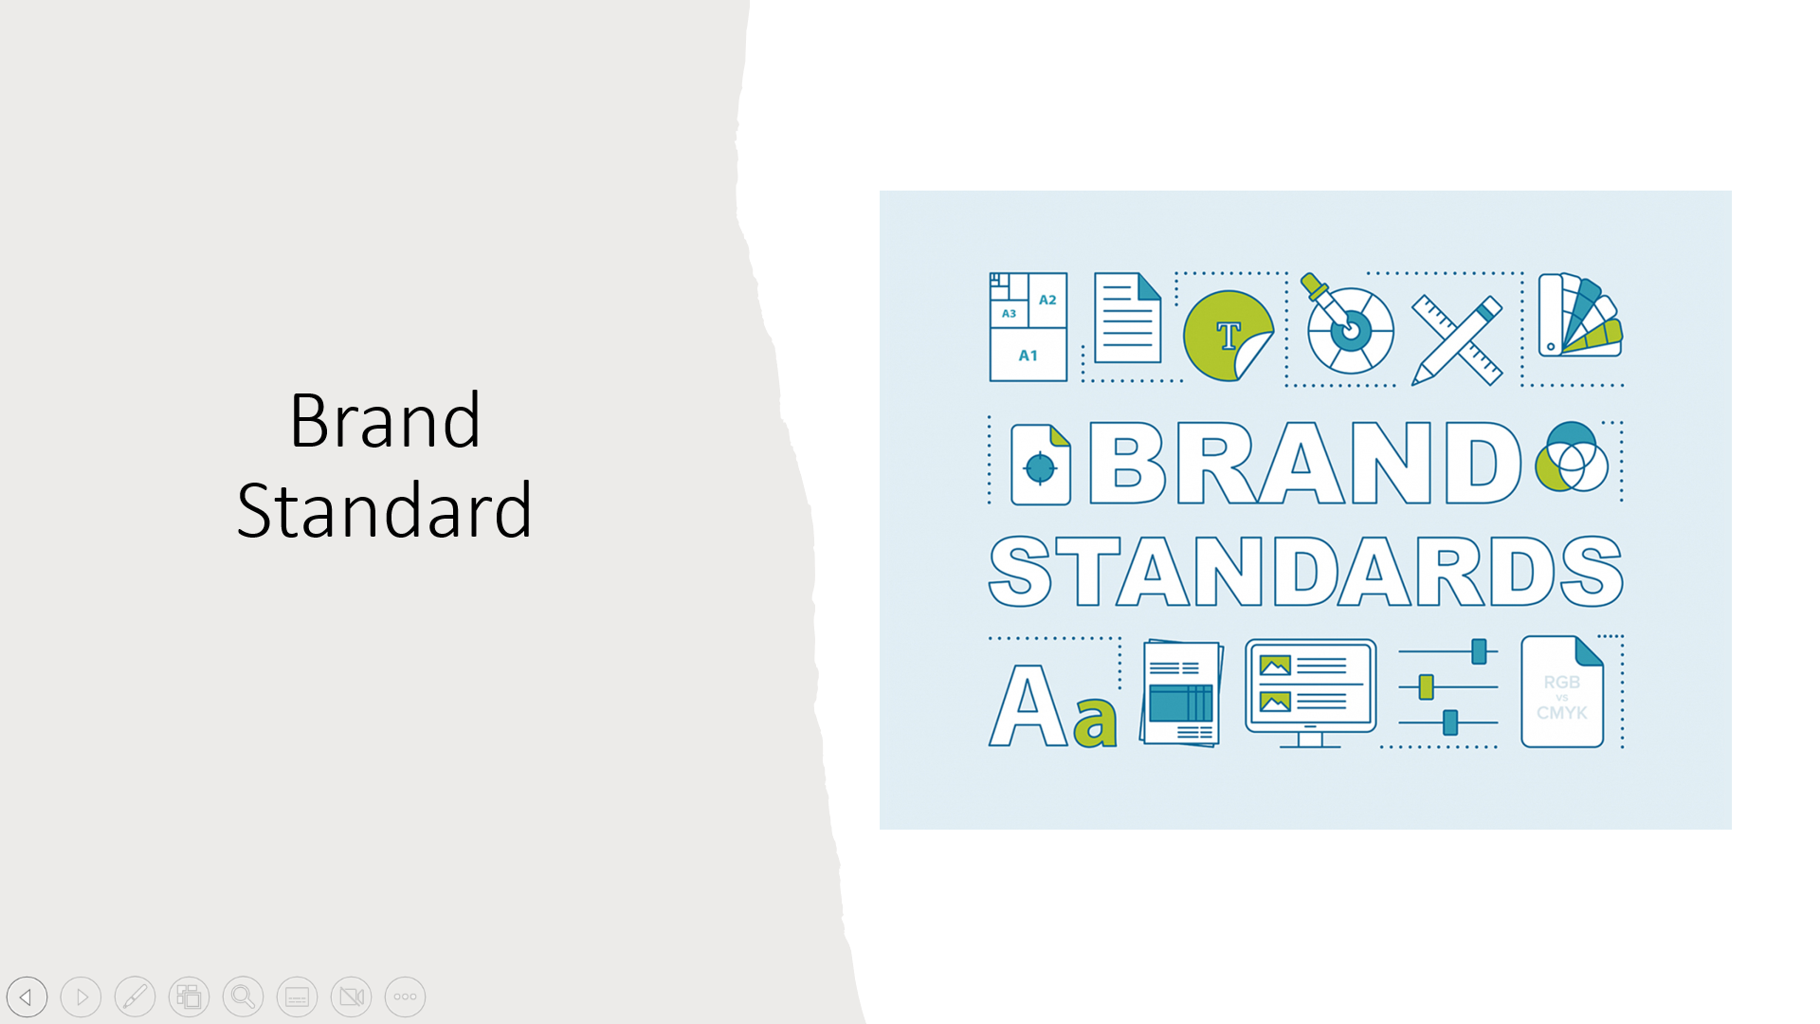

Training Notes: Brand standard is a very important part of any businesses, please ensure all our branded products are displayed properly so its easily seen by customers, when cleaning the rooms please follow our brand standards and cleaning room route to make sure everything and every room is the same



Training Notes: Effective communication is about more than just exchanging information, its about understanding the emotion and intentions behind the information. The way you look, listen, move and react to another person tells them more about how your feeling than words alone ever can.
Training Notes:
Training Notes:
Training Notes:
Training Notes:

References

