[Assessment-2] [Word Count: 2000 Words]
Sustainability Report [Actual: 1848 Words]

Entitled:
Report

Name:
Rukhsana Kousar

Student ID:
2128265

Module:
BMIH5006 – Sustainable Hospitality & Tourism Management

Lecturer:
Kathryn Roberts

Table of Contents
Introduction 3
Greenwashing accusation against Hilton 4
Areas that support greenwashing accusation against Hilton 5
Self-evaluation of Hilton 6
The causes of self-evaluation by business organisations 6
Identifying the sustainability of using ‘green’ technology 7
Things companies can do other than self-evaluation 8
Conclusion 10
References 11

Table of Figures
Figure 1: Increasing number of climate-related lawsuits 4
Figure 2: Reasons of doing self-evaluation by companies 7
Figure 3: Impacts of green technology 8

Introduction
Greenwashing is a big problem for the tourism industry. As a result of their negative impact on the surroundings, hospitality companies need to safeguard the environment by resisting the practice of "greenwashing." Greenwashing can be caused by a variety of factors; thus, business entities should not rely just on their assessment of their sustainability reporting to prevent it. In this situation, inviting other parties can help businesses do their finest work. If businesses can guarantee consistent green operations, they can attain maximum customer satisfaction and identify the areas that require improvement. Thus, it is imperative to refrain from self-evaluation so as to prevent greenwashing, and various third parties ought to be involved in the creation of green reports (Heller & Seiger, 2021). This report will discuss the allegations of greenwashing against Hilton, possible greenwashing sectors, self-assessment of green reports, justifications for firms employing self-evaluation, and different kinds of self-evaluation.

Greenwashing accusation against Hilton
Hilton is highly known for its green practices. This hospitality firm contributes to environmental protection and has been contributing to social development for a long. However, some people have raised questions about the sustainable hospitality practice of Hilton. In this case, the greenwashing concern has been raised against this hospitality firm. One of the key examples of greenwashing accusations against Hilton is destroying mangrove forests. This organisation destroyed the mangrove forest of Maldives to spread the business operation of the firm by building more hotels within the nation in 2006.

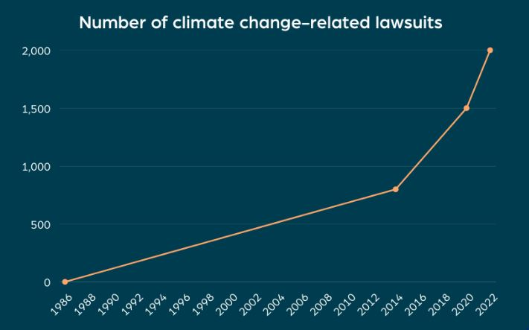
Figure 1: Increasing number of climate-related lawsuits
Source: (Arte & Wang, 2023)

People have shown their outrage against this hotel due to the forest destruction. Here, the firm has also uprooted palm trees to build new resorts within the nation (Andreoli & Costa, 2022). This has significantly destroyed the mangrove forest of the nation. Hilton has always tried to ensure a green and clean mission for the firm in terms of sustainable business practices but this forest destruction activity of the firm has significantly raised questions about the sustainable tourism practice. Here, Hilton has disputed the claim but the question of ensuring sustainability and protecting the environment has been compromised by this hospitality firm.

Highlighting small changes is another key example of the greenwashing of Hilton. This organisation has always tried to make sure that the customers are using the towels that have been used before. This practice of this firm may highlight the sustainable hospitality practice. However, have raised questions against this hospitality firm for neglecting energy consumption. This hotel has been listed for using a large amount of energy (Windsor, 2021). This has been raising questions about the sustainable business performance of this firm. Here, this is also supporting the greenwashing accusation of this firm. Since the firm is not directly involved in the greenwashing practice, these particular incidents may raise questions against the organisation in terms of greenwashing practice.

Areas that support greenwashing accusation against Hilton
Certain aspects may suggest that Hilton may have engaged in greenwashing. Concerns about the impact on the employees may also give rise to concerns about this company's greenwashing tactics. Hilton has chosen to forego housekeeping at its discretion (Cooperrider, 2022). The remuneration of the firm's housekeeper may be adversely affected by this specific practice of the company. Additionally, by lessening their responsibilities, the housekeepers may earn less money directly from the lodging establishment. In this situation, Hilton’s sustainable practices are contributing to employee unhappiness, casting doubt on the company's sustainability initiatives.

The absence of transparency is a major example that suggests that Hilton goes for greenwashing. In this situation, Hilton provides insufficient proof of the company's sustainability initiatives. Furthermore, this business provides proof of the various environmental effects of the initiatives this company has implemented (Lin & Chen, 2020). For instance, it is impossible to tell from the details provided by this business if the initiatives are operational or not. Concerns regarding this company's energy conservation can also be raised by others. Additionally, several people claimed that Hilton may have exaggerated the company's sustainable footprint in terms of energy conservation.

Again, a more significant example of greenwashing application by Hilton is shifting the load of sustainable business practices. Customers are constantly encouraged by Hilton to employ renewable energy; however, they have shown disapproval of the hotel's policies. Several clients have expressed dissatisfaction with Hilton’s attempt to place the onus of adopting environmentally friendly company policies on them as opposed to enforcing a strict approach (Ramus & Montiel, 2022). The company's very low participation in this instance suggests the possibility of greenwashing. Another important factor that suggests the possibility of greenwashing is the continued emphasis on minor adjustments. Hilton shows a strong concern for reusing towels within the premises, which is a positive step in the direction of resource conservation. But this company is not considering the big picture. In this situation, Hilton is prioritising the accomplishment of smaller goals over the accomplishment of more significant ones, such as lowering energy consumption and carbon emissions. Consequently, concentrating on minor adjustments may also prompt concerns about the possibility of greenwashing.

Self-evaluation of Hilton
Conducting a self-evaluation concerning greenwashing may raise several inquiries for a company. This may give rise to concerns regarding the company's reports' integrity. Additionally, it can restrict the engagement of third parties, which helps guarantee the correctness of green hospitality. In this case, Hilton conducts a self-evaluation regarding its sustainable representation and environmentally conscious operations. The sustainability disclosure of Hilton is one of the main examples of several self-evaluation initiatives (Heller & Seiger, 2021). Every year, Hilton makes sure to produce a sustainability report that details the company's prior actions with reference to various sustainability initiatives. Additionally, these papers outline this company's sustainability plans for the future. This information may be misled by the self-evaluation.

Additionally, Hilton employs internal audits to evaluate the company's accomplishments in terms of sustainability. Here, the company maintains a progress report on the entire sustainability programme the company has embarked on through its internal auditors. The information produced by this division lacks trustworthiness (Schultz & Seele, 2020). Hilton, though, accepts third-party accreditation. In this particular situation, the company employs a variety of certifications and the most notable one is LEED. Independent observers are always included in this program to assess the firm's adherence to sustainable practices. This ensures the minimum integrity effort by Hilton in terms of disclosing the sustainable business performance of this firm.

The causes of self-evaluation by business organisations
There are specific reasons why businesses conduct self-evaluations. the businesses can monitor advancement with the use of self-evaluation. Businesses that have multiple sustainability targets must monitor their progress. In this situation, tracking this progress through self-evaluation can help businesses pinpoint their areas for development (Arte & Wang, 2023). Additionally, this may indicate actions that should be made as a means to implement sustainable company practices. Moreover, finding personal strengths and shortcomings is one of the main causes of this situation. Companies can more easily recognise their strengths and flaws when they do self-evaluations.
In addition, publishing the results of self-evaluation demonstrates the firms' accountability for adopting sustainable company operations. Customers develop confidence in hotels and are willing to spend more for them when they demonstrate the success of their environmental initiatives.

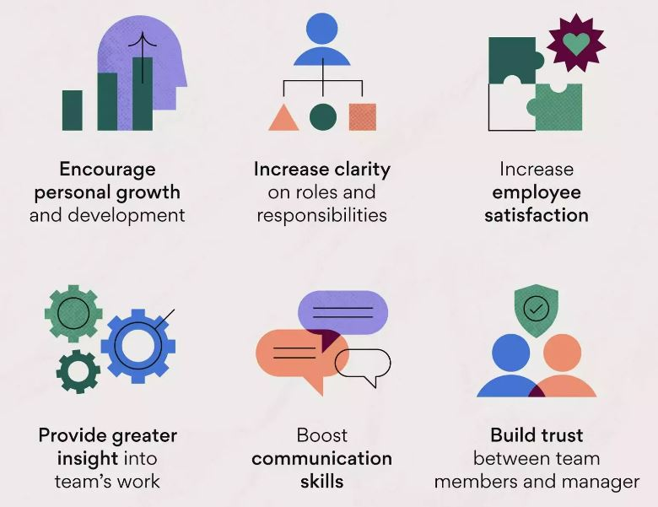
Figure 2: Reasons of doing self-evaluation by companies
Source: (Lin & Chen, 2020)

Additionally, self-assessment helps individuals stand out from the crowd. Businesses that undertake self-evaluation will not release information about their unsuccessful endeavours. In this scenario, the businesses will be in a stronger position compared to businesses that opt for independent assessment to release more comprehensive assessments on their green practices (Thompson, 2021). Moreover, a further reason why businesses should use self-evaluation is because it raises morale among staff members.

Identifying the sustainability of using ‘green’ technology
Utilising eco-friendly technologies has been contributing to a greener tomorrow. In this instance, employing green technologies will ultimately help the hospitality industry. The market for green technologies is expanding. By 2025, this market is predicted to grow by over £4.39 trillion. This indicates that there is a bright future for green technologies (Pedersen & Andersen, 2023). This can involve using green power and transport, among other things. Renewable sources of energy can also guarantee lower emissions. Businesses that are committed to achieving sustainable and environmentally friendly operations are prepared to cut back on carbon emissions. In this situation, utilising green technologies can help the environment grow.

Minimising waste is also aided by green technologies (Andreoli & Costa, 2022). In this situation, recycling and reducing trash production are related to green technology. In this case, green technology helps businesses guarantee sustainable company performance and lessen waste output.

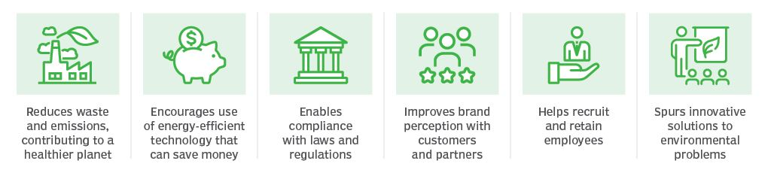
Figure 3: Impacts of green technology
Source: (Heller & Seiger, 2021)

Moreover, green technology helps businesses reap the rewards of conservation. In this case, environmentally friendly structures can guarantee a healthy ecosystem, which is essential for the hospitality industry. It may aid in reestablishing a natural ecosystem. Green technologies can therefore guarantee efficiency. It can encourage the effective use of resources inside the hotel business, which is vital to this industry.

Things companies can do other than self-evaluation
External verification is one of the primary actions that can be conducted in place of self-evaluation. Businesses can choose a third-party assessment in this situation. A variety of programmes are offered to guarantee third-party approval concerning sustainable company performance. Here, businesses can achieve external accreditation by employing Energy Star (Windsor, 2021). Concerning the investment in eco-friendly operations and ethical business practices, companies may additionally opt for external audits. Here, the independent auditors will calculate the greenhouse gas emissions along with other environmental effects of the businesses' operations and will issue the required certification for the operational practices' sustainability.

Stakeholder involvement is another significant effort that the company can take on. Stakeholder participation can provide firms with assistance in this situation. In this particular situation, various stakeholders may collaborate. They may include members of the public, workers, or various environmental organisations. These parties can offer the company the essential consultation. Public disclosure can also help to ensure that an organisation follows green practices (Cooperrider, 2022). It will be simple for businesses to stick to the standard procedure if they are committed to providing transparent reporting on green activities. In this situation, the company will include its annual objectives and projections in its reports for the public. These objectives will motivate the businesses to strive for annual improvement.

Conclusion
Hospitality organisations may choose to use a misleading marketing strategy known as "greenwashing" with the aim to attract customers' attention and win their choice in the market. In this situation, organisations present fictitious reports to the public to win their trust. The companies establish lofty goals for themselves that may appear unachievable at first, but they receive great reviews for their public reports. Since the companies do not have to discuss operational concerns in public, the majority of greenwashing occurs when they conduct self-evaluations (Tucker, 2021). If hospitality firms want to achieve the best market attention and ensure their presence in environmental protection, they will be required to offer a fair sustainability report in front of people.

References
Andreoli, T. and Costa, E. (2022) ‘Consumer judgment on the practice of greenwashing: Scale development and validation’, Brazilian Business Review, 19(5), pp. 508–524. doi:10.15728/bbr.2022.19.5.3.en.
Arte, P. and Wang, Y. (2023) Sustainable International Business: Smart Strategies for Business and Society. Cham: Springer International Publishing AG.
Cooperrider, D.L. (2022) Strategic Corporate Social Responsibility: Tools & Theories for Responsible Management. London: SAGE.
Heller, T.C. and Seiger, A. (2021) Settling climate accounts: Navigating the road to net zero. Cham, Switzerland: Palgrave Macmillan.
Lin, Y.-H. and Chen, H.-C. (2020) ‘Critical factors for Enhancing Green Service Innovation’, Journal of Hospitality and Tourism Technology, 9(2), pp. 188–203. doi:10.1108/jhtt-02-2017-0014.
Marrucci, L. and Daddi, T. (2023) Sustainable Hospitality Environmental Management in practice. London: Routledge.
Pedersen, E.R. and Andersen, K.R. (2023) ‘Greenwashing: A broken business model’, Journal of Business Models, 11(2). doi:10.54337/jbm.v11i2.7352.
Przychodzeń, W.P. (2023) ‘Greenwashing – myth or Reality in the world of business?’, Management and Business Administration. Central Europe, 21(4), pp. 132–138. doi:10.7206/mba.ce.2084-3356.85.
Ramus, C.A. and Montiel, I. (2022) ‘When are corporate environmental policies a form of greenwashing?’, Business &amp; Society, 44(4), pp. 377–414. doi:10.1177/0007650305278120.
Schultz, M.D. and Seele, P. (2020) ‘Business Legitimacy and Communication Ethics: Discussing greenwashing and credibility beyond habermasian idealism’, Handbook of Business Legitimacy, pp. 655–669. doi:10.1007/978-3-030-14622-1_8.
Thompson, S. (2021) Green and Sustainable Finance: Principles and practice. London: Kogan Page Inc.
Tucker, L.M. (2021) Designing sustainable residential and commercial interiors: Applying concepts and practices. New York: Fairchild Books.
Windsor, D. (2021) ‘Cross-functional integration in sustainability-driven business practice’, Handbook of Sustainability-Driven Business Strategies in Practice [Preprint]. doi:10.4337/9781789908350.00040.

