

Evaluate Security Differences Between Commercial and Open-Source VPN Packages

Supervisor: Nitheesh Kaliyamurthy

Independent Project ACCA6020
Author: James Harris 1902641

June 2022

DECLARATION
Declaration of Originality
I, James Daniel Harris declare that I am the sole author of this project; that all references cited have been consulted; that I have conducted all work of which this is a record, and that the finished work lies within the prescribed word limits.

This work has not previously been accepted as part of any other degree submission.

Signed : James Daniel Harris

Date : 08/06/2022

Contents
Table Of Figures 5
1. Introduction 7
1.1 Project Overview 7
1.2. Networks 7
1.2.1. Local Area Network (LAN) 7
1.2.2. Wide Area Network (WAN) 7
1.2.3. Personal Area Network (PAN) 7
1.2.4. Virtual Private Network (VPN) 7
1.3. What Is an VPN 7
1.4.1 Purpose of a VPN 7
1.5. What is an Open Source 8
1.5.1. What is Commercial 8
1.5.2. Differences between VPNs 8
1.6. Pros/ Cons of VPNs 8
1.7. Overview of VPN Security 8
1.8. Aim 9
1.9. Objectives 9
2.Literature Review 10
2.1 Chapter Introduction 10
2.2 VPN Importance for Public Networks 10
2.3 Benefits of VPNs 10
2.4 Different Versions of VPNs 11
2.5 Cyber-attacks On VPNs and Other forms of Protection 11
2.7. VPN Testing 12
2.7.1. Virtual Private Network 12
2.8.1. Domain Name System (DNS) 13
2.8.2. IPv4 and 6 13
2.8.3. WebRTC 13
2.9. Security Software 14
2.9. Vulnerabilities Test 14
2.10. With or Without Comparison for VPNs 14
2.11 Chapter Summary 14
3. Methodology 15
3.1. Chapter Introduction 15
3.2. Research Overview 15
3.2.1. Research Philosophy 15
3.2.2. Research approach 16
3.2.3 Research Strategy 16
3.2.4. Research Method 16
3.2.5. Time Horizons 16
3.2.6. Data Collection Method 16
3.3. Hypothesis 17
3.4. Hardware being used 17
3.5. Software being used 17
3.6. Explanation on reliability for Project 17
3.7. How the Experiment was Conducted 17
3.8. Ethical Considerations made for Project 18
3.9. Chapter Summary 18
4. Design and Implementation 19
4.1. Introduction 19
4.2. What Testing should be done 19
4.3. Understanding for Testing Decision 19
4.4. Leaks being tested 19
4.5. Testing process 19
4.6. Limitations 20
4.7. VPN Selecting 20
4.8. Diagrams 20
4.9. Testing 20
4.9.1. Note for Testing logs 20
4.9.2. Discovering IP address 21
4.10. WebRTC Leak Diagram 21
4.11. WebRTC Leak Test 22
4.11.1. Commercial VPN 1 Result (WebRTC) 22
4.11.2. Commercial VPN 2 Results (WebRTC) 23
4.11.3. Open-Source VPN Results (WebRTC) 23
4.11.4. Mini Summary WebRTC (Leak) 23
4.12. DNS Leak Diagram 24
4.13. DNS Leak Test 24
4.13.1. Commercial VPN 1 Results DNS 25
4.13.2. Commercial VPN 2 Results DNS 26
4.13.3. Open Source VPN Results (DNS) 27
4.13.4. Mini Summary DNS (Leak) 28
4.15. Issues 28
4.16. Conclusion 28
5. Evaluation 29
5.1. Conclusion from data gathered 29
5.2. Was the aim achieved 29
5.3. Were the objectives achieved 29
5.4. Were the results given expected 29
5.5. What would be done differently if given the opportunity again 29
6. Conclusion and Recommendation 31
6.1. Overall Summary 31
6.2. Further Research possibilities 31
6.3. Recommendations 31
7. Reflection 32
7.1. What I have learnt when doing my independent project 32
7.2. How did it affect me a person 32
8. References 33
9. Appendices 36
9.1. Appendix 1 – Literature Analysis 36
9.2. Appendix 2 – Time Plan For Project 40

Table Of Figures
Figure 1 - Research Onion Diagram [33] 15
Figure 2 - Process to Find IP Address 21
Figure 3 - IP Address for the Device being used for Testing 21
Figure 4 - WebRTC Leak Process Diagram [34] 22
Figure 5 - Result for Commercial VPN 1 on United States Connection (WebRTC Leak Test) 22
Figure 6 - Result for Commercial VPN 1 on Netherlands Connection (WebRTC Leak Test) 23
Figure 7 -Result for Commercial VPN 2 on United States Connection (WebRTC Leak Test) 23
Figure 8 - Result for Commercial VPN 2 on Netherlands Connection (WebRTC Leak Test) 23
Figure 9 - Result for Open-Source VPN on United States Connection (WebRTC Leak Test) 23
Figure 10 - Result for Open-Source VPN on Netherlands Connection (WebRTC Leak Test) 23
Figure 11 - DNS Leak Process Diagram [34] 24
Figure 12 - IP address of Device before Starting the standard DNS Leak Test 24
Figure 13 - Results for the Device before testing with VPNs 25
Figure 14 - United States IP for Commercial VPN 1 before starting standard Test (DNS Leak Test) 25
Figure 15 - Result for Commercial VPN 1 on United States Connection (DNS Leak Test) 25
Figure 16 - Netherlands IP for Commercial VPN 1 before starting standard Test (DNS Leak Test) 26
Figure 17 - Result for Commercial VPN 1 on Netherlands Connection (DNS Leak Test) 26
Figure 18 - United States IP for Commercial VPN 2 before starting standard Test (DNS Leak Test) 26
Figure 19 - Result for Commercial VPN 2 on United States Connection (DNS Leak Test) 26
Figure 20 - Netherlands IP for Commercial VPN 2 before starting standard Test (DNS Leak Test) 27
Figure 21 - Result for Commercial VPN 2 on Netherlands Connection (DNS Leak Test) 27
Figure 22 - United States IP for Open-Source VPN before starting standard Test (DNS Leak Test) 27
Figure 23 - Result for Open-Source VPN on United States Connection (DNS Leak Test) 27
Figure 24 - Netherlands IP for Open-Source VPN before starting standard Test (DNS Leak Test) 28
Figure 25 - Result for Open-Source VPN on Netherlands Connection (DNS Leak Test) 28

Introduction

1.1 Project Overview
It is possible to connect to a wide variety of different networks around the world by using Virtual Private Networks (VPNs) and by using a VPN associated with security software it ensures that a person’s devices become safer. This research is needed to express how different types of VPNs do not all provide the same level of services as well as to inform more people about the importance of investing in a VPN.

1.2. Networks
There are a large variety of different types of networks some of these include:

1.2.1. Local Area Network (LAN)
A LAN is a variety of different devices which are all connected to one physical location. These can be used for a small or large places, for example a home network connecting one person’s devices to the network, or it can be many devices being attached to the network, for example a school. This means that all the devices within the network will be connected to one place, so that devices for example the neighbour next door will not be allowed to connect to the same network. [1]

1.2.2. Wide Area Network (WAN)
A WAN network allows a user to talk and share information between a wide variety of different devices around the world and this can be done through the user’s WAN provider. [1]

1.2.3. Personal Area Network (PAN)
A PAN is a network that is used to provide a network connection within a very small area. This Is usually covered over a small area, for example a few metres and is primarily used for a user to connect their personal devices to the network for example smartphones, headphones as well as laptops. [1]

1.2.4. Virtual Private Network (VPN)
A VPN allows a user to connect to a network using virtual security tools to establish a secure connection from a user’s device and the selected network private network using encryption technology to make it more difficult for somebody to gain information about the user. There are many different types of protocols that are used when using virtual private network protocols to secure a network for example Layer 2 Tunnelling Protocols, Internet Key Exchange and OpenVPN. [1]

1.3. What Is an VPN
A VPN tries to provide an established protected connection to the given network in most cases when using a public network in places such as coffee shops or anywhere with free Wi-Fi available. VPNs will encrypt a person’s device on the network to hide their online identity from being exposed. It can be useful when preventing any third parties who try to gain access to an identity or try to steal any of private information. All encryptions can be made on the network to keep data safe which will occur in real time so that once a connection is made with the network, the VPN will automatically begin to encrypt. [1]

1.4.1 Purpose of a VPN
There are many different aspects to a VPN. One of these is protecting someone’s personal data on any unreliable Wi-Fi connection that is available. Another one is setting the person’s given device to a different location around the world to allow users to watch a TV show that would only appear in their restricted countries. For example, a show might not be on the UK’s Netflix but could be on the Spanish Netflix so to watch these shows a VPN would be required. By using a VPN, it also makes it more difficult for any third parties to gain any information.

1.5. What is an Open Source
Open-source means that somebody is allowed to modify, use, or share something that has already been designed; the reason being that it has been made to be used by the public. When providing some open-source software, it does not mean that the user is not just gaining the access to the design of the software but is also granted the accessibility to view and modify the code that is embedded within the software itself. [2]

1.5.1. What is Commercial
Commercial source means that somebody or some organisation has created some sort of code to be used for the sole purpose for the company in question and not anybody else. This is done through licensing issues making it so that other companies cannot use their code. Some commercial software is allowed to be used by others outside of the company or individual who owns the software, but it would require a payment to be used. This also does not mean any changing of the code or software is allowed to take place unless given permission by the company once it has been bought. However, this is usually very unlikely when dealing with commercial products. [3]

1.5.2. Differences between VPNs
Open-source VPNs are available for everybody without the requirement of any sort of payment being needed to use them. Some open sources do require payment, it will have a low-cost licensing options when trying to get the VPNs. On the other hand, all commercial VPNs will require some sort of payment upfront before a person is allowed to use the product. The price can vary between a range or different prices depending on what company is chosen. These amounts can be paid yearly or monthly depending on the user’s preference. Some commercial VPNs provide the users with more security compared to open VPNs, so the payment is worth it if wanting more protection from anybody trying to steal any information from the user. [4]

1.6. Pros/ Cons of VPNs

Below is a table of some different advantages and disadvantages that VPNs provide for the users:
Advantages | Disadvantages
Virtual Private Networks help users to keep their information safe | Virtual Private Networks can sometimes slow down your connection speed
It allows users to gain access to blocked content from different locations around the world | Sometimes depending on the country, it might be illegal for you to use the VPN
Some VPNs cost nothing for users to use depending on which provider is chosen | Your VPN providers has the capability to view what the user is looking at this depends on which VPN provider is selected
You can use the VPN wherever you go given you take the selected device with the VPN installed onto it

1.7. Overview of VPN Security
VPNs provide security due to its extremely encryption allowing all a user’s information to be disguised before it reaches the VPNs server. It will make all data traffic pass through safely due to VPN tunnelling. This will make it more difficult for anybody to intercept a user’s information due to the intense security protocols put into place. Allowing the viewing and gathering of a user’s data to become problematic for someone who has not been granted access by the owner.

1.8. Aim
- Assess the different vulnerabilities which VPNs could posses

1.9. Objectives
- Construct a literature review to show a clear understanding in the subject
- Explore a wide variety of different protective software’s
- Carry out testing of VPNs to see their protection capabilities
- Evaluate the results from testing and document the findings
- Provide a suitable recommendation for VPNs according to user requirements

2.Literature Review

2.1 Chapter Introduction
The literature review section of my report was created to display how my understanding of VPNs has expand since starting research into my project idea. But not only just from researching into VPNs I expanded my knowledge on that selected part I’ve also helped to get a greater understanding on cyber-attacks that have occurred over the past few years and how a VPN could have helped to prevent any potential data breaches from occurring in the first place.

2.2 VPN Importance for Public Networks

Within this blog it explores the essentialness of why a virtual private network is important when securing a company and its information. The use of sending and receiving documents and other pieces of information safely is discussed. Many different benefits are also listed within the passage one of them being able to maximize how efficiently everything that is going on within the workplace effectively. The new trend of using VPNs within a business is becoming more popular as stated in the article due to being one of the best forms of security that a business can use to preserve their information from getting exposed. [5]

Within this passage he states a wide variety of different situations you might want to consider when selecting which VPN provider to choose. A brief description about what a VPN does as well as some of the benefits that it can provide. A list of different VPNs recommendations is provided by experts are listed to help users when searching for what type of VPN to get what key parts should be considered within the purchasing process. The use of using any type of open-source VPN is not recommend in the passage as its believed that your information might be at risk as for the VPN services to run and maintain they need some sort of income to maintain the flow of effectiveness within the system. [6]

As explained within the article a comparison between a private networks and public networks is discussed with the key point one being that requires some sort of password to get onto the network in the first place for example home network and the other not requiring any form of password to be used this could be a place of work or some sort of coffee shop. The ability to interchange between a public network and private network likewise the other way around is demonstrated with the use of picture aids as well information about why someone would decide to do the changes to their network. Advise on turning on and off as well customize a computer firewall settings are also provided with the use of helpful visual aids. The process to customize the discovery settings on a windows system in demonstrated through a step-by-step list as well as the end screen that should appear if the process has been followed correctly. [7]

2.3 Benefits of VPNs

The journal provides the reader an introduction into how a VPN can be connected to a public network and make sure that the device being connected through the VPN is secured as well as provides a variety of different VPNs that can be used for different purposes. All a description on how tunnelling as well as encryption works is also stated to inform the user about how helpful using a VPN that uses these can be very beneficial. Multiple diagrams are used to help demonstrate the process that would be taking place as well as make it more interesting for the reader two of these diagrams were VPN getting connected to a remote client by using a private intranet and the other displayed a VPN establishing a connecting with two separate networks through an intranet. [8]

Talks about how many advertisements are being used online to display their products however some of these can cause harm due to them being not what they appear to be as well VPNs are discussed as being a way to stop any of the dangerous attacks from occurring. [9]

The advantages and disadvantages for open VPNs and open SSHs are stated in the passage. The use of the VPN and SSH is discussed to provides the reader with the best idea for which one to use in certain situations as well as a comparison between the two is also stated in the passage. Tunnelling is also explored states how OpenVPN and OpenSSH can in be useful when dealing with tunnelling. TCP and UDP are also talked about as only the OpenVPN can use both as OpenSSH are not supported to use them. The use of a VPNs functionality is mentioned by the author and recommending the use of OpenSSH to be used when dealing with a company. [10]

Within the article is talks about the advantages and disadvantages of using a VPN. As well as provides a discussion or the ethical issues and legal issues the company that provide VPNs might face and how they are able to overcome these certain issues. [11]

2.4 Different Versions of VPNs

The testing of a large variety of different VPNs providers to test the services that should be being provided to the users. They state that all the VPNs being tested are all commercial rather than open-source VPNs. The test being done is against an active measurement system to test the different privacy protocol services which should be being provided by the vast variety of VPNs. An overall conclusion with the finding that have been found through the extensive testing is provided stating how some VPNs did leak some users information as well as other information the countries being advertised for the users. [12]

2.5 Cyber-attacks On VPNs and Other forms of Protection
This is a News article provided by the BBC explains how a large amount of T-Mobile customers data got exposed due to a data breach to the company. The company believes that none of the customers with the company had any of their financial information exposed however their personal information was exposed. The information was reportedly not only for people currently with T-Mobile but also with customers that had tried to apply to them. The amount of people who got exposed was able to be identified using cybersecurity experts that also provide help and advice with resolving the issues the company were having with the hackers. [13]

In the novel it states the how using the VPN tunnelling scheme is allowed to see most attacks which are trying to happen within the networks being monitored. It states in that the testing used many different real-life users located around the entire world to test the capabilities of the VPN tunnelling scheme. Over 88 percent of the attacks are supposedly detected by using the VPN tunnelling scheme on the suggested network profiling protocol. Also, the mentioning of what proxies are is discussed and how they can be used. A diagram is also provided to show the process being used to identify the risk authentication within the network. [14]

Within the passage it talks about how advertising is being used to gather data about the users without them knowing about it. It was stated that all the information stored on to the users mobile this being a range of different things such as location and apps downloaded would be linked to the device using a specific advertisement ID linked into the given device. An experiment was later conducted and were only able to recover a small amount of the IOS device and Android impressions using reidentifying. They explore that a VPN was used to see if it behaved any differently when using privacy seeking technology. Once doing this it was discovered how the large amount of IP address as well as location of the device could be easily accessible using unmasking technology embedded in advertisements. [15]
Within the blog it describes the types of devices and activities that most users will do daily within a network as well as explains why a VPN would help to protect the data someone is storing on the device. The importance of how the use of a virtual private network within the modern era especially even more so within the recent years. Within the article it doesn’t only explore the idea of using VPNs for security but as well indulges the reader into the idea of using VPNs to watch different entertainment that might not be provide within their country. [16]

The journal talks about how since covid 19 the increase in cyber-attacks has risen and that not everybody was prepared for the given attacks. The suggestion for the use of multiple factoring authentication should be used within business to help dealing with the increase of cyber-attacks is also discussed. The suggestion about the type of people working conditions as well as forms businesses being run that might be more at risk is also touched upon within the journal. The recommendation to get some sort of insurance against cyber-attacks is also stated and for which business type should priorities getting the insurance as soon as possible. [17]

2.7. VPN Testing
Within the journal article the many different types of vulnerabilities that happen very often to VPNs are explored. The recent COVID-19 pandemic is mentioned due to the amount of internet traffic has increased by a large percentage since the start of the pandemic. A brief description about what a VPNs purpose is as well as a diagram is provided to show the process of a virtual private network being used. A large list of a couple configurations which can be integrated into a VPN are listed these being for the purposes of server or a client. By using a survey, a pie chart was created to conveys the rise of attacks which have happen to VPN security and caused some sort of impact. The chart clearly shows the amount of CVE vulnerabilities that have been exposed over the past few years. The results gathered through the testing are stated as the firmware used for the VPN hardware as being highly vulnerable with a list of the vulnerabilities as well polices which should be implanted into the VPNs to lower risk of exposer to vulnerabilities. [18]

In the article many different protocols to see if a individuals VPN is performing the certain tasks to make sure that none of the data is getting leaked to anyone who isn’t permitted to view it. These are all stated in a step-by-step manner making it easier to identify the certain issues easily for someone who doesn’t contain a vast knowledge on the subject matter. There is also a basic level of security tests for the VPN to be tested and a more advanced version stated later within the passage if interested in going into a deeper dive into the VPN to check every single area data could be leaking data. [19]

The discussion about if a VPN is performing the duties which it is meant to stated and how to check that it is also is discussed within the article. The testing to see if the VPN is working has been stated in a few different ways to check the performance as well as consideration on how the VPN might not have been working in the first place. The amount of time that a VPN should be tested to check it is still working is also explored in the article and how much of an importance that an individual or business should use a VPN to protect the person or companies information from getting exposed. [20]

2.7.1. Virtual Private Network
Within this newspaper article it provides the reader with what the definition of a VPN as well as brief description about what a VPN is meant to do for a user or company. Listed throughout the article are a few different points about what a VPN can do for example Secure Internet Connection then is provided with a minimum of two paragraphs for each of the subheading to convey the import information needed to show the reader why it is necessary for user to get one with a provided ending paragraph to reinforce the reasoning behind getting one in the first place. [21]

In the newspaper which was published by the Business Insider an explanation about what a VPNs used for and express this information through a few bullet points making it easier to read and make sure all the points are coming across clearly to the reader. This technique is done once again with the newspaper when describing all the many different VPN services that can be provided once purchasing one as well helpful statics show the amount for certain VPNs can cost. The points relating to services for the VPNs are not all based on security there also mentioning of watch many different countries for watching services and the amount of speed provided by VPN being interacted into a user system. [22]

2.8.1. Domain Name System (DNS)
An exploration into the world of a DNS is stated within the journal article. Within the paper the history about when the idea of DNS was going to be created as well as description what a Domain Name System is and about how people outside of the networking field will not even release that the use of DNS is being used without them even knowing. One of upsides that are listed within the journal is how a DNS will increase the efficiency when using search engine to make sure that the most reliable sites appear. An introduction on how attackers can use DNSs to make the persons system crash due to the large amount of data getting sent to the machine being used. [23]

This website article provides the reader with an explanation about what the process is when a DNS leak is happening to somebodies security system. It states that a DNS leak occurs when an internet provider accidentally gathers the domain name system request which should not be visible due to the use of a VPN. Multiple ways to prevent a DNS leak from occurring are stated later within the article one of these being using a VPN which has a very good reputation rather than one which has not been heard. The reasoning behind this is stated earlier in the article when it said that VPNs can be still vulnerable to DNS leaks from occurring. [24]

2.8.2. IPv4 and 6
The comparison between a IPv4 and IPv6 address are discussed highlighting the main difference one another have from each other. One of the first examples that compare the two different types of addresses are the amount of different unique Ips that can be formatted as IPv6 can produce 340 undecillion address and the IPv4 address can only produce around 4,294,967,296 billion which is extremely lower. Helpful tips on how to discover what a user’s IP address is stated. Also, a discussion about somebody getting access to a user’s IP address and what they can do once it has been acquired by the intruder. Another point about how a VPN can help to hide the IP from being exposed to any who is not meant to have access to it. [25]

2.8.3. WebRTC

In the passage a quick explanation of what a WebRTC is used for and how it works. As well informs the reader about what a WebRTC leak does and the importance of how dangerous it can be to someone’s personal information. Later, within the text it goes into detail how to test and prevent a leak from happening. Two ways are stated about how to prevent the leak one of them being disabling the WebRTC on the browser and provides a step-by-step guide on how to do so on a few different browser formats. The other protection mentioned is by purchasing a VPN with the capabilities to prevent the leak from occurring. [26]

In the extract it explores what a WebRTC stands for as well as provides an insight into what a WebRTC could be used and how to understand if its working to the fullest of its potential. A guide on how to set up and run WebRTC is stated into a three different parts making it easier to understand for the reader as well as helps to understand if its secured properly. The use of browser extensions on a few different browsers and four different VPNs are listed as recommendations to prevent any WebRTC leaks from occurring. An example of disabling this is mentioned not just for web browsers and desktops but also provides helpful advice when wanting to disable WebRTC on a user’s mobile device. [27]

2.9. Security Software
The exploration into the large variety of different type of software implementations for a VPNs gateway as well as their effectiveness is stated throughout with different testing backing up the data gathered. As well as the comparison between a OpenVPN, Linux, IPsec and Wire Guard is discussed. With further testing it was later discovered that Wire Guard was the best form of software which could be used to for interaction with VPNs for the use of architectural standpoint. This was decided upon when testing of how fast the VPN was able to perform alongside with Wire Guard capabilities. [28]

This paper discusses how the security systems can be improved through the construction of a model network to check if certain areas seem more at risk than others and will check the best solution to overcome the vulnerable areas. The model used in the paper has a wide variety of different open-source software as well as networking tools that can perform within a cheaper hardware and can provide the owner of the model with notification when any form of attack to the system will be occurring. This includes the use of VPNs and how they can used to improve the security for the network. [29]

This involved comparisons between the Layer 2 and Layer 3 Virtual Private Network consisting of their creation/deletion time and other comparisons between the layers. This testing was allowed to be done using emulation environment making it so the routing software could be supported for the testing on the network to proceed. [30]

2.9. Vulnerabilities Test

Within this article an attack is being made on a range of devices are being tested to check in for any vulnerabilities to appear once the testing begins and then proceed to discover the issues that would not appear normally. The reasoning behind the testing is due to the increasing number of devices being exploited for attacks has increased over the past years according to the paper. The use of VPN private services is used to help with detection and prevent as many attacks as possible. Two separate forms of analysing the data from the supposedly malicious traffic are discussed. [31]

2.10. With or Without Comparison for VPNs

A comparison between using a VPN to somebody not using a VPN is made by constructing a basic machine learning model and deploying a DSRR to see the flow-based features and then see how each model performs with the task. The VPNs encryption being implemented into the network level is stated within the paper to be extremely difficult to gain access from and identify any of the applications being protected by the VPN. [32]

2.11 Chapter Summary
Within this chapter the relevance to the information being stated has been related back into the chosen topic subject area and has been explained and categorized into different section to provide a greater understanding of the projects goal. As well all the information has got a correlation linking back to VPNs within different scenarios some protecting and others stating why it is needed against cyber threats.

3. Methodology

3.1. Chapter Introduction
Within this section the writer of the project will discuss the many different research methods that had to be done to allow completion of the project. This part of the report will explore the range of different methods that had to be used within the project to help accomplish the initial aims and objectives set out for project.

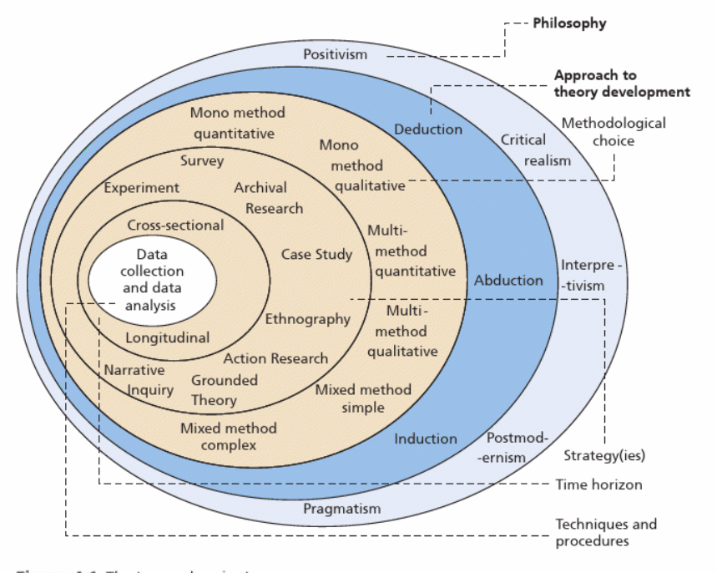
Figure 1 - Research Onion Diagram [33]

3.2. Research Overview
With the help of the research onion the author was able to form a very good and clear understanding on type of structure was needed to accomplish the projects goals. Inside of the research onion there is six different sections these being Philosophy, Approaches, Strategies, Choices, Time Horizons and Data Collection Methods the use of all these different parts allowed the completion of the proposed project to happen. Below is an image of the research onion which was used to help with the project as well descriptions of each of the individual sections and the reasoning behind the decision for each one is also listed below. [33]

3.2.1. Research Philosophy
When selecting what type of philosophy should be used for the project the decision to use positivism was the best option. The reasoning for the use of the positivism is because the author wants to explore the vulnerabilities within the security of a VPN by carrying out an experiment to gather these results. Positivism research focuses on the research which has been gathered through scientific evidence which refers to producing data the is used to support or counter a theory that’s been made. The use of an experiment can be stated as scientific evidence that is how the final decision to use positivism research for the project was made by the author. [33]

3.2.2. Research approach
When deciding upon what type of research should be used for the project the author of the paper decided to use the deductive approach as it was the most appropriate for the testing of the theory. It is believed by the author that VPNs these being commercial and open have some of the same security protocols, but they do not all function correctly. This evidence that will be gathered by the author should backup the viewpoint and reinforce the theory being tested for the purpose of the project. [33]

3.2.3 Research Strategy
From the use of the onion the research strategy that was decided to be used by the author was the experiment-based strategy approach. The reasoning behind the choice of the strategy selected is that many different tests will be done to multiple VPN to see if any vulnerabilities with their security protocols. This will provide the ability for the tests to be documented and the later compared to help provide an overall conclusion if the given vulnerabilities exposer tests were successful against any of the VPNs which were selected by the author for testing . [33]

3.2.4. Research Method
For the project of choice, the decision to use a quantitative research method approach was made due to it being the most relevant to the projects main purpose. A quantitative data research method is useful for needing to collect pieces of information primarily based upon the use of statics instead of qualitative which focuses more on research using information in text form as well as videos or audio files. Quantitative data is chosen by the author as its helpful when trying to identify any trends and patterns that are occurring throughout the testing period. The limitations that this type of research approach provides one of them it means that the focus on certain variables and other measurements needed for testing might cause some other relevant pieces of observations to be forgotten about. As well as if any form of setting or other know variables change than the results gattered through the testing might not be reliable due to some of the tests being done differently causing unfair result. . [33]

3.2.5. Time Horizons
When deciding between what time horizon approach should be used for the project the decision using either the longitudinal or the cross-sectional from the research onion the author decided to pick the use of cross sectional for the project overall. When using the cross-sectional method, it allows the testing to all be done at one specific time rather than doing the testing over a large amount of time with constant monitoring possibly being needed. This method is used as the testing must only has to last a short period of time rather than being months long. This also allows the author to help plan testing as well as other parts of the report within a certain amount of time allowing the completion and success of the project to occur. . [33]
The initial time of study had changed due to a few different factors some of these including. Whilst carrying out research into a specified area of my project report another interesting sector that could be interrupted into the report and only discovering this certain new area once already starting the research part of my studies. Making it when finding new sections of study that could be integrated into the report it would slow down the progress of the planned time scale which the author was going to be following for the specified tasks. [33]

3.2.6. Data Collection Method
When the author was deciding for what type of collection method should be used to gather the result needed for the specific aims and objective to be met the conclusion to use multiple methods of data collection be used was the most appropriate for the project these being sampling and data analysis collection methods. [33]

3.3. Hypothesis
The hypothesis decided by the author was to investigate if paying for a VPNs security services is worth when the option to not pay for VPN security services are available.
The prediction for the results should show that all the given testing aspects should be believed to be perfectly fine for the ones which have been paid for however the one that has not been paid for might not have all the same security aspects successful as the lack of payment subscription does imply that it should not perform the same sort of functions as the one that requires payment.

3.4. Hardware being used
The hardware that was required to perform the testing was very basic as it involved the use of either a laptop or computer to carry out the necessary requirements to perform the testing. As well as the use of a mouse, keyboard and monitor would also be needed to operator the computer unlike the laptop which does not require the additional monitor for testing.

3.5. Software being used
All the software which was required for testing to be done was very important. The two selected commercial VPNs that were being used for the main part of the testing were required as without them the project goals wouldn’t be able to be accomplished. As well a selection of an opensource VPN was needed to form a comparison between the commercial and open VPN security to be done. To document all the findings from the test in organized manner the software program known as Microsoft Excel was used and then for the following type up to structure was put into a Microsoft word document as it’s a very reliable tool for gathering and documenting data.

3.6. Explanation on reliability for Project
The main concern before any of the design and testing process had begun was to make sure that the results being generated through testing would be the most reliable as if the results were not reliable then the all the results would not be allowed to be used. Many different considerations were integrated into testing and designing process to guarantee the reliability of testing. Making sure all the testing was done on the same network was one of the first things that had to done as the whole project idea was secure based around keeping a network secure with the use of VPNs so by making sure all the VPNs used the same network was crucial as different networks could have possibly generated different results. Using the same hardware and software to produce the results was a very big factor to the testing as well as the same process being done to one of the VPNs had to be done to all the other VPNs as if the process was different for example doing WebRTC leak test they could produce different results depending on the overall steps to get to the finished result.

3.7. How the Experiment was Conducted
All the processes taken place to complete the experiment part for the project have been put into chapter 4 Design and Implementation. Within that chapter is a step-by-step guide on the process how the testing was done as well as all the appropriate considerations needed when testing was being done.

3.8. Ethical Considerations made for Project
For the study, appropriate considerations have been given to all aspects if the ethics form. This considers possible ethics implications that could affect the independent project. It was found that there are no risks or benefits to the author of this study; there were no adult or child participants. There is no planned future re-use of the data. The data storage will be held on a laptop with password access and a backup on a USB storage device that will be kept in a lockable drawer.

3.9. Chapter Summary
Throughout this section the author of the project has explained the various sections of the research onion which helped with the completion of the project. These consisted of doing research into these specified area philosophy, approach, strategies, choices, time horizons and data collection. This chapter is one of the most important parts to help find the correct process and certain techniques which should be done to complete all the targets initially set out by the author. As well as the type of experiment and ethical considerations made when exploring the project.

4. Design and Implementation

4.1. Introduction
Within this section the different sections one of which being design and the other implementation will be explained. This chapter helps to lay out the entire process needed to help carry out the experiment. Within this section all the designs and results behind all the different VPNs vulnerability tests will be highlighted. The decision making which has been done to decide what test will be done will also be explored. The limitation which the author faced when planning the tests are conveyed and the issues which appeared during the testing phase is also stated with this section of the report. The decision making for the VPNs which should be used is also explored.

4.2. What Testing should be done
When deciding upon what type of test should be done against open and commercial VPNs to see if there is a protective difference in their securities it became more challenging than originally thought before starting the chosen project.

4.3. Understanding for Testing Decision
Before starting to do the independent project the amount of information behind knowing what VPNs were and did was not massive however after expanding my knowledge the understanding of VPNs has grown massively. However, this helped the author to identity what should be testing however not how to test the given areas required against attacks that might occur.

4.4. Leaks being tested
Below are the selected areas which are being tested to see if they would be being exposed to hackers and the public making their data not being completely safe:
- DNS Leak
- WebRTC Leak
The reasoning behind picking all these specific types of security for leaks is due to them being the most basic form of security which a VPN should be able to provide no matter which type of version a user buys this being commercial or open. As well as another reason behind picking these specific types of area to be tested is due to them not being extremely difficult to see if these VPNs are using these security aspects properly.

4.5. Testing process
The testing that will be done for all the VPNs will use the exact same sort of process to make sure that fair testing is taking place. When also deciding upon what networks the VPNs should be tested on the decision came to testing all the different security parts on the same network. This network will be a public network as these type of networks is one hundred percent sure secure. This also provides all the data to become more reliable as there would be a lot less variables which are different.

4.6. Limitations
One of the main limitations that had to been considered by the author was how much money was willing to be spent on the VPNs which were required for testing. The decision which was decided by the author was to buy higher end VPNs rather than lower costing VPNs as the more expensive VPN should not possess less vulnerabilities to be exploited so by testing these ones it shows if the leaks appear that not the more expensive one does not mean that it’s the most protective.

4.7. VPN Selecting
When selecting which VPNs to use for testing the process for the commercial VPNs to be picked was a lot easier than the open-source VPNs. When deciding the commercial VPNs, the author wanted to find the most used and heard of as these would the most credible and secure ones so that when testing for vulnerabilities, they should not have any which occur. The VPNs that were selected are Express and Nord VPN these are two of the most well-known VPNs one due to their amazing reputations as well as marketing teams which get brand deals with well-known influencers that focus on the main demo graphic which VPNs are used by primarily. The open-source VPN which was decided for vulnerability tests was Proton VPN. The reasoning behind this choice is due to them being compared to Nord and Express when using the paid subscription version however when using the free version, the author wanted to see if the comparison in results would differ due to the open-source version of Proton providing less than the paid subscription version.

4.8. Diagrams
The creation of multiple diagrams for each one of the specific tests these being a DNS leak as well as the WebRTC leak have been made as it will not be testing all the given tests at the exact same time. This is being done due to when testing all the different leaks that could be occurring it might cause the results to not be completely accurate making it so if doing the test separately it causes less chance of effected results as well makes it easier to monitor all the testing taking place.

4.9. Testing

4.9.1. Note for Testing logs
All the different VPNs being tested have been given different names in order to categories them easier e.g Express VPN is Commercial VPN 1; Nord VPN is Commercial VPN 2, and the Open-Source VPN is Proton VPN. This makes it so the author can clearly see how the open and commercial VPNs results compare differently.

4.9.2. Discovering IP address
Before activating the VPNs to do the following tests the decision to check what the IP address for the given device was before any of the testing had begun. This was able to be done by searching “What’s my Ip address?” into any search engine the one used for testing was Google.
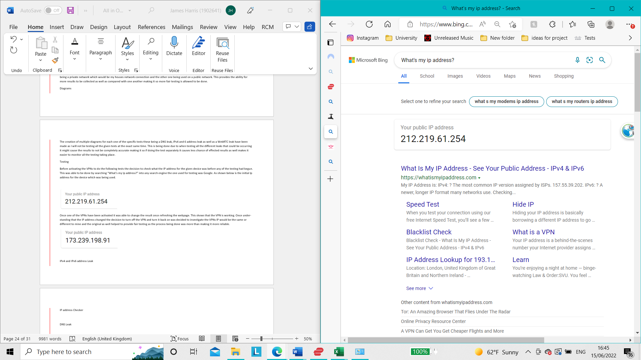
Figure 2 - Process to Find IP Address
As shown below is the initial public Ip address which was provider for the device which was going to be used for testing purposes.
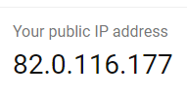
Figure 3 - IP Address for the Device being used for Testing

4.10. WebRTC Leak Diagram
The digram displayed below shows the process on how a WebRTC leak are done. The image below helps the author visuals how a leak occurs. The process from someone communitating from one browser to another this can through different forms of socail media such as emails and video calls. From the image the interception between communication is what become vunerable as the IP of the users browser is required in order for the communication to take place. This is when the IP gets discovered and can possible result in a leak from occuring.
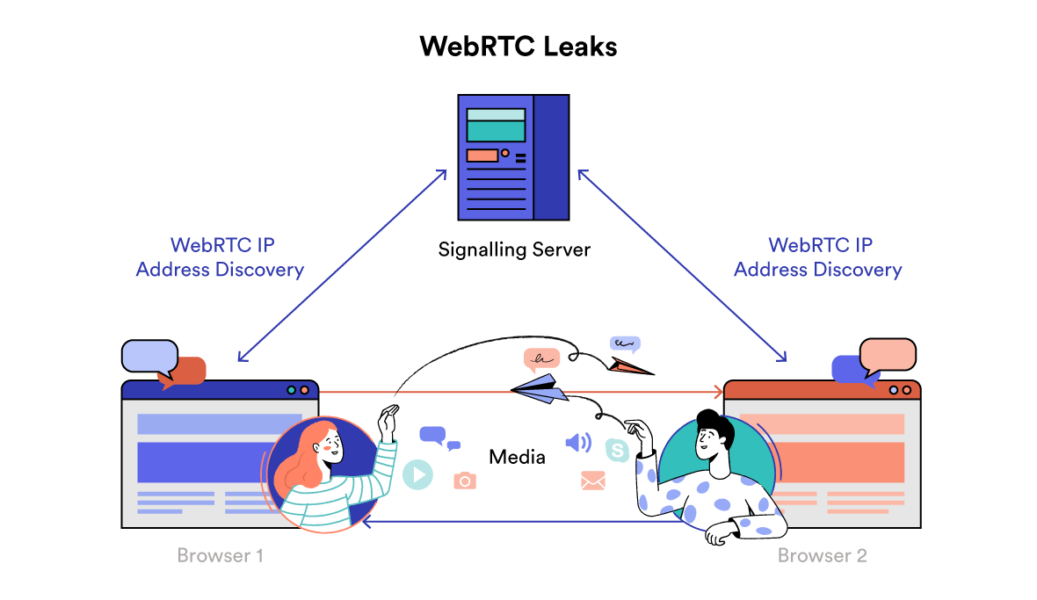
Figure 4 - WebRTC Leak Process Diagram [34]

4.11. WebRTC Leak Test
When activating one of the VPNs and refreshing the webpage where the initial IP address for the device was discovered. It showed that the VPN is working making sure that the WebRTC is not being leaked. The reasoning behind this conclusion is because if any form of leak WebRTC leak was occurring the IP address would not have changed from the original which was displayed before connecting the VPN to the network. Once understanding that the IP address had changed the decision to turn off the VPN and turn it back on was decided to investigate if the VPNs IP address would be the same or different to the last VPN address and the original. This allowed the results to be double checked by the author and help to make sure that any WebRTC leaks were occurring from the selected VPN. This process was then done to all the VPNS that were selected for testing.

4.11.1. Commercial VPN 1 Result (WebRTC)

4.11.1.1. United States of America
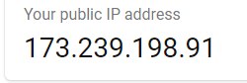
Figure 5 - Result for Commercial VPN 1 on United States Connection (WebRTC Leak Test)

4.11.1.2. Netherlands
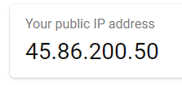
Figure 6 - Result for Commercial VPN 1 on Netherlands Connection (WebRTC Leak Test)

4.11.2. Commercial VPN 2 Results (WebRTC)

4.11.2.1. United States of America
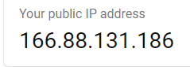
Figure 7 -Result for Commercial VPN 2 on United States Connection (WebRTC Leak Test)

4.11.2.2. Netherlands
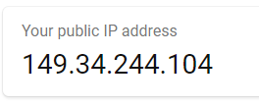
Figure 8 - Result for Commercial VPN 2 on Netherlands Connection (WebRTC Leak Test)

4.11.3. Open-Source VPN Results (WebRTC)

4.11.3.1. United States of America
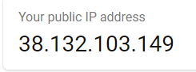
Figure 9 - Result for Open-Source VPN on United States Connection (WebRTC Leak Test)

4.11.3.2. Netherlands
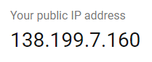
Figure 10 - Result for Open-Source VPN on Netherlands Connection (WebRTC Leak Test)

4.11.4. Mini Summary WebRTC (Leak)
All the different VPNs were able to produce new IP address for the device which was being used for testing. This means that there are not any signs of WebRTC leaks happening as all the IP address which have appear don’t match with the initial IP address which was set for the given device on the network.

4.12. DNS Leak Diagram
As displayed by the diagram below the process of how a DNS leak works is shown. As shown the author can see how an ISP DNS Server will try to intercept the data getting transferred from the internet browser to the VPN DNS Server by trying to get the information before reaching the VPN Tunnel which is being used to send the DNS request through.
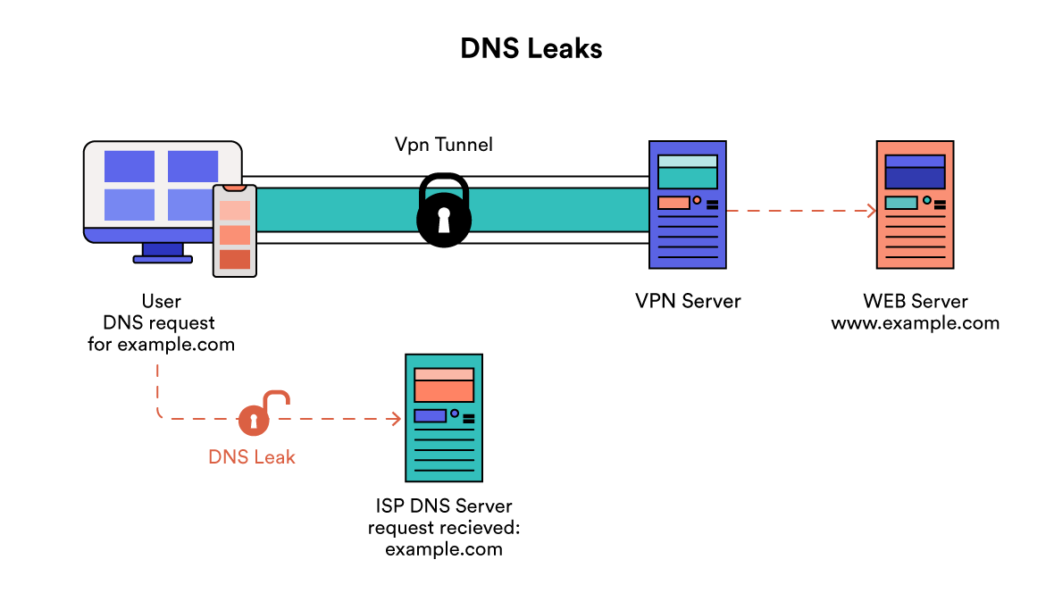
Figure 11 - DNS Leak Process Diagram [34]

4.13. DNS Leak Test
This DNS leak test was being done using a Google browser which was recommended by many different videos that were discovered by the author during the process of identifying different vulnerabilities which could be tested. There is anecdotal evidence that supports this test. [35]
Before beginning the DNS test on the device, the decision to enter the website before enabling the VPN was decided to be able to have a greater comparison between the results.
Initial results before VPN being active are as shown in the image below the initial location of the device has been exposed and managed to identify which country the equipment is being used from.
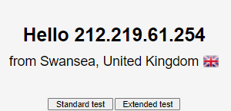
Figure 12 - IP address of Device before Starting the standard DNS Leak Test
When proceeding to perform a standard test for the network without the VPN being activated the following image shows all the servers which were able to be located. When enabling the VPN, the country where the device is being used can be displayed however all the listed servers will be gathering the data.
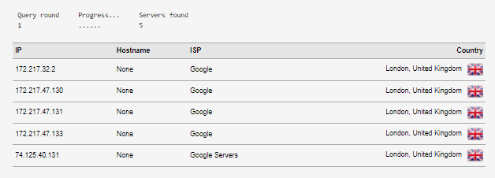
Figure 13 - Results for the Device before testing with VPNs
When activating the VPNs and setting them all to the different countries are shown below with the given results that appeared. All these different VPNs had followed the same method to make sure reliability is more successful.

4.13.1. Commercial VPN 1 Results DNS

4.13.1.1. United States of America
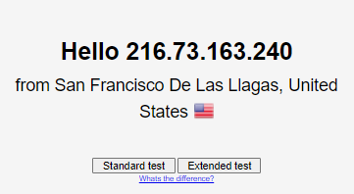
Figure 14 - United States IP for Commercial VPN 1 before starting standard Test (DNS Leak Test)

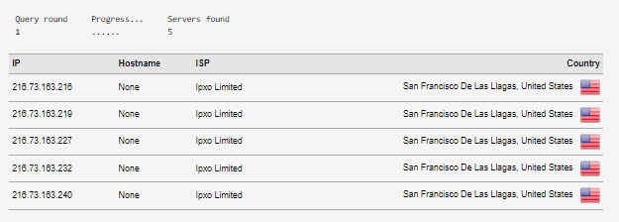
Figure 15 - Result for Commercial VPN 1 on United States Connection (DNS Leak Test)

4.13.1.2. Netherlands
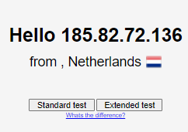
Figure 16 - Netherlands IP for Commercial VPN 1 before starting standard Test (DNS Leak Test)
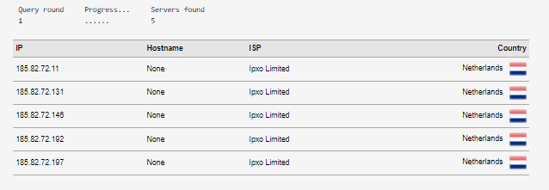
Figure 17 - Result for Commercial VPN 1 on Netherlands Connection (DNS Leak Test)

4.13.2. Commercial VPN 2 Results DNS

4.13.2.1. United States of America
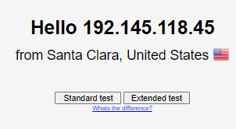
Figure 18 - United States IP for Commercial VPN 2 before starting standard Test (DNS Leak Test)

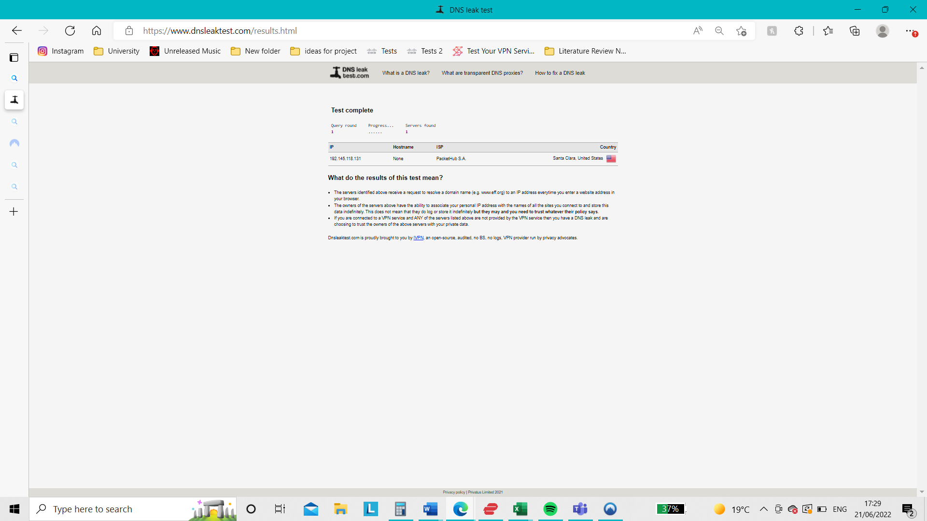
Figure 19 - Result for Commercial VPN 2 on United States Connection (DNS Leak Test)

4.13.2.2. Netherlands
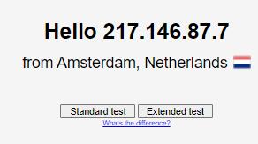
Figure 20 - Netherlands IP for Commercial VPN 2 before starting standard Test (DNS Leak Test)
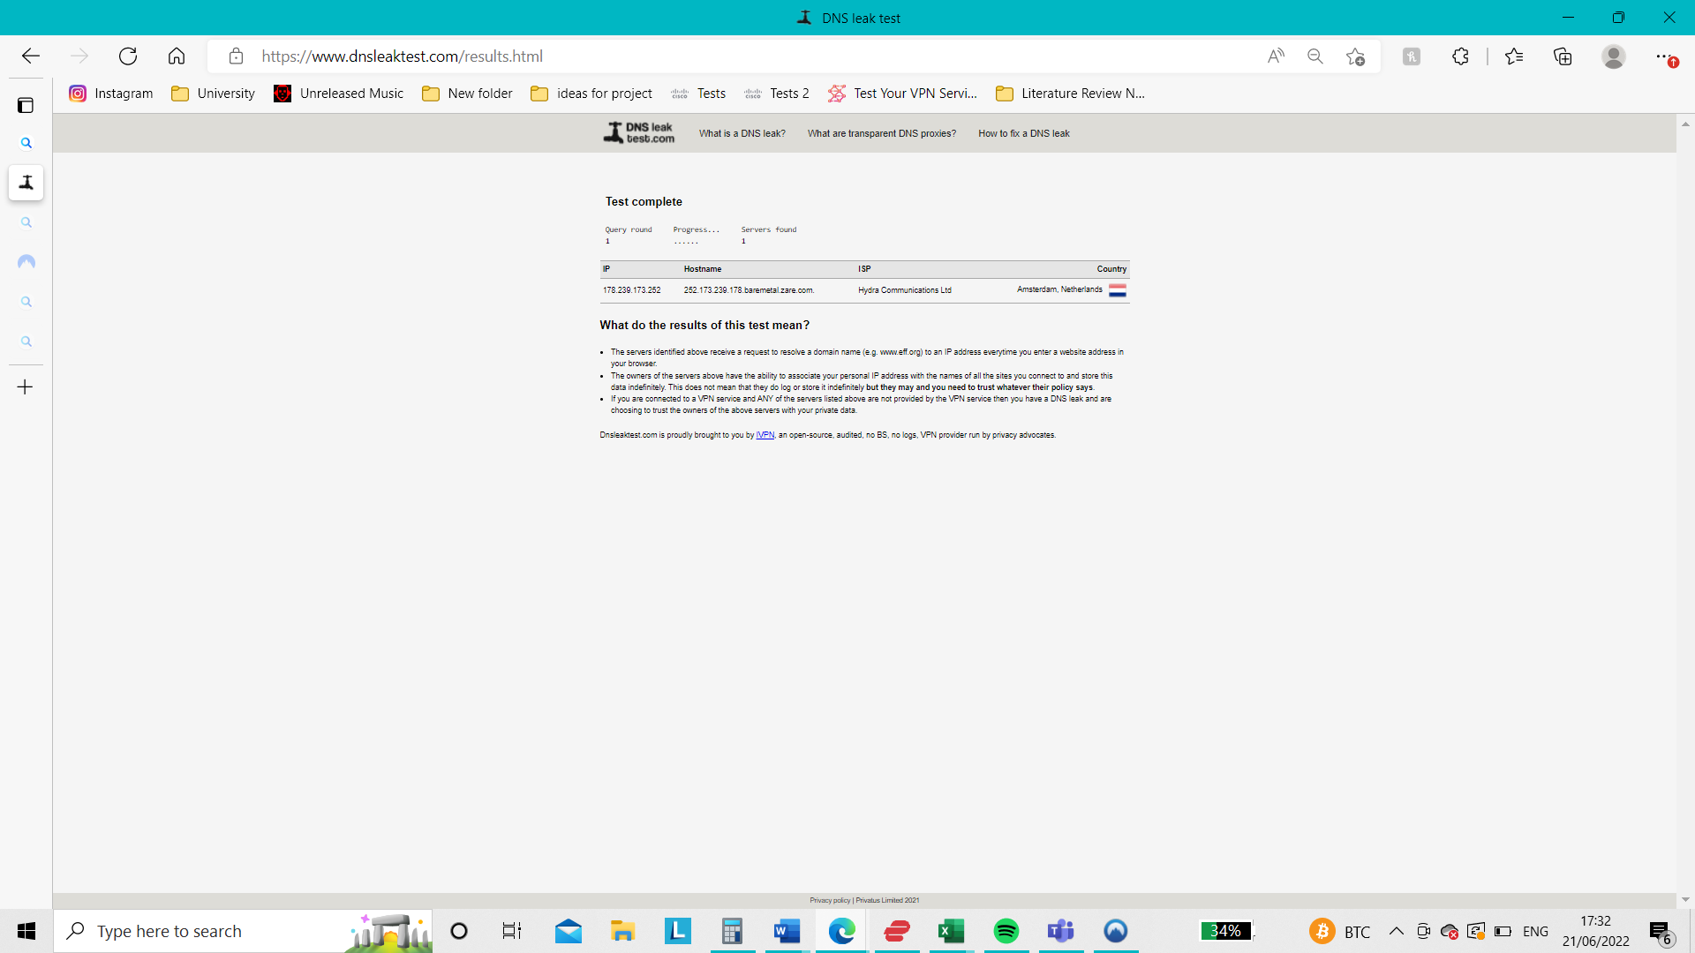
Figure 21 - Result for Commercial VPN 2 on Netherlands Connection (DNS Leak Test)

4.13.3. Open Source VPN Results (DNS)

4.13.3.1. United States of America
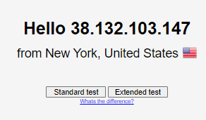
Figure 22 - United States IP for Open-Source VPN before starting standard Test (DNS Leak Test)

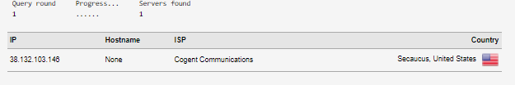
Figure 23 - Result for Open-Source VPN on United States Connection (DNS Leak Test)

4.13.3.2. Netherlands
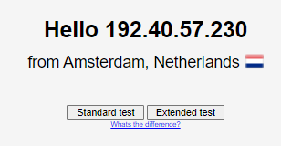
Figure 24 - Netherlands IP for Open-Source VPN before starting standard Test (DNS Leak Test)
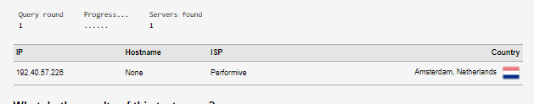
Figure 25 - Result for Open-Source VPN on Netherlands Connection (DNS Leak Test)

4.13.4. Mini Summary DNS (Leak)
All the different VPN showed that the countries had servers which showing the location of where the VPNs were being connected to not the original IP location of the device being used meaning no signs of any leaks are appearing.

4.15. Issues
When trying to use the selected public networks to perform the tests needed to get the results not all the VPNs were allowed access to use any form of internet connection. This made it harder for the tests to be fair test due to the lack of the same network because the different networks could have different outcomes. However, after looking for different networks to use finally a public network which allowed all the VPNs to be used was eventually found.

4.16. Conclusion
Within this section all the tests for vulnerabilities have been explored with the results being that none of the VPNs had leak occur for the tests which had been done. The different complications and considerations for different aspects of the testing process have also been explored and stated within this section.

5. Evaluation

5.1. Conclusion from data gathered
Multiple forms of vulnerabilities were tested against the selected VPNs used for testing. The information which was gathered helped to identify that the selected VPNs did not show any signs of WebRTC leaks from the tests that were done. Likewise with the other vulnerability which was tested there was not any signs of DNS leaks from happening to the VPNs which were selected for testing.

5.2. Was the aim achieved
The aim which was initially set out by the author was able to be met throughout doing the project. The author had set out the aim for the project as assess the different vulnerabilities which VPNs could possess. This was managed to be done with the help of the objectives as they helped manage a path for the author to use to guarantee that the main aim for the project was not forgotten about when diving further and further into the report and testing fazes of the project.

5.3. Were the objectives achieved
All the five different objectives which were set out at the start of the project by the author were able to be accomplished. This was able to be done due to all the objectives were all selected to make sure that the project would be done successfully using the objectives all most being a step-by-step guide making it easier for the author to check if any of the objectives were missed. The only objective which was considered possibly not accomplished by the author was explore a wide variety of different protective software’s as the other protective software was not massively explored but when constructing the literature review some of the articles expanded upon other forms of protection software not just VPNs specifically.

5.4. Were the results given expected
The result which was received by carrying out all the testing for vulnerabilities was somewhat expected. The reasoning behind this is due to the VPNs which were used to check for any vulnerabilities are the most well-known. For example, both commercial VPNs not only have a very good review and security privileges on which they offer but as well are one of the most seen due to them being used to sponsor many content creators around the world. Likewise for the open-source VPN which was used the reputation for the security protocols is also high and well-known. It also provides the option for payment to upgrade the system being used already. As the author understood how well the open-source VPNs was the decision to test the capabilities was perfect. So overall when the VPNs did not show any signs of leaks this being commercial or open source the results were not very surprising for the author.

5.5. What would be done differently if given the opportunity again
The project has helped to highlight a few considerations for the author if the project was going to be done again. The different considerations have all been listed below with the reasoning behind each one of the differences being explained by the author.
- Investigate more into the use of a virtual working environment as that could have allowed more types of testing that could presented more factors and research into the projects goals.
- Spend more time during the testing period so that everything which was being displayed could have been analysed in greater detail just in case something might have been missed from first glance.
- Explore the use of other or more VPNs so that more testing could take place as well as see if any more VPNs would have performed differently to have a stronger conclusion due to multiple testing’s.
- Carry out a large range of test to see if any other areas of VPNs could be vulnerable.
- Use multiple networks to see if the initial networks being used could act differently when the VPNs are active for example the network not being as secure as if the used on another network.

6. Conclusion and Recommendation

6.1. Overall Summary
This project has explored the different types of VPNs being ones which require payment or do not. All the different aims and objectives which were set out by the author were accomplished throughout the projects report. As stated previously the results which were gathered through testing were not expected however the outcome was not surprising that all of them did not show signs of leaks as they have good reputations.

6.2. Further Research possibilities
The project has the potential to be further explored in a few different ways. Further vulnerabilities could be tested to see if any different leaks might appear. As well as other VPN could have the test as they might have not the same results as the ones which have been tested within the report. However no further plans to carry out any more research have been planned.

6.3. Recommendations
All of the different VPNs which were used for testing these being Express VPN, Nord VPN and Proton VPN would be recommended for use as there is not any signs of vulnerabilities from the test which were done meaning that there more likely to secure you data safely.

7. Reflection

7.1. What I have learnt when doing my independent project

I have learned a large amount about what a VPN is and how they are used to protect a user’s information from getting exposed to anyone that could use the data for harmful reason. As well I have learned a lot about the different types of VPN packages which can be acquired for many different purpose e.g security or entertainment use. My understanding as well on other forms of security have also increased slightly due to them being mentioned when investigating VPN. I’ve also learnt a lot about the increase of cyber-attacks which have been done over the previous year’s. My knowledge on how secure a public networks connection e.g pub or cafes is when not using any forms of protection for a person’s devices.

7.2. How did it affect me a person
I’m now more aware how all my cyber information on any of my devices can be exposed and cause major issues so I’m going to make sure that all my devices have some form of protection software to avoid any of my information from being exposed. I will try to more not to connect any public network unless some sort or security for example VPN is install on my device and if no security software, I’ll try to remember to use my 4G instead as its safer for my data.

8. References

[1] | S. Petryschuk, “Auvik,” 3 February 2021. [Online]. Available: https://www.auvik.com/franklyit/blog/types-of-networks/. [Accessed 26 September 2021].
[2] | R. Hat. [Online]. Available: https://opensource.com/resources/what-open-source. [Accessed 19 September 2021].
[3] | “Techopedia,” [Online]. Available: https://www.techopedia.com/definition/4245/commercial-software. [Accessed 16 September 2021].
[4] | K. Thompson, “Geospatial World,” [Online]. Available: https://www.geospatialworld.net/blogs/what-is-the-difference-between-a-free-vpn-and-a-paid-vpn/. [Accessed 21 September 2021].
[5] | IntelligentHQ, “Knowing The Utmost Importance Of The VPN Security,” 11 December 2018. [Online]. Available: https://www.proquest.com/docview/2253464099/citation/40685D9CA6054E94PQ/1?accountid=130472. [Accessed 25 January 2022].
[6] | D. Gewirtz, “Understanding VPNs and how to choose one,” 7 March 2017. [Online]. Available: https://www.howtogeek.com/245982/WHATS-THE-DIFFERENCE-BETWEEN-PRIVATE-AND-PUBLIC-NETWORKS-IN-WINDOWS/. [Accessed 15 March 2022].
[7] | C. Hoffman, “What's the Difference Between Private and Public Networks in Windows?,” 10 July 2017. [Online]. Available: https://www.howtogeek.com/245982/WHATS-THE-DIFFERENCE-BETWEEN-PRIVATE-AND-PUBLIC-NETWORKS-IN-WINDOWS/. [Accessed 5 May 2022].
[8] | B. B. Rao and S. Kavitha, “Connect Users to Private Networks Securely over Public Networks using Virtual Private Networks,” International Journal of Advanced Research in Computer Science, vol. 6, no. 3, May 2015.
[9] | M. Ozsoy, “Frequency based advertisement blocking on Android mobile devices using a local VPN server,” 2016. [Online]. Available: https://www.proquest.com/docview/1851236425/abstract/E27A724C8C724746PQ/1?accountid=130472. [Accessed 7 March 2022].
[10] | I. Coonjah, P. C. Catherine and K. M. Soyjaudah, “Design and Implementation of UDP Tunneling-based on OpenSSH VPN,” in 2018 International Conference on Advances in Computing, Communication Control and Networking (ICACCCN), Greater Noida, 2018.
[11] | A. A. Niaki, S. Cho, Z. Weinberg, N. P. Hoang, A. Razaghpanah, N. Christin and P. Gill, “ICLab: A Global, Longitudinal Internet Censorship Measurement Platform,” in 2020 IEEE Symposium on Security and Privacy (SP), San Francisco, 2020.
[12] | M. T. Khan, J. Deblasio, G. M. Voelker, A. C. Snoeren, C. W. Kanich and N. Vallina-Rodriguez, “An Empirical Analysis of the Commercial VPN Ecosystem,” in IMC '18: Proceedings of the Internet Measurement Conference 2018, 2018.
[13] | S. Read, “BBC,” 18 August 2021. [Online]. Available: 40 million T-Mobile customers hit by US data breach - BBC News. [Accessed 19 September 2021].
[14] | E. Rivera, L. Tengana, J. Solano, A. Castelblanco, C. Lopez and M. Ochoa, “Risk-based Authentication Based on Network Latency Profiling,” in AISec'20: Proceedings of the 13th ACM Workshop on Artificial Intelligence and Security, 2020.
[15] | K. Sung, J. Huang, M. D. Corner and B. N. Levine, “Re-identification of mobile devices using real-time bidding advertising networks,” in MobiCom '20: Proceedings of the 26th Annual International Conference on Mobile Computing and Networking, 2020.
[16] | “Newstex,” 29 October 2019. [Online]. Available: https://www.proquest.com/blogs-podcasts-websites/valuewalk-how-virtual-private-networks-evolved/docview/2309913016/se-2?accountid=130472. [Accessed 17 September 2021].
[17] | P. Yacuboski, “Cyber attacks on the rise,” Northeast Pennsylvania Business Journal, vol. 36, no. 9, pp. B9-B10, 2021.
[18] | R. Bansode and A. Girdhar, “Common Vulnerabilities Exposed in VPN – A Survey,” Journal of Physics: Conference Series, vol. 1714, no. 1, 7 January 2021.
[19] | S. Taylor, “VPN Tests – How to Check if Your VPN is Working in 2022,” 15 March 2022. [Online]. Available: https://restoreprivacy.com/vpn/test-check-vpn-working/. [Accessed 25 May 2022].
[20] | A. Vigderman and G. Turner, “How to Test Check Your VPN To See If It's Working,” 3 March 2022. [Online]. Available: https://www.security.org/vpn/test/. [Accessed 9 April 2022].
[21] | The Spectrum, “How to use a Virtual Private Network: What is a Virtual Private Network (VPN)?,” 16 July 2019. [Online]. Available: https://www.proquest.com/docview/2258063820/citation/3674B1CAAB54BD3PQ/1?accountid=130472. [Accessed 18 May 2022].
[22] | Business Insider, “What is a VPN? How a Virtual Private Network can help protect your privacy online,” 17 July 2020. [Online]. Available: https://www.proquest.com/docview/2424561797/citation/351E1F164C6C4E5APQ/1?accountid=130472. [Accessed 15 April 2021].
[23] | K. Shaw and J. Fruhlinger, “What is DNS and how does it work?: The Domain Name System resolves the names of internet sites with their underlying IP addresses adding efficiency and even security in the process,” Network World (Online), 26 Auguest 2020.
[24] | J. Phipps, “Webopedia,” 11 December 2020. [Online]. Available: https://www.webopedia.com/definitions/dns-leak/#:~:text=A%20DNS%20leak%20is%20a%20security%20issue%20that,Internet%20users%20to%20send%20domain%20name%20requests%20privately.. [Accessed 15 May 2022].
[25] | G. Eastman, “Current security issues with IPv4 and emerging security issues with IPv6,” 2014. [Online]. Available: https://www.proquest.com/docview/1563381431/abstract/AA772DC4A3894C9BPQ/1?accountid=130472. [Accessed 10 April 2022].
[26] | Newstex Global Business Blogs, “ValueWalk: What Is A WebRTC Leak And How To Prevent It?,” 18 June 2019. [Online]. Available: https://www.proquest.com/docview/2242293825/citation/870553E95E9B4225PQ/1?accountid=130472. [Accessed 19 January 2022].
[27] | S.-V. Mocan, “What is WebRTC? (Simple Guide for Beginners) - TechNadu,” 26 April 2020. [Online]. Available: https://www.technadu.com/webrtc/99645/. [Accessed 1 March 2022].
[28] | M. Pudelko, P. Emmerich, S. Gallenmuller and G. Carle, “Performance Analysis of VPN Gateways,” in 2020 IFIP Networking Conference (Networking), Paris, 2020.
[29] | S. Thapliyal, H. Gupta and S. K. Khatri, “An Intruder Monitoring System for Improving the Network Security,” in 2019 4th International Conference on Information Systems and Computer Networks (ISCON), Mathura, 2019.
[30] | G. Lopez and E. Grampin, “Scalability testing of legacy MPLS-based Virtual Private Networks,” Montevideo, 2017.
[31] | A. Tambe, Y. L. Aung, R. Sridharan, M. Ochoa, N. O. Tippenhauer, A. Shabtai and Y. Elovici, “Detection of Threats to IoT Devices using Scalable VPN-forwarded Honeypots,” in CODASPY '19: Proceedings of the Ninth ACM Conference on Data and Application Security and Privacy, 2019.
[32] | R. Nigmatullin, A. Ivchenko and S. Dorokhin, “Differentiation of Sliding Rescaled Ranges: New Approach to Encrypted and VPN Traffic Detection,” in 2020 International Conference Engineering and Telecommunication (En&T), 2020.
[33] | M. N. Saunders, P. Lewis and A. Thornhill, Research methods for business students, 8th ed., Harlow: Pearson, 2019.
[34] | Top10VPN, “Do I Leak? IP, WebRTC & DNS Leak Test: VPN & Torrent IP Check,” 2022. [Online]. Available: https://www.top10vpn.com/tools/do-i-leak/. [Accessed 4 May 2022].
[35] | Raw Traveler, “Check for DNS Leak on VPN,” 26 May 2016. [Online]. Available: https://www.youtube.com/watch?v=oARyevTRZvY. [Accessed 1 May 2022].

9. Appendices

9.1. Appendix 1 – Literature Analysis

Sl | Title of the Paper | Author | Publisher | Date of Publication | DOI/ Link to access | 50 WORDS DESCRIPTION
[1] | Scalability testing of legacy MPLS-based Virtual Private Networks | Gustavo Lopez  Eduardo Grampin | IEEE | 23-25 October 2017 | Scalability testing of legacy MPLS-based Virtual Private Networks | IEEE Conference Publication | IEEE Xplore (uwtsd.ac.uk)  10.1109/URUCON.2017.8171874 | There’re comparisons between the Layer 2 and Layer 3 Virtual Private Network consisting of their creation/deletion time and other comparisons between the layers. This testing was allowed to be done using emulation environment making it so the routing software could be supported for the testing on the network to proceed.[1]
[2] | Design and Implementation of UDP Tunnelling-based on OpenSSH VPN | Irfaan Coonjah  Pierre Clarel Catherine  K. M. S. Soyjaudah | IEEE | 12-13 October 2018 | Design and Implementation of UDP Tunneling-based on OpenSSH VPN | IEEE Conference Publication | IEEE Xplore (uwtsd.ac.uk)  10.1109/ICACCCN.2018.8748849 | The advantages and disadvantages for open VPN’s and open SSH’s are stated in the passage. The use of the VPN and SSH is discussed to provides the reader with the best idea for which one to use in certain situations. Tunnelling is also explored and displays how it benefits open sources.[2]
[3] | An Empirical Analysis of the Commercial VPN Ecosystem | Mohammad Taha Khan  Joe DeBlasio  Geoffrey M. Voelker  Alex C. Snoeren  Chris Kanich  Narseo Vallaina-Rodriguez | Association for Computing Machinery | 31 October 2018 | An Empirical Analysis of the Commercial VPN Ecosystem | Proceedings of the Internet Measurement Conference 2018 (uwtsd.ac.uk) | The testing of a wide variety of different VPNs providers all being commercial ones is tested against a system to test the privacy which the VPNs exactly provide. As well as an overall conclusion with the finding that have been found through the extensive testing.[3]
[4] | Detection of Threats to IoT Devices using Scalable VPN-forwarded Honeypots | Amit Tambe  Yan Lin Aung  Ragav Sridharan  Martin Ochoa  Nils Ols Tippenhauer  Asaf Shabtai  Yuval Elovici | Association for Computing Machinery | 13 March 2019 | Detection of Threats to IoT Devices using Scalable VPN-forwarded Honeypots | Proceedings of the Ninth ACM Conference on Data and Application Security and Privacy (uwtsd.ac.uk) | In the article its mentioned what a VPN provider and what a VPNN forwarder is and how they’re useful when providing security to a physical device. This is also mentioned and tested by using commercial connections and VPN services with attacks to test the actual effectiveness of the security software.[4]
[5] | An Intruder Monitoring System for Improving the Network Security | Sourav Thapliyal  Himanshu Gupta  Sunil Kumar Khatri | IEEE | 21-22 November 2019 | An Intruder Monitoring System for Improving the Network Security | IEEE Conference Publication | IEEE Xplore (uwtsd.ac.uk)  10.1109/ISCON47742.2019.9036195 | This discusses how security systems can be improved through the construction of a model network to check if certain areas seem more at risk than others and will check the best solution to overcome the vulnerable areas. This includes the use of VPNs and how they can used to improve the security for the network.[5]
[6] | ICLab: A Global, Longitudinal Internet Censorship Measurement Platform | Arian Akhavan Niaki  Shinyoung Cho  Zachary Weinberg  Nguyen Phong Hoang  Abbas Razaghpanah  Nicolas Christin  Phillipa Gill | IEEE | 18-21 May 2020 | ICLab: A Global, Longitudinal Internet Censorship Measurement Platform | IEEE Conference Publication | IEEE Xplore (uwtsd.ac.uk)  10.1109/SP40000.2020.00014 | Within the article is talks about the advantages and disadvantages of using a VPN. As well as provides a discussion or the ethical issues and legal issues the company that provide VPNs might face and how they are able to overcome these certain issues.[6]
[7] | Performance Analysis of VPN Gateways | Maximilian Pudelko  Paul Emmerich  Sebastian Gallenmuller  Georg Carle | IEEE | 22-26 June 2020 | ​Performance Analysis of VPN Gateways | IEEE Conference Publication | IEEE Xplore (uwtsd.ac.uk) | The exploration into the large variety of different type of software implementations for a VPNs gateway as well as their effectiveness is stated throughout with different testing backing up the data gathered. As well as the comparison between a OpenVPN, Linux, IPsec and Wire Guard is discussed.[7]
[8] | Re-identification of Mobile Devices Using Real-Time Bidding Advertising Networks | Keen Sung  JianYi Huang  Mark D. Corner  Brian N. Levine | Association for Computing Machinery | 21 September 2020 | Re-identification of mobile devices using real-time bidding advertising networks | Proceedings of the 26th Annual International Conference on Mobile Computing and Networking (uwtsd.ac.uk) | Within the passage it talks about how advertising is being used to gather data about the user. There mentioning on how the testing of using different types of software such as VPN have been used to try and prevent the stealing of information. Also states the effectiveness of these software’s.[8]
[9] | Risk-based Authentication Based on Network Latency Profiling | Esteban Rivera  Lizzy Tengana  Jesus Solano  Alejandra Castelblanco  Christian Lopez  Martin Ochoa | Association for Computing Machinery | 13 November 2020 | Risk-based Authentication Based on Network Latency Profiling | Proceedings of the 13th ACM Workshop on Artificial Intelligence and Security (uwtsd.ac.uk) | In the novel it states the how using the VPN tunnelling scheme how its allowed to see most attacks which are trying to happen within the networks being monitored. Also, the mentioning of what proxies are is discussed and how they can be used.[9]
[10] | Differentiation of Sliding Rescaled Ranges: New Approach to Encrypted and VPN Traffic Detection | Raoul Nigmatullin  Alexander Ivchenko  Semyon Dorokhin | IEEE | 25-26 November 2020 | Differentiation of Sliding Rescaled Ranges: New Approach to Encrypted and VPN Traffic Detection | IEEE Conference Publication | IEEE Xplore (uwtsd.ac.uk)  10.1109/EnT50437.2020.9431285 | A comparison between using a VPN to somebody not using a VPN is made by constructing a basic machine learning model and deploying a DSRR to see the flow-based features and then see how each model performs with the task.[10]

9.2. Appendix 2 – Time Plan For Project
Week Commencing | Week Number | Your workload
21 Sep | 1 | Start thinking of a Proposal Idea
28 Sep | 2 | Decide the final Proposal Idea will be
5 Oct | 3 | Begin the write up Proposal Idea
12 Oct | 4 | Do final checks and upload Project Proposal Idea
19 Oct | 5 | Start gathering information about VPNs benefits and drawbacks
26 Oct | 6 | Start gathering information about general Commercial VPNs
2 Nov | 7 | Start gathering information about general Open-source VPNs
9 Nov | 8 | Investigate the VPNs which will be allowed to be tested
16 Nov | 9 | Contact the companies to find out if testing is allowed
23 Nov | 10 | Proceed to go into more research into the VPNs which have been approved
30 Nov | 11 | Find out about cybersecurity attacks that have occurred recently
7 Dec | 12 | Make sure that all the main research has been done and find any more information if relevant
4 Jan | 13 | Prepare for interim Viva
11 Jan | 14 | Carry on interim Viva preparation
18 Jan | 15 | Finish interim Viva
25 Jan | 16 | Begin the construction of the testing system
1 Feb | 17 | Finish construction of the testing system
8 Feb | 18 | Start testing the data to be analysed
15 Feb | 19 | Gather more data to be analysed through testing
22 Feb | 20 | Finish the testing process
1 Mar | 21 | Make the tables without rearranging the data to most to least effective
8 Mar | 22 | Organize the data into a table to show clear overall outcome
15 Mar | 23 | Start construction of the Final Report
22 Mar | 24 | Carry on making the Final Report
19 Apr | 25 | Begin gathering the Exhibition Materials
26 Apr | 26 | Make sure that everything is finished
3 May | 27 | Make sure that everything is finished

