LUXE NAILS STUDIO
Professional Nail Care – Affordable, Hygienic, Welcoming

Program / Module: CLM4006 – Enterprise and Entrepreneurship
Assignment: Component 2 – Business Pitch Presentation

💡 Business Idea

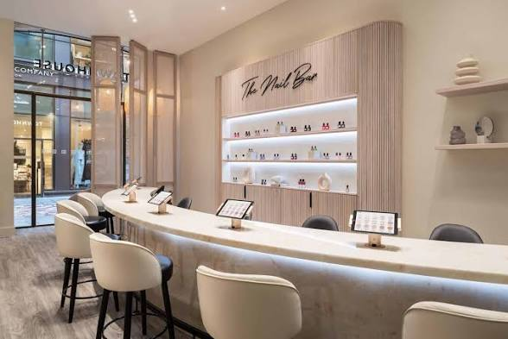

• Services: Manicures, pedicures, acrylic/gel extensions, custom nail art
• USP: Premium quality & hygiene, friendly service, at fair, affordable prices
• Target customers: Women aged 15+, students, working professionals, regular beauty clients
• Legal & Structure: Operates as a Sole Trader

️ Legal & Team

Legal Status: Sole Trader
✅ Simple to set up, low admin costs
✅ Full control over decisions & profits
✅ Registered with HMRC for self-assessment; VAT registration to follow if turnover meets the threshold
⚠️ Owner has personal responsibility for business debts & legal duties

Management & Staffing
• Owner/Manager: Strategy, finance, marketing, operations
• Qualified Nail Technician: Delivers treatments, maintains standards, stock management
• Future expansion: Hire extra staff as demand grows

🌍 External Environment

1. Economic – Demand for "affordable luxury" self-care remains strong even in uncertain times; Norwich’s mix of students and professionals creates a stable customer base

2. Social – Fast-growing interest in nail care, trends spread quickly via social media; high share of women aged 16+ locally

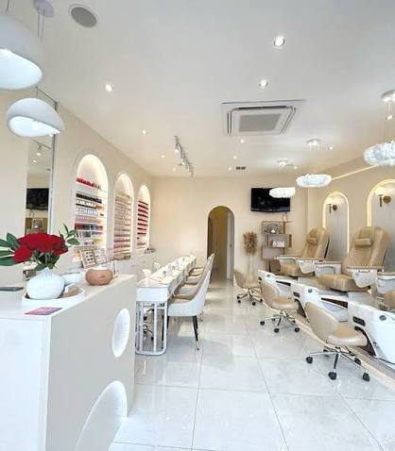
3. Environmental – Rising preference for eco-friendly, cruelty-free products and low-waste operations

🆚 Competition

• Premium salons: High quality, but too expensive for many locals

• Budget salons: Low prices, but often seen as lower quality or less hygienic

• Other salons: Mixed standards, inconsistent service

✨ Our Competitive Edge
Premium quality + strict hygiene + friendly service + fair prices
Build trust via loyalty schemes and strong local social media presence
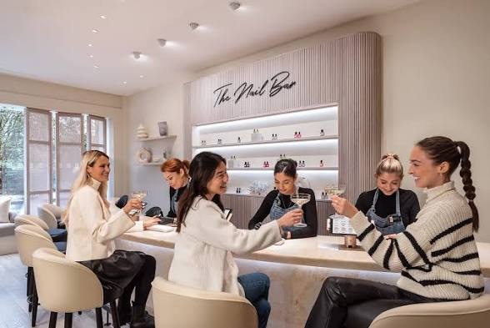
Speaker notes:

📣 How We Reach Customers

1. Social Media (Primary Channels)
◦ Instagram & TikTok: Post high-quality work, trend ideas, customer reviews, offers
◦ Facebook: Local updates, community engagement
Why? Our target audience uses these daily – easy to showcase our work directly

2. Promotions & Retention
◦ Opening discounts, student pricing, seasonal bundles
◦ Loyalty points, referral rewards, birthday offers
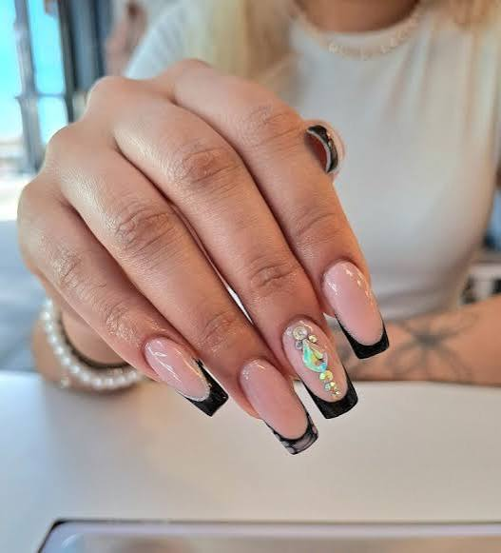
◦ Local partnerships & community events

💰 Start-Up Funding
Total needed: £10,000
• Sources: Majority from personal savings, remainder from a small bank loan.
How funds will be allocated:
Category | What it covers
Equipment & Furniture | Nail stations, lamps, sterilisation units, safety gear
Stock & Materials | Gels, polishes, acrylics, hygiene supplies
Premises | Rent deposit, first month’s rent
Marketing & Branding | Signage, social media setup, opening materials
Legal & Insurance | Public liability, professional cover, registration costs
Contingency | Reserve for unexpected expenses

🎯 Summary

• Fills a clear gap in Norwich’s nail care market

• Simple, scalable structure

• Strong demand and competitive position

• Realistic funding plan

• Goal: Become the most trusted local salon for accessible, high-quality nail care

