DS 1 Template

My Screenshots/Photos
- Please add 4–6 screenshots or photos of your digital life.
- You can use your phone or laptop.
- For each screenshot, write one or two sentences explaining what it shows.

Screenshot/Photo 1
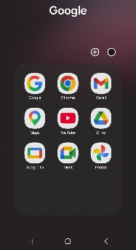
My frequent used apps are in this screenshot. These applications include Gmail, Chrome, Maps, Drive, Meet, and YouTube.
I use these tools for communication, online learning as well as navigation and storing files.
I feel confident in using maps application for my daily commuting.

Screenshot 1 – Google Apps Folder

Screenshot/Photo 2
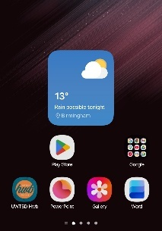
I use digital tools including, Word, PowerPoint, Play Store, and the UWTSD Hub app. These apps help me complete university work and edit any documents. Download new applications.
I want to improve my skills in Word as I do struggle editing work and using the features.
Screenshot 2 – Mobile Home Screen

Screenshot/Photo 3
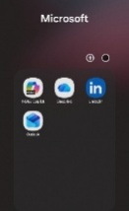
This digital skill shows Microsoft applications such as Outlook and OneDrive, Linkd in and Co Pilot. I use Outlook to manage university emails and OneDrive to store and access files across different devices.
These skills matter to me as they allow me to communicate with my lectures and Co Pilot has been very useful for work.
Linkd In has been helping me find jobs and communicate with professionals.

Screenshot 3– Microsoft Apps Folder

Screenshot/Photo 4

Google Search is used daily by me. Information online when using google search has saved me a lot of time researching products and information. I use search engines to research topics.
This demonstrates my ability to use online information and sources effectively.
Screenshot 4 – Google Search

Screenshot/Photo 5
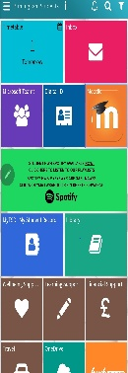
UWTSD Hub app is one of the applications on my phone.
I use it to access my timetable, Moodle, Microsoft Teams, library services, and student, also to access assignments.
It helps me stay organised and manage my university work and help me meet deadlines.
I need to improve my skills regarding locating exam report and feedback.
Screenshot 5 – UWTSD Hub App

Screenshot/Photo 6
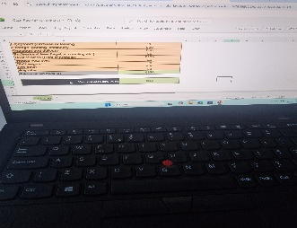
Microsoft excel is used on my laptop to create a cash flow spreadsheet. I can enter data, organise information, and perform basic calculations.
These skills help me manage my business finances.
There is still a lot I need to improve in excel like accounting skills.

Screenshot 6 – Excel Cash Flow Spreadsheet

My Short Reflection
- Write 5–8 simple sentences about your digital life.
- You can use the sentence starters below if helpful.
I use digital tools every day for my studies and communication for my personal use. I often use the UWTSD Hub app for university work such as Moodle, Outlook, Word, PowerPoint, Excel, and OneDrive. These tools help me access course materials, communicate with my lecturers, complete assignments, and organise my work in an efficient way.
I feel confident using my phone applications, I search for information online. I can create documents in Word, presentations in PowerPoint, and simple spreadsheets in Excel I use google meets for work collaboration and having discussion with my lecturers.
I would like to improve my skills in Excel and other advanced digital tools because they are important for my profession at work and for future. Learning more about data analysis, formulas, and digital productivity tools will help me become more efficient and keep up with the digital pace.
Digital skills are important because they help me study independently, communicate effectively and prepare for future employment. I hope this module will help me develop greater confidence and improve my digital abilities for both university and my future career.

- I feel confident using:
Microsoft Word, PowerPoint, Outlook, Google Search, and most mobile applications.
- I want to improve:
My Excel skills, data analysis skills, and knowledge of advanced digital tools.

- I often use these tools:
UWTSD Hub, Moodle, Google Search, Outlook, Word, PowerPoint, Excel, and OneDrive.
- I sometimes feel nervous about:
Using unfamiliar software and new application that I’m not familiar with.
- I hope this module will help me:
Improve my digital skills and become more confident using technology for study, work and day to day life.
- Digital skills are important for me because:
They help me access and manage my university workload, communicate effectively, and prepare for my future career. It boosts my confidence in knowing I can keep up with the digital world.

Sentence starters
- I use digital tools to …
- I feel confident when I …
- I want to improve …
- I often use these tools: …
- I sometimes feel nervous about …
- I hope this module will help me …
- Digital skills are important for me because …
You can write more if you want.

Submission Checklist
Before you submit, please check:
​​​ ☒ I added 4–6 screenshots
☒ I wrote short sentences for each screenshot
☒ I wrote my short reflection
☒ My work is my own
☒ My file opens correctly
​​

