2403712

Research project design
HND/BSc Construction Management

Both virtual reality and augmented reality are new technologies in the world and in the construction sector. Virtual reality creates this content with advanced software, but it does not involve the physical world like augmented reality does. Augmented reality projects 3D content into the real world, giving preconstruction views of what will be built. Within the industry, these technologies collaborate and can be combined to create digital data for a building project.

This research will outline and detail the applications and fundamentals of both AR (augmented reality) and VR (Virtual Reality) and take a view on the main sections of work and stages of a project where it can be utilized the most by also reviewing not only where they can aid construction but how they can be progressed and engineered further in the future. By incorporating these technologies with software such as BIM (Building Information Management) your benefits can include not only visual but also operational guidance through each and every stage of the project.
The study will identify different ways the industry can benefit from these technologies also identify any current limitations within the industry that can prevent the full potential of reality technologies in the construction industry.
The study on the emergency technologies begins with gathering the different views from industry specialists.

Contents
- Introduction
  - Background……………………………………………………………………………
  - Rationale………………………………………………………………………………
  - Research Questions………………………………………………………………….
  - Aim and Objectives…………………………………………………………………...
  - Research Methodology……………………………………………………………...
  - Limitations……………………………………………………………………………
  - Dissertation Structure……………………………………………………………….
- Research Methodology………………………………………………………………………
  - Introduction………………………………………………………………………………
  - Literature Review……………………………………………………………………….
  - Questionnaire Survey………………………………………………………………….
- Literature Review…………………………………………………………………………….
  - Introduction……………………………………………………………………………...
  - Augmented and Virtual Reality………………………………………………………...
  - Findings…………………………………………………………………………………
  - Analysis of the data……………………………………………………………………
  - Questionnaire…………………………………………………………………………...
- Implications to the Construction Industry………………………………………………
  - Virtual Reality…………………………………………………………………………
  - Augmented Reality……………………………………………………………………
  - Health and Safety…………………………………………………………………….
- Conclusions and Recommendations.………………………………………………….
  - References

- Introduction

  - Background
When working within and researching the construction industry it can be clearly considered that one of the main downfalls during construction that not only affects the budget but timescale and follow on works is the lack of ability to see potential clashes that will arise during construction of a project. By furthering both AR and VR and incorporating BIMs clash detection, unforeseeable problems can be easily identified. Another main downfall within the construction industry is health and safety, despite improvements an average of 42 construction workers dies each year in the UK. I feel AR and VR can drastically aid health and safety in construction and will research this in my study.
  - Rationale
This research around emerging and upcoming technologies was conducted as although they are relatively new to the industry many people have a lack of knowledge and belief on how and where they can be of use in construction. Despite this as the industry advances the number of specialists in these fields are increasing although there is ‘A race to digitalise the construction industry and new technologies are being used such as BIM and analytical tools.’ this is also an issue as the increased complexity of software must be met by sufficient competent people in the field of work. I have chosen to identify the main benefits of AR and VR, and also identify how to reduce the current limitations on the subject. (Stone, 2023)
Research Questions
My research on the use usage of AR and VR within construction and current applications of VR and AR it led me to a few main questions on the matter all of which the research has been conducted to follow and meet.
- How can Augmented and Virtual Reality aid construction with a focus on services and installation?
- How can they be progressed and engineered further in the future?
- Can AR and VR increase health and safety in the industry?
These questions will be analysed to ensure the research is developed to a focus of answering the above.
  - Aim and Objectives
The purpose of this research is to understand and identify how Augmented and Virtual Reality can be used to identify methods in which they can aid in a buildings design period, installations and can aid in quality checks. I will be researching information and gathering opinions from specialists within the construction sector in order to get a better understanding and create a solid conclusion on the chosen subject.

  - Limitations
Throughout my research, the main limitations I faced was my personal lack of first hand experience and knowledge within the fields. I have not worked on a project that heavily utilizes augmented/virtual reality; however, I think that it is a growing aspect in construction and will be heavily depended on in the future. Time constraints was another main barrier to myself due to other assignments that I had to complete. Therefor restricting my time on my research project was sacrificed until last to ensure other units were completed for their deadlines. I am unable to use much software as the job I am currently working on requires no AR/VR. Equipment is very expensive and is hard to come across. However, as construction progresses, there will be a greater use and will allow site teams to work closer together and will be able to use and understand the common data environment and BIMs sharing benefits. Not all parts of the site team are involved with these technologies as it is currently only digital engineers, designers and architects along with BIM experts are typically the main personnel involved in AR & VR. Due to the lack of competent operatives that currently work with these new technologies.

- Research Methods

  - Introduction
The research methodology will firstly highlight what research is and what is involved in gathering the evidence. The research consists of reviewing and critiquing literature from present and past then finding where the industry lacks knowledge and concepts for the future. This methodology includes a literature review and information on the questionnaire survey produced.
  - Literature Review
To guarantee that sufficient data was gathered to enable my research and findings drawn are of a high calibre with appropriate support and justification, a wide variety of sources were used in various formats. Past research can further validate the study. I came up with specific topics like health and safety to put a building project's perspective on after reading a variety of online literature/information. The research I carried out was challenging to understand due to a lot of new software and systems being introduced into the construction industry.

  - Questionnaire Survey
To enable myself to support the research and justify why. I created a questionnaire with the aim of discovering what usage and possible methods available with AR & VR in how they can aid health and safety within the industry. All methods identified will be broken down to highlight advantages and disadvantages in order to clearly see where new technologies can be integrated. Technology should be focused upon with the greatest benefits. The questionnaire that I produced was given to different professionals within the company I currently work for. I have decided on this as I can get a clear and non-bias set of results due to the relationships I have with these individuals. I chose a wide range of individuals from construction manager, design managers, BIM specialists, planners, defect managers, M&E managers and more. I chose a wide range of individuals with different roles within construction to gather a wider field of results to enable me to get more of an understanding on how certain people may favour or be against Augmented reality and Virtual reality.
- Literature review

  - Introduction
A literature review is the section that details the research gathered by allowing the findings of particular areas of which there were previous gaps. Through doing this literature review allows discoveries and findings to be made which may assist in filling in any voids in the research, allowing for a more evidence-based argument and allowing for a more accurate conclusion. When reviewing current literature, I could highlight different sections of work of which AR & VR can be used and be successful.

  - Virtual & Augmented Reality
Although it has recently become a reality, augmented reality has been researched and explored since it was first developed. “Augmented reality was invented in the 1960s by Ivan Sutherland. Sutherland was an electrical engineer and computer scientist and won the Turing award, a reward given to one person a year for contribution to technologies in the computing world. He invented the Sword of Damocles, a head mounted display which allowed us to experience computer generated graphics alongside normal sight”
Augmented Reality creates and brings life into the computer and other technology we have. It creates imagery generated through the system and mapped out specifically to the area you’re viewing through a headset or eyewear. (Liu, n,d)
Virtual similarly to augmented is also visualisations using technology to digitise sections of work for viewing prior to construction although mainly through technology such as CAD (Computer Aided Design) or BIM. The breakthrough of BIM within the industry is greatly progressed both augmented and virtual ideas. whereas augmented works with technology such as DAQRI smart helmet a specialized piece of augmented technology. DAQRI smart technology allows for the following advancements in the industry. ‘DAQRI Guide is an application that is part of Work sense™, a set of augmented reality (AR) applications that enables the most common AR tasks, helping organizations dramatically improve existing business processes. DAQRI Guide brings work instructions, job plans, and reference media into AR view. Guide helps deliver the right content to the workforce in the context of their jobs and environment. DAQRI allows for view work instructions, job plans, and reference materials hands-free. Easily bring existing content like training videos, manuals, and schematics into AR with simple authoring tools. Track step by step progress through training or complex tasks.’ Daqri.com. (2019). DAQRI - Augmented Reality Devices and Software for Industrial Tasks.
Above all this the main innovations of AR and VR is collaboration, DAQRI aids collaboration within the industry through helping the site team through different techniques such as voice, video, and animations. Also, ‘your audience can observe, guide, or annotate your real-world view with digital tools, instructions, and even screen sharing. Gain hands-free interaction with remote experts who can help you diagnose incidents, or to deliver the ultimate product support experience to your customers.’ Support.daqri.com. (2019). DAQRI Support. [online]
  - Findings
I presume that Augmented reality will be used consistently within the industry throughout the future and within the next couple of years I believe there will be major improvements involving the use AR and VR in the industry especially with the ability to implement the use of BIM which is closely related to VR & AR. I have noticed a link between age and job role and people’s views on AR & VR through many discussions on site however I feel this will reduce drastically as the average age within the industry decreases.
Below I have displayed a chart showing characteristics of Augmented reality displaying my source of which I discovered the literature to conduct the research, the characteristics states the outcome then the detail justifies how this is completed by Augmented Reality within the construction industry both in the present and future.
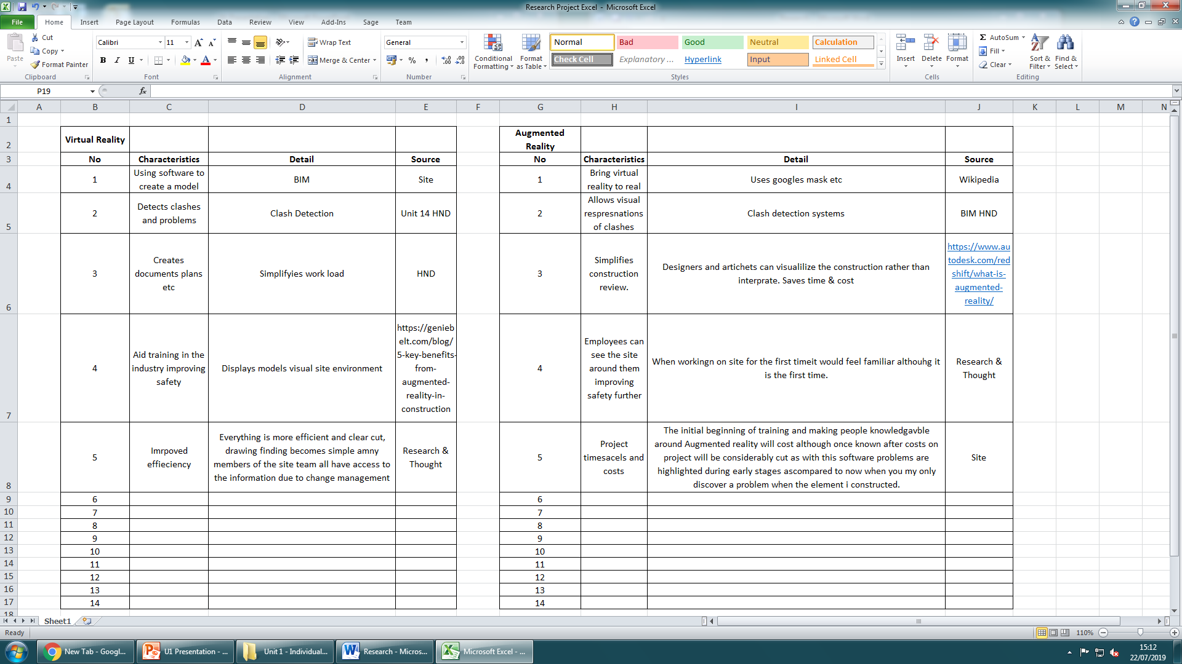
  - Analysis of the data
Thirteen of the twenty people that conducted the questionnaire voted that Augmented and virtual reality can aid construction which results in a majority vote. Then when I analysed the data further of the twenty people theseve individuals that were to not support AR & VR were mostly of a greater age than the rest, through this I discovered a direct link between views on the subject and age, although I feel this is only present due to the high average age in construction of which of decreasing each year due to more opportunity within the sector for younger people to work. I feel that each year it can be considered that both VR & VR will be more widely supported within construction as times are changing and these newer technologies can hopefully significantly aid the indistury. The split opinions on the usage of AR and VR and how it can benefit the industry, seven of the 20 people all voted that health and safety would be the greatest aspect where AR & VR can be used. In my opinion this highlights that Health and Safety within construction is overlooked despite all of the precautions currently set in palce. When the individuals were asked about the usage of AR and VR in an M&E context, 5 people said it would be the most beneficial. I further questioned them on their opinions and had very similar answers across the board. To summarise, everyone most in favour of AR and VR for M&E works all said it would be greatly beneficial due to the high chances of getting M&E works wrong. As M&E is often a massive aspect of a project (Often worth up to 30% alone) there is a lot that has the possibility to go wrong. These opinions have come from designers, BIM experts and M&E managers with everyone sharing similar on site issues that AR and VR could really assist in limiting.
  - Questionnaire
I created the questionnaire to further enhance my research and gather a stronger understanding of my colleague’s views and opinions on the the usage of new technologies withing the industry.. The questionnaire I created presented three different questions with different answers usually in an A. B. C. answer format, firstly the question was asked if they thought AR & VR could benefit the construction industry, this simple yet effective question will instantly give us an insight of peoples thoughts before getting more information on why they are for or against it.
Secondly, I questioned the areas in which both pieces of technology can be used within the industry
- Health and safety
- M&E accuracy
- Other
Lastly, I questioned if my colleagues were knowledgeable around the field of vAR and VR and if they have had any previous experience with these technologies already. By receiving answers to each of these questions it allowed me to fully review my findings allowing me to justify any views I previously collected. This further assisted my initial findings of the links between job titles and views or age.
My results allowed me to highlight health and safety and M&E assistance as the main areas AR & VR can benefit the industry.
- Implications to construction

  - Virtual Reality
Virtual reality represents the future of emerging construction technologies within the industry, through many different methods VR is revolutionizing the current industry applications in ways such as scaling, efficient collaboration and effective client project visuals through use of BIMs 3D CAD modelling.
Virtual realist can be experienced and used both on or off site have and have two different sections of compatibility which are either non-immersive described as operating software in an office through a table or desktop with system unit. The other usage of virtual realityis the higher level is classed as immersive which entails collaboration with the usage of head mounted displays similar to glasses or goggles (HMD) such as devices like Oculus Rift or Samsung Gear VR. Google.com. (2019). bim virtual reality - Google Search. [online]
The collaboration and addition of the CDE (Common data environment) assists in virtual reality to aid the industry as it allows clear visualization of a project before the construction phase begins to a fully finished project almost instntly, this allows for site teams to share so all parties can suggest new ideas and discuss different views and question ideas together without having to meet on site which can become a slight issue if the project is complicated, often there is never a real chance to get every competent individual in for a discussion as people are often working on different projects and are based everywhere.
Another area in which VR is increasing in population is not only amongst only main and sub contractual teams but client’s teams and consultancy teams. Customer/client personal visuals VR is able to provide to the client long before the team even arrive on site, benefits of this include both time and money savings for the main contractor and client due to decreased rework and by giving the client the ability to raise any queries and re consider or plan any changes before site teams arrive.
All the methods in which VR aids construction it also helps further relationships with client and contractor as visual models create a more persuading aspect of what we will constructed where as previously the client would be reliant on the contractor based purely on 2D drawings with little detail of the final build. ’By improving scalability, streamlining collaboration, and upgrading the customer experience, VR helps construction companies tackle old and new problems to create a more profitable and satisfying construction experience.’ Sharifi, S. (2019). 3 Ways Virtual Reality in Construction is Shaping the Industry. [online] Connect.bim360.autodesk.com.

  - Augmented Reality
‘Augmented reality (AR) is an interactive experience of a real-world environment where the objects that reside in the real-world are enhanced by computer-generated perceptual information, sometimes across multiple sensory modalities, including visual, auditory, haptic, somatosensory and olfactory. The overlaid sensory information can be constructive (i.e. additive to the natural environment), or destructive (i.e. masking of the natural environment). This experience is seamlessly interwoven with the physical world such that it is perceived as an immersive aspect of the real environment. In this way, augmented reality alters one's ongoing perception of a real-world environment, whereas virtual reality completely replaces the user's real-world environment with a simulated one. Augmented reality is related to two largely synonymous terms: mixed reality and computer-mediated reality.’En.wikipedia.org. (2019). Augmented reality. [online]
Although AR & VR working almost perfectly together leading them to often be confused with one another they are actually two different technologies. Despite this they are often linked together through other technologies the major one being design stages of construction. The design stage is essential as it results in efficient or an inefficient construction of a building project due to importance of adequate design in construction. Computer software’s such as BIM can overlay virtual reality with augmented reality by incorporating the 3D modelling of virtual reality into real life projecting the information written into BIM on top of the information virtual reality already provides, augmented reality can also project this information onto any location of the project or simply projecting it onto a wall in a meeting room to allow for multiple professionals and experts to collaboratively share views and opinions to improve the design resulting in numerous expertise to benefit the ease of construction once there is a start on site leading in a significant decrease of rework during construction.
Again, differently to virtual reality augmented reality’s objective through its construction applications is to create a much more efficient and vivid view of the built that is imitated otherwise in a drawing or model, each individual pieces of a build every material layer and specifics of the installations such as tolerances and sizes form and positions. To allow this as mentioned previously virtual holograms and 3D plans even the ability to allow viewing of virtual videos displaying he site can all be used to aid project understanding and efficient execution of the project build from start to finish as AR can be used for visualizing positioning of services etc. Without the need to remove ceilings, walls, movable furniture etc.Arch Daily. (2019). 9 Augmented Reality Technologies for Architecture and Construction. [online]

6.0 References
https://www.flowforma.com/blog/5-key-trends-for-digitalization-in-the-construction-industry

Available at: https://medium.com/autodesk-university/the-modern-bim-manager-human-machine-or-team-7b8724f56f8c
Available at: https://www.rlf.org.uk/resources/what-is-a-literature-review/
Support.daqri.com. (2019). DAQRI Support. [https://support.daqri.com/#!/content/features
Available at: https://daqri.com/worksense/
Available at: https://www.designingbuildings.co.uk/wiki/Common_data_environment_CDE
Available at: https://connect.bim360.autodesk.com/virtual-reality-in-construction [
Available at: https://en.wikipedia.org/wiki/Augmented_reality
Available at: https://www.thebalancesmb.com/building-information-modeling-bim-benefits-845045
Available at: https://www.google.com/search?rlz=1C1GGRV_enGB769GB770&ei=7IhZXcWYM7yM1fAPyICsoA8&q=bim+virtual+reality&oq=bim+virtual+reality&gs_l=psy-ab.3...74728.83431..83702...0.2..0.109.1121.14j1......0....1..gws-wiz.......0i71j0i67j0j0i22i30j0i22i10i30..11%3A1j12%3A8j13%3A0.kQ-3L2h2gYA&ved=0ahUKEwjFvr-M94zkAhU8RhUIHUgAC_QQ4dUDCAo&uact=5
Available at: https://www.archdaily.com/914501/9-augmented-reality-technologies-for-architecture-and-construction

