Cameron Davies P150422
university TriniTy Saint David
gROUP working reflective essay

Contents
1.0 Introduction 2
2.0 Main Body 3
2.1 Current Quote System 3
2.2 Glass Industry Overview 4
2.3 Digital Age 5
2.4 Prince 2 5
2.5 Risks 6
2.6 Forming the Team 7
2.7 Actions within the Project 7
3.0 Conclusion 10
4.0 Bibliography 11

1.0 Introduction
Wall Colmonoy (2019), is a materials focused engineering company, engaged in the manufacturing of Colmonoy surfacing and nicrobraze brazing products, precision castings, coatings, and engineered components, across aerospace, automotive, glass container, oil & gas, mining, energy and other industrial sectors.
It has been identified during a meeting with senior management and the board of directors that improvements are required to reduce the turnaround time with quotations. This objective is primarily focused at customers within the glass industry. The quoting into this sector has proven to be too slow which is impacting on business performance and, customers being lost due to a lack of efficiency and lead-times.
A project instigated to identify causes for this slow turn-time and provide a solution to the problem, and I was selected to be project manager. The first step was to formulate a team with all relevant stakeholders to support the project. Within this reflective report of the project the following subjects will be covered; the current quoting system, an overview of the glass industry, a look into the digital age and why Wall Colomony (WCL) will need to adapt with it, the forming and actions of the team, the reflection after the project was complete and finally a conclusion as to whether or not the quoting system has now been improved, and if any changes are needed.
The reason a team is needed to complete a project according to McPheat (2019), is a team bring “new and different skills to the table”, and can work together in a “synergetic, energetic and creative manner” which will be useful in finding an “innovation for the change” within quoting. These following reasons stated by McPheat illustrate why creating a team when starting a project is useful, as they will help the project progress, grow and have the right path to be successful. Gleeson (2019), states that having a cross-functional team, where different departments employees come together to “pursue a common goal”. The practical benefits of having a cross-functional team are they provide “new talent for hierarchical management”, which moves the company “forward at a faster pace”.

2.0 Main Body

2.1 Current Quote System
The current process for generating a quotation is an enquiry is received from a customer, the quoting team will then, use multiple databases and spreadsheets to log and calculate, how much the component will cost to manufacture. Following costing being completed, an appropriate gross margin is included to produce a price for the customer. The team then respond back to the customer with a quotation. There are inherent problems with this due to the system being antiquated and slow. As there are a number of customers requiring quotes and not enough workforce, resources and time to respond to all of them quickly. 50-60% of quotes are turned around within 24 hours, meaning 40-50% of the customers will take longer to get a quote which can result in WCL losing a competitive advantage and customers will look elsewhere. This is the main reason that senior management within Wall Colmonoy demanded change and progress on quoting.
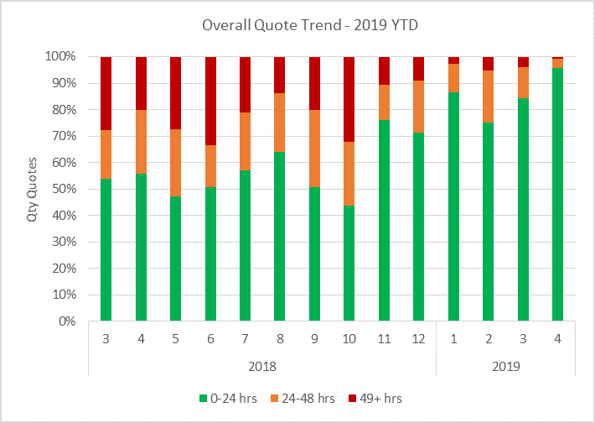
The above graph shows the quote trend over the last working year of WCL. It shows on average in the past year, 35% of quotations are not being completed which loses customers. The gradual increase in percentage of successful quotations being sent out, is due to the increased man power that is being sacrificed to improve the situation. This does have the disadvantage of increasing the labour cost to achieve this. If three individuals are quoting all shift every day, which is often the case within WCL then it will cost £84,240 annually on labour cost just for the workforce to respond to quotations. The time and money could be used more effectively should a solution arise.
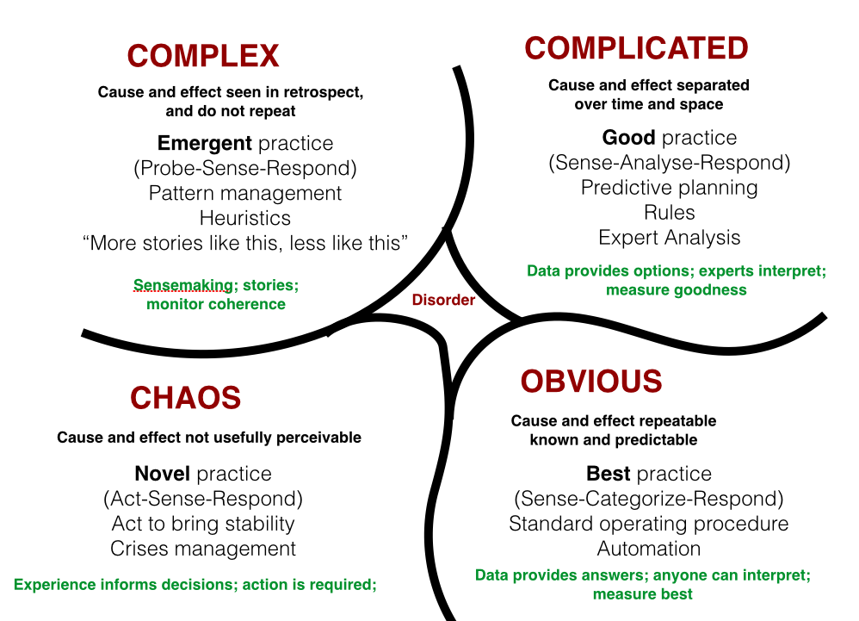
Mind Tools (2019
David Snowden is a scholar who came up with a framework that could be used as a “problem solving tool”, to help a company identify what of the “5 different types” of problematic “environments” their business is in. Looking into the environment Wall Colomony’s quoting system is in using Cynefin’s Framework, it can be argued the company quoting is “Complicated” due to the cause and effect of the slow quoting, mainly due to the outdated system and software.
A problem solving approach I identified was to use the “5 whys”, which possibly could be used to help solve the quoting issue. The steps of the “5 Whys” framework are as followed;
- Create a team
- Identify the problem
- Ask the first why
- Ask why four more times
- Understand when all problems have been identified
- Address the problems
- Monitor the actions made

2.2 Glass Industry Overview
The glass industry produces “sheet glass, optical glass, glass fiber, household glassware, glass containers, various glass items and materials, and the glass used in construction, illuminating engineering, and electrical engineering”. Within Wall Colmonoy, the quoting team will bid in the glass industry for work through auction sites, where they will be competitive with their competitors. The problem however is the slow turnaround in quotes back to the customers, with the outdated technology, limited workforce and time, holding back the company.

2.3 Digital Age
IGI Global (2019) states, the digital age is the time in history that the use of “digital technology” became prevalent and of common use “throughout the world”. The digital age began in earnest with the “widespread use of the Internet”. It is an interconnected world, with a vast amount of data that works at a fast pace. Wall Cololmony will need to adapt to this age, or they will be left behind, as the quoting system is predominantly a technology problem. A way that Wall Colomony can embrace this is to create a website for their customers, where they can benefit through the use of the internet and not have to worry about antiquated software.

2.4 Prince 2
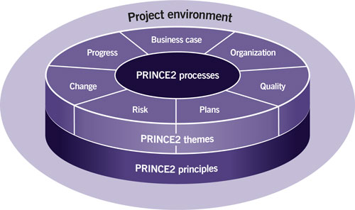
Axelos (2019)
When starting the plan, I identified the Prince2 model an ideal method to use when working through the project due to its efficient structure. Tech Target (2019) states, Prince2 is a project management methodology “developed by the government of the UK” and used internationally, “especially in information technology IT environments”. PRINCE2 makes use of the best proven practices from a “variety of industries and backgrounds”. The following are steps of Prince2, that we followed when undertaking this project;
- Plan (Looking into timing, activity scheduling, process streaming and risk analysis)
- Outline plan of action
- Direct the team members as to what roles they will be doing
- Initiate the plan
- Control the stages ensuring all tasks are completed up to date
- Manage the stages throughout the project
- Product delivery ensure the software is efficient and correct
- Closing where a review will be made and once approved by the senior managers, the project will be closed

Risks
When starting a new project there could always be the potential for different risks, it is the duty of the entire project team to ensure they are identified and resolved as soon as possible. The advancement of technology shows that WCL is adapting to the current digital age, and in implementing that into the new quoting system it shows the company is growing, but not all companies are the same.
Risk | Effect | Action to Minimise Risk
Customers may not be used to change | Some customers could reject the change as it is unfamiliar to them and something they do not fully understand, this could mean losing potential customers. | WCL promoted the new website so that customers and other companies can understand the vison that we are setting to ensure no customers are lost. Training guides can also be provided.
Cost | Although money will be saved in the long term if the project succeeds, in the short-term a lot of money has been invested, which will have been wasted should the project fail. | WCL will confirm that the team make all the necessary steps to ensure that the project does not fail, following the correct objectives and procedures through to completion.
Cyber Crime as customer details could become exposed or corrupt | Private customer details will be on a website, which could be corrupt or lost. | To privatise and secure the website so that customers can only use the website if they have been invited.
Time wasted | Time could be wasted which again relates to effecting the cost. As this is a big project that requires the workforce to spend a lot of time to make the website, which could be wasted should the project fail. | WCL can ensure that the team make all the necessary steps to ensure that the project does not fail and time is not wasted, by following all correct objectives and procedures through to completion.

2.6 Forming the Team
As project manager, I selected team members that I felt could carry out my vison, and could essentially support and improve the quoting system within the glass industry.
Team Members: | Responsibilities within project:
Cameron Davies (Team Leader) | To create a structured plan (taking into account timing, resources, risk assessments and cost)  Assign roles for the different team members ensuring that all task were done correctly and on time  Monitor progress of project, ensuring it remains on task
Declan Bale (Components Estimator) | To design prototype glass components in Autodesk Inventor. Which through the use of iLogic and a Website, the customers will be able to access
Michael Shreeve (Senior Process & Commercial Engineer) | To find an external supplier who can create the website that customers will be able to access, in a way to improve quoting
Kaine Angus (Castings Apprentice Engineer) | To ensure that all Gantt charts, data and timetables are up to date
Luke Davies (Quality Technician) | To ensure that all standards are met, and that the project is running appropriately
Darren Morris (Components Estimator) | Being someone who is part of old quoting team for glass industry, Darren will test out the new website to ensure it works efficiently

2.7 Actions within the Project
The first thing I did was look into available technology that I thought could help innovate the quoting system. After researching I found an application on the software Autodesk Inventor called iLogic. iLogic can be used to automatically generate a part, by simply adding in the dimension values. The goal would be for a customer to apply this process, adding in the different part and dimensions required, and in response a quote would be produced.
iLogic can be used to enable”rules-driven design, providing a simple way to capture and reuse work”. Also used “to standardize and automate design processes and configure virtual products”. As this function is part of Autodesk Inventor, it would cost no extra money which is a motivator for using it, as it saves money of finding a new system, as well as time of needing to find a similar process.
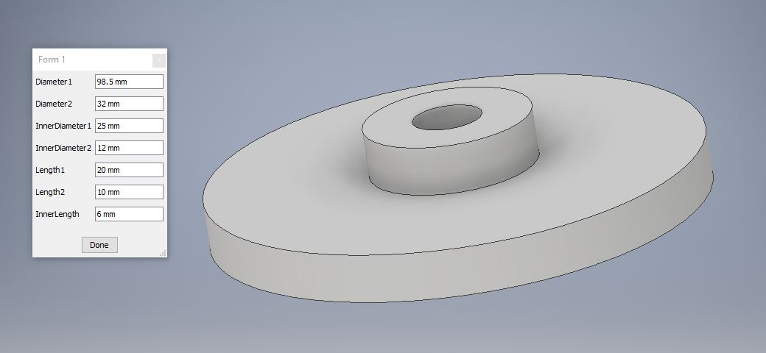
Above is a Guide Plate, which is an example of one of the different glass components that we sell, and shows how the system would work. The customer would type the figures in the table on the left of the image, then the part on the right would be generated.
Once this application was researched and analysed, I gave Declan the role to create template models for all glass components due to his experience and quality on Inventor. I then asked Michael if he could find a way of adding this iLogic function into a website so that customers could access it. Michael after researching found an external supplier who could help us achieve this. We called him in for a meeting and clarified that he could help create our customer based website. After looking into other options and comparing the costs, it was decided we would go with this external supplier, and after having the project costs signed off by senior management we asked the supplier to create the website. Throughout this project I tasked Kaine to keep Gantt charts with project progress, data and timetables up to date to make sure we all were aware of our progress and whether or not any deadlines needed to be met. Luke was tasked to ensure that all standards are met, and that the project is running appropriately and orderly.
Once the website was made, I trialled its ability with one of the estimating team. At first there was a problem with the individual accepting the change of system, due to familiarity and habit of the old process. Upon reflection, this links to the Kubler-Ross model as it shows the individual progressing from denial of no longer doing the old process, too frustration and depression of having to learn a new way of quoting. I addressed this by showing him how much easier the website would be to use, and that it would benefit the entire company which helped him understand why the change was needed.

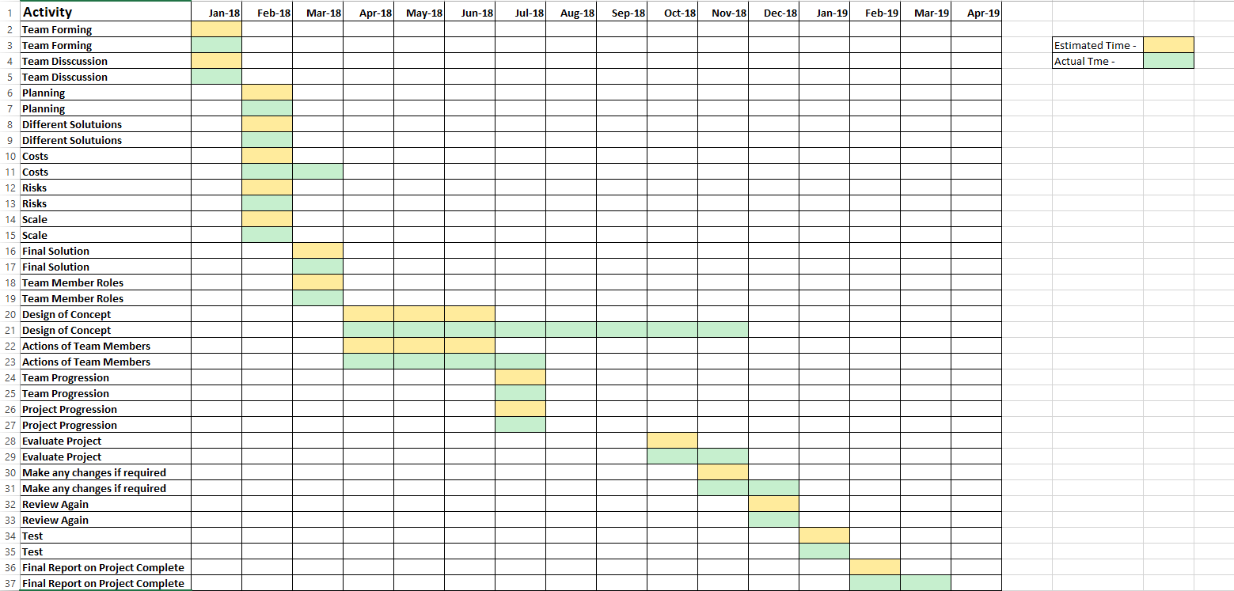
A Gantt chart was created and filled in by Kaine to show and monitor the progression of the project, as shown above .
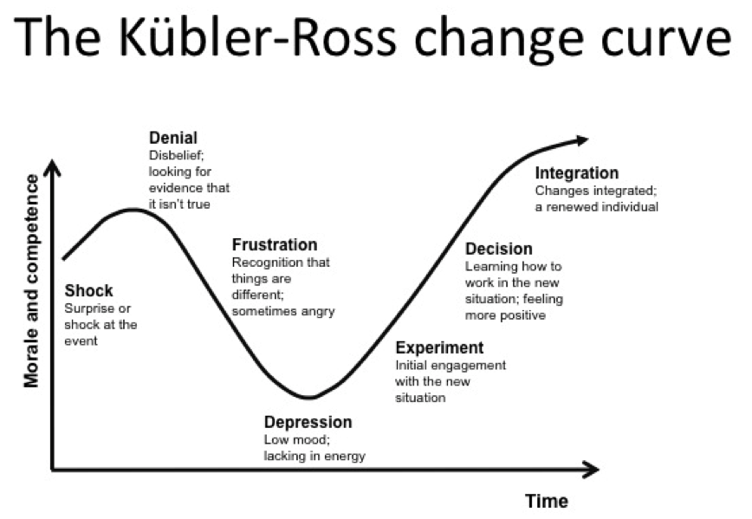
BP (2019)
I then went on to use PDCA (Plan-Do-Check-Act), which is a four stage model that is used “for continually improving processes, products or services, and for resolving problems”. I would look over any changes that needed to be made so that they could be addressed immediately. For example when the website was made, it was identified by Darren when trailing the website, any figure could be typed into the table to generate the parts, which would be deceiving the customers as we have limits of what part sizes we can make. I instructed Declan to change the iLogic rules to the glass template parts so that all of them had maximum and minimum vales so that we were only offering parts that we can make.

3.0 Conclusion
Due to antiquated systems and software 40-50% of customers received quotes back 24 hours after sending them to us. Which meant customers were lost, I was made project manager in order to address this problem.
The first task I set myself was to create a team. I ensured that I gave each member of the team a role that best suited them, and would always look into each member’s progression. Next I looked into creating a plan for how to structure the project, this was as followed; look into latest technology that could be used, identify multiple concepts, finalise which concept would be most effective, create the concept, review, make any changes, then finally review again.
The concept of creating a website that customers could access was decided. On this website there would be a function that could be used by the customer to simulate a glass part to generate a quote. This could be done using the iLogic function on Autodesk Inventor, rules could be created so that customers could add figures and features to a part that we could create. I instructed Michael to find an external supplier who could create this website and combine it with iLogic. I instructed Declan to create the template glass components on Inventor using iLogic, so that they could be put on the website for the customer to enquire.
After the website was created, a review was applied so that we could test and identify any problems or deficiencies. This is where the first problem was raised, as when testing the new system on Darren someone who was used to the old quoting system, he struggled to adapt to it. I showed him why it was a beneficial and easy process that could help the company to progress, and this gave Darren the understanding that this was a positive change.
The gateway of the project was connecting our company databases with the website for customers to access, so that we could not only help improve the quoting system but also keep a record of the customer trends in what different parts they are buying.
In conclusion after the new quoting system was innovated, it provided great benefits to the company. As it could respond to customers at a much faster and efficient way, it meant less customers were lost and the time of the workforce could be better utilised. If I was to do this project again I would look into how this website could be expanded and become more progressive, so that it could not only help the glass industry but also all of the other industries within WCL.

4.0 Bibliography
Wall Colmonoy (2019) ‘Who we are’ [Online] Available: https://www.wallcolmonoy.com/company-profile/who-we-are/
Management Training Specialsts (2019) ‘Why build a Team’ [Online] Available: https://www.mtdtraining.com/blog/why-build-a-team.htm
Chang, R. (1995). Building a dynamic team : A practical guide to maximizing team performance (High performance team series). London: Kogan Page.
Chron (2019) ‘Strengths and Weaknesses of Cross Functional Teams’ [Online] Available: https://smallbusiness.chron.com/strengths-weaknesses-cross-functional-teams-24653.html
Automation Journal (2019) ‘Cynefin Framework’ [Online] Available: https://www.automationjournal.org/wp-content/uploads/2016/12/CynefinFrwk.png
Mind Tools (2019) ‘Cynefin Framework’ [Online] Available: https://www.mindtools.com/pages/article/cynefin-framework.htm
Puik, & Ceglarek. (2015). The Quality of a Design will not Exceed the Knowledge of its Designer; an Analysis Based on Axiomatic Information and the Cynefin Framework. Procedia CIRP, 34(C), 19-24.
Mind Tools (2019) ‘5 Whys’ [Online] Available: https://www.mindtools.com/pages/article/newTMC_5W.htm
The Free Dictionary (2019) ‘Glass Industry’ [Online] Available: https://encyclopedia2.thefreedictionary.com/Glass+Industry
IGI Global (2019) ‘Digital Age’ [Online] Available: https://www.igi-global.com/dictionary/engaging-adult-learners-innovative-technologies/7562
Adi, Grigore, Crowther, Adi, Ana, Grigore, Georgiana, Crowther, David, & Social Responsibility Research Network. (2015). Corporate social responsibility in the digital age (First ed., Developments in corporate governance and responsibility ; Volume 7).
Axelos (2019) ‘Prince2’ [Online] Available: https://www.axelos.com/Corporate/media/Images/Product%20Images/Figure-1-1-500x296.jpg
Steffey, J. (2017). Prince[2]. Broken Pencil, (77), 40.
Bentley, C. (2002). Prince 2 : A practical handbook (2nd ed., Computer weekly professional series). Oxford: Butterworth-Heinemann.
Tech Target (2019) ‘Prince2’ [Online] Available: https://whatis.techtarget.com/definition/PRINCE2
AutoDesk (2019) ‘iLogic’ [Online] Available: https://knowledge.autodesk.com/support/inventor-products/learn-explore/caas/CloudHelp/cloudhelp/2014/ENU/Inventor/files/GUID-B98DF82D-E489-4C19-8351-11C0ED63C349-htm.html
BP (2019) ‘The Change Curve’ [Online] Available: https://1.bp.blogspot.com/-TSFGgB5NBuI/Uwbp5sDom_I/AAAAAAAACb8/TM_25AlyLV4/s1600/The-Change-Curve.png
Kearney, K., Hyle, Adrienne, Mathers, Judith, Harris, Edward, & Bull, Kay. (2002). Study of the Emotional Effects on Employees Who Remain Through Organizational Change: A View Through Kubler-ross (1969) in an Educational Institution.
Mind Tools (2019) ‘PDCA’ [Online] Available: https://www.mindtools.com/pages/article/newPPM_89.htm
Arturo Realyvásquez-Vargas, Karina Cecilia Arredondo-Soto, Teresa Carrillo-Gutiérrez, & Gustavo Ravelo. (2018). Applying the Plan-Do-Check-Act (PDCA) Cycle to Reduce the Defects in the Manufacturing Industry. A Case Study. Applied Sciences, 8(11), 2181.

