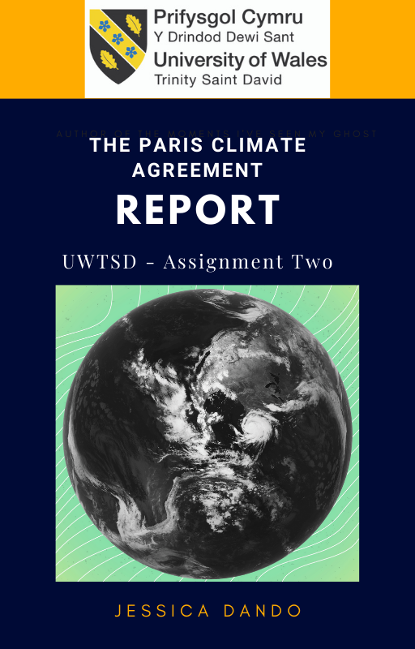

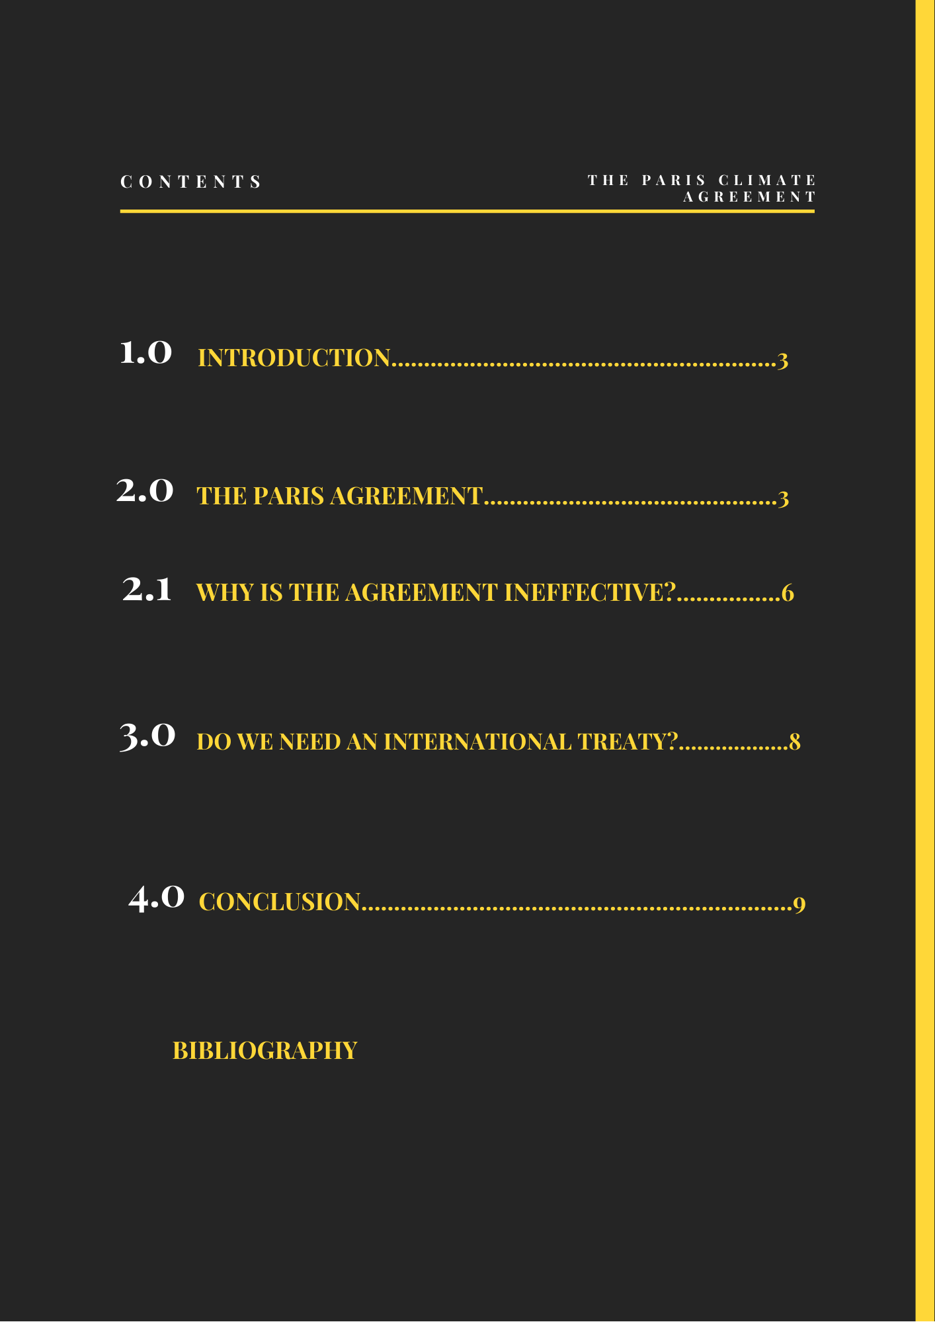

Introduction

Climate change is currently a real and very serious threat facing our world today. Not only are we excavating and burning fossil fuels at an alarming rate, UNEP (2018) has reported that production of fossil fuels is estimated to increase by over 2 per cent per year. We are also cutting down forests at a rate measuring the area of the UK every year, which removes the earth’s capacity to naturally remove carbon from the air in the form of carbon sinks. (Cockburn, 2020; IPCC, 2018)

Global temperatures have already risen over 1 degree Celsius above pre-industrial levels, and this has resulted in extreme conditions of weather around the world. 30 hurricanes have occurred in the last year, wildfires have decimated areas in Australia and America, the Arctic is melting fast, and Siberia has seen more and more heatwaves. (UN, 2020)

In 2016, according to (EPA.gov) emissions were calculated to be at a level around 50 billion tonnes, by 2019 this had risen to 55 tonnes. The UN environment programme (UNEP, 2018) has announced the reduction of emissions throughout lockdowns at a rate of 17 per cent, but the fact that most remained untouched is proof that there is so much more work to be done to reduce emissions to an acceptable rate.

If the Climate Change and Global Warming issue is not addressed, then (Leah, 2019; Ediboglu, 2018; Brenton, 2013) estimate that the planet will not only be left with unlivable areas, rising sea levels and a scarcity of food and water but economically - billions will be lost, as well as over 250,000 lives between 2030 and 2050 (World Health Organization, 2015; 2018)

Over the last 50 years, several attempts have been made to bring the world together to address the issue of climate change, (Warne,2019) most have been unsuccessful at varying degrees.

This report will identify issues that relate to the most recent agreement to tackle climate change - the Paris Accord, and argue that an agreement like this may do more to hinder than help the cause.

The Paris Agreement

Globally in 2015, it was the warmest winter on record. A World Band/Potsdam report (2012) suggests a disaster will ensue if the world were to reach the 4 degrees Celsius above pre-industrial levels predicted to happen. (IPCC, 2018; Clemecon, 2016)

On the 12th of December 2015, 196 parties met in Paris and agreed to a legally binding international Climate Change treaty, with a goal to limit Global Warming to well below 2 degrees pre-industrial levels, and ideally 1.5 degrees. (Preston, 2021; Roberts, 2019;) To reach this ambitious goal, countries would aim to reach a level of greenhouse Gases as soon as possible, with an aim to achieve a climate neutral situation worldwide by the middle of the century. (ccc.org)

Many people have seen the Paris Agreement as a great success, as for the first time a legally binding agreement that brought all nations together against a common cause had finally been created. Working on a cycle of five-year climate action carried out by the 196 countries. (Plumer et al, 2018; Ross, 2021) All countries would submit plans for climate action by putting forward their Nationally determine contributions (NDCs) They communicated what they would do to as a country to reduce their Greenhouse gases and communicate what they will do to assist with the countries who would be most seriously impacted by climate change and plans to adapt to global warming in general. (Harvey, 2020)

First, it is necessary to look at what countries are doing to address this, what impact these pledges have had a few years on and then to identify three ways in which the plan so far has been effective.

The US to begin with, initially pledged to reduce their GHG’s by 26 to 28%. This was over a 16 per cent reduction compared to levels in 1990. (Pledges and targets – USA)
Predominantly, America’s plans for the reductions stemmed from a shift from coal-fired power plants and fossil fuels to renewable energy technology. Rather than the 26-28 per cent reduction in GHG’s this has risen. The United States has a history with failing to commit to addressing Climate change. (Ibid)

After Trump left the agreement reducing a three-year process of withdrawal to one day, Biden’s administration was quick to reassure the world that they were still wanting to be a part of the agreement. (Lubber, 2020) The ‘We are still in’ coalition, made up of US representatives from 50 states committed to action on climate change, have expressed that they are still willing to bring their emissions below 2 degrees pre-industrial levels and to support the Paris accord working with the other countries to meet the requirements to combat climate change. (Americaspledgeonclimate.com)

China

China’s pledge was to reduce energy intensity by four per cent a year, as opposed to the three per cent pledged previously (Carrato, 2015) Although the pledge did not identify how they were necessarily going to reach that reduction (Westphal et al, 2015) Their NDC doesn’t go into detail about how they will evaluate the pledge, making it seem like an empty promise with no real plans to back it up.

India

India was not very ambitious in their plans; they had declared in the past that they would reduce the intensity of their emissions by 1.65 tonnes.(Hurst et al, 2020) Even though India are seen as a developing country, they are now the third biggest emitter. (Ibid) They refuse to give an emissions reduction target and are still using the same justifications prevalent within the Kyoto protocol where they feel as a developing country, they should not be subject to the same NDCs or pledges as other developed countries. Extreme weather conditions have hit India much harder than other countries, (Dubash, 2012) and they have now, since 2020 offered to improve the carbon intensity and invest in renewable energy, despite making very little in the way of pledges, they have requested financial assistance to allow them to invest in more renewable energy and shelve plans for more coal plants. (Ibid)

The EU

The EU’s NDC contains an emissions target of at least 40 per cent below pre-industrial levels by 2030 (UNFCCC, 2015) Several recent studies have seen the achievement of a 65 per cent reduction target for Europe is achievable (Climact, 2020; Consortium, 2020; DIW, 2020)

Graphics Ross (2021)

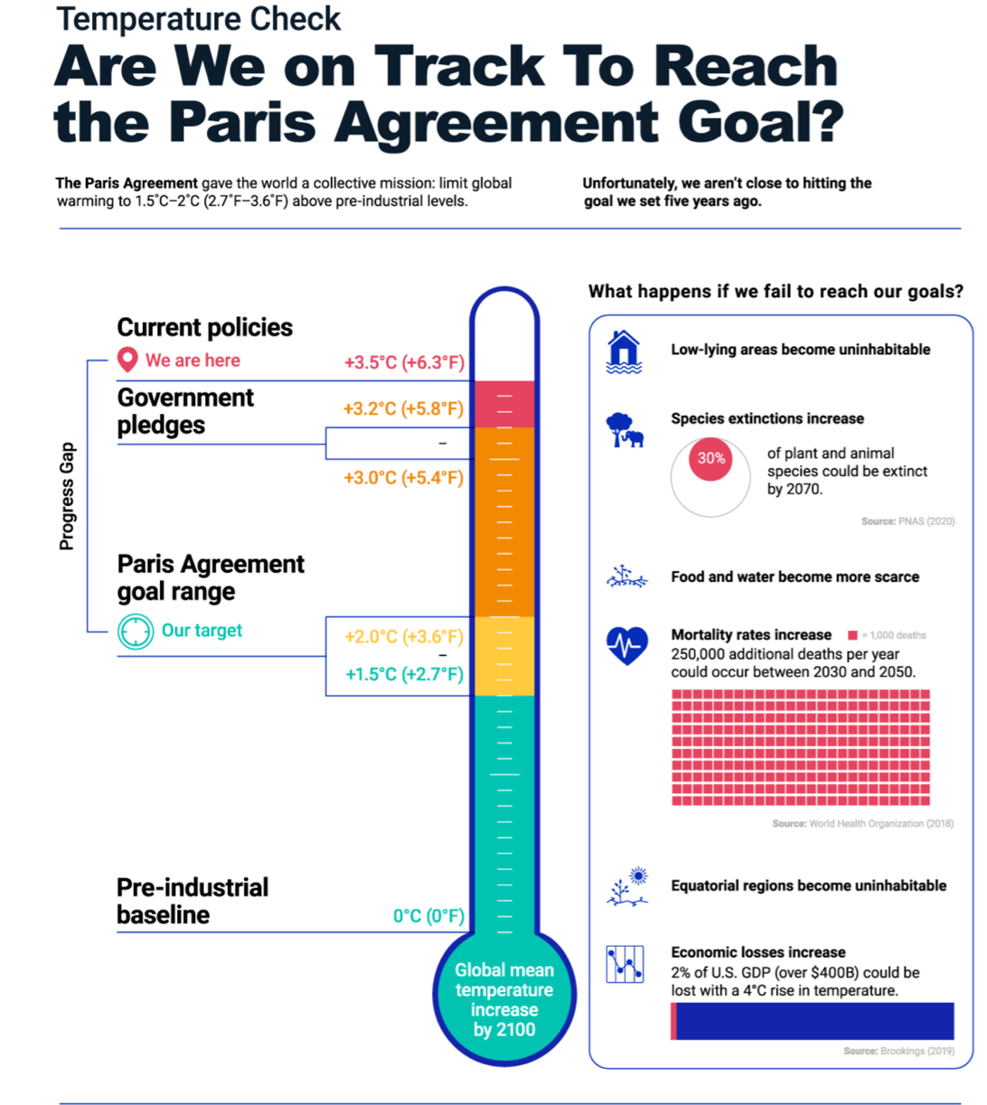

Tracking Our Progress
To date, signing nations are not close to hitting the goal set five years ago.
Scenario | Global Mean Temperature Increase by 2100
Pre-industrial baseline | 0℃ (0℉)
Paris Agreement goal range | 1.5-2.0℃ (2.7-3.6℉)
Government pledges | 3.0-3.2℃ (5.4-5.8℉)
Current policies | 3.5℃ (6.3℉)

Why is the Paris Agreement ineffective?

There are several reasons why the Paris Agreement seems to look much better on paper, than it is.

Firstly, The NDCs pledged in the agreement are seen to be recycled failed bottom-up approach created by the Copenhagen accord, and the Cancun agreement (Falkner, 2016; Savaresi, 2016) Many see the agreement as false hope to many who believe by forming the agreement, we are going to see solid results that will prevent the level of catastrophe that has been predicted by scientists, therefore creating a false sense of security and restricting real action worthy of such threat. (Ibid)

According to (Savreski, 2016; Allen, 2019) NGOs have legitimized the agreement despite being aware of its shortcomings, with developing countries citing the agreement as a ‘resounding triumph of multilateralism’ UNFCCC seemed to use it to save themselves form another failure, still requiring the positive Publicity needed after failing at Copenhagen. Criticisms about how the agreement fails to adequately address the situation at hand are numerous, some of these include the exclusion of liability; the inability to address loss and damage and no real commitment to pursue a 1.5-degree commitment (Binaz, 2016)

According to Gustin (2019) Most countries are not cutting emissions quickly enough and the NDCs are insufficient. In a report by the IPCC, (2018) at least two thirds of the pledges were unlikely to reach the climate targets. The report is compiled by scientists that have been involved in the panel on climate change. They found the GHGs need to be reduce by over 50 per cent by 2030 and then reach net zero by mid-century, although the targets set out by the agreement seek to do that, most of the pledges do not represent any realistic way of achieving this. The Universal Ecological fund (2021) published a report that analysed the pledges of the 184 countries that signed up to the Paris Agreement, assessed the commitments made and found only 36 countries made pledges that could reach goal set out by the IPCC. The rest are also not likely to be reached.

Eyre et al (2019) argue that a transition to a system that can replace our reliance on fossil duels will require massive societal and technological adjustments. Allen, (2019) if the current NDCs are to be applied, with the failings attached, then by the second half of the century the Pacific islands will no longer exist.

Even though there are legal implications regarding whether the NDCs are legitimized, and rules set out to encourage those who have submitted to follow through, there are no set punitive measures for those who fail or for those who leave the agreement, such as when Trump exited the agreement in (Young, 2016) the agreement is too loose, too voluntary. Countries can continue to pollute and burn fossil fuels without having to suffer negative consequences, there is no body to regulate them or sanctions, carbon taxes or fines. (Ibid)

In Copenhagen in 2009, developed countries committed to providing over one hundred billion in financial support for developing countries to assist them with developing measures and renewable energy technology.(Kuebler, 2020) A report by the Organization for Economic Co-operation and development found that 62 billion in finance for climate action was committed by developed countries and banks towards the goal (OECD, 2015) many criticize the report as exaggerating actual financial assistance. The Paris accord has been criticized for not addressing the issue of finance in enough detail or without seriousness to address issues such as wealth inequality; disaster mitigation and management and the funding of developing countries, some of which have now lost funding post-COVID-19, with the UK withdrawing funding to concentrate of rebuilding the economy (gwpf.com)

Many have criticized the Paris agreement for not addressing the worldwide reliance on fossil fuels to drive the growth of the economy or being realistic with their goals and good intentions. MIT’s program on the Science and policy of global change (1991) calculates that by the end of the century the improvements will only be 0.2 degrees Celsius. Comparing this to IPCC projections, (IPCC,2018) shows that there will be no improvement, despite the good intentions laid out by the Paris Accord, this does not bode well in actual terms. China is offering to reduce their emissions around 2030, but the Lawrence Berkley national laboratory predicted emissions would peak around 2030, and a Bloomberg analysis showed China’s projected targets were less ambitious than the level it would reach without doing anything to change their current level of activity. (Cass, 2015)

The system of voluntary pledges and unenforceable loose promises by countries signed up to the Paris agreement is not anywhere near serious enough to address what is a very real and very serious issue the world now faces; repercussions will be felt by the poorest of countries. The Paris accord has brought many countries together to acknowledge the issue of Climate change, but has fallen short in many areas, which have been described above.

2.0. Do we need an international treaty to solve climate change?

The only way that the agreement would work, is if major adjustments are made to the way it is laid out, and certain additional requirements were added. We need a solution for climate change that is real, tangible and can be implemented fast, the only way this will be effective in the form of a treaty would be if the following adjustments were made to make the Paris accord, making the treaty an enforceable, legally binding agreement that forces countries to find and maintain a solution.

Firstly, a carbon tax makes the most sense when enforcing targets for emissions. Economists; businesses; governments; NGOs and international organizations such as the world band and the OECD, are suggesting that carbon pricing would be the most efficient way to facilitate the transition to a low carbon economy (Okonkwo, 2017) Putting a price on carbon increases the perceived value of a sustainable future, and the incentives to invest in renewable energy, and nothing talks louder than money to corporations and countries that have so far seen little incentive to reduce their emissions, to the point where initial investments are needed to make these changes. (ibid)

The EU emissions trading system is a prime example of how this type of thing can be used to reduce GHGs in a way that is cost effective. (eciu.net) Carbon pricing has been a great success in Europe, where it has seen reductions in the use of coal used for power, leading to an 8.3 % drop in emissions. The introduction of the scheme in China will hopefully see further increases. Carbon offset trading will be a key talking point in the COP26 talks and is an important aspect to be focused on when improving the Paris agreement. (Ibid)

Putting a price on carbon, or even an added tax, could be a powerful tool with more governments implementing this, According to Carbon Market Watch, (2017) the design of effective carbon pricing should be informed by input from society and NGOs. Sweden has already priced carbon and brought in a tax for carbon in 1991. The EU established a cap-and-trade system in 2008. (ibid) Many other countries have put a price on carbon, but to incorporate this within the agreement and get firm commitment from other countries to implement this, would be an effective and worthy upgrade of the agreement and make it more worthwhile. (Stern, 2018; Luther-Jones et al, 2019)

Another aspect of the agreement that would make the accord more effective overall would be to decide on enforceable sanctions that would make the agreement enforceable. There are provisions that can be made in international law to gain approval of all participating countries to agree to the requirements of the agreement. This could mean a parliamentary vote and may require legislation or an act which could be implemented. Once the agreement has been legislated, countries could deposit instruments of ratification with the UN secretary general (Faulkner, 2016; Hermwill et al, 2017) This will then be the final requirement necessary to make the accord enforceable (Bodansky, 2016) Technology can be utilized to assist members with their commitments and the make sure that countries do stick to their pledges. (Bailey & Tomlinson, 2016)

Conclusion

There is no doubt that climate change is one of the biggest challenges the world has faced post-industrialization. Agreements have been attempted before, both in Copenhagen and Kyoto, but all have been a failure. (Cass, 2015) The Paris accord is seen as a successful treaty that has finally achieved what once seemed impossible. After reviewing the evidence, and the NDCs put forward by many developed and developing countries it has become obvious that a false sense of security seems to have been created, in which the agreement has been seen as a solution rather than just a start to the huge task of addressing climate change. Therefore, the opinion reached after much deliberation; is that unless the proposed changes to the agreement take place, enforcing legally binding pledges and accelerating the reduction of emissions, agreements like the Paris Accord are not serious enough to spur the kind of collective and serious action needed to quickly address the disaster that threatens our survival.

Bibiliography

Advances in Climate Change Research, Volume 8, Issue 4, Pages 213-219,ISSN 1674-9278,

Aldy, J., Pizer, W., Akimoto, K (2015), For a model on ‘organizing metrics on mitigation efforts’ cf. Comparing Emissions Mitigation Efforts across Countries.

Apparicio, S., & Sauer, N. (2020). Which countries have not ratified the Paris climate agreement?. https://www.climatechangenews.com/2020/08/13/countries-yet-ratify-paris-agreement/

Bairin, P., & Woodyatt, A. (2021). France not doing enough to tackle climate change, court rules - CNN. https://edition.cnn.com/2021/02/04/europe/paris-climate-inaction-court-intl-scli/index.html

Barrett, S. & Stavins, R., (2003), Increasing Participation and Compliance in International Climate Change Agreements, International Environmental Agreements: Politics, Law and Economics, Vol. 3, pp. 349–376

Beardsworth, R. (2020). Climate science, the politics of climate change and futures of IR. International Relations, 34(3), 374–390. https://doi.org/10.1177/0047117820946365

Beslik, S. (2019). 5 Reasons Why the Paris Agreement is a Joke (and How We Can Fix It). https://medium.com/in-search-of-leverage/5-reasons-why-the-paris-agreement-is-a-joke-and-how-we-can-fix-it-4b636409bb05

Bodansky., D., Day O’Connor, S (2015), The Durban Platform: Issues and Options for a 2015 Climate Agreement Center for Climate and Energy Solutions.

BORENSTEIN, S., & JORDANS, F. (2020). Five years on, signs that Paris climate accord is working. https://apnews.com/article/paris-europe-climate-climate-change-e005822b0c98b188736f623a1fcd4256

BORUNDA, A. (2020). The U.S. has officially left the Paris Agreement. What happens next?. https://www.nationalgeographic.com/environment/article/us-officially-left-paris-agreement-whats-next-climate

Boyle, L. (2021). What is the Paris Agreement and why has Biden rejoined the climate pact? | The Independent. https://www.independent.co.uk/climate-change/news/biden-paris-climate-agreement-what-is-b1790624.html

Brenton, A. Sir, (2013) Great Powers’ in climate politics, Climate Policy, 13:5, 541–546.

Brian J Preston, (2021) The Influence of the Paris Agreement on Climate Litigation: Legal Obligations and Norms (Part I), Journal of Environmental Law, Volume 33, Issue 1, Pages 1–32, https://doi.org/10.1093/jel/eqaa020

Caparrós, A. (2016). The Paris Agreement as a step backward to gain momentum: Lessons from and for theory. Revue d'économie politique, 3(3), 347-356. https://doi.org/10.3917/redp.263.0347

Cass, O. (2015). Why the Paris climate deal is meaningless – POLITICO. https://www.politico.eu/article/paris-climate-deal-is-meaningless-cop21-emissions-china-obama/

Chadwick, M. (2021). What is the Paris climate agreement and why does it matter? | Greenpeace UK. https://www.greenpeace.org.uk/news/what-is-paris-climate-agreement-and-why-does-it-matter/

Climate Action – United Nations Sustainable Development. https://www.un.org/sustainabledevelopment/climate-action/

Climate Change & the Paris Deal - Ethics Unwrapped. https://ethicsunwrapped.utexas.edu/case-study/climate-change-paris-deal

Clémençon, R. (2016). The Two Sides of the Paris Climate Agreement: Dismal Failure or Historic Breakthrough? The Journal of Environment & Development, 25(1), 3–24. https://doi.org/10.1177/1070496516631362

CNN, 2018, accessed on 30 December 2018

Cobbe, E. (2021). Paris court finds France guilty of failing to meet its own Paris climate accord commitments. https://www.cbsnews.com/news/paris-climate-agreement-france-court-government-guilty-failing-commitments/

Cockburn, H. (2020). Climate crisis: Failure to hit Paris agreement goals ‘could cost world $600 trillion’ | The Independent | The Independent. https://www.independent.co.uk/climate-change/news/climate-crisis-paris-agreement-economic-cost-study-university-beijing-a9466406.html

Cornwall, W. (2020). The Paris climate pact is 5 years old. Is it working. https://www.sciencemag.org/news/2020/12/paris-climate-pact-5-years-old-it-working

Dehm, J. (2018) Reflections on Paris: Thoughts towards a critical approach to climate law, Revue de droit international 1(1): 61-91

Denchak, M. (2021). Paris Climate Agreement: Everything You Need to Know | NRDC. https://www.nrdc.org/stories/paris-climate-agreement-everything-you-need-know
https://doi:10.1080/02646811.2016.1133983

Dundas, M. (2021). Paris court finds French state guilty in landmark lawsuit over climate inaction. https://www.france24.com/en/live-news/20210203-french-government-found-guilty-in-landmark-lawsuit-over-climate-inaction

Economics and Policy, Working Paper No. 222, available at https://www.lse.ac.uk/GranthamInstitute/wp-content/uploads/2015/ 07/Working-Paper-197-Falkner.pdf.

Ediboglu, E. (2018). Effectiveness Analysis of the United Nations Climate Change Regime | Blog | School of Law | The University of Aberdeen. https://www.abdn.ac.uk/law/blog/effectiveness-analysis-of-the-united-nations-climate-change-regime/

Even ‘climate progressive’ nations fall far short of Paris Agreement targets. (2020). https://www.manchester.ac.uk/discover/news/even-climate-progressive-nations-fall-far-short-of-paris-agreement-targets/

Falkner, R. (2015), A Minilateral Solution For Global Climate Change? On Bargaining Efficiency, Club Benefits And Inter- national Legitimacy, Centre for Climate Change

Greenberg, J. Fact-check: Does the Paris accord fail to hold China and India accountable?. https://eu.statesman.com/story/news/politics/politifact/2021/01/27/fact-check-paris-climate-agreement-easier-china-india-than-united-states/4276557001/

Grunbaum L, From Kyoto To Paris: How Bottom-Up Regulation Could Revitalise the UNFCCC, UCLA Journal of Environmental Law & Policy, Environmental Law Review Syndicate, 2015

Gupta, J., (2012) Negotiating Strategies and Climate Change, Climate Policy, 12 630–644.

Harvey, F. (2020). The Paris agreement five years on: is it strong enough to avert climate catastrophe? | Paris climate agreement | The Guardian. https://www.theguardian.com/environment/2020/dec/08/the-paris-agreement-five-years-on-is-it-strong-enough-to-avert-climate-catastrophe

Hirst, D. (2020). The history of global climate change negotiations. https://commonslibrary.parliament.uk/the-history-of-global-climate-change-negotiations/

Hovi J., et al (2015), The Club Approach: A Gateway to Effective Climate Cooperation?, Working Paper presented at isa 2015 convention, available at
http://www.bath.ac.uk/ipr/pdf/events/climate-change/Hovi.pdf
https://doi.org/10.1016/j.accre.2017.08.005.(https://www.sciencedirect.com/science/article/pii/S1674927817300849

Hurst, L. (2020). Climate change: Five years on from Paris Agreement, is Europe on track to hit the deal’s targets? | Euronews. https://www.euronews.com/2020/12/11/paris-climate-agreement-five-years-on-is-europe-on-track-to-hit-the-deal-s-targets

Intergovernmental Panel on Climate Change, Press Release, Summary for Policymakers of IPCC Special Report on Global Warming of 1.5°C 8 October 2018

Jen Iris Allan; (2019) Dangerous Incrementalism of the Paris Agreement. Global Environmental Politics 19 (1): 4–11. doi: https://doi.org/10.1162/glep_a_00488

Kerr, B. P. (2020). Clear skies or turbulence ahead? The international civil aviation organization’s obligation to mitigate climate change. Utrecht Law Review, 16(1), 101–116. DOI: http://doi.org/10.36633/ulr.551

Kilian Raiser et al 2020 Environ. Res. Lett. 15 083006

Koop, F. (2019). Almost all countries are failing their Paris Agreement contributions. https://www.zmescience.com/ecology/almost-all-countries-are-failing-their-paris-agreement-contributions/

Kuebler, M. (2020). Has the Paris climate agreement lived up to the hype?. https://www.dw.com/en/5-years-paris-climate-agreement/a-55901139

Leahy, S. (2019). Most countries aren’t hitting 2030 climate goals, and everyone will pay the price. https://www.nationalgeographic.com/science/article/nations-miss-paris-targets-climate-driven-weather-events-cost-billions

Lessons From Kyoto: Why The Paris Agreement Will Fail - The Global Warming Policy Forum. (2016). https://www.thegwpf.com/lessons-from-kyoto-paris-agreement-will-fail-national-economies-and-the-climate/

Lubber, M. (2020). Why Rejoining The Paris Agreement Is So Important For The U.S. https://www.forbes.com/sites/mindylubber/2020/12/10/why-rejoining-the-paris-agreement-is-so-important-for-the-us/?sh=42d6f2e5405f

Luther-Jones, N., Douglas-Henry, J.-P., & Eaves, B. (2019). Five Years into the Paris Agreement - Success or stalling? - Lexology. https://www.lexology.com/library/detail.aspx?g=05b01509-0ca1-4d0c-8962-9fe1cc16ce03

Maizland, L. (2021). Global Climate Agreements: Successes and Failures | Council on Foreign Relations. https://www.cfr.org/backgrounder/paris-global-climate-change-agreements

Maljean-Dubois, S. , Wemaere, M., Spencer, T., A comprehensive assessment of options for the legal form of the Paris Climate Agreement, Working Paper No. 15, November 2014;

Masson-Delmotte V et al, IPCC 2018, Global Warming of 1.5°C: Summary for Policy Makers, Intergovernmental Panel on Climate Change, World Meteorological Organisation, 2018

Mcbride, james. (2017). The Consequences of Leaving the Paris Agreement | Council on Foreign Relations. https://www.cfr.org/backgrounder/consequences-leaving-paris-agreement?gclid=Cj0KCQjw16KFBhCgARIsALB0g8Kh3lyrrRgQ4SGl4PpFGCtPW84k1MjXdY3071ThXmIsSwVnlujETh4aAmeZEALw_wcB

McGrath, M. (2020). Climate change: US formally withdraws from Paris agreement. https://www.bbc.co.uk/news/science-environment-54797743

Odendahl, T. (2016). The Failures of the Paris Climate Change Agreement and How Philanthropy Can Fix Them. https://ssir.org/articles/entry/the_failures_of_the_paris_climate_change_agreement_and_how_philanthropy_can/

Paris Agreement hampered by inconsistent pledges. (2019). https://www.sciencedaily.com/releases/2019/07/190725193646.htm

Paris Climate Agreement: a good but insufficient step forward | ACT Alliance EU. https://actalliance.eu/news-post/paris-climate-agreement-a-good-but-insufficient-step-forward/

Pledges And Targets - EU. https://climateactiontracker.org/countries/eu/pledges-and-targets/

Pledges And Targets - USA. (2020). https://climateactiontracker.org/countries/usa/pledges-and-targets/

Plumer, B. (2015). Past climate treaties failed. So the Paris deal will try something radically different. - Vox. https://www.vox.com/2015/12/14/10105422/paris-climate-deal-history

PLUMER, B., & POPOVICH, N. (2018). SHARE The World Still Isn’t Meeting Its Climate Goals. https://www.nytimes.com/interactive/2018/12/07/climate/world-emissions-paris-goals-not-on-track.html

Popovski, V. (Ed.). (2018). The Implementation of the Paris Agreement on Climate Change. Taylor and Francis. https://www.perlego.com/book/1383174/

Roberts, D. (2019). The Paris climate agreement is at risk of falling apart in the 2020s - Vox. https://www.vox.com/energy-and-environment/2019/11/5/20947289/paris-climate-agreement-2020s-breakdown-trump

Ross, jenna. (2021). The Paris Agreement: Is the World's Climate Action Plan on Track?. https://www.visualcapitalist.com/the-paris-agreement-is-the-worlds-climate-action-plan-on-track/

Savaresi, A. (2016). The Paris agreement: A new beginning? Null, 34(1), 16-26.

Stern, T. (2018). The future of the Paris climate regime. https://www.brookings.edu/on-the-record/the-future-of-the-paris-climate-regime/

Strengthening US-China Climate Change and Energy Engagement --Recommendations for Leaders and Policymakers in the US and China available at https://www.ndrc.org/sites/default/files/int_09021801a.pdf

Sutter J, Planetary Emergency: After 30 years, Leaders are Still Fighting about Basic Truths of Climate Science,

The good, the bad and the ugly of the Paris Agreement - Climate Change Committee. https://www.theccc.org.uk/2015/12/21/the-good-the-bad-and-the-ugly-of-the-paris-agreement/

The Paris Agreement. (2021). https://unfccc.int/process-and-meetings/the-paris-agreement/the-paris-agreement

The Paris Climate Agreement: What’s Next and How We Can Meet Our Climate Goals | Earthjustice. https://earthjustice.org/features/paris-agreement?gclid=Cj0KCQjw16KFBhCgARIsALB0g8LHkjrMUAhmZwhmo1fgO-p3dSKjtWuL5MVGupvsyFl0WTw98keqDNQaArDUEALw_wcB

This briefing aims to answer all your questions on COP26 | Energy & Climate Intelligence Unit. https://eciu.net/analysis/briefings/international-perspectives/what-is-cop26-who-will-attend-it-and-why-does-it-matter

U.N. Climate Change, China first NDC submission, Sept. 2, 2016

UNEP, The Emissions Gap Report 2018, United Nations Environmental Programme, Nairobi

UNFCCC, An Introduction to the Kyoto Protocol Compliance Mechanism https://unfccc.int/process/the-kyoto-protocol/compliance-under-the-kyoto- protocol/introduction/

Victor, D. (2015). Why Paris Worked: A Different Approach to Climate Diplomacy - Yale E360. https://e360.yale.edu/features/why_paris_worked_a_different_approach_to_climate_diplomacy

Waldman, S. (2021). Biden's First Climate Actions Include Rejoining Paris Agreement - Scientific American. https://www.scientificamerican.com/article/bidens-first-climate-actions-include-rejoining-paris-agreement/

Warne, Ibrahim. (2019). Effectiveness of the Paris Agreement.

We Mean Business, Business Call for Increased Climate Ambition, Climate Ambition COP24, 2018:
https://www.wemeanbusinesscoalition.org/policy/cop24/

What are the world’s countries doing about climate change? | Grantham Institute &ndash; Climate Change and the Environment | Imperial College London. https://www.imperial.ac.uk/grantham/publications/climate-change-faqs/what-are-the-worlds-countries-doing-about-climate-change/

Yong-Xiang Zhang, Qing-Chen Chao, Qiu-Hong Zheng, Lei Huang, (2017) The withdrawal of the U.S. from the Paris Agreement and its impact on global climate change governance,

Young, O. (2016). The Paris Agreement: Destined to Succeed or Doomed to Fail?. Politics and Governance, 4(3), 124-132. doi:https://doi.org/10.17645/pag.v4i3.635

Young, Oran. (2016). The Paris Agreement: Destined to Succeed or Doomed to Fail?. Politics and Governance. 4. 124. 10.17645/pag.v4i3.635.

Zhang, H., Dai, H., Lai, H., & Wang, W. (2017). U.S. withdrawal from the paris agreement: Reasons, impacts, and china's response. Advances in Climate Change Research, 8(4), 220-225. doi: https://doi.org/10.1016/j.accre.2017.09.002

