BMIH5007
BA SOTAH – International Hotel Management
Financial Management for the Hotel Industry
Assignment 2:
Hilton Hotel Budget
Planner

Student ID: 1905828
Liviu Topala

A comprehensive introduction to budgeting
Zero-based budgeting, as its name suggests, starts with a balance of zero and is currently the most widely used method of creating a budget. Each new budget must be created using this technique from scratch, ignoring all previous organizational objectives. However, it is currently among the best long-term cost-cutting strategies available (Ibrahim, 2019). When the cost drivers were thoroughly investigated and identified before implementing the strategy, businesses that successfully used zero-based budgeting experienced long-term productivity increases. This budgeting method does not require significant spending cuts because those are unnecessary given that top-down objectives vary from company to company. It's a common misconception that adopting zero-based budgeting takes a lot of time and work. Zero-Based Budgeting can be implemented in less than a year, despite its complexity (Singh, 2016). The organization must have a cost management strategy that is not just the responsibility of one person before using zero-based budgeting. It ensures that all workers adhere to cost-cutting guidelines, enabling everyone to support the business's efforts to minimize costs. Techniques for Zero-Based Budgeting List the goals of the company. The first step in zero-based budgeting is to condense and summarize the organization's goals and objectives from the previous fiscal year at the beginning of each new fiscal year. The company is currently debating whether increasing earnings, reducing costs, or a combination of both should be its top priority.
The Zero Budgeting Systems (ZBB)
Zero-based budgeting may be a multi-year process where managers or group leaders examine a few functional areas because of its attention to detail. As per the views of Beredugo et al. (2019), money could be saved by using zero-based budgeting to stop significant budget increases or decreases. However, compared to conventional cost-based planning, it is a labour- and time-intensive strategy. Since they are simpler to justify than customer service and R&D units, the strategy also favours divisions that directly produce goods or services. Zero-based budgeting, which is popular in business, is also available to individuals and families.
Zero-Based Budgeting vs. Traditional Budgeting
Additionally, zero-based budgeting (ZBB) calls for an explanation of both recurrent and one-time spending, whereas traditional budgeting solely evaluates fresh expenses. As suggested by Al-attara et al. (2020), zero-based budgeting aims to balance expenses and income to maximize a company's value.
An illustration of a budget that is created from nothing
Consider a company that manufactures construction equipment and uses a zero-based budgeting strategy that demands a more detailed analysis of manufacturing department spending. The price of various external parts used in the company's finished products is rising at a 5% yearly rate. The employees of the company can produce these components. The company concludes that it can produce the components for less money than the external source after weighing the advantages and disadvantages of internal manufacture. The business may choose whether it is preferable to make the component itself or to buy it from a third party, rather than unilaterally increasing the budget and hiding the cost increase. As opined by Immaniar et al. (2019), using conventional budgeting techniques, it could be challenging to pinpoint cost drivers inside departments. Zero-based budgeting is a more thorough method of estimating and justifying expenditures. Any possible savings must be balanced against the procedure's expenses because zero-based budgeting requires more work.
The application of zero-based budgeting differs significantly by place.
In the first Global Cost Management Report from Deloitte, ZBB consumption will decrease globally by 23%, from 13% to 10%. (Survey respondents were questioned about whether they had used ZBB in the previous 24 months and whether they intended to do so in the following 24 months.) However, regional consumption patterns varied greatly. The adoption of zero-based budgeting is anticipated to decrease by 56% (from 16% to 7%) in Latin America and the US. (down 40% in real terms, from 15% to 9%). At 7% and 16%, respectively, ZBB usage is anticipated to remain steady in Europe and Asia-Pacific. These results are rather unexpected given that ZBB is frequently viewed as a tactical strategy and that the potential cost savings connected with tactical techniques are typically constrained.
Examples of zero-based budgeting's effectiveness, abuse, and implementation issues
The good news is that those that use zero-based budgeting have a little higher rate of success in meeting their cost goals. Comparatively, 63% of those who did not use ZBB did not meet their cost targets, while 58% of those who did so globally did. Users of ZBB had reduced failure rates overall, although cost program failure rates were greater in the
- US (65% vs. 57%).
- (57 % versus 68 % in Latin America.
- 52 % over 56 % in Europe
- 60 % versus 71 % in Asia Pacific).
ZBB may be more challenging to obtain and implement than other cost-cutting strategies due to the additional challenges that businesses using it must overcome. Weak/unclear business cases (42% vs. 25% for non-ZBB users) and "poorly structured tracking and reporting" are particularly challenging for ZBB users to overcome (43 percent vs. 23 percent for non-ZBB users). High-cost objectives and high failure rates suggest that businesses in the US may be utilizing zero-based budgeting improperly as a tactical tool to achieve audacious goals that call for strategic cost reductions. In Brazil, where ZBB first became well-known, implementation problems seem to be limiting penetration (Platje and Quintana, 2019). The Asia-Pacific region is likely to see little change in ZBB adoption, with China being the only country where usage is expected to rise, probably as a result of fewer implementation problems and failure rates.
Digital budgeting is more effective when starting from scratch.
For businesses, a digital strategy to help make zero-based budgeting more effective, straightforward, and efficient.
The following improvements are notable:
Using cognitive technology
By decreasing the amount of human processing, these technologies help disclose potential hidden cost reductions and speed up the ZBB process. A focus on strategic components By doing this, the most important areas are improved while change management at ZBB is made easier. The argument's two sides are taken into consideration. A top-down perspective, which can be implemented with less data, can be added to ZBB's conventional bottom-up approach to improve it.
Building a budget from scratch
The universal cost towers that are relevant to all industries are addressed by Zero-Based Budgeting In a Box solution. The plan addresses G&A costs that are independent of the industry with new solutions that shorten time to value. These include standardized techniques for roll-ups and reporting, cost-cutting initiatives, and zero-base department budget planning.
Exactly what is ZBB?
- The trends differ by region.
- Infographic Exploitation and achievement
- Budgeting on a zero basis is employed in the digital world.
Real-world examples of zero-based budgeting
Ibrahim came up with a workable plan for implementing zero-based budgeting in government agencies (2019). There were five possible steps in his model.
- The business starts by creating a strategy based on financial research and planning. Zero-based budgeting should be used annually to focus spending on initiatives and activities that are strategically important, as opposed to replacing the organization's current budgeting and planning processes.
- The Organization will therefore give priority to measures that increase the usefulness of Zero-based solutions. Many businesses limit their use of zero-based budgeting to selling, general, and administrative costs as well as other less well-known sectors where significant amounts of indirect costs are incurred (Dirsmith & Jablonsky, 1979). This makes it possible for firms to focus on particular aspects of their processes and generate significant returns on a small investment without compromising their customer-facing operations (Dirsmith & Jablonsky,1979). Others decide to use alternate budgeting techniques for existing operations, such as cash flow projections, and reserve Zero-Based Budgeting for brand-new projects and funding requests.
- As a result, the Organization compiles operational and accessible data into a single repository. Managers must have a solid understanding of and keen insight into asset consumption drivers to use zero-based planning (Coyte et al., 2020). True knowledge of costs at the level of a single employee, a business trip, or a marketing campaign requires direct access to data on activity levels, efficiency, and resource usage.
- The modelling process should then be streamlined by the company. Models of causality establish unequivocally the connection between activity levels and demands for resources and staff (Aladdin & Dali, 2021). Managers need to be able to weigh the financial implications of changing operating volumes and service levels.
- For common financial planning and analysis procedures, the Organization uses Zero-based budgeting models. The first enterprise-wide model of causal linkages tying together operations across several corporate divisions will be the Zero-based budgeting model. Rolling re-forecasts and annual planning should be accommodated in the model by the finance and accounting teams to increase budgeting effectiveness and give more information (Al-Qattara et al., 2020). Zero-based budgeting is now seen as the first step in the revolution of corporate planning and budgeting, which might lead to fully integrated business planning, rather than as a standalone activity thanks to repurposing models.
Conclusion
In a world where digital disruption and exponential technologies rule, traditional strategies to raise pricing and margins are ineffective. On strategic cost management, you can find more details, and advice on how to reduce spending in the right ways. Although, it is unusual in Europe, zero-based budgeting is expected to persist. In comparison to other regions, this one has far lower cost targets, and formal cost management techniques are rarely used. ZBB as a systematic method may be appealing to some organizations.

REFERENCES
Beredugo, S.B., Azubike, J.U. and Okon, E.E., 2019. Comparative analysis of zero-based budgeting and incremental budgeting techniques of government performance in Nigeria. International Journal of Research and Innovation in Social Science, 3(6), pp.238-243.
Al-attara, H.A., Mashkourb, S.C. and Hassanc, M.G., 2020. Zero-based budget system and its active role in choosing the best alternative to rationalise government spending. International Journal of Innovation, Creativity and Change, 13(9), pp.244-265.
Immaniar, D., Mulyati, M. and Musliawati, U.J.P., 2019. The Utilization Of Financial Information System To Support The Creation From Budget Costs Using e-Budgeting. APTISI Transactions on Management (ATM), 3(2), pp.119-125.
Platje, J. and Quintana, D.S.Z., 2019. Business Unsustainability and Early Warning Systems. Encyclopedia of Sustainability in Higher Education, pp.150-157.
Platje, J. and Quintana, D.S.Z., 2019. Business Unsustainability and Early Warning Systems. Encyclopedia of Sustainability in Higher Education, pp.150-157.
Al-attara, H. A., Mashkourb, S. C., & Hassanc, M. G. (2020). Zero-based budget system and its active role in choosing the best alternative to rationalize government spending.International Journal of Innovation, Creativity and Change,13, 244-265.
Alddin, A. E. M. S., & Dali, N. R. S. M. (2021). The Strengths And Weaknesses Of The Zero-Based Budgeting System: Future Agenda.
Coyte, R., Messner, M., & Zhou, S. (2020). The revival of zero‐based budgeting: drivers and consequences of firm‐level adoptions.Accounting & Finance.
Dirsmith, M. W., & Jablonsky, S. F. (1979). Zero-based budgeting as a management techniqueand political strategy.Academy of Management. The Academy of Management Review (pre-1986),4(000004), 75.
Ibrahim, M. M. (2019). Designing zero-based budgeting for public organizations.
Problems and Perspectives in Management,17(2).
Lin, T. W., & Miklos, V. A. (1979). Zero-based budgeting analysis. In
Published in the Proceedings of Western AIDS Conference.
Maheshwari, S. N., Maheshwari, S. K., & Maheshwari, M. S. K. (2021).Principles of Management Accounting. Sultan Chand & Sons.
Messner, M., Coyte, R., & Zhou, S. (2021). The revival of zero-based budgeting: Drivers and consequences of firm-level adoptions.Accounting and Finance, forthcoming.
Moses, M. (2022). Conventional Budgeting Solutions. In The Municipal Financial Crisis(pp.53-62). Palgrave Macmillan, Cham.
Pyhrr, P. A. (2012). Zero‐Based Budgeting.Handbook of budgeting, 677-696.
Schulze, W. C. (1988). Zero-Based Budgeting As A Planning And Budgeting Tool For me.Journal of Information Management,9(1), 1.
Singh, A. (2016). Zero Based Budgeting: An Important Tool.Trinity Journal of Management,IT& Media,7(1), 21-24.
Kazar, G., Mutlu, U., & Tokdemir, O. B. (2022). Development of zero-based budgeting approach for multinational construction contractors. Engineering, Construction and Architectural Management, (ahead-of-print).
Coyte, R., Messner, M., & Zhou, S. (2022). The revival of zero‐based budgeting: drivers and consequences of firm‐level adoptions. Accounting & Finance, 62(3), 3147-3188.
Mangwanya, M. (2022). The performance based budgeting as a catalyst for effective delivery of primary health care. International Journal of Research in Business and Social Science (2147-4478), 11(1), 170-177.
Khalifa, H. A. E. W., & Alodhaibi, S. S. (2021). Enhancing Zero-Based Budgeting Under Fuzzy Environment. International Journal of Fuzzy Logic and Intelligent Systems, 21(2), 152-158.
Alddin, A. E. M. S., & Dali, N. R. S. M. (2021). The Strengths And Weaknesses Of The Zero-Based Budgeting System: Future Agenda.
Jarad, H. A., & Rashid, S. A. E. (2021). The integration between the zero-based budget and the activity-based budget and its impact on achieving the strategic goals of the economic units (Proposed Framework). JOURNAL OF ADMINISTRATION AND ECONOMICS, 10(39).
Pyhrr, P. A. (2012). Zero‐Based Budgeting. Handbook of budgeting, 677-696.
Schneider, K. G., & O'Bryan, C. (2018). Zero-based budgeting in A cutback scenario for A small academic library. Library Leadership & Management, 32(2).
Serol, P. A. G. (2022). Methodology proposal for budgeting process on manufacturing and logistics organisation (Doctoral dissertation).

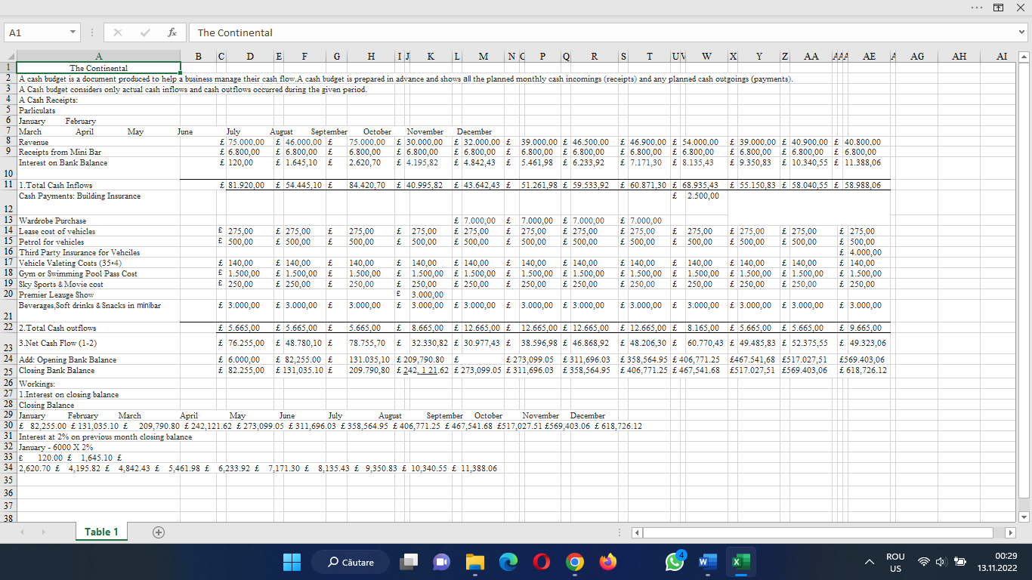
Appendix:

