

Entrepreneurship
Task 1 - Business plan
“Ramina Soaps”

Student name: Mihaita Marius David
Student ID: 2113993
Title: Business plan: Task 1 - Business plan “Ramina Soaps”
Module name: Entrepreneurship
Module code: LCBB5001
Lecturer name: Amer Kareem
Submission date: 28/04/2024

Table of Contents
Business Description / Market Opportunity 3
Industry Analysis 4
Market Research 4
Competitor Analysis 5
Swot Analysis 6
Operation and Management Team 6
Operational Activity 6
Management Team 7
Marketing Plan and Strategy 8
Market Entry and Sales Process 8
Target Market and Positioning 8
Segmentation, Targeting, and Positioning Strategy 9
Marketing Mix 9
Financial Plan 9
Source and Uses of Funds 9
Financing Options 10
Six-Month Cash Budget Forecast 10
Closing Summary 11
References: 12

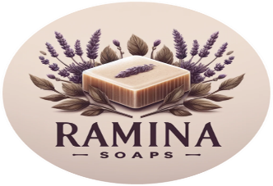
Business Description / Market Opportunity
Ramina Soaps was founded at a time when there was a growing need for organic skincare products and there was also a growing concern for the preservation of the environment.
According to Godas and Coughlan (2023), the primary notion is around the utilisation of the inherent quality of pure components during the production of a variety of handcrafted soaps. In particular, goat milk, rainwater, and essential oils that have been extracted are utilised. The purpose of this plan is to evaluate the chances of Ramina Soaps achieving success and to investigate the motivational reasons that serve as the foundation for the formulation of the aforementioned plan.
Since customers are increasingly opting for handcrafted products created with natural materials rather than those that include chemicals, the organic skincare market has undergone tremendous expansion (Sharma & Narang, 2024). This trend represents a significant shift in consumer preferences. By delivering products that place an emphasis on quality and environmental sustainability, Ramina Soaps is able to capitalise on this transformation and provide products that are highly appealing to modern consumers because they are essential components. The brand's Unique Selling Product (USP) is founded on the fact that it is prepared using a handmade approach, that it makes use of special ingredients, and that it is persistently committed to being environmentally responsible. In addition to being able to differentiate itself from conventional products, Ramina Soaps is also able to resonate with the ethical concepts that are significant to the customer base that it is aiming to attract.
The decision to go with this particular commercial operation was driven by a wide range of complex and diverse motivator factors. A significant aspect was the individual's tremendous excitement for living in an environmentally responsible manner, as well as the recognition of a specific need in the market that places an emphasis on openness and sustainability (GlobeNewswire, 2023). In addition, a powerful motive was the desire to provide a product that improves the well-being of the client while simultaneously reducing the amount of harm that is caused to the environment. In Ramina Soaps, the primary philosophy is built on the link of personal values with corporate aims. This connection is the foundation of the company.
The financial projections for Ramina Soaps are optimistic, taking into account the possibilities of expanding the production of soap as well as the prospect of providing a diverse range of products. According to Gil-Pechuán et al. (2014), the business has the ability to achieve a big audience by leveraging online platforms and effectively utilising digital marketing tactics. This allows the firm to avoid paying the costs that are associated with traditional retail outlets. Furthermore, the emphasis placed on customisation increases the level of individual interaction with clients, which in turn increases the possibility of customers remaining loyal to the brand and making similar purchases in the future. The competitive landscape, on the other hand, is naturally fraught with difficulties. Because of the growing number of artisanal soap producers operating on a smaller scale, the market climate is becoming increasingly competitive, which Ramina Soaps must learn to navigate properly. According to Rees (2021), in order for the company to handle this issue, it is necessary for the corporation to maintain a compelling brand story and to be persistent in its pursuit of innovation in both product development and marketing strategies.

Industry Analysis

Market Research

Ramina Soaps is strategically entering the organic personal care market, which is seeing strong growth due to a growing customer desire for health and environmentally friendly goods.
According to Data Bridge Market Research (2023), the market for organic personal care products is expected to experience a Compound Annual Growth Rate (CAGR) of around 7.29% from 2023 to 2030. This growth reflects a notable change in consumer purchasing preferences towards natural and organic components. The market's transformation is primarily propelled by increasing apprehensions over detrimental chemicals in cosmetics and a wider societal transition towards sustainability.

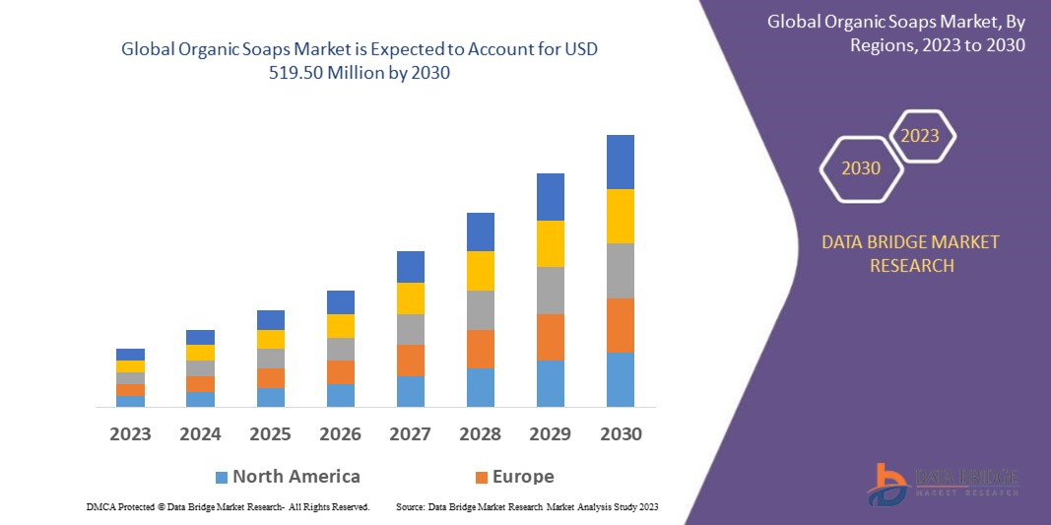

Additional analysis from Global News Wire (2023) reveals that within the larger market, the organic soap category is notably dynamic. Consumers are progressively seeking products that possess organic certifications and exhibit transparent labelling of components, a characteristic that perfectly corresponds to the business concept of Ramina Soaps. The increasing inclination towards ethical consumerism, whereby customers take into account the social and environmental consequences of their choices, is also promoting expansion in this industry.

Competitor Analysis

The Little Soap Company is well-known for its commitment to creating organic and natural soap products that are easily available to ecologically aware consumers. Ramina Soaps positions itself strongly in the niche by emphasising eco-friendly procedures and cruelty-free certifications (The Little Soap Company, 2024). Therefore, it is recommended that Ramina focuses on highlighting distinct soap compositions and personalised alternatives in order to set itself apart from competitors.
The English Soap firm is a specialised firm that focuses on producing exquisitely packaged, high-end soap bars that primarily target gift purchasers and premium consumers. While they prioritise aesthetic and sensory appeal over organic credentials, their success in the luxury market segment demonstrates the potential for significant profitability in this field (The English Soap, 2024). To gain a similar audience, Ramina Soaps should emphasise the inherent quality of their products in addition to attractive packaging.
Rocky Mountain Soap Company is a direct rival that shares similar ethical beliefs and product offerings. They prioritise the use of all-natural ingredients and are dedicated to providing chemical-free products (Rocky Mountain Soap Company, 2024). Ramina Soaps could benefit from studying the robust brand narrative and community-oriented marketing strategies employed by this company. It may be advantageous for Ramina Soaps to concentrate on incorporating locally sourced materials or engaging in partnerships with local craftsmen to establish a distinctive niche in the market.
Dove is a widely recognised brand that has a large global presence. It focuses on offering products that are affordable and easily accessible to a wide range of consumers. Dove positions its products as being soft and moisturising (Dove, 2024). Although not a direct rival in the organic market, its supremacy acts as a standard for Ramina Soaps in terms of consumer confidence and brand recognition. In order to remain competitive, Ramina Soaps should prioritise emphasising its transparent and legitimate organic certifications, as well as highlighting the real advantages of its natural components.
Dr. Squatch effectively targets a predominantly male audience by employing a comprehensive online presence and marketing plan that combines humour with product information. This demonstrates the success of niche marketing and the ability to communicate with customers online (Dr. Squatch, 2024). Ramina Soaps might implement a comparable strategy by focusing on particular demographics or hobbies through customised marketing campaigns that emphasise the distinctive advantages of their organic soap selection.

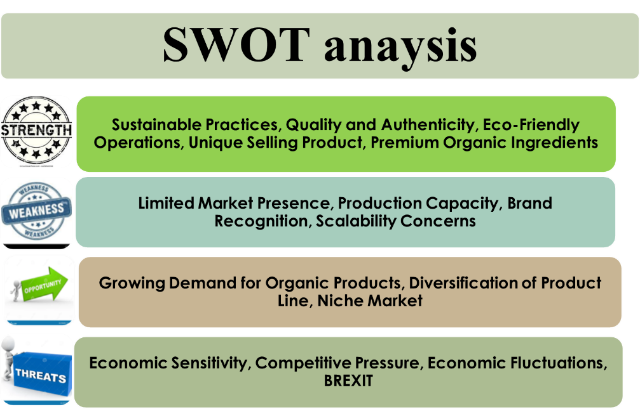
Swot Analysis

Operation and Management Team

Operational Activity

Production Facility and Process
Ramina Soaps operates from a specialised workshop where all manufacturing procedures occur. This facility is furnished with essential tools and equipment for soap production, including as mixers, moulds, and cutting tools, which are specifically tailored for small-scale manufacturing to guarantee meticulous quality control and skilled craftsmanship.
The soap manufacture adheres to a conventional cold process technique, enabling enhanced preservation of the inherent advantages of the ingredients. This procedure entails:
Mixing: The saponification process begins by precisely measuring and combining natural oils and butters with lye.
Moulding: The fluid is subsequently put into moulds, where it solidifies into a certain form.
Curing: After solidification, the soap bars are extracted from the moulds and sent to a designated drying room for a period of 4-6 weeks. This process guarantees that the bars become mild and durable.
Quality checks
Quality checks are integrated in the production process, guaranteeing that every batch of soap adheres to strict criteria for safety, effectiveness, and customer satisfaction. This entails conducting pH tests and visual inspections to confirm the uniformity and excellence of the product.
Supply Chain and Sourcing
Ramina Soaps places a high importance on procuring materials locally and ethically. The company actively collaborates with local farmers and suppliers whenever feasible to minimise the environmental impact and contribute to the local economy. The organisation has a streamlined inventory system to save waste and guarantee the freshness of materials.
Packaging and Distribution
The brand's dedication to sustainability is evident in the packaging of all soaps, which are made from biodegradable or recyclable materials. The completed goods are stored in a controlled environment with regulated temperature and humidity until they are dispatched to clients or retail outlets. The distribution is handled by means of direct web sales and collaborations with environmentally conscious retailers.

Management Team

- CEO/Founder: Oversees all company operations, sets strategic direction, and represents the company externally.
- Operations Manager: Manages day-to-day operations, production scheduling, and supplier relationships.
- Finance Manager: Handles budgeting, accounting, and financial planning, ensuring the company's financial security.
- Health and Safety Manager: Tasked with developing and enforcing safety protocols related to the handling of chemicals used in the production process.
- Product Development Lead: Innovates and refines product lines, ensuring quality control and adherence to brand values.
- Production Line Manager: Responsible for overseeing the entire production process of the soap making from raw material sourcing to final product packaging.

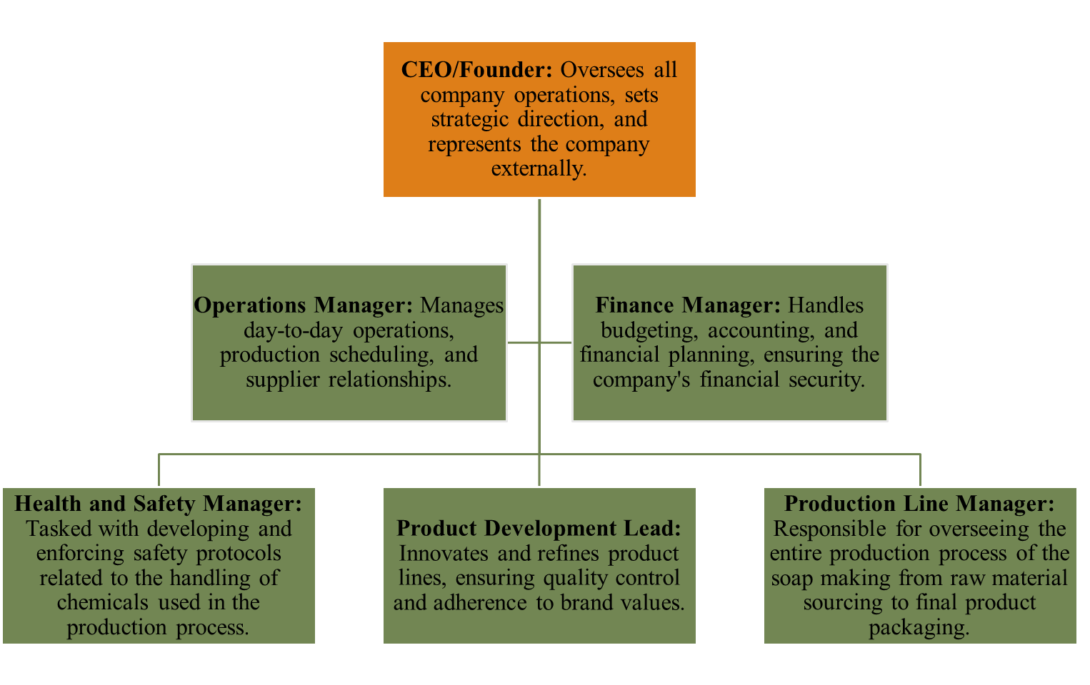

Marketing Plan and Strategy

Market Entry and Sales Process
Initial market entry will focus on online sales and local farmers' markets to build brand recognition. The sales process will be streamlined through an e-commerce platform, providing a seamless customer experience from browsing to delivery.

Target Market and Positioning
The primary target market for Ramina Soaps includes health-conscious customers, who prefer organic skincare products and value sustainability, luxury, and skin wellbeing. The company positions itself as a premium brand focusing on quality and sustainability.

Segmentation, Targeting, and Positioning Strategy

- Segmentation: The market is segmented based on age, gender, and lifestyle preferences.
- Targeting: Focused on eco-conscious consumers looking for premium, safe skincare products.
- Positioning: Positioned as a luxury, eco-friendly brand that offers a unique sensory

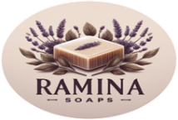
Marketing Mix

- Brand Logo: "From Nature to Skin: Nature’s Purity in Every Bar"
- Unique Selling Product: Soaps made with Goat Milk, Rainwater, and Pressed Essential Oils for a luxurious and effective cleanse.
- Product: A range of organic soaps with different fragrances and health benefits.
- Price: Premium pricing strategy to reflect the quality and uniqueness of the product.
- Place: Online sales through an e-commerce website and selective distribution through organic stores.
- Promotion: Online marketing, social media campaigns, and partnerships with influencers in the wellness sector.

Financial Plan

Source and Uses of Funds
The initial funding requirement is £50,000, to be sourced from investors and potentially a crowdfunding campaign. The funds will be allocated as follows:
- Raw Materials and Supplies (£15,000):
Purchase of organic oils, lye, essential oils, herbs, and other soap-making ingredients; Procurement of packaging materials, including eco-friendly boxes and labels.
- Equipment and Tools (£10,000):
Soap molds, mixers, cutters, and safety equipment.
Initial setup costs for a small workshop, including worktables and storage units.
- Marketing and Branding (£8,000):
Development of a brand identity, including logo design and website creation.
Initial marketing campaigns, social media advertising, and promotional materials.
- Operating Expenses (£7,000):
Rent for workshop space and utilities for the first few months.
Insurance and business licenses.
- Research and Development (£5,000):
Experimentation with different soap formulas and scents.
Testing for product quality and safety compliance.
- Emergency Fund (£5,000):
Reserved for unexpected expenses or shortfalls in the initial operating period.

Financing Options

- Dragon’s Den funding: TV show to raise funds from the Dragons investors audience.
- Equity Financing: Selling company shares to strategic investors or venture capitalists.
- Debt Financing: Loans from financial institutions or small business grants.
- Crowdfunding: Online platforms to raise funds from a broader audience.

Six-Month Cash Budget Forecast

Launch Products & Online Presence (Months 1-4): Complete product development, launch the e-commerce site, and initiate social media marketing to build brand awareness.
Achieve Initial Sales Target (500 Units by Month 6): Reach the first significant sales milestone through online sales and marketing efforts, establishing a customer base.
Establish Wholesale Partnerships (By Month 9): Form strategic partnerships with boutiques and eco-stores to expand distribution channels beyond direct-to-consumer sales.
Introduce New Product Line (Month 10): Expand the product range based on market trends and customer feedback, fostering growth and diversification.
Reach Financial Break-Even (By Month 12): Achieve financial stability by balancing initial investment with revenue from sales, setting a foundation for future profitability.

Closing Summary
In summary, the business concept for Ramina Soaps is well-founded, supported by a noticeable market demand and clearly delineated unique selling features (USPs). The motivational factors add to the brand's genuineness, which is highly esteemed in a market that values honesty. Ramina Soaps has the potential to exert a significant impact in the sustainable skincare industry because of its innovative marketing and steadfast commitment to its core beliefs. In order for a firm to attain sustained success and expansion, it is imperative to uphold the ability to adjust to market changes while being resolute in its aim (Kahn, 2021).
Ramina Soaps is prepared to enter the organic personal care industry with a distinctive product line that prioritises excellence, sustainability, and ethical principles. The proficient management team is adequately prepared to manage the operational, marketing, and financial aspects of the firm. The financial strategy is formulated to facilitate a strong and successful introduction into the market, guaranteeing the company's expansion and enduring viability.

References:
- (2021) 2020: Tech Nation’s year in Review - Tech Nation. Available at: https://technation.io/news/2020-in-review-tech-nation/ (Accessed: 23 March 2024).
- About dove (2024) dove. Available at: https://www.dove.com/us/en/stories/about-dove.html (Accessed: 23 April 2024).
- All natural soap co - award winning handmade soaps (2024) All Natural Soap. Available at: https://allnaturalsoap.co.uk/ (Accessed: 23 March 2024).
- Award winning Luxury & Eco Friendly Soaps (2024) The English Soap Company. Available at: https://theenglishsoapcompany.com/ (Accessed: 23 March 2024).
- Award winning Luxury & Eco Friendly Soaps (2024) The English Soap Company. Available at: https://theenglishsoapcompany.com/ (Accessed: 24 April 2024).
- Beauty and personal care retailing - uk - 2024 : Consumer Market Research Report : Mintel.com (2024) Mintel Store. Available at: https://store.mintel.com/report/uk-beauty-and-personal-care-retailing-market-report (Accessed: 23 March 2024).
- Brown, K. (2023) The 15 best mens soap brands (2024), Irreverent Gent. Available at: https://www.irreverentgent.com/best-mens-soap-brands/ (Accessed: 23 March 2024).
- Coutu, D.L. (2021) How resilience works, Harvard Business Review. Available at: https://hbr.org/2002/05/how-resilience-works (Accessed: 23 March 2024).
- Environmental sustainability (2023) GOV.UK. Available at: https://www.gov.uk/government/collections/environmental-sustainability (Accessed: 25 March 2024).
- Gil-Pechuán, I. et al. (2014) Strategies in e-business positioning and social networking in online markets. Boston, MA: Springer US.
- Global Organic Soaps Market – Industry Trends and forecast to 2030 (2023) Data Bridge Market Research. Available at: https://www.databridgemarketresearch.com/reports/global-organic-soaps-market (Accessed: 23 April 2024).
- Godas, M. and Coughlan, A. (2023) Organic beauty: All illustrated guide to making your own skincare. Naarm (Melbourne), Victoria: Smith Street Books.
- Handmade soap - award winning natural soap (2024) Little Soap Company. Available at: https://www.littlesoapcompany.co.uk/ (Accessed: 25 April 2024).
- Handmade soap bar with herbal ingredients around. homemade toxic-free natural organic soap. stock photo (no date) Adobe Stock. Available at: https://stock.adobe.com/uk/images/handmade-soap-bar-with-herbal-ingredients-around-homemade-toxic-free-natural-organic-soap/371087676 (Accessed: 23 March 2024).
- Handmade soap by Wharfedale Soaps, Yorkshire, UK (2024) Wharfedale Soaps. Available at: https://wharfedalesoaps.co.uk/ (Accessed: 23 March 2024).
- Jan (2018) How to make your own soap with herbs, blog. Available at: https://blog.mountainroseherbs.com/how-to-make-herbal-soap (Accessed: 23 March 2024).
- Jefferies, N. (2021) The impacts of Eu exit and coronavirus (COVID-19) on UK trade in services: November 2021, The impacts of EU exit and coronavirus (COVID-19) on UK trade in services - Office for National Statistics. Available at: https://www.ons.gov.uk/economy/nationalaccounts/balanceofpayments/articles/theimpactsofeuexitandcoronaviruscovid19onuktradeinservices/november2021 (Accessed: 25 March 2024).
- Kahn, M.E. (2021) Adapting to climate change: Markets and the management of an uncertain future. New Haven: Yale University Press.
- Kouzes, J.M., Posner, B.Z. and Kouzes, J.M. (2009) Leadership challenge. Weinheim: Wiley-VCH-Verl.
- Lambert, F. (2024) 🌟 Ultimate guide to getting started in handmade soap making, FrancoisLambert.One. Available at: https://www.francoislambert.one/en/blogs/blogue-de-francois/les-bases-de-la-fabrication-artisanale-de-savon-un-guide-pour-les-debutants (Accessed: 24 March 2024).
- Organic soap: Natural soap: Handmade soap (2024) UK. Available at: https://uk.drsquatch.com/ (Accessed: 23 April 2024).
- Our passion for genuine cruelty free natural soap – about Little Soap Company (2023) Little Soap Company. Available at: https://www.littlesoapcompany.co.uk/about-us/ (Accessed: 23 March 2024).
- Proficient Market Insights (2023) Handmade soap market size ($ 224.45 billion by 2031 at CAGR of 5.94% CAGR) - which is booming strong growth in the globe till 2031, GlobeNewswire News Room. Available at: https://www.globenewswire.com/news-release/2023/09/22/2747794/0/en/Handmade-Soap-Market-Size-224-45-Billion-by-2031-at-CAGR-of-5-94-CAGR-which-is-Booming-Strong-Growth-in-the-Globe-till-2031.html (Accessed: 23 April 2024).
- Rees, S. (2021) Public relations, branding and authenticity: Brand Communications in the Digital age. Abingdon, Oxon: Routledge, Taylor & Francis Group.
- Rocky Mountain Soap (2024) Natural soap, Rocky Mountain Soap. Available at: https://www.rockymountainsoap.com/collections/natural-soap (Accessed: 23 March 2024).
- Rocky Mountain Soap (2024) Rocky Mountain Soap Company - 100% natural skin care, Rocky Mountain Soap. Available at: https://www.rockymountainsoap.com/ (Accessed: 25 April 2024).
- Schumpeter, J.A., Opie, R. and Swedberg, R. (2021) The Theory of Economic Development. London: Routledge.
- Sharma, R. and Narang, R. (2024) ‘Psychographic profiling of prospective organic skin care product users’, Global Business Review [Preprint]. doi:10.1177/09721509241227292.
- Shop, E. (2023) Benefits of making your own soap, Essencetics. Available at: https://essencetics.com/blogs/interesting/benefits-of-making-your-own-soap (Accessed: 23 March 2024).
- Soap making craft courses & workshops (2024) Find a Craft. Available at: https://findacraft.co.uk/product-category/beauty-body/soap-making/ (Accessed: 23 March 2024).
- Stewart, W.H. and Roth, P.L. (2001) ‘Risk propensity differences between entrepreneurs and managers: A meta-analytic review.’, Journal of Applied Psychology, 86(1), pp. 145–153. doi:10.1037/0021-9010.86.1.145.

