Urban Renewal

ACBA6004

Advanced Construction &
Civil Engineering Technology

Jacob Thomas

Contents Table
Introduction 3
Substructure 3
Geology 3
Considerations 3
Excavation and piling 4
Waterproofing 4
Structural frame 4
Fit for purpose 4
Sustainability 5
Installation & Removal 5
External Facade 6
Aesthetics 6
Performance 6
Fire safety 7
Conclusion 8
Appendix 9
Assumptions 9
Drawings 10
References 14
Bibliography 15

Introduction
The objective is the creation of a building that boasts vast open spaces open to adaptation for the user to maximise their area for the benefit of their business. Modern, stylish, and practical, this development will create a multi-use building with the latest in construction technology and contemporary design, while remaining subtle within its local cityscape. The surrounding area is home to buildings with great heritage and historical importance, giving rise to a local design criterion that must be appraised. The location of this urban renewal poses a myriad of challenges. With access limited, space at a premium and neighbouring buildings likely to suffer much disruption, efficient and strategic planning is key to success. Sustainability and reducing carbon footprint as the main objectives, much consideration has preceded the design and procurement of materials to cost-effectively reduce the environmental impact during construction, and throughout the life of the building. Cardiff Council have proposed a 5-year city centre rejuvenation plan to bring high quality architecture, job opportunities and increased biodiversity. We aim to be the spearhead in an exciting chapter for Cardiff City Centre. (Milne, 2022)

Substructure

Geology
Using results from an archaeological assessment conducted for Cardiff Universities new development just half a mile from our proposed site we can assume a stratum consisting of Mudstone bedrock (Davies, 2016). This material is a brittle fine-grained sedimentary rock consisting of an aggregate of compressed clay and silt with a bearing capacity of up to 2000kN/m² (Structural Foundation Designers' Manual, 2008). Mudstone has a high affinity for water which can lead to softening and swelling in the presence of groundwater. However, at depth it becomes a more stable material with good compression strength meaning its characteristics are suitable for a high-rise development. (British Geological Survey, 2002). Based on this assumption and the variables mentioned above, the most applicable substructure to cope with such loading is end baring Auger piles situated beneath supporting columns and around the perimeter forming the basement walls. These piles will extend beyond the basement floor level to penetrate deep into the stratum to prevent overturning of the piles.

Considerations
Due to the close proximity of neighbouring buildings in the centre of Cardiff, care must be taken to ensure the structural integrity of such structures is maintained. During excavation, if the land adjacent to these existing buildings is altered without due diligence, this could severely affect the bearing capacity of the surrounding soil, causing subsidence and a potential catastrophic substructure failure as a consequence. The Party Wall Act 1996 outlines a party’s duty of care for neighbouring buildings by ‘right of support’. Careful consideration must be taken to assess the potential disruption to surrounding land and action must be taken to provide adequate support for nearby buildings to avoid litigation (Clayton , Woods, & Milititsky, 1993).
Highrise developments require deep substructures to provide adequate support. We must consider various influences which will dictate the specification of our substructure. As buildings get taller the vertical load increases exponentially, increasing the chance of settlement. Wind-induced lateral forces offer additional challenges as we build higher as they can degrade the foundation capacity and cause potential settlement by giving rise to dynamic resonance (Poulos, 2016).

Excavation and piling
To maximise the space within the building a multi-storey carpark will be situated within a dry basement along with services and a gym. The basement excavation will be facilitated by a secant pile wall around the perimeter of the basement reaching a depth of 24 metres. Primary unreinforced piles are installed first with secondary reinforced piles constructed between them to provide adequate strength to retain the surrounding soil and to excavate deeper. Each pile will measure 850mm diameter and filled with high strength concrete with a hard/soft formation to withstand the loads imposed by the structure above and to allow for movement which will avoid cracking of the harder concrete. By reinforcing with steel, it increases tensile strength of the wall while overlapping the primary piles adds to wall stiffness and reduces water ingress. An overlap of 150mm will be sufficient for the desired performance. Shotcrete infill will create a flat finish to the piles to create an even layer of the envelope. See drawing 1. Secant Pile Wall Detail in appendix.
As cement produces up to 8% of the worlds carbon footprint, the environmental impact of such a development could be significant. To combat this, hydrated lime will be used in the curing phase to absorb CO2 and reduce the quantity of Portland Cement required by over 60% (Rosa-Aquino, 2021). The concrete mixture will further reduce environmental impact as we incorporate synthetic aggregates, particularly recycled plastic as we push for increased project sustainability.
Surrounding listed buildings could be susceptible to damage from excessive vibration used when installing sheet piles using impact or vibratory hammers. Site noise is often a nuisance to neighbouring homes or offices. To limit such disruption, the decision was made to construct the retaining wall using auger piles to create very little noise and vibration as biproducts compared to other piling options. Piling rigs are easily adapted to occupy as little space as possible, ideal for a compact city centre project such as this.

Waterproofing
Concrete is a porous material that can be susceptible to water damage if untreated. The dry basement will face great hydrostatic pressure which will eventually force moisture through the overlapped piles. Smaller domestic projects use tanking slurry on the internal or external face of the envelope to prevent water ingress. However, on larger commercial projects such waterproofing methods may be impractical and insufficient. ‘Type C’ waterproofing is the most efficient option for a deep basement such as this as it collects water as it travels through the envelope. A drainage membrane on the inner surface of the piles manages water ingress by capturing moisture in its studs and draining it to a suitable outlet via drainage channels. The outlet often referred to as a sump pump drainage system will discharge water from the basement (Peter Cox, 2022). See drawing 2. Basement Wall Cross Section in appendix.

Structural frame

Fit for purpose
Creating a multi-use building with versatile spacing will benefit users with various requirements. We aim to create large spaces with flexible internal features that can be easily adapted to suit future renters to avoid costly retrofitting work. A steel frame specification is most appropriate for a building with many different uses. When utilising large spans, steel maximises natural light into the building and creates vast open spaces, ideal for offices and retail units. Steel is a lightweight and durable material with good compressive and tensile properties, allowing it to withstand the lateral loads imposed on high-rise buildings. The structure will consist of both compression and tensile members to provide adequate support to the building while adding aesthetic value through architectural design.
Prefabrication of steel offsite is advantageous due to shortage of storage facilities on site and the limited transport access. Good management of material will be required to ensure that materials are fitted ‘just-in-time’, mitigating transport delays and space wasted for storage. Offsite fabrication means that steel can be customised to fit exactly according to the building specification which reduces on-site adjustments of the members. The frame can be constructed rapidly as joints fit perfectly together using bolts to secure with ease. Furthermore, steel frame construction can be completed in adverse weather conditions compared with concrete as concrete pouring is weather permitting. Unlike concrete, steel does not require curing time once fitted further reducing time constraints and can be constructed with ease using less skilled labour (GLW Engineering & Construction Ltd, 2018).

Sustainability
With the aim to reduce the carbon footprint of the construction process there were a number of factors which required consideration. Due to current affairs such as rising material prices due to the Coronavirus pandemic and the recent conflict in Ukraine we have taken the decision to procure mostly local material to avoid potential shipping delays and inflated prices. Therefore, the superstructure is to be constructed using only recycled steel sourced in the United Kingdom to reduce the environmental impact of manufacturing new steel. Although around 85% of steel is recycled, the UK exports 8 million tonnes of scrap metal each year as far as Japan in some cases, which could be recycled locally and used to sustain the UK’s need for steel in construction. By using recycled steel, waste is reduced, primary resources saved, and energy used is reduced as the incineration of recycled steel uses less energy than production of new steel, and moreover, the number of times that steel can be melted down and reused is infinite (Galvanizers Association, n.d.).
Using GREENSTEEL strategies we will procure the scrap steel with the lowest embodied CO² and melt it down in electric arc furnaces. The UK’s recycling of steel has fallen behind other European countries due to expensive energy and lack of facilities to refine the scrap economically. We will form a partnership with Liberty Steel who are pushing to make steel production more environmentally friendly by focussing production of recycled steel from the UK for sustainable developments such as ours. Their Rotherham plant operates during the hours of 11pm-6am to maximise efficiency and reduce costs, but ideally, we would like to use renewable energy to achieve net zero steel, which is something Cardiff Council are looking to pursue in their green initiatives. (Pioneering GREENSTEEL through low carbon technologies, 2021).

Installation & Removal
Our sustainability strategy building goes further than the construction and building usage. We aim to create a building that remains sustainable beyond its end of life. The steel fittings will use bolt connections as opposed to welding for ease of deconstruction to maximise the amount of steel that can be reused without refining it. Connections will be easily accessed with standardised bolts to facilitate deconstruction and further reduce the need for demolition. The design and construction of the structure will be recorded in depth with this information accessible to aid refurbishment and deconstruction, saving material and creating a cyclical economy (Elland Steel, 2021). See drawing 4. Standard Steel Connection in appendix.
The same approach to installation and deconstruction will be attributed to the services. The services will include a single press connection method across the whole project to standardise as much as possible. This creates a system with greater efficiency as training and equipment requirements are reduced due to gas, water and heating all being fitted using the same method. To further improve the system efficacy, we aim to procure our materials from a single manufacturer to benefit the management of the project. Specific quantities of materials can be delivered strategically to reduce storage space required and maintain progress. The manufacturer selected will carry out maintenance and services work throughout the lifetime of the building (CIBSE Journal, 2019).

External Facade

Aesthetics
Due to the location of this development and surrounding buildings there are parameters by which the architectural design must fall within. By submitting a Design and Access Statement (DAS) we can ensure that we comply to the Planning Wales Act of 2015 and provide a rationale for our design to help understanding to mitigate objections from various parties seeking to protect Cardiff’s historical assets. As part of our build, we aim to incorporate this building into the cityscape without having a detrimental effect on local heritage and historical buildings with the vicinity. The composition of the external envelope will be a thin stone façade, allowing the development to blend in with nearby buildings of similar design on Westgate Street. Comprised of honeycomb aluminium panels; this lightweight stone alternative is installed rapidly with ease by utilising steel T, J & L anchors for a perfect fit. It will provide the building with a non-porous external envelope which is not only aesthetically pleasing and compliant within its environment, but high performing in terms of protecting the structure from weathering (StonePly, 2022).
Large steel spans facilitate the designing out of load bearing walls which allows for the inclusion of large curtain walls. These glass finishes allow maximum amount of light into the building whist improving views from within. Potential wind loads must be ascertained to ensure the external façade can perform under the stress required for a high-rise building.

Performance
Prefabricated infill panels will be used part of the external envelope to create an airtight and thermally efficient exterior that reduces thermal bridging and risk of moisture ingress. Bespoke panels will be constructed off site using predetermined measurements for an exact fit, easing the installation process, and reducing material wastage on site. Offsite manufacture is done within a controlled environment to mitigate the effect of adverse weather and human error to speed up the build programme. Constructed using steel as the fame, the insulation and internal skin will form the layers of the panel which can be delivered to site as one unit. This unit can then be craned into position and fixed directly to the structure shortly after delivery. The steel frame will provide anchor points to attach the external stone cladding for further ease of fixing without compromising the insulation (Steel Framing Industry Association, 2022). Although timber is more sustainable, steel is preferred over timber for the panel’s composition to better support the load of the external stone façade and to better cope with wind loads by using upstands and additional fixtures.
The panels will consist of four principal control layers: rain, air, vapour and thermal. These layers will protect the building from the elements and provide a safe and comfortable place to dwell. The external layer is the stone cladding layer which acts as our rain and ultraviolet light control by preventing water ingress and UV radiation hitting the building. This envelope will consist of a stone facade with a continuous layer of honeycomb insulation attached to protect the structural steel from adverse temperatures, reducing the effects of contraction and expansion. An air cavity helps to distance the building from the external facade to further prevent water movement and provide ventilation, should any moisture permeate. The excess water is removed from the cavity through sufficient ventilation of this cavity. Beyond this cavity is a sheathing board which provides waterproofing for the internal insulation layer. The internal insulation is thicker than the external insulation to prevent heat escaping from inside and to create an airtight enclosure to maximise efficiency. The internal face of the building requires a layer of plasterboard which can be finished as the tenant requires (Lstiburek, 2010). See drawing 3. Cladding Detail in appendix.
The roof structure will be a flat roof consisting of thermal insulation to prevent heat loss, control vapour and provide comprehensive waterproofing. We’ve opted for Derbigum Olivine membranes as they’re 100% recyclable and further enhance the buildings quest for environmental vitality. This naturally occurring material neutralises CO² when in contact with rainwater and will continue to do so for up to 30 years. The roof will be fully waterproofed using lapped membranes at edges, torched to effectively seal for a watertight finish. A slight gradient will ensure water is gathered at selected locations for drainage. This finish requires minimal maintenance with a 40-year guarantee (Alumasc, 2021).
Highrise structures can be prone to acoustic problems if insufficient attention is spent on this aspect of the design. A mix use building with retail units and a car park could potentially cause much disruption to other parts of the building without due consideration. To mitigate these effects, the floor will be fitted with noise and vibration mats to reduce disruption and comply with building regulations Approved Document E – Resistance to sound.

Fire safety
In the wake of the tragedy at Grenfell the fire safety of high-rise buildings has been rightly subject to much speculation due to the scale of devastation. Fire safety in construction was under reform after the Grenfell disaster to prevent such an occurrence in future. With considerations specific to planning gateway one, throughout every aspect of this buildings design the safety of the occupants has been paramount. The design includes measures to aid the evacuation process whilst helping to contain the fire through compartmentalisation. The structural steel will be coated with intumescent paint to provide a reactive fire protection system which swells once exposed to extreme heat to form a protective layer reducing the rate of heat transfer. This paint can be used in conjunction with intumescent boards in potentially higher fire risk areas of the building as part of the fire resistance plan. To satisfy Approved Document B, these precautions along with a sprinkler system are a safe and cost-effective method to delay the time taken for steel to reach its critical temperature (CLM Fireproofing, 2020).
An external façade consisting of stone is inherently non-combustible but can be prone to shattering when exposed to extreme heat. To counter this, an epoxy adhesive is used to secure the thin stone to the aluminium honeycomb panels to encourage the stone to flake off in smaller pieces. An investigation by BRE found that non-combustible honeycomb panels prevent the spread of fire as flames we unable to spread vertically or horizontally during testing. These panels withstood 19 minutes of thermal exposure before the fire reached the cavity while mitigating the amount of falling debris and burning droplets (BRE Global Ltd, 2020). The onus of such design is to reduce the blaze as much a possible as the requirement of a cavity within the external envelope can create a chimney effect which could further exacerbate the blaze. Building within a close proximity in the town centre requires further measures to fireproof the envelope to prevent fire spreading to adjacent buildings. This includes sheathing panels and fire-resistant insulation throughout the building.

Conclusion
Modern construction requires a continuous balancing act between contemporary design, heritage, sustainability, budget, safety, and many others. Each of these factors has undergone much consideration to provide the city of Cardiff with a state-of-the-art multi-use building that prioritises safety and sustainability. A report by Mark Farmer in 2016 highlighted many issues with modernisation in the construction industry and steps we can take to improve practice. As a result, we have designed a structure that incorporates modern methods of construction to maximise productivity by manufacturing off site to save time and reduce waste on site. Each component of the building is designed specifically within an enclosed environment to fabricate exact standard items that perfectly fit for ease of installation so that labour on site is reduced. Furthermore, site safety is improved and disruption to the surrounding area is minimised as we strive for accreditation of Considerate Contractors. We hope to change the way we build using steel in the UK by showing that we can source recycled material locally by partnering with likeminded businesses to create a sustainable future for the construction industry.

Appendix

Assumptions
1. Stratum consisting of Mercia Mudstone within specified area.
2. Pile foundation specification sufficient to withstand required loading.
3. The availability of recycled steel from the UK and feasibility.
4. Land is not contaminated.

Drawings
1. Secant Pile Wall Detail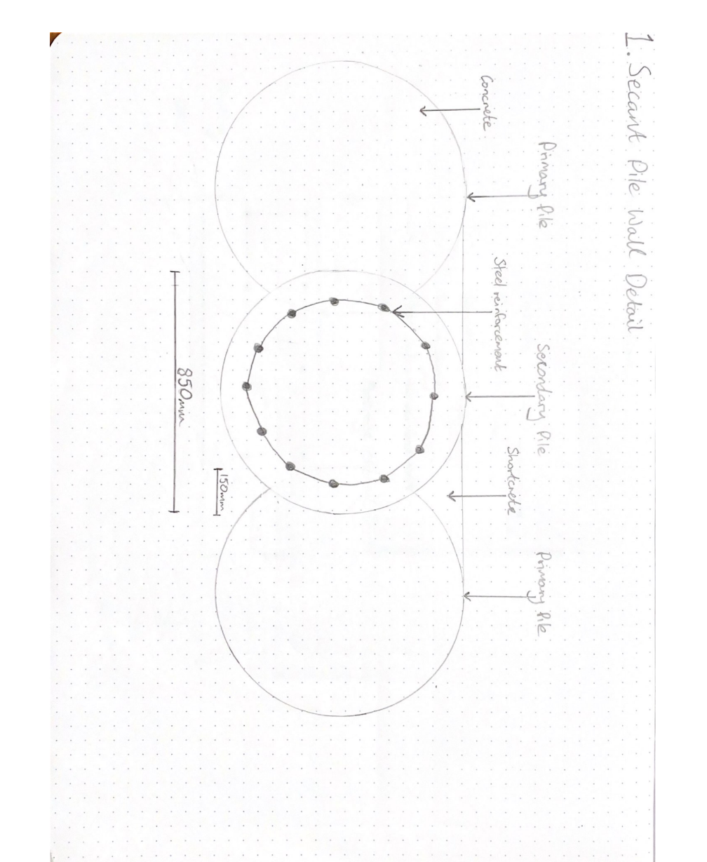

2. Basement Wall Cross Section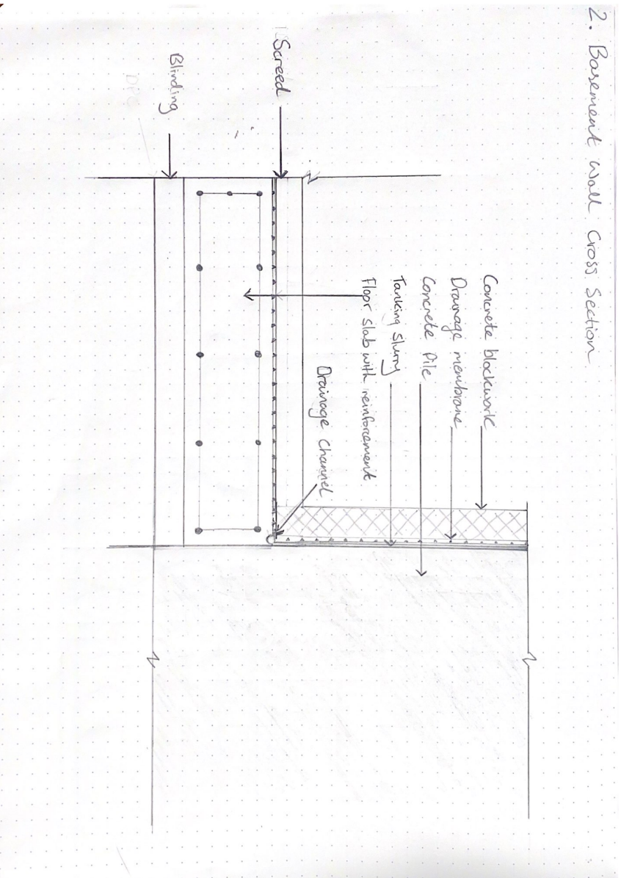
3. Cladding Detail
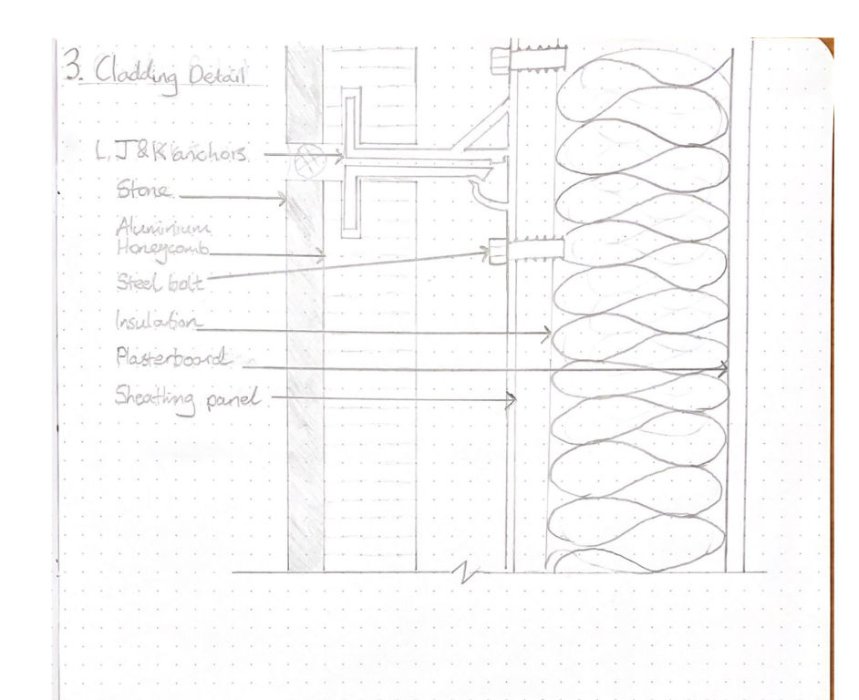

4. Standard Steel connection

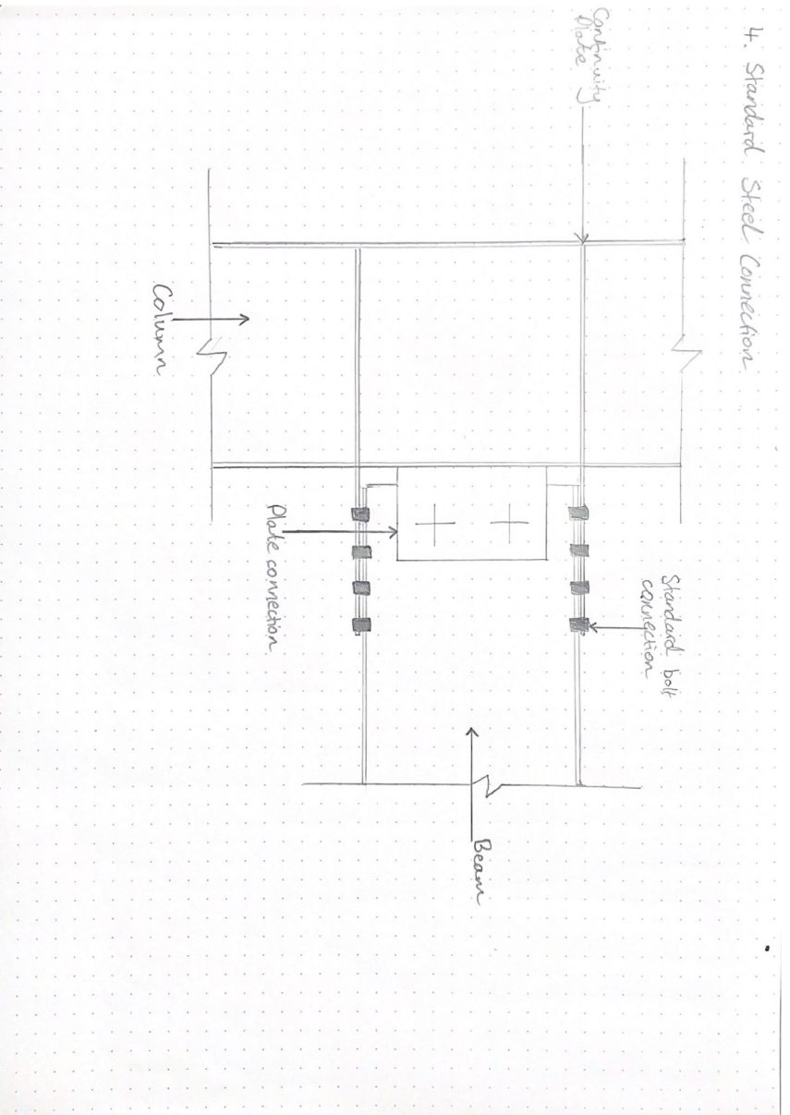

References
Alumasc. (2021). Derbigum Olivine Membrane. Retrieved from Alumasc Roofing: https://www.alumascroofing.com/products/waterproofing/bituminous-membranes/derbigum-olivine-membrane/
BRE Global Ltd. (2020). Fire Performance of Cladding Materials Research. London: BRE Global Ltd.
British Geological Survey. (2002). Engineering geology of British rocks and soils. Mudstones of the Mercia Mudstones Group. Nottingham: Natural Environment Research Council.
CIBSE Journal. (2019, May). Simplifying building services installation. Retrieved from CIBSE Journal: https://www.cibsejournal.com/uncategorized/simplifying-building-services-installation/
Clayton , C. R., Woods, R. I., & Milititsky, J. (1993). Earth Pressure and Earth-Retaining Structures. London: Taylor & Francis.
CLM Fireproofing. (2020). Passive Fire Protection. Retrieved from CLM Fireproofing: https://clmfireproofing.com/how-does-fire-affect-structural-steel/#:~:text=Structural%20steel%20can%20withstand%20approximately,%C2%B0C%20or%20just%20under.
Davies, T. (2016). Archeological desk-based assessment. Cardiff: The Glamorgan-Gwent Archaeological Trust Ltd. Retrieved from https://planningonline.cardiff.gov.uk/online-applications/files/A6B77BAECAB2FBE2645CE86C05877660/pdf/16_01739_MJR-CSL_-_ARCHAEOLOGY-1813494.pdf
Elland Steel. (2021). Design for Deconstruction. Retrieved from Elland Steel: https://www.ellandsteel.com/design-a-steel-frame-for-deconstruction/
Galvanizers Association. (n.d.). Steel recycling. Retrieved from Galvanizers Association: https://www.galvanizing.org.uk/sustainable-construction/steel-is-sustainable/steel-recycling/
GLW Engineering & Construction Ltd. (2018). The Advantages & Disadvantages Of Steel Frame Construction. Retrieved from GLW Engineering & Construction Ltd: https://blog.glwengineering.co.uk/the-advantages-disadvantages-of-steel-frame-construction
Lstiburek, J. (2010). The Perfect Wall. Building Science Corporation.
Peter Cox. (2022). Waterpoofing refulations. Retrieved from Peter Cox: https://www.petercox.com/specialist-expertise/waterproofing-tanking/regulations/
Pioneering GREENSTEEL through low carbon technologies. (2021). Retrieved from Liberty Steel Group: https://libertysteelgroup.com/delivering-cn30/greensteel/
Poulos, H. (2016). Tall building foundations: design methods and applications. Innovative Infrastructure Solutions , 1-15.
Rosa-Aquino, P. (2021, May 21). Is This Concrete's Breakthrough Moment? Retrieved from New York Intelligencer: https://nymag.com/intelligencer/2021/05/how-new-forms-of-concrete-could-capture-carbon.html
Steel Framing Industry Association. (2022). Retrieved from BuildSteel : https://buildsteel.org/framing-products/wall-panels/exterior-insulation-cfs/
StonePly. (2022). Fire Safety. Retrieved from StonePly: https://www.stoneply.com/en/info/technical-bulletins/fire-safe-stone-cladding/
Structherm. (2019). Structural External Wall Insulation For The Refurbishment Of Non-Traditional Low & High Rise Properties. Retrieved from Structherm: https://www.structherm.co.uk/our-solutions/structural-external-wall-insulation/
Structural Foundation Designers' Manual. (2008). Oxford: Wiley-Blackwell.
Milne, R. (2022, 01 28). Cardiff city centre rejuvenation proposals promised. Retrieved from The Planner: https://www.theplanner.co.uk/news/cardiff-city-centre-rejuvenation-proposals-promised

Bibliography
Aarsleff. (2019, 07 23). Top 10 Advantages of Sheet Piling. Retrieved from Aarsleff: https://aarsleff.co.uk/company-news/top-10-advantages-of-sheet-piling/
Aarsleff. (2021). Sheet piling. Retrieved from Aarsleff: https://aarsleff.co.uk/services/techniques/sheet-piling/#:~:text=Sheet%20pile%20retaining%20walls%20have,commence%2C%20thus%20allowing%20shorter%20programmes.
Alumasc. (2021). Derbigum Olivine Membrane. Retrieved from Alumasc Roofing: https://www.alumascroofing.com/products/waterproofing/bituminous-membranes/derbigum-olivine-membrane/
BRE Global Ltd. (2020). Fire Performance of Cladding Materials Research. London: BRE Global Ltd.
British Geological Survey. (2002). Engineering geology of British rocks and soils. Mudstones of the Mercia Mudstones Group. Nottingham: Natural Environment Research Council.
CIBSE Journal. (2019, May). Simplifying building services installation. Retrieved from CIBSE Journal: https://www.cibsejournal.com/uncategorized/simplifying-building-services-installation/
Clayton , C. R., Woods, R. I., & Milititsky, J. (1993). Earth Pressure and Earth-Retaining Structures. London: Taylor & Francis.
CLM Fireproofing. (2020). Passive Fire Protection. Retrieved from CLM Fireproofing: https://clmfireproofing.com/how-does-fire-affect-structural-steel/#:~:text=Structural%20steel%20can%20withstand%20approximately,%C2%B0C%20or%20just%20under.
Davies, T. (2016). Archeological desk-based assessment. Cardiff: The Glamorgan-Gwent Archaeological Trust Ltd. Retrieved from https://planningonline.cardiff.gov.uk/online-applications/files/A6B77BAECAB2FBE2645CE86C05877660/pdf/16_01739_MJR-CSL_-_ARCHAEOLOGY-1813494.pdf
Dr. Russell Hall, D. W. (2021). Domestic Scrap Steel Recycling . Coventry: Univerisity of Warwick.
Elland Steel. (2021). Design for Deconstruction. Retrieved from Elland Steel: https://www.ellandsteel.com/design-a-steel-frame-for-deconstruction/
Galvanizers Association. (n.d.). Steel recycling. Retrieved from Galvanizers Association: https://www.galvanizing.org.uk/sustainable-construction/steel-is-sustainable/steel-recycling/
GLW Engineering & Construction Ltd. (2018). The Advantages & Disadvantages Of Steel Frame Construction. Retrieved from GLW Engineering & Construction Ltd: https://blog.glwengineering.co.uk/the-advantages-disadvantages-of-steel-frame-construction
Lstiburek, J. (2010). The Perfect Wall. Building Science Corporation.
Peter Cox. (2022). Waterpoofing refulations. Retrieved from Peter Cox: https://www.petercox.com/specialist-expertise/waterproofing-tanking/regulations/
Pioneering GREENSTEEL through low carbon technologies. (2021). Retrieved from Liberty Steel Group: https://libertysteelgroup.com/delivering-cn30/greensteel/
Poulos, H. (2016). Tall building foundations: design methods and applications. Innovative Infrastructure Solutions , 1-15.
Rosa-Aquino, P. (2021, May 21). Is This Concrete's Breakthrough Moment? Retrieved from New York Intelligencer: https://nymag.com/intelligencer/2021/05/how-new-forms-of-concrete-could-capture-carbon.html
Steel Framing Industry Association. (2022). Retrieved from BuildSteel : https://buildsteel.org/framing-products/wall-panels/exterior-insulation-cfs/
StonePly. (2022). Fire Safety. Retrieved from StonePly: https://www.stoneply.com/en/info/technical-bulletins/fire-safe-stone-cladding/
Structherm. (2019). Structural External Wall Insulation For The Refurbishment Of Non-Traditional Low & High Rise Properties. Retrieved from Structherm: https://www.structherm.co.uk/our-solutions/structural-external-wall-insulation/
Structural Foundation Designers' Manual. (2008). Oxford: Wiley-Blackwell.
Farmer, M, 2016. The Farmer Review of the UK Construction Labour Model: Modernise or die.
Seward, L (2009). The Effect of Continuous Flight Auger Pile Installation on the Soil-Pile Interface in the Mercia Mudstone Group. (Unpublished Doctoral thesis, City, University of London)
Chandler, R.J. & Forster, A. (2001) Engineering in Mercia Mudstone. Report C570, CIRIA, London.
J.F. Straube and Burnett, E.F.P. (2005) Building Science for Building Enclosures, Building Science Press, Westford, MA.
Welsh Government. (2017) Design and Access Statements in Wales.
https://gov.wales/sites/default/files/publications/2018-09/design-and-access-statements.pdf
Milne, R. (2022, 01 28). Cardiff city centre rejuvenation proposals promised. Retrieved from The Planner: https://www.theplanner.co.uk/news/cardiff-city-centre-rejuvenation-proposals-promised.
Punter, Prof John. (2006). Design Review in Wales. Design Commission for Wales Ltd.

