DEVELOPING RELATIONSHIPS AND
WORKPLACE ACHIEVEMENT

Student name : ALINA NCOLETA MACARIE
STUDENT NUMBER: 1713499@studentuwtsd.co.uk
MODULE: BMSW5002_LON
LECTURER :ZE ZOOK

Table of content
Introduction 1
Company overview 2
Critically assessing the potential benefits to Boots UK and the individual of personally developing individuals in the workplace 3
Critically evaluating Development vehicles available to Boots UK and explaining the extent to which they are appropriate in meeting the development needs of the individual 8
Developing a plan to meet the identified development needs and expectations of an Individual 13
Conclusion 18
References 19

Table of Figures
Figure 1: Logo Source: (Boots.com, 2019) 2
Figure 2: Potential benefits to the organisation of individual development Source: (Liu, 2018) 3
Figure 3: Potential benefits to employees Source: 5
Figure 4: Learning styles and the range of training/development opportunities available Source: (Nerstad et al., 2018) 9
Figure 5: Development needs and expectations of an Individual Source: (Kuntz et al., 2017) 11
Figure 6: Career development strategies including the wider context of sustainability Source: (Talwar and Thakur, 2016) 13

Introduction
While increasing productivity, the organisation needs to ensure the highest level of the relationship between the management and the employees that increases the achievement orientation of the employees. As the employees who work in the organisation needs to get the work motivation by the behaviour the get from the management while doing the work. The management will ensure that the works are done through proper motivation to the employees that will reinforce the workplace achievement and reduce the deviant workplace behaviour by the employees (Albrecht et al., 2018). That is why the management needs to provide a supportive organisational culture to make sure that the employee feels motivated towards the job as they will feel at home while doing the work at the organisation. Therefore, the prime task of the management is to provide an employee workplace and enforcing them toward achieving the organisational goal by continuously empowering them towards the organisational goal accomplishment in an effective and efficient way. This report is based on the development of relationship and workplace achievement in Boots UK to give a better understanding of the overall topic.

Company overview
Boots UK is a health and beauty retailer and pharmacy chain business that works in the UK that was formerly known as the Boots the Chemists PLC. Besides the UK, it also runs the business in Ireland, Thailand and other countries to ensure a huge market coverage as well as a huge revenue stream by providing quality health and beauty items to those markets (Boots.com, 2019).

Figure 1: Logo Source: (Boots.com, 2019)
John Boot was the founder of this business and currently, 56,000 employees are working in the UK and 1900 in Ireland to ensure serving a huge market more efficiently by ensuring a balanced workplace achievement and relationship orientation.

Critically assessing the potential benefits to Boots UK and the individual of personally developing individuals in the workplace
As a successful organisation with a huge diversified workforce, it maintains various short term and long term strategic goal that contains developing employees to achieve long term benefits from them by retaining them to the organisation. As recruitment hiring and training, the employees need a huge investment on the employees and thus the organisation can't afford to spend a huge amount again and again on them that makes the individual development has some potential benefits to the organisation itself (Martini and Cavenago, 2016). The potential benefits of developing a workforce to the Boots UK and the employees are as follows:
Potential benefits to the organisation of individual development
Boots UK gets some potential benefit from providing training and development to the employees those are working in this organisation to make sure that it can reduce some cost regarding the hiring as well as the turnover rate. The benefits of the organisation are given below:
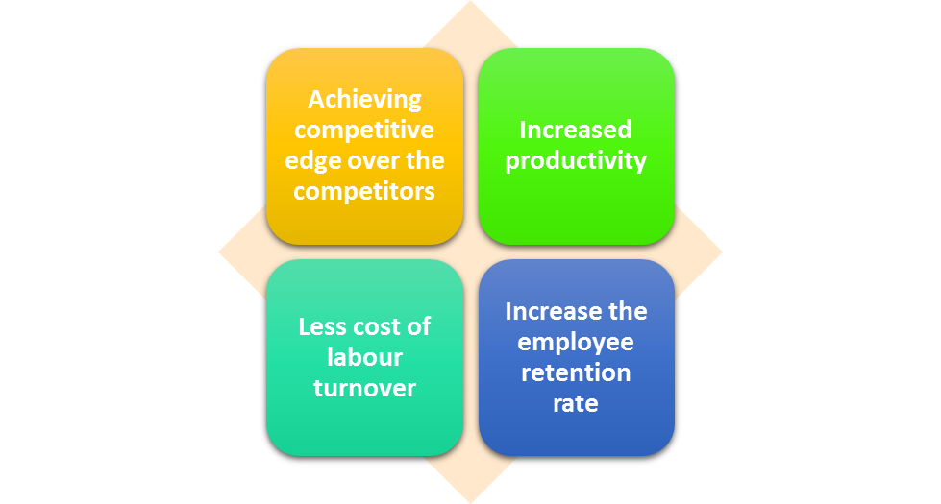
Figure 2: Potential benefits to the organisation of individual development
Source: (Liu, 2018)
Achieving competitive edge over the competitors: As the employees work in the organisation for a longer time period, it increases the competitive edge to the organisation as the employees can take quick decision and doesn’t that much cost of motivating them as they are quite motivated towards the job. The success of the organisation doesn’t depend on the strategy it takes to achieve the organisational goal. Rather it depends on how it can manage to achieve that goal in an effective and efficient way by motivating its employees towards the goal (Boots.com, 2019). As the employees know how to do the job more efficiently and effectively, it reduces the cost of acquiring and doing the job and the error rate are reduced that makes the company has the competitive edge over the competitors as the retention of the employees is a tough job nowadays as the loyalty towards the organisation as reduced (Martini and Cavenago, 2016). If the employees don't how to do the job properly, he will lose the motivation and that will force him to leave the job or doing a less efficient job. Thus it will help to get a competitive edge over the competitors.
Increased productivity: Those employees who are trained and developed works more frequently and makes fewer errors while working and thus it increases the productivity of the organisation. As it focuses on continuous development program by empowering the employees and necessary training Programs, the productivity of the employees increases as they gain more capabilities by the training programs they are given by the organisation to them (Liu, 2018). The increase in productivity increases the overall revenue of the organisation as it provides the ultimate result to this organisation by the introduction of a development program to them (Burke and Cooper, 2013). As they feel empowered and at home, they do more work than the normal time to ensure that the organisation can make a more efficient outcome. That's why it increases productivity.
Less cost of labour turnover: As the labour turnover increases the cost of labour recruitment, hiring and other necessary development cost and it occurs much when the employees don’t have the clue what is to be done and how to be done (Kuntz et al., 2017). But developing them reduces that cost as they can properly understand the context of the job and thus the labour turnover reduces so thus the cost of recruiting. As the labour cost reduces, it increases the profit margin of the organisation that is a huge help for the organisation in the long run (Alblas and Wijsman, 2016). As it can retain many employees, it gets some human resources and they remain loyal to the organisation as it values them.
Increase the employee retention rate: Increasing the training and development program increases the efficiency of the employees working in the organisation and thus it increases the retention rate of the organisation. It is one of the prime desire of every organisation to retain as much as employees it can (Armstrong and Landers, 2018). Those who can manage a good relationship with the employees by providing proper motivation along with the payment and promotional activities like training and development can enjoy much retention rate compared to the other organisation those cant make good relationship with their employees. as it maintains a huge employee base and maintains a good relationship with them can retain much more employees than the other organisation by providing proper and timely training to them (Lewin et al., 2016). That reduces the cost of recruiting employees to the organisation as it doesn’t need to make timely recruitment as the employees are retained by the organisation.
Potential benefits to employees
As the employees are given the training by this organisation, it increases the productivity of the employees that works better in the long run and that’s why it creates some potential benefits to the employees. the potential benefits of a training program to the employees are:
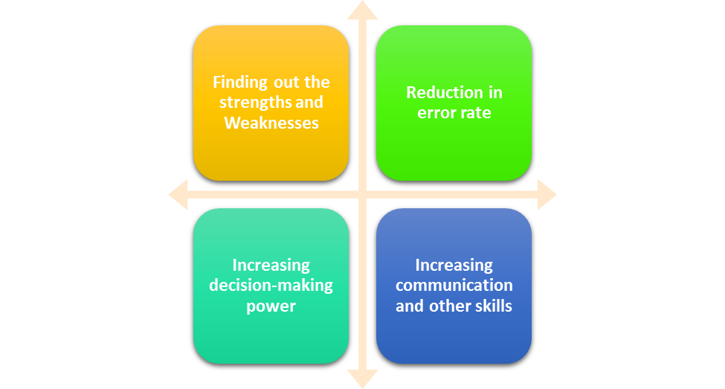
Figure 3: Potential benefits to employees
Source:
Finding out the strengths and weaknesses: As it operates in various countries, it can make some problem that the new employees can't find out. But as the employees work for a longer time by getting training and development program, they know the context of the job they are given and thus it increases the strength of the business (Nerstad et al., 2018). As increasing the empowerment to the employees increases the decision-making ability to the employees, they remain more cautious while doing anything to make the things right and thus it increases the strength of the business by diminishing the weaknesses in the long run (Naim and Lenka, 2018). The trained employees are the assets of the organisation that is supposed as the strength that every organisation wants to maximize to ensure a better outcome.
Reduction in error rate: Those employees who are trained makes less fault than the untrained ones. The higher rate of error they make, the deviation of the expected result occurs for the faulty works. As they don’t make the right thing without the training and development program, it increases the error rate and reduces productivity by a particular employee (Talwar and Thakur, 2016). As the employees will be trained according to the organisational standard, the deviation from the expected result will reduce to the minimum possible and thus it will be helpful in achieving the organisational overall goal for the long run (Solis, 2017). So it runs the training and development program to ensure the betterment of the goal achievement of increasing efficiency in the production process.
Increasing decision-making power: Employees with training and development program can take a better decision that of the untrained one that increases the potential benefit to the employees as they can make the proper decision (Manuti et al., 2017). The employees with better decision-making capabilities get the chance to work in the promoted position and that’s why it creates some potential benefits to the employees as it can increase the decision making the base of the employees that will work for the long run. So it is the benefit of the employees as he gets paid along with the training program provided by an organisation that is increasing his skills though it is done for the organisational purpose (Han, 2017). But he is the one who gets rewarded for the increasing performance made for the given training to him.
Increasing communication and other skills: As the employees who are been given the training and development program as well as the empowerment, they tend to communicate more frequently and in an easier way than the other people who haven’t been trained. That’s why it increases the communication and other necessary skills of the employees by the training program (Sharma et al., 2016). A fresh graduate may have the difficulties in communicating with others but the training program reduces that hassle by increasing their confidence level and communicating skills that provide long term benefit to the employees. as lack of communication, skill is treated as the most vulnerable characteristics of the employees at the workplace, but the training can reduce that barrier and increase the efficiency of the employees to communicate in a better and far efficient way that creates long term benefit for the employees (Adegbite et al., 2017).

Critically evaluating Development vehicles available to Boots UK and explaining the extent to which they are appropriate in meeting the development needs of the individual
As the employees are being developed by this organisation based on some predetermined criteria to make sure that the training is adequate and proper to ensure the strategic intent of the organisation (Nerstad et al., 2018). That’s why it uses proper development tools to make sure that their cost doesn’t increase and the efficiency is maintained properly to ensure a balanced result of the organisation. While using the development vehicle to the organisation, the efficiency of using the technique should be measured as they won't be providing the same result if they aren’t applied properly according to the organisational needs. These things should be taken care off by Boots UK while selecting the development vehicle for it:
Techniques for supervision and formal appraisal: The technique for supervision plays a vital role in determining the performance of the employees as the employees will be feeling demotivated if they are being supervised by the employers for most of the time. The supervision should be adequate enough as the 360-degree supervision will be ensured within the organisation as everyone working in the organisation will be supervising the work of the colleagues, superior or subordinate to give a better outcome of the result along with with the supervisor himself (Manuti et al., 2017). As supervising by the supervisors only will demotivating the employees as they will be taking it as a lack of trust of management towards them. And reducing the supervision for that purpose will be increasing the error of the employees as they will be taking the work less seriously than before. That’s why 360-degree supervision will be used here to make sure that the supervision is accurate enough (Martini and Cavenago, 2016). The person with the highest rating will be promoted to the next position for the supervision result and it should be the only way to appraise the employees, not because of the nepotism made by the manager to ensure better employee management relationship and the better outcome made by the employees.

Methods of ensuring fair and objective appraisal: The evaluation of the employee performance is to be made properly by using the 360-degree method as the use of supervision should be made adequately and properly to ensure that the employees remain ready to be assessed by the management at any time while working. The management uses 4 methods to assess the employee performance in Boot UK and 360-degree assessment is used mainly to ensure proper employee performance. The balanced scorecard, management by objective, self-assessment are used in this organisation to ensure a fair and proper assessment of the employee performance within the organisation (Sharma et al., 2016). Employees are given the chance of showing integrity by using self-assessment and 360-degree assessment within the organisation. The employee involvement is assessed by using the management by objective (MBO) to see that who are most active and who doesn’t participate in any decision making as well as the communication skills of the employees that ensure the fairness and objective of the performance appraisal within the organisation.
Methods to monitor evaluate and record individual feedback: It is very important to collect and implement regular feedback from the employees to ensure the proper outcome of the feedback program. It uses basically suggestion box and personal feedback providing to ensure proper feedback are taken without disclosing the identity of the person who is providing feedback. As a result, the proper feedback is ensured within the organisation as the employees aren’t treated badly if they provide any negative feedback to the authority and the corrective measures are taken properly after the feedback are taken (Martini and Cavenago, 2016). The feedbacks are collected and recorded to the organisational record to ensure that the change is applied and the employees are satisfied with the management performance to them. That increases the employee performance towards the organisation as the peer who gets the application of his feedback motivates his peers to provide feedback to the management about any problem he has been facing while doing the work.

Reporting performance appraisal including the importance of confidentiality: While running the appraisal by using 360 methods proper confidentiality is maintained within this organisation as the organisation wants to motivate the employees while taking feedback (Manuti et al., 2017). If they disclose the identity to the employees about the person who has provided the feedback, it would harm the relationship among that person as the negative appraisal will reduce the relationship intensity to a certain extent (Margol, 2017). To make a cohesive team, the management uses proper confidentiality and appraisal method within the team that increases the performance by balancing the team and reducing the negativity among the parties who provide feedback to the organisation.
Mechanisms to provide appropriate feedback to individuals: It provides feedback to the employees properly and regularly to maintain the performance level as the decrease in performance level is warned to the employees in a positive way. As there is two way of motivating employees by providing feedback, it uses positive feedback to the employees in a direct way and uses negative feedback by maintaining proper delicacy as they would lose their will to work if they are provided with their weakness in a harsh way (Talwar and Thakur, 2016). The increase in work motivation is been done by the positive feedback providing and the easy way of providing negative feedback to the employees. It doesn’t go for the retrenchment or any termination at the very beginning of the performance is reduced, rather it provides some corrective actions to the employees for more than twice and thrice to solve the problem of the employees (Brooks, 2017). if they can't comply with the change of their problem, they are been terminated for not maintaining compliance with the organisational change.
Learning styles and the range of training/development opportunities available: There are various learning and training opportunities available to this organisation and these are described below:
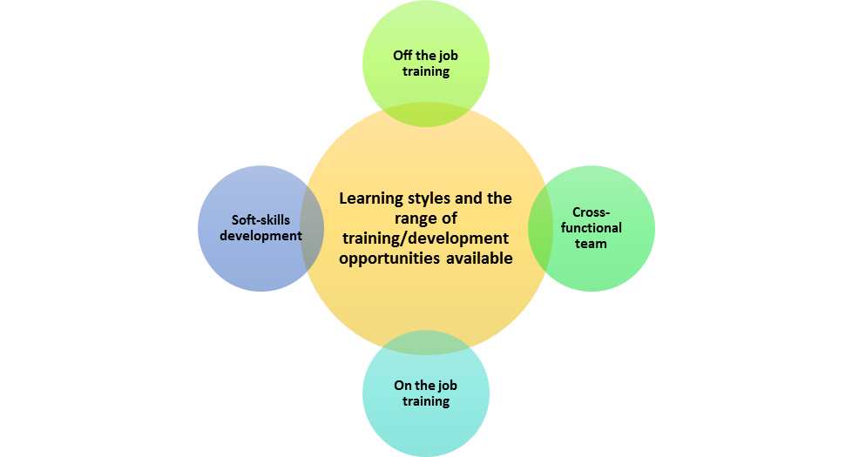
Figure 4: Learning styles and the range of training/development opportunities available
Source: (Nerstad et al., 2018)
On the job training: The employees are given the chance of learning by promoting self-learning among the employees by providing them on the job training. as they are given the chance of doing their own job in a given situation, it promotes creative soliton of the problem they face while doing the job (Sharma et al., 2016). That’s why the one the job training program is made by this organisation to get some interesting solution from the learner though they provide their solution to the learner if they aren't able to find out any solution of the problem they face while doing the job.
Cross-functional team: The organisation are provided with some cross-functional training as the employees are given the task of joining a cross-functional team that enables them to learn something new from the new team members and as a result, they learn something new from them (Armstrong and Landers, 2018). As they need to do every work while working in those team, they get the cross-functional promotion while working with them without knowing that they are learning a new thing. That’s why it is a very interesting thing that increases the learning among the team members and the effect of this learning provide a very long term result to the employees as they learn from their peer which is more effective from learning from the teachers.
Off the job training: There is some job which cant be done while providing a real-life solution as it can make some detrimental solution to the organisation. That’s why the off the job training are provided to the employees by making them ensured the thing that should be done while facing a new situation (Manuti et al., 2017). As it is a chemical oriented business, it can provide some basic learning to the employees and it remains attractive for a very limited time. As a result, it cant provide some lucrative outcome to the management without providing a short term benefit.
Soft-skills development: The soft skill of the employees are the most important thing for employees as it cant be taught to the employees that easily as it needs personal finding from the work they have been doing. For that purpose, the soft skills development program is being run by this organisation to give them a little grasp of the problem-solving (Nerstad et al., 2018). That’s why they use this technique though it can't provide that much success as it is subconscious learning rather than the conscious learning.

Developing a plan to meet the identified development needs and expectations of an Individual
Examining the expectations and requirements of people: As the employees want to be involved in the development plan that would reduce their hassle and increase productivity for the long run. They are given some task in a given situation to make sure that what should be done at that moment. If they can't solve the problem, then it is thought that he has lackings in that particular thing and provided with the needed training to solve the problem (Talwar and Thakur, 2016). The expectation of the employees isn’t the same for most of the cases as they have different expectations while being in a different stage of their personal life. The higher-level employees are given with non-monetary motivation along with the monetary and the lower level employees gets the monetary reward and training to ensure maximum satisfaction.
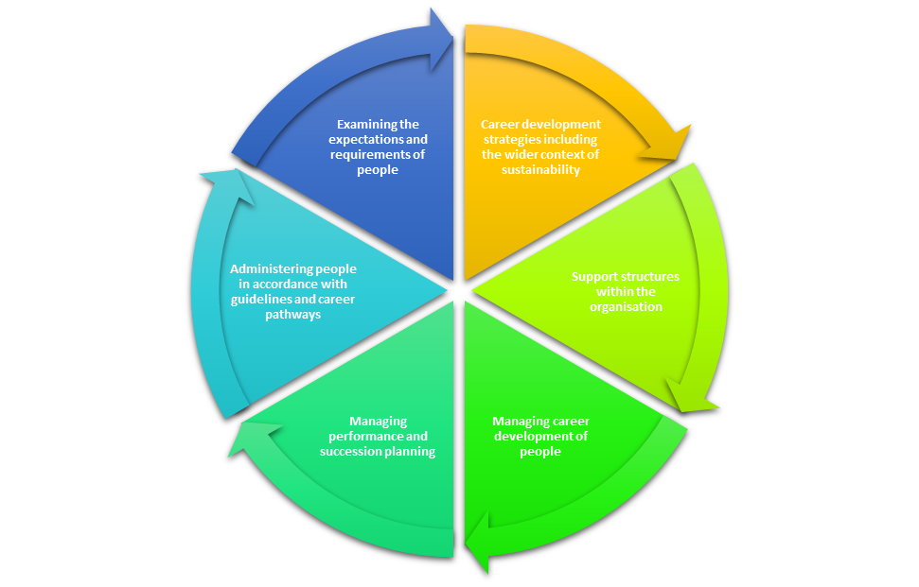
Figure 5: Development needs and expectations of an Individual
Source: (Kuntz et al., 2017)

Administering people in accordance with guidelines and career pathways: Same career pathways won't be helping the different people as the applicability of the models towards a person. That’s why the person with different skill and mindset would be provided with different career pathways (Manuti et al., 2017). That’s why they are been given self-learning opportunities and collection of management trainee would increase the chance of collecting the employees who have a different skillset. It is done to assess whether the employee has the skills to do the job and according to the response of the employees to the job, he is assigned with the department they would be working in the working days.
Managing performance and succession planning: The succession planning is needed to be prepared at the very beginning while starting the training program as it will be defining who will be assigned to the top position after the result of the training program achieved. The employees with better development would come forward of the succession planning to ensure the integrity of the training program (Kuntz et al., 2017). As the top position would be vacant in the recent future, some potential candidates are prepared within the organisation to make sure that the management doesn’t need to panic while finding the match for that position. And that makes the management deciding who are on the list of being the potential manager of the organisation. A chart is maintained by this organisation to see the result of the succession planning to assign the job to the most active person.
Managing career development of people: Dawn Lennon Hit mentioned in his model while developing people within the organisation that the management needs to ensure two things while developing individual within the organisation (Armstrong and Landers, 2018). He mentioned the role of HR in maintaining the culture of growth within the organisation to enable the employees to develop themselves in a better way by increasing their own effort to develop them. And another thing is the effort of the employees in developing their own skillset to adopt the change brought by the management. That’s why the HR management and the employees should be working jointly to bring better change within the organisation.
Support structures within the organisation: The structure that enables the development of the employees should be followed within the organisation. As the organisation allows the employees to maintain self-learning and increase efficiency, the management makes the empowerment of the employees and increase the motivation to achieve success in the long run (Nerstad et al., 2018). The organisational structure allows the employees to get more promotion as it doesn’t follow bureaucracy to maintain a rigid structure, rather it follows a flexible organisational structure to make sure the employees are given the chance of making a decision about their work and get timely promotion according to their performance and skill level.
Career development strategies including the wider context of sustainability: The career development strategies include the following steps to maintain sustainability:
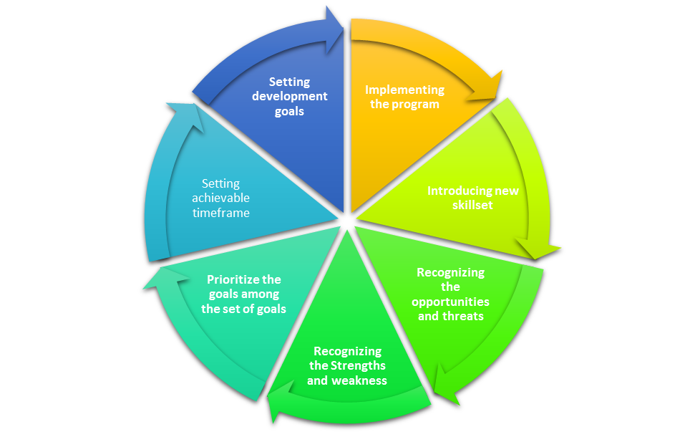
Figure 6: Career development strategies including the wider context of sustainability
Source: (Talwar and Thakur, 2016)
Setting development goals: First of all the goals are to be set by the management about what should be measured by the management to develop their employees. that’s why the development plan will start from setting the goal such as increasing the IT expert within the organisation (Sharma et al., 2016). The attainable goals and objective may be set to make sure that the employees don’t take it as a burden to be fulfilled it becomes unrealistic to them.
Prioritize the goals among the set of goals: As it is a multi-domestic organisation, it has a lot of goals to be accomplished and that’s why it should make a priority list to make sure that the most important goals are attained through making a priority list for the organisation (Martini and Cavenago, 2016). The priority list will determine what should be achieved in this year and what should be done in the following years to ensure a better performance.
Setting achievable timeframe: To be a smart goal, the goal must have a timeframe and the management must set the time to make sure that the goals are achieved within a limited time. The goal without time is like a ship without an anchor (Harteis, 2012). That’s why it should be setting a predefined time which will ensure that what is the achievement of the goal within the limited time set by the management.
Recognizing the Strengths and weakness: The management needs to find out the internal strength and weakness of the organisation and the employees to apply the HR policy to develop the employees and make it sustainable to the organisation (Manuti et al., 2017). If the management doesn’t consider the strength and weaknesses of the organisation and the employees, the change won't be bringing any attainment within the organisation.
Recognizing the opportunities and threats: The change may bring some opportunities to bring some competitive advantage towards the organisation as it will be helping the management to make decisions about bringing sustainable development (Talwar and Thakur, 2016). But there is a huge chance of increasing turnover as the employees who gets training program leaves the organisation to get a job with a high position as they have the capabilities.
Introducing new skillset: The management will need to introduce some new skillset to the organisation to take the development program and thus it will be helpful in bringing change to the organisation (Kuntz et al., 2017). As the employees don’t know what to be done at the very first time, the change needs some skillset to make it meaningful and easy to the management as it will be helping the employees to get a direction about which should be followed.
Implementing the program: After deciding the precondition about what should be done, who will be given the promotion, who will be in charge of the development program, what should be promoted off the employees, the program started (Albrecht et al., 2018). The most it can define the problem, the more effective the solution will be as the detailed specification is needed to ensure efficiency within the change implementation to maintain the proper result.
Measuring progress: After introducing a development program to the organisation, the organisation needs to assess what has been done to the employees after implementing the change in it and then measuring the progress of the development program should be assessed to get a balanced solution of the training and development program more sustainable.

Conclusion
As the human resource plays the vital most role in achieving the organisational goals, the management needs to remain cautious about the fulfilment of the goal by assessing and training the human resources of the organisation to make sure that the employees are able to fulfil the strategic intent. The empowerment of the employees in decision making should be increased to make sure that they remain active and creative solution is accepted within the organisation. If it allows the more creative solution to the organisation, it would result in finding out a more frequent solution by breaking the rigid structure to a flexible one. Ensuring proper employee empowerment along with proper developing and training tool, more efficient decision making would be done to increase the competitive advantage of the business as a human is the main source of achieving core competency.

References
Adegbite, O., Simintiras, A., Dwivedi, Y. and Ifie, K. (2017). Organisational adaptations. Cham: Springer Verlag.
Alblas, G. and Wijsman, E. (2016). Organisational behaviour. [S.l.]: ROUTLEDGE.
Albrecht, S., Breidahl, E. and Marty, A. (2018). Organizational resources, organizational engagement climate, and employee engagement. Career Development International, 23(1), pp.67-85.
Armstrong, M. and Landers, R. (2018). Gamification of employee training and development. International Journal of Training and Development, 22(2), pp.162-169.
Boots.com. (2019). [online] Available at: https://www.boots.com/ [Accessed 8 Dec. 2019].
Brooks, I. (2017). Organisational Behaviour. Harlow, United Kingdom: Pearson Education Canada.
Burke, R. and Cooper, C. (2013). The fulfilling workplace. Burlington, Vt.: Gower.
Han, X. (2017). Workplace Specialization, Individual Intra-Firm Experience Diversity and Entrepreneurship. Academy of Management Proceedings, 2017(1), p.14464.
Harteis, C. (2012). When workplace learning fails: individual and organisational limitations â exemplarily demonstrated by the issue of responsibility in work life. International Journal of Human Resources Development and Management, 12(1/2), p.92.
Kuntz, J., Connell, P. and Näswall, K. (2017). Workplace resources and employee resilience: the role of regulatory profiles. Career Development International, 22(4), pp.419-435.
Lewin, D., Gollan, P., Pyman, A. and Wilkinson, A. (2016). Employee Voice in Emerging Economies. Bingley: Emerald Group Publishing Limited.
Liu, W. (2018). High-involvement human resource practices, employee learning and employability. Career Development International, 23(3), pp.312-326.
Manuti, A., Impedovo, M. and De Palma, P. (2017). Managing social and human capital in organizations. Journal of Workplace Learning, 29(3), pp.217-234.
Margol, E. (2017). Microlearning to boost the employee experience. Alexandria, Va: Association for Talent Development.
Martini, M. and Cavenago, D. (2016). The role of perceived workplace development opportunities in enhancing individual employability. International Journal of Training and Development, 21(1), pp.18-34.
Naim, M. and Lenka, U. (2018). Development and retention of Generation Y employees: a conceptual framework. Employee Relations, 40(2), pp.433-455.
Nerstad, C., Dysvik, A., Kuvaas, B. and Buch, R. (2018). Negative and positive synergies: On employee development practices, motivational climate, and employee outcomes. Human Resource Management, 57(5), pp.1285-1302.
Sharma, N., Sharma, T. and Agarwal, M. (2016). Measuring employee perception of performance management system effectiveness. Employee Relations, 38(2), pp.224-247.
Solis, R. (2017). Employee training strategies for today’s workforce. Strategic HR Review, 16(6), pp.250-254.
Talwar, E. and Thakur, M. (2016). Training and Development and its Impact on Employee Performance. We'Ken- International Journal of Basic and Applied Sciences, 1(1), p.18.

