Artificial Intelligence
Ziyao Chen-2200438
Abstract
The MNIST handwritten digit recognition dataset was originally used to evaluate common ML algorithms, however, its overall simplicity makes it a poor choice for evaluating modern supervised classification ML algorithms. More recently this dataset has been replaced with the MNIST fashion dataset that consists of a similar number of images, pixels and classes.
In this assignment, I used the method I learned in class to solve the above database classification problem. Specifically, two machine learning algorithms were used to design and implement a system for classifying MNIST datasets. This article mainly includes an introduction to the MNIST fashion dataset, KNN, decision tree classifier, usage, performance comparison and so on.
Contents
1.Introduction 2
1.1 MNIST fashion dataset 2
1.2 KNN 3
1.2.1 Basic Principles 3
1.2.2 Description of algorithm 3
1.2.3 Distance calculation: Euclidean distance 3
1.2.4 Main parameter Settings 3
1.2.5 The key to KNN algorithm 4
1.3 decision tree 4
1.3.1 Introduction to decision tree 4
1.3.2 Construction of decision tree 5
1.3.3 Characteristics and process of decision tree 5
1.3.4 Three main algorithms for decision trees 6
1.3.5 Pruning of the decision tree 7
2.Related Work 8
2.1KNN 8
2.2decision tree 9
3.Experiment and result analysis 9
3.1KNN 9
3.1.1 Performance measurement method 9
3.1.2 Test set and training set partition 9
3.1.3 Performance indicators obtained under different parameters 9
3.2 decision tree 11
3.2.1 Index of evaluation 12
3.2.2 ROC curve 12
References 13
Appendix 14

Introduction

1.1 MNIST fashion dataset
MNIST fashion dataset is basically a database of pictures that replaces the MNIST numerals dataset. It is provided by the research arm of Zalando, a German fashion and technology company. It includes a total of 70,000 positive images of different types of products from 10 categories. The size, format, and training/test set division of the MNIST fashion dataset are equally as the original MNIST- 60,000/10000 training test data partition, 28x28 gray scale picture.
The MNIST data set has become one of the mandatory data sets for fellow scholars.
In order to be compatible with MNIST, Fashion-MNIST and MNIST format, category, data volume, train and test division, exactly the same.
It can be said that MINIST fashion database has brought new evaluation standards for data sources and algorithms to the field of machine learning. On the one hand, it brings a large amount of picture data into the algorithm evaluation system, which can analyze and evaluate machine algorithms more carefully and accurately. On the other hand, the same data organization form as the traditional MINIST database can facilitate researchers to better use the new database and enhance the efficiency of scientific research.
In the MNIST fashion dataset, the training set contains 60,000 image samples, while the test set contains 10,000 samples. The samples were divided into 10 categories, such as clothes, trousers, shoes and bags that are common in our lives. Each sample is a 28×28 grayscale image and contains a total of 10 categories of labels corresponding to its own picture. As it shows in Figure 1.
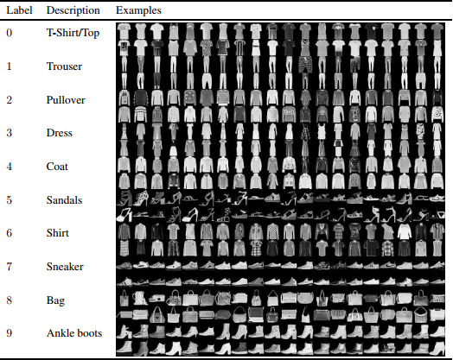
Fig.1

KNN

1.2.1 Basic Principles
The most important idea of KNN algorithm is that if a sample is closest to the nearest k samples in space, and has the characteristics of this class of samples, then this sample and these samples should be classified in principle. The basic idea of this method is to find one or several samples closest to this sample, and judge the category of this sample by the category of these samples. KNN method only needs to use decimal adjacent samples in classification decision. KNN determines its own category mainly through adjacent samples that are close to it, rather than by identifying the region where the samples are located. As it shows in Figure 2.
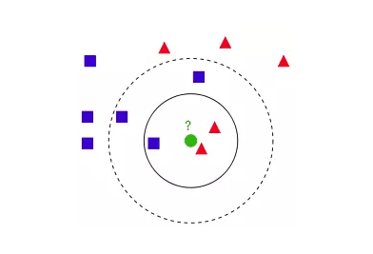
Fig.2

1.2.2 Description of algorithm
1) Calculate successively the distance;
2) According to the size of the distance calculated above, increment sort;
3) Pick the K points that are the smallest of all distances;
4) The category frequency appearing in the first K points is statistically determined;
5) The categories identified with the highest frequency are returned and recorded as the predicted category of the target test data.

1.2.3 Distance calculation: Euclidean distance
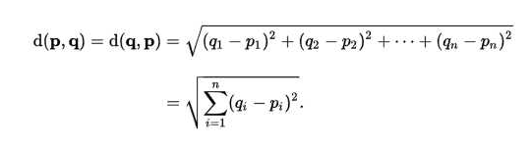

1.2.4 Main parameter Settings
- n_neighbors: indicates the k value of KNN
- weight
- algorithm
- leaf_size
- metric: Used for distance measurement, i.e., p=2 Euclidean distance (Euclidean metric). (The default metric is minkowski)

1.2.5 The key to KNN algorithm
(1) All features of the sample should be quantified comparably.
For example, the sample features contain colors, which can be converted into gray values to achieve distance calculation.
(2) The sample features should be normalized.
(3) Use a function that calculates the equivalent distance to calculate the distance between two samples.

decision tree

1.3.1 Introduction to decision tree
Decision tree: It is a very classical method to deal with classification problems and carry out effective regression. This paper mainly discusses decision tree for target classification.
In the classification problem, it mainly carries out the corresponding classification and regression process of the target object according to the characteristics of the target object.
Decision trees usually have three steps: feature selection, decision tree generation and decision tree pruning.
Decision tree classification (Fig.3): first of all, the process is to test the corresponding main features of the target from the root node, and according to the results, the target features are assigned to the nodes as the corresponding relationship. In this point, every child node links to a corresponding value of the feature. Loop through this method, recursively testing and assigning the characteristic value of the target until it reaches the leaf node, and finally assigning the target to the class given to the leaf node.

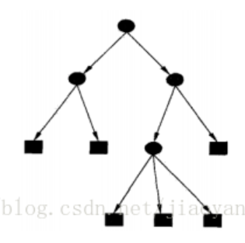
Fig.3
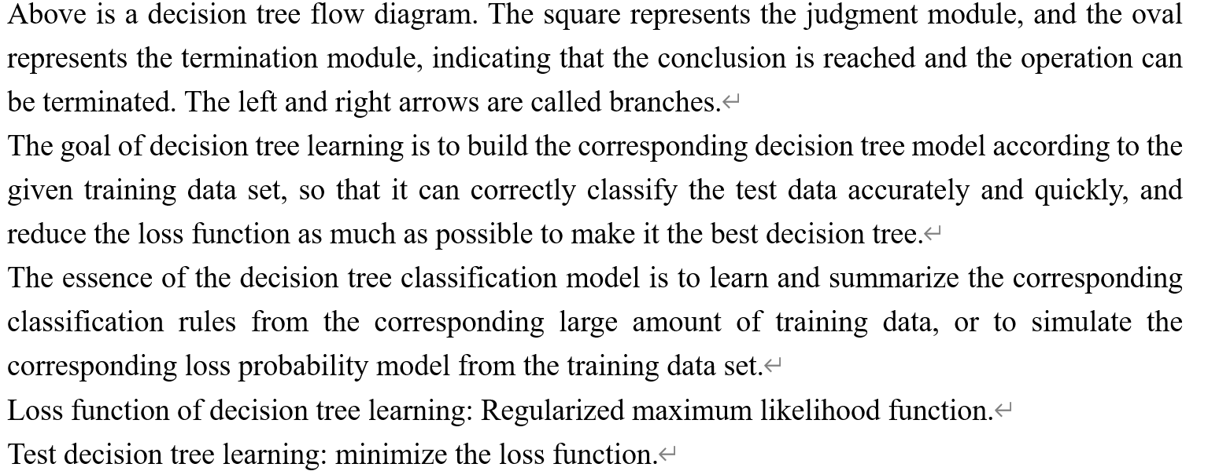
Although K-nearest neighbor algorithm can complete many classification tasks and the organization form of its data is very easy to understand and read, it still has a relatively large limitation, that is, it cannot accurately translate the internal meaning of the data and the internal relationship between the data.

1.3.2 Construction of decision tree
The steps of decision tree generation include tree building and pruning. Tree building process: The decision tree is built using a top-down pattern. Pruning process: Pruning is mainly to remove noise. After the decision tree is generated, test samples are used to conduct repeated test on the decision tree. Once the decision tree fails to meet the requirements, it needs to be re-pruned until it reaches the standard. Under the decision tree structure, each non-leaf represents the detection and decision of data items. Select the branch from the decision result, start from Root, judge from top to bottom, iterate to the end node, a decision tree is successfully constructed. In the whole decision, the existence of data interference or noise causes errors or deviations in the training branch. The method of pruning can be used to preprocess interference data or noise data. In practice, using inductive method to delete exceptions or non-important branches can also reduce the dependence of decision tree on test data and improve the accuracy of data classification. In the real world, it is impossible to ensure the completeness of the data possessed. Therefore, if the training set contains a lot of noise or abnormal data or insufficient analysis, the decision tree generated by the decision tree algorithm will have branch exceptions. Therefore, trees generated by too simple algorithms will inevitably overfit training samples.

1.3.3 Characteristics and process of decision tree
Cons: Can cause overmatching problems (i.e., overfitting)
Applicable data types: numeric and nominal
Using decision trees to make predictions requires the following processes:
1) Data collection;
2) Data preparation;
3) Data analysis;
4) Training algorithm;
5) Test algorithm;
6) Use algorithms.

1.3.4 Three main algorithms for decision trees
1) ID3
Attribute selection is the key of ID3 algorithm. Firstly, all the information in the database is tested, the information gain between each attribute is calculated, the attribute with higher information gain is used as the attribute of the test, the field with the largest information gain is found as the construction condition of the decision tree, and then the branches of the decision tree are established according to the different values between different fields. In the decision tree algorithm, ID3 algorithm selects attributes by calculating information gain, and C4.5 algorithm is improved based on it. Basically, CART algorithm proposed at the same time selects the Gini index with the smallest set of tested attributes as the standard. Because Gini index is difficult to deal with multiple class problems, classification data will always reside in memory, which greatly affects the performance.
The methods are:
- Firstly, feature screening should be carried out all features of the node and corresponding information gain should be calculated and counted;
- Different values of the features calculated above are used to establish child nodes, and then recursive methods are used to call and build decision trees for child nodes.
- End up.
ID3 is the same as the selection of probabilistic model by maximum likelihood method.
2) Generation algorithm of C4.5
C4.5 algorithm can be used for statistical classification and classification problems in machine learning and data mining.
The goal of C4.5 algorithm is to use learning methods to find a correspondence between attribute values and categories, and this correspondence can be used to classify new entities whose categories are unknown. C4.5 algorithm is a classical algorithm after improvement of ID3 algorithm, mainly improved from the following aspects: incomplete data and non-discrete data
Be able to handle.
C4.5 algorithm has been widely used in finance, industry, medical treatment, insurance and other fields to convert data into useful information and knowledge due to its advantages of easy interpretation of construction rules, fast classification speed and high accuracy. Therefore, the research and improvement of C4.5 algorithm is of great significance and value to a large extent and is also very important. At present, domestic and foreign scholars have focused on the improvement of C4.5 algorithm from how to deal with the improvement of continuity attribute, how to improve the operation speed of C4.5 algorithm, etc.
Recently, C4.5 arithmetic is often used to deal with data mining work. Data mining is a step of database knowledge discovery, its goal is to search out the hidden and useful information from the huge data full of many uncertainties. Through the extraction of useful data for analysis to predict the future of a certain behavior and trend, and then help the group of users to make corresponding decisions. Data mining is generally related to the computer profession, will involve a lot of technical fields, integrated statistics, database technology and artificial intelligence technology. It also has many functions. In order to meet different target needs, it often contacts with each other to jointly find the rules in data information and constantly improve the process of prediction model. Data mining technology is actually to extract useful knowledge for people. The extraction of useful knowledge must have the following characteristics: can be accepted, can be used, can be understood, and is not the universal law of society. Due to different sources of data samples, different mining requirements, different data types and data meanings, the process of data mining does not have unified step requirements. Generally speaking, data mining can be divided into five processes: target positioning, data preparation, data mining, data evaluation and knowledge representation.
- Recursively build the decision tree:
The data set partition may have two or more branches due to the possibility of having more than two eigenvalues in the data.
- The conditions for the end of the recursion are:
The program needs to completely traverse all data attributes in the data set partition, or data that has the same classification attribute under each branch. If the corresponding instance has exactly the same classification.
3) cart algorithm
CART: Classification and regression tree.
CART is a classification method to learn and make decisions on the conditional probability distribution corresponding to the output that the input is fixed. In CART methods, it is generally assumed that the decision tree is a binary tree. Such a decision tree is equivalent to using recursive method to divide each feature into a certain number of decision units, and predict the corresponding probability distribution on these units, that is, predict the conditional probability distribution of output under given input conditions.
Gini index:
The generation of decision tree is the process of using recursive method to construct binary tree. I'm going to focus here on classification trees. For a given sample set D, its Gini index is: Gini(D) represents the degree of uncertainty of random variables in set D. The smaller the Gini index is, the higher the purity of the data is; conversely, the larger its value is, the greater the uncertainty of the sample set is, which is similar to entropy. When the probability of a class in a sample set D is 0, Gini(D) gets the maximum value, and the random variable is the most uncertain at this time.
It should be noted that CART is a binary tree when a feature is used to divide some sets, it only has two sets: 1. If the sample set is equal to the given eigenvalue D1, 2. If the sample set D2 is not the same as the eigenvalue which is already given, it is in fact a binary process with multiple eigenvalues.
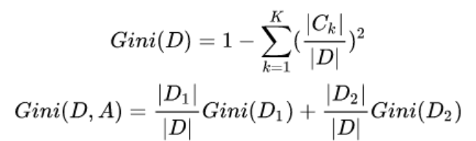
CART generation algorithm:
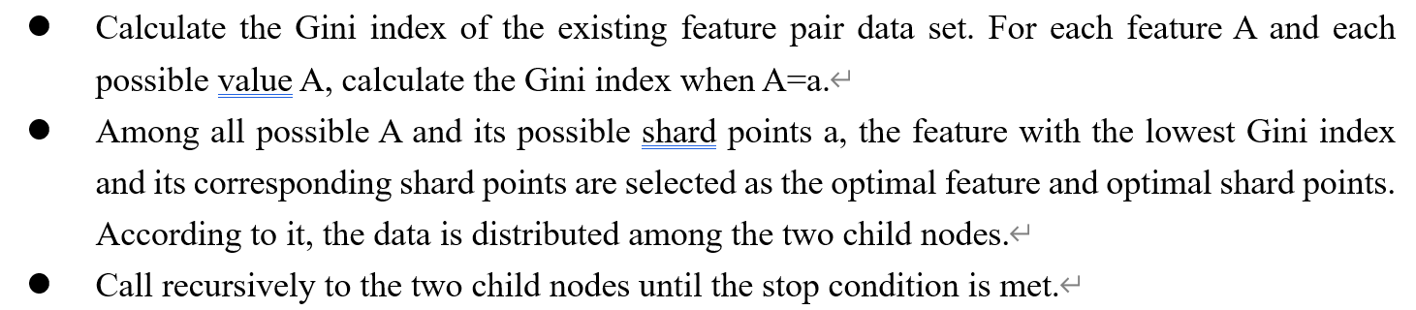

1.3.5 Pruning of the decision tree
Pruning is to select the model with the smallest loss function.
The loss function is just the balance between the two.
The loss function considers that the uncertainty degree of each classification endpoint (leaf node) is the loss factor of classification, while the number of leaf nodes is the complexity of the model. As a penalty term, the first term of the loss function is the training error of the sample, and the second term is the complexity of the model. The larger the loss function value of a subtree is, the worse the subtree is. Therefore, we hope to make the loss function value of each subtree as small as possible. The minimization of loss function is the process of model selection by regularized maximum likelihood estimation.
The pruning process (generalization process) of the decision tree is to recurse from the leaf node. The subtree after shrinking all the child nodes is denoted by its parent node as Tb (the classification value is the characteristic value with the largest proportion of categories), and the subtree without shrinking is T a. If Cα (T a) ≥ Cα (Tb), the loss function decreases after shrinking. Then this subtree should be shrunk and recursively until it cannot be shrunk. In this way, pruning with the idea of "greedy" can reduce the value of the loss function and also make the decision tree generalized.
It can be seen that during the generation of decision tree, only the improvement of information gain is considered to better fit training data, but the pruning of decision tree also considers the process of reducing model complexity and loss by optimizing loss function.

Related Work

2.1KNN

1951 Evelyn Fix and Joseph Lawson Hodges Jr. The nearest neighbor rule was first proposed. But because of the social environment at the time, they did not publish this work.
in 1962, George S Sebestyen named KNN as Proximity Algorithm in his Decision-making processes in pattern recognition.
In 1965, Nils J. Nilsson wrote the book Learning Machines: Foundations of Trainable Pattern-Classifying Systems -- Classifying Systems KNN is called a Minimum Distance Classifier.
In 1967, Thomas Cover and Peter Hart officially introduced KNN in the paper Nearest neighbor pattern classification, which was the first official publication of KNN.
After the proposal of KNN, the subsequent research work mainly focuses on two aspects: efficiency and effect.
Efficiency optimization: KNN comparison is suitable for relevant classification problems of large sample data size, but it is easy to misjudge problems with small sample size. Therefore, according to the current research status, it is a mainstream direction of KNN efficiency optimization to reduce the number of samples and their features, and greatly reduce the attribute features that have little impact on classification results. In 2006, Zhang et al., in their paper SVM-KNN: A new machine vision classification method based on SVM and KNN similarity measurement framework is 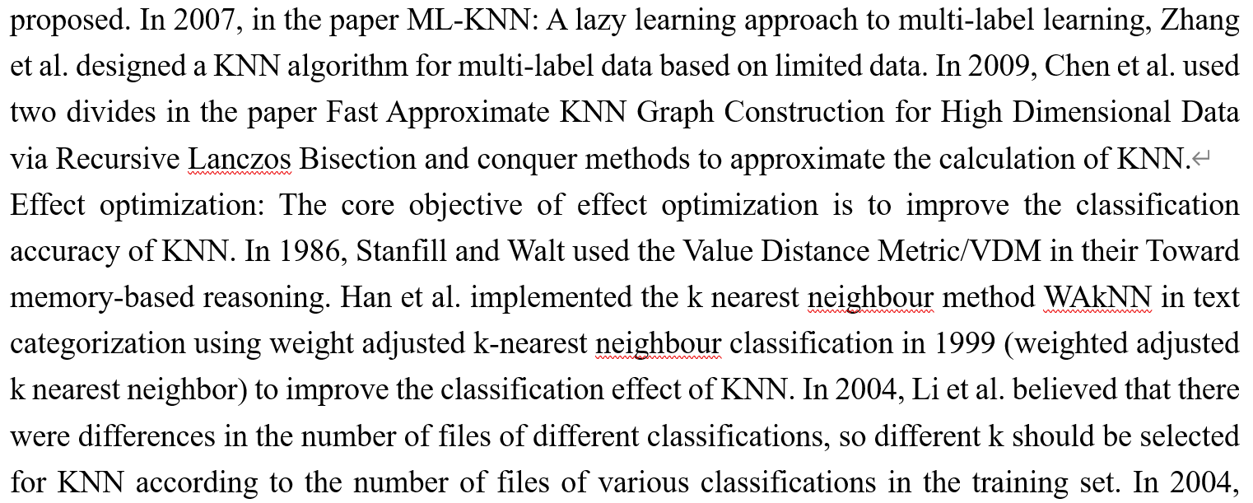
Goldberger et al applied Mahalanobis distance to KNN in the neighborhood components analysis (NCA) to achieve dimension reduction.
The above is a brief introduction to the development of KNN. From the initial idea germination to the continuous optimization of efficiency and effect, researchers have continued to explore for nearly 60 years. It is worth mentioning that although KNN has gradually faded out of the public eye, it is still the first choice in most fields.

decision tree
The earliest decision tree algorithm is CLS proposed by Hunt et al in 1966. The current optimal influence algorithm is ID3 proposed by Quinlan in 1986 and C4.5 proposed by Quinlan in 1993.

Experiment and result analysis

3.1KNN
KNN：85.97%

3.1.1 Performance measurement method
Precision, Accuracy, F1 (Precision, Recall)

3.1.2 Test set and training set partition
It includes a total of 70,000 positive images of different types of products from 10 categories. The size, format, and training/test set division of the MNIST fashion dataset are equally as the original MNIST- 60,000/10000 training test data partition, 28x28 gray scale picture.

3.1.3 Performance indicators obtained under different parameters
Constantly adjust parameter k, take other values as default values, and observe the change curve of its accuracy. A total of 10 times of training, k value from small to large 1 to 10, draw the curve of k value and accuracy, according to the curve observation, it can be seen that when k=4, the correct rate is the highest, so we set the value of k as 4 in the following experiment.
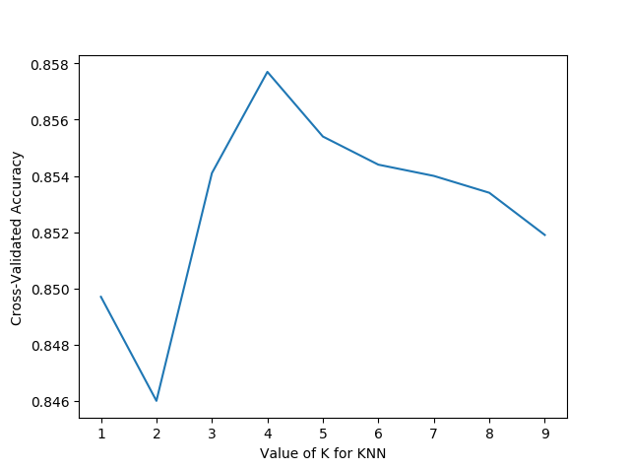

k = 4.
 | Change weights k=4
weights | uniform | distance
Precision | 86.04 | 86.26
Accuracy | 85.77 | 85.97

Accuracy, recall rates, F1 values for each category.
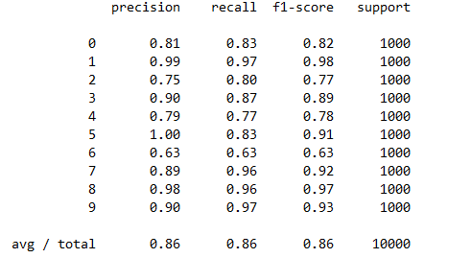

ROC curves for each category.

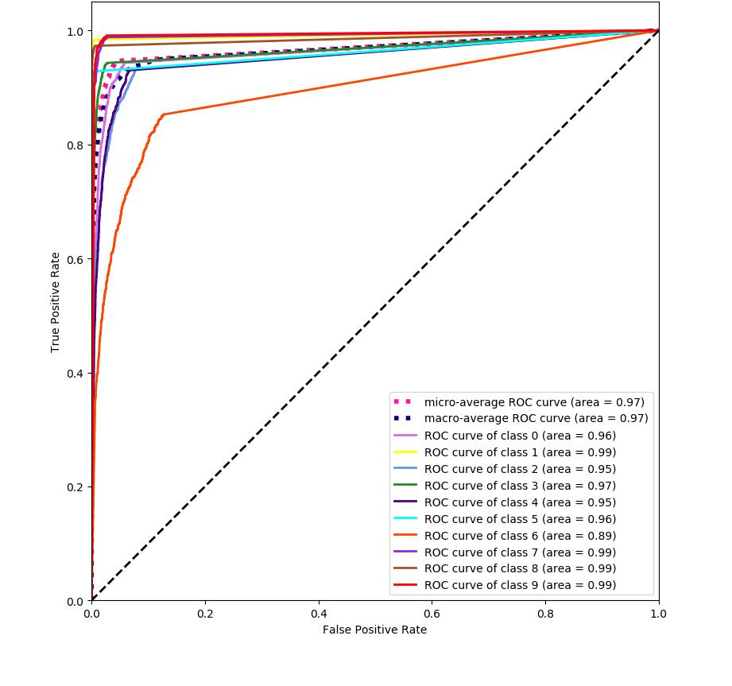

3.2 decision tree
decision tree: 83.1%

3.2.1 Index of evaluation
- accuracy
- precision
- recall

3.2.2 ROC curve
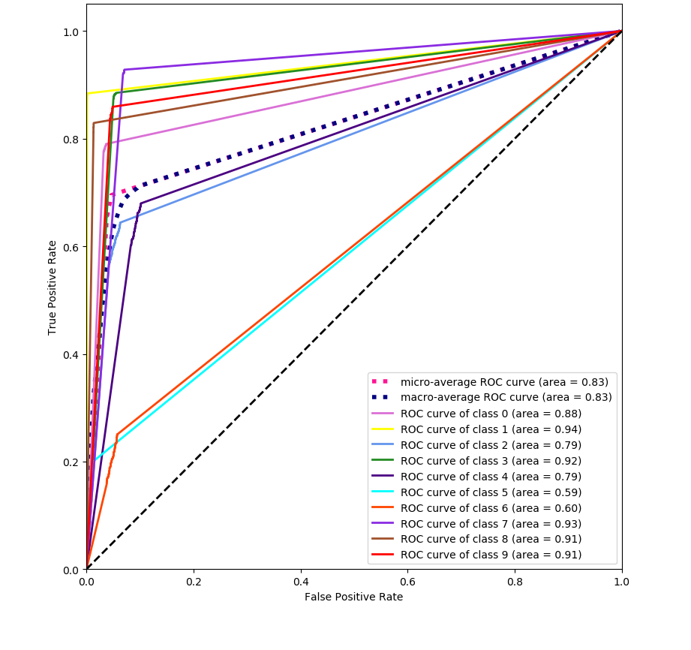

References
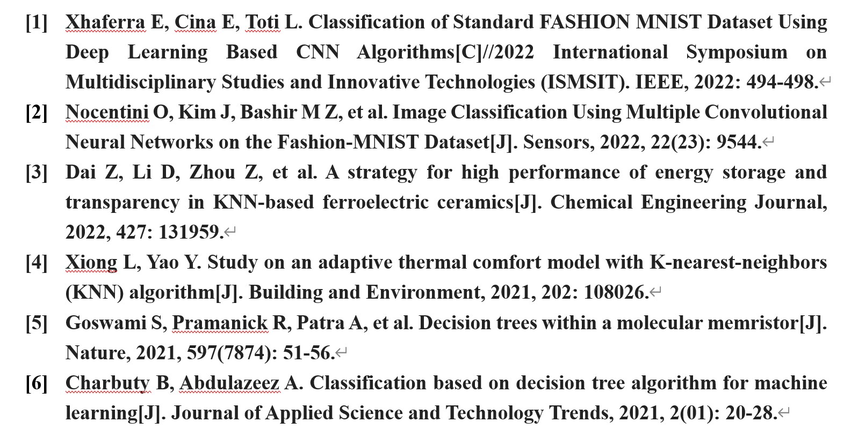

Appendix
written/edited programming code (KNN)
Run make_data.py to get the training and test set image files, training set and test set labels under fashion_mnist.
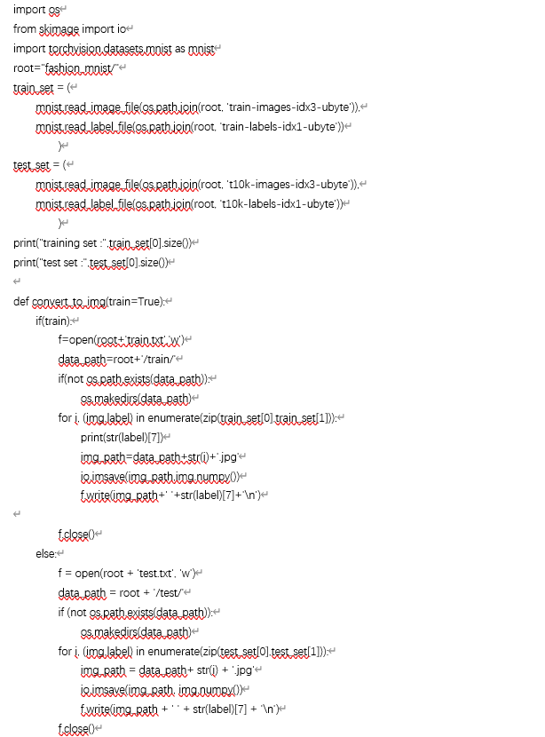
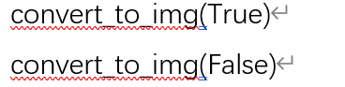
Run train_minst.py to test the performance of three different machine learning classifiers.
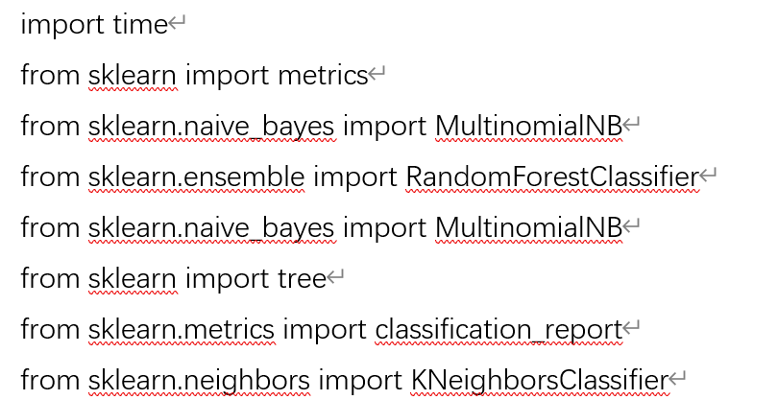
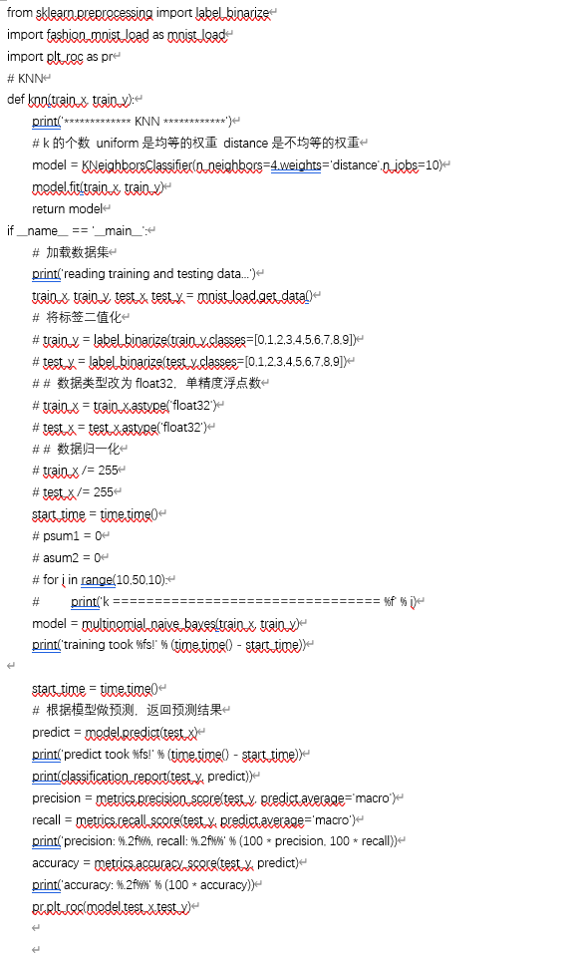

Run knn. py to find the best parameter k in KNN
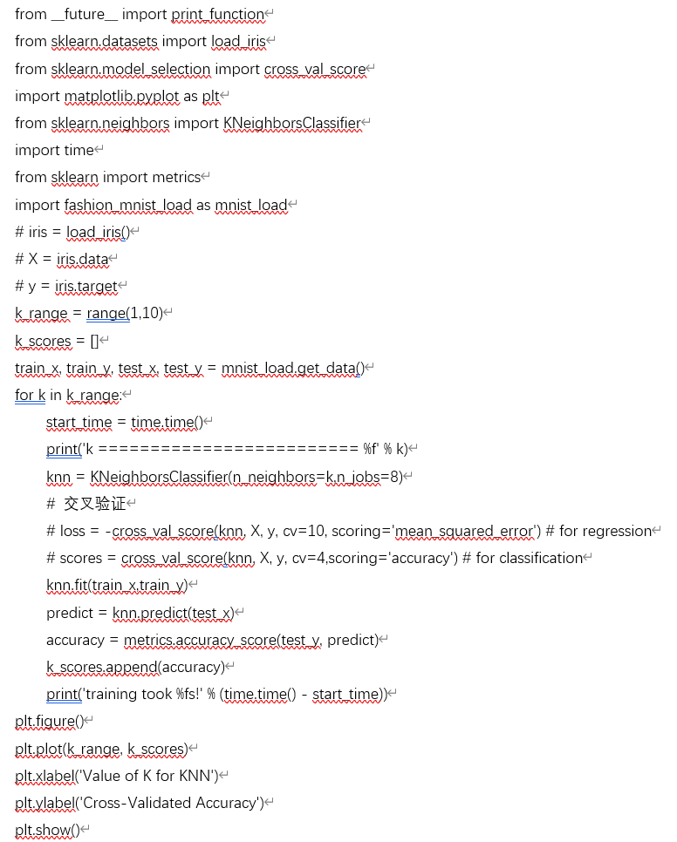written/edited programming code (decision tree)


