

Cloud Engineering Principles and Practice

ACCA7027 Assessment Report

Student Name:
Dharmik Patel
Student ID:
2506712
Programme:
MSc Cybersecurity and Digital Forensics
Submission Date:
Wednesday, 18th December 2025

Contents
Overview of Cloud Technologies and the Rise of Docker 1
Understanding Docker and Its Role in Modern Cloud Systems 2
1. Foundations of Virtualisation in Cloud Computing 2
2. The Concept and Advantages of Containerisation 2
3. Practical Use of Docker: Image Creation and Deployment 2
Key Docker Features and Their Role in Cloud Systems 3
4. Ensuring Data Durability with Docker Volumes 3
5. Networking Capabilities in Docker Networking 4
6. Docker’s Role in Cloud-Native Architecture 4
7. Docker and Application Scalability 4
Essential Cloud Computing Mechanisms: Load Balancing, Scalability, and Application Gateways 5
1. The Role of Load Balancing in Cloud-Based Systems 5
2. Understanding Scalability in Cloud Computing 5
3. Application Gateways in the Modern Cloud Infrastructures 6
4. Integrating Docker with Load Balancing, Scalability, and Application Gateways 6
Serverless Computing and Containerisation in Cloud Environments: A Comparative Perspective 7
1. Understanding Serverless Computing 7
2. Introduction to Containerization 7
3. Comparing Serverless Computing and Containerisation 8
4. Factors Driving the Growth of Cloud Computing 8
Influence of Docker and Containerisation on Modern Cloud Computing 9
Conclusion 9
References 10

Overview of Cloud Technologies and the Rise of Docker
Cloud computing has become an essential part of the contemporary IT that provides organisations and developers with unequaled flexibility, fast scalability, and costs less to operate. One of the underlying components of this change is the virtualisation that allows the physical hardware to be partitioned into several virtual environments. The applications and services can be executed in these virtual machines without any contact with the actual hardware [1].
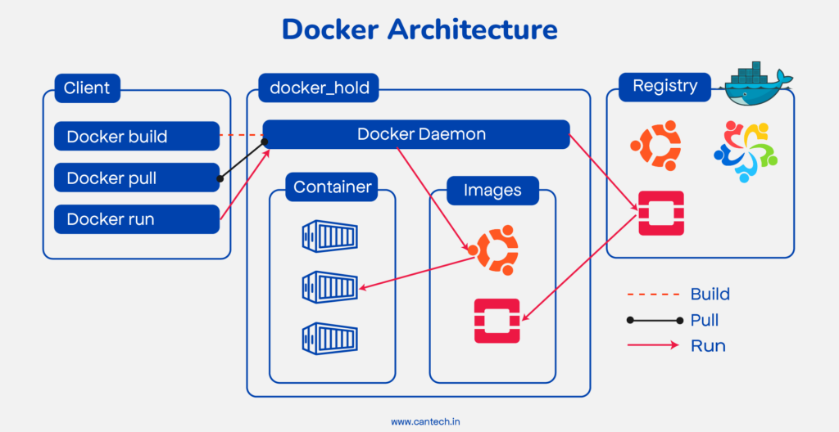
This report explores the place of Docker in cloud computing and how it has changed the manner in which applications are created, packaged, and distributed. Containers using Docker are fast to start, use little system resources and are compatible with major cloud vendors like AWS, Azure, and the Google Cloud. These features make Docker quite efficient in the environments when there is a need to scale fast and use dependable automated deployment. Unified working environment also helps developers to enjoy continuous working environment throughout the entire development lifecycle, starting with early codes writing until testing and roll out of production [2].
In a bid to give a systematic explanation, this report starts by giving a background of the concepts of virtualisation and containerisation. It continues with the practical uses of Docker in cloud scenarios, such as creation of images, data persistence by using volumes, and networking between containers. One critical benefit of Docker that has been emphasized in this report is that it is highly compatible with cloud platforms, therefore, allowing cloud-native applications and making the distribution of distributed applications much easier [3].

Understanding Docker and Its Role in Modern Cloud Systems

1. Foundations of Virtualisation in Cloud Computing
One of the basic principles of cloud computing is virtualisation since multiple virtual machines (VMs) can use one physical machine. The hardware of a server, including CPU, memory, and storage, is divided into a number of independent virtual machines, each of which is using a separate operating system by a hypervisor. This allows the cloud providers to optimise hardware use and allocate resources dynamically in respect to demand [2].
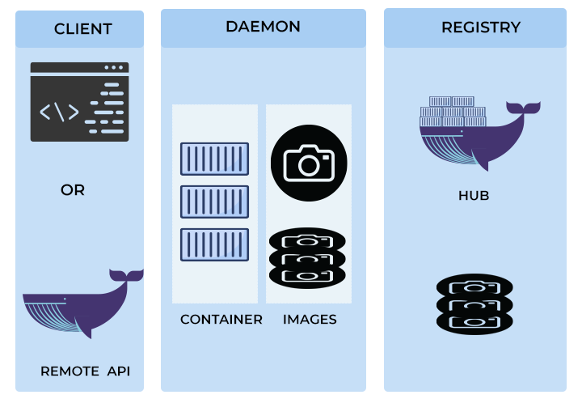
There are also some significant constraints with virtualisation even with its advantages. Due to the surrounding full operating system, each VM has been found to be a heavy resource of the system. Scaling VMs on a single server is more memory and CPU intensive, which is not usually efficient, particularly when workload demands high-speed scaling.
Docker has created a solution to these limitations, which is containerisation that is more lightweight. Containers use the host OS kernel, and the only difference is the isolation of the user space of the application. This helps to decrease memory overhead, startup time is fast and applications scale easily. Container technology thus suits cloud platforms which are dependent on rapid deployment and elastic resource assignment [3].
In one of our practicals, we developed a simple web application with Docker. We did not need to configure a whole virtual machine to do it, but just started a containerised edition of the app. It was very efficient due to its fast boot up and replicability, which meant that it could easily handle more traffic during testing. [18].

2. The Concept and Advantages of Containerisation
Another model that can be used to deploy an application is the concept of containerisation, which isolates the application environment but does not duplicate an operating system. Containers contain all necessary parts, such as libraries, runtimes, and configuration files yet they rely on the host OS kernel. Docker is the most popular platform that makes it possible due to the easy tools that it provides to package, distribute, and run applications in various environments [4].
Cross platform portability is one of the greatest strengths of Docker. A container image is a self-sufficient collection of resources that a program requires to be executed in any machine with Docker. This does away with the traditional works on my machine problem that always interferes with the work process in developing and producing products [2].
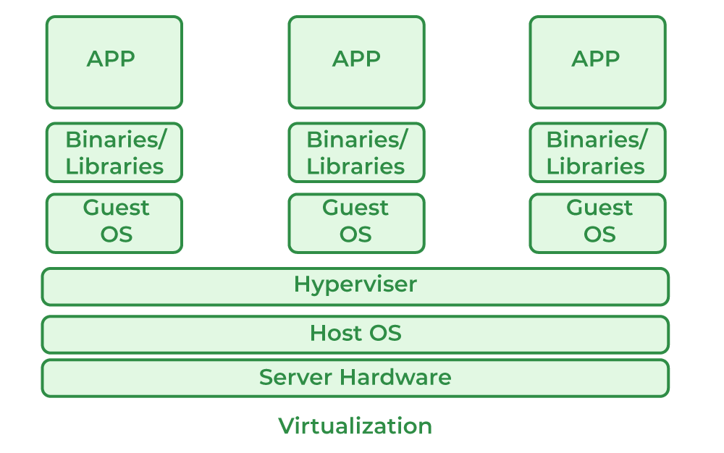
To illustrate, in class we containerised an application built using the Node.js programming language by creating a Dockerfile that included instructions like setting a base image, installing dependencies, and setting environment variables. Once the image was built, we could execute the application the same way in any system that had the Docker installed.
Resource efficiency is another major advantage. Containers are smaller and lighter than virtual machines because a full OS is not included in them. It means that a single server can host numerous more containers than VMs, which makes Docker a better choice in areas of cloud-native workloads that need to scale fast and consume minimal resources [4].
3. Practical Docker: Creation of an Image and Deployment.
A Docker image is a template to start containers. It has all instructions, application code, dependencies, system tools and environment variables. Images are usually built by the developers with a Dockerfile that defines the commands that are followed one by one to build the environment.
We created a Python Flask application in one workout in the classroom as a Docker image. In our Dockerfile, we used an official image of Python and copied the files of the application, installed dependencies, and defined the way the application is going to run. The simplified version is presented below:
FROM python:3.9-slim
WORKDIR /app
COPY . /app
RUN pip install -r requirements.txt
EXPOSE 5000
ENV FLASK_ENV=production
CMD ["python", "app.py"]
After preparing the Dockerfile, we generated the image with:
docker build -t flask-app-demo .
We then launched the application using:
docker run -p 4000:5000 flask-app-demo
This mapped port 5000 inside the container to port 4000 on the host machine, enabling us to access the running app at http://localhost:4000.
To support collaboration, we uploaded the image to Docker Hub, a public registry. The process involved logging in, tagging the image, and pushing it:
docker login
docker tag flask-app-demo yourusername/flask-app-demo
docker push yourusername/flask-app-demo
Once published, any team member could pull and run the same image, guaranteeing consistent behaviour across development machines and cloud servers.

Key Docker Features and Their Role in Cloud Systems

4. Ensuring Data Durability with Docker Volumes
One of the greatest advantages of Docker is that every container is running in an isolated environment with a clean environment, and there is no conflict between applications. Nonetheless, there is a restriction to this isolation, namely that the internal data of a container is temporal. Any data held within a container is lost when the container is halted, revised or deleted. This is a severe challenge to applications that use persistent data, like databases, log storage, analytics modules and other stateful services.
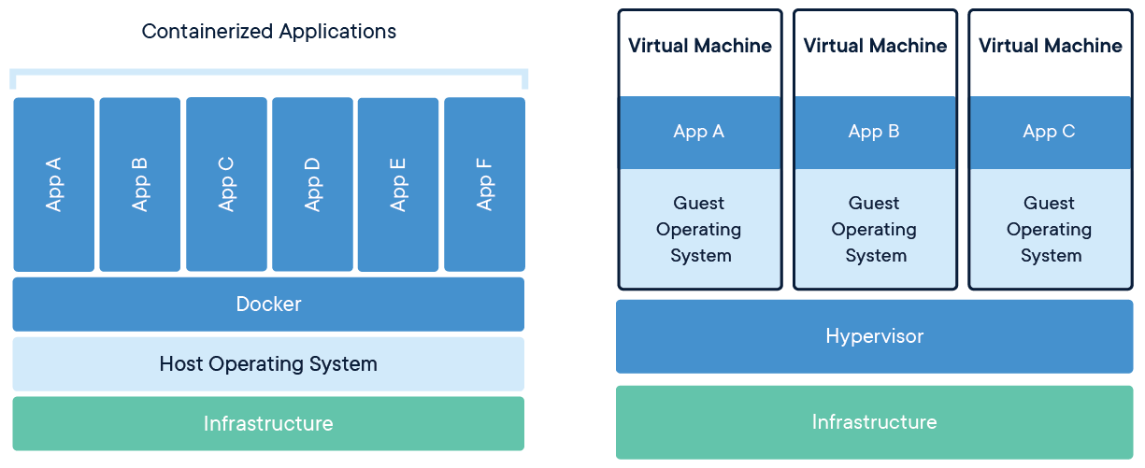
As part of our practical activity, we were running a MySQL database in a Docker container and a volume as the volume to keep the database files. First, we created the volume:
docker volume create mysql data.
And then we started the MySQL container and also mounted the volume:
docker run -d -v mysql_storage:/var/lib/mysql mysql -name mysql_server.
We did this to make sure that database records were not in the container by mapping (/var/lib/mysql) to the external volume. The data was saved even after the restart or deletion of the container. This method has been very popular in cloud deployment where reliability and continuous storage is required [5].
5. Docker Networking Networking Capabilities.
Docker has also an impressive networking infrastructure that allows the containers to not only communicate with each other but also other applications. Containers are defaulted to be isolated, although various networking drivers are provided in Docker to address various use cases:
- Bridge Network – The standard Docker network, offering isolated internal communication and external access via port mapping.
- Host Network – Containers share the host’s networking layer, allowing near-native network performance.
- Overlay Network – Designed for multi-host environments, enabling containers on different machines to communicate seamlessly.
- Macvlan Network – Assigns a unique MAC address to each container, making them appear as physical devices on the network.
As a demonstration in a classroom, we ran a Flask web app over a custom bridge network:
docker network create -d bridge app_network

docker network create -d bridge database network.
docker run -p 5000:5000 -network app_network flask-app.

This configuration provided an internal network of safe communication among containers and external users were still allowed to connect.

We also discussed a microservices-style architecture. There was one container that was dedicated to data processing, and another that was dedicated to authentication. The containers were also able to communicate with each other by means of an overlay network, despite being ready on various Docker hosts. This indicates the importance of Docker networking in distributed, cloud-native applications that require effective service-to-service communications [6].

MY YOUTUBE VIDEO LINK:
https://youtu.be/Uqxxnw_nqoM

6. The Docker part in Cloud-Native Architecture.
Docker will form a significant part of cloud-native application development that is focused on scalability, automation, and resilience. Such applications are typically based on container orchestration software, including Kubernetes and Docker Swarm, which handle container deployment, health monitoring, traffic distribution and scaling resources.
One of our practical laboratories deployed a cloud platform based on Kubernetes and a web application. Application load was monitored by Kubernetes and the number of containers were dynamically increased or decreased accordingly as demand varied. This enabled the system to support the sudden rise in traffic without human interventions so that high performance and availability was achieved [20].
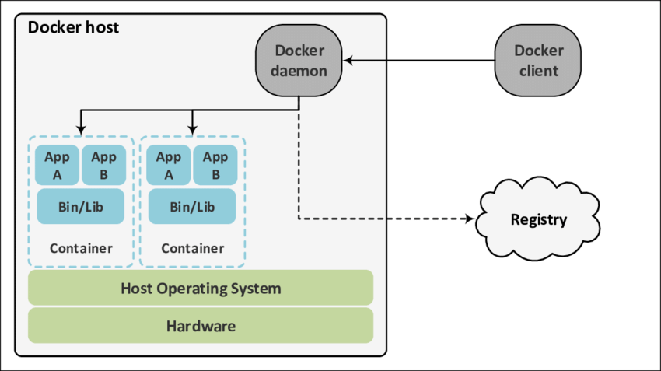
Docker is also significant in CI/CD pipelines. Containers allow eliminating incompatibility problems between local machines and test servers as well as production systems because of the consistency of the environment across all development phases.

7. Docker and Application Scalability
Scalability is a defining characteristic of cloud computing, and Docker supports both major forms of scaling:
- Horizontal scaling – adding more container instances to handle increased load.
- Vertical scaling – allocating more CPU, RAM, or storage to a single container.
During a lab session, we had used Docker Swarm to scale a containerised application horizontally across several hosts. Swarm automatically redistributed the incoming requests over the replicas to keep the application responsive with increasing demands [8].
After the application was brought up as a Swarm service, we scaled the service using the following command:
docker service scale web-service=5.
This resulted in five running replicas of the containerised application and this is what shows scaling horizontally.
This raised the use to five running containers.
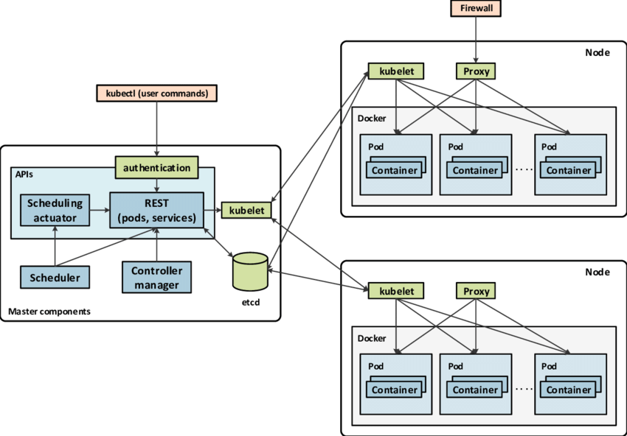
Docker is also compatible with vertical scaling in case of more resource-intensive workloads. We can give the container more power by changing the resource limits of the container at runtime:
docker run -d -memory 2g -cpus 2 analytics app.
This setup provides the container with 2 GB of RAM and two CPU cores, which means that the operations can be more demanding.
Docker allows vertical and horizontal scaling, thus allowing the flexibility to create adaptive, efficient cloud applications. This makes sure that resources are utilized optimally without unnecessary wastage and so Docker is a core component of modern scalable architectures.

Essential Cloud Computing Mechanisms: Load Balancing, Scalability, and Application Gateways

1. The Role of Load Balancing in Cloud-Based Systems
balancing is one of the techniques that are utilized in cloud computing to ensure that there is smooth flow of application without any interruption. Simply stated, it balances the incoming network traffic among a number of servers, virtual machines or containerised instances in such a way that no system becomes overloaded. In the absence of load balancing, the occurrence of a burst traffic may overload one server, leading to delays, crashing, or the total crash of the applications. Having a load balancer, traffic is redirected intelligently to resources available so that the performance remains steady even during peak operations [10].
All the industry giants, Amazon Web Services (AWS), Microsoft Azure and Google Cloud Platform (GCP), provide sophisticated load balancing solutions that are adjusted to various workload. AWS offers the Elastic load balancer (ELB) suite which has the capacity of automatically routing web traffic to healthy EC2 instances as well as integrating with auto-scaling groups. In Cloud Azure, Azure Load Balancer has a similar role to play in case of the virtual machines and the container instances. These managed services will check the health of the servers, and they will redirect traffic out of bad nodes and will also add capacity when the usage conditions vary [3].
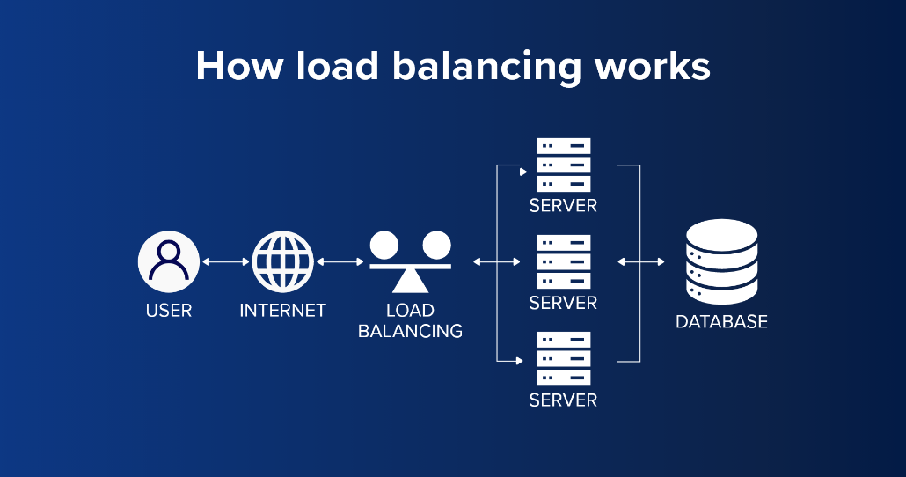
The concept of load balancing becomes even more significant in the case of microservices architecture where applications are decomposed into numerous small and autonomous services themselves which operate in their own containers. When the load balancer is used in these types of environments, it does not just send the traffic across the board evenly as well as helps to do service discovery by identifying the service instance that is available, healthy and capable of accepting their requests. This renders load balancing one of the important requirements of any cloud-native system which requires strong resilience, rapid recovery in case of failure and optimal utilization of resources [4].

2. Understanding Scalability in Cloud Computing
Scalability is among the most important characteristics of cloud computing that allows applications to process more extensive loads with dignity. A scaling system is able to increase resources when there is an increase in demand and to decrease the resources when the demand decreases. This elasticity has made it to achieve optimum performance at a low price of operation [11].
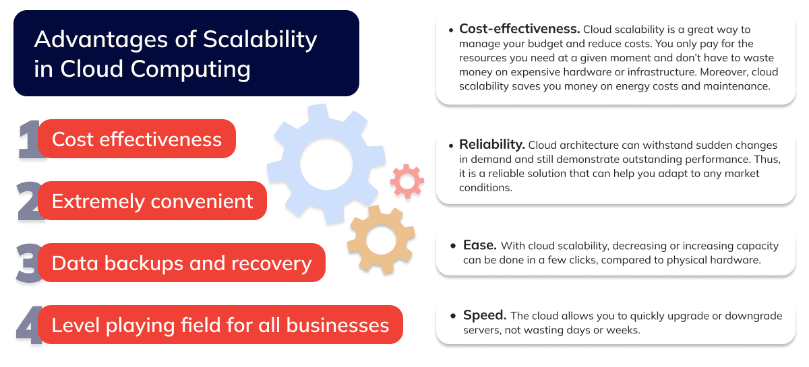
Scalability is of two main types:
Scaling out (Horizontal Scalability) provides the ability to expand server capacity by adding additional servers as needed without impacting server availability (correctly set up).<|human|>Scaling out (Horizontal Scalability) is the capability to increase the capacity of the server by adding new servers on demand without affecting the availability of the servers (properly configured).
AWS, Azure and GCP have cloud platforms which offer auto-scaling features, which enable the auto-scaling process to take place. As an example, AMW Auto Scaling can be applied to track metrics like CPU utilization or inbound traffic and automatically create or delete EC2 instances. This guarantees that there is no performance loss when there is high traffic, and the cost is reduced when there is low traffic [7].
In our classroom exercise, we deployed a containerised application in a Kubernetes cluster, and it was used to scale automatically. Kubernetes continuously checked the usage of resources and automatically changed the quantity of running containers in accordance to real demand. Kubernetes scaling was very efficient because Docker containers can be brought up fast and they require less resources compared to full VMs. Such an integration of containerisation and orchestration gave us a system that was never down even when there was a sudden surge in activity [2].

3. Application Gateways in the Modern Cloud Infrastructures
Another important component of a cloud architecture is application gateways. They are smart traffic controllers that lie between the users and the backend services. In contrast with the traditional load balancers that have their main feature in distributing traffic equally across the board, application gateways offer more sophisticated, application-layer functionality.
These include:
- Content-based routing (e.g., routing requests based on URL paths or HTTP headers)
- SSL/TLS termination, removing the burden of decryption from backend services
- Request inspection and filtering
- Authentication and access control
- Rate limiting and protection against malicious requests [12].
Both large cloud vendors also have a gateway solution. An example of such is the Azure Application Gateway that consists of URL-based routing, session affinity, termination ofSSL and Web Application Firewall (WAF) that secures against prevalent web attacks. In like manner, the Application load balancer (ALB) offered by AWS also supports HTTP/Https routing, WebSocket communication and sophisticated application-based guidelines.
In a practice we carried out in a class, an Azure Application Gateway was configured to send traffic to various backend containerised services depending on URL paths. As an illustration, the API requests to /api were directed towards an API container, and forwarded to /app requests were forwarded to a frontend container. The gateway also offloaded the processing of the SSL which made a significant impact on the burden that the backend systems had to handle [20].
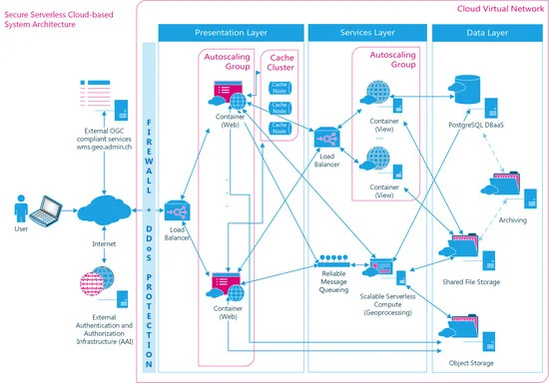
Application gateways are particularly important to microservices architecture, where applications consist of numerous interacting services. The architecture would have to be complex and security would be minimal without a gateway where users would need to be connected to each service separately. Gateways provide a unified and safe point of access to all external traffic getting requests routed properly and eliminating bottlenecks to enhance the reliability of the entire system in general [4].
4. Combination of Docker, Load Balancing, Scalability and Application Gateways.
Docker containers can be integrated with load balancers in the cloud, auto-scaling and application gateways to provide a powerful system to run cloud-native applications. Docker offers the transportability and uniformity needed in the contemporary applications, and cloud services take care of routing, performance optimization, and scaling.
A typical workflow of requests in a distributed architecture using Docker may resemble the following:
- A user sends a request → The request first reaches an application gateway.
- The gateway evaluates the request → It routes the request based on URL path, rules, or content type.
- The request is passed to a load balancer → The load balancer identifies the healthiest and least busy container instance.
- Auto-scaling adjusts real-time performance → If traffic rises, the auto-scaling system spins up more containers; if demand drops, it scales them down.
- Docker ensures consistency → Each container performs identically, no matter how many replicas exist or where they run.
This integrated model ensures high availability, fault tolerance, and smooth performance, even in heavily distributed microservices environments [13].
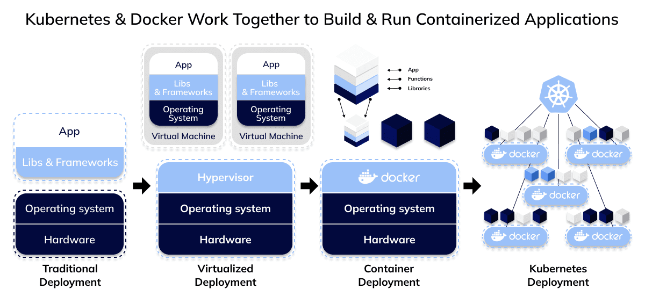
The lightweight containers of Docker can be scaled almost instantly by the load balancers and evenly distribute the workload. Application gateways provide higher security and routing intelligence. Together, these pieces form a scalable and strong cloud-native system that can be used by the contemporary enterprise applications.

Serverless Computing and Containerisation in Cloud Environments: A Comparative Perspective

1. Understanding Serverless Computing
Serverless computing is one of the significant changes in the way applications are run on cloud systems. Rather than leaving the developers to handle the server hardware, configure virtual machines, or watch the runtime environments, serverless computing makes all these areas the responsibility of the cloud provider. In this model, developers simply write and deploy the code and the cloud service takes care of all the operational needs by dynamically provisioning and automatically scaling the resources in the background. This strategy eliminates the overhead of maintaining infrastructure and lets the teams devote their entire time to application logic and business functionality [2].
One of the most important features in a serverless system is that it is event-driven. Events can be certain uploads, APIs being received, a time timer, etc., and only in this case, compute resources are allocated. These resources are released as soon as the function has been accomplished. This model will make sure that organisations only pay based on the actual compute time, but not the idle servers in the background waiting to get a request. It is specifically such on-demand execution model that contributes to the fact that serverless computing is highly scalable and cost-effective [14].

We developed a basic image processing script that was set off every time a new file was uploaded to an Amazon S3 bucket. AWS Lambda instantly ran the function, ran the image and shut down the task and only charged based on the milliseconds of execution. In this exercise, we noted that serverless computing can particularly be very relevant to applications whose activity is intermittent, whose workload is unpredictable or which may need to respond quickly and automatically [3].
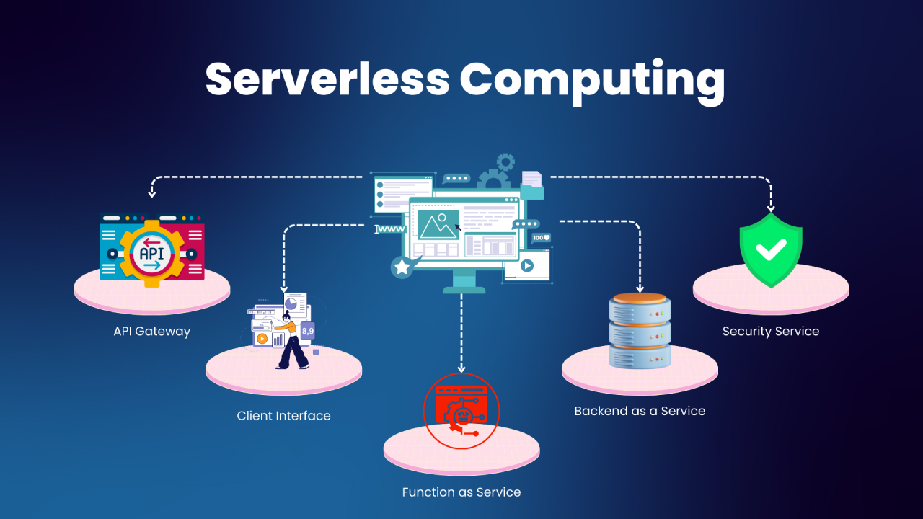
To conclude, serverless architecture is an effective blend of low operational costs, auto-scaling, and affordability. This makes it suitable in organisations with the need to develop rapid event-based applications not necessarily having to struggle with maintaining traditional server environment.

2. Introduction to Containerization
Another game changer in cloud computing is known as containerisation, but it has a completely different approach to the serverless architecture option. Containerisation provides developers with a lot of control over the application environment, as opposed to concealing the infrastructure layer. An application with all of its dependencies, libraries, configurations, runtimes, etc. is packaged into a small and completely portable unit that is consistent in its behavior across different computing environments. This means that an application tested locally can be used in staging, production or any cloud system[13] without any difference.
Containerisation can be especially useful in microservice-based architecture, in which applications are broken down into smaller, independent parts. Containerised services can be created, modified and scaled individually to support more efficient work by teams and the smooth growth of applications. The organisations can also automate processes like deployment of containers, monitoring, scaling, self-healing, and load balancing with the help of orchestration tools like Kubernetes. Kubernetes will keep containers alive, restart them when needed and scale up and down replicas automatically based on demand. [15].
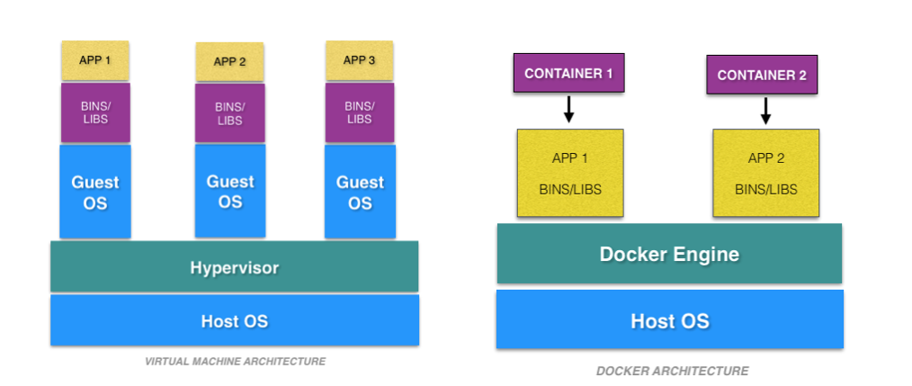
Containerisation is more useful in microservice architectures, where applications are broken down into smaller self-deployable units. Workloads are easily isolated, and individual components can be scaled with ease with each service operating within a container, and high availability can be ensured. Containers are not only lightweight and replicable, but also very portable which is also a critical requirement of cloud-native applications [2].
Since traffic was growing we could easily scale up the backend API in a horizontal manner by simply adding more container replicas. This emphasized how containers make it easy to manage complex systems and performs efficient scaling, portability and stable performance in cloud environment [9].
3. A comparison of Serverless computing and Containerisation.
Serverless computing and containerisation are both believed to facilitate the deployment of applications to the cloud, but there is a sharp contrast between the two models in terms of purpose, control, performance aspects, and best applications.
Maximum abstraction is offered by serverless computing. The developers create small, event-driven functions and the cloud provider does the rest. The servers do not have to be managed, scaling rules do not have to be established, underlying systems do not need to be configured. This simplicity has made serverless to be appropriate in backend applications like image or data processing, chatbots integration, form submissions, real-time notifications, and applications with uneven traffic trends. Serverless is a cost-effective option only on workloads that are not running constantly, because it is only charged based on execution time. [3].
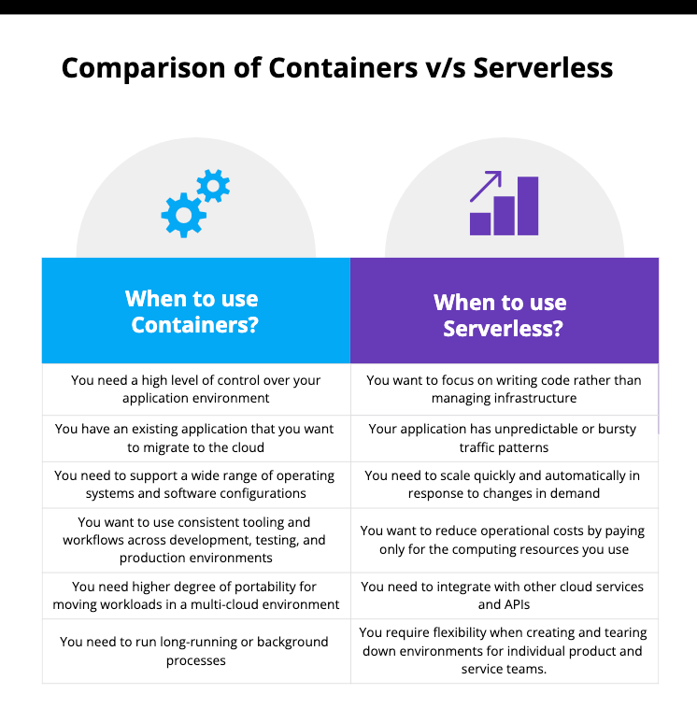
Containerisation, on the side, provides full authority to developers on the application environment. Containers are capable of running in a continuous mode, they support any programming runtime as well as giving developers the ability to install custom libraries and dependencies. Containership applications are far more appropriate to applications which need long running processes or background tasks, or need persistent workflows. Containers are not limited in terms of time and can run indefinitely unlike serverless functions which frequently have time restrictions to their execution ([14]).
A viable analysis of the two strategies came up during one of our classroom assignments. It was capable of doing larger and consistent loads and could be operated continuously. However, it also had to be managed manually during scaling and monitoring. By this comparison, it was evident that serverless computing is more effective in lightweight and event-driven functionality, and containerisation is more applicable to the multi-service architecture and more sustained cloud-based applications. [18].

4. Factors Driving the Growth of Cloud Computing
Cloud computing has grown fast in industries owing to the fact that it is flexible, economical, and scalable. There are a number of powerful forces that have led to its popularity and further proliferation [11]. Cost reduction is one of the driving forces. Historically, companies were required to spend a lot of money to install physical servers, storage technologies, network devices, and data centers. These were costly to buy, sustain and upgrade. Cloud computing will remove this burden by using a pay-as you go model that allows companies to only pay the money they actively consume. This renders cloud technologies affordable even to small and medium-sized companies that did not have the financial power to make substantial IT investments [15].
Also, the technological innovation which is ongoing has aided in the development of cloud computing. The adoption of such tools as Docker, Kubernetes, serverless frameworks, and new technologies of greater security has revolutionized the way software is developed, deployed and managed. The innovations enable companies to modernize their applications, embrace microservice architecture, automate, and build solutions with even more reliability and at a faster rate. [8].

Influence of Docker and Containerisation on Modern Cloud Computing
Docker has been a revolutionary in the history of cloud computing to replicate the way applications are packaged, deployed and scaled in distributed environments. The introduction of it signaled a transition to cloud-native development, in which an application is implemented completely anew to leverage the capabilities of the cloud, such as elasticity, modularity, and resilience. It is the uniformity of Docker containers, whether they are running on a local computer or a cloud provider such as AWS, Azure, or Google Cloud, that has enabled organisations to embrace the principles of cloud-native with significantly more certainty, as they can predict how they will perform in any of these environments [16].
The emphasis on environmental consistency and portability is one of the most significant contributions that Docker made. Prior to containerisation, developers used to face configuration issues due to differences between development, testing and production environments. These differences caused errors and failure to deploy with ease. Docker does away with these challenges by putting all the elements of the application: runtime, libraries, dependencies, and configuration in one container image. The behaviour of the application is the same, irrespective of both the hardware and operating system, provided that it is supported by Docker. This radically simplifies deployment pipelines and enables a single image of a container to be depended upon to work on a variety of cloud infrastructures or hybrid systems. [3].
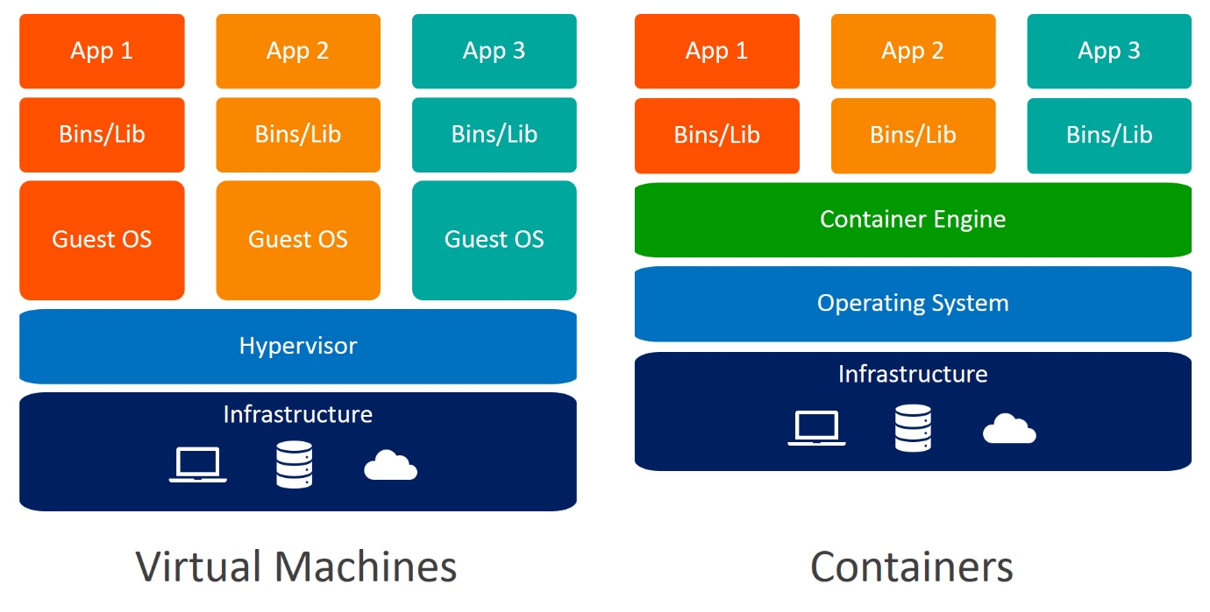
Moreover, Docker is currently a foundational technology in Continuous Integration (CI) and Continuous Deployment (CD). The current CI/CD pipelines are based on Docker images to ensure predictable yet repeatable environment in which code could be built, tested, and deployed in a controlled way. Since the environment is the same at each step, developers can detect bugs earlier, minimize integration conflicts, and shorten release times due to containers. This has been particularly critical in agile developmental settings, where there are constant, incremental changes that are required. Repeatability enables Docker to automate many aspects of a team, which eventually simplifies the deployment process and increases the reliability of the software [17].

Conclusion
Containerisation and serverless computing have become the core of the latest cloud ecosystems, and each of them is associated with its special advantages that can address specific types of applications. However, since both methods attempt to make the deployment process less cumbersome and more scalable, they do so with the help of different operational models that render them applicable in different situations. [8].
Containerisation gives a different perspective that provides the application environment to be under complete control of the developers. Containers package applications together with all the necessary libraries and configurations and provide a consistent behaviour on development, testing, and production. This is particularly useful in the context of containerisation and microservices architecture where specific services should be isolated, scaleable as well as deployable independently. Containers can be configured to run continuously as opposed to serverless systems and can be configured to custom runtime settings. Other tools like Docker, Kubernetes, and Docker Compose extend the capability of the container-based systems by facilitating automated scaling, rolling updates, resilience, and resource optimisation of the distributed environments [15].

Screenshots

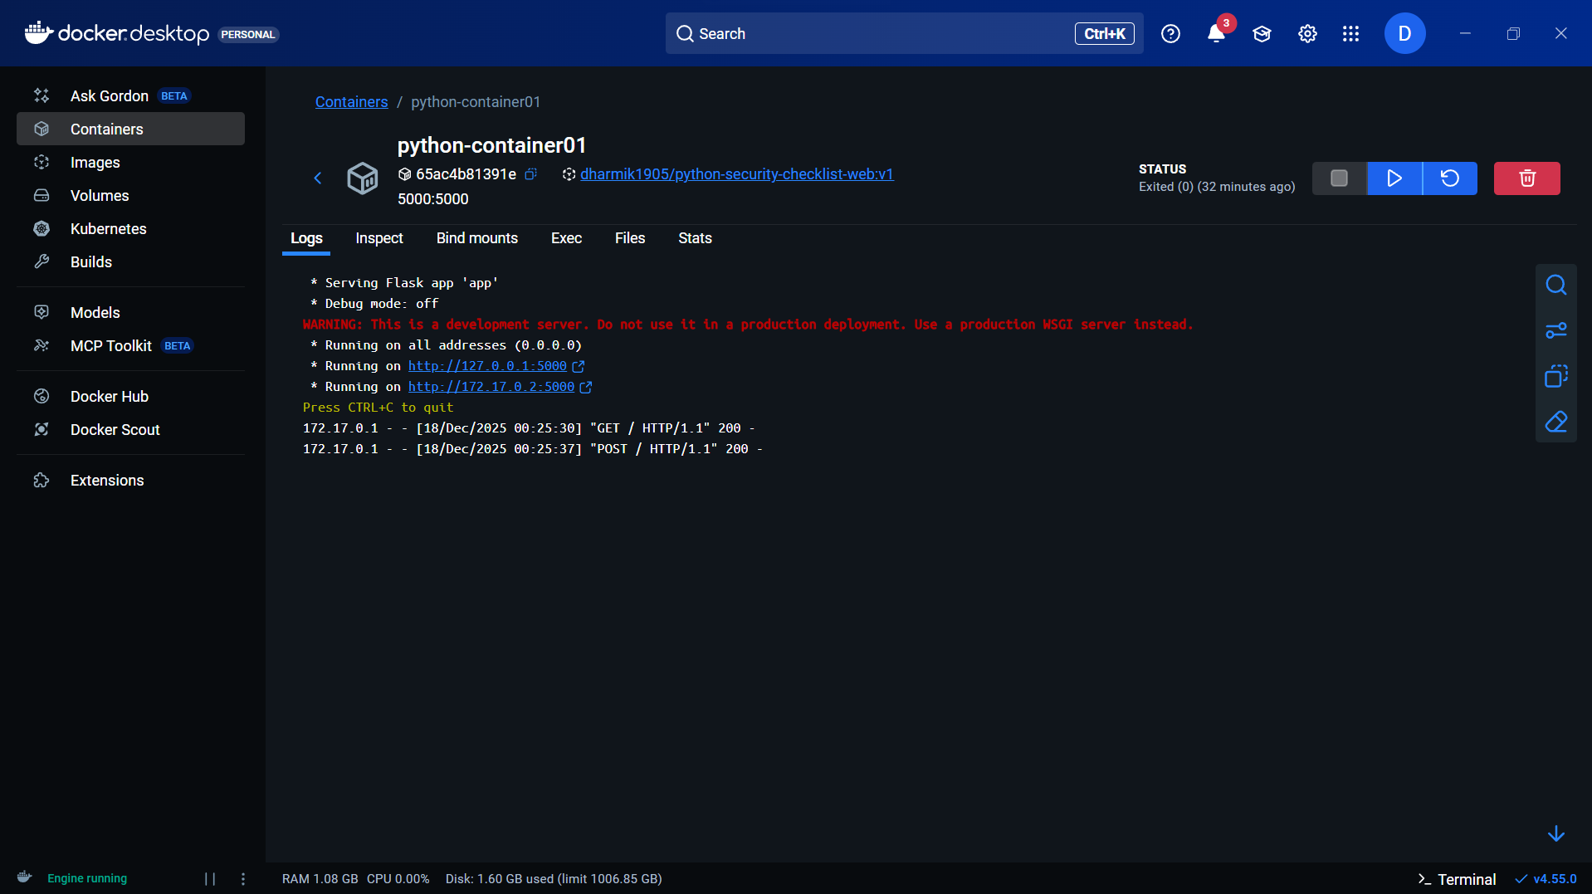

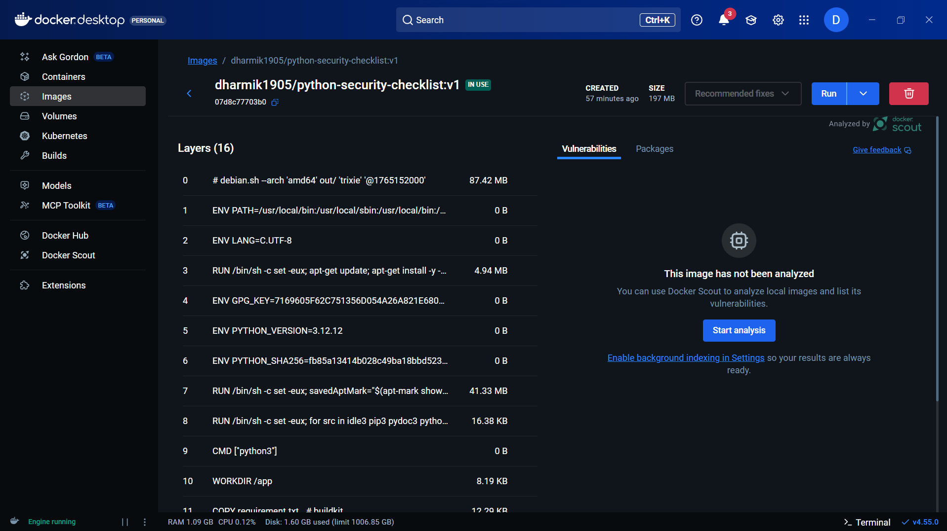

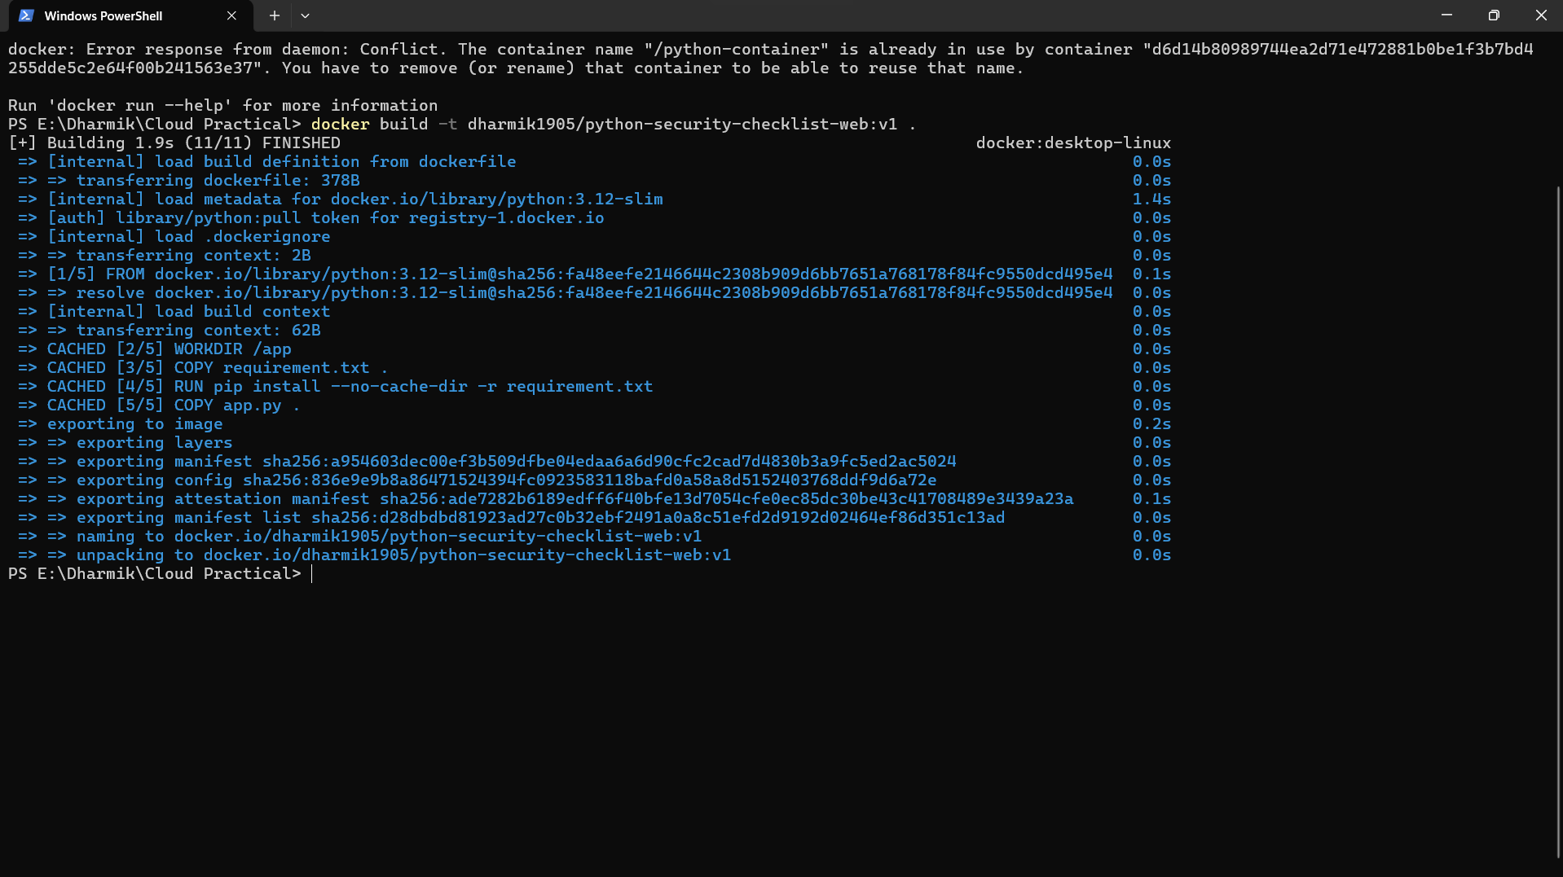

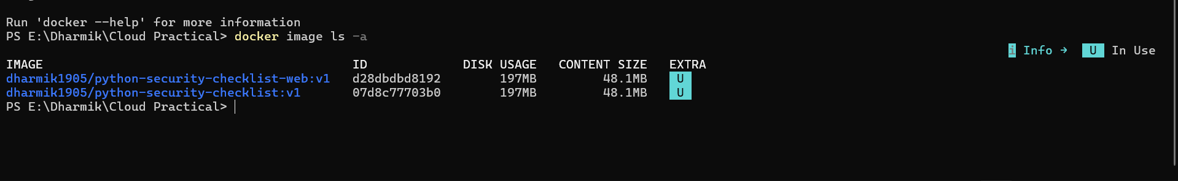

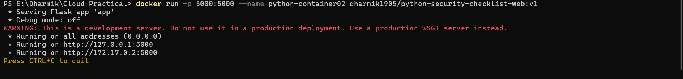

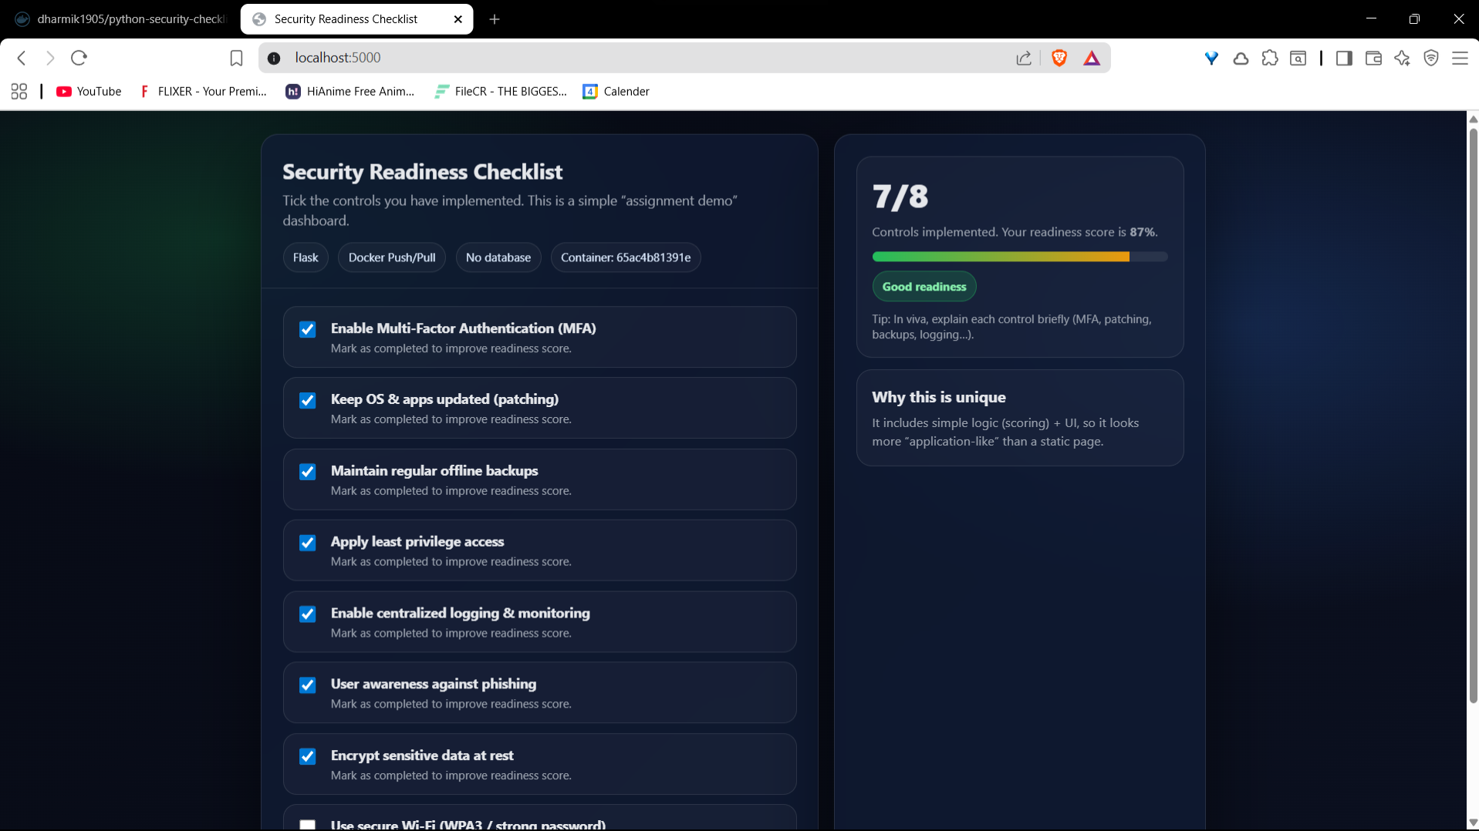

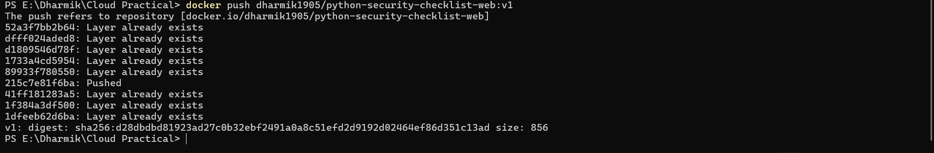

References
[1] M. Armbrust, A. Fox, R. Griffith, A. D. Joseph, R. Katz, A. Konwinski, G. Lee, D. Patterson, A. Rabkin, I. Stoica, and M. Zaharia, “A view of cloud computing,” Commun. ACM, vol. 53, no. 4, pp. 50–58, Apr. 2010. Communications of the ACM
[2] D. Merkel, “Docker: Lightweight Linux containers for consistent development and deployment,” Linux Journal, May 2014. ACM Digital Library
[3] C. Boettiger, “An introduction to Docker for reproducible research,” ACM SIGOPS Operating Syst. Rev., vol. 49, no. 1, pp. 71–79, 2015. ACM Digital Library
[4] J. Turnbull, The Docker Book: Containerization Is the New Virtualization. 2014. O'Reilly Media
[5] K. Hightower, B. Burns, and J. Beda, Kubernetes: Up and Running: Dive into the Future of Infrastructure, O’Reilly Media, 2017. O'Reilly Media
[6] I. Baldini, P. Castro, K. Chang, P. Cheng, S. Fink, V. Ishakian, N. Mitchell, V. Muthusamy, R. Rabbah, A. Slominski and P. Suter, “Serverless computing: Current trends and open problems,” arXiv:1706.03178, Jun. 2017. arXiv
[7] E. Jonas, Q. Pu, S. Venkataraman, I. Stoica, and B. Recht, “Occupy the cloud: Distributed computing for the 99%,” in Proc. ACM Symposium on Cloud Computing (SoCC), 2017. EECS at UC Berkeley
[8] G. Atıcı, S. Izbicki, and A. Vahdat, “A performance analysis of container cluster networking,” ACM, 2020. (See article / DOI for full details.) ACM Digital Library
[9] S. Shirinbab et al., “Performance evaluation of virtual machines and containers in cloud environments,” Concurrency and Computation: Practice and Experience, 2020. Wiley Online Library
[10] P. Saha, A. Beltre, P. Uminski, and M. Govindaraju, “Evaluation of Docker containers for scientific workloads in the cloud,” arXiv:1905.08415, May 2019. arXiv
[11] Amazon Web Services, “Elastic Load Balancing — Documentation,” AWS Docs. [Online]. Available: AWS Elastic Load Balancing documentation. AWS Documentation
[12] Microsoft, “Azure Application Gateway — Documentation,” Microsoft Learn. [Online]. Available: Azure Application Gateway docs. Microsoft Learn
[13] Docker Inc., “Volumes — Docker Engine” (official documentation). [Online]. Available: Docker docs — volumes. Docker Documentation
[14] Docker Inc., “Compose file reference: volumes,” Docker Compose documentation. [Online]. Docker Documentation
[15] Docker Inc., “CI with Docker — Docker documentation (Continuous integration guidance and best practices),” Docker Docs. Docker Documentation
[16] M. Armbrust et al., Above the Clouds: A Berkeley View of Cloud Computing, UC Berkeley Tech. Rep. (Berkeley view on cloud computing), 2009. Academia
[17] “How Elastic Load Balancing works,” AWS Elastic Load Balancing user guide (detailed technical explanation of ALB/NLB behavior, health checks, scaling). AWS Documentation
[18] “Storage — Docker Engine: volumes and storage drivers,” Docker official storage docs (explains named volumes, bind mounts, persistence best practices). Docker Documentation
[19] S. Park et al., “Performance analysis of container effect in deep learning workloads,” Applied Sciences, 2023. (Study comparing container vs host performance for DL workloads.) MDPI
[20] Research & survey articles on serverless and cloud-native trends: Z. Li et al., “The Serverless Computing Survey / Technical Primer,” and various reviews (surveys and primers on serverless, FaaS, cold starts, cost models). (See the ACM/ArXiv surveys for consolidated background and open problems.)

