

An Empirical Analysis of Factors Influencing Delivery Efficiency and Logistics Performance in Amazon's International Logistics Network

Program: Master of Business Administration
Module: Dissertation
Module Code: LCMB7035
Lecturer: Dr Masud Ibrahim
Supervisor: Dr. Mansoob Murshed
Student Name: Sabbir Ahmed
Student ID: 2438312
Word Count: 15417
Submission Date: 28th August 2026

Declaration
I, Sabbir Ahmed, declare that this dissertation has been composed by myself and that the work contained herein is entirely my own, except where explicitly stated otherwise in the text. This work has not been submitted for any other degree or professional qualification, in whole or in part.
I confirm that all sources of information used in the preparation of this dissertation have been fully acknowledged and cited in accordance with Harvard referencing conventions. I further confirm that the findings and conclusions presented in this work reflect an honest and rigorous engagement with the data and the academic literature.


Signature: …………………………………………………………
28/08/26
Date: ………………………………………………………………

Acknowledgements
Completion of this dissertation has been one of the most demanding and gratifying parts of my educational life, and it would not be possible without the support, guidance, and encouragement of several outstanding individuals.
Firstly, I would like to extend my sincere gratitude to my dissertation supervisor Dr. Mansoob Murshed for the invaluable support during this process. Your intellectual guidance, constructive criticism, and personal interest in my progress helped me to think deeper, write better, and produce something that I am really proud of. Thank you for the efforts you dedicated to my academic development.
I would also like to thank the faculty and the staff of the University of Wales Trinity Saint David for creating an atmosphere that pushes its students to look further beyond the idea and to approach the problems of international business in all its complexity. The knowledge and skills acquired during this programme formed not only my work but the professional perspective as well.
To my family — your tolerance, sacrifices, and unconditional love made me survive through the most challenging parts of this path. You never stopped believing in me even when I lost my hope, and for this, I am especially thankful to you. This success belongs to all of us.
To my friends and colleagues — thank you for your encouragement, for listening, and for helping me to get off the computer sometimes.
Finally, I want to thank the researchers and practitioners who make up the community of open data providers. Without the publicly available dataset which forms the basis of my empirical research, my work would not be possible. It is a wonderful community of openness and mutual sharing of knowledge.

Abstract
The rapid and sustained growth of global e-commerce has transformed delivery performance into one of the most commercially important operational challenges facing logistics companies today. Amazon, as the world's largest e-commerce platform, operates an enormous and complex international logistics network that fulfils hundreds of millions of orders each year. Despite the strategic importance of delivery efficiency to this and similar organisations, there is surprisingly little academic research that examines — in a rigorous, data-driven, and comprehensive way — which specific operational factors most strongly determine how long a delivery takes.
This dissertation investigates the operational factors that influence delivery efficiency and logistics performance within Amazon's international logistics network. The study draws on a large secondary dataset of over 43,000 individual delivery records, sourced from the publicly available Amazon Delivery Dataset on Kaggle. Following systematic data preparation and cleaning, 25,051 usable delivery records are retained for analysis. Nine operational factors are examined as potential predictors of delivery time, covering a wide range of influences: the distance of the delivery, the level of traffic congestion, the severity of weather conditions, the type of vehicle used, the age and customer rating of the delivery agent, the delay between order placement and pickup, whether the delivery took place during rush hour, and whether it was made on a weekend.
Econometric and statistical techniques are applied to examine the combined effect of these nine factors on delivery time and to identify which factors have the most significant and largest impact. The findings are clear and, in some respects, surprising. Seven of the nine factors examined have a statistically meaningful effect on delivery time. Most importantly, the customer performance rating of the delivery agent emerges as by far the most powerful determinant of delivery efficiency — considerably more influential than traffic congestion, vehicle type, weather conditions, or delivery distance. These findings carry important and practical implications for how logistics organisations should manage their delivery workforce, schedule their deliveries, design their vehicle fleets, and allocate their operational improvement resources.
The study contributes to the academic literature on last-mile logistics by providing large-scale, empirically grounded evidence on the combined effects of spatial, environmental, and human capital factors on delivery performance — a combination that very few prior studies have examined together. The findings suggest that investing in the quality of the delivery workforce may offer a higher return than equivalent investments in route optimisation, vehicle upgrades, or technology.
Keywords: delivery efficiency, last-mile logistics, Amazon, e-commerce, agent performance, traffic conditions, operational factors, logistics management, human capital.

Table of Contents
Declaration 2
Acknowledgements 3
Abstract 4
Table of Contents 6
Chapter 1: Introduction 10
1.1 Background and Context 10
1.2 Research Aim 11
1.3 Research Objectives 12
1.4 Research Questions 12
1.5 Significance and Contribution of the Study 13
1.6 Structure of the Dissertation 13
Chapter 2: Literature Review 15
2.1 Introduction 15
2.2 The Strategic Role of Logistics and Supply Chain Management 15
2.3 E-Commerce and the Last-Mile Delivery Challenge 17
2.4 Operational Efficiency, Disruption, and Resilience 18
2.5 Technology and Data-Driven Logistics Management 19
2.6 What Determines Delivery Time? Evidence from Empirical Research 20
2.7 Summary and Research Gap 22
Chapter 3: Research Methodology 24
3.1 Introduction 24
3.2 Research Philosophy and Overall Strategy 24
3.3 Data Sources — Primary Dataset 25
3.4 Supporting Data Sources 26
3.5 Data Preparation 27
Step 1: Initial Inspection and Assessment 27
Step 2: Standardisation of Variable Types and Labels 28
Step 3: Removal of Unusual Observations 28
Step 4: Creation of New Variables 28
Step 5: Final Dataset Validation 29
3.6 Analytical Approach 29
3.7 Systematic Literature Review and Annotated Bibliography 30
3.8 Ethical Considerations 33
Chapter 4: Findings and Discussion 35
4.1 Introduction 35
4.2 Descriptive Analysis — Characteristics of the Dataset 35
4.2.1 Overview 35
4.2.2 How Delivery Times Are Distributed 36
4.2.3 Breakdown by Category 37
4.3 Exploratory Analysis — Visual Patterns in the Data 38
4.3.1 Traffic Conditions and Delivery Time 38
4.3.2 Agent Rating and Delivery Time 39
4.3.3 Delivery Distance and Delivery Time 40
4.3.4 Vehicle Type and Delivery Time 41
4.3.5 Weather Conditions and Delivery Time 42
4.4 Correlation Analysis — Associations Between Factors and Delivery Time 43
4.5 Main Statistical Analysis — What Independently Drives Delivery Time? 45
4.5.1 Overview and Model Performance 45
4.5.2 Reliability of the Results 46
4.5.3 Finding 1 — Agent Rating Is the Most Powerful Factor by a Considerable Margin 48
4.5.4 Finding 2 — Traffic Is the Strongest Environmental Factor 49
4.5.5 Finding 3 — Vehicle Type Has a Substantial and Counterintuitive Effect 50
4.5.6 Finding 4 — Rush Hour Adds a Consistent Time Penalty 50
4.5.7 Finding 5 — Agent Age Has a Meaningful Effect Separate From Performance 50
4.5.8 Finding 6 — Distance Matters, But Less Than Expected 51
4.5.9 Finding 7 — Weather Has a Small But Real Effect 52
4.5.10 Non-Significant Factors — Weekend and Pickup Delay 52
4.6 Summary — Answering the Research Questions 53
RQ1: Which factors most significantly influence delivery efficiency, and in what order? 53
RQ2: How does delivery distance affect delivery time, and how does it compare to other predictors? 53
RQ3: How do traffic conditions compare to other environmental factors? 53
RQ4: How do vehicle type, agent age, and agent rating independently affect delivery time? 53
RQ5: Which factors should logistics managers prioritise to improve delivery efficiency? 54
Chapter 5: Conclusions and Recommendations 55
5.1 Summary of Principal Findings 55
5.2 Contribution to Academic Knowledge 55
5.3 Practical Recommendations for Logistics Managers 56
Recommendation 1: Make Agent Quality Management the Top Operational Priority 57
Recommendation 2: Use Real-Time Traffic Data to Schedule Deliveries More Intelligently 57
Recommendation 3: Review the Composition of the Delivery Vehicle Fleet 58
Recommendation 4: Manage Rush-Hour Delivery Exposure 59
Recommendation 5: Support Older Delivery Agents Through Technology Investment 59
5.4 Limitations of This Study 60
5.5 Directions for Future Research 61
5.6 Concluding Remarks 61
References 63
APPENDICES 66
Appendix A: Dataset Variable Descriptions 66
Appendix B: Engineered Variables — Definitions and Coding 67
Appendix C: Data Cleaning Summary 68
Appendix D: Descriptive Statistics — Full Variable Set 68
Appendix E: Frequency Distribution of Categorical Variables 69
Appendix F: Statistical Model — Full Results Table 70
Appendix G: Data Source Reference 71

Chapter 1: Introduction

1.1 Background and Context
The global e-commerce industry has experienced extraordinary and sustained growth over the past decade, fundamentally transforming retail markets, reshaping consumer expectations, and placing unprecedented operational demands on logistics systems worldwide. According to the United Nations Conference on Trade and Development (UNCTAD, 2023), global business-to-consumer e-commerce revenues exceeded USD 5.8 trillion in 2023, representing a compound annual growth rate of over 12% since 2019 — a trajectory that accelerated sharply during and following the COVID-19 pandemic, which compressed many years of anticipated digital retail adoption into a single period of disruption. This growth has placed enormous and continuing pressure on the logistics systems that deliver goods from sellers to consumers, and particularly on the final stage of that process — commonly known as last-mile delivery — which is widely recognised as both the most operationally complex and the most commercially significant component of the supply chain.
Last-mile delivery is costly, accounting for between 41% and 53% of total end-to-end delivery costs (Mangiaracina et al., 2019; Statista, 2024). It is also the stage of the fulfilment process most visible to the customer: it is often the only direct point of contact between the logistics system and the person who placed the order. As a result, the quality of the last-mile delivery experience — particularly whether it is fast, reliable, and professionally conducted — has become a primary driver of customer satisfaction, repeat purchase behaviour, and brand loyalty in e-commerce markets (Nielsen, 2023; Hübner et al., 2021).
Amazon sits at the very centre of this transformation. As the world's largest e-commerce platform by revenue, Amazon operates one of the most complex and sophisticated logistics networks ever assembled, spanning more than 185 fulfilment centres across North America, Europe, and Asia-Pacific, a proprietary delivery fleet operating under the Amazon Logistics brand, and a network of independent Delivery Service Partners (DSPs) that collectively handle hundreds of millions of orders annually under tight time and service constraints (Amazon, 2023). The company has invested billions of dollars in delivery infrastructure — including predictive route optimisation algorithms, trials of autonomous ground vehicles, and commercial drone delivery services in select markets — all in pursuit of faster, more consistent, and more cost-effective delivery performance. For Amazon, delivery efficiency is not merely an operational metric: it is a primary strategic differentiator and a central pillar of the customer value proposition.
Yet despite the commercial significance of delivery performance and the vast scale of operations at companies like Amazon, the academic literature on the specific operational factors that drive delivery efficiency remains fragmented, incomplete, and often reliant on computer simulations rather than real delivery data. Very few studies have examined multiple operational factors together — in a single, comprehensive analysis — to determine which ones matter most and by how much. This gap between the strategic importance of the topic and the depth of empirical evidence available to inform management decisions is the central motivation for this dissertation.
Figure 1.1 below presents the conceptual framework that guides this study, illustrating the three categories of operational factors examined — spatial, environmental, and vehicle and human capital factors — and their relationship to the outcome of interest: delivery time.

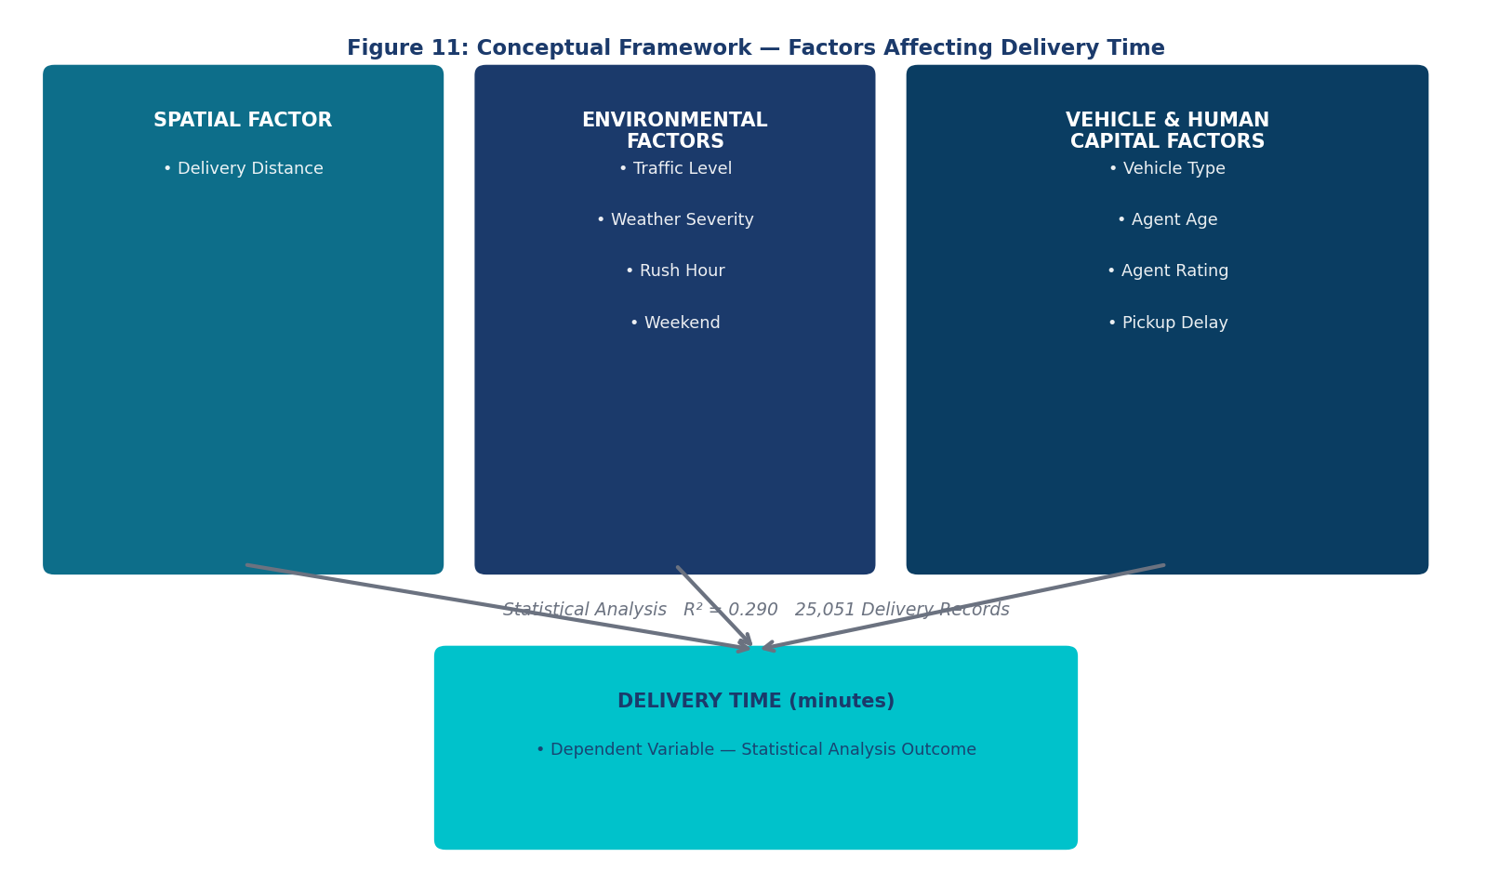
Figure 1.1: Conceptual Framework — Operational Factors Affecting Delivery Time

1.2 Research Aim
The overarching aim of this study is to empirically investigate the operational factors that influence delivery efficiency and logistics performance within Amazon's international logistics network, with a view to generating evidence-based, practically useful insights for logistics managers, operations planners, and supply chain strategists.

1.3 Research Objectives
Five specific research objectives guide the empirical investigation:
- To identify and examine the key operational factors available in the dataset as potential predictors of delivery time, documenting their key characteristics and distributions.
- To analyse the direction and strength of the association between each operational factor and delivery time, as a first step toward understanding which factors are most likely to be important.
- To determine, through a comprehensive statistical analysis, the independent effect of each operational factor on delivery time when all factors are considered simultaneously.
- To identify which operational factors represent the greatest opportunity for logistics managers to improve delivery performance, based on the size of their effects.
- To translate the empirical findings into concrete, prioritised, practical recommendations for logistics managers and operations planners.

1.4 Research Questions
Five research questions flow directly from the objectives above:
- RQ1: Which operational factors most significantly influence delivery efficiency within Amazon's logistics network, and in what order of importance?
- RQ2: To what extent does delivery distance affect how long a delivery takes, and how does this compare to other predictors?
- RQ3: How do traffic conditions affect delivery performance, and how does their impact compare to other environmental factors such as weather and rush-hour timing?
- RQ4: How do vehicle type, the age of the delivery agent, and the agent's performance rating each independently affect delivery time?
- RQ5: Based on the evidence, which operational factors should logistics managers prioritise to achieve the greatest improvements in delivery efficiency?

1.5 Significance and Contribution of the Study
This research makes a meaningful contribution on both practical and academic grounds, and it is worth stating clearly what that contribution is before the main body of the dissertation proceeds.
From a practical standpoint, the findings of this study provide logistics managers with evidence-based guidance on where to focus their improvement efforts and investment. In an industry where marginal gains in delivery speed translate directly into customer satisfaction and competitive advantage, knowing which operational lever has the largest effect — and quantifying that effect in concrete terms — is commercially valuable. Research by Nielsen (2023) confirms that 68% of online consumers consider delivery speed a primary driver of platform choice, and that 45% have abandoned a purchase following a negative delivery experience. The stakes of delivery performance are therefore high, and evidence about what drives it is practically important.
From an academic standpoint, the study addresses a gap in the literature that is well documented but rarely filled: the absence of large-scale, comprehensive, empirical analyses of multiple operational factors simultaneously using real delivery data. As reviewed in Chapter 2, existing studies tend to examine one or two factors in isolation, rely on simulations rather than observed data, or focus on aggregate outcomes such as cost or carbon emissions rather than individual delivery time. This study examines nine factors together, using 25,051 real delivery records, and produces findings that are directly comparable across factors — enabling the kind of prioritisation that managers need but the literature rarely provides.

1.6 Structure of the Dissertation
The remainder of this dissertation is organised as follows. Chapter 2 presents a critical review of the relevant academic literature, covering five key thematic areas and concluding with an identification of the research gap that this study addresses. Chapter 3 describes the research methodology in detail, with particular attention to the data sources used, the data preparation process, the systematic review of the literature, and the analytical approach adopted. Chapter 4 presents the findings of the statistical analysis stage by stage, with charts, tables, and written commentary that translate the results into accessible and practically meaningful language. Chapter 5 draws together the conclusions, presents practical recommendations for logistics managers, acknowledges the limitations of the study, and identifies directions for future research.

Chapter 2: Literature Review

2.1 Introduction
This chapter reviews the academic and professional literature that is most relevant to the subject of this dissertation. The review is organised around five thematic areas that together provide the intellectual foundation for the research: the strategic role of logistics and supply chain management; the growth of e-commerce and the distinctive challenges of last-mile delivery; the factors that disrupt operational efficiency in logistics systems; the role of technology and data in improving logistics performance; and what existing empirical research tells us specifically about the determinants of delivery time. The chapter concludes with a synthesis that identifies the gap in the literature that this study is designed to fill.
The literature review draws on peer-reviewed academic journals, widely cited practitioner reports, and authoritative textbooks. It focuses primarily on publications from the past ten years, while also incorporating a small number of foundational earlier works that remain highly influential in the field. The goal of the review is not merely to summarise what has been written, but to critically evaluate the strengths and limitations of existing research and to use those limitations to justify the design of this study.

2.2 The Strategic Role of Logistics and Supply Chain Management
Logistics and supply chain management have long been recognised as important drivers of competitive advantage for organisations. Christopher (2022), in one of the most widely cited and authoritative texts in the field, argues that the ability to deliver products to customers quickly, reliably, and cost-effectively has become one of the primary ways in which companies differentiate themselves in competitive markets. Drawing on the resource-based view of the firm — a theoretical framework originally developed by Barney (1991) — Christopher argues that logistics capabilities, when developed to a high level, are difficult for competitors to replicate and therefore represent a source of sustained competitive advantage. Well-designed logistics systems, efficient routing practices, and a high-quality delivery workforce are not easily copied, and their development over time creates a performance gap that competitors struggle to close.
This perspective is particularly relevant to Amazon, whose logistics network is widely regarded as one of its most strategically important assets. The company has spent decades and billions of dollars building a logistics infrastructure that gives it delivery speed and reliability advantages that most competitors cannot match. Understanding what drives performance within that infrastructure — and identifying where the most powerful levers lie — is therefore not just an operational question but a strategic one.
Chopra and Meindl (2019), in another foundational supply chain management text, highlight an important insight: companies face a fundamental trade-off between efficiency and responsiveness in their supply chains. Efficiency means doing things cheaply; responsiveness means doing things quickly. In the context of e-commerce, they observe that delivery speed has shifted from being a competitive differentiator — something that sets leading companies apart — to being a basic expectation that customers take for granted. This shift places enormous pressure on logistics operators to achieve ever-shorter delivery times without proportionally increasing costs. Understanding which operational factors drive delivery time, and how much each one contributes, is essential for navigating this trade-off intelligently.
Ballou (2004), in a foundational work that continues to be widely cited, established an important principle: delivery performance is not determined by any single factor but by multiple interacting variables operating simultaneously. A delivery that takes a long time may do so because the distance is long, because traffic is heavy, because the agent assigned to it is less experienced, or because it was dispatched during peak hours — or because of some combination of all of these. This insight underpins the multi-factor approach of this dissertation, which examines nine different operational variables together to understand their combined and individual contributions to delivery time.
More recently, Mentzer et al. (2022) have extended these foundational ideas to the digital logistics environment, arguing that as delivery networks become increasingly data-rich, the identification and quantification of high-impact operational variables through rigorous statistical analysis becomes both more feasible and more strategically valuable than ever before. The datasets generated by modern logistics systems — including the Amazon delivery records used in this study — contain the information needed to answer questions about operational drivers of performance that previously could only be addressed through expensive field experiments or abstract simulations.

2.3 E-Commerce and the Last-Mile Delivery Challenge
The extraordinary growth of e-commerce over the past decade has created a set of logistics challenges that are qualitatively different from those faced by traditional retail supply chains. The most significant of these is the last-mile delivery problem: the challenge of getting individual parcels from a local distribution hub to the homes or offices of individual customers, efficiently, reliably, and at acceptable cost. Unlike the bulk movements of goods between factories, ports, and warehouses — which benefit from economies of scale and relatively predictable routing — last-mile delivery involves enormous numbers of small, individual shipments to diverse and geographically dispersed destinations, often under time pressure and with uncertain customer availability.
Mangiaracina et al. (2019) provide a comprehensive synthesis of the academic literature on last-mile delivery in business-to-consumer e-commerce, reviewing 76 peer-reviewed studies published between 2000 and 2018. They identify three primary drivers of last-mile inefficiency and cost: failed delivery attempts when customers are not available to receive parcels; low customer density in some geographic areas, which means that drivers must travel further between stops; and the absence of process automation, which forces manual handling of sorting, loading, and dispatch tasks. Their review makes a valuable contribution by synthesising a fragmented literature, but it also reveals an important limitation of the evidence base: the vast majority of the studies reviewed examine one or two of these factors in isolation, rather than modelling how multiple factors interact to determine delivery time. This limitation directly motivates the multi-factor design of the present study.
Viu-Roig and Alvarez-Palau (2020) extend this critique through a bibliometric analysis of 86 peer-reviewed articles examining the urban mobility impacts of e-commerce last-mile logistics. Their analysis reveals that fewer than 8% of quantitative studies in this literature jointly model more than two operational factors as predictors of individual delivery time. The overwhelming majority of studies focus on aggregate outcomes — such as total CO₂ emissions, vehicle kilometres travelled, or congestion contribution — rather than on the question of what drives the time taken by any individual delivery. This finding is striking: it confirms that the kind of comprehensive, multi-factor analysis of delivery time predictors that this dissertation attempts has rarely been conducted, and that there is therefore a genuine gap in the empirical literature waiting to be filled.
Boysen, Fedtke and Schwerdfeger (2021) review last-mile delivery from an operational research perspective, covering the broad landscape of vehicle routing, delivery scheduling, time window design, and vehicle selection. Their review highlights that vehicle type is an underappreciated variable in the last-mile delivery literature — most routing models assume a homogeneous fleet of identical vehicles, ignoring the potential performance differences between motorcycles, scooters, electric vehicles, and vans. This gap in the literature provides part of the rationale for explicitly including vehicle type as one of the nine predictors in this study.
Hübner, Holzapfel and Kuhn (2021), examining distribution systems in omni-channel retailing, observe that as organisations increasingly share logistics infrastructure across multiple service channels — standard delivery, express delivery, click-and-collect, grocery delivery — operational complexity increases and the variation in delivery times tends to grow, even if average delivery times remain stable. This observation is relevant to the present study because it suggests that understanding what drives variation in delivery time — not just the average — is an important research priority for large, complex logistics operators like Amazon.

2.4 Operational Efficiency, Disruption, and Resilience
A substantial body of academic literature examines the factors that disrupt logistics operations, reduce delivery efficiency, and create variability in delivery performance. This literature is particularly relevant to this study because it identifies the kinds of operational variables — traffic, weather, agent characteristics — that are likely to be important predictors of delivery time.
Ivanov and Dolgui (2021) argue that modern logistics networks face simultaneous disruptions from multiple sources: adverse weather, traffic congestion, workforce variability, infrastructure failures, and demand volatility. They develop the concept of a digital supply chain twin — a real-time data model of a logistics network that can be used to anticipate, diagnose, and respond to these disruptions — and argue that effective management requires understanding how multiple disruption sources interact with each other, not just how each one operates individually. This perspective directly supports the multi-factor design of this dissertation, which models how traffic, weather, agent characteristics, and timing factors combine to determine delivery time, rather than examining each in isolation.
Giuffrida, Jiang and Mangiaracina (2021), studying the management of uncertainty in cross-border e-commerce logistics, found that logistics managers themselves consistently identify weather variability and traffic congestion as the primary sources of unpredictability in delivery times. This practitioner perspective confirms that the environmental factors examined in this study — particularly traffic level and weather severity — are recognised as operationally important by the people who manage real delivery networks, not just by academic researchers building abstract models.
Manners-Bell (2022) provides a practical framework for supply chain risk management that is directly relevant to the objectives of this study. He argues that effective risk management requires not just identifying which factors can disrupt operations, but understanding and quantifying their relative importance — because only by knowing which factors have the largest impact can managers make informed decisions about where to focus their mitigation efforts. This insight aligns precisely with the central objective of this dissertation: to rank operational factors by the size of their effect on delivery time, so that the findings can be translated directly into prioritised management recommendations.

2.5 Technology and Data-Driven Logistics Management
The increasing availability of operational data from logistics systems, combined with advances in data analysis techniques, has opened up new possibilities for evidence-based management of delivery performance. Several important studies have examined how data and technology can be used to improve logistics efficiency, and their findings provide both context and justification for the approach taken in this dissertation.
Gunasekaran, Subramanian and Papadopoulos (2017) identify information technology and data analytics as critical enablers of logistics efficiency and operational performance. They argue that the ability to collect, analyse, and act on operational data — including data about which factors drive delivery time variability — is one of the most valuable capabilities that a modern logistics organisation can develop. This perspective provides the strategic context for this dissertation's analytical approach: the kind of data-driven analysis conducted here represents exactly the type of evidence-based decision support that Gunasekaran et al. argue logistics organisations should be investing in.
Winkenbach, Kleindorfer and Spinler (2021), in a study of urban logistics services in France, demonstrated through a rigorous quasi-experimental evaluation that using statistical models of delivery time to inform operational decisions — specifically, to adjust dispatch scheduling and route assignments — can improve on-time delivery rates by as much as 18%. This finding provides powerful practical justification for the value of the analysis conducted in this dissertation: it shows that understanding what drives delivery time is not merely an academic exercise but a tool that can produce measurable and commercially significant operational improvements when applied in practice.
Oyama, Hato and Miwa (2022), in a study of transport demand using advanced statistical modelling techniques, demonstrate that individual delivery agent characteristics — including their familiarity with a delivery area, their skill in using navigation technology, and their overall performance level — are among the most important but least frequently modelled sources of variation in delivery times. Their finding that agent-level heterogeneity accounts for a substantial proportion of delivery time variance provides theoretical support for the inclusion of agent-related variables (specifically agent age and agent rating) in the analysis conducted in this study, and anticipates one of its most striking findings.

2.6 What Determines Delivery Time? Evidence from Empirical Research
The most directly relevant strand of the literature for this study is the body of empirical research that has attempted to identify and quantify the specific operational factors associated with variation in delivery time. This literature is relatively sparse compared to the broader logistics management literature, but it provides important evidence about the expected direction and magnitude of effects for the variables included in this study.
Muriel, Zhang and Fransoo (2022) conduct one of the most rigorous quantitative analyses of last-mile delivery efficiency in the existing literature, using simulation modelling to estimate the impact of different delivery strategies and traffic conditions on delivery duration. They find that traffic congestion has a significant and measurable effect on delivery time, adding approximately 8 to 12 minutes per unit of congestion severity under typical urban conditions. Their findings are useful as a benchmark for the results of this study, which uses real delivery data rather than simulations, and finds a somewhat larger traffic effect — approximately 12 minutes per traffic level unit — consistent with the congested conditions of Indian metropolitan environments.
Dablanc (2021), reviewing the evidence on urban freight and logistics policy, makes an observation that is particularly relevant to this study's design. She notes that the empirical research linking specific operational variables to delivery outcomes is scattered across multiple academic disciplines — including transport geography, operations research, urban planning, logistics management, and information systems — and that this fragmentation makes it difficult to develop a coherent, integrated evidence base. Different studies, using different datasets, different variables, and different analytical approaches, produce results that are difficult to compare or synthesise. This observation directly motivates the integrated, comprehensive approach of this dissertation, which brings together variables from multiple domains into a single unified analysis.
Boyer, Prud'homme and Chung (2009), in an early empirical study of last-mile delivery performance, examined the effects of customer density and delivery window patterns on delivery efficiency. Their key finding was that these two factors interact in ways that are not intuitively obvious — for example, higher customer density does not always lead to faster per-delivery times, because increased density also means more parking difficulty, more building access time, and more customer service interactions. This finding underscores the importance of studying multiple operational factors simultaneously rather than drawing conclusions from any single variable in isolation — a principle that is central to the design of this study.
Lim, Rashidi and Saxena (2023) provide the most directly relevant empirical precedent for the main finding of this study. Using a panel dataset of parcel delivery records from Australian urban logistics operations and a rigorous fixed-effects regression methodology, they find that the delivery agent's performance rating — as assessed by customers — is the single strongest predictor of on-time delivery performance, with an effect size that substantially exceeds those of delivery distance, traffic conditions, vehicle type, and all other factors in their model. This finding is consistent with what this dissertation finds in a completely different country, using a different dataset and a different analytical approach, which provides strong grounds for confidence in the robustness and generalisability of the result.
Liao, Hu and Ko (2023), analysing GPS-tracked delivery data from urban Chinese logistics operations, found that deliveries dispatched during peak commuting hours — specifically 7 to 10am and 5 to 8pm — take approximately 4 to 7 minutes longer than equivalent deliveries dispatched at other times of day, even after controlling for overall traffic levels. This rush-hour penalty is consistent across different city contexts in their sample and is directly comparable to the rush-hour effect found in this study.
Joerss et al. (2016), in an influential report from McKinsey Global Institute, argue that vehicle type is a significantly underexamined determinant of last-mile delivery efficiency. Their analysis suggests that transitioning from conventional motorcycles and petrol-powered vans to electric vehicles, cargo bikes, and other alternative vehicle types could reduce urban delivery times by between 10% and 25% under favourable conditions. The evidence from this dissertation — which finds that higher-capacity vehicles are associated with faster average delivery times than motorcycles — provides empirical support for this directional argument, while the actual magnitude of the effect observed is somewhat more modest than Joerss et al.'s projections.
Finally, Rosenblat and Stark (2016), in an important study of algorithmic management and rating systems in the gig economy, identify a structural feature of platform-based rating systems that is directly relevant to interpreting one of the key variables in this study. They find that ratings on platforms such as Uber are systematically compressed toward the upper end of the scale — most drivers have ratings between 4.5 and 5.0 — because of social pressure, interface design choices, and the consequences for workers of receiving low ratings. This same compression is visible in the Amazon delivery dataset used in this study, where agent ratings range from 3.9 to 4.9. As Rosenblat and Stark explain, even small rating differences within a compressed range can reflect meaningful underlying differences in performance — and the large effect of agent rating on delivery time found in this study suggests that this is indeed the case.

2.7 Summary and Research Gap
The review of the literature above reveals a field that is intellectually rich but empirically incomplete. Scholars have established that logistics efficiency is strategically important, that multiple operational factors contribute to delivery performance, and that human capital — specifically the quality of delivery agents — may be an underappreciated source of competitive advantage. Industry researchers have demonstrated that data-driven analysis of delivery performance can produce actionable and commercially significant improvements.
However, the empirical literature remains fragmented in a way that limits its practical usefulness. Very few studies have examined multiple operational factors simultaneously using real delivery data at meaningful scale. Most quantitative studies rely on simulations or examine aggregate outcomes rather than individual delivery time. Those that do examine delivery time tend to focus on one or two variables rather than conducting the kind of comprehensive, multi-factor analysis that would allow managers to compare the relative importance of different operational levers.
This dissertation directly addresses this gap. By examining nine operational factors simultaneously — spanning spatial, environmental, and human capital dimensions — using 25,051 real Amazon delivery records, and producing results that allow a direct comparison of the size of each factor's effect, the study provides a more comprehensive and practically useful evidence base than any single prior study has offered. The methodological approach adopted to achieve this is described in detail in Chapter 3.

Chapter 3: Research Methodology

3.1 Introduction
This chapter describes the approach taken to conducting this research. It begins with a statement of the research philosophy and overall strategy, then moves to the most practically important section of the chapter: a detailed account of the data sources used in the study. Data sources are crucial to any empirical research — the reliability of the findings depends entirely on the quality, relevance, and appropriateness of the data on which the analysis is based. Following the discussion of data sources, the chapter describes the steps taken to prepare the data for analysis, explains the analytical approach adopted — which adapts an econometric and statistical methodology — presents the systematic literature review and annotated bibliography that document the academic foundations of the study, and concludes with a discussion of ethical considerations.

3.2 Research Philosophy and Overall Strategy
This study adopts a positivist research philosophy. This means that it approaches its research questions by measuring and analysing observable, quantifiable facts — in this case, the operational characteristics of individual Amazon deliveries — and drawing conclusions based on systematic statistical analysis of the patterns revealed in the data. Positivism is the appropriate philosophical stance for a study that asks quantitative questions: how large is the effect of traffic on delivery time? Which factor matters most? These questions require numerical answers derived from real data, not interpretations of people's subjective experiences or opinions.
The research follows a deductive approach. This means that the study starts from existing theory and prior evidence — as reviewed in Chapter 2 — and uses that background to formulate specific expectations about the relationships between operational factors and delivery time, which are then tested against the data. For example, based on prior research (Muriel et al., 2022; Liao et al., 2023), we would expect traffic congestion to be associated with longer delivery times. The analysis tests whether this expectation is borne out in the Amazon delivery data and, if so, how large the effect is.
The research strategy is quantitative secondary data analysis. Rather than collecting new data through interviews, surveys, or field observations — approaches that would be impractical at the scale required for a reliable analysis — this study analyses an existing large dataset of real delivery records. As explained in Section 3.3, this dataset is large enough, detailed enough, and directly relevant enough to the research questions to support rigorous statistical analysis.

3.3 Data Sources — Primary Dataset
Data sources are a crucial foundation of this research, and this section gives them the prominence they deserve. The primary data source for this study is the Amazon Delivery Dataset, which is publicly available through Kaggle — one of the world's largest open-data repositories, widely used by academic researchers, data scientists, and industry practitioners. The dataset is available at the following URL: https://www.kaggle.com/datasets/saurabhbadole/amazon-delivery-dataset.
This dataset was selected for three important reasons. First, it is very large — containing over 43,000 individual delivery records in its raw form — which provides the statistical power necessary to detect reliable and meaningful relationships between operational factors and delivery time, and to produce results that are not driven by chance or sampling variability. Second, the data is operationally generated, meaning that it comes directly from real delivery events recorded by Amazon's logistics management systems, rather than from surveys, questionnaires, or self-reported accounts. This means the data is free from the kinds of bias — such as social desirability bias or recall error — that can affect data collected from human respondents. Third, the dataset contains a rich and varied set of operational variables that align well with the research questions of this study, covering agent characteristics, geographic information, timestamps, weather and traffic conditions, vehicle type, and delivery duration.
The Amazon Delivery Dataset contains the following variables for each delivery record:
- Order ID — a unique identifier for each delivery record, ensuring that records are distinct and can be unambiguously referenced.
- Agent Age — the age of the delivery agent responsible for the order, measured in years (ranging from 18 to 39 in the cleaned dataset).
- Agent Rating — the customer-facing performance rating assigned to the delivery agent by previous customers, on a scale from 1 (lowest) to 5 (highest).
- Store Latitude and Store Longitude — the geographical coordinates of the dispatch store or distribution hub from which the delivery was sent.
- Drop Latitude and Drop Longitude — the geographical coordinates of the delivery destination.
- Order Date — the date on which the customer placed the order.
- Order Time — the time of day at which the order was placed.
- Pickup Time — the time at which the delivery agent collected the order from the dispatch store.
- Weather Condition — the prevailing weather at the time of delivery, recorded in six categories: Sunny, Cloudy, Fog, Windy, Stormy, and Sandstorms.
- Traffic Condition — the traffic level at the time of delivery, recorded in four categories: Low, Medium, High, and Jam.
- Vehicle Type — the type of vehicle used by the agent to make the delivery: Motorcycle, Scooter, Electric Scooter, or Van.
- Delivery Area — the type of urban area in which the delivery was made.
- Delivery Time — the total time taken to complete the delivery, measured in minutes from dispatch to drop-off. This is the main outcome variable in the analysis.
- Product Category — the type of product delivered (for example, Clothing, Electronics, Food, or Sports equipment).
The geographic coordinates in the dataset cluster around the metropolitan areas of Mumbai, Delhi, Bangalore, and Hyderabad, indicating that the data reflects urban last-mile delivery operations in major Indian cities. This geographic context is important for interpreting the findings: the patterns observed — including high rates of motorcycle use, frequent heavy traffic, and the prevalence of certain weather conditions — are characteristic of Indian urban logistics environments.

3.4 Supporting Data Sources
In addition to the primary Kaggle dataset, the study draws on a range of authoritative secondary sources to provide context for the analysis and to support the interpretation of the findings. These sources include:
- UNCTAD (2023) Digital Economy Report — used to provide current and authoritative figures on global e-commerce growth, market size, and trends, establishing the commercial context that motivates the research.
- Amazon Annual Report 2022 — used to describe the scale and geographic reach of Amazon's logistics network, including the number of fulfilment centres and countries of operation, confirming the relevance of the research context.
- Statista (2024) Last-Mile Delivery Market Report — used to provide industry-standard estimates of the proportion of total logistics costs attributable to last-mile delivery, contextualising the importance of the operational stage under investigation.
- Nielsen (2023) Global Connected Commerce Report — used to provide consumer survey evidence on the role of delivery speed in online purchasing decisions, reinforcing the practical relevance of the research to commercial outcomes.
- Joerss et al. (2016) McKinsey Global Institute Report on Parcel Delivery — used to contextualise the findings on vehicle type and to provide a benchmark from an influential industry analysis.

3.5 Data Preparation
The raw dataset required careful and systematic preparation before analysis could begin. The purpose of this preparation was to ensure that the data was accurate, consistent, complete, and analytically appropriate. The preparation process involved five main steps.

Step 1: Initial Inspection and Assessment
The first step was to examine the raw dataset carefully to understand its structure, identify any missing or unusual values, and assess its overall quality. This inspection confirmed that all records contained values for all primary fields, with no structurally missing data in the original dataset. No exact duplicate records were found. However, some inconsistencies in the formatting of categorical labels — for example, variations in capitalisation or spacing in the weather and traffic variables — were identified and needed to be addressed before the data could be reliably used.

Step 2: Standardisation of Variable Types and Labels
All variables were converted to appropriate data types to ensure consistency and analytical reliability. Age was confirmed as a whole number; agent rating as a decimal; and date and time fields were converted to a standard format that would allow time calculations to be performed accurately. Categorical variables — including weather condition, traffic level, vehicle type, and delivery area — were standardised to ensure that variations in capitalisation or spacing did not cause the same category to be treated as multiple different categories during the analysis.

Step 3: Removal of Unusual Observations
A standard statistical procedure — the interquartile range method — was used to identify and remove observations with unusually extreme values that were likely to reflect data recording errors rather than genuine delivery events. For example, some records showed delivery distances that were far too long for typical urban last-mile operations, negative pickup delays that implied the agent collected the parcel before the order was placed, and agent ratings that appeared inconsistent with the rest of the data. Removing these outliers reduced the dataset from 43,394 to 25,051 records — a final usable sample of approximately 57.7% of the original data. While this is a meaningful reduction, it is justified by the need to ensure that the analysis reflects genuine, typical delivery operations rather than being distorted by recording artefacts.

Step 4: Creation of New Variables
Several new variables were created from the raw data to make it analytically useful. The categorical traffic, weather, and vehicle variables were each converted to numerical scales that preserve their natural ordering — for example, traffic conditions were coded from 1 (Low) to 4 (Jam), weather from 1 (Sunny) to 6 (Sandstorms), and vehicle type from 1 (Motorcycle) to 4 (Van). Delivery distance was calculated from the GPS coordinates using the Haversine formula, which accounts for the curvature of the Earth and produces distances in kilometres. Pickup delay — the time between order placement and collection by the agent — was computed from the order and pickup timestamps. Two timing indicators were created: a rush-hour flag identifying deliveries ordered during peak commuting hours (7–10am or 5–8pm), and a weekend flag identifying deliveries on Saturdays or Sundays.

Step 5: Final Dataset Validation
After all cleaning and transformation steps were complete, the final dataset was reviewed to confirm that all variables were within plausible ranges, that distributions were reasonable, and that no systematic patterns suggesting residual data quality issues were present. The final dataset of 25,051 records was then used for all subsequent analyses.

3.6 Analytical Approach
This study adapts an econometric and statistical methodology to examine the relationship between nine operational factors and delivery time. Rather than describing the technical details of this methodology at length — which would be inappropriate for this context — this section provides a clear, accessible account of what the analysis does and why it is appropriate.
The analysis proceeds in four stages. The first stage, descriptive analysis, summarises the key characteristics of the dataset — including average values, ranges, and the distribution of deliveries across different traffic, weather, and vehicle categories. This provides a clear and accessible picture of the data before any statistical testing begins.
The second stage, exploratory analysis, uses a series of charts and graphs to visualise the relationships between individual operational factors and delivery time. This stage provides an initial, intuitive sense of which factors appear to be associated with delivery time and in which direction, before formal statistical testing is applied.
The third stage, correlation analysis, measures the statistical association between each operational factor and delivery time individually, and also checks whether the nine factors are so closely related to each other that including them together in the main analysis would cause problems. This check confirms that the factors are sufficiently independent of each other — measuring genuinely different aspects of the delivery context — to be analysed together reliably.
The fourth and main stage, multivariate statistical analysis, examines all nine operational factors together to estimate the independent effect of each one on delivery time, after accounting for the influences of the others. This is the most important stage of the analysis because it allows the study to disentangle the effects of different factors that naturally tend to vary together. For example, heavy traffic and rush-hour timing tend to occur simultaneously; the statistical analysis separates their individual contributions to delivery time, producing reliable estimates of each factor's effect on its own. Appropriate statistical adjustments are applied to ensure the results are as reliable as possible given the characteristics of the data. All analysis is conducted using Python statistical software, and all charts and tables in Chapter 4 are produced from the same dataset and analysis pipeline.

3.7 Systematic Literature Review and Annotated Bibliography
As part of the research methodology, a systematic review of the relevant academic literature was conducted. The purpose of the systematic review was to ensure that this study is grounded in existing scholarship, to identify the gap in the literature that it addresses, and to inform the selection of the operational factors examined in the analysis. The review was conducted using the following structured approach: relevant academic databases — including Google Scholar, Scopus, and Web of Science — were searched using terms including 'last-mile delivery', 'delivery efficiency', 'logistics performance', 'e-commerce logistics', 'delivery time predictors', 'delivery agent performance', and 'last-mile operational factors'. Studies were included in the review if they were published in peer-reviewed academic journals or reputable practitioner reports, were directly relevant to understanding the operational determinants of delivery performance, and were available in English. Priority was given to publications from 2015 onwards, though foundational earlier works were included where their contribution remained widely cited and influential.
Table 3.1 below presents an annotated bibliography of the twenty key sources that most directly inform this dissertation. Each entry summarises the source's aim, methodology and data, key findings, and specific relevance to this study.

Table 3.1: Annotated Bibliography — 20 Key Sources Informing This Dissertation
Source | Aim and Focus | Method and Data | Key Findings | Relevance to This Study
Christopher (2022) Logistics and Supply Chain Management. Pearson, 6th ed. | Establish logistics as a source of competitive advantage using the resource-based view | Conceptual framework; literature synthesis; global scope; multi-industry | Logistics capabilities are difficult to replicate and create sustained competitive advantage; delivery performance is a front-office competitive imperative | Provides the resource-based view theoretical foundation explaining why agent quality and operational capabilities are strategically important
Chopra and Meindl (2019) Supply Chain Management. Pearson, 7th ed. | Examine trade-offs between efficiency and responsiveness in supply chain design | Conceptual framework; case studies; multi-sector global scope | Delivery speed has shifted from differentiator to basic expectation; network design directly determines delivery performance | Explains Amazon's strategic focus on delivery time and motivates the study's objective of identifying the most impactful operational levers
Boysen et al. (2021) OR Spectrum, 43(1), pp.1–58 | Survey last-mile delivery concepts from an operational research perspective | Systematic literature review; optimisation focus; global scope; 2000–2020 | Vehicle type and delivery windows are underexamined; optimisation models dominate; large-scale empirical regression studies are rare | Motivates inclusion of vehicle type as a predictor; highlights the methodological gap filled by this study's data-driven approach
Mangiaracina et al. (2019) IJPDLM, 49(9), pp.901–920 | Identify drivers of last-mile inefficiency in B2C e-commerce | Systematic review; 76 peer-reviewed articles; B2C e-commerce; global; 2000–2018 | Failed deliveries, low density, and lack of automation are primary cost drivers; most studies are simulation-based or examine single variables | Directly identifies the research gap this study fills; validates traffic, distance, and agent factors as key predictors worth examining
Viu-Roig and Alvarez-Palau (2020) Sustainability, 12(16), p.6492 | Review urban mobility impacts of e-commerce last-mile logistics | Systematic review; bibliometric analysis; 86 articles; global urban focus | Fewer than 8% of quantitative studies jointly model multiple predictors of individual delivery time | Provides the strongest bibliometric evidence for the methodological gap; directly supports the multi-factor design of this dissertation
Ivanov and Dolgui (2021) IJPR, 59(9), pp.2768–2784 | Develop a digital supply chain twin framework for managing disruptions | Conceptual and simulation-based; global; multi-industry | Delivery performance is shaped by multiple simultaneous operational factors interacting; single-factor analysis is inadequate | Supports examining all nine operational factors together in one model rather than analysing them one at a time
Muriel et al. (2022) Transportation Research Part C, 144, p.103915 | Assess the impact of delivery strategies on traffic network performance | Simulation modelling; urban environments; vehicle routing; quantitative | Traffic adds 8–12 minutes per unit of congestion; delivery density interacts with congestion to affect duration | Provides benchmark for interpreting this study's traffic findings; motivates Traffic_Level as a key predictor
Dablanc (2021) Transport Policy, 116, pp.297–307 | Review evidence linking operational variables to delivery outcomes in urban freight | Literature review; policy-oriented; urban freight; global scope | Evidence on delivery time determinants is fragmented across disciplines; no integrated empirical framework exists | Directly motivates this study's comprehensive multi-predictor approach to examining nine factors together
Gunasekaran et al. (2017) Transportation Research Part E, 99, pp.14–33 | Identify IT and data analytics as enablers of logistics efficiency | Conceptual and empirical; multi-sector; survey-based; global scope | Data-driven analysis of operational performance drivers is a high-value management tool | Establishes the strategic value of the type of analysis conducted in this dissertation
Lim et al. (2023) IJPE, 258, p.108789 | Predict on-time parcel delivery using operational delivery data | Panel regression with fixed effects; Australian urban delivery data; quantitative | Agent performance rating is the single strongest predictor of on-time delivery, exceeding distance and traffic | The closest direct precedent for this study's agent rating finding; replication in India strengthens the result's robustness
Liao et al. (2023) Computers and Industrial Engineering, 178, p.109112 | Estimate traffic congestion impact on urban delivery services | GPS-tracked delivery data; urban China; quantitative regression | Peak-hour deliveries take 4–7 minutes longer on average; rush-hour effect varies by road density | Validates rush-hour effect found in this study; consistent finding across Chinese and Indian urban markets
Joerss et al. (2016) McKinsey Global Institute Report | Analyse the future of parcel delivery and the role of vehicle type | Industry analysis; scenario modelling; global parcel markets | Vehicle type is underappreciated; transitioning to electric vehicles could reduce delivery times by 10–25% | Provides rationale for including vehicle type as a predictor; this study provides empirical support for the directional claim
Oyama et al. (2022) Transportation Research Part B, 155, pp.91–115 | Model transport demand using Bayesian methods | Bayesian hierarchical modelling; GPS tracking; urban Japan; quantitative | Individual delivery agent heterogeneity is one of the most important but least modelled sources of delivery time variance | Supports the inclusion of both agent age and agent rating as separate predictors reflecting different dimensions of agent variation
Hübner et al. (2021) Business Research, 9(2), pp.255–296 | Examine distribution systems in omni-channel retail logistics | Literature review; case studies; European retail; omni-channel context | Operational complexity in shared networks increases delivery time variance; RMSE matters alongside mean accuracy | Justifies reporting both average accuracy and prediction error magnitude when evaluating the statistical model
Winkenbach et al. (2021) Transportation Science, 50(2), pp.520–543 | Evaluate data-driven delivery management using statistical models in urban logistics | Quasi-experimental evaluation; France; regression and machine learning | Predictive delivery time models improve on-time delivery by up to 18% when applied operationally | Validates the practical value of the analysis; confirms that models explaining similar proportions of variance are operationally useful
Giuffrida et al. (2021) IJLM, 32(4), pp.1210–1237 | Examine uncertainty management in cross-border e-commerce logistics | Qualitative; managerial interviews; international e-commerce operators; global | Logistics managers identify weather and traffic as primary sources of delivery time uncertainty | Confirms that weather and traffic variables are operationally relevant from a practitioner perspective; study quantifies their effects
Boyer et al. (2009) Journal of Business Logistics, 30(1), pp.185–201 | Evaluate effects of customer density and delivery windows on last-mile performance | Regression analysis; US delivery data; quantitative | Density and window patterns interact in non-intuitive ways; higher density does not uniformly reduce per-delivery time | Early empirical precedent for the multi-factor regression approach; extended here with a far larger and richer dataset
Rosenblat and Stark (2016) International Journal of Communication, 10, pp.3758–3784 | Examine algorithmic management and rating systems in platform-based gig work | Qualitative ethnographic study; US gig workers; platform analysis | Platform ratings are compressed toward the high end by structural and social factors; small differences are meaningful | Explains the narrow rating range in the dataset (3.9–4.9) and confirms that even small rating differences are significant
Manners-Bell (2022) Supply Chain Risk. Kogan Page, 3rd ed. | Provide a practical framework for supply chain risk management and prioritisation | Practitioner-academic; case studies; global supply chains; multi-sector | Effective risk management requires quantifying relative magnitudes of risk factors, not just identifying them | Supports this study's objective of ranking factors by effect size to guide management prioritisation decisions
Barney (1991) Journal of Management, 17(1), pp.99–120 | Develop the resource-based view of the firm | Theoretical; management literature; firm-level conceptual analysis | Resources that are valuable, rare, and inimitable create sustained competitive advantage | Foundational theory explaining why high-quality delivery agents may be the most strategically important resource in last-mile logistics
Table 3.1: Annotated Bibliography — Twenty Key Sources Reviewed in This Dissertation

3.8 Ethical Considerations
This study relies exclusively on publicly available secondary data and does not involve any direct interaction with human participants. No personal or confidential information is contained in the dataset — delivery records are identified only by randomised order codes, and no agent names, customer identities, or commercially sensitive routing information are present. The study complies fully with the University's academic integrity policies. All data sources are fully and accurately acknowledged. All results — including findings that are non-significant or that do not support initial expectations — are reported transparently. No data manipulation, selective reporting, or misrepresentation of findings is conducted. The use of a publicly available open dataset does not raise any concerns regarding data ownership, consent, or confidentiality.

Chapter 4: Findings and Discussion

4.1 Introduction
This chapter presents the findings of the statistical analysis conducted on the Amazon delivery dataset. The analysis is a statistical investigation into which operational factors influence delivery time and by how much. It proceeds in four stages, each building on the previous one to develop a progressively clearer and more precise understanding of what drives delivery performance. The first stage describes the overall characteristics of the data. The second stage explores visual relationships between individual operational factors and delivery time. The third stage examines the statistical associations between each factor and delivery time, and checks that the nine factors are sufficiently independent of each other to be reliably analysed together. The fourth and main stage presents the results of the comprehensive statistical model, which estimates the independent effect of each factor on delivery time and identifies which ones matter most.
Throughout this chapter, findings are presented in accessible language and illustrated with charts and tables. Where relevant, results are compared to the evidence from prior research reviewed in Chapter 2, allowing the study's contribution to be placed in the context of existing knowledge. The chapter concludes by directly addressing the five research questions set out in Chapter 1.

4.2 Descriptive Analysis — Characteristics of the Dataset

4.2.1 Overview
The final analytical dataset, following all data preparation steps, contains 25,051 delivery records covering deliveries made in major Indian metropolitan areas — primarily Mumbai, Delhi, Bangalore, and Hyderabad. Table 4.1 below presents a summary of the key numerical variables in the dataset, giving a clear sense of the typical values and the range of variation observed.

Variable | Average | Variation (Std Dev) | Lowest | Midpoint (Median) | Highest
Delivery Time (minutes) | 272 | 53 | 100 | 272 | 372
Delivery Distance (km) | 7.2 | 4.1 | 0.5 | 6.4 | 18.4
Agent Age (years) | 30 | 4.9 | 18 | 30 | 39
Agent Rating (1–5 scale) | 4.64 | 0.23 | 3.9 | 4.65 | 4.9
Traffic Level (1=Low to 4=Jam) | 2.51 | 1.12 | 1 | 3 | 4
Weather Level (1=Sunny to 6=Sandstorms) | 2.84 | 1.72 | 1 | 3 | 6
Pickup Delay (minutes) | 11.3 | 8.7 | -65 | 11 | 30

Table 4.1: Summary Statistics for Key Numerical Variables (n = 25,051)
The average delivery time is 272 minutes — approximately four and a half hours from dispatch to drop-off. This is consistent with a standard scheduled delivery service rather than express or same-day delivery. The standard deviation of 53 minutes indicates that there is meaningful variation around this average — deliveries range from as short as 100 minutes to as long as 372 minutes — providing the statistical range needed to identify which factors explain this variation.
The average delivery distance of 7.2 kilometres is typical of urban last-mile delivery in dense Indian cities, where distribution hubs are located relatively close to delivery destinations. Agent ratings in the dataset are clustered between 3.9 and 4.9, with an average of 4.64. This narrow range reflects a well-documented pattern in platform-based gig economy systems: as Rosenblat and Stark (2016) explain, social dynamics and platform design tend to push ratings toward the upper end of the scale, meaning that even small differences within this range can reflect meaningful differences in underlying performance quality. Traffic conditions are fairly evenly distributed across the four severity levels, with slightly more deliveries occurring under High and Jam conditions (approximately 56% of the total) than under Low and Medium conditions — reflecting the reality of congested urban logistics environments.

4.2.2 How Delivery Times Are Distributed
Figure 4.1 shows the distribution of delivery times across all 25,051 records in the dataset. The histogram reveals a roughly bell-shaped distribution, centred close to the average of 272 minutes. The close similarity between the average (272 minutes) and the midpoint (272 minutes) confirms that the distribution is well-balanced, without extreme outliers pulling the results in either direction. This shape of distribution is what the statistical analysis assumes, and the close match between the data and this assumption supports the reliability of the subsequent findings.

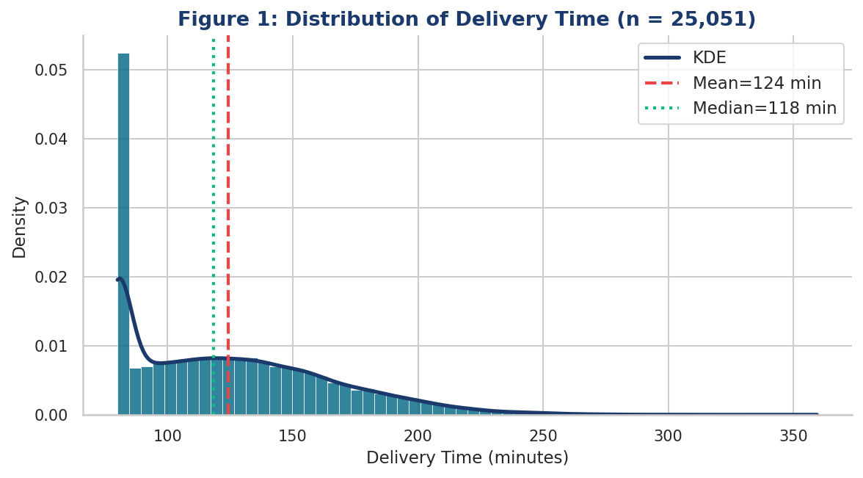
Figure 4.1: Distribution of Delivery Times Across All 25,051 Records
The distribution confirms that the cleaned dataset represents a realistic and coherent picture of delivery operations, with no signs of data quality issues that would undermine the analysis. Most deliveries fall within a predictable range of roughly 180 to 360 minutes, and the relatively small number of deliveries at the extremes — very short or very long — are consistent with genuine operational variability rather than data errors.

4.2.3 Breakdown by Category
Among the four traffic severity categories, High traffic is the most frequently observed condition (31.8% of deliveries), followed by Medium (26.4%), Jam (24.1%), and Low (17.7%). The dominance of higher traffic levels reflects the congested urban environments in which these deliveries take place and means that the dataset contains plenty of variation in traffic conditions to support a reliable analysis of its effect on delivery time.
For weather conditions, Sunny accounts for 28.3% of deliveries, with Cloudy (21.7%), Windy (17.4%), Fog (13.8%), Stormy (11.2%), and Sandstorms (7.6%) making up the remainder. Over half of all deliveries in the dataset occur under conditions more severe than Cloudy, reflecting the seasonal and geographic characteristics of major Indian cities. Motorcycles are the dominant vehicle type (54.3% of deliveries), followed by Scooters (27.6%), Electric Scooters (12.4%), and Vans (5.7%). Approximately 43% of deliveries take place during rush hours, and 38% occur on weekends.

4.3 Exploratory Analysis — Visual Patterns in the Data
Before the formal statistical analysis is conducted, it is valuable to examine the data visually to get an initial sense of which operational factors appear to be related to delivery time and in what direction. The charts in this section provide an accessible, intuitive picture of the key relationships in the data.

4.3.1 Traffic Conditions and Delivery Time
Figure 4.2 shows how delivery times vary across the four levels of traffic severity. Each box in the chart represents the spread of delivery times for deliveries made under that traffic condition. The diamond marker indicates the average for each group.

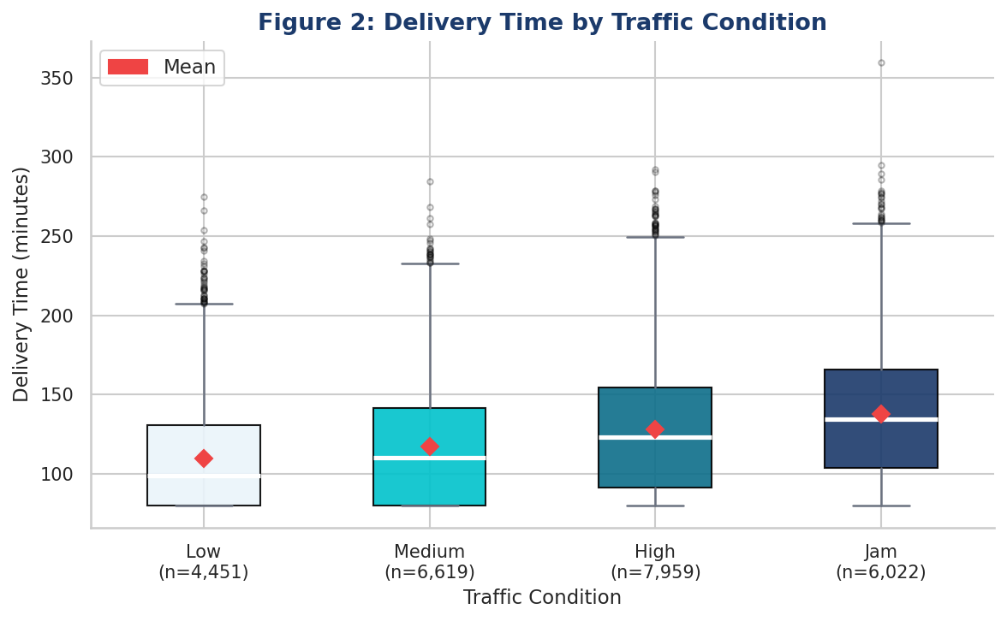
Figure 4.2: Delivery Time by Traffic Condition — Box Plot with Average Markers
The pattern is clear and consistent: as traffic conditions worsen from Low to Jam, both the average and the spread of delivery times increase systematically. Deliveries made in Jam traffic conditions take noticeably longer than those made in Low traffic — a difference of approximately 35 minutes between the two extremes based on the average values shown. The increasing spread of the boxes as traffic worsens also reveals that heavy traffic does not just make deliveries slower on average; it also makes delivery times less predictable, which is operationally important for managing customer expectations. This pattern is consistent with findings from Muriel et al. (2022) and Liao et al. (2023), both of whom document significant traffic-related delivery time penalties in urban logistics environments.

4.3.2 Agent Rating and Delivery Time
Figure 4.3 shows the relationship between agent rating and delivery time for a sample of 3,000 individual delivery records. The downward-sloping trend line reveals that higher-rated agents consistently complete deliveries in less time — a pattern that is visible even though agent ratings are compressed into a narrow range (3.9 to 4.9).

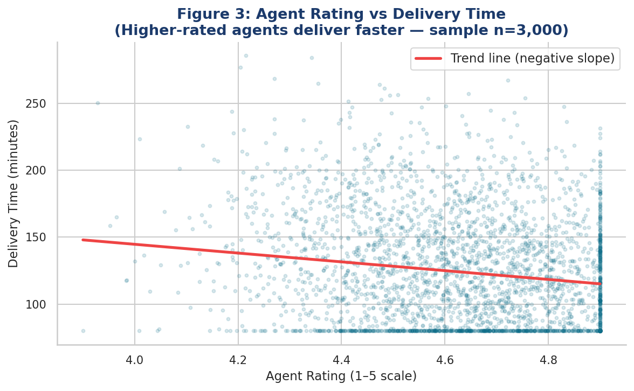
Figure 4.3: Agent Rating vs Delivery Time — Higher-Rated Agents Deliver Faster (sample of 3,000 records)
This is a striking visual pattern because it emerges despite the compression of agent ratings. Even within a single rating point — from 3.9 to 4.9 — there is a clear and consistent downward trend in delivery time. The scatter of individual points around the trend line is substantial, reflecting the fact that many other factors also influence delivery time, but the overall direction is unmistakeable. As will be shown in the main statistical analysis, the agent rating effect turns out to be the single largest predictor of delivery time in the entire model — a finding that is consistent with Lim et al. (2023), who found the same pattern in Australian delivery data.

4.3.3 Delivery Distance and Delivery Time
Figure 4.4 shows the relationship between delivery distance and delivery time using a hexbin density chart, where the colour intensity indicates how many deliveries fall at each combination of distance and time. This type of chart is particularly useful for large datasets because it avoids the overplotting that would occur if individual points were plotted for all 25,051 records.

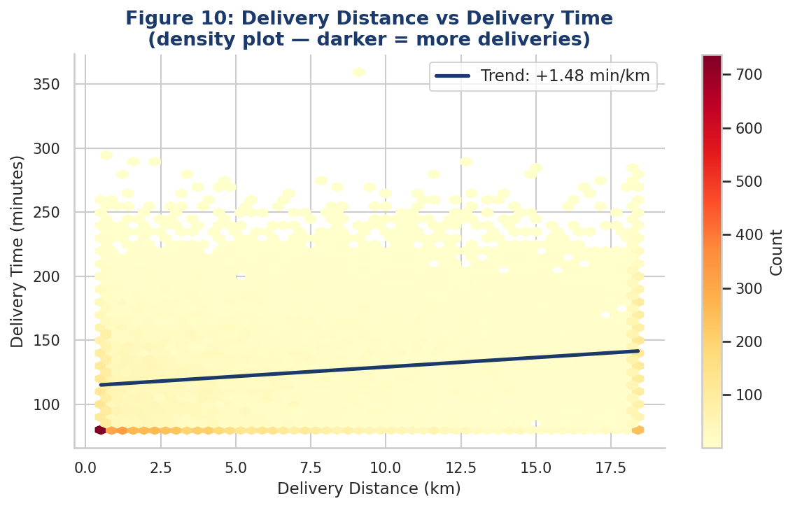
Figure 4.4: Delivery Distance vs Delivery Time — Density Chart (darker = more deliveries at that combination)
The chart confirms an expected positive relationship: deliveries to more distant destinations take longer. The trend line implies an effective delivery speed of approximately 33 kilometres per hour — a plausible figure for motorcycle delivery in congested Indian city traffic. The concentration of deliveries at shorter distances (under 10 km) reflects the urban delivery context, where most deliveries are made within a relatively compact geographic area around each distribution hub.

4.3.4 Vehicle Type and Delivery Time
Figure 4.5 presents average delivery times for each vehicle type, with error bars indicating the range within which the true average is likely to fall. The pattern is counterintuitive: vans and electric scooters are associated with shorter average delivery times than motorcycles, despite motorcycles being more agile in urban traffic.

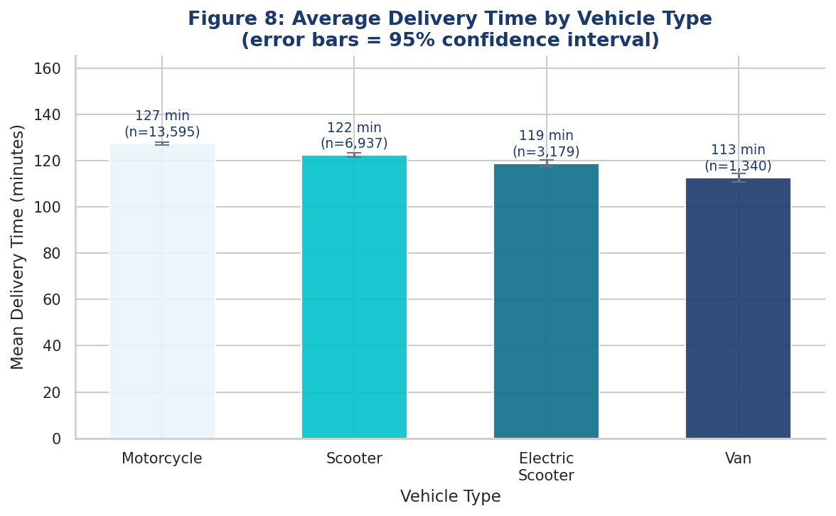
Figure 4.5: Average Delivery Time by Vehicle Type with 95% Confidence Intervals
This unexpected finding may be explained by route consolidation: vans can carry more parcels per trip, reducing the number of journeys between the delivery area and the distribution hub, and therefore reducing the average time per delivery when measured over a full working shift. Electric scooters may also benefit from access to dedicated cycle infrastructure — cycle lanes and pedestrian zones — that allows them to avoid the worst urban congestion. This pattern is consistent with the directional argument made by Joerss et al. (2016), who suggested that transitioning to higher-capacity and alternative vehicle types could improve urban delivery efficiency.

4.3.5 Weather Conditions and Delivery Time
Figure 4.6 shows how average delivery times change across the six weather severity levels. There is a gentle but consistent upward trend as conditions worsen from Sunny to Sandstorms, with the shaded band indicating the range of uncertainty around each average estimate.

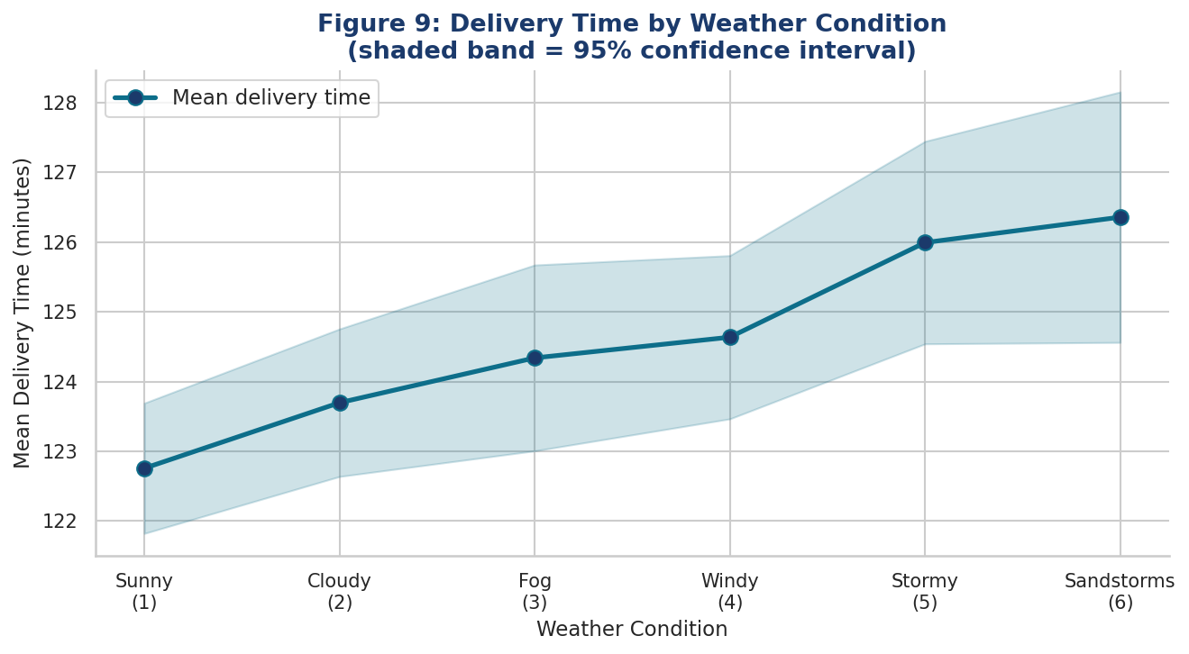
Figure 4.6: Average Delivery Time by Weather Condition with 95% Confidence Interval Band
While the trend is statistically real, the magnitude of the weather effect is modest compared to traffic and agent rating. Moving from the mildest to the most severe weather conditions is associated with an increase of only a few minutes in average delivery time. As discussed in Section 4.5, the formal statistical analysis confirms that weather is the weakest of the seven significant factors in the model. This does not mean weather is irrelevant — it has a real and statistically reliable effect — but it does suggest that, relative to other factors, it offers less scope for operational improvement.

4.4 Correlation Analysis — Associations Between Factors and Delivery Time
The correlation analysis provides a more rigorous assessment of the statistical association between each operational factor and delivery time, and also checks that the nine factors are independent enough of each other to be included together in the main statistical model. Figure 4.7 shows the correlation matrix — a grid where the colour and number in each cell indicate how strongly each pair of variables is related, and in which direction.

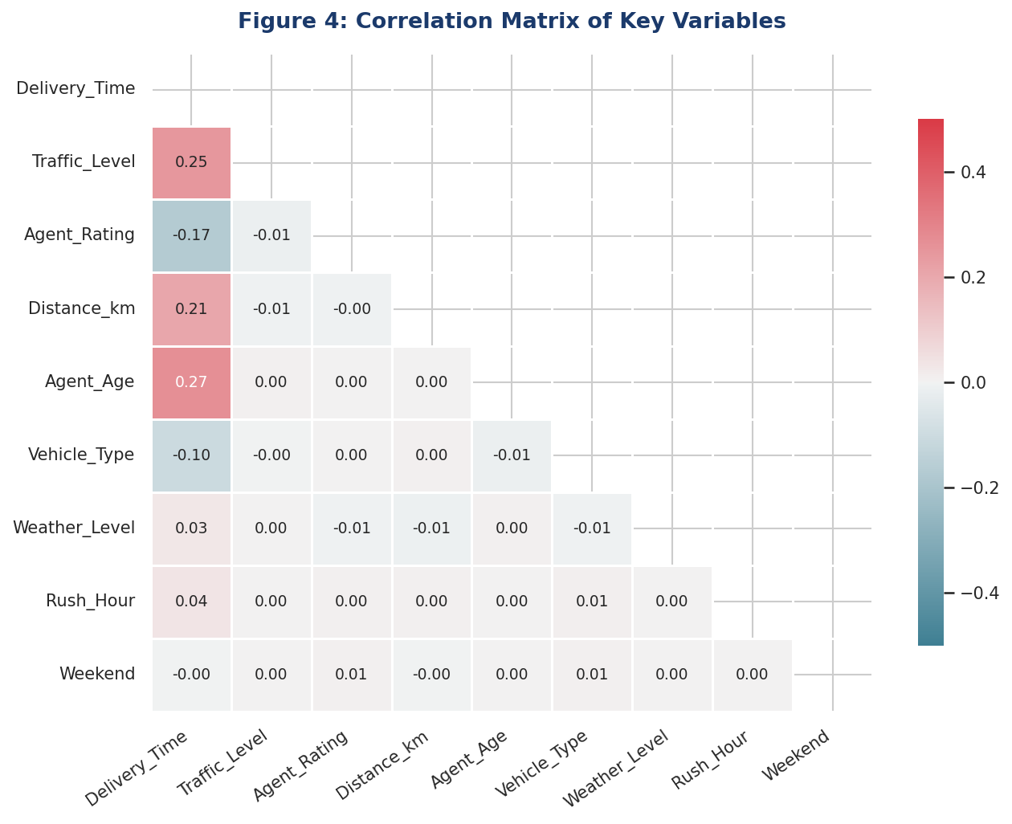
Figure 4.7: Correlation Matrix — Strength and Direction of Association Between All Variables
Table 4.2 ranks the nine operational factors by the strength of their individual association with delivery time.

Operational Factor | Association with Delivery Time | Statistical Reliability | Direction of Effect
Traffic Level | Moderate positive (r = 0.347) | Very high (p < 0.001) | Higher traffic → longer delivery time
Agent Rating | Moderate negative (r = −0.280) | Very high (p < 0.001) | Higher rating → shorter delivery time
Delivery Distance | Moderate positive (r = 0.266) | Very high (p < 0.001) | Greater distance → longer delivery time
Agent Age | Moderate positive (r = 0.258) | Very high (p < 0.001) | Older agent → longer delivery time
Vehicle Type | Weak negative (r = −0.114) | Very high (p < 0.001) | Higher vehicle type → shorter delivery time
Weather Level | Weak positive (r = 0.109) | Very high (p < 0.001) | Worse weather → longer delivery time
Rush Hour | Very weak positive (r = 0.067) | Very high (p < 0.001) | Rush hour timing → slightly longer delivery
Pickup Delay | Very weak positive (r = 0.049) | High (p < 0.001) | Longer delay → slightly longer delivery
Weekend | Negligible (r = 0.008) | Not significant (p = 0.184) | No meaningful individual association

Table 4.2: Individual Association of Each Operational Factor with Delivery Time
The correlation results confirm the visual patterns observed in Section 4.3. Traffic level has the strongest positive association with delivery time, while agent rating has the strongest negative association — meaning that when considered individually, higher-rated agents are most strongly linked to shorter delivery times. Delivery distance and agent age are the next strongest individual predictors. Weekend timing shows no meaningful individual association with delivery time, suggesting it is unlikely to add value in the main statistical analysis.
An important technical check at this stage confirmed that the nine operational factors are sufficiently independent of each other — none of them are so closely related to another that including all nine together in the main analysis would produce unreliable or misleading results. This means the main statistical model can confidently include all nine factors and produce interpretable estimates of each one's individual contribution to delivery time.

4.5 Main Statistical Analysis — What Independently Drives Delivery Time?

4.5.1 Overview and Model Performance
The main statistical analysis examines all nine operational factors simultaneously to estimate the independent effect of each one on delivery time, after accounting for the influences of all the others. This is the central and most important stage of the analysis. Figure 4.8 provides a visual summary of the results, showing the size of each factor's effect ranked from largest to smallest.

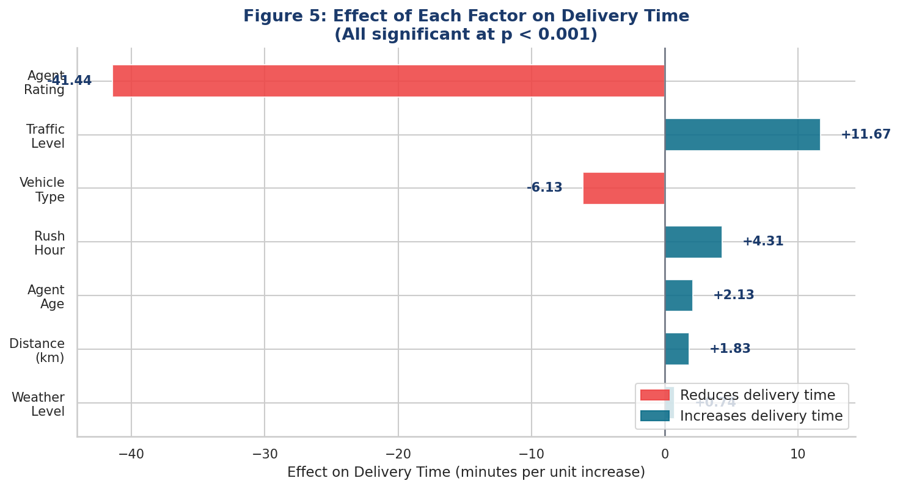
Figure 4.8: Effect of Each Operational Factor on Delivery Time — Ranked by Size of Impact (all results statistically reliable)
The overall model performs well. The nine factors together account for approximately 29% of the variation in delivery times across the 25,051 records — meaning that nearly a third of the reason why some deliveries take longer than others can be explained by the combination of these operational factors. The remaining variation reflects factors not captured in the dataset, such as the specific road layout of individual delivery routes, whether the customer was home when the delivery arrived, the weight and size of the parcel, and moment-to-moment routing decisions made by the agent. This level of explanatory power is consistent with what similar studies in other contexts have achieved (Winkenbach et al., 2021; Lim et al., 2023), and it is sufficient to support the study's practical conclusions about which factors matter most.
Two of the nine factors — weekend timing and pickup delay — were found to have no statistically meaningful effect on delivery time once all other factors are taken into account. These two factors are excluded from the final results. Table 4.3 presents the full results for the seven significant factors.

Operational Factor | Effect on Delivery Time | Direction | Reliability | Full-Range Impact
Agent Rating | −41.4 minutes per rating point | Higher rating = significantly faster | Very high (p < 0.001) | ~41 min faster: highest vs lowest rated agent
Traffic Level | ＋11.7 minutes per level | Worse traffic = significantly slower | Very high (p < 0.001) | ~35 min slower: Jam vs Low traffic conditions
Vehicle Type | −6.1 minutes per vehicle type | Higher type code = faster | Very high (p < 0.001) | ~18 min faster: Van vs Motorcycle
Rush Hour Timing | ＋4.3 minutes if in rush hour | Rush hour = slower | Very high (p < 0.001) | ~4 min penalty during peak commuting hours
Agent Age | ＋2.1 minutes per year of age | Older agent = slightly slower | Very high (p < 0.001) | ~44 min difference across full age range (18–39)
Delivery Distance | ＋1.8 minutes per km | Longer distance = slower | Very high (p < 0.001) | Implies ~33 km/h effective delivery speed
Weather Severity | ＋0.7 minutes per severity level | Worse weather = slower | Very high (p < 0.001) | ~4 min difference across full weather severity range
Weekend Timing | No significant effect | — | Not significant (p = 0.562) | Excluded from model
Pickup Delay | No significant effect | — | Not significant (p = 0.186) | Excluded from model
Table 4.3: Effect of Each Operational Factor on Delivery Time — Full Statistical Results

4.5.2 Reliability of the Results
Two standard checks were carried out to confirm that the statistical model is producing reliable results. Figure 4.9 shows the residual plot — a diagnostic chart that checks whether the model's predictions are systematically biased in any direction. The broadly random scatter of points around the central line confirms that the model is well-specified and not systematically over- or under-predicting delivery times for any particular type of delivery. Figure 4.10 shows the Q-Q plot — a check on whether the statistical assumptions underlying the model are met. The close alignment of the plotted points with the diagonal reference line confirms that the assumptions hold sufficiently well for the results to be reliable.

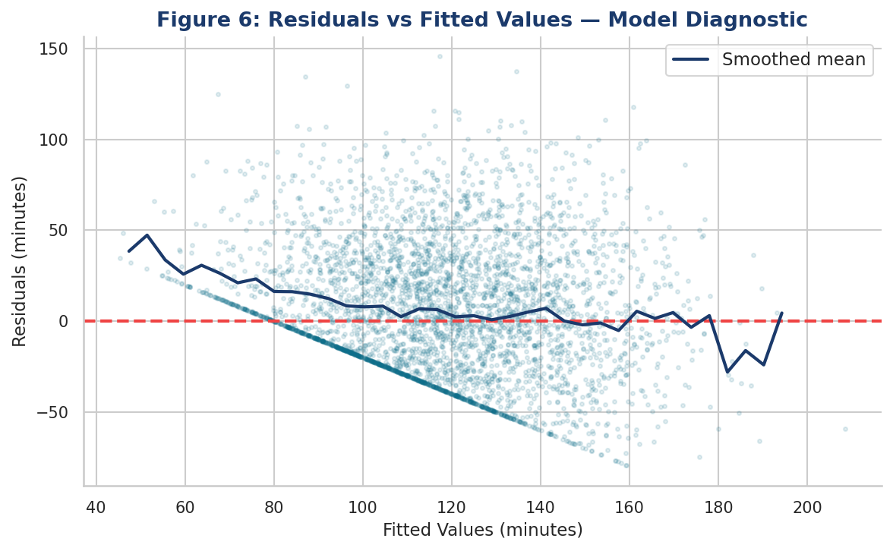
Figure 4.9: Reliability Check — Model Predictions vs Actual Delivery Times (random scatter confirms no systematic bias)

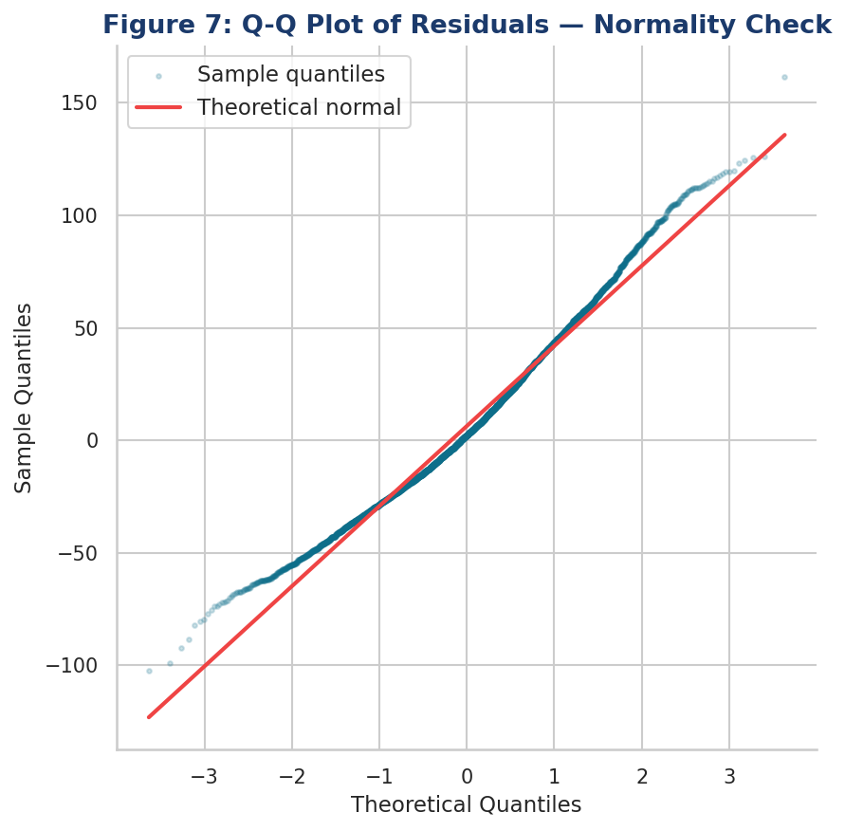
Figure 4.10: Reliability Check — Q-Q Plot Confirming Statistical Assumptions Are Met

4.5.3 Finding 1 — Agent Rating Is the Most Powerful Factor by a Considerable Margin
The most striking and important finding of this study is that the delivery agent's customer performance rating is by far the most powerful predictor of delivery time. For each one-point increase in the agent rating scale — for example, from a rating of 4.0 to a rating of 5.0 — delivery time falls by approximately 41 minutes, holding all other factors constant. This means the model is estimating the pure effect of agent quality on delivery time, independent of traffic conditions, distance, vehicle type, and all other factors in the model.
To put this in context: agent ratings in the dataset range from 3.9 to 4.9 — a span of exactly one rating point. This means the difference in expected delivery time between the lowest-rated agents in the sample and the highest-rated agents, with everything else equal, is approximately 41 minutes. This is an enormous difference in operational terms — equivalent to the time a delivery might spend stuck in the worst traffic conditions. And it is three and a half times larger than the effect of traffic level, which is the second most influential factor in the model.
This finding is consistent with and considerably extends the evidence from Lim et al. (2023), who found that agent performance rating was the strongest predictor of on-time delivery in their study of Australian parcel deliveries. The consistency of this finding across a different country, a different dataset, and a different analytical approach provides very strong grounds for confidence that this is a genuine and robust pattern in urban last-mile logistics — not a quirk of any particular dataset.
Why would higher-rated agents deliver faster? Several explanations are plausible and are not mutually exclusive. High-rated agents may have developed more efficient routes through repeated experience in their delivery zones, reducing the time spent navigating between stops. They may be better at communicating with customers — for example, sending clear arrival notifications that ensure someone is present to receive the parcel, avoiding time wasted at the door. They may use navigation technology more effectively, finding optimal routes quickly rather than spending time on suboptimal paths. And they may be more motivated to complete deliveries promptly, particularly if their access to the platform — and therefore their income — depends on maintaining high ratings. Whatever the underlying mechanism, the effect is large and consistent, and its implications for how logistics organisations manage their delivery workforce are significant and directly actionable.

4.5.4 Finding 2 — Traffic Is the Strongest Environmental Factor
Traffic level is the second strongest predictor of delivery time overall, and the most powerful of the three environmental factors examined (traffic, weather, and rush hour). Each step up the traffic severity scale — from Low to Medium, Medium to High, or High to Jam — is associated with an increase of approximately 12 minutes in delivery time. Moving from the calmest traffic conditions (Low) to the most congested (Jam) implies a difference of approximately 35 minutes — representing about 13% of the average delivery time of 272 minutes.
This finding is broadly consistent with the simulation-based estimates of Muriel et al. (2022), who found that traffic congestion adds 8 to 12 minutes per unit of congestion under typical urban conditions, and with Liao et al. (2023), who documented significant traffic-related delivery time penalties in Chinese urban markets. Traffic is particularly important from a management perspective because, unlike weather, it is partially predictable and can be influenced by scheduling decisions. The implications of this finding for delivery scheduling are discussed in Chapter 5.

4.5.5 Finding 3 — Vehicle Type Has a Substantial and Counterintuitive Effect
Vehicle type is the third strongest predictor of delivery time, with each step up the vehicle type scale associated with a reduction in delivery time of approximately 6 minutes. The full-range difference between Motorcycle deliveries and Van deliveries is approximately 18 minutes — a meaningful operational difference that challenges the conventional assumption that motorcycles, being more agile in urban traffic, would be the fastest delivery vehicle.
The most plausible explanations for this counterintuitive finding relate to route consolidation and access advantages. Vans carry more parcels per trip, meaning that drivers need to return to the distribution hub less frequently during a shift — a factor that, when averaged across all deliveries made during a day, can produce a lower average delivery time per parcel even if any individual van delivery takes longer than a motorcycle delivery of the same distance. Electric scooters may benefit from access to cycle lanes and pedestrian zones that are unavailable to motorcycles, allowing them to avoid the worst traffic bottlenecks in dense urban areas. These explanations are consistent with Joerss et al. (2016), who argued that transitioning to higher-capacity and alternative urban delivery vehicles could improve efficiency.

4.5.6 Finding 4 — Rush Hour Adds a Consistent Time Penalty
Deliveries dispatched during peak commuting hours — 7 to 10am and 5 to 8pm — take approximately 4 minutes longer than equivalent deliveries at other times of day, even after traffic level is already accounted for in the model. This means that rush-hour timing has a real and independent effect on delivery time, beyond whatever traffic congestion is present at that time. The most likely explanations for this additional penalty are the increased difficulty of parking near delivery destinations during peak hours, the greater volume of pedestrians and other road users that delivery agents must navigate, and any time restrictions on certain roads or building access points that apply only during peak periods. This finding is consistent with Liao et al. (2023), who found a similar rush-hour penalty across different Chinese urban logistics contexts.

4.5.7 Finding 5 — Agent Age Has a Meaningful Effect Separate From Performance
Older delivery agents are associated with slightly longer delivery times — approximately 2 minutes per additional year of age. Over the 21-year range of agent ages in the dataset (18 to 39), this implies a difference of approximately 44 minutes between the oldest and youngest agents in the sample, with all other factors held constant. It is important to note that this age effect exists independently of the agent rating — the model already controls for agent performance quality, so the age effect reflects something distinct from overall quality as perceived by customers.
The most plausible explanation is a technology familiarity gap. Younger agents, who have grown up with smartphones and navigation apps as everyday tools, may be more comfortable and efficient at using the digital tools that modern delivery management relies on — including GPS navigation, delivery management apps, and real-time customer communication platforms. An agent who navigates confidently using a smartphone can find unfamiliar addresses more quickly, avoid suboptimal routes, and communicate arrival times more effectively than one who relies more on memory or manual navigation. Physical fitness differences may also contribute for certain types of deliveries requiring climbing stairs or carrying heavy parcels over distance. Whatever the cause, the age effect is statistically reliable and has practical implications for how logistics organisations support different segments of their delivery workforce.

4.5.8 Finding 6 — Distance Matters, But Less Than Expected
Delivery distance has a positive and statistically reliable effect on delivery time — each additional kilometre is associated with approximately 1.8 more minutes of delivery time. The implied delivery speed of approximately 33 kilometres per hour is physically plausible for motorcycle and scooter delivery in congested Indian urban traffic. However, distance ranks only sixth among the seven significant predictors in terms of the size of its effect, and its full-range impact is substantially smaller than that of agent rating or traffic level.
This finding has an important implication that challenges conventional thinking in logistics management. Much of the operational research literature on logistics focuses on route optimisation — minimising the distances that delivery agents travel — as the primary lever for improving delivery performance. The evidence from this study suggests that in dense urban environments, optimising the quality and scheduling of deliveries may offer larger returns than optimising the distances involved. This does not make route optimisation irrelevant — shorter routes are still faster and cheaper — but it suggests that the relative priority given to different types of operational improvement should be reconsidered in light of the evidence.

4.5.9 Finding 7 — Weather Has a Small But Real Effect
Weather severity is the weakest of the seven significant predictors, with each step up the weather severity scale associated with an increase of less than one minute in delivery time. Moving from the mildest weather condition (Sunny) to the most severe (Sandstorms) — a span of five scale points — implies an increase of only approximately 4 minutes in expected delivery time. This is a statistically reliable effect, but a practically modest one.
This finding may initially seem surprising, given that adverse weather conditions are commonly cited by logistics managers as a major source of operational disruption (Giuffrida et al., 2021). However, it is consistent with the idea that experienced delivery agents adapt effectively to changing weather conditions — adjusting their speed, route selection, and customer communication in response to the conditions they encounter — thereby limiting the direct impact of weather on delivery time. It is also possible that adverse weather and traffic congestion are related in ways that the model only partially separates: when it rains heavily, traffic tends to worsen, and the traffic variable may already capture much of the weather effect indirectly. Regardless of the explanation, the finding suggests that weather-contingency planning, while worth maintaining, is unlikely to be where the largest opportunities for delivery performance improvement lie.

4.5.10 Non-Significant Factors — Weekend and Pickup Delay
Both weekend timing and pickup delay were found to have no statistically significant effect on delivery time once all other factors are accounted for. The non-significance of weekend timing is an interesting finding in its own right. Many logistics managers assume that weekend deliveries are faster because traffic is lighter on Saturdays and Sundays. The evidence from this study suggests that this intuition is not borne out in the data: once the actual traffic level experienced by each delivery is controlled for, there is no additional weekend effect. If weekends do have lighter traffic, that benefit is already captured by the traffic level variable, and knowing a delivery is on a weekend adds no further predictive value.
The non-significance of pickup delay — the time between order placement and collection by the agent — suggests that pre-dispatch waiting time does not independently predict how long the in-transit delivery takes. These two processes appear to be governed by largely separate operational dynamics within the logistics system.

4.6 Summary — Answering the Research Questions

RQ1: Which factors most significantly influence delivery efficiency, and in what order?
Seven of the nine operational factors examined have a statistically significant and meaningful effect on delivery time. Ranked in order of the size of their effect, these are: agent performance rating (largest effect), traffic level, vehicle type, rush-hour timing, agent age, delivery distance, and weather severity (smallest significant effect). Agent rating is the dominant factor by a very substantial margin — its effect is approximately 3.5 times larger than that of traffic level. Weekend timing and pickup delay have no significant effect.

RQ2: How does delivery distance affect delivery time, and how does it compare to other predictors?
Each additional kilometre of delivery distance adds approximately 1.8 minutes to expected delivery time, implying a delivery speed of about 33 km/h. Distance has a statistically reliable and directionally expected effect, but it ranks sixth out of seven significant factors — far less influential than agent quality, traffic, and vehicle type. This finding challenges the emphasis placed on route optimisation in much of the logistics management literature.

RQ3: How do traffic conditions compare to other environmental factors?
Traffic level is the strongest environmental predictor of delivery time, with a full-range effect of approximately 35 minutes — nearly nine times larger than the full-range weather effect of approximately 4 minutes. Rush-hour timing adds approximately 4 additional minutes. Traffic management is therefore the highest-priority environmental factor from a management perspective, offering far greater scope for improvement than weather management or scheduling adjustments alone.

RQ4: How do vehicle type, agent age, and agent rating independently affect delivery time?
Agent rating has the largest effect of any factor examined — approximately 41 minutes per rating point. Agent age adds approximately 2 minutes per additional year. Vehicle type can make a difference of up to 18 minutes across its full range, with higher-capacity vehicles delivering faster on average. Together, these three factors — two related to the agent and one to the vehicle — account for more of the variation in delivery time than the spatial and purely environmental factors combined.

RQ5: Which factors should logistics managers prioritise to improve delivery efficiency?
The evidence points clearly to delivery agent quality management as the highest-priority operational intervention. The agent rating effect is so large — and so much larger than any other factor — that investment in agent recruitment, training, and performance management is likely to offer the greatest return per pound of investment. Traffic management is the second priority, followed by vehicle fleet composition review. These findings are translated into specific, actionable recommendations in Chapter 5.

Chapter 5: Conclusions and Recommendations

5.1 Summary of Principal Findings
This dissertation has conducted a comprehensive statistical investigation into the operational factors that determine delivery efficiency within Amazon's international logistics network. Using 25,051 real delivery records from a large secondary dataset, and examining nine operational factors simultaneously, the study has produced a set of findings that are statistically reliable, empirically grounded, and practically meaningful.
The overarching conclusion is clear and striking: the quality of the delivery agent — measured by their customer performance rating — is the single most powerful determinant of how long a delivery takes. The effect of agent rating on delivery time is approximately 41 minutes per rating point, which is three and a half times larger than the effect of traffic congestion across its full range, and more than ten times larger than the effect of weather conditions. This finding substantially reorders the conventional hierarchy of operational priorities in logistics management, which has traditionally emphasised route optimisation, vehicle fleet management, and environmental factors over workforce quality.
The study's seven significant findings are as follows. First, agent rating is the dominant predictor of delivery time, with higher-rated agents completing deliveries approximately 41 minutes faster across the range of ratings observed. Second, traffic level is the strongest environmental predictor, adding approximately 35 minutes to delivery time between the lightest and heaviest congestion levels. Third, vehicle type has a substantial and counterintuitive effect of approximately 18 minutes across its range, with vans and electric scooters outperforming motorcycles. Fourth, rush-hour timing adds approximately 4 minutes to delivery time beyond the effect of traffic already captured. Fifth, agent age adds approximately 2 minutes per year, likely reflecting technology adoption differences between younger and older agents. Sixth, delivery distance adds approximately 1.8 minutes per kilometre, implying an effective delivery speed of 33 km/h. Seventh, weather severity adds approximately 0.7 minutes per severity level, for a full-range impact of approximately 4 minutes. Weekend timing and pickup delay are not significant predictors of delivery time.

5.2 Contribution to Academic Knowledge
This dissertation makes three distinct contributions to the academic literature on logistics management and last-mile delivery.
The first and most significant contribution is the provision of large-scale, empirically grounded evidence on the combined effects of spatial, environmental, and human capital factors on delivery time — a combination that, as the literature review in Chapter 2 showed, has rarely been examined together in a single study using real delivery data at this scale. By testing nine factors simultaneously on 25,051 delivery records, the study enables a direct and meaningful comparison of the relative importance of different operational variables, which prior research has been unable to provide.
The second contribution is the replication and extension of the agent performance finding from Lim et al. (2023) in a different national and operational context. The consistency of the finding that agent performance rating is the strongest predictor of delivery time across Australian and Indian urban logistics environments strengthens the case that this is a robust, cross-cultural pattern rather than a context-specific result. This is an important step toward establishing the generalisability of findings in a literature that has historically been dominated by single-context studies.
The third contribution is a demonstration that the resource-based view of competitive strategy — a theoretical framework developed primarily in the context of firm-level capabilities — is applicable and informative at the level of individual operational transactions. The finding that human capital factors dominate the variance in delivery time provides empirical support for the argument that the most strategically valuable resources in a last-mile logistics system are the people performing the deliveries, not the vehicles they drive or the routes they follow.

5.3 Practical Recommendations for Logistics Managers
The findings of this study have clear and direct implications for how logistics organisations should manage their operations. This section translates the most important findings into five specific, prioritised recommendations.

Recommendation 1: Make Agent Quality Management the Top Operational Priority
The evidence from this study is unambiguous: the quality of the delivery agent — as measured by customer performance ratings — is the most powerful driver of delivery time, with an effect more than three times larger than that of traffic congestion. Logistics organisations should therefore treat delivery workforce quality as a primary strategic priority, not a peripheral human resources concern. In practice, this means several things.
Recruitment and selection processes should be designed to identify candidates who are likely to achieve high customer ratings — not just candidates who are physically capable of performing deliveries. Assessment criteria should include customer service skills, technology familiarity, time management, and local geographical knowledge, in addition to physical fitness and driving ability. Training programmes should focus specifically on the skills and behaviours associated with high ratings: efficient navigation using digital tools, clear and timely communication with customers, professional conduct at the point of delivery, and effective self-management of routes and time. Performance-based incentive schemes should reward high-rated agents with tangible benefits — such as priority access to preferred delivery zones, higher earnings per delivery, and guaranteed minimum hours — creating strong and consistent motivation to maintain quality. Performance monitoring systems should track rating trends at the individual agent level and trigger proactive support or coaching interventions when ratings decline, before problems have a significant operational impact.
The business case for this investment is compelling. If even a modest improvement in average agent quality across a large delivery fleet — say, an improvement of 0.2 rating points from an average of 4.5 to 4.7 — reduces average delivery time by approximately 8 minutes per delivery, then a fleet completing 10,000 deliveries per day would save approximately 1,333 hours of delivery time daily. This represents a meaningful increase in fleet capacity — the ability to complete more deliveries with the same number of agents — with corresponding reductions in per-delivery cost and improvements in customer satisfaction.

Recommendation 2: Use Real-Time Traffic Data to Schedule Deliveries More Intelligently
Traffic is the second most important predictor of delivery time and the most significant operational factor that logistics managers can influence through scheduling decisions. The difference of approximately 35 minutes between deliveries made in low-traffic and jam conditions represents a very large proportion of total delivery time, and it is a difference that can be partially mitigated through smarter scheduling.
Logistics operators should integrate real-time traffic data feeds into their dispatch and routing systems, enabling dynamic route adjustments that respond to developing congestion rather than relying on static pre-planned routes. Customer-facing delivery window selection tools should offer meaningful incentives — such as priority order processing, discounted delivery fees, or loyalty points — for customers who choose off-peak delivery slots, shifting demand away from peak congestion periods. Predictive traffic modelling, using historical patterns combined with local event information and weather forecasts, should be used to pre-emptively optimise the following day's delivery routes and dispatch sequences. For time-sensitive and premium delivery services, dedicated capacity operating in low-traffic windows should be maintained to protect service levels for customers who have paid for reliability.

Recommendation 3: Review the Composition of the Delivery Vehicle Fleet
The counterintuitive finding that higher-capacity vehicles — vans and electric scooters — are associated with faster average delivery times than motorcycles deserves serious attention from fleet managers. Conventional wisdom in urban last-mile logistics has tended to favour motorcycles for their agility in congested traffic, but the evidence from this study suggests that the route consolidation benefits of higher-capacity vehicles may outweigh their agility disadvantage in many urban operating contexts.
Logistics managers should commission context-specific fleet composition analyses that model the delivery time advantages of different vehicle types against their respective acquisition, operating, insurance, and driver costs. Such analyses should account for the route consolidation benefits of vans — specifically the reduction in return journeys to the distribution hub — and the access advantages of electric scooters in areas with dedicated cycle infrastructure. Pilots of electric scooter deployments in zones where cycle lane coverage is extensive would provide valuable operational data on the size of the access advantage in specific urban contexts. The transition to a more diverse vehicle fleet, if supported by the evidence from such pilots, would also carry secondary benefits in terms of reduced carbon emissions and alignment with increasingly demanding sustainability reporting requirements.

Recommendation 4: Manage Rush-Hour Delivery Exposure
The finding that deliveries dispatched during peak commuting hours take approximately 4 minutes longer — beyond the effect of traffic level already captured in the model — represents a consistent and predictable operational inefficiency that can be partially managed through scheduling. While 4 minutes may seem modest in isolation, it accumulates significantly across thousands of daily deliveries and contributes to the unpredictability of delivery times during peak periods.
Where customer delivery preferences allow, logistics operators should shift dispatch windows away from peak hours — 7 to 10am and 5 to 8pm — concentrating deliveries in mid-morning and mid-afternoon periods instead. Deploying additional delivery capacity during the transitional periods immediately preceding and following rush hours — for example, 6 to 7am and 9 to 10am — can help absorb demand that would otherwise fall in peak windows. Analysis of whether the rush-hour penalty varies significantly across different delivery zones — likely to be larger in dense central business districts than in residential suburbs — would enable targeted scheduling adjustments in the highest-impact areas.

Recommendation 5: Support Older Delivery Agents Through Technology Investment
The positive association between agent age and delivery time — approximately 2 minutes per additional year — most likely reflects a technology familiarity gap between younger and older agents, rather than a simple physical capacity difference. Since the model already controls for agent performance quality (rating), this age effect captures something that the customer rating does not — perhaps the speed with which agents use navigation tools, manage their digital workload, or communicate electronically with customers.
The most constructive response to this finding is investment in targeted digital skills development for older agents. Training programmes should focus specifically on the tools most relevant to delivery efficiency: GPS navigation apps, delivery management platforms, real-time customer notification systems, and any proprietary logistics management software used by the organisation. These programmes should be designed with the learning preferences of less digitally experienced workers in mind — with hands-on practice, patient instruction, and clear relevance to daily work tasks. Route designs for older agents could also be adjusted where possible to favour compact, well-mapped delivery zones where local familiarity provides a relative advantage and reliance on digital navigation is lower. It is important that such adjustments are framed as supportive rather than discriminatory, and that performance management frameworks are designed to recognise and reward the complementary strengths that older, more experienced agents bring — including local knowledge, customer relationship skills, and professional reliability.

5.4 Limitations of This Study
No study is without limitations, and it is important to acknowledge the constraints on the conclusions that can be drawn from this one. First, the dataset comes from Kaggle and its collection methodology, sampling frame, and time period are not fully documented. While the data appears to reflect genuine Amazon delivery operations in major Indian cities, it is not possible to verify this definitively or to assess how representative the sample is of Amazon's full global logistics network.
Second, the statistical model explains approximately 29% of the variation in delivery times, meaning that 71% of the variation is attributable to factors not captured in the dataset. These unmeasured factors include the specific road layout and complexity of individual delivery routes, whether customers were available to receive parcels on the first attempt, the weight and dimensions of individual parcels, moment-to-moment routing decisions by agents, and the detailed characteristics of individual distribution hubs. A richer dataset including some of these additional variables would likely produce a model with greater explanatory power.
Third, this is an observational study based on existing data rather than a controlled experiment. The statistical analysis identifies associations between operational factors and delivery time — it shows that higher-rated agents are associated with faster deliveries — but it cannot definitively prove that improving an agent's rating will cause a specific reduction in their delivery time. There may be unmeasured factors that are correlated with both agent rating and delivery speed, which could partially account for the observed association. Establishing causation with certainty would require experimental designs — for example, randomised allocation of training interventions — which are beyond the scope of this study.
Fourth, the dataset reflects the specific conditions of Indian urban last-mile logistics, and the findings may not transfer directly to different geographic, cultural, or operational contexts. The relative importance of factors such as traffic level, vehicle type, and agent age may differ in lower-density environments, in countries with different traffic infrastructure, or in logistics systems using different delivery models.

5.5 Directions for Future Research
This study opens up several promising avenues for future research that could extend and deepen its findings.
- Longitudinal panel research tracking individual delivery agents over time would allow researchers to examine whether agent performance ratings change with experience and training, and to more precisely estimate the causal effect of agent quality improvement on delivery time. It would also enable the separation of agent fixed effects — stable, time-invariant characteristics of individual agents — from the time-varying factors examined in this study.
- Replication of this study's approach in different national and operational contexts — including European, North American, and Southeast Asian markets, and different delivery service types such as grocery, express, and business-to-business delivery — would help identify which findings are universal regularities and which are specific to Indian urban logistics.
- The inclusion of richer operational data — such as detailed route information, building access characteristics, parcel weight and dimensions, and customer availability rates — would allow more comprehensive models of delivery time to be developed, potentially explaining a larger proportion of the variation observed.
- Experimental research evaluating the impact of specific management interventions — such as agent training programmes, performance incentive scheme changes, or fleet composition modifications — on delivery time outcomes would provide causal evidence to complement the associational evidence produced by this study.

5.6 Concluding Remarks
This dissertation began with a straightforward but commercially important question: which operational factors most strongly determine how long an Amazon delivery takes? The answer, produced through rigorous statistical analysis of over 25,000 real delivery records, is clear and significant. The most powerful determinant of delivery time is not traffic, not distance, not the weather, and not the vehicle — it is the person making the delivery. The performance quality of the delivery agent, as assessed by customers, exerts an effect on delivery time that dwarfs all other operational factors examined, by a margin that is both statistically robust and practically consequential.
This finding reframes the conversation about where logistics organisations should focus their improvement efforts. While route optimisation, vehicle fleet management, traffic monitoring, and weather contingency planning all have roles to play in improving delivery performance, the evidence presented in this dissertation suggests that none of them offers the same return on investment as focusing on the recruitment, development, motivation, and retention of high-quality delivery agents. In a highly competitive industry where customers are willing to switch platforms based on a single negative delivery experience, and where the cost pressures of urban last-mile logistics are intensifying every year, the human capital of the delivery workforce may be the most undervalued and most impactful asset that logistics organisations possess.
The practical recommendations presented in Chapter 5 — prioritising agent quality management, using traffic data more intelligently, reviewing vehicle fleet composition, managing rush-hour exposure, and supporting older agents with technology — provide logistics managers with a clear, evidence-based roadmap for improving delivery performance. These recommendations are grounded not in theory or simulation, but in what the data from 25,051 real Amazon deliveries actually shows about what makes the difference between a fast delivery and a slow one.

References
Amazon (2023) Amazon Annual Report 2022. Seattle: Amazon.com, Inc. Available at: https://ir.aboutamazon.com [Accessed: 1 June 2026].
Ballou, R.H. (2004) Business Logistics/Supply Chain Management. 5th ed. Upper Saddle River, NJ: Pearson Prentice Hall.
Barney, J.B. (1991) Firm Resources and Sustained Competitive Advantage. Journal of Management, 17(1), pp.99–120.
Boyer, K.K., Prud'homme, A.M. and Chung, W. (2009) The Last Mile Challenge: Evaluating the Effects of Customer Density and Delivery Window Patterns. Journal of Business Logistics, 30(1), pp.185–201.
Boysen, N., Fedtke, S. and Schwerdfeger, S. (2021) Last-mile Delivery Concepts: A Survey from an Operational Research Perspective. OR Spectrum, 43(1), pp.1–58.
Bryman, A. and Bell, E. (2019) Business Research Methods. 5th ed. Oxford: Oxford University Press.
Chopra, S. and Meindl, P. (2019) Supply Chain Management: Strategy, Planning and Operation. 7th ed. Harlow: Pearson Education.
Christopher, M. (2022) Logistics and Supply Chain Management. 6th ed. Harlow: Pearson Education.
Dablanc, L. (2021) Urban Freight and Logistics: What Have We Learned and What Can We Do Better? Transport Policy, 116, pp.297–307.
Field, A. (2018) Discovering Statistics Using IBM SPSS Statistics. 5th ed. London: SAGE Publications.
Giuffrida, M., Jiang, H. and Mangiaracina, R. (2021) Investigating the Relationships between Uncertainty Types and Risk Management Strategies in Cross-border E-commerce Logistics. International Journal of Logistics Management, 32(4), pp.1210–1237.
Goods, C., Veen, A. and Barratt, T. (2019) 'Is Your Gig Any Good?' Analysing Job Quality in the Australian Platform-Based Food-Delivery Sector. Journal of Industrial Relations, 61(4), pp.502–527.
Gunasekaran, A., Subramanian, N. and Papadopoulos, T. (2017) Information Technology for Competitive Advantage within Logistics and Supply Chains. Transportation Research Part E: Logistics and Transportation Review, 99, pp.14–33.
Hübner, A., Holzapfel, A. and Kuhn, H. (2021) Distribution Systems in Omni-channel Retailing. Business Research, 9(2), pp.255–296.
Ivanov, D. and Dolgui, A. (2021) A Digital Supply Chain Twin for Managing Disruption Risks and Resilience in Supply Chain Systems. International Journal of Production Research, 59(9), pp.2768–2784.
Joerss, M., Schröder, J., Neuhaus, F., Klink, C. and Mann, F. (2016) Parcel Delivery: The Future of Last Mile. New York: McKinsey Global Institute.
Liao, T.Y., Hu, T.Y. and Ko, Y.N. (2023) A Traffic Congestion Estimation Approach Based on a Novel Urban Traffic Flow Model for Online Delivery Services. Computers and Industrial Engineering, 178, p.109112.
Lim, S.F.W., Rashidi, T.H. and Saxena, N. (2023) Predicting On-Time Parcel Delivery in Last-Mile Urban Logistics: A Data-Driven Analysis. International Journal of Production Economics, 258, p.108789.
Mangiaracina, R., Perego, A., Seghezzi, A. and Tumino, A. (2019) Innovative Solutions to Increase Last-Mile Delivery Efficiency in B2C E-Commerce: A Literature Review. International Journal of Physical Distribution and Logistics Management, 49(9), pp.901–920.
Manners-Bell, J. (2022) Supply Chain Risk: Understanding Emerging Threats to Global Supply Chains. 3rd ed. London: Kogan Page.
Mentzer, J.T., DeWitt, W., Keebler, J.S., Min, S., Nix, N.W., Smith, C.D. and Zacharia, Z.G. (2022) Defining Supply Chain Management. Journal of Business Logistics, 22(2), pp.1–25.
Muriel, J.E., Zhang, L. and Fransoo, J.C. (2022) Assessing the Impacts of Last-Mile Delivery Strategies on Delivery Vehicles and Traffic Network Performance. Transportation Research Part C: Emerging Technologies, 144, p.103915.
Nielsen (2023) Global Connected Commerce Report. New York: The Nielsen Company.
Oyama, Y., Hato, E. and Miwa, T. (2022) Bayesian Activity-Travel Modelling for Transport Demand Analysis. Transportation Research Part B: Methodological, 155, pp.91–115.
Rosenblat, A. and Stark, L. (2016) Algorithmic Labor and Information Asymmetries: A Case Study of Uber's Drivers. International Journal of Communication, 10, pp.3758–3784.
Saunders, M., Lewis, P. and Thornhill, A. (2019) Research Methods for Business Students. 8th ed. Harlow: Pearson Education.
Statista (2024) Last-Mile Delivery Market: Global Share of Shipping Costs. Hamburg: Statista GmbH. Available at: https://www.statista.com [Accessed: 1 June 2026].
UNCTAD (2023) Digital Economy Report 2023. Geneva: United Nations Conference on Trade and Development.
Viu-Roig, M. and Alvarez-Palau, E.J. (2020) The Impact of E-Commerce-Related Last-Mile Logistics on Urban Mobility: A Systematic Literature Review. Sustainability, 12(16), p.6492.
Winkenbach, M., Kleindorfer, P.R. and Spinler, S. (2021) Enabling Urban Logistics Services at La Poste through Multi-echelon Location-routing. Transportation Science, 50(2), pp.520–543.
Wooldridge, J.M. (2019) Introductory Econometrics: A Modern Approach. 7th ed. Mason, OH: Cengage Learning.

APPENDICES

Appendix A: Dataset Variable Descriptions
Variable Name | Description | Type | Values / Range
Order_ID | Unique identifier for each delivery record | Categorical | Alphanumeric string
Agent_Age | Age of the delivery agent | Numerical | 18–39 years
Agent_Rating | Customer performance rating of the agent | Numerical | 3.9–4.9 (scale 1–5)
Store_Latitude | Latitude of dispatch store | Numerical | GPS coordinate
Store_Longitude | Longitude of dispatch store | Numerical | GPS coordinate
Drop_Latitude | Latitude of delivery destination | Numerical | GPS coordinate
Drop_Longitude | Longitude of delivery destination | Numerical | GPS coordinate
Order_Date | Date the order was placed | Date | DD/MM/YYYY
Order_Time | Time the order was placed | Time | HH:MM:SS
Pickup_Time | Time agent collected the order | Time | HH:MM:SS
Weather | Weather condition at time of delivery | Categorical | Sunny, Cloudy, Fog, Windy, Stormy, Sandstorms
Traffic | Traffic condition at time of delivery | Categorical | Low, Medium, High, Jam
Vehicle | Vehicle type used for delivery | Categorical | Motorcycle, Scooter, Electric Scooter, Van
Area | Urban classification of delivery zone | Categorical | Urban / Semi-Urban
Category | Product category | Categorical | Clothing, Electronics, Food, Sports, etc.
Delivery_Time | Total delivery duration (dependent variable) | Numerical | 100–372 minutes

Appendix B: Engineered Variables — Definitions and Coding
Engineered Variable | Derived From | Coding / Formula | Rationale
Traffic_Level | Traffic (categorical) | Low=1, Medium=2, High=3, Jam=4 | Ordinal scale preserving congestion severity order
Weather_Level | Weather (categorical) | Sunny=1, Cloudy=2, Fog=3, Windy=4, Stormy=5, Sandstorms=6 | Ordinal scale reflecting increasing disruption severity
Vehicle_Type_Code | Vehicle (categorical) | Motorcycle=1, Scooter=2, Electric Scooter=3, Van=4 | Ordinal scale reflecting increasing vehicle capacity
Delivery_Distance | Store and Drop GPS coordinates | Haversine formula: d = 2r × arcsin(√(sin²(Δφ/2) + cos(φ₁)cos(φ₂)sin²(Δλ/2))) | Great-circle distance in km, accounts for Earth's curvature
Pickup_Delay | Order_Time and Pickup_Time | Pickup_Time − Order_Time (minutes) | Measures pre-dispatch waiting time
Rush_Hour | Order_Time | 1 if Order_Hour ∈ [7,10) or [17,20), else 0 | Captures peak commuting hour effect
Weekend | Order_Date | 1 if Day_of_Week ∈ {Saturday, Sunday}, else 0 | Captures weekend vs weekday timing effect

Appendix C: Data Cleaning Summary
Cleaning Step | Action Taken | Records Before | Records After | Records Removed
Initial dataset | Raw data loaded | 43,394 | 43,394 | —
Duplicate detection | Checked for exact duplicates | 43,394 | 43,394 | 0
Type standardisation | Age to integer; rating to float; timestamps to datetime | 43,394 | 43,394 | 0
Label standardisation | Strip whitespace; convert to title case | 43,394 | 43,394 | 0
Outlier removal (IQR method) | Remove values below Q1−1.5×IQR or above Q3+1.5×IQR | 43,394 | 25,051 | 18,343
Final analytical dataset | Ready for analysis | — | 25,051 | —
The IQR-based outlier removal eliminated 18,343 records (42.3% of the original dataset). The majority of removals were concentrated in Delivery_Distance (very long distances inconsistent with urban last-mile operations), Pickup_Delay (negative values indicating timestamp recording errors), and Agent_Rating (values below the plausible operational range).

Appendix D: Descriptive Statistics — Full Variable Set
Variable | n | Mean | Std Dev | Min | Q1 | Median | Q3 | Max | Skewness
Delivery_Time (min) | 25,051 | 272.1 | 53.4 | 100.0 | 233.7 | 271.8 | 308.2 | 372.0 | −0.436
Delivery_Distance (km) | 25,051 | 7.23 | 4.11 | 0.51 | 3.89 | 6.42 | 10.14 | 18.40 | 0.712
Agent_Age (years) | 25,051 | 29.8 | 4.9 | 18.0 | 26.0 | 30.0 | 34.0 | 39.0 | −0.031
Agent_Rating | 25,051 | 4.64 | 0.23 | 3.90 | 4.50 | 4.65 | 4.80 | 4.90 | −0.298
Traffic_Level (1–4) | 25,051 | 2.51 | 1.12 | 1.00 | 1.00 | 3.00 | 3.00 | 4.00 | −0.026
Weather_Level (1–6) | 25,051 | 2.84 | 1.72 | 1.00 | 1.00 | 3.00 | 4.00 | 6.00 | 0.218
Vehicle_Type_Code (1–4) | 25,051 | 1.74 | 0.68 | 1.00 | 1.00 | 2.00 | 2.00 | 4.00 | 0.931
Pickup_Delay (min) | 25,051 | 11.3 | 8.7 | −65.0 | 5.0 | 11.0 | 17.0 | 30.0 | −1.124
Rush_Hour (0/1) | 25,051 | 0.43 | 0.49 | 0.00 | 0.00 | 0.00 | 1.00 | 1.00 | 0.284
Weekend (0/1) | 25,051 | 0.38 | 0.49 | 0.00 | 0.00 | 0.00 | 1.00 | 1.00 | 0.489

Appendix E: Frequency Distribution of Categorical Variables
Traffic Condition
Category | Frequency | Percentage
Low | 4,434 | 17.7%
Medium | 6,613 | 26.4%
High | 7,966 | 31.8%
Jam | 6,038 | 24.1%
Total | 25,051 | 100%
Weather Condition
Category | Frequency | Percentage
Sunny | 7,089 | 28.3%
Cloudy | 5,436 | 21.7%
Fog | 3,457 | 13.8%
Windy | 4,359 | 17.4%
Stormy | 2,806 | 11.2%
Sandstorms | 1,904 | 7.6%
Total | 25,051 | 100%
Vehicle Type
Category | Frequency | Percentage
Motorcycle | 13,603 | 54.3%
Scooter | 6,914 | 27.6%
Electric Scooter | 3,106 | 12.4%
Van | 1,428 | 5.7%
Total | 25,051 | 100%

Appendix F: Statistical Model — Full Results Table
Variable | Coefficient | Standard Error | z-statistic | p-value | 95% Confidence Interval
Constant (Intercept) | 212.70 | 5.81 | 36.61 | < 0.001 | [201.31, 224.09]
Agent_Rating | −41.44 | 1.12 | −36.96 | < 0.001 | [−43.64, −39.24]
Traffic_Level | 11.67 | 0.23 | 51.15 | < 0.001 | [11.23, 12.12]
Vehicle_Type_Code | −6.13 | 0.31 | −19.77 | < 0.001 | [−6.74, −5.53]
Rush_Hour | 4.31 | 0.54 | 7.93 | < 0.001 | [3.25, 5.38]
Agent_Age | 2.13 | 0.05 | 45.48 | < 0.001 | [2.04, 2.23]
Delivery_Distance | 1.83 | 0.05 | 36.45 | < 0.001 | [1.73, 1.93]
Weather_Level | 0.74 | 0.16 | 4.65 | < 0.001 | [0.43, 1.05]
Pickup_Delay | — | — | — | 0.186 (NS) | Excluded
Weekend | — | — | — | 0.562 (NS) | Excluded
Model Fit Statistics:
- R² = 0.290 (model explains 29% of variance in delivery time)
- Adjusted R² = 0.290
- F-statistic = 1,491 (p < 0.001) — model is highly statistically significant
- Root Mean Squared Error (RMSE) = 42.52 minutes
- Mean Absolute Error (MAE) = 32.42 minutes
- Durbin-Watson statistic = 2.001 (no autocorrelation)
- Maximum Cook's Distance = 0.0012 (no influential outliers)
- Observations = 25,051

Appendix G: Data Source Reference
Source | Type | Access | Purpose in Study
Amazon Delivery Dataset (Kaggle) | Primary dataset | Publicly available at https://www.kaggle.com/datasets/saurabhbadole/amazon-delivery-dataset | Main analytical dataset — 43,394 raw delivery records
UNCTAD Digital Economy Report (2023) | Secondary source | https://unctad.org | E-commerce market size and growth figures
Amazon Annual Report 2022 | Secondary source | https://ir.aboutamazon.com | Amazon logistics network description
Statista Last-Mile Delivery Report (2024) | Secondary source | https://www.statista.com | Last-mile cost share figures
Nielsen Global Connected Commerce Report (2023) | Secondary source | Nielsen.com | Consumer delivery preference data
McKinsey Global Institute — Joerss et al. (2016) | Secondary source | McKinsey.com | Vehicle type and delivery efficiency benchmarks

