

Changemakers: Creativity and Value Creation in Health and Social Care
Online Portfolio of Set Exercises

Student Name: Farzaneh Biglar
Student Number: 2417680
Module: BMHP5014
Lecturer: Caroline Salami

Table of Contents
Table of Contents 2
Introduction 3
Task 1 3
Defining Key Concepts in Practice: 3
Innovation 3
Creativity 3
Value Creation 3
Change 4
Task 2 5
Mind Map 5
Task 3 6
Self-Reflection of Group Activity 6
Task 4 6
Case Study Analysis of a UK Innovation 6
Task 5 7
Research 7
Task 6 8
Digital Innovation in Health and Social Care 7
Task 7………………………………………………………………………………………………….9 Comprehending the Framework for NHS Leadership 9
Task 8 10
Self-Reflection Journal Entry 10
References 11

Introduction
Because of growing patient demands, advancements in technology, and issues with the workforce, the context in which health and social care services operate is continuously changing. To provide excellent, person-centred care, professionals need to be imaginative, creative, and flexible. While innovation aids in transforming these concepts into useful advancements that benefit organisations and service customers, creativity facilitates the development of fresh ideas. Value creation guarantees that healthcare resources are used efficiently to produce improved results, and effective change management enables the adoption of practice improvements. Through real-world examples, introspection, research, and digital innovation in the NHS and health and social care contexts, this portfolio examines these fundamental ideas.

Task 1

Defining Key Concepts in Practice:

Innovation
Innovation is the introduction of new concepts, tools, or techniques that enhance current services, procedures, or results. Innovation in health and social care enables organisations to adapt to evolving patient requirements while enhancing effectiveness and care quality (Rogers, 2003). Successful ideas are progressively embraced when people realise their benefits and utility, according to Rogers' Diffusion of Innovation Theory (Rogers, 2003). For instance, the NHS built virtual wards so that patients could use remote monitoring technologies to securely get treatment at home. In addition to improving patient satisfaction and utilising NHS resources more effectively, this innovation has contributed to a decrease in hospital admissions.

Creativity
The capacity to come up with unique, practical ideas that address issues or enhance services is known as creativity Amabile (1996). She also asserts that creativity arises when people integrate their knowledge, abilities, and drive to generate worthwhile concepts. In the fields of health and social care, creativity allows practitioners to modify their methods to suit the particular needs of each individual. For example, a dementia nurse may employ individualised music therapy to help people with dementia communicate better and have less anxiety. By acknowledging the unique preferences and experiences of each patient, this innovative technique promotes person-centred treatment.

Value Creation
Improving patient outcomes while efficiently utilising available resources is known as value generation. Value in healthcare is achieved when better patient outcomes are achieved relative to the costs of delivering treatment (Porter 2010). Value creation is crucial because it promotes sustainable, high-quality healthcare services. Multidisciplinary team (MDT) work, in which physicians, nurses, therapists, and social workers work together to create integrated care plans, is one example. Through integrated care, this strategy promotes patient outcomes, decreases service duplication, and improves communication.

Change
The process of implementing and overseeing organisational adjustments to improve performance and service delivery is referred to as change. According to Lewin's Change Management Model, change is a three-step process that involves unfreezing current behaviours, introducing new behaviours, and then refreezing them into regular practice (Burnes, 2017). Because health and social care services must constantly adapt to new data, technological advancements, and patient expectations, change is crucial. For instance, several NHS organisations have effectively implemented electronic health records, which enhance professional information exchange, lower documentation errors, and promote safer, better coordinated patient care.

Task 2

Mind Map

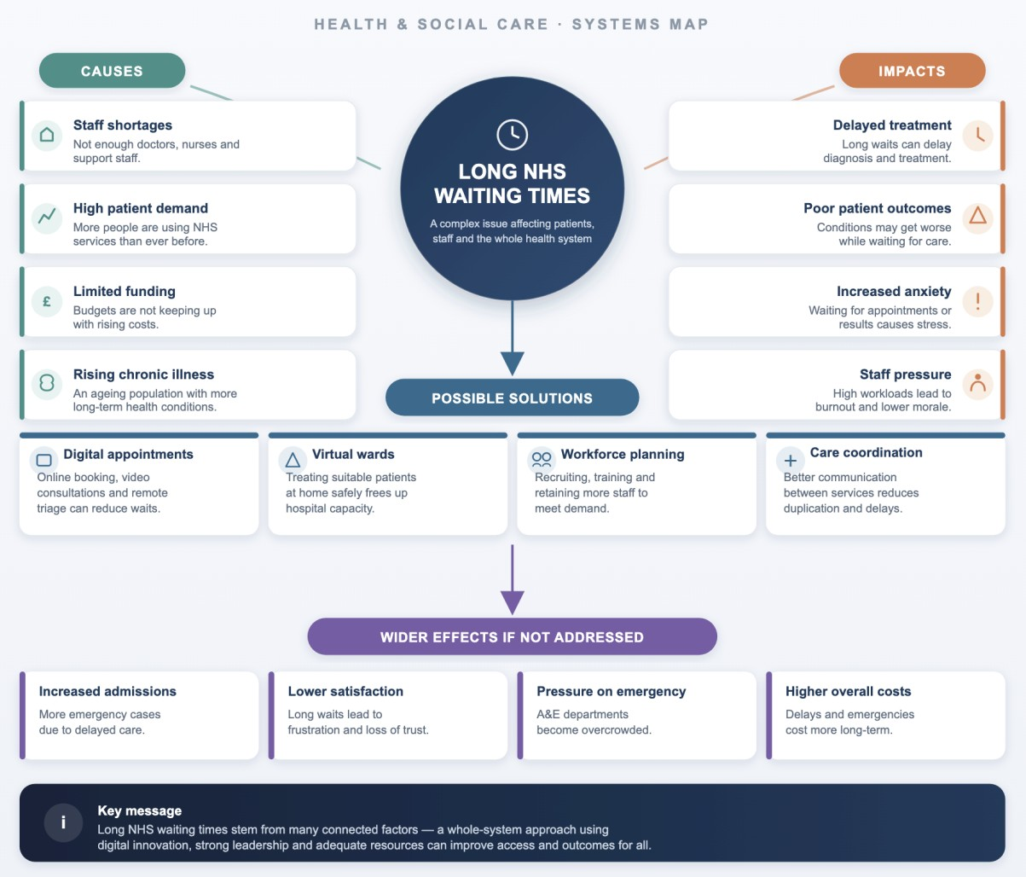

Long NHS wait times are a major problem because they can cause patients to experience more anxiety and worse health outcomes by delaying diagnosis and treatment. Staff shortages, rising healthcare service demand, scarce resources, and an ageing population with increasing chronic illnesses are the primary factors. These interrelated elements put more strain on medical personnel, lowering the standard and effectiveness of care. A systems thinking approach acknowledges that waiting times are impacted by numerous interrelated health system components rather than a single problem (Meadows, 2008). Enhancing coordination between health and social care services, growing virtual wards and digital consultations, and hiring more healthcare professionals are all potential solutions. Patients may suffer from deteriorating health, a lower quality of life, and increased demand on emergency services if this issue is not resolved.

Task 3

Self-Reflection of Group Activity
I discovered how various thought processes aid in problem-solving during the convergent and divergent thinking group exercise. While convergent thinking concentrates on assessing those ideas and choosing the best solution, divergent thinking entails coming up with a range of ideas without passing judgement on them right away. Gibbs' Reflective Cycle (1988) offers a methodical way to think back on events and pinpoint areas that need work.
My group came up with several solutions to a health and social care issue at the start of the exercise. I helped by urging everyone to express their thoughts and provide workable ideas. I proposed talking about the benefits and drawbacks of each choice when we couldn't agree on one. This illustrated the value of convergent thinking and assisted the group in coming to a consensus.
As I thought back on the exercise, I discovered that I naturally like hearing other people's perspectives before making a choice. I also realised that cooperation, respect, and communication are essential for productive teamwork. My confidence in participating in group conversations has grown because of this experience, which also taught me the importance of fusing creativity and critical thinking. To give everyone a chance to voice their opinions, I will start contributing my thoughts early in future group activities and urge more reserved group members to join in. This will foster a more diverse and innovative team atmosphere.

Task 4

Case Study Analysis of a UK Innovation
The Virtual Ward initiative is one significant innovation that the NHS has implemented. Through remote monitoring, frequent communication with medical personnel, and digital technology, virtual wards enable eligible patients to receive hospital-level treatment in the comfort of their own homes. This invention was created to ease the burden on hospitals, enhance patient satisfaction, and assist individuals in safely recovering outside of hospital environments (NHS England, 2023).
By fusing digital technology with conventional healthcare services, creativity was crucial in the creation of virtual wards. Healthcare providers employ digital equipment to monitor patients' vital signs and act promptly if their condition changes, eliminating the need for patients to stay in the hospital. Rogers' Diffusion of Innovation Theory states that when new healthcare methods are perceived as practical, helpful, and advantageous, they are more likely to be implemented (Rogers, 2003). This process is reflected in the NHS's growing usage of virtual wards.

Patients, medical staff, and the larger NHS have all benefited from virtual wards. Hospitals can cut down on needless admissions, medical staff can make better use of hospital beds, and patients frequently feel more comfortable and independent while recuperating at home. The positive effects of this innovation have been demonstrated by NHS England, which has reported improvements in patient outcomes, shorter hospital stays, and increased capacity within acute services (NHS England, 2023).

Task 5

Research
Stress and burnout among employees is a major problem for the health and social care sectors. Burnout can worsen employee well-being, compromise patient safety, and worsen labour shortages. According to Maslach's Burnout Theory, prolonged emotional exhaustion, depersonalisation, and decreased personal accomplishment are the main causes of burnout in professionals (Maslach and Jackson,1981). According to West et al. (2018), high workloads, a lack of staff, and inadequate organisational support are the main reasons why healthcare workers experience burnout. According to the study, fostering supportive work cultures and enhancing staff wellness can improve patient care and employee satisfaction. This study shows that both individual experiences and organisational characteristics have an impact on burnout. In a similar vein, Hall et al. (2016) found that high levels of burnout are linked to higher rates of medical errors, poorer care quality, and lower patient satisfaction. The authors stress that, to maintain safe and efficient services, healthcare organisations should give staff welfare priority.
Both articles concur that a variety of workplace pressures, rather than just one, lead to burnout. However, Hall et al. lay more emphasis on how burnout affects patient outcomes, while West et al. concentrate more on enhancing organisational culture. When taken as a whole, these studies show how important it is to address staff welfare to support a sustainable NHS workforce and enhance healthcare quality.

Task 6

Digital Innovation in Health and Social Care
Wearable health technology advantages:
  - Smartwatches and fitness trackers are examples of wearable health devices that are being used more frequently to help people with long-term medical conditions like diabetes, heart disease, and hypertension. By continuously monitoring health indicators like heart rate, physical activity, and sleep patterns, these devices enable patients and medical professionals to spot health changes early. Long-term health outcomes can be improved, and complications reduced, with early intervention. According to the Technology Acceptance Model, people are more inclined to use digital technologies if they believe them to be practical and simple to use (Davis, 1989). For instance, a patient with heart disease can wear a smartwatch to track their heart rate and communicate the data to their medical team, facilitating more rapid clinical decisions and promoting better self-management of their condition (NICE, 2022).

EHRs, or electronic health records:
  - By providing approved healthcare workers with accurate and current patient information across various healthcare settings, Electronic Health Records (EHRs) enhance communication. This minimises test duplication, minimises errors in documentation, and facilitates improved decision-making. Because physicians, nurses, chemists, and social workers can access the same clinical data when planning care, EHRs also enhance collaboration between multidisciplinary teams. The Technology Acceptance Model states that when digital technologies are easy to use and increase efficiency, healthcare personnel are more inclined to adopt them (Davis, 1989). For instance, community healthcare providers can access a patient's electronic record upon discharge from the hospital, ensuring continuity of treatment and lowering the possibility of communication breakdowns (NHS England, 2023).

Using Digital Technology to Promote Health and Preventative Care:
  - To prevent disease and encourage better lifestyles, digital technology is crucial. People may monitor their health, get individualised guidance, and access trustworthy health information with the help of wearable technology, mobile health applications, and online health platforms. Before major health issues arise, these technologies encourage people to make better decisions. The NHS App, for instance, makes healthcare services more accessible and encourages people to take charge of their own health by enabling users to schedule appointments, obtain repeat prescriptions, view their medical data, and receive health advice (NHS England, 2023). By assisting people in identifying possible health issues early on and seeking the proper medical assistance, this promotes preventative care. People are more likely to interact with digital health tools when they are useful, practical, and easy to use, according to the Technology Acceptance Model (Davis, 1989).

Task 7

Comprehending the Framework for NHS Leadership
- An overview of the NHS Leadership Framework
The NHS Leadership Framework offers recommendations on the actions, knowledge, and abilities required to provide high-quality healthcare and enhance patient outcomes. It motivates executives at all organisational levels to collaborate, communicate clearly, and support ongoing development. The framework emphasises the value of accountability, teamwork, person-centred care, and experience-based learning. It acknowledges that leadership is a duty shared by all healthcare workers rather than concentrating solely on senior managers.
The framework is crucial because good leadership fosters a productive workplace where employees feel appreciated, encouraged, and inspired to deliver safe, compassionate care. Additionally, strong leadership fosters innovation by assisting teams in adapting to evolving patient needs and new methods of operation. This leads to better patient experiences, higher-quality services, and more effective use of healthcare resources (NHS Leadership Academy, 2013).

- Leadership Style: Caring Leadership
One crucial leadership trait is "Leading with Care." Leaders who exhibit this trait promote employees' well-being, pay attention to their worries, and foster a courteous workplace. Employees are more inclined to contribute to service enhancements and share fresh ideas when they feel supported. This upholds the highest standards of patient care while fostering innovation and creativity. According to the theory of transformational leadership, leaders can inspire and encourage people by fostering professional growth, fostering a shared vision, and establishing trust (Bass and Avolio, 1994). A compassionate leader in the health and social care sectors can boost employee morale, foster teamwork, and ultimately improve patient and service user outcomes.

- Thinking Back on Education
I've learned from studying the NHS Leadership Framework that leadership is a duty that anyone can carry out in real life, not just managers. I now know that excellent communication, cooperation, and encouraging leadership are essential to creativity and innovation. During this module, I came to understand that positive leaders inspire employees to collaborate and exchange ideas to solve issues. I intend to use these leadership behaviours in my future work in health and social care by encouraging teamwork, listening to others, and supporting ongoing development to provide safe, person-centred care.

Task 8

Self-Reflection Journal Entry
My perspective on creativity, innovation, and value creation in health and social care has evolved because of completing this study. I thought that innovation mostly entailed presenting new technology at the start of the module. But I now realise that innovation also entails enhancing routine procedures, coming up with original solutions to issues, and providing person-centred care. I was able to think critically about what I had learned and see how reflection could enhance professional practice thanks to Gibbs' Reflective Cycle (1988).
The exercises especially impacted my viewpoint on leadership, digital innovation, and divergent and convergent thinking. They demonstrated to me the importance of strong collaboration, communication, and encouraging leadership in creating innovative solutions that enhance patient outcomes. I will put these lessons into practice in my future work in health and social care by keeping an open mind, collaborating with colleagues, and regularly evaluating my work. These abilities, in my opinion, will enable me to improve services and give clients safe, considerate, and excellent care.

References

Amabile, T.M. (1996) Creativity in Context. Boulder, CO: Westview Press.
Bass, B.M. and Avolio, B.J. (1994) Improving Organizational Effectiveness through Transformational Leadership. Thousand Oaks, CA: Sage Publications.
Burnes, B. (2017) 'Kurt Lewin and the Harwood Studies: The Foundations of Organisation Development', The Journal of Applied Behavioral Science, 53(3), pp. 255–281.
Davis, F.D. (1989) 'Perceived usefulness, perceived ease of use, and user acceptance of information technology', MIS Quarterly, 13(3), pp. 319–340.
Gibbs, G. (1988) Learning by Doing: A Guide to Teaching and Learning Methods. Oxford: Oxford Polytechnic.
Hall, L.H., Johnson, J., Watt, I., Tsipa, A. and O'Connor, D.B. (2016) 'Healthcare staff wellbeing, burnout and patient safety: A systematic review', PLOS ONE, 11(7), e0159015.
Maslach, C. and Jackson, S.E. (1981) 'The measurement of experienced burnout', Journal of Occupational Behaviour, 2(2), pp. 99–113.
Meadows, D.H. (2008) Thinking in Systems: A Primer. White River Junction, VT: Chelsea Green Publishing.
National Institute for Health and Care Excellence (NICE) (2022) Evidence Standards Framework for Digital Health Technologies. London: NICE.
NHS England (2023) Delivery Plan for Recovering Access to Primary Care. London: NHS England.
NHS England (2023) Transforming NHS Services Through Digital Technology. London: NHS England.
NHS England (2023) Virtual Wards Including Hospital at Home. London: NHS England.
NHS Leadership Academy (2013) Healthcare Leadership Model. Leeds: NHS Leadership Academy.
Porter, M.E. (2010) 'What is value in health care?', New England Journal of Medicine, 363(26), pp. 2477–2481.
Rogers, E.M. (2003) Diffusion of Innovations. 5th edn. New York: Free Press.
West, C.P., Dyrbye, L.N. and Shanafelt, T.D. (2018) 'Physician burnout: Contributors, consequences and solutions', Journal of Internal Medicine, 283(6), pp. 516–529.

