Investigation into the Human Factors that lead to the Flixborough Disaster

Cameron Lane- OME Apprentice

ACDA 4020 – Human Factors in High Hazard Environments


Table of Contents
Introduction 0
Flixborough 1
The Dirty Dozen 3
The Three Key Factors 4
Conclusions 5

Introduction
On the 1st of June 1974, the cyclohexane plant of the Nypro Flixborough Chemical Works exploded, with the equivalent force of 15-45 tons of TNT, killing 28, seriously injuring 89, and damaging or destroying over 2000 buildings in the surrounding area [1][6]. Investigations into the disaster revealed the cause to be the deflagration of a vapour cloud of cyclohexane released under high pressure and temperature. Of even greater importance from these investigations however was the establishing of the circumstances that lead to this leak, ultimately concluding that the disaster was the result of an improperly planned modification to the chemical plant, and was both foreseeable and preventable. This work will seek to investigate the causes of this disaster, and how they fit into the ‘dirty dozen’ causes of human error, ultimately identifying the top three that resulted in the destruction of Flixborough, and the death and injury of so many.

Flixborough
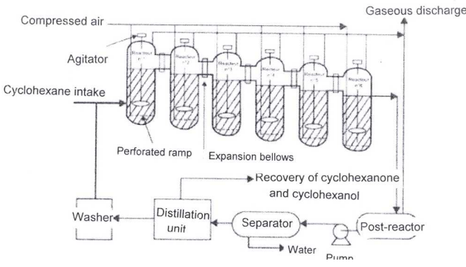
Nypro was formed in 1964 as a joint venture between Dutch State Mines (DSM), and Fisions Limited, whose subsidiary previous ran the site for nitrogen production. Following the forming of Nypro, the site was modified for the production of caprolactam, a material used in the production of nylon. This capability first came online in 1967, with an annual production of 20,000 tons [6]. At this time, the company was reconstituted, with DSM owning 45%, Fisions Limited 10%, and the National Coal Boards owning the remaining 45%, with DSM eventually buying out Fisions Limited in 1972. At this time, work began on expanding the production capacity of caprolactam from 20,000 tons to 70,000 tons, through the use of a new process, at a cost of £15 million, the equivalent of over £178 million today [1][6]. This new process involved the oxidation of cyclohexane, a far more dangerous method compared to what was in place previously. This process ran cyclohexane through a series of 6 reactors, seen in figure 1 below. During this process, the cyclohexane is kept at 155ºC, above its atmospheric evaporation point, at a pressure of 8.8 Bar. The reactors are connected to each other through the use of 28-inch pipes, joined with expansion bellows.
Figure 1 - The Oxidation Process at Flixborough [1]
On March 27th, a leak of cyclohexane was identified in reactor 5, necessitating the shutdown of the plant. With the crack covering a significant portion of the side of the reactor, the decision was made to remove the reactor from the series, installing a bypass, and resume operations, seen in figure 2 below. This bypass was constructed using a 20-inch pipe, the largest available on site, and supported on scaffolding to allow the movement with the bellows [6]. This ran from the 1st April to the 29th of May without issue. On the 29th May and 1st of June, numerous leaks were discovered in the process, resulting in repeated rounds of shutdowns and repairs. Following these, the plant was restarted for production on the morning of June 1st [6]. This startup process involves numerous stages, with both pressures and temperatures reaching above the standard operating values, and venting values for steam and nitrogen opened and closed a number of times to bring the whole system to the correct pressure and temperature.
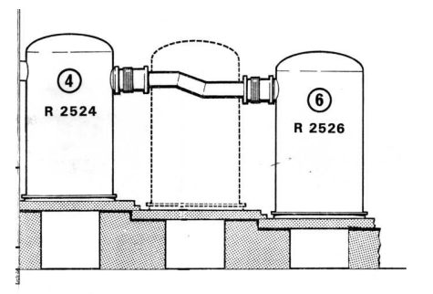
Figure 2 - The Bypass of Reactor 5 [1]
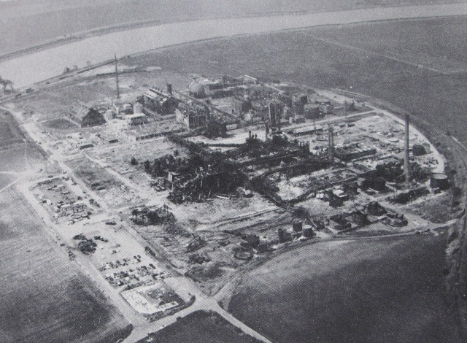
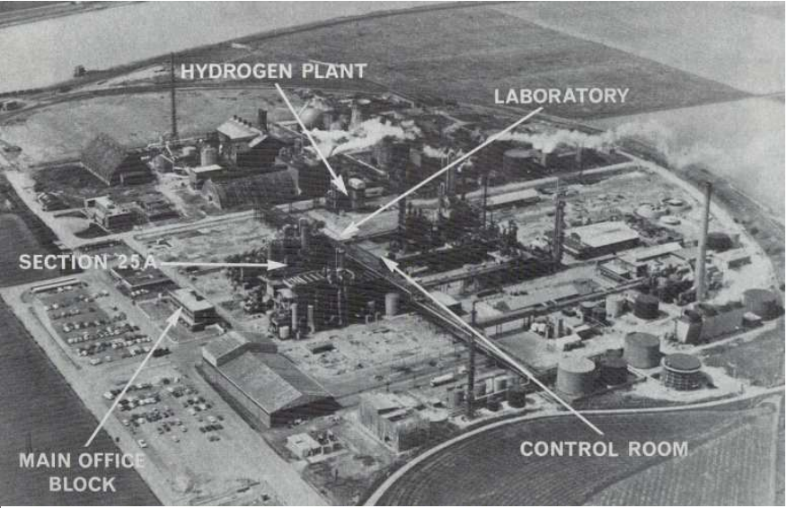
At 4:53pm on the 1st of June, Section 25A, the site of the caprolactam production unit, exploded. All 19 staff in the nearby control room were killed, a further 9 staff on site died, 36 staff were injured, and a further 53 members of the public were seriously injured [1][4][6]. Fortunately, it was a Saturday, otherwise the death toll could have been significantly higher, with up to 550 staff present on site in the nearby laboratories and office blocks, all of which were destroyed, seen in figure 3 [1]. Over 200 buildings in the surrounding area were destroyed, with debris from the explosion found up to 32 Km from the plant [1].
Figure 3 - An overview of the site before and after the blast [5]

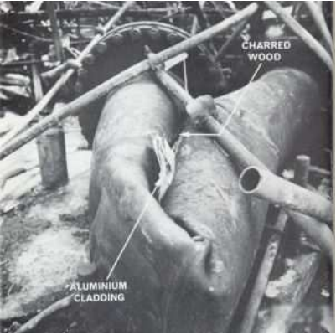
The inquiry into the disaster found the cause of the explosion to be a failure in the bypass installed for reactor 5. The two bellows linking reactors 4 and 6 to the temporary 20-inch pipe failed, crushing the pipe and releasing 40-60 tons of high temperature, high pressure cyclohexane, which vapourised under atmospheric conditions [1][6]. This cloud spread, until it reached the nearby hydrogen plant, where it ignited, resulting in a blast of 15-45 tons of TNT.
Figure 4 - The Damage to the Temporary Bypass Pipe [1]

The Dirty Dozen
The ‘Dirty Dozen’ shown in the table below, are a method for breaking down the causes of human error. While the actual cause of a disaster may come down to numerous factors, ultimately, they can be broken down to these 12 factors on a basic level.
Lack of Communication | Lack of Resources | Complacency
Pressure | Lack of Knowledge | Lack of Assertiveness
Distraction | Stress | Lack of Teamwork
Lack of Awareness | Fatigue | Norms

None of these factors are meant to assign blame to specific people, they can all be achieved through perfectly normal actions, carried out under the best of intentions. Fatigue can be through someone working long shifts to cover vacancies, a lack of knowledge may be through not realising the need for knowledge, pressure can lead to working hard, with the consequences overlooked. At Flixborough, many of these factors will have had an impact, of which the three with the greatest impact are examined below. There was significant pressure on the plant to maintain and increase production, there was some lack of communication between shifts regarding the pressures and temperatures of the plant during handovers, there was a significant amount of stress on Mr Blackman, the Area 1 and 2 engineer, resulting in engineering issues being missed, and both a lack of assertiveness from Mr Blackman in pushing the safety issues identified, but a lack of teamwork in understanding these issues. As the last few examples highlights, it is almost certain that none of the dozen contributing towards a disaster will contribute alone. Mr Blackman’s stress over the removal of reactor 5 could have contributed to the lack of assertiveness over the safety issues present in the bypass, with the lack of teamwork in working on these issues being compounded by the lack of knowledge in understanding the scale of the risks, and the pressure in resuming production.

The Three Key Factors
The three key factors that this work will argue caused the Flixborough disaster are Pressure, Lack of Knowledge, and Complacency, which will be explained further below. Pressure as a factor is the easiest of the three to explain. The plant at Flixborough had been expanded by Nypro with works finishing in 1972, to expand the production capacity of the site from 20,000 tons of caprolactam to 70,000 tons per year, at a cost of £15 million, equivalent to £178 million in 2025 money [1]. However, as of 1974, the plant was only making 47,000 tons per year, resulting in significant losses to the company. With the plant already losing money, “the emphasis at the meeting was directed to getting the oxidation process on stream again with the minimum possible delay” following the removal of Reactor 5 [6]. With such a costly investment not paying off in normal running, and the possibility of a lengthy time shut down to fix the broken reactor, it is understandable how there was such pressure on the plant to resume production, without proper consideration for the engineering.
The Lack of Knowledge amongst staff is the second key factor that led to the disaster. At the time of the disaster, there was no one filling the role of Works Engineer in the company. The responsibilities of this role were being covered at the time by Mr Boynton, a trained electrical engineer, however not a mechanical engineer [1][6]. This role was in the process of being replaced, and a mechanical engineer was available from the National Coal Board, however when combined with the other two factors, Pressure and Complacency, the available knowledge of the NCB engineer was not consulted, resulting in a staff with expertise largely in chemistry The solution put in place to connect Reactor 4 to Reactor 6, through a 20-inch pipe, was checked for basic mechanical properties, the flow of fluid through the pipe, and the structural integrity at the working pressure. Due to the lack of knowledge however, it was not adequately checked for the forces acting on the pipe in the final dog leg shape that it was installed in, nor were the forces that would be acting on the bellows calculated, which were far higher than during normal operations of the plant as designed.
Finally, there is the Complacency in the company. This is largely tied in with the lack of knowledge and the pressure that the plant was under, and while it is not a direct cause of the accident, complacency led to the situation where the disaster was allowed to develop. The primary indication of the complacency was in the immediate aftermath of the removal of Reactor 5. The plant was shut down due to the discovery of a 6 foot crack in the side of the reactor that was leaking cyclohexane, indicating that it was the full depth of the wall of the reactor, 5/8th inch thick steel [6]. While the staff were aware enough that the plant should be shut down, and the reactor should be taken out of service due to the leak, no effort was made to ascertain the cause of such serious damage to the reactor, no was there any investigation of the remaining reactors, to ensure that there was no damage forming on them. Additionally, when designing and fitting the bypass for reactor 5, the ‘Designer’s Guide’ for the bellows was not consulted. If it was, it would have been know “that two bellows must not be used out of line in the same pipe” without adequate support, which the scaffolding used to support it did not do. It is this factor of complacency that directly links together the pressure that the plant was under to the lack of knowledge amongst the staff. Despite the significant pressure that the plant was under, and the general lack of mechanical engineering expertise amongst the staff, had the actions taken at this stage of the disaster been less complacent, with consideration given to the causes of the cracking of reactor 5, and the consulting of the ‘Designer’s Guide’, it is possible the explosion would not have occurred. Inspecting the other reactors would have taken time, which despite the pressure to restart production, would have increased the likelihood of the engineering challenges being considered and addressed, allowing for the lack of knowledge to be overcome.

Conclusions
The explosion at the Flixborough Chemical plant was a disaster, through no intention of anyone involved, caused by human error. The huge amount of pressure on the plant to resume production following the removal of reactor 5 resulted in an engineering solution that was not mechanically sound put in place with the resources available. This solution was compounded by the lack of knowledge amongst the staff, with the engineering challenges not adequately understood, or addressed in the fix put in place, resulting in far higher forces acting on the pipework that was understood. And finally, the complacency amongst the staff that reactor 5 was the only reactor damaged, and no further checks on the rest of the plant needed to be conducted, that removed the opportunity for increased timelines, and the chance for the lack of knowledge to be identified. The leak of cyclohexane that lead to the explosion was unfortunately preventable, however it was a risk that was not understood at the time, allowing it to go unchecked until disaster struck.

Bibliography
[1] Anonymous "Catastrophic Explosion of a Cyclohexane Cloud," 2008. Available: https://www.aria.developpement-durable.gouv.fr/wp-content/files_mf/FD_5611_flixborough_1974_ang.pdf.
[2] Anonymous . Flixborough (Nypro UK) Explosion 1st June 1974. Available: https://www.hse.gov.uk/comah/sragtech/caseflixboroug74.htm.
[3] R. Turney. (May 30). Flixborough 50 Years On: Lessons for Managers and Engineers Today. Available: https://www.thechemicalengineer.com/features/flixborough-50-years-on-lessons-for-managers-and-engineers-today/.
[4] R. Turney, "Flixborough: Lessons which are still relevant today," Loss Prevention Bulletin, (272), 2020. Available: https://www.icheme.org/media/8955/xxiv-paper-60.pdf.
[5] M. Dunton, "Flixborough, 1 June 1974 - The National Archives blog," 2014. Available: https://webarchive.nationalarchives.gov.uk/ukgwa/20250613143158/https://blog.nationalarchives.gov.uk/flixborough-1-june-1974/.
[6] J. A. Pope, J. F. Davidson and W. J. Simpson, "The Flixborough Disaster:
report of the court of inquiry," Department of Employment, 1975 Available: https://www.icheme.org/media/17752/the-flixborough-disaster-report-of-the-court-of-inquiry.pdf.

