Business and Business Environment
Tesco analysis

Student Name: Caldararu Andrei-Alexandru
Student number:1818674
Module title: COMMUNITY ENGAGEMENT
Assessment title: Assessment 1
Module Lecture’s Name: Christopher Mafuva

Introduction
Businesses are formed based on different aims and objectives because different businesses deal with different types of stakeholders to run and manage the entities. The major kinds of business or business entities are; the private sector, the public sector and the voluntary entities. These entities have different leadership and operational levels that are considered to be the determinant of the productivity and the profitability and effectiveness of a business (Walther, 2010). The ownership of these businesses and their management are often dependent on the category that the organizations functions or operate. In this essay, the main focus is to discuss the various forms of organizations and the interrelationship of the various functions and structures.
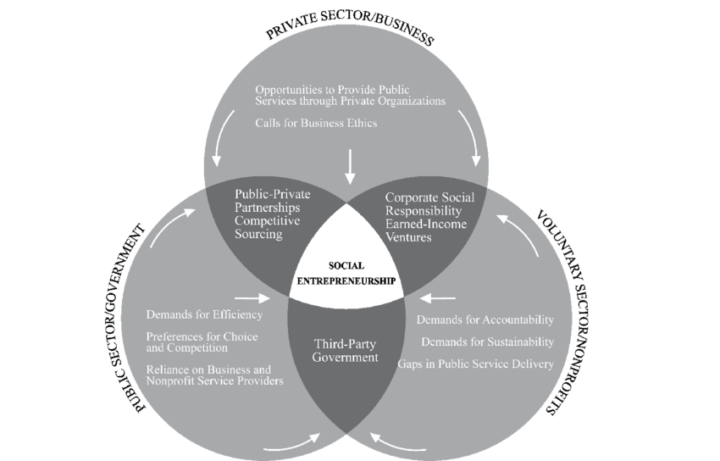
Fig 1: Social Entrepreneurship
Source: Walther, 2010

Different types of organisations
The firms in the public sector and these owned by the government and are meant to serve the citizens of the state under the public domain. The citizens of the country are known to pay taxes to the state and the received revenue is used to fund the public domain. The main ideas driving the public organizations are; offering people with the basic services and using the resources to create benefits to the community. These entities in the public sector usually educate, inform and offer services to its clients. One of the examples of organizations in the public domain is the public owned hospitals whose mission is to treat and offer medical assistance to the public in the state. The government-owned hospitals have workers who are recruited by the government and works under the authority of the government. The main role of the doctors in these facilities is to offer the patients the services they need and when they need it (Walther, 2010).

The public sector organizations have mostly been constructed by the government through the taxpayers’ money. The services at these organizations are meant to give the citizens of the country any important information that they need to know and when they need to know. Other organizations in the public domain include the government ministries and departments. These are entities where the citizens can walk in and out freely and they expect to get the help they need from these offices because they pay taxes to facilitate and fund the operations of these entities. The organizations in the public sector are expected to be fair and equitable in serving the citizens of the country. They are also expected to respect the people and acknowledge the fact that it is their taxes that makes the operations possible.
Profitable organizations (Private)
Profitable organizations are the entities in the private sectors and are owned by individuals or corporations. These are non-government entities whose main agenda is to offer services or products at a fee to be able to make profits. Some of the for-profit entities are owned by the shareholders and company members who do not engage in trading their corporate stock to the general public on the market exchanges. One of the businesses in the profitable sector is Woolworths and it is operating worldwide. The entity is limited and operates via several divisions including clothing and general house merchandise. The objective of the business is to be at the heart of its customers and be the best-loved retailer for the kids, home and family leisure (BARON, 2012).
The goal of the business in the profitable sector include improving the stock turns and optimizing networks efficiencies while making sure their customers are satisfied with the services being offered. Such companies invest in large supply chain management systems. Some of the values for the companies in this sector are quality and style where the key aims are to offer the customers with the best satisfaction levels. These are businesses that acknowledge and appreciate that offering easy and fair deals that extends to giving the clients with the best products at friendly prices. In the case of Woolworths, the company upholds innovation and it is the primary thing that the entity does to give the customers the best. The company discovers new ideas and new items and processes and it has pleasure in thinking beyond the nose to offer the customers the best solution for their issues.

Size and scope of the organisations
Microenterprises are businesses that can be found in the neighboring such as the ice-cream parlor or the case around the corner. Micro businesses are the small entities that have minimal employees and minimal capital. They operate with less than 10 people and they can be started with little capital. In the developing nations, there are forces that compel such businesses to represent the majority of the small business sectors. They are known to add value to the economy through creating micro-business and enhancing incomes as well as reducing the overall business costs. The number of micro businesses is high because it does not need any training or formal jobs to be operated. In the developing countries, these businesses are believed to produce both good and services for their localities. These businesses often come in the form of local firms, selling cooked food from the sidewalk among others (WEATHERLEY and OTTER, 2014).
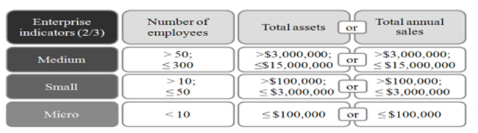
Fig 2
Source: WEATHERLEY and OTTER, 2014
Small businesses are the ones that employ a small population of employees and they do not have high sales volumes. They can be said to be independent entities and are as well operated firms that are limited in size and revenue although these depends on the industry of operation. The enterprises are often owned by private sole investors, proprietorships or corporations and partnerships. In every industry, there are small entities and they range from the convenience stores to the small manufacturing plants. The small businesses can be the local businesses employing 10 people or the manufacturing plants that employ 50 people. Small enterprises have been varied in size, revenues, and regulatory authorities. Some of these businesses; like the accounting firms may only need license to operate. On the other hand, some of them like the daycares and orphanages are highly regulated.
Medium businesses are the businesses that are employing less than 250 people. Such businesses emerge from the slow and steady growth of the successful small businesses. As the companies earn more revenue, they start keeping some capital that will later be used for building, purchasing equipment and recruiting more workers. The business will then change to big companies (WORTHINGTON and BRITTON, 2014).
Large-scale businesses are the entities that involve the large-scale corporations and have controlled finances and business activities. These can be considered to be the mega-corporations or the multinational firms. The large-scale businesses are believed to be the ones with more employees and are complex and terms of their management hierarchy than in the medium scale-businesses. The large-scale entities have high operations on a daily basis and as a rule; they can be characterized by large clients, businesses contacts and high business communication.
It is important to note that the grouping is an indication of the largest magnitude of business comfortable at type. This is to mean that the entrepreneurial type can be comfortable with running the business on a smaller scale than the group they are placed on a diagram. It is important to note that running the business larger than the large business might be challenging and risky and needs strategies and planning.

Conduct internal (SWOT/TOWS analysis) and external (Five forces model) analysis of a UK Supermarket to identify its strengths and weaknesses
The internal and external analysis of Tesco, which is the UK based supermarket, is done as under. To conduct the external analysis, the strategic tool used is Five Force Model is used. This helps in analyzing the key factors analyzing the key forces including threat of competitors, substitutes and bargaining power of suppliers influencing the business. On the other hand, the internal analysis of the organization is done using SWOT analysis.
SWOT analysis of TESCO is as under-
Strengths -  As far as Tesco is concerned, the organization has the ability to retain its position in the market place and maintain its business reputation. The ability has been made possible because of the long and outstanding image that Tesco has displayed in the industry. Tesco has also had various positive reviews from clients and this has been a great contributor to the strength the company holds in the market (West, Ford & Ibrahim, 2015). | Weaknesses-  Despite of the much strength, Tesco has also displayed some weaknesses in its operations. Because of the great reputation in the industry, the company finds it a challenge to reduce the prices in the market to meet the needs and abilities of the entire market population. Thus, there are possibilities that customers might begin finding other retail supermarkets that compete with Tesco in the UK market area.
Threats: With the threats in the industry, there are threats because of the situation in the market. There are low customers and Tesco’s competitors have started offering low priced items making customers shift from Tesco. There are also chances that the losses are there because of the low customer in the market (Fernando, 2011). | Opportunities: For the opportunities in the market, there is a variety including upholding the reputation of Tesco and continue offering the best products and services in the market. With its best services, Tesco is set to continue satisfying the customers and the reputation will still be at the top.

Five Force Analysis of Tesco is as under-
Threat of substitute products and services: the threat of substitutes is high for TESCO in the UK. It is due to the reason that there are several supermarkets such as ASDA and Morrisons that give tough competition to the company. Although Tesco believes in offering products at reasonable prices, the same approach is adopted by many supermarkets (Fernando, 2011).

Threat of new entry: Although supermarket and grocery industry in the UK is well-established and there is a huge scope for development. But it requires huge capital investment for a new company to establish brand name among large supermarkets like Tesco. So threat of new entry is low.
Competitive rivalry: The intensity of competition is high for Tesco in the UK market. Supermarkets such as ASDA, Morrisons, and Sainsbury’s give tough competition to Tesco in terms of price, products and marketing. The slow growth of market means that there is high increase of market share from competitors which has intensified the market rivalry. This is a threat for the market leadership position of Tesco (Uyan-Atay, 2015).
Bargaining power of buyers: the bargaining power of buyers is high in this case as products are standardized instead of being differentiated. The buyers can turn to other brands if they do not like the product or do not get what they need.
Bargaining power of suppliers: The bargaining power of suppliers is low due to the fact that the number of suppliers is high. The supermarkets have high probability to switch their supplier if they do not get the appropriate rate (Uyan-Atay, 2015).
The Five Force Analysis of Tesco helps in determining the industry is highly competitive and the supermarket has to keep looking for engaging steps to retain their customers always.
The strengths and weaknesses displayed by Tesco have been found to relate with the external factors in the company. The economic elements that are found in the market including the inflation and interest rates are among the external factors that interrelate with Tesco’s financial strengths. Tesco is financially viable and thus, it will have enough finance and its pricing and marketing approaches will not be affected.
Tesco has a good brand image due to which the supermarket is highly famous among people of the UK. The approach of the organization to offer high quality products at reasonable prices makes it one of the popular supermarkets among people (Uyan-Atay, 2015). There are also political and legal elements that interrelate with the strengths of the business. The changes in the legal aspects affect the ways thatTesco faces the legal issues and there is a need to have professional legal advisors in this case. With regards to technology, Tesco has the ability to upgrade the technology to more recent systems and therefore, there will be no need to adopt changes. The environmental elements are the external factors that interrelate with the weaknesses of the company. However, the company faces huge competition due to which there is a need for the organization to always come up with engaging steps to retain its customers.
Although Tesco is known to use the natural resources to offer products and services,the business does not use wood products and as such, it will not have to follow the environmental rules and it will also not misuse the natural resources. Socially, to be able to face the challenges of changing the social and cultural factors, Tesco needs to have good staff, viable financial resources and natural resources. The company needs to have the will to fulfill the customers taste and preferences as part of their demand that is based on their beliefs and value.

Conclusion
The major kinds of business or business entities are; the private sector, the public sector and the voluntary entities. These entities have different leadership and operational levels that are considered to be the determinant of the productivity and the profitability and effectiveness of a business. Microenterprises are businesses that can be found in the neighboring such as the ice-cream parlor or the case around the corner. Micro businesses are the small entities that have minimal employees and minimal capital. Small businesses are the ones that employ a small population of employees and they do not have high sales volumes. They can be said to be independent entities and are as well operated firms that are limited in size and revenue although these depends on the industry of operation. Medium businesses are the businesses that are employing less than 250 people. Such businesses emerge from the slow and steady growth of the successful small businesses. Large-scale businesses are the entities that involve the large-scale corporations and have controlled finances and business activities. These can be considered to be the mega-corporations or the multinational firms. It is important to note that the grouping is an indication of the largest magnitude of business comfortable at type.



