

The correlation between Serious offenders and Adverse Childhood Experiences

Name: Daniella Fewings
Student ID: 1900678
School: UWTSD Swansea business campus
Degree: Professional Policing
Due date: 6th May 2022
Word count:

1.Chapter One: Introduction

Introduction

Within the following chapter will outline the organisation of this research project, including the goals and objectives, as well as the study's history and justification. The aim of this dissertation is to explain in detail on whether a serious offender has previously suffered with ACES and the correlation between them both.
The research aims to analyse the publics knowledge on what a serious offender is, along with their knowledge of Adverse childhood experiences and if there is a link between reoffenders who have suffered with Adverse childhood experiences. Many researches have found that a “serious offender” is an induvial who has offended and is now serving a life sentence. This comes under section 3 (1) of the Crimes (Administration of Sentences Act 1999 (Communities and Justice, 2015).

1.2 Background
Adverse childhood experiences, or ACEs, were first utilised in a survey conducted in the United States in the 1990s. Numerous ACEs investigations have been undertaken since then in a variety of nations. An large amount of research evidence has accumulated over the last three decades on the link between adverse childhood experiences (ACEs) and a variety of individuals making bad choices, including offending (Scottish Government, 2022).

1.3 Aim and Objectives

1.3.1 Aim:
To explore the publics perceptions on what a serious offender is, their knowledge on Adverse childhood experiences, and the link between reoffenders who have suffered with Adverse childhood experiences.

1.3.2 Objectives
1. To critically analyse what a serious offender is

2. To conduct research on how Adverse childhood experiences can affect a person later in life

3. Review statistics on reoffenders that have suffered with Adverse childhood experiences

1.4 Research Structure

There are going to be five chapters within this research project to achieve the three objectives. Chapter one will consist of the introduction, where the research project will be introduced, along with the reasons why the research is being conducted. Followed by the aims and objectives for the project. Within chapter two will be a literature review which will provide a better insight of the topics within the research project. The literature aids in the comprehension of the topic by highlighting places where similar investigations have been conducted and the results obtained. Chapter three will include the research methods and methodology that will determine the finest potential primary research approaches and procedures. The data will be analysed after the research is complete.

1.5 Conclusion
Within the first chapter of this research project the aims and objectives were stated along with an introduction being provided. The next chapter will consist of the literature review, which will touch upon what was discussed in chapter one in more depth.

2.0 Chapter Two: Literature review

2.1 Introduction

The purpose of this chapter is to obtain a better knowledge of the ideas and subjects that will be discussed throughout this dissertation by looking at previous literature on the topic. The literature review will breakdown into sections what Adverse childhood experiences are, the impact of ACEs and how to prevent them, along with what are serious offenders, how ACEs are links to offending, followed up with a conclusion.

2.2 Adverse childhood experiences

Adverse childhood experiences, also known as ACEs, are described as painful early life experiences that can have a negative impact on health later in life (Waite & Ryan, 2020). Adverse childhood experiences affect children's health and well-being in both the short and long term (Banyard et al, 2017). While the types of adversities defined as ACEs vary by context, they typically include harms that directly affect the child, such as neglect and physical, verbal, and sexual abuse; and harms that affect the child's environment, such as domestic violence, parents no longer together, divorce, being under the same roof with an individual who suffers from mental illness, substance abuse, or has been incarcerated. According to a study conducted in England, 47 percent of adults have been exposed to ACEs (Bellis et al, 2014). . According to Park & Larkin (2018) their studies show that 87% that were conducted no less than 1 of 10 ACEs previous to the age of 18. 53.2%, which were reported as over half came back that four or more ACE’s, a large fraction had been through a parental loss, being neglected emotionally, being in a household with a substance abuser and being abused emotionally. A study was conducted within the UK in 2014 on ACEs, it was found that 47% of people had said they have previously had one ACE at the least, along with 9% of the population having four or more (Bellis et al, 2014). In addition to this, according to Public Health Wales (2016) people who have had four or more ACEs are more likely to be a high-risk drinker or drug user, have poorer mental health, and are more likely to have heart disease, lung disease, and type 2 diabetes, along with them being more likely to have either perpetrated or been a victim of violence. Moreover a study from Quigg, butler and bellis, (2020) states that Individuals who reported four or more ACEs were more than seven times more likely to have been a victim of violence than those who reported none.

2.3 How to prevent adverse childhood experiences

There are many ways that ACEs can be prevented, which include strengthen economic supports to families, this can be done by strengthening household financial security and family friendly work policies. By changing social norms to support parents and positive parenting can prevent ACEs by public engagement and enhancement campaigns, also by legislative approaches to reduce corporal punishment. If quality care and education early in life is given to a child by improved quality of childcare through licensing, the ACEs can be prevented. ACEs can also be prevented by enhancing parenting skills to promote healthy child development (Centers for Disease Control and Prevention, 2016).Scottish Government (2020) are attempting to address people's social and economic problems. Poverty and gender inequality, for example, can have an impact on levels of early adversity and trauma, as well as people's ability to overcome them. The COVID-19 pandemic has worsened social inequality while also increasing childhood adversity and trauma in some cases. The Welsh Government's Early Years initiative, Flying Start, is for families with children under the age of four who live in some of Wales' most impoverished districts. The program's main components are free, high-quality part-time day-care for children aged two to three, an improved health visiting service, access to parental programmes, and speech, language, and communication support. Families with drug addiction problems, domestic violence or abuse, a history of aggressive or abusive behaviour, or mental health issues can be referred to the Welsh Government-funded Integrated Family Support Services (Public Health Wales NHS Trust, 2015).

2.4 Impact on Adverse childhood experiences

ACEs, like an attachment, can have an impact on our future physical and mental health, and they can often be hurdles to children building good attachment relationships. ACEs have many effects on individuals physical and mental health which include, an increase in the likelihood of mental health issues such anxiety, worry, and post-traumatic stress disorder. ACEs are linked to 1 out of every 3 diagnosed mental health problems in adults (NHS, 2022). The pattern of interactions that people had with their parents or caregivers when they were young is referred to as attachment. It is the emotional link that develops between a parent and their child from birth and has a significant impact on our growth (NHS, 2022). Children who are exposed to toxic stress as they grow up may struggle to build healthy and secure relationships. They may also have a history of insecure employment as adults, and struggle with money, jobs, and depression throughout their lives. These consequences can be handed down to their children. Some children may be subjected to additional toxic stress because of historical and continuing traumas as a result of systematic racism or the effects of poverty as a result of limited educational and economic possibilities (Centers for Disease Control and Prevention, 2021). The longer an individual is exposed to an ACE, and the more ACEs they are exposed to, the greater the impact on a healthy development. When experiencing ACEs the ability to recognise and regulate various emotions are extremely difficult as well as the ability to form and maintain healthy friendships and other relationships, and the ability to control behaviour in school is also an impact on ACEs (NHS, 2022). On a typical day, one-fifth of respondents to the Public Health Wales NHS Trust (2015) survey (20.5 percent) reported eating less than two pieces of fruit or vegetables. However, as the number of ACEs encountered grew (16.9%, no ACEs; 32.0 percent, four or more ACEs), an increasing prevalence of poor nutrition was noted. Vitamins and minerals, such as folate, vitamin C, and potassium, are abundant in fruits and vegetables. They're high in dietary fibre, which can help keep your gut healthy and prevent constipation and other digestive issues. A high-fiber diet can also lower your risk of bowel cancer. They can aid in the prevention of heart disease, stroke, and some forms of cancer (NHS, 2018).

2.5 Serious Offender

Communities and Justice (2015) describes a serious offender in six different ways part a is as an offender who is serving a sentence for life, this comes under Section 3 (1) of the Crimes (Administration of Sentences) Act 1999. Part b is a person serving a sentence for which a non-parole period has been imposed under Schedule 1 of the Crimes (Sentencing Procedure) Act 1999. Another description of a serious offender is an offender serving a sentence (or a series of sentences) for which the term of the sentence (or the sum of the terms of all the sentences in the series) is such that the offender will not be eligible for release from custody, including parole, until he or she has served at least 12 years. Part D is an offender who is being handled as a serious offender for the time being because of a decision of the sentencing court, the Parole Authority, or the Commissioner. Part E describes a serious offender as a person who has been found guilty of murder and is serving a term as a result of the conviction. The last part is for the purposes of this definition, an offender who belongs to a class of people designated by the regulations as serious offenders.

2.6 The link between reoffenders and ACEs

The impact of trauma on juvenile offenders has been widely documented, with estimates ranging from 75 percent to 93 percent of youth entering the juvenile justice system having experienced trauma, compared to 25 percent to 34 percent of the general population (Carly and Dierkhising et al, 2013). According to a study conducted in England, a history of ACE exposure could account for around half of all adults experiencing violence victimisation between 2019 and 2020 (Quigg, butler and bellis, 2020). One ACE study looked at the impact of different types of abuse, as well as the number of different risks of sexual assault in adulthood. Importantly, the study found that, while all ACE factors were related with adult sexual violence victimisation, child sexual abuse was the main determinant of adult sexual violence victimisation. Further to that, additional adversities faced by child sexual abuse victims, consistent with the ACE cumulative effect concept, increased the risk of adulthood sexual violence beyond the risk associated with child sexual abuse alone (Quigg, butler and bellis, 2020). There is a clear link between ACEs and criminality, according to research. People who have had numerous ACEs are more prone to engage in criminal activities that are hazardous to their health and, more importantly for the justice system. According to the Welsh ACEs Study (Public Health Wales NHS Trust, 2015), those with four or more ACEs were 14 times more likely to be a victim of violence, 15 times more likely to be a perpetrator of violence during 2017-2018, and 20 times more likely to have been involved in violence within their life (Gov.scot, 2018). These figures were lower in 2015 as in a survey done by Public Health Wales NHS Trust, (2015) stated that within the year of 2015 the likelihood of being a victim of violence was nearly nine times higher in those who had four or more ACEs than in those who had none (35.9%, four or more ACEs; 3.6 percent, no ACEs). This is indicating that the figures are continuing to rise and there is still a link between ACEs and violence (Public Health Wales NHS Trust, 2015).

2.7 the offences caused due to ACEs

A quarter of those polled admitted to using cannabis at some point in their lives. the prevalence of Cannabis use, on the other hand, increased with the number of ACEs, rising from 14.2 percent of those with no ACEs to 64.5 percent of those with four or more ACEs (Public Health Wales NHS Trust, 2015). After accounting for national population demographics, the findings show that if no one in the population was exposed to ACEs, the percentage of adults who have ever used cannabis may be as low as 41.6 percent lower. This would equate to around 205,804 fewer people in Wales having ever tried cannabis. Overall, 4.4 percent of those polled said they had used crack cocaine or heroin at some point in their life. However, as the number of ACEs increased, the prevalence of heroin or crack cocaine usage increased, rising from 1.4 percent of those without ACEs to 20.3 percent of those with four or more ACEs.

2.8 Conclusion

To begin, a greater understanding of the impact of early life experiences on children's long-term health, social, and economic prospects is essential. A wide range of specialists (health, education, social, criminal justice, and others) should have access to information about ACEs, their implications, and how they can be avoided. The general population, particularly those planning or expecting children, should be informed. In Wales, all parents and their children should have access to support services, particularly in the early years. However, a greater knowledge of what kind of support everyone should and eventually receives is required. Support must be based on what has been proven to work in the prevention of ACEs and the successful development of resilience in children (Public Health Wales NHS Trust 2015). If ACEs is not helped it can be passed down to future children and carried out through adulthood. The experiences can affect the child’s education which leads to failure in job applications, which then leads to lack of money. Lack of money then leads to poverty. poverty can be escaped if the correct support is available. There is a clear link between offenders who have experienced ACEs, this is down to the lack of support and the up bringing environment. Increased public and professional awareness, evidence-based universal service standards, effective pathways to additional support, intervention coverage and content monitoring, and routine audit of fidelity to intervention specifications can all help to prevent ACEs. What works in the prevention of ACEs and the successful development of resilience in children is still being discovered. (Public Health Wales NHS Trust 2015).

Chapter Three: Research and Methodology

3.1 Introduction:
The previous chapter assessed a wide range of past research of the correlation between Serious offenders and Adverse Childhood Experiences, providing a detailed understanding of what is classified as Adverse Childhood Experiences, what a serious offender is, re offenders who have suffered from Adverse Childhood Experiences, and what is being done to assist those affected by Adverse Childhood Experiences and to reduce the number of serious offenders.
This chapter tries to determine the public's perception of the link between serious offenders and Adverse Childhood Experiences by using a step-by-step research approach. The research onion established by Saunders et al., 2019, will be used to do this.
This chapter will assist in the creation of an online survey as well as the selection of appropriate research methodologies.

3.2 Research Onion:
The major structure for this chapter will be based on Saunders et al (2016) research onion, which gave a valuable awareness of the significance of research along with how it should be conducted. The methodical process of inquiry that examines the collection of information in order to offer a considerable body of knowledge on a topic in order to share it and raise questions about the issue is known as research (Saunders et al, 2007). Research onion Saunders et al,2019, proposed figure 1. The research onion contains multiple layers/stages that must be done to make sure that the researcher's approach is effective. The outer layers of research methodology begin with philosophy, research techniques, tactics, and time spans.

Figure 1: The Research Onion (Saunders et al., 2016)

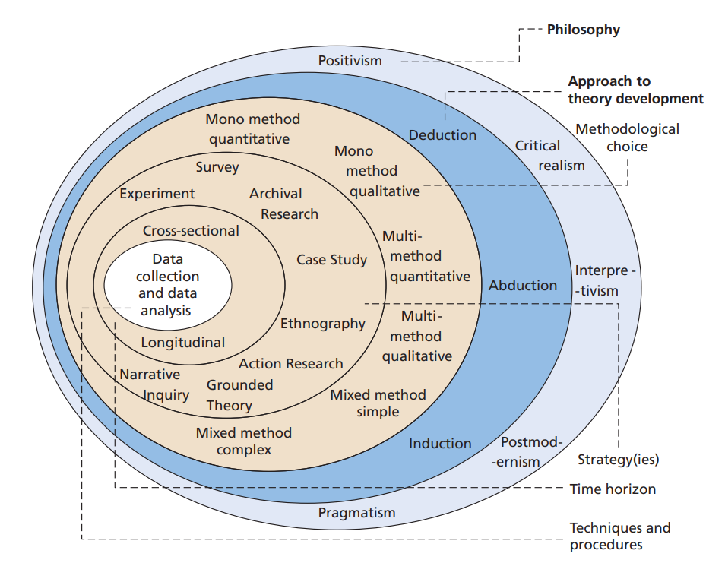

3.2.1 Philosophy

The assumptions and opinions about the knowledge collected for the study are referred to as research philosophy. The researcher will make a lot of assumptions both subconsciously and consciously as the investigation progresses. A organised set of assumptions will assist in the formation and underpinning of a comprehensive research study (Saunders et al. 2019).
Positivism and interpretivism are the two basic research philosophies. These ideologies offer two fundamentally different approaches to understanding the world: positivism holds that reality exists independently of humans, allowing researchers to study reality objectively. Reality is considered as very subjective in interpretivism since it is moulded by people's perceptions (Collis and Hussey, p.45). The investigation will employ both ontological and epistemological theories.The participants' points of view will be incorporated as part of the research in this study, which employs interpretivism. The study also employs a positivist methodology, allowing the researcher to present statistical statistics based on quantifiable data and observations (Saunders et al. 2012).

3.2.2 Approach

An online questionnaire will be used to collect primary data for this study. A questionnaire, according to Houston, (2021), creating a questionnaire is one of the most effective ways to acquire data. A questionnaire can provide the researcher an opportunity to ask questions of a specific audience in order to collect and analyse data. The findings of the questionnaire will be analysed to identify gaps in the questions, which will then be utilised to create an interview.
The questionnaire will be administered in a mainly quantitative manner, allowing the researcher to supply questions depending on the findings of the research and allowing all data to be successfully assessed (Coghlan and Miller, 2014).

3.2.3 Strategy

although an interview or interviews were explored, it was ultimately agreed that a questionnaire would be the best way for gathering primary data for this project. According to Saunders et al. (2009), a survey is the most ideal way for obtaining results fast and efficiently comparing them, especially if the data sought is quantitative (Chetty and Walia, 2020). A survey, on the other hand, will be able to gather qualitative data, and allow the individuals filling out the questionnaire to explain their answers in depth when it comes to the "why" questions, as well as quantitative data.
Google Forms will be used to build the survey for this project. After the survey is created, a link is provided that, when clicked, grants access to the survey to everyone who has clicked on it. This link will be shared on Facebook and other social media platforms. Because of its sheer popularity and simplicity of sharing, Facebook is a fantastic platform for getting the survey in front of as many people as possible. The link will also be forwarded to many Whatsapp group chats, which is a great approach to collect responses because individuals may share it with their friends, family, and other groups. The survey will be brief and to the point, as well as anonymous and confidential. Following a brief introduction, the respondent will complete 12 "tick the box" questions and three questions for which they can provide a more detailed response.

3.2.4 Choice

This research project will use a mixed methods study, which involves quantitative and qualitative data gathering and analysis in one study. Because these methodologies can each answer various issues on their own, combining them can yield more in-depth results. Generally, quantitative data is preferable at answering queries such as "What is a serious offender?" while qualitative data can explain how and why you arrived at these conclusions (UK Health Security Agency, 2020). Although qualitative data is more difficult to understand since it collects descriptions and views that are challenging to analyse. Creating word clouds can be done for the qualitative data as it can state the most common answers given.

3.2.5 Time Horizon

According to Saunders et al. (2009), there are two sorts of timeframes to consider which include, longitudinal and cross-sectional. A longitudinal study is repeated throughout time, while a cross sectional study is conducted in a single time range. Due to this being a short-term study, the most appropriate time horizon for this research is cross-sectional. A cross-sectional time frame would also allow for additional research in the future, if necessary. When compared to the longitude approach, it is also a less costly way of research (Lavrakas, 2008).

3.2.6 Techniques for Data Collection, Survey Design & Analysis

3.2.6.1 Data Collection:

For this project a questionnaire was chosen to be used to gather primary research. Questionnaires are usually created and sent via the internet which tends to save time for researchers, which is an advantage. As previously said, internet surveys enable a researcher to connect to many people with similar characteristics in a short period of time, despite the fact that they may be in a totally different country/city (Bachmann & Elfrink, 1996). Another benefit of using a questionnaire is that participants can fill it out anonymously, which stops the unwelcome attention as a result of sharing sensitive information (Andrews et al., 2003). However, there are some drawbacks to using a questionnaire, such as attendees being un-willing to expose if they've ever had an ACE and if so, it may trigger traumatic memories, or could be sensitive about a few of the questions.

3.2.6.2 Survey Design:

The researcher utilised a questionnaire with three questions that require more detail, and 12 tick box questions to collect data. This allowed the individuals answering to fully express their thoughts on the topic at hand, as well as provide the researcher with a better understanding of how much knowledge people had about Adverse childhood experiences and identify a potential theme from the responses, allowing them to reach a more comprehensive conclusion to their research. Some people might not have had an answer that relates to them in the multiple choice questions for instance, the second question asked respondents to mark their gender yet, some participants may feel uncomfortable answering this question. To address this issue, the researcher included an additional option for them to 'prefer not to say'.

3.2.6.3 Pilot Survey:

A pilot study on the researchers' questionnaire was undertaken to check that it adhered to the standards of reliability and validity, along with ensuring it was morally correct and displayed clarity to the participants. This enables the researcher to change or adjust any questions in order to acquire the findings they wanted. To confirm that the questionnaire was appropriate for the targeted participants, the pilot research consisted of a limited sample of the questionnaire.

Table 3.1 Question and Literature Review Matrix:
Question in Survey | Relation to Chapter Two
Q1. The information gathered through this survey will be kept anonymous and confidential, and that the University of Wales Trinity Saint David will only use it for academic and instructional purposes. | This particular question was added to ensure that the respondents were aware of the purpose and usage of the answers they provided to the research.
Q2. What age bracket do you come under?  Q3. What is your gender? | Demographic questions were asked for question 2 and question 3 as they were designed to offer context for the analysis.
Q4. In your opinion what are Adverse childhood experiences? | This open question was used to collect respondents' opinions on what they consider to be Adverse childhood experiences. It will have an effect on the progress of the survey, as well as all other questions that are tailored to their concept of Adverse childhood experiences.
Q5. Have you ever suffered from Adverse childhood experiences?  ‘Adverse childhood experiences (ACEs) are traumatic events occurring before age 18. ACEs include all types of abuse and neglect as well as parental mental illness, substance use, divorce, incarceration, and domestic violence.’ (Child welfare, 2022). | This question was asked to see how many people had suffered from ACEs to see if more could be done.
Q6. Which one of these do you think are Adverse childhood experiences? | Question six and seven were added to give more context to the public's understanding.
Q7. Which one of these would you class as a serious offender?
Q8. Do you think Adverse childhood experiences can affect people later on in life? | This question was asked to be able to see if the public know the consequences of ACEs.
Q9. In your opinion are criminals who have suffered from Adverse childhood experiences more likely to re-offend and why? | This question is in place to have an insight on the responder’s opinion on re offenders and ACEs.
Q10. Do you believe that there should be more support for individuals who have suffered from Adverse childhood experiences? | This question was added to evaluate if the police are doing a good job of helping victims of adverse childhood experiences.
Q11. Do you believe people commit crimes due to their upbringing? | This question was included to see if people think the background of individuals affect their actions.
Q12. Does a serious offender deserve life in prison? | This question was included to get a viewpoint on the serving time serious offenders receive.
Q13. What do you think is the most commonly committed Serious Crime in England and Wales in 2019/20, according to statistics published by the Home Office in 2020 ? | This question was included to discover what the public believes is the most typically committed serious crime, and to see if they genuinely understand which category it is.  Previous Research – Home Office, (2022)
Q14. Who do you believe the main perpetrators of Adverse childhood experiences are? | This question was included to examine who the participants believe are the main offenders of Adverse childhood experiences, which may provide useful knowledge that the police would not have discovered.
Q15. Are there facilities are in your area to prevent people who have suffered from Adverse childhood experiences from offending?  If so, please list what is available. | The fifth teen question is in place to determine how many facilities are available in the participant's location.

3.2.6.4 Analysis:

The researcher will use Microsoft Excel, a well-known software for making spreadsheets and analysing data, to analyse the data from the obtained online questionnaire. In order to analyse the open questions in the questionnaire, Excel will also be used to develop a common theme. The researcher will look for trends in the answers when analysing the data from the closed questions.

3.3 Sample:

Carrying out a questionnaire involving just people who made have suffered from adverse childhood experiences would be too difficult to form, therefore this project was open for the public, ranging from both genders and all ages to ensure it was made fair. the researcher had a total of 100 respondents.

3.4 Reliability and validity:

The need of ensuring that the research is accurate and genuine is critical because the study would become obsolete without them. The social desirability of replies may have an impact on surveys exploring sensitive personal problems. To combat this, each participant was told that answering each question in the questionnaire was optional, and that if they wanted to stay anonymous, their data would be kept private.

3.5 Limitations

One downside to this type of study is that the results aren't always socially acceptable. Because the topic of debate is can be sensitive, some individuals may give dishonest replies in order to avoid negative consequences within themselves. To address this, the researcher verified that if a participant wished to take the questionnaire anonymously, their information would be kept private until the study was over. The coronavirus was a major limitation throughout the research, as it prevented any plans of taking the survey into work places to hand out to individuals and ask them to complete it in person. However, it could be argued that doing the survey online was always a better means of gathering findings due to people at home would be more relaxed sitting down and filling out a quick survey rather than someone in a rush or being hassled whilst at work.

3.6 Ethical Considerations:

An ethics form issued by UWTSD must be completed before any study may begin, and it must be authorised by the supervisor and the program director. The survey form must pass ethical concerns, thus the researcher has guaranteed that mechanisms will be in place to protect participants' privacy and sensitive information. All information will be kept safely and securely. During the research process, ethical consideration is critical since participants must not be harmed or put at risk. According to Saunders (2009), ethics must be considered when conducting research, interviewing people along with online surveys. It is critical that the public's privacy is protected.

3.7 Conclusion:

The relevant research methods for this investigation were selected in this chapter. It then validated the researcher's decision to use an interpretive quantitative approach in the form of a questionnaire with a diverse group of people. The data from the survey will be analysed and evaluated in the following chapter.

Chapter Four: Data Analysis

4.1 Introduction:
The previous chapter explored and analysed all of the techniques and methods that a researcher may employ in order to obtain the most useful data for determining whether or not their theory is right. Questionnaires or interviews, determining which data collection method to utilise (qualitative or quantitative), and understanding the limitations and ethical considerations associated with each type of data gathering method are only a few of the procedures addressed in the preceding chapter.The primary data that has been obtained will be calculated and examined in this chapter of the study. One hundred people responded to the public survey, which was designed to find out how they felt about the link between Adverse childhood experiences and serious offenders.
Between April 22nd and April 30th, a total of 100 questionnaires were collected. The questionnaire has 15 questions, including an opening declaration, introduction questions, and "why?" questions. The data was gathered and analysed using Google Forms and Google Sheets, as well as the Monkey Learn which is a generation tool for the word clouds.
There were 42 male responders (42%) and 58 female respondents (58%) in total for the questionnaire. Although, "Other" and "won't disclose" were provided as options none of the respondents checked those boxes.In terms of age, 39 (39%) of respondents were between the ages of 19 and 29, 42 (42 %) were between the ages of 30 and 50, and the remaining responses were evenly distributed amongst the other age groups, which spanned from 18 or below or 70 plus.

4.2 Data Presentation
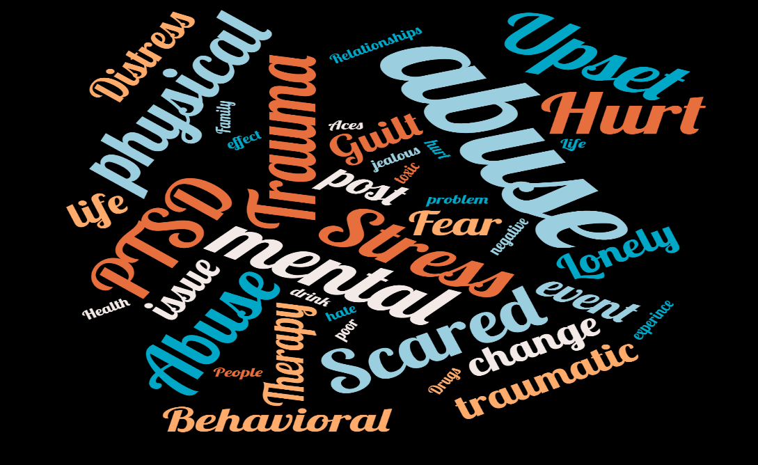
Q.4 In your opinion what are Adverse childhood experiences?

Figure 4.4: A Word Cloud of the Most Common Words and Phrases used to describe Adverse childhood experiences in Questions 4.

The data from the "explain" question has been compiled into a word cloud to show some of the most prominent topics in the explanations of the participants. "Abuse" was the most frequently used word, appearing in 38 replies. The common theme of these comments was that abuse is a major factor in adverse childhood experiences. "Trama," which appeared 35 times, and "PTSD," which appeared 27 times, were also common words. The opinion of the public here seems to correlate with that of Leonard (2020) and CDC (2019) who state Adverse childhood experiences are potentially traumatic events for instance, abuse that occur in childhood.

Q5. Have you ever suffered from Adverse childhood experiences?

Figure 4.5: Graph Presenting Data Findings from Question 5

The graph above shows that 38% of people who answered the survey have been through Adverse childhood experiences however, 51% have never experienced it and 11% chose not to answer this question. Centres for Disease Control and prevention (2019) state that 1 in every 6 people have suffered from ACEs in their lifetime. Therefore, these results come as no surprise.

Q 6. Which one of these do you think are Adverse childhood experiences?

Figure 4.6: Graph Presenting Data Findings from Question 6
The majority of people who answered this question all ticked the “all of the above” which includes neglect, abuse, trauma, mental health problems, parents separating and parents serving prison time. 4 people just ticked abuse alone and 6 people stated just trauma is an adverse childhood experience.

Q7. Which one of these would you class as a serious offender?

Figure 4.7: Graph Presenting Data Findings from Question 7

The graph above shows the different age categories of the participants of the questionnaire and it contrasts them into four categories. The findings show that the 60 plus category were the only ones who ticked "all of them" which means they are the only age group that considers a burglar as a serious offender. All age categories stated that a serial killer was classed as a serious offender.

Q8. Do you think Adverse childhood experiences can affect people later on in life?

Figure 4.8: Graph Presenting Data Findings from Question 8

This graph shows that people aged 41 plus (a total of 24%) thinks that Adverse childhood experiences can affect people later on in life. Under 18s all stated that they don’t know. This suggests they do not have enough knowledge of the topic.

Q9 .In your opinion are criminals who have suffered from Adverse childhood experiences more likely to re-offend and why?

Figure 4.9: Graph Presenting Data Findings from Question 9

The majority of people questioned stated that they think people who have suffered from ACE’s are most likely going to re-offend. When asked “why” the most common answers were that they is not enough support, and that they’ve done it once they will do it again.

Q10. Do you believe that there should be more support for individuals who have suffered from Adverse childhood experiences?
Figure 4.10: Graph Presenting Data Findings from Question 10

This question also received a majority “Yes” answers, with only 17 participants responding “No”. This suggests that the individuals who chose no don’t have much knowledge on how much support there is out there for people who have suffered from Adverse childhood experiences.

Q11. Do you believe people commit crimes due to their upbringing?

Figure 4.11: Graph Presenting Data Findings from Question 11

This question was very close when it came down to a final answer, 51% of people agreed that people commit crimes due to how they were brought up, and 49% disagreed with this statement and thought it was down to a different reason as to why people commit crimes, or they thought it wasn’t just their upbringing as to why they commit crimes. Public health (2013) agrees with the 51% of people who said yes as they state that Adverse childhood experiences tends to play an important role in drink, drugs, violence, and other criminal behaviour in adulthood.

Q12. Does a serious offender deserve life in prison?

Figure 4.12: Graph Presenting Data Findings from Question 12

Most who took part in the questionnaire said that serious offenders do deserve life in prison, 30% said they didn’t know if serious offenders deserved life in prison, this could be related to people not knowing what is classed as a serious offender. 5% of those who took part in the questionnaire said that serious offenders do not deserve life in prison this could be because a life sentence is 15 years (CPS, 2020), this suggests the people who ticked ‘no’ could be instigating they deserve more than that.

Q13. What do you think is the most commonly committed Serious Crime in England and Wales in 2019/20, according to statistics published by the Home Office in 2020 ?

Figure 4.13: Graph Presenting Data Findings from Question 13

During that start of the pandemic Fraudsters have been taking advantage of the spread of the coronavirus (COVID-19) to commit fraud and cybercrime. Scams using the coronavirus have increased, according to the police (The Charity Commission, 2020). This suggests that the majority of people chose fraud due to the circumstances over the last few years with the pandemic.

Q14. Who do you believe the main perpetrators of Adverse childhood experiences are?
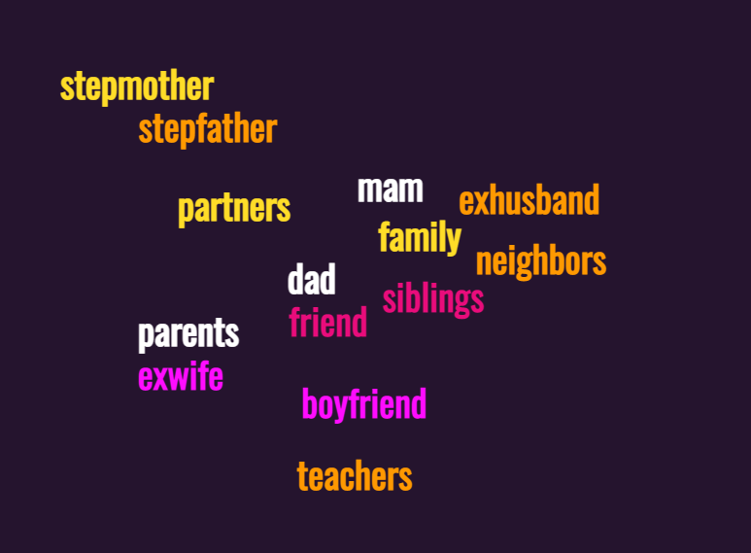
Figure 4.14: A Word Cloud of the Most Common Words and Phrases used to describe the main perpetrators of Adverse childhood experiences in Questions 14.
The word cloud above are just a few of the most stated words that the responders gave when asked who they believed are the main perpetrators of Adverse childhood experiences.

Q15. Are there facilities are in your area to prevent people who have suffered from Adverse childhood experiences from offending? If so, please list what is available.

Figure 4.15: Graph Presenting Data Findings from Question 15
The final question asked if there were facilities in their area to support people who have suffered from Adverse childhood experiences. The majority of people who answered didn’t know. 31% of people said no and 27% of people said yes. This suggests that there needs to be more knowledge and support on the topic.

4.3 Conclusion

This chapter achieved the aim:
‘To explore the publics perceptions on what a serious offender is, their knowledge on Adverse childhood experiences, and the link between reoffenders who have suffered with Adverse childhood experiences’
The last chapter will summarise and conclude this chapter's results, as well as provide future recommendations.

5. Chapter Five: Conclusions and Recommendations

5.1 Introduction

The data acquired by the researchers Questionnaire was examined in the previous chapter, and probable conclusions were presented. The researcher applied a variety of Open-Ended Questions as well as Multiple Choice Questions in the Questionnaire and used Graphs to help highlight their findings from the Multiple Choice Questions, as well as selected themes from the Open-Ended Questions to help highlight what the Survey participants said, and added word clouds.
The goal of this chapter is to draw conclusions and provide recommendations based on the information gathered in order to assist those who have had adverse childhood experiences. To accomplish this goal, the researcher will draw information from the results analysed in the preceding chapter and provide realistic recommendations for help that can be given to victims of ACEs as well as offenders who have committed crimes as a result of having previously suffered from Adverse childhood experiences.

5.2 Main Findings

The survey data provided the researcher with a better understanding of how the general public viewed Serious offenders and Adverse Childhood Experiences. The majority of the participants believe there is not enough support for victims of Adverse childhood experiences, according to the data collected.
Furthermore, the majority of those who completed the survey believed that people commit crimes as a result of their upbringing, implying that individuals who have had Adverse childhood experiences are more likely to commit crimes repeatedly.

5.3 Implications

An implication for the researcher was that they were unable to perform a face-to-face interview due to some people still being cautious regarding Covid. Another implication was that some people may have been triggered by the researchers’ questions due to past experiences so they may have found it different to answer the questions truthfully.

5.4 Recommendations

The information in this study was gathered from a small group of 100 individuals. If can not be made certain that these are the views of the entire United Kingdom. As a result, more research should be done in this area, using a much larger data set to refine results even more and determine whether these perspectives are shared by the entire population. To determine whether there are any differences.More assistance is needed for offenders who have experienced ACEs. The primary research in this paper shows that simply adding more facilities to an area could help. More support from government-run law enforcement agencies and the criminal justice system is needed to ensure that ACE offenders do not re-offend, as well as to ensure that ACE sufferers do not offend at all by being aware of the serious implications.

5.5 Limitations

Most of the information was obtained via the internet due to Covid, which has a number of drawbacks. Technical challenges, as well as user engagement, are some of the barriers to data collection in this strategy. Lefever et al (2007) states that It is also known that questionnaire sites can increase the chance of dishonest participants, raising concerns about the accuracy of the responses submitted. One option to mitigate this is to require participant identification, but for this study, individuals were kept strictly confidential.
The survey was largely filled out by women; the researcher may have re-issued it to get more replies overall, but more especially from men, in order to get a more accurate result.

5.6 Future research

This study came to conclusions about present practise, but it did not go into detail on what measures might be available to help ACE offenders avoid reoffending. It would be beneficial to conduct study on how to support people from a young age and identify if they are suffering from ACEs in order to prevent them from committing crimes later on, as well as compare and contrast their findings.

5.7 Self reflection
Due to the researcher being passionate about assisting others and altering their ways for the better, they set out to gain a deeper understanding of what Adverse Childhood Experiences are. The researcher was interested in shedding light on the problem to understand more and analyse areas for development. The researcher has gained a variety of new abilities as a result of this study, which will be useful in future research efforts.

5.8 conclusion

The goal of this study was to see if there was a link between Adverse childhood experiences and serious offenders. It has provided additional knowledge and a foundation for future research in order to provide more help and support for individuals who have had Adverse childhood experiences and have committed a crime. The research project is now complete.

Chapter Six: Bibliography
Andrews, D., Nonnecke, B., & Preece, J. (2003). ‘Electronic survey methodology: A case study in reaching hard-to-involve Internet users’. International Journal of Human-Computer Interaction, Volume 16, Issue 2, pp. 185–210.
Bachmann, D., & Elfrink, J. (1996). Tracking the progress of e-mail versus snail-mail. MarketingResearch, Volume 8 Issue 2, pp. 31–35.
Banyard, V, Hamby, S & Grych, J 2017, 'Health effects of adverse childhood events: Identifying promising protective factors at the intersection of mental and physical well-being', Child Abuse and Neglect, vol. 65, pp. 88-98. https://doi.org/10.1016/j.chiabu.2017.01.011
Bellis, M.A., Hughes, K., Leckenby, N., Perkins, C. and Lowey, H. 2014. National household survey of adverse childhood experiences and their relationship with resilience to health-harming behaviours in England. BMC medicine, 12(1), p.72.
Butler, N, Quigg, Z and Bellis, A (2020) Cycles of violence in England and Wales: the contribution of childhood abuse to risk of violence revictimisation in adulthood (online) available at: Cycles of violence in England and Wales: the contribution of childhood abuseh to risk of violence revictimisation in adulthood (biomedcentral.com) [Accessed: 20th February 2022].
Carly B. Dierkhising, Susan J. Ko, Briana Woods-Jaeger, Ernestine C. Briggs, Robert Lee & Robert S. Pynoos (2013) Trauma histories among justice-involved youth: findings from the National Child Traumatic Stress Network, European Journal of Psychotraumatology, 4:1, 20274, DOI: 10.3402/ejpt.v4i0.20274
CDC, (2019) ‘Adverse childhood experinces’ (online) Available at: Adverse Childhood Experiences (ACEs) | VitalSigns | CDC [Accessed: 28th April 2022].
Centers for Disease Control and Prevention (2016) Preventing child abuse and neglect: A technical package for policy, norm, and programmatic activities (online) Available at: Adverse Childhood Experiences (ACEs) | VitalSigns | CDC [Accessed: 3rd February 2022].
Centers for Disease Control and Prevention, (2021) Preventing Adverse childhood experiences (online) Available at: Preventing Adverse Childhood Experiences |Violence Prevention|Injury Center|CDC [Accessed: 20th February 2022].
Chetty, P and Walia, A, (2020). How to formulate a research strategy? (online) Available at: How to formulate a research strategy? (projectguru.in) [Accessed: 26th April 2022].
Child welfare, (2022) ‘Adverse childhood experiences’ (online) Available at www.childwelfare.gov/topics/preventing/preventionmonth/resources/ace/ [Accessed: 27th April 2022].
Coghlan, D., Brydon-Miller, M. (2014). The SAGE encyclopedia of action research (Vols. 1-2). London, : SAGE Publications Ltd doi: 10.4135/9781446294406
Collis, J. and Hussey, R. (2014). Business research. 4th ed. Basingstoke: Palgrave Macmillan.
Communities and Justice (2015) Serious Offender (online) available at: Serious Offenders (nsw.gov.au) [Accessed: 16th February 2022].
Communities and Justice, (2015) Serious offenders (online) Available at: Serious Offenders (nsw.gov.au) [Accessed: 20th December 2021].
CPS, (2020). ‘Sentencing - Mandatory life sentences in Murder cases’ (online) Available at: Sentencing - Mandatory life sentences in Murder cases | The Crown Prosecution Service (cps.gov.uk) [Accessed: 30th April 2022].
Gov.Scot (2020) Adverse childhood experiences (ACEs) and trauma (online) Available at: Adverse Childhood Experiences (ACEs) and Trauma - gov.scot (www.gov.scot) [Accessed: February 15th 2022].

Houston, K, (2021), How to use the questionnaire method of data collection, (online) Available at: How to use the questionnaire method of data collection | The Jotform Blog [Accessed: 25th April 2022].
Lavrakas P (2008) ‘Cross sectional data. Cross-Sectional Data’ (online) Available at: https://methods.sagepub.com/reference/encyclopedia-of-survey-research-methods/n119.xml [Accessed on: 26th April 2022].
Lefever S, Dal M, Matthiasdottir A (2007) ‘Online data collection in academic research: advantages and limitations.’ Available at: https://d1wqtxts1xzle7.cloudfront.net/46417092/j.1467-8535.2006.00638.x20160612-22482-3m9znc.pdf?1465740809=&response-content-disposition=inline%3B+filename%3DOnline_data_collection_in_academic_resea.pdf&Expires=1619007427&Signature=hEDzGz~BY4uO4f1emT3PzrXX5dj3wc-rXplaSohnZLo0FNQHcjt5nquvvmELTjU7S~dsjVbXB7x-LgqTluA8zeVfwbwUZ-dgzK1sORbCNDAdv3M5VDZv6xG8bMr1cdFZCeS0fXK--3WTPdhMzNKHBxnxqUcXXKBRHui4Imls83eaOl5ZJ-hE1nCpBfWTpcjo-kzYYWWOExRXXk6qFjYgnX93NK7Psc9mmX6S8odD26tLjrBDXq7McqoBOBUS1HlI1r5WyatsUUkZVFj8Xyaetbh~L~H~DA3uD-i8anz1UekL5CCo~ldHjT35-cTPt8FTSmC89ILOpfhokMZz820MfQ__&Key-Pair-Id=APKAJLOHF5GGSLRBV4ZA [Acessed on: 22 April 2022].
Leonard, J, (2020) ‘Everything you need to know about adverse childhood experiences’ (online) Available at: Adverse childhood experiences: Definition and examples (medicalnewstoday.com) [Accessed: 28th April 2022].
Myers, M.D. (2008) Qualitative Research in Business & Management, SAGE Publications
NHS, (2018) Why 5 a day? (online) available at: Why 5 A Day? - NHS (www.nhs.uk) [Accessed: 20th February 2022].
NHS, (2022) Adverse childhood experiences and attachments (online) Available at: Adverse Childhood Experiences (ACEs) and Attachment - Royal Manchester Children's Hospital (mft.nhs.uk) [Accessed: February 15th 2022].
Park, J & Larkin, H (2018) Adverse Childhood Experiences (ACEs), Service Use, and Service Helpfulness Among People Experiencing Homelessness [online] Available at: https://journals.sagepub.com/doi/pdf/10.1606/1044-3894.4192 (Accessed: 3rd February 2022).
Public health (2013) ‘Linking Childhood and Adult Criminality: Using a Life Course Framework to Examine Childhood Abuse and Neglect, Substance Use and Adult Partner Violence’ (online) Available at: Linking Childhood and Adult Criminality: Using a Life Course Framework to Examine Childhood Abuse and Neglect, Substance Use and Adult Partner Violence - PMC (nih.gov) [Accessed: 28th April 2022].
Public Health Wales (2016) ACE Report (online) Available at: Public Health Wales | ACE Report 1 [Accessed: 16th February 2022].
Public Health Wales NHS Trust, (2015) Adverse Childhood Experiences and their association with chronic disease and health service use in the Welsh adult population (online) Available at: ACE Chronic Disease report (9) (2).pdf (wales.nhs.uk) [Accessed: 20th February 2022].
Saunders, M., Lewis, P. and Thornhill, A. (2009) Research methods for business students. England: Pearson Education Limited. Available at: https://books.google.co.uk/books?hl=en&lr=&id=utxtfaCFiEC&oi=fnd&pg=PA2&dq=Saunders,+et+al.,+2009&ots=DxGSImJdfN&sig=q4Fvt293s6HMBNiTkpEtrWFeE4#v=onepage&q=Ethical%20considerations&f=false [Accessed 25th April 2022].
Saunders, M., Lewis, P. and Thornhill, A. (2019) Research methods for business students. 7th ed. Nueva York: Pearson Education. Available at: https://www.researchgate.net/profile/Mark_Saunders4/publication/330760964_Research_Methods_for_Business_Students_Chapter_4_Understanding_research_philosophy_and_approaches_to_theory_development/links/5c53056f299bf12be3f0e2cf/Research-Methods-for-Business-Students-Chapter-4-Understanding-research-philosophy-and-approaches-to-theory-development.pdf [Accessed 25th April 2022].
Scottish Government (2018) what have ACEs got to do with Justice? (online) Available at: Understanding Childhood Adversity, Resilience and Crime (www.gov.scot) [Accessed: 20th February 2022].
Scottish Government, (2022) ‘Adverse childhood experiences and trauma’ (online) Available at: ACEs policy background - Adverse Childhood Experiences (ACEs) and Trauma - gov.scot (www.gov.scot) [Accessed: 1st May 2022].

The Charity Commission, (2020) ‘Coronavirus (COVID-19): increased risk of fraud and cybercrime against charities’ (online) Available at: Coronavirus (COVID-19): increased risk of fraud and cybercrime against charities - GOV.UK (www.gov.uk) [Accessed: 2nd May 2022].
UK Health Security Agency, 2020. Mixed methods study (online) Available at: Mixed methods study - GOV.UK (www.gov.uk) [Accessed: 26th April 2022].
Waite and Ryan, (2020) :Adverse Childhood Experiences : What Students and Health Professionals Need to Know, 1st edn: Abingdon, Oxon
(Banyard, Hambly, & Grych, 2017
Wright, K. (2017), ‘Researching Internet-Based Populations: Advantages and Disadvantages of Online Survey Research, Online Questionnaire Authoring Software Packages, and Web Survey Services’, Journal of Computer-Mediated Communication, Volume 10, Issue 3, pp. 2.

