What Causes Lack of Job Satisfaction in the workplace?

Module Code- BMSW4004
Student Name- Elizabeth Oladeji Johnson
Student Number – 1907179
Lecturer – Dr Mushfigur Rahman
Date- September 2020

Content Page
Title Page No
Title page……………………………………………………………………….1
Content page……….…………………………………………………………...2
Introduction….…………………………….……………………………………3
Purpose of Report……………………………………………………………….3
Problem.................................................................................................................4
Complex Problem……………….........................................................................4
Examples of Complex Problems in the Workplace…………………………….4
Causes of Problems …………………………………………………………..4-5
Problems identified in my organisation…………………………………………5
Stages in Problem Solving……………………………………………………...6
Problem Solving Methods……………………………………………………....6
Fishbone Diagram-(Cause and Effect Diagram)……………………………..7-8
Recommendation……………………………………………………………..8-9
Conclusion…………………………………………………………………….10
References…………………………………………………………………… 11
Appendix……………………………………………………………………...12

Introduction
Work is considered as a fundamental feature for individual existence, according to Harnois, & Gabriel, (2000) work provides financial security, gives personal identity and also gives an opportunity to make a meaningful contribution to the professional community. The workplace is regarded as a crucial area for the individuals who are engaged in either full or part time work. They experience numerous cases, issues and problems at the workplace, which can be sometimes negative.
Growing concerns for problems and issues in the workplace all over the world which are caused by culture difference, religious difference and individual backgrounds is a major role in such issues. Even though some of the workplace issues can be managed when identified therefore, organisations need to ensure all issues in the workplace are defined, analysed and then determine ways to deal with the issues, implement problem solving strategy and continuously evaluate the process ensure that it is working for the business.
This report will;
- Define Problem and Complex Problem.
- It will discuss some of the complex problems encountered in the workplace,
- Then it will discuss some causes of complex problems,
- Furthermore, it will identify a specific problem in my workplace, its causes and impact on the organisation.
- Then, it will consider some problem solving tools to solve the problems,
- And finally propose recommendations to help the organisation to address the issues.

Problem
Problem in the workplace can be described as an unpleasant situation that suddenly occurred and which is likely capable of affecting employee performances creating problems for managers to deal with thereby having a significant impact on performances and productivity. CMI (2014) however describes problem in the workplace as “the distance between how things currently are and the way they should be”.
Complex Problem
A complex problem in the workplace can be described as problems that are beyond the scope of the organisation to understand and respond to when it occurs. There are often issues for organisations to identify the cause of complex problems as well as how to address them however those problems although can be addressed but in most cases may not be completely resolved.
Examples of Complex Problems in the Workplace
The main problems that are experienced by employees within the work environment include the following;

- Discrimination
- Poor Communication
- Bullying
- Harassment
- Interpersonal conflict
- Low Motivation
- Lack of Job satisfaction
- Poor Performance

Causes of problems in the Workplace
Problems are caused by a wide range of factors including the following;
- Conditions of the work environment
- Poor conflict resolution
- Lack of knowledge and information
- Work related stress
- Poor communication
- Diversity
- Harassment

Problem within my Workplace
I work in the make-up/beauty industry where communication is critical to the success of the business e.g. customers visit the stall and describe what they require, a service provider then interprets the customer requirement and provide a service based on customer request. The organisation is an equal opportunity employer with a representation of individuals from every cultural background and different religious groups. Whilst working as a team is critical to this role, employees do not only work with their colleagues from their organisation but also teamwork with employees from other concession organisations, arrange days out and also lunch together.
There are situations where employees have spoken to colleagues about their role and through that employees get to know what is being offered by other organisations that they are not privileged to have, through this employees start to find faults in the employers and find that they are not happy with their working condition. This then leads to lack of job satisfaction then they will leave the job eventually for another job that offers better working conditions. Consultants get to discuss with their colleagues and compare work life experiences.
Below is a five (5) stage tool that I will be using to define the problem, analyze the problem, determine what to do about the problem (plan), implement the plan to know if you are doing what you plan to do and evaluate the progress of the plan. According to (CMI, 2015) “most problem solving methods follow a common pattern, beginning with a definition of the problem, moving on to the consideration of potential solutions, and culminating with the selection, testing and implementation of a chosen course of action”.
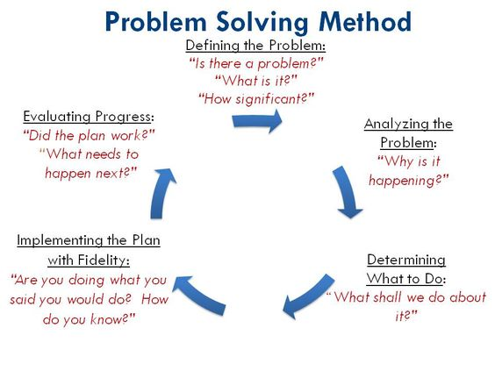
https://www.wrike.com/blog/top-15-problem-solving-activities-team-master/
Stages in Problem Solving Method
Identify the problem
The main and specific problem identified in my workplace is lack of ‘Job Satisfaction’. The effect of the problem on the business is high employee turnover rate. Employee Turnover rate refers to the rate at which employees leave an organization and the rate at which the organisations replaces them with new employees over a set period e.g. a year, 6 months. This is usually measured in numbers and percentage and can be helpful for employers who are concerned about the reasons why employees are leaving and also to monitor due to the cost of hiring for budget purposes.
Specify the cause
The main cause of the problem is the fact that employees lack job satisfaction within the working setting in relation to the following;
Pay –low pay compared to competitors and no annual increase to pay
Promotion – there is no promotion except a consultant applies for a higher role in the organisation otherwise, they continue to be a consultant.
Job security and safety – there is lack of job security, the job is based in departmental stores, if anything happens and the stores cannot carry on transacting business, it will surely affect the job of the employee. Also safety at work is not assured, regardless of the health condition employees are standing all day except for the break times.
Working condition – working in the departmental stores require the ability to work on shift basis and finishes as late as 10pm during late night shopping and sales period. It also requires working Saturday and Sundays including bank holidays. This does not promote family life balance; employees seem to want some weekends off to spend with their family which are sometimes impossible.
Relationship with supervisors- there are some occasions when the managers and supervisors exhibit favouritism by giving privileged treatment to one employee over the other employees for reasons unrelated to performance.
Another issue with supervisors and managers is a breech in confidentiality where managers and supervisors discuss confidential information relating to an employee with their colleagues and such colleagues reacting based on information they hold about colleagues.
Relationship with colleagues – Racism among colleagues is a big issue in the workplace, religion, culture, language of other colleagues, some colleagues are against other peoples religion, language (accent) and culture and base their work relationship on that which causes conflicts within the organisation.

The fishbone diagram (Ishikawa)
A fishbone diagram also known as a ‘cause and effect’ analysis tool was developed by Professor Kaoru Ishikawa for the initial purpose of quality control however with time, it became a useful tool that can help you perform a cause and effect analysis for a problem you are trying to solve most especially in projects. This type of analysis is highly visual, systematic, organised and also enables you to discover the root cause of a problem.
For the problem in my organisation, I have used a Fishbone analysis tool to find the root cause of the problem of lack of job satisfaction which is the reason why employees are leaving the organisation in high rate i.e. every year, at least thirty (30) employees leave the organisation considering the cost of employing each person and training them to the standard of delivering great customer service that meets and surpasses customer’s expectations.
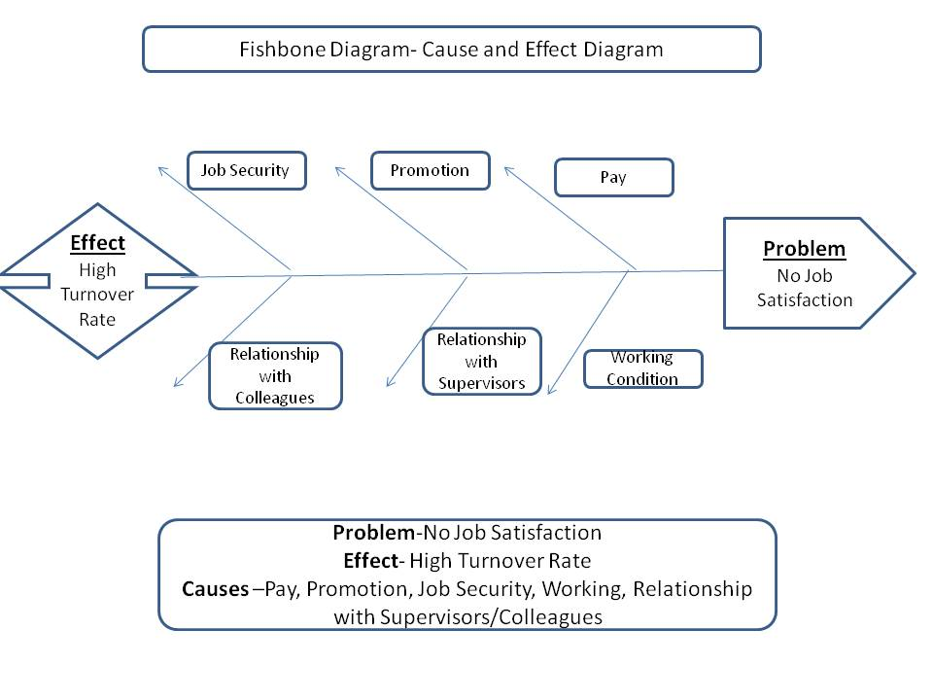
Diagram created by student-Elizabeth O Johnson
Identify possible solutions - Recommendations
Possible solutions to the problems caused by lack of job satisfaction within my organisation includes although may not likely be limited to the following;
Pay- possible solution to the issue of pay will be to use a strategy that matches the employee pay with competitors in the business, add a minimum amount annually so that an increase reflects and it does not look like the salary has been on a standstill and also ensure that the national minimum wage is considered.
Promotion- firstly providing a culture that engages everyone in the running of the business will give a sense of belonging, also giving opportunities to progress into administrative positions after a certain period as a consultant will give employees hope of having the opportunity to work in the office at some point.
Job Security and Safety- in order to overcome the fear of job insecurity for employees, I propose a culture that will identify and retain talents amongst the employees and give them the opportunity of being put forward to fill up vacant positions, through this employees would have known well enough about the organisation and little training will be required to aid their performances as compared to employing an individual from outside the business and use a large amount to train them to standard, this will also help to enhance the performances of the retained employee as they will feel like a talent to the organisation.
Working Condition- as part of safety measures to ensure a conducive working environment for employees, late night work for shifts ending at 10pm should be reviewed; finishing a shift at 10pm and having to travel back home for duration of an hour or hour and a half means travelling unhealthy hours where individuals are prone to dangerous attacks during travel. Another option to consider is to employ local residents so that within half an hour, they will be back in their home. Constant breaks are also proposed for health and safety since the work requires a lot of on the feet activities. Finally, a business culture that promotes family life balance is proposed so that employees can have weekends and bank holidays off to spend with their family which are sometimes impossible.
Relationship with Supervisors- to enhance the performances of supervisors and managers, additional training programs are advised because they provide information to the supervisors on how to perform their job duties adequately, and measures that would prove to be productive to the organization. One important training will be the GDPR law, it will teach them the importance of not sharing personal information without consent, it will educate the supervisors as well as the employees about the organisations expectations of individuals and promote a professional relationship. Through the knowledge learnt from these trainings, supervisors and managers will have better knowledge of why they should not share other people’s private information.
Relationship with Colleagues- as racism is an issue between colleagues; it is proposed that knowledge of the Equality and Diversity law should be tailored into the training culture so that employees will continue to be aware of the implications of racism. Diversity recognizes, understands, accept people with respect to age, class, race, ethnicity, gender, disabilities valuing differences amongst individuals. According to Green et al, (2015), companies need to embrace diversity and look for ways to become inclusive organizations because diversity has the potential to yield greater work productivity and competitive advantage also, awareness of differences in culture, religion, language (accent) should be thought to avoid conflicts and promote tolerance.
Conclusion
In conclusion, it is very important for organisations to evaluate the recommendations proposed above and give trial to the most promising of them and then plan the action and monitor to ensure that it is working. Doing this will create a more professionally healthy working environment that will not only be free from complex issues but also make the workplace a healthy working environment.

References
- Chartered Management Institute. (2014). Solving Problems. Problem Solving. 1 (1), p1-5.
- Green, K., Lopez, M., Wysocki, A., Kepner, K., Farnsworth, D., & Clark, J.L. . (2015). Diversity in the Workplace: Benefits, Challenges, and the Required Managerial Tools. Available: https://edis.ifas.ufl.edu/pdffiles/HR/HR02200.pdf. Last accessed 27th August 2020.
- Harnois, G. and Gabriel, P. (2010). Mental health and work: Impact, issues and good practices. Geneva-Switzerland: R-designs. P 3-51.
https://edis.ifas.ufl.edu/pdffiles/HR/HR02200.pdf
- Martin, J. (2010). Employee Communication and Consultation. In: Martin, J. Key Concepts in Human in Human Resources Management. London: SAGE Publication. 95.
- Rozhkov, M., Cheung, C. F. & Tsui, E.. (2017). Workplace context and its effect on individual competencies and performance in work teams. International Journal of Business Performance Management. 18 (1), p29-78.
- Sanyal, S. and Hisam, M. (2018). The impact of teamwork on work. Performance of employees. Journal of Business and Management. 20 (3), p 15-22.
- Wrike.com. (2018). Top 15 Problem Solving Activities for Your Team to Master. Available: https://www.wrike.com/blog/top-15-problem-solving-activities-team-master/. Last accessed 27th August 2020.

Appendix
(Diagram 1)

(Diagram 2)

