University of Wales Trinity Saint Davis
London
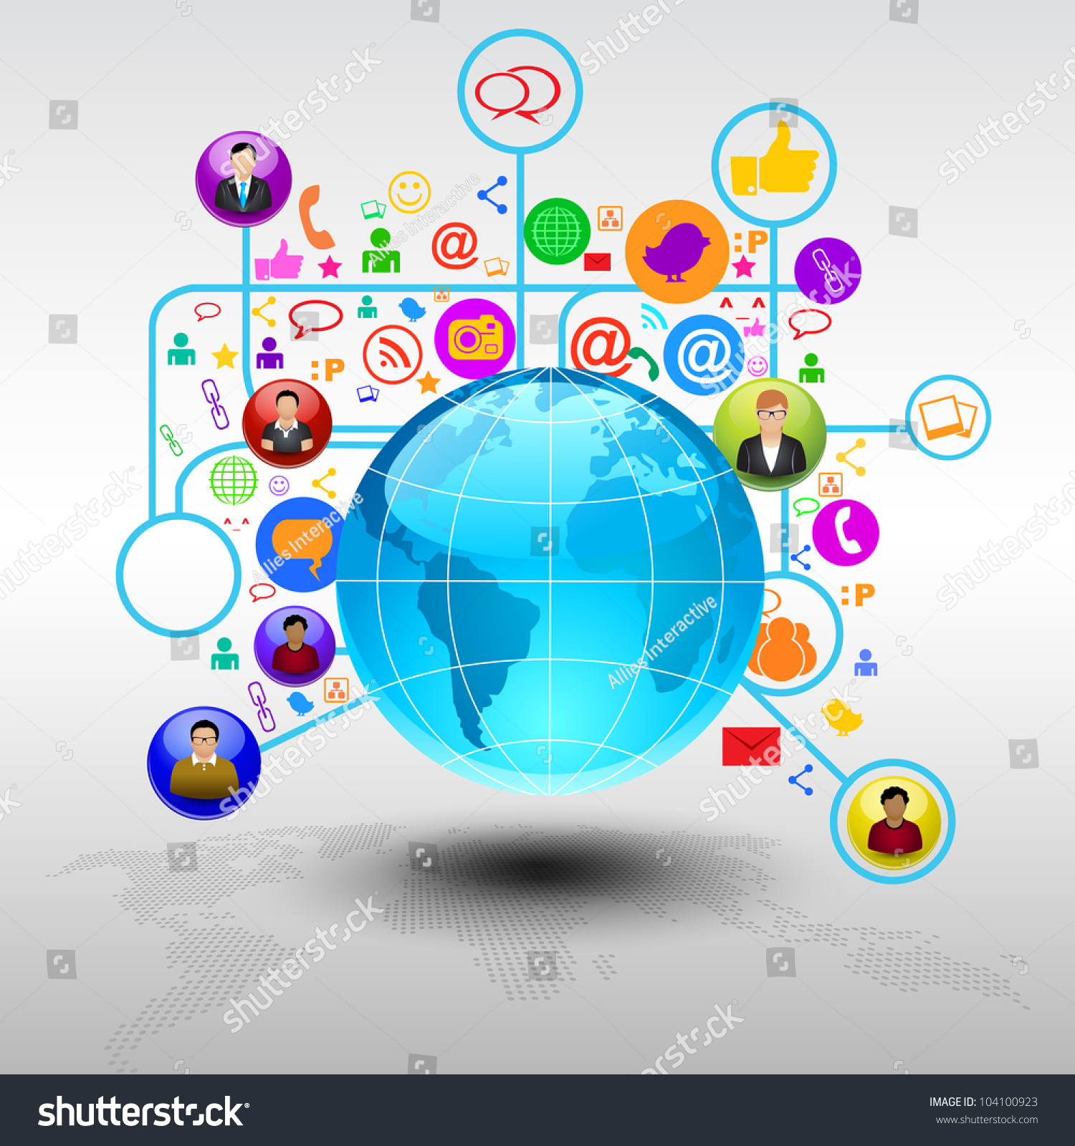  REpORT  DIGITAL SKILLS | REpORT  How social and digital media can reach a wider customer base  Academic years 2024 -2025  Tatyana Ivanova  LCLM4002 -2412523  Centre Business Skills for  the Workplace LN10XX  Lecturer: Mohammad Shaijee  Date submission: 12 December 2024

London

CONTENT

Introduce………………………………………………………………………. 2 page

1. Social media as a marketing tool………………………………….. 2

1.1.Global reach and visibility…………………………………………2
1.2. Increasing brand recognition…………………………………… 3

1.3. Updating information on the site………………………………. 3
2. Digital media as a strategic channel………………………………. 4

2.1.Identifying the target audience…………………………….…… 4

2.2.Advertising with high returns………………………………..… 4

2.3.Email Marketing………………………………………………... 4

3. Strategies to Expand Customer Reach………………………..… 5

3.1. Cross-platform campaigns……..…………………..…….…… 5

3.2. Virtual events and webinars…………………………….….…. 5

3.3. Gamification……………………………………………….….… 5

Conclusion…………………………………………………………..…………….. 6
Reference…………………………………………………………..……………….. 7

INTRODUCE
We live in a time when it is essential to use social and digital technologies to achieve wide and easy access to information. It, in turn, makes a given product visible recognisable and easy access to the customer. The possibility of visibility from anywhere in the world increases the profits of the given business. Social media such as Facebook, Twitter, Google, and LinkedIn are only a small part of the popular and recognisable sites.
The presence of attractive and active advertising, the updating of the site and its easy opening upon activation are essential for a site to be recognisable. Constant monitoring for new trends like product distribution techniques is obtained due to the competition available in the market.

1. Social media as a marketing tool

Global reach and visibility

The recognizability of the given site means that it is easily remembered, identified and associated with a certain brand, service or product by the user. This is achieved through visual recognition, clear and understandable language of the text.

1.2. Increasing brand recognition

The recognizability of the given site means that it is easily remembered, identified and associated with a certain brand, service or product by the user. This is achieved through visual recognition, clear and understandable language of the text.

1.3. Updating information on the site
By constantly adding new information, publications, promotions, or images to the site, a product's credibility is strengthened. For example, using keywords makes it easy to find a certain site. This is a sign of activity and interest in product development.
Case Study 1: Company X
Company X, an e-commerce fashion store, has successfully expanded its customer base through social media marketing. Using Instagram's visual platform, they created stunning product images and engaged with their target audience through comments and direct messages. They also collaborated with influencers in the fashion industry to reach a wider audience. As a result, their sales skyrocketed and they gained a loyal customer base.
Case Study 2: Company Y
Company Y, a software-as-a-service (SaaS) provider, uses LinkedIn's professional network to expand its customer base. It regularly shares informative articles and industry insights on its company page, positioning itself as an expert in its field. It also uses LinkedIn's targeting options to reach decision-makers in its target industries. This strategy not only increases its brand visibility but also attracts high-quality leads and new customers.

2. Digital media as a strategic channel
One of digital media's main advantages is its ability to reach a global audience. Platforms like social media, websites, and email allow businesses to connect with customers anytime, anywhere.

2.1.Identifying the target audience
By constantly adding new information, publications, promotions, or images to the site, a product's credibility and recognition are strengthened.

2.2.Advertising with high returns
Advertising is critical to success. According to marketing studies on Facebook, Twitter, and Instagram.Cleaning up promotions by polling readers for their thoughts and opinions, sharing cross-platform content, and continuously updating by addressing and fixing bugs.

2.3.Email Marketing
Emails are a proven effective channel for building personalised customer relationships. Automated campaigns can inform, offer discounts, or encourage repeat purchases. Working links and accounts are very important

3. Strategies to Expand Customer Reach
According to” Iimskills” (2024), brand recognition is achieved by reaching and engaging new and future customers, maintaining the established customer base and stakeholders, creating quality content, and developing a marketing strategy that includes the word-of-mouth method.
According to Google (2024), the key to success is to consider the quality and quantity as high when searching for a site. The site is shown higher in the search engine as proof of credibility based on the rate of opening or watching a video. In order for the site to be successful, it is necessary to carefully monitor the competing sites and observe their marketing strategy and content. Chat rooms and chatbots for customer service with constant live connection through chats.

3.1. Cross-platform campaigns
Chat rooms and chatbots for customer service with the constant live connection with customers through chats and polling readers for their thoughts and opinions, by sharing cross-platform content, and continuously updated by taking into account errors and fixing them. Constantly renewing products and periodically offering a new one, thus maintaining interest in the brand.

3.2. Virtual events and webinars
Creating high-quality, interactive content, including videos, infographics and polls, encourages consumers to interact with the brand. For example, campaigns on TikTok with challenges or on Instagram with live streams often go viral, increasing the reach

3.3. Gamification
Incorporating games, prizes or challenges into marketing campaigns drives engagement and attracts a younger audience. Also, showing an ad on viewable sites guarantees success.

CONCLUSION

Social media marketing looks promising. Businesses that embrace these changes will
One of digital media's main advantages is its ability to reach a global audience. Platforms like social media, websites, and email allow businesses to connect with customers anytime, anywhere. This accessibility ensures that organisations remain visible and recognisable.
ads published on watchable sites or blogs provide an opportunity for a quick return on investment, allowing business optimisation.
Cleaning up promotions by polling readers for their thoughts and opinions, by sharing cross-platform content, and continuously updating by addressing and fixing bugs.

REFERENCE

- Google ads help(2024)19 strategies for increasing your Audience reach and improving conversions Available at:support.google.com/google-ads/answer/2476691?hl=en-GB(accessed 10/12/24)

- Iimskills(2024)Social Media Marketing Strategies To Increase Customer Reach Available at:iimskills.com/social-media-strategies-business-growth/ ( Accessed 12/12/24)

- Jennelle McGrath(2024)Available at:marketveep.com/blog/how-to-use-social-media-marketing-to-grow-customer-base(Accessed 12/12/24)

- Sproutsocial(22/08/2024)Social media marketing: What it is and how to build your strategy Available at: URLsproutsocial.com/insights/social-media-marketing-strategy/ (Accessed 12/12/24)

