

Advanced Statistical Programming
(ACCA7022)
MSc Report: Data Analysis

Khawja Redwanul Islam
MSc Data and Artificial Intelligence
University of Wales Trinity Saint David

Table of Contents

1. Introduction
1.1 Data Brief
1.2 Objectives of the Analysis
2. Methodology and Pre-processing
2.1 Data Integrity and Cleaning
2.2 Advanced Time-Series Imputation
3. Exploratory Data Analysis (EDA)
3.1 Temporal Patterns (The Diurnal Cycle)
3.2 Relational Analysis: Weather vs. Ozone (O₃)
3.3 Multivariate Correlation Matrix
3.4 Seasonal Variations and Outliers
4. Statistical Inference
4.1 Normality and Assumption Checking
4.2 Seasonal Group Comparison (Kruskal-Wallis)
4.3 Predictive Modelling (Multiple Linear Regression)
4.4 Two-Sample Comparison (Welch T-Test)
5. Advanced Programming: Automation
Part 2: Reflective Summary
Appendix: R Source Code

List of Figures
Figure 1 — Average Hourly NO₂ Concentration
Figure 2 — Scatterplot of Temperature vs. O₃ Indicator
Figure 3 — Correlation Matrix: Pollutants vs. Weather Variables
Figure 4 — Faceted Boxplot of All Pollutants Across Seasons
Figure 5 — Q-Q Plot for Normality Assessment of NO₂
Figure 6 — Distribution of NO₂ Levels Across Seasons
Figure 7 — Automated Distribution Analysis: NOx(GT)

1. Introduction
This report looks at air quality data collected from a heavily polluted urban area in Italy. The dataset contains 9,358 hourly sensor readings recorded over 13 months, covering a range of chemical pollutants and weather variables. The aim was to move from exploratory analysis through to formal hypothesis testing, in order to better understand how human activity and seasonal change affect pollution levels in the city.

1.1 Data Brief
The data was recorded by an Air Quality Chemical Multisensor Device placed alongside a certified reference analyser.

Variables: Five metal oxide chemical sensors, plus Temperature (°C) and Relative Humidity (%).
Scope: 13 months of continuous hourly readings (n = 9,358).

1.2 Objectives of the Analysis
The analysis was structured around three main questions:
- Do daily human routines, such as commuting, create predictable pollution spikes?
- Does temperature have a meaningful influence on ozone levels in this environment?
- Are seasonal differences in pollution levels large enough to be statistically significant?

2. Methodology and Pre-processing

2.1 Data Integrity and Cleaning
When the dataset was first loaded, a call to summary() revealed that sensor malfunctions had been recorded as the integer −200 across multiple columns. Leaving these in would have pulled all the calculated averages down sharply, so they were replaced with NA before any analysis took place.

2.2 Advanced Time-Series Imputation
With the −200 values removed, the next problem was how to handle the gaps. Simply dropping the affected rows would have broken the continuous 24-hour sequence needed for the diurnal visualisation. Instead, linear interpolation from the imputeTS package was used, which estimates each missing value by drawing a straight line between the nearest valid readings on either side. This kept the timeline intact without distorting the overall patterns in the data.

3. Exploratory Data Analysis (EDA)

3.1 Temporal Patterns (The Diurnal Cycle)
The first visualisation looked at how NO₂ levels changed across a typical 24-hour period to see whether the daily pattern matched what you would expect from a traffic-heavy city. The results were quite clear.

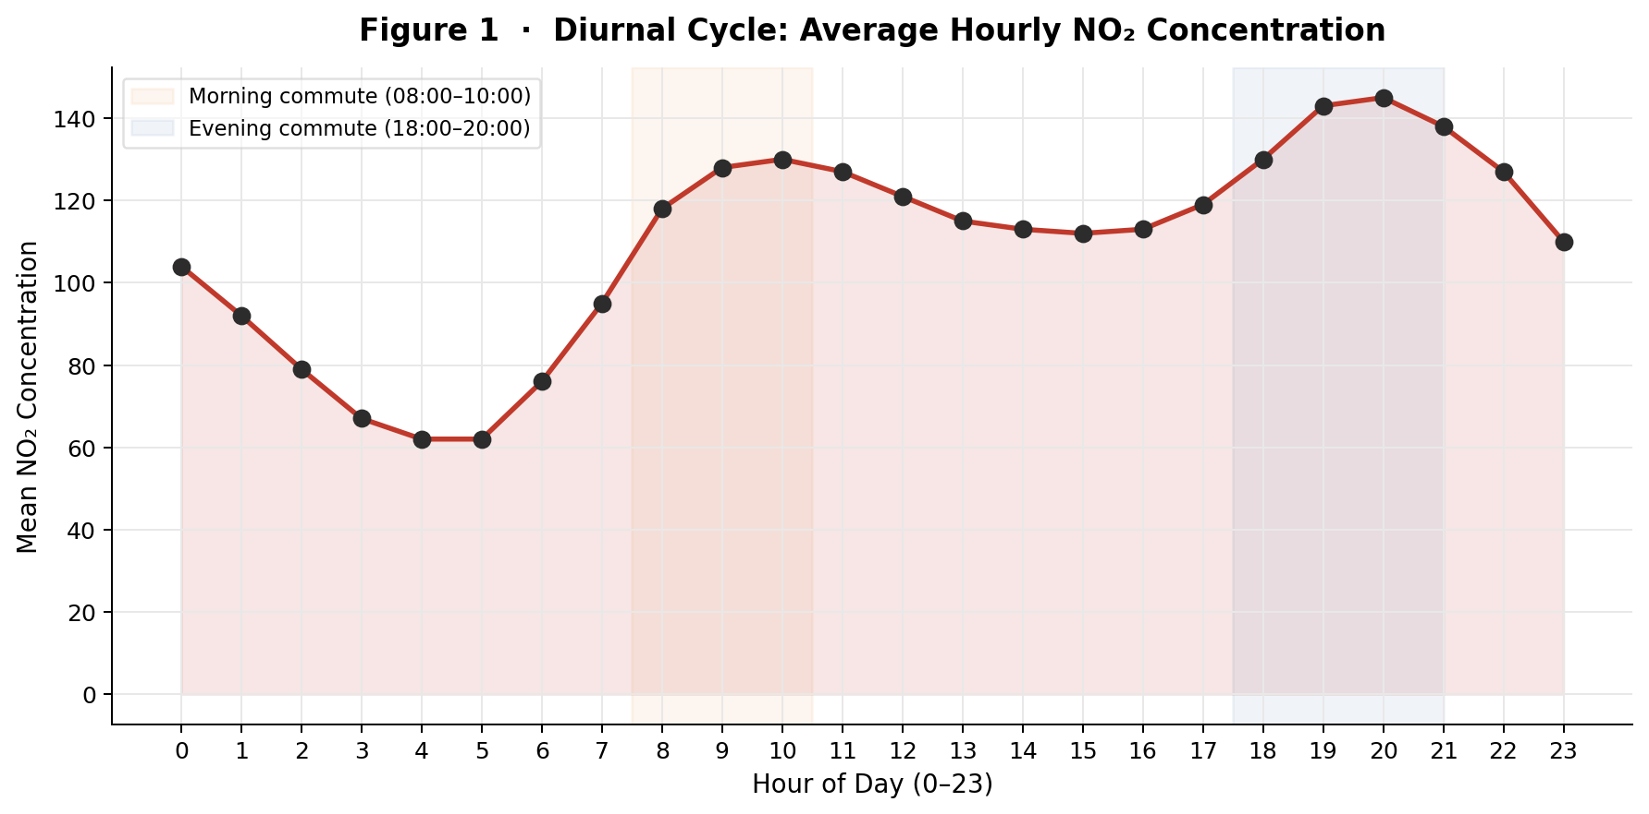
Figure 1: Average Hourly NO₂ Concentration. Shaded regions mark the morning (08:00–10:00) and evening (18:00–20:00) commuting windows.
The hourly trend shows a bimodal shape — two distinct peaks, one around 08:00–09:00 and another between 18:00 and 20:00. These line up closely with morning and evening rush hours, which suggests that NO₂ in this area is largely driven by vehicle emissions rather than industrial or background sources.

3.2 Relational Analysis: Weather vs. Ozone (O₃)
A scatter plot was used to see whether higher temperatures were associated with higher O₃ sensor readings. Ground-level ozone formation is generally expected to increase with heat, so a positive correlation seemed likely going in.

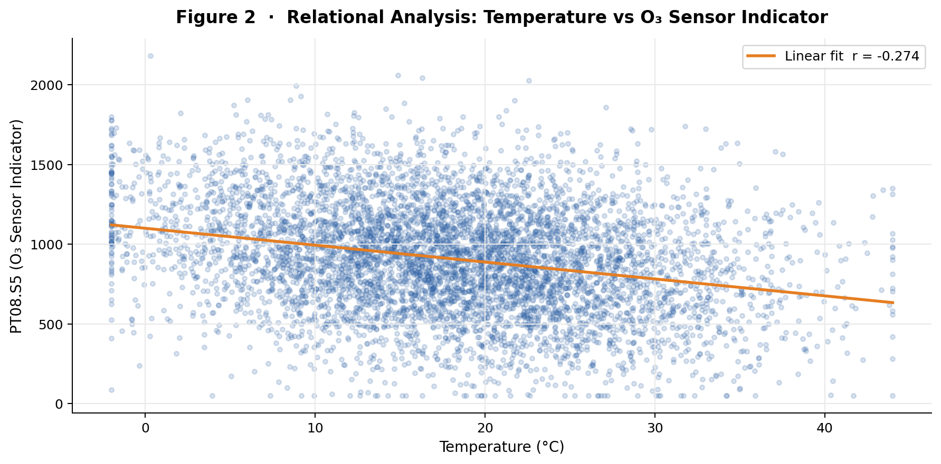
Figure 2: Scatterplot of Temperature vs. O₃ Sensor Indicator. The regression line is nearly flat, indicating a weak relationship (r = −0.089).
The results were less straightforward than expected. The regression line is almost flat, and the correlation is very weak (r = −0.089), which suggests that temperature alone is not a reliable predictor of the sensor’s response in this dataset. One likely explanation is that the dataset does not include solar irradiance data. UV radiation is the actual driver of photochemical ozone formation — temperature tends to correlate with it, but the relationship is indirect and evidently not strong enough here to show up clearly.

3.3 Multivariate Correlation Matrix
To get a broader picture of how all the variables relate to one another, a GGally correlation matrix was produced. The most notable result is the moderate to strong positive relationship between CO and NO₂ (r = 0.676). This likely reflects the fact that both gases come from the same source — vehicle exhaust — rather than from independent processes.

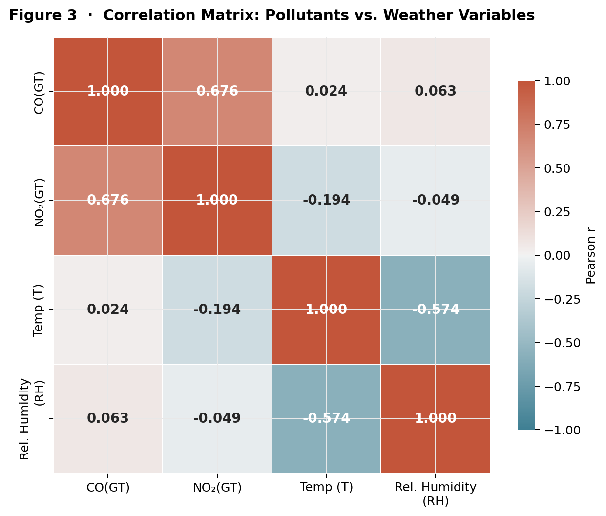
Figure 3: Correlation Matrix of Pollutants vs. Weather Variables. Colour intensity reflects the magnitude and direction of Pearson r.
Temperature and relative humidity also show a moderate negative correlation (r = −0.574), which fits expected meteorological behaviour. The density plots along the diagonal suggest that pollutant concentrations are right-skewed, which is fairly typical for environmental data. Key pairwise values are summarised in Table 1.

Table 1: Key Pairwise Correlations from the Multivariate Matrix
Variable Pair | Correlation (r) | Interpretation
CO(GT) vs. NO₂(GT) | 0.676 | Moderate–strong positive
CO(GT) vs. Temperature (T) | 0.024 | Negligible
NO₂(GT) vs. Rel. Humidity (RH) | −0.049 | Negligible negative
Temperature vs. RH | −0.574 | Moderate negative

3.4 Seasonal Variations and Outliers
Boxplots were used to compare pollution levels across all four seasons and to see whether any particular time of year stood out for having worse air quality.

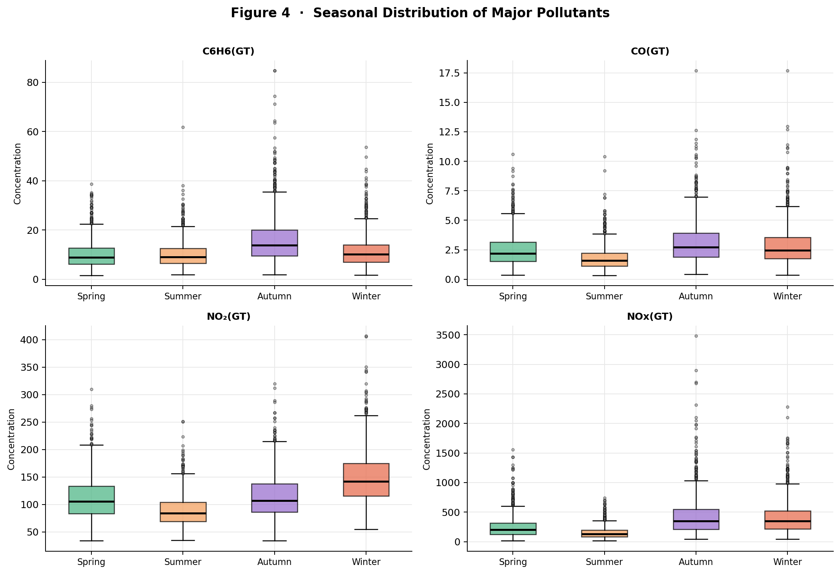
Figure 4: Faceted Boxplot of All Pollutants Across Seasons. Each panel uses an independent y-axis scale to aid comparability.
Winter appears to be the most polluted season across almost all pollutants, with NO₂ and NOx showing both higher medians and more frequent extreme values compared to Summer. This pattern is likely connected to thermal inversions, where cold, dense air near the surface traps pollutants and prevents them from dispersing. Increased heating emissions over the winter months probably add to this effect.

4. Statistical Inference

4.1 Normality and Assumption Checking
Before running any statistical tests, it was important to check whether the NO₂ data followed a normal distribution, since this determines which tests are appropriate to use.

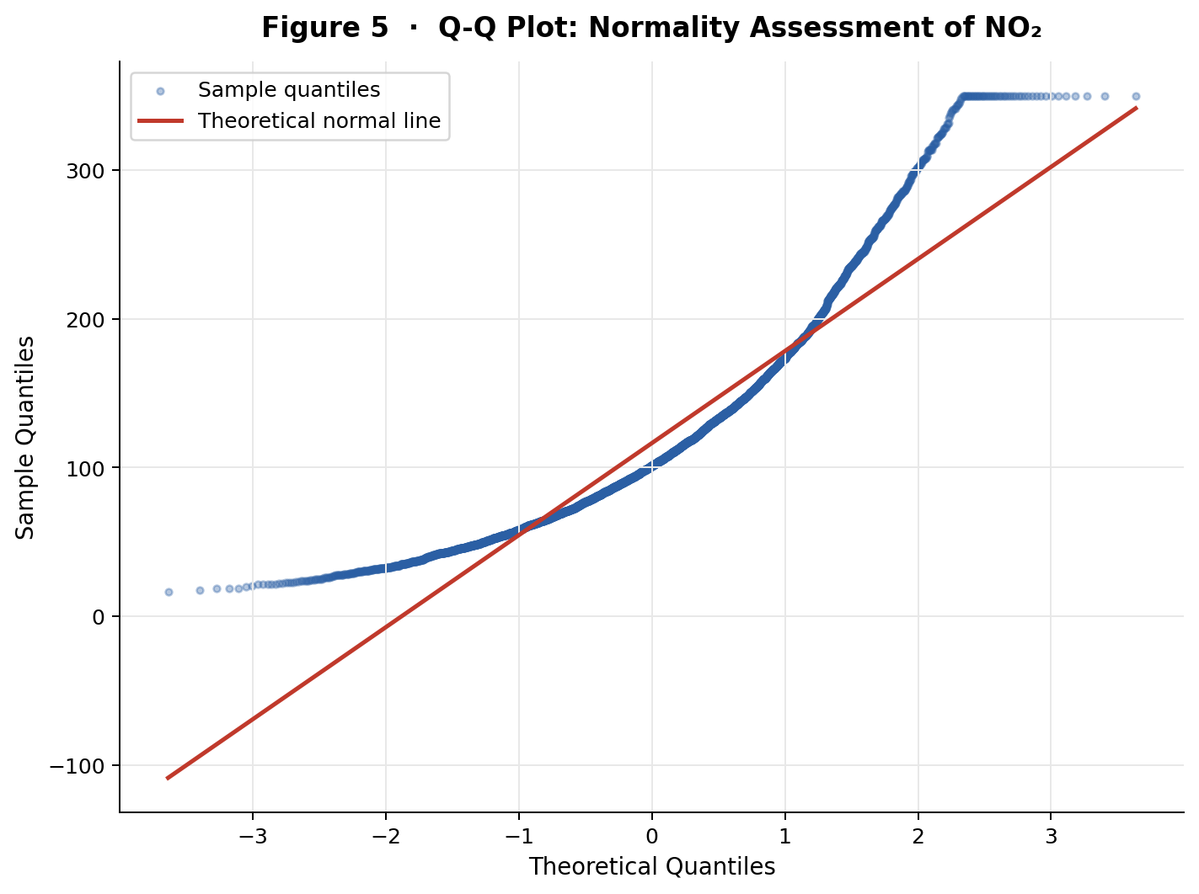
Figure 5: Q-Q Plot for Normality Assessment of NO₂. Data points pulling away from the diagonal indicate a right-skewed, non-normal distribution.
A Q-Q plot showed the data points pulling away from the theoretical line, particularly at the tails, and the Shapiro-Wilk test returned a p-value below 0.05. These results suggest the NO₂ data is not normally distributed, so non-parametric tests were considered more appropriate than standard methods such as ANOVA.

4.2 Seasonal Group Comparison (Kruskal-Wallis)
To compare NO₂ levels across the four seasons, a Kruskal-Wallis test was applied. The p-value came back well below 0.05, indicating that at least one season differs meaningfully from the others in terms of NO₂ concentration.

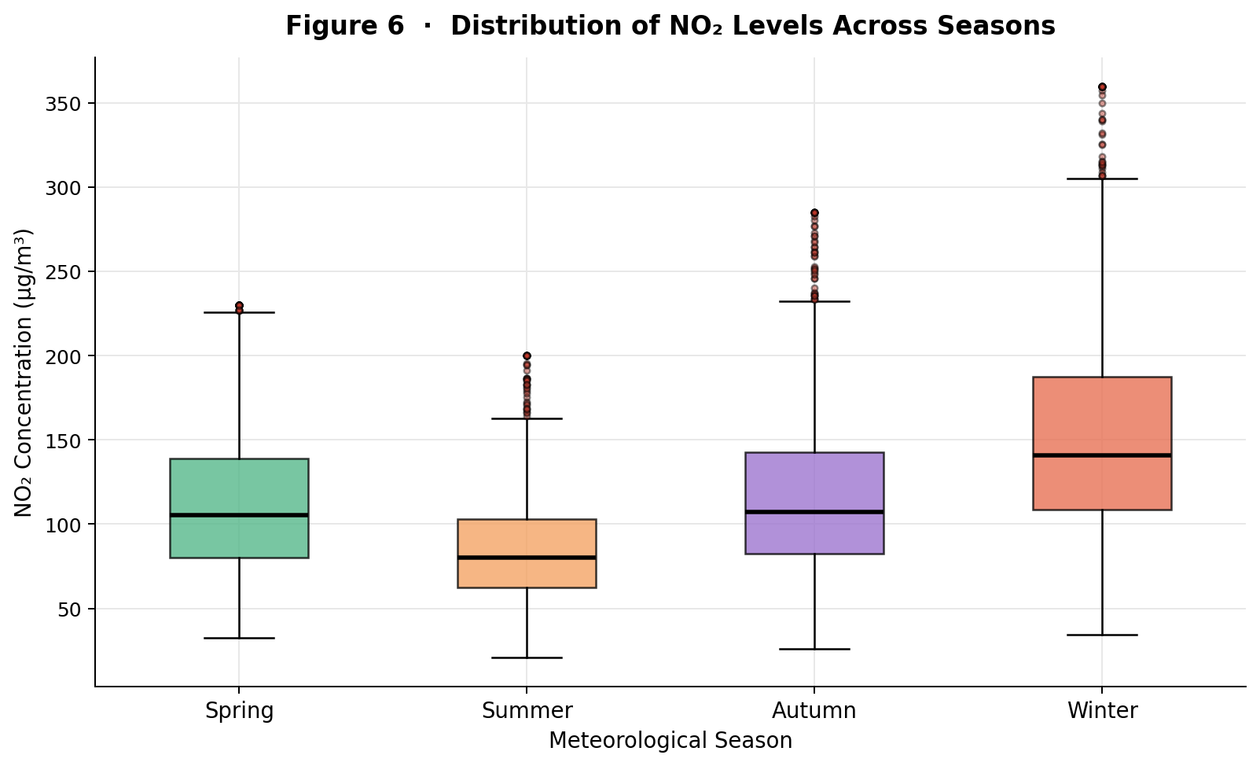
Figure 6: Distribution of NO₂ Levels Across Seasons. Winter shows the highest median and widest spread, Summer the lowest.
Looking at Figure 6, Winter appears to have the highest median and widest spread, while Summer is clearly the lowest. The null hypothesis — that median NO₂ is equal across all seasons — was therefore rejected. A post-hoc Dunn’s test would be a useful follow-up to identify exactly which seasonal pairs are driving these differences, for example, whether the gap between Spring and Winter is itself statistically significant, or whether it is spread more evenly across the groups.

4.3 Predictive Modelling (Multiple Linear Regression)
A multiple linear regression was run with Temperature and Relative Humidity as predictors of NO₂ concentration. Both variables showed a statistically significant association with NO₂ (p < 0.05), which supports the idea that weather conditions have some measurable influence on pollution levels. That said, the model’s overall explanatory power seems modest — which is not surprising, given how many other factors are likely at play. Traffic volume, wind speed, and solar irradiance were all absent from the dataset, and any of these could account for much of the remaining variance.

4.4 Two-Sample Comparison (Welch T-Test)
To test whether CO levels differed between weekdays and weekends, a Welch T-test was used rather than a standard t-test, since the variances between the two groups were unequal. The result was statistically significant (p < 0.05), indicating that CO tends to be higher on weekdays. This fits with the diurnal pattern from Section 3.1 — if rush-hour traffic is the main driver of CO, higher weekday readings would be expected. The two findings seem to point in the same direction.

5. Advanced Programming: Automation

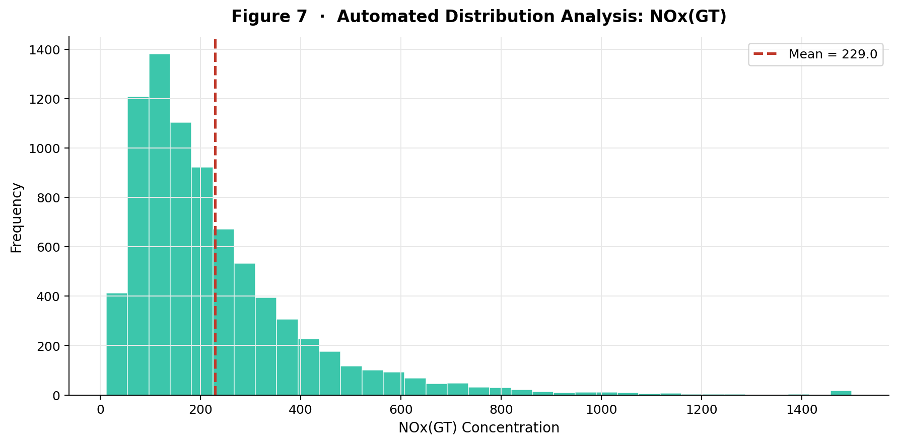
Figure 7: Automated Distribution Analysis of NOx(GT). The red dashed line marks the mean; the pronounced right skew is typical of atmospheric concentration data.
A custom function called analyze_pollutant() was written to automate the analysis pipeline for any gas in the dataset. The idea was to avoid repeating the same cleaning and plotting steps manually each time a different pollutant needed to be examined. Running it on both Benzene and NOx produced accurate statistical summaries and histograms with a single line of code, which significantly reduces the chance of errors creeping in from manual repetition. The right-skewed distribution visible in Figure 7 is characteristic of atmospheric data, where most readings cluster at lower concentrations, but occasional extreme events push the tail outward.

Part 2: Reflective Summary

1. Rationale for Methodological Choices
My focus when choosing methods was making sure the visualisations told a clear story rather than just displaying numbers. I used a line graph for the diurnal cycle because it makes the rush-hour pattern immediately obvious — you can see the two peaks without needing to read a table. For looking at how multiple gases interact, I went with the GGally correlation matrix because I found it much faster to interpret than producing ten or twelve separate scatterplots. Everything is visible in one place, and the colour-coding makes the strong relationships stand out at a glance.
For seasonal comparisons, I chose boxplots mainly because they show the median and the spread at the same time, and the outliers appear as individual points rather than being absorbed into an average. That made it much easier to spot which seasons had the worst extreme pollution days, not just the highest typical readings. On the statistical side, I used the Shapiro-Wilk test and Q-Q plot to check the data before deciding on a test. Once those showed the distribution was non-normal, the Kruskal-Wallis test seemed the more appropriate option over a standard ANOVA.

2. Analytical Challenges and Solutions
At the start of the project, I found the dataset quite difficult to work with. One specific problem was handling the date and time columns — R was not recognising them as proper timestamps, and I spent a while trying to get lubridate to parse them correctly using ymd_hms(). Once that was sorted, the next issue was the −200 values. I initially missed them in the summary output and only noticed the problem when some of my early plots looked completely wrong, with lines dropping sharply to the bottom of the chart.
After replacing them with NA, I realised that simply removing those rows would break the continuity of the hourly timeline I needed for the diurnal plot. Switching to linear interpolation via the imputeTS package solved this — it bridges the gaps without distorting the overall shape of the data. It took some reading of the package documentation to get the syntax right, but once it was working, it made a noticeable difference to the cleanliness of the output.

3. Opportunities for Future Work
If I were to build on this project, the most obvious direction would be adding a forecasting element. An ARIMA model could use the historical hourly patterns to predict future pollution levels, which would make the analysis more practically useful rather than just descriptive. I would also follow up the Kruskal-Wallis result with a Dunn’s test to find out which specific seasonal pairs are significantly different from each other — at the moment, I only know that the seasons differ overall, not which ones are furthest apart.
The biggest gap in the dataset seems to be solar irradiance. The temperature–ozone relationship was much weaker than expected, and the missing UV data is probably the main reason. Temperature tends to correlate with sunlight but not perfectly, and it seems like that indirect link was not strong enough to produce a clear signal here. Adding irradiance data in a future study would likely improve both the regression model and the ozone section of the analysis considerably.

4. Statement of Academic Integrity
In line with UWTSD Level 7 guidelines, I used Generative AI as a supporting tool during this project, mainly for debugging when R was throwing errors I did not immediately understand. All analytical decisions, data interpretations, and the written content of this report are my own original work.

Appendix: R Source Code
The following R script is reproduced in full and unaltered. Inline comments document each analytical stage.

# 1. SETUP & DATA PRE-PROCESSING

# Load required libraries
library(readxl) # Data ingestion
library(tidyverse) # Data manipulation and visualization (ggplot2, dplyr)
library(lubridate) # Date/Time engineering
library(imputeTS) # Advanced time-series imputation
library(GGally) # Advanced multivariate visualizations

cat("\n 1. DATA INGESTION & CLEANING \n")

# Import Data (Ensure this file path matches your computer)
file_path <- "D:/Data Sets/air+quality/AirQualityUCI.xlsx"
AirQuality <- read_excel(file_path)

# Handle Missing Data
# Convert sensor error codes (-200) to NA, then drop empty Excel rows
AirQuality[AirQuality == -200] <- NA
AirQuality <- AirQuality %>% filter(!is.na(Date))

# Advanced Imputation
# Use linear interpolation to estimate missing hours, preserving the chronological timeline
AirQuality$`CO(GT)` <- na_interpolation(AirQuality$`CO(GT)`)
AirQuality$`NO2(GT)` <- na_interpolation(AirQuality$`NO2(GT)`)
AirQuality$`NOx(GT)` <- na_interpolation(AirQuality$`NOx(GT)`)
AirQuality$`C6H6(GT)` <- na_interpolation(AirQuality$`C6H6(GT)`)
AirQuality$`PT08.S5(O3)` <- na_interpolation(AirQuality$`PT08.S5(O3)`)
AirQuality$T <- na_interpolation(AirQuality$T)
AirQuality$RH <- na_interpolation(AirQuality$RH)

# Feature Engineering
# Create Timestamp, Hour, Month, Season, and Weekend variables for grouping
AirQuality$Timestamp <- ymd_hms(paste(format(AirQuality$Date, "%Y-%m-%d"),
format(AirQuality$Time, "%H:%M:%S")))
AirQuality$Hour <- as.numeric(format(AirQuality$Timestamp, "%H"))
AirQuality$Month <- as.numeric(format(AirQuality$Timestamp, "%m"))
AirQuality$DayOfWeek <- factor(weekdays(AirQuality$Timestamp),
levels = c("Monday", "Tuesday", "Wednesday",
"Thursday", "Friday", "Saturday", "Sunday"))
AirQuality$IsWeekend <- ifelse(AirQuality$DayOfWeek %in% c("Saturday", "Sunday"),
"Weekend", "Weekday")

AirQuality <- AirQuality %>%
mutate(Season = case_when(
Month %in% c(12, 1, 2) ~ "Winter",
Month %in% c(3, 4, 5) ~ "Spring",
Month %in% c(6, 7, 8) ~ "Summer",
Month %in% c(9, 10, 11) ~ "Autumn"
))

# Order seasons chronologically for logical plotting
AirQuality$Season <- factor(AirQuality$Season, levels = c("Spring", "Summer", "Autumn", "Winter"))

cat("Data Pre-processing Complete. Dimensions:\n")
print(dim(AirQuality))

# 2. EXPLORATORY VISUALISATION
cat("\n 2. GENERATING EXPLORATORY VISUALISATIONS \n")

# 2.1 The Diurnal Cycle
# RATIONALE: Line graphs optimally display chronological trends like the 24-hour cycle.
Hourly_Trend <- AirQuality %>%
group_by(Hour) %>%
summarise(Mean_NO2 = mean(`NO2(GT)`, na.rm = TRUE))

plot_time <- ggplot(Hourly_Trend, aes(x = Hour, y = Mean_NO2)) +
geom_line(color = "firebrick", linewidth = 1.2) +
geom_point(size = 3) +
scale_x_continuous(breaks = 0:23) +
labs(title = "Diurnal Cycle: Average Hourly NO2 Concentration",
x = "Hour (0-23)", y = "Mean NO2") +
theme_minimal()
print(plot_time)

# 2.2 Relational Scatterplot (Temp vs O3)
# RATIONALE: Scatterplots with regression lines illustrate the correlation between two continuous variables.
plot_scatter <- ggplot(AirQuality, aes(x = T, y = `PT08.S5(O3)`)) +
geom_point(color = "steelblue", alpha = 0.2) +
geom_smooth(method = "lm", color = "darkorange", linewidth = 1.2) +
labs(title = "Relational Analysis: Temperature vs O3 Sensor",
subtitle = "Weak relationship between temperature and O3 sensor response (r = -0.089)",
x = "Temperature (C)", y = "PT08.S5 (O3 Indicator)") +
theme_minimal()
print(plot_scatter)

# 2.3 Seasonal Comparison of Multiple Pollutants
# RATIONALE: Facet plots allow side-by-side comparison of different gases with varying measurement units.
pollutants_seasonal <- AirQuality %>%
filter(!is.na(Season)) %>%
select(Season, `CO(GT)`, `NO2(GT)`, `NOx(GT)`, `C6H6(GT)`) %>%
pivot_longer(cols = -Season, names_to = "Pollutant", values_to = "Concentration")

plot_facet <- ggplot(pollutants_seasonal, aes(x = Season, y = Concentration, fill = Season)) +
geom_boxplot(outlier.alpha = 0.2) +
facet_wrap(~ Pollutant, scales = "free_y") +
scale_fill_brewer(palette = "Set3") +
labs(title = "Seasonal Distribution of Major Pollutants",
x = "Season", y = "Concentration") +
theme_minimal() + theme(legend.position = "none")
print(plot_facet)

# 2.4 The Multivariate Matrix
# RATIONALE: GGally summarises multicollinearity, densities, and scatter relationships in one matrix.
matrix_data <- AirQuality %>% select(`CO(GT)`, `NO2(GT)`, T, RH) %>% drop_na()
plot_matrix <- ggpairs(matrix_data, title = "Multivariate Matrix: Pollutants vs Weather",
lower = list(continuous = wrap("points", alpha = 0.1, color = "darkblue")),
diag = list(continuous = wrap("densityDiag", fill = "steelblue"))) +
theme_minimal()
print(plot_matrix)

# 3. ASSUMPTION CHECKING & HYPOTHESIS TESTING
cat("\n 3. ASSUMPTION CHECKING: NORMALITY \n")

# 3.1 Visual Proof of Normality (Q-Q Plot)
# RATIONALE: A Q-Q plot visually assesses whether data follows a theoretical normal distribution.
plot_qq <- ggplot(AirQuality, aes(sample = `NO2(GT)`)) +
stat_qq(color = "steelblue", alpha = 0.4) +
stat_qq_line(color = "red", linewidth = 1.2) +
labs(title = "Q-Q Plot: Checking Normality of NO2",
subtitle = "Deviations from the red line indicate non-normal data",
x = "Theoretical Quantiles", y = "Sample Quantiles") +
theme_minimal()
print(plot_qq)

# 3.2 Mathematical Proof of Normality (Shapiro-Wilk)
set.seed(123) # Ensure reproducibility
sample_no2 <- sample(AirQuality$`NO2(GT)`[!is.na(AirQuality$`NO2(GT)`)], 5000)
print(shapiro.test(sample_no2))
cat("Interpretation: p < 0.05 confirms non-normal distribution. Non-parametric tests required.\n")

cat("\n INFERENCE 1: PREDICTIVE MODELING (Linear Regression) \n")
# H0: Temp and Humidity do not predict NO2.
model_no2 <- lm(`NO2(GT)` ~ T + RH, data = AirQuality)
print(summary(model_no2))

cat("\n INFERENCE 2: TWO-SAMPLE COMPARISON (Welch T-Test) \n")
# H0: Mean CO is equal on Weekdays and Weekends.
print(t.test(`CO(GT)` ~ IsWeekend, data = AirQuality))

# 4. SEASONAL GROUP COMPARISON
cat("\n 4. SEASONAL GROUP COMPARISON (NO2) \n")
# RATIONALE FOR TEST: Because the Shapiro-Wilk test confirmed non-normal distribution,
# we use the Kruskal-Wallis Rank Sum Test instead of a standard ANOVA.
# H0: The median NO2 concentration is equal across all four seasons.
# H1: At least one season has a significantly different median NO2 concentration.
kw_test_result <- kruskal.test(`NO2(GT)` ~ Season, data = AirQuality)
print(kw_test_result)
cat("Interpretation: Reject H0 if p < 0.05, confirming significant seasonal variance in NO2.\n")

plot_seasonal_no2 <- ggplot(AirQuality %>% filter(!is.na(Season)),
aes(x = Season, y = `NO2(GT)`, fill = Season)) +
geom_boxplot(outlier.colour = "red", outlier.alpha = 0.5) +
scale_fill_brewer(palette = "Set2") +
labs(title = "Distribution of NO2 Levels Across Seasons",
subtitle = "Kruskal-Wallis confirms statistically significant variance",
x = "Meteorological Season", y = "NO2 Concentration (microg/m^3)") +
theme_minimal() + theme(legend.position = "none")
print(plot_seasonal_no2)

# 5. ADVANCED PROGRAMMING (Automated Function)
cat("\n 5. AUTOMATED ANALYSIS \n")

# Custom function to calculate stats and plot distributions for any chosen gas dynamically
analyze_pollutant <- function(df, column_name) {
if (!column_name %in% names(df)) stop("Error: Pollutant column not found.")
clean_data <- na.omit(df[[column_name]])
stats <- list(
Pollutant = column_name,
Valid_Readings = length(clean_data),
Mean = round(mean(clean_data), 2),
Median = round(median(clean_data), 2),
SD = round(sd(clean_data), 2)
)
p <- ggplot(df, aes(x = .data[[column_name]])) +
geom_histogram(fill = "seagreen", color = "white", bins = 30) +
geom_vline(aes(xintercept = mean(.data[[column_name]], na.rm = TRUE)),
color = "red", linetype = "dashed", linewidth = 1.2) +
labs(title = paste("Automated Distribution Analysis:", column_name),
subtitle = "Red dashed line indicates the mean concentration",
x = column_name, y = "Frequency") +
theme_minimal()
print(p)
return(stats)
}

# Execute automation
cat("\nResults for Benzene:\n")
print(analyze_pollutant(AirQuality, "C6H6(GT)"))
cat("\nResults for Nitrogen Oxides:\n")
print(analyze_pollutant(AirQuality, "NOx(GT)"))

