Load Transfer Prediction and Validation
University of Wales Trinity Saint David
School of Engineering
Leighton Coughlin (1802971)
Bsc Automotive Engineering
Emissions Control & Diagnosis – M5X02202

Contents Page
Title Page ………………………………………………………………………………………………. Page 1
Contents Page ………………………………………………………………………………..….. Page 2-3
List of figures ………………………………………………………………..………………………. Page 3
1. Introduction ………………………………………………..…………..……………………….. Page 4
2. Research …………………………………………………….….……………..………………….. Page 5
3. Methodology ……………………………………………………………………………….. Page 6-10
4. Results …………………………………………………………………..…………………….….. Page 11
5. Conclusion ……………………………………………………………………..….…………….. Page 22
6. References …………………………………………………………………….…..…….. Page 23-24

1. Introduction
In this assignment load splits found will be calculated and then compared with real track data and data obtained through simulation. The track data will be provided whilst the simulation data will be taken by a working group with analysis being done individually. The corner weights and ride heights will also be taken in the workshop in order to calculate the roll centre heights.

Once complete data will be given which is then required to be entered in to Motec. Once the data has been loaded maths channels are to be developed to calculate load splits. Then a point at which the vehicle is in steady state will be selected and compared between measured and calculated. Throughout the validity of the calculated will be compared with the measured data as well as the reliability of the measured data.

2. Methodology

2.1. Safe Working Practises
In order to obtain some insight into how the vehicle operates the vehicle corner weights were taken. In order to ensure safe working practises when working on the vehicle it is very important to follow the correct guidelines for the environment your in. The HSE or health and safety executive (HSE, 2009) express that, steel toe cap boots to protect your feet and overalls to protect your skin and clothes must be worn before entering the workshop. It is also very important to use protective eyewear to protect the eyes from any liquids or dust that may be encountered in the automotive workshop environment. Any loose accessories must also be removed such as jewellery, ties and watches to prevent them from being either snagged or coming off during testing. The HSE also state that protective gloves can be used to stop the effects of dermatitis as well as hard hats to prevent damage from falling objects when working under a vehicle. Pictured below is an example of the correct PPE to be worn.
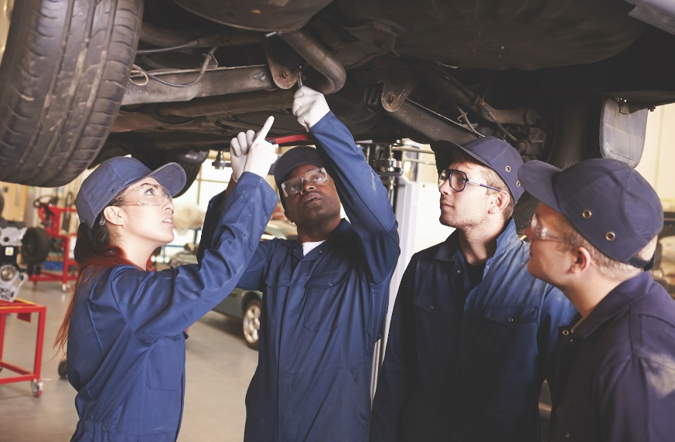

Figure 1

In the UK there is many health and safety laws which employers must adhere to. Regulations such as the workplace regulations (The Workplace, health, safety and welfare regulations, 1992) advises businesses to provide employees which adequate facilities in the works place. These facilities include but are not limited to toilets, washing stations and a canteen to eat and rest. The regulations also state that at an employee’s workstation, the area must be safe, hygienic and well ventilated to ensure the safety of the employee.

3. Results

4. Analysis

5. Evaluation

6. Conclusion

7. References
HSE, (2009). ‘’Health and safety in motor vehicle repair and associated industries’’
Available at: https://www.hse.gov.uk/pubns/priced/hsg261.pdf
Accessed 2nd May. (2020)

The Workplace, Health, Safety and Welfare Regulations (1992)
Available at: http://www.legislation.gov.uk/uksi/1992/3004/contents/made
Accessed 2nd May. (2020)

