Student name: Ruxandra Laczko 2107521
Module title: Management & Organisational Behaviour
Module code: BMIH5004
Lecturer name: Robyn Griffiths
Title: Intercontinental Hotels Group (IHG).

Table of content:
Executive summary: p 3
The IHG hotel Organisation structure: p 5
Culture: p 6
Suggestion; p 9
Reference: p 10

Executive summary:
The IHG hotel group, with 6170 hotels worldwide, aims to provide "true hospitality for good" by prioritizing guest and employee care, sustainable practices, and a strong governing body. The group prioritizes people, community, and the environment, with a focus on sustainable development and culture. In 2020, the group prioritized wellbeing and reduced costs to protect the business. The governance structure includes CEOs, Executive Committees, and senior leaders, delivering strategic plans with sustainable values.
As of December 31, 2022, the organization's employee structure includes 13 directors, 10 executive committees, 59 executive committee direct reports, 98 senior managers, and 12,899 employees. Centralised and decentralised structures have advantages and disadvantages, such as time-consuming implementation and employee behaviour. Effective management strategies are crucial for a successful organisation. Modern technology and information and communication technologies are enabling firms to adapt quickly to market changes, providing flexibility and competitive advantages.
The hotel group is committed to gender balance and promoting inclusivity in leadership positions. They prioritize wellbeing and human rights, but research suggests that social investment can be sustainable. The hotel group aims to develop opportunities for women in leadership positions, as female gender is less prevalent in the tourism industry. The IHG organization's culture can be categorized as task-oriented, value-driven, or a mix of both. Factors such as history, firm function, size, and location influence the development of organizational culture, including decision-making, leadership style, communication, structure, and reward systems.
Mullins (2019) suggests that an organization's success depends on its people's satisfaction with a shared goal. Factors affecting organizational behaviour include individuals' compatibility, social needs, planned structure, leadership style, and environmental impact. Cultural diversity is a common issue, requiring more leadership, mutual trust, and equal treatment. Global organizational culture can be influenced by nation culture, and efficient general management is crucial for understanding key jobs, customer needs, trends, and relation issues. Organizational culture that promotes social services implementation can lead to positive social outcomes.
Research reveals that cultural beliefs in the workplace are learned from experienced employees and can be influenced by nation culture. In today's complex business strategies, efficient general management is crucial for understanding key jobs, customer needs, trends, and relation issues. Organizational culture that promotes social services can have positive social outcomes. Hotels should consider business objectives and choose the best structure for optimal performance. Forces for change include globalization, technological innovation, social media, competitors, customer demands, government policies, and green technology. Hotels and tourism depend on natural resources, and global environmental change motivates companies to reduce emissions and optimize green energy use.
IHG aims for responsible travel, preserving natural resources, promoting diversity, and reducing energy and carbon emissions. Marriott International and Hilton share similar values, emphasizing service and product as key factors in profitability. Online services, smartphones, and social networking have significantly impacted hotels, providing a competitive advantage by introducing new technology and innovations, enhancing efficiency, service quality, and cost reduction.

About the Intercontinental Hotel Groups known as IHG.
The hotel group have various brands across the globe and 6170 hotels opened are globally present (ihgplc.com, 2023).
This report should outline the organisation structure, culture and goals, with recent changes and improvements, factors that had impact on change and how well they were managed, including the business performance and the strategic direction within the hospitality sector.
The IHG hotel group state that their purpose means to provide a “true hospitality for good” (ihgplc.com, 2023). The group business approach states the care for guests and employees, while applying a sustainable practice for the environment and community. It states the culture as a strong governing body, including clear policies with a straightforward business plan. Describing their priorities as care for the people, community and earth. Emphasising on future goals as sustainable development and culture. According to the intercontinental hotels group business update made in 2020 when covid 19 impacted globally the organisation with closures in hotels and travel restrictions, the group prioritised the wellbeing of people and had a strategic plan to reduce cost to protect the business (InterContinental Hotels Group PLC, 2020).
The hotel groups governance structure is made up of top as CEO, Executive Committee, senior leaders and their objectives to deliver strategic plans with sustainable values.
As of 31 December 2022, the organisation employee structure:
Total Directors: 13
Executive Committee: 10
Executive Committee direct reports: 59
Senior managers: 98
All employees: 12,899. (ihg.com, 2023)
Centralised organisation structure is described to have a general control and decisions are made by one person; the disadvantage can be the process of implementing the decisions might be time consuming. While the decentralised organisation structure can benefit the faster reaction to decisions, however the concept only will not affect the employee behaviour, thus effective management strategies need to be in place (Brooks, 2018). IHG organisation structure can be apply the decentralisation structure, thus in hotels managers can make direct decisions when needed. According to Brooks (p.235, 2018) organisational structure are influenced by the size of the organisation, strategy, new technologies, thirst for power within management, the nature of the profession, and national culture. The increase of modern technology and new information and communication technologies affecting direct on the organisation structure, is “enabling firms to adapt rapidly to market changes”. The modern communication technology can give flexibility to businesses and gives competitive advantages, hotels are adapting to changes.

The hotel group stating to take commitment on gender balance throughout leadership position, using a culture of inclusion between employees, owners and suppliers, prioritising the wellbeing and promoting human rights. However, research (Husted and Allen, 2011) argues that firms that perform social investment can be a sustainable choice, but companies may imitate the strategy thus to be effective it may need to be competitive environment. The hotel group also recognise the gender diversity and trying to develop and give opportunities to women in leadership position. According to research (Tran, 2015) the tourism industry the female gender is less than man in a leading position.

Culture
The IHG organisation culture could be categorised into a task culture means it is job oriented, seeking to bring together the correct resource including the people with, and utilises the groups strength to unite, however some complex organisations might have conflicting subcultures where the employee distinct itself from the main culture (Mullin,2019). It can also be a culture that brings values into people's life, emphasising on wellbeing, traditions, hotels as a mix organisation should adapt a culture and value strategy to be successful. According to Mullins (2019) the organisational culture development is influenced by factors such as history, the function of the firm, size and location. Also, national culture can affect the organisation cultural system, such as decision making, leadership style, communication, structure and reward system (Jolita Vveinhardt, 2018).
According to Mullins (2019) an organisation does not have a goal, but people do, when they have the same goal, it can be measured by how satisfied they are and that may lead to a successful organisation. The organisation behaviour can be affected by different factors such as: individuals' compatibility and satisfaction, the existing group that have social needs, organisation that have a planned structure and leadership style to manage the process, environmental impact which implies external factors such as economic, technological and cultural influences.
Mullins (pg.311, 2019) describes cultural diversity as a common fact which will increase, and require more leadership style, mutual trust, equal treatment to manage.
Research explains the cultural beliefs in a workplace to be learned from one experienced employee to another which shares the beliefs of how the job should be done, globally organisational culture can be influenced by the nation culture (Wood. 2013). At present days major hotels complex business strategies require efficient general management to understand the key jobs, the customer's needs, new trends and relation issues (Rutherford, D.G. and O’Fallon, M.J. 2007). Studies have shown that organisation culture that are promoting the implementation of social services and help managers to practice can have social outcomes (Ramish, Aslam and Liaquat, 2021).
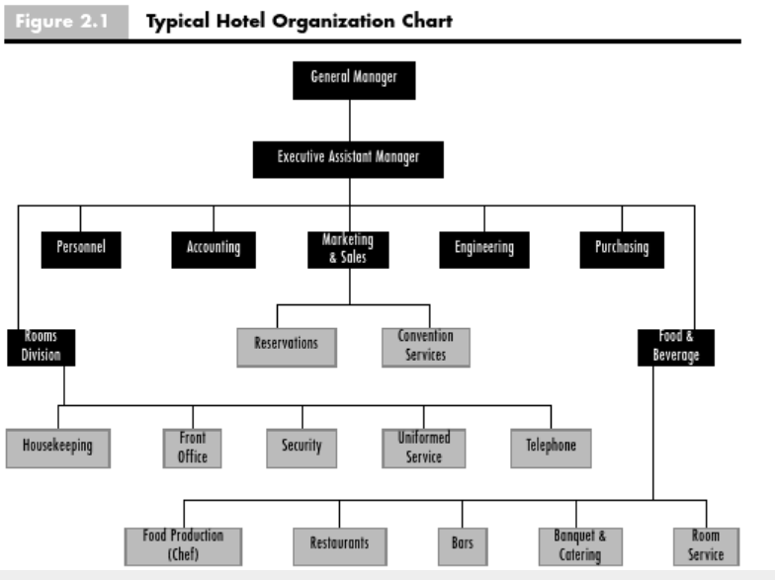
This figure represents a typical hotel organisation structure, and Rutherford, D.G. and O’Fallon, M.J. (2007) describes the basic divisions in a hotel organisation as to deliver food and sell rooms for the guest.

According to research (Tavitiyaman, Hanqin Qiu Zhang and Qu, 2012) hotels should consider business objectives and choose the best structure for optimal performance. Forces for change can be globalisation, technological innovation, and social media, competitors, customers' demands, government policies, green technology, structure may be changed if the organisation need to be more efficient, and culture as one factor with management system also can affect the company's performance (Brooks, 2018).
Hotels and tourism are dependent on natural resources such as landscape, water irrigation of hotel, global environmental change motivate companies to implement commitment goals to reduce emissions and optimise the use of green energy (Gössling, S. and Hall, M.C. 2006).
IHG aims to achieve responsible travel, helping communities, future generations to preserve natural resources, promote diversity, with a culture of inclusion, while working to reduce the use of energy and carbon emissions to protect the planet (ihg.com, 2023). However, there are other international organisation that promote a similar concept of culture and sustainability plan. Example: Marriott international, having a diversity and inclusion culture with sustainable goals for the future (Marriott International, 2022). Hilton hotels are sharing similar vision and culture (Hilton,2022). Martin (2019) suggests that in hotels the service and the product is the essence of making profit, customers tend to return if they are happy with the service, it is essential to maintain and improve the premises, marketing brings benefits when delivering accurate information of the accommodation. According to Cunill (2006) a brand prestige is a crucial element in hotel chain globalisation, therefore brand loyalty is important.

Suggestions:
The use of the online service such as online reservations, with smartphones, apps, including the social networking had a significant impact on hotels, with the service processing it can be competitive advantage to bring new technology and innovations into the hotel, it can attribute to the efficient operation, service quality and reducing cost (Chiang, Chen and Hsu, 2019).

Reference:

‌
‌

Asher Ramish, Haris Aslam and Sabtain Liaquat (2021) ‘Impact of Manager’s Social Commitment on Organization’s Social Performance Influenced by Socially Sustainable Supply Chain Practices and Sustainability Culture’, Indonesian journal of sustainability accounting and management (Online), 5(1), pp. 45–56. Available at: https://doi.org/10.28992/ijsam.v5i1.278.
Brooks, I. (2018) Organisational behaviour: individuals, groups and organisation. 5th edition. Harlow: Pearson.
Chiang, C.-F., Chen, W.-Y. and Hsu, C.-Y. (2019) ‘Classifying technological innovation attributes for hotels: an application of the Kano model’, Journal of travel & tourism marketing, 36(7), pp. 796–807. Available at: https://doi.org/10.1080/10548408.2019.1575786.
Cunill, O.M. (2006) The Growth Strategies of Hotel Chains: Best Business Practices by Leading Companies. New York: Routledge.
Gössling, S. and Hall, M.C. (2006) Tourism and Global Environmental Change: Ecological, Economic, Social and Political Interrelationships. First edition. Edited by S. Gössling and M.C. Hall. London: Taylor & Francis.
Hilton (2022). Hotels by Hilton - Book the Best Rates Across All Brands. Hilton. Available at: https://www.hilton.com/en/. (Accessed at: 15.06.2023)
Husted, B. and Allen, D.B. (2011) Corporate social strategy: stakeholder engagement and competitive advantage Cambridge: Cambridge University Press.
Intercontinental Hotel Group (2023) Annual report. Available at: annual-report-2022.pdf (ihgplc.com). (Accessed at: 10.06.2023).
Intercontinental Hotel Group (2023). Available at: InterContinental Hotels Group PLC (ihgplc.com). (Accessed: 10. 06. 2023).
InterContinental Hotels Group PLC. (20.03.2020). InterContinental Hotels Group PLC Business Update. Available at: https://www.ihgplc.com/en/news-and-media/news-releases/2020/intercontinental-hotels-group-plc-business-update. (Accessed at: 15.06.2023).
Jolita Vveinhardt and Vveinhardt, J. (2018) Organizational Culture. Edited by J. Vveinhardt. London: IntechOpen.
Marriott International (2022). About Marriott International | Corporate Information. Marriott.com. Available at: https://www.marriott.com/marriott/aboutmarriott.mi. (Accessed at: 14.06.2023)
Martin, A. (2019) The Practical Guide to Understanding and Raising Hotel Profitability. First edition. London: Routledge.
Mullins, L.J. and McLean, J.E. (2019) Organisational behaviour in the workplace. Twelfth edition. Harlow, United Kingdom: Pearson Education Limited.
Rutherford, D.G. and O’Fallon, M.J. (2007) Hotel management and operations. 4th ed. Hoboken, N.J: John Wiley, p. 70, graph.
Shaw, P. (2002) Changing conversations in organizations a complexity approach to change. London: Routledge.
Tavitiyaman, P., Hanqin Qiu Zhang and Qu, H. (2012) 'The effect of competitive strategies and organizational structure on hotel performance', International Journal of Contemporary Hospitality Management, 24(1), pp. 140-159. doi: 10.1108/09596111211197845.
Tavitiyaman, P., Qiu Zhang, H. and Qu, H. (2012) ‘The effect of competitive strategies and organizational structure on hotel performance’, International journal of contemporary hospitality management, 24(1), pp. 140–159. Available at: https://doi.org/10.1108/09596111211197845.
Tran, B. (2015) 'The Next Generation of Leaders: Women in Global Leaderships in Hotel Management Industry', in Feng, J., Stocklin, S. and Wang, W. (eds.) Educational Strategies for the Next Generation Leaders in Hotel Management Hershey, PA, USA: IGI Global, pp. 16-42.
Wood, R.C. (2013) Key concepts in hospitality management. Edited by R.C. Wood. London: SAGE Publications Ltd.

