University of Wales Trinity St David

Engineering Design Project
ACMA400 – L4 - Engineering Design

BEng Energy & Environment Engineering
Richard Morgan

By Antony Wingate (1904205)

Table of Contents
2. Table of Contents 2
3. Table of Figures 2
Introduction 3
Critical Appraisal of Original Concept 3
Codes of practise 4
Design specification 5
Materials 6
Aluminium 6
Steel 7
Polymers (thermoplastic) 7
Manufacturing method 7
Modified designs 7
Shortened design 8
Cut-out design 9
Slotted cut out design 9
Recess design (Final design) 10
Cost drivers 11
Conclusion 11
Bibliography 12

Table of Figures

Figure 1 Design Specification 6
Figure 2 Strength vs density materials chart ( Granta Design, 2020) 7
Figure 3 Short DPMSU design view 2 9
Figure 4 Short DPMSU design view 1 9
Figure 5 Cut-out DPMSU design 10
Figure 6 Sloted DPMSU design 11
Figure 7 Final DPMSU design side view 12
Figure 8 Final DPMSU design top view 13

Introduction

This report will critically appraise the original Drill Press Main Sliding Unit (DPMSU), considering customer needs, functional requirements and aesthetic considerations. Based on the findings, several modified designs have been created, outlining the benefits and downfalls of each design. A final design will be selected, and a technical drawing produced with the technical specifications of the design. A manufacturing method will be selected based on cost drivers and the quantity required to be produced in the specified timeframe.

Critical Appraisal of Original Concept

Critical appraisal of the design identified the following areas for consideration.
Customer needs
It must function well, be easy to use and have a long service life. It must be safe, made from un-harmful material, and have as few sharp edges as possible.

Functional requirements
It must work well in various environments, conditions, and temperatures. It must be hard wearing and not fatigue. It should be strong enough to withstand forces applied to it during use. It must be as light as possible. It must slide smoothly along the shaft when used, with little friction. It must function in different levels of humidity.

Aesthetic considerations
Although it is not vital, the design should be aesthetically pleasing. The original concept has a very “boxy” appearance, adding curves would make the design more visually pleasing.

Serviceability requirements
It must be easily removable from the main drill press shaft. The spring on the current design could be quite fiddly to fit and remove from the unit.

Ethical considerations
Ethical considerations, such as where the item is produced, if slave labour is involved and how recyclable or sustainable the material is, must all be considered.

Material requirements
The DPMSU must be hard wearing so it does not wear out quickly. The material used should have a good level of machinability and must not change dimension in various temperatures. It must also be resistive to corrosion and be strong enough to support the weight of the drill and associated forces applied to it. A lighter weight material is preferable for transport and manoeuvrability to reduce the strength of spring needed.

Codes of practice

Depending on where the product is sold, it must adhere to regulations within that country. For example, for products sold within the EU it is mandatory that they are CE marked. The presence of CE marking indicates that a product has been inspected and assessed by the manufacturer and meets EU health and safety, as well as environmental requirements (CE marking – obtaining the certificate, EU requirements, 2021).

Design specification

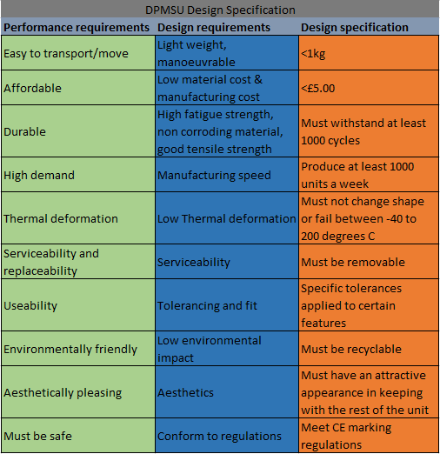
The design specification is detailed in Figure 1 below.
Figure 1 Design Specification

Materials

When considering what material to use for the DPMSU, the main considerations should be cost, weight, strength and how the material reacts to temperature.
Figure 2 shows a material strength vs density chart. Looking at the red line, which represents strength vs density, there are various materials that could be considered. Metals such as aluminium alloys and steel offer good strength, but at the cost of a higher density. Polymers such as PEEK and PET could also be considered, offering slightly lower strength, but they are considerably lighter.

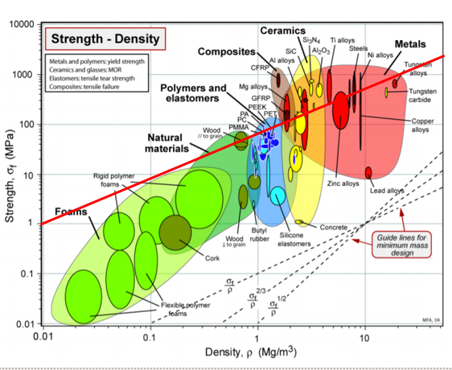
Figure 2 Strength vs density materials chart ( Granta Design, 2020)

Aluminium

Aluminium alloy is not as strong as steel; however, it is considerably lighter. Due to this lighter weight, aluminium is not as rigid as steel. Unlike steel, aluminium is corrosion resistant and does not need any further treatment to stop corrosion and does not rust. Aluminium is more malleable and elastic than steel, meaning it can be shaped easier than steel and create shapes that steel cannot. Aluminium reacts better to cold temperatures than steel, becoming stronger as the temperature drops. Compared to steel, aluminium expands more at higher temperatures, although it is a negligible amount. Aluminium is slightly more expensive than steel (Hornbacher, 2019).

Steel

Steel is very strong; however, this strength comes at a cost. It is roughly 2.5 times heavier than aluminium. Steel is not as malleable and ductile as aluminium, and can crack and break if shaped incorrectly. Steel is not resistant to corrosion and as such requires additional coating to prevent rust forming (Steel vs aluminum – MR Industrial Services, 2020).

Polymers (thermoplastic)

Polymers such as polyetherimide (PEI) and polyether ether ketone (PEEK) show some very desirable characteristics. PEEK in particular offers very good heat resistance, high tensile strength and low weight compared to aluminium or steel. It is easy and quick to process via injection moulding. Neither of these polymers are suitable for this product due to their high cost (Kaur, 2021).

Manufacturing method

Die casting is a process that forces molten metal under high pressure into a mould. It can produce complex shapes with a high degree of accuracy, repeatedly (Stark, 2019). Die casting leaves a smooth finish and does not require any further processing. The advantages of die casting are high strength, high corrosion resistance and good processing properties (Stark, 2019).
Sand casting could also be considered, as it is cheaper than die casting and there is no requirement for a permanent mould. However, it is much less dimensionally accurate, and the final product would require additional processing, as sand casting does not produce a smooth finish (Cavallo, 2020).

Modified designs

Below are various designs developed from the original concept of the DPMSU, with the chosen design listed last.

Shortened design

This design uses a shorter body for the DPMSU, requiring less material.
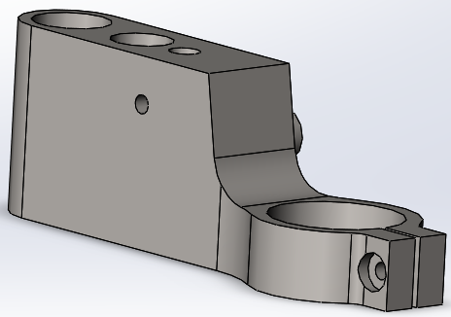
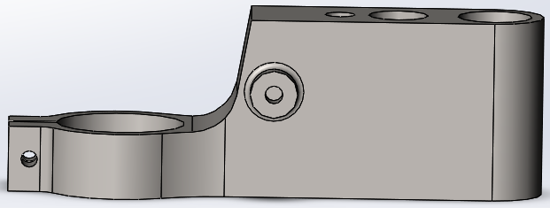
Figure 3 Short DPMSU design view 2
Figure 4 Short DPMSU design view 1

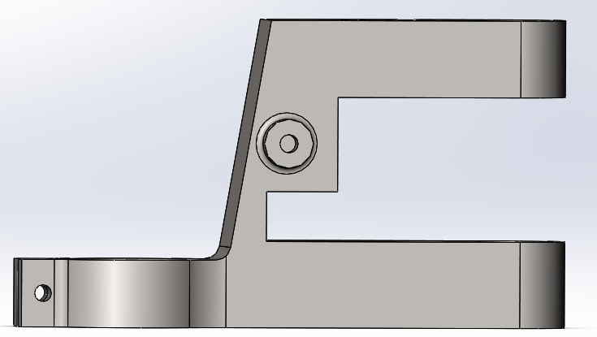
Cut-out design
Figure 5 Cut-out DPMSU design

This design features a cut-out in the middle of the DPMSU. The area removed would be replaced by a plastic insert. This would help cut down production costs by reducing the amount of material needed.

Slotted cut out design

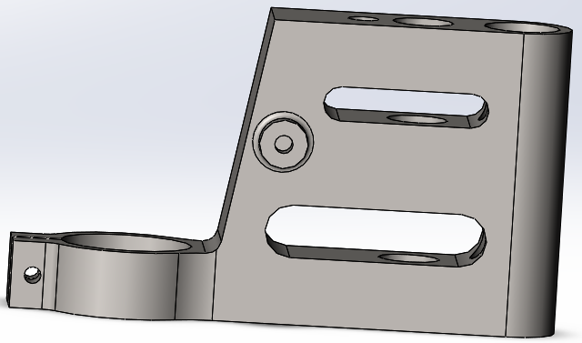
This slotted design saves weight whilst adding a different look compared to the original concept.
Figure 6 Sloted DPMSU design

Recess design (final design)

This design features two recessed sides and added fillet along the collar facing edge (green arrow). The recessed cut-outs reduce the material needed, reducing weight. A fillet has been used to make the top frontal face curved rather than the original flat faced design, also reducing weight. Sharp corners and edges can also increase stress concentration points; therefore, this filleted surface manages stress better. The lower fillet on the front face (red arrow in figure 7) has also been increased in diameter; this improves the strength whilst adding to the aesthetics of the design. The diameter of the fillet that joins the collar to the main body, shown by the red arrows in figure 8, has been increased from 20mm to 40mm to increase strength. This part of the DPMSU will be under significant strain when in operation. A cut-out has also been added through the spring hole. This allows the user to easily access the area where the spring hooks onto the DPMSU, as well as reducing weight. The diameter of the shaft that the spring attaches to has been increased to improve strength, whilst the fillet has been removed to reduce the weight and simplify the production process.
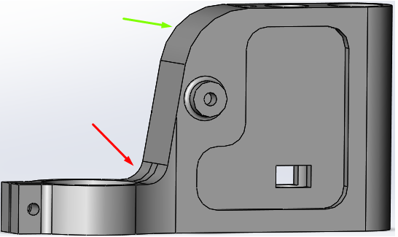
Figure 7 Final DPMSU design side view

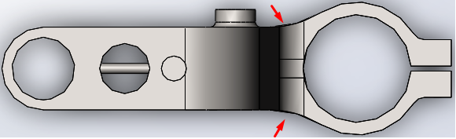
Cost drivers
Figure 8 Final DPMSU design top view

There are several cost drivers to consider for the DPMSU production.
Material used: some materials are harder to machine than others. In this case, an aluminium will be used, as it has a good level of machineability.
Manufacturing process: a more complicated manufacturing process will take longer, and therefore increase labour costs and the number of machine hours.
Tolerances: tolerancing plays an important role in how much a part will cost and how long it will take to produce. For the DPMSU, a general tolerance of 0.1mm can be used. However, there are two features where there must be specific tolerances. The most important is the hole for the main sliding shaft. For this, a close clearance fit (H7, g6) was used. This feature is vital for the performance of the DPMSU, as bigger tolerance would allow for play between the DPMSU and the shaft, causing excess wear. This would also cause the DPMSU not to slide smoothly on the shaft. The second feature requiring a specific tolerance is the hole accommodating the smaller shaft on top of the DPMSU. This smaller hole on top of the DPMSU is not as important as the main shaft hole, however, it must still have a tighter tolerance than the general tolerance used. For this, an average clearance fit (H8, f7) was used (Velling, 2020).

Conclusion

When designing a product, there are many things to take into consideration. Planning is key to success of a production process. If the product is poorly designed, it will cause customer dissatisfaction. A design specification should be produced considering as many aspects as possible. Various “cost drivers” must be considered, such as what material is used, the way in which it is processed and manufactured, but also the tolerances of the product itself. This report critically appraised a DPMSU, considering the user needs, regulatory requirements, and cost drivers, to create a revised design for optimal user experience, cost effectiveness, as well as ease and speed of manufacture. The final design takes all these factors into consideration and results in an improved product.

Bibliography

Your Europe. 2021. CE marking – obtaining the certificate, EU requirements. [online] Available at: <https://europa.eu/youreurope/business/product-requirements/labels-markings/ce-marking/index_en.htm> [Accessed 13 May 2021].
Velling, A., 2020. Limits & Fits | Types of Fits Explained & Tolerance Charts | Fractory. [online] Fractory. Available at: <https://fractory.com/limits-and-fits/> [Accessed 14 May 2021].
Kaur, K., 2021. Replacing Metals with PEEK (Polyetheretherketone). [online] AZoM.com. Available at: <https://www.azom.com/article.aspx?ArticleID=10147> [Accessed 8 May 2021].
Mrindustrialservices.co.uk. 2020. Steel vs aluminum – comparison and main differences – MR Industrial Services. [online] Available at: <https://mrindustrialservices.co.uk/steel-vs-aluminum-comparison-and-main-differences/> [Accessed 13 May 2021].
Granta Design. 2020. Material property charts | Granta Design. [online] Available at: <https://www.grantadesign.com/education/students/charts/> [Accessed 12 May 2021].
Stark, A., 2019. What is Die Casting? Development, Processes and Materials in Die Casting. [online] Spotlightmetal.com. Available at: <https://www.spotlightmetal.com/what-is-die-casting-development-processes-and-materials-in-die-casting-a-818604/> [Accessed 13 May 2021].
Cavallo, C., 2020. Die Casting vs. Sand Casting - What's the Difference?. [online] Thomasnet.com. Available at: <https://www.thomasnet.com/articles/custom-manufacturing-fabricating/die-casting-vs-sand-casting/> [Accessed 17 May 2021].

