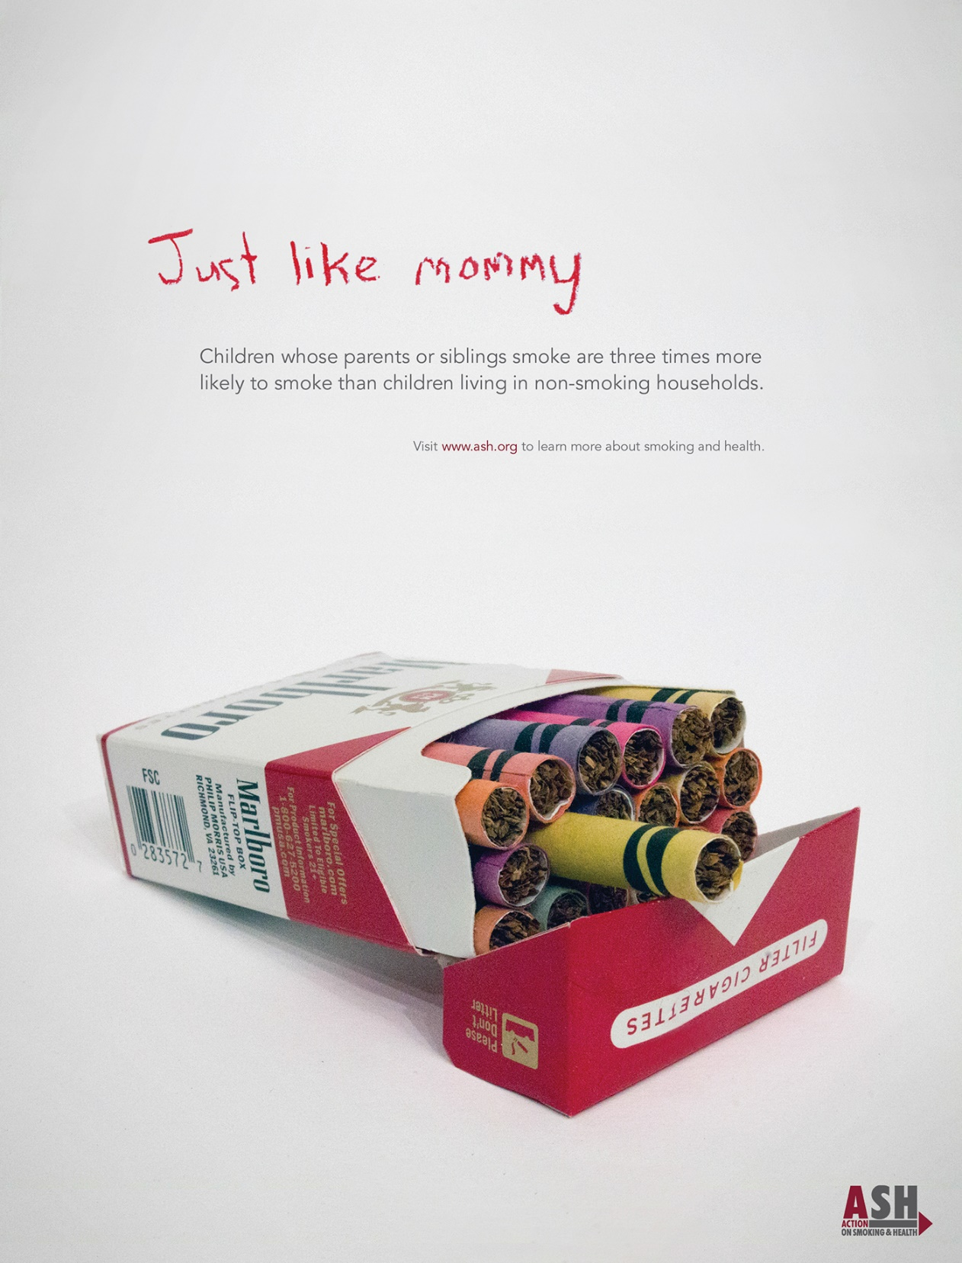

Semiotics are our combined understanding of how we can deconstruct and analyse advertisment. ‘semiology has an elaborate analytical vocabulary for describing how signs make sense’ (Rose, 2023). This is through scrutinising polysemic and rebus symbols. It is how we differentiate between a sign, signifier and the signified. ‘signs take the form of words, images, sounds, gestures and objects’ (Chandler, 2022).
Justins Hernandez’ anti-smoking campaign advertisement is linked to the relationship of growing up around smoking and how likely this impacts them smoking in the future. His advert uses visual rhetoric’s to convay the harmful influence being around smokers at a young age can be and how this impact their lives negatively. The aim of the advert is to persuade smokers quit or be more concious of the effect of household smoking in the presence of children.
This advert depicts a cigarette box with cigarettes wrapped in crayon paper. The branding of both the cigarettes and crayons is very easy to associate with both well-known brands. The use of the classic ‘Marlboro’ box makes it more recognisable to the viewer with the stark difference of the childlike and playful imagery of the crayons within. The juxtaposition of the crayons filled with tobacco shows the innocence of how a child would view cigarettes versus the potential harm they can cause. The colourful crayons represent how cigarettes can be view through youngster’s eyes and how they view them similar to a toy compared to an adult’s addiction. The connotation of this is that cigarettes will seem more appealing to children as they are unaware of the risks and believe them to be enjoyable. Consequently, they will be more influence to buy them in the future.
How the cigarette packet is placed tilted towards the viewer and how it is the focal point is important in the interpretation of the advertisement. The packet being open and not hidden shows how easily it is for children too see your bad habits and adopt them. The partially drawn cigarette almost teasing the viewer is demonstrating how tempting smoking is but also how easy it is to.
This is linked to the text above ‘ Just like mommy ’ which is also written with crayon. It is written in big scrawled childlike manner in such that a young child would write furthered by the use of ‘ mommy ‘ and not mum which an older child would more often use. This denotes how young children are influenced by what they grow up with and who is around them as they look up to them and want to be more like them.
In contrast to this, the short sentence below explains the message in a more adult way in a grey text that almost blends with the background. This is less impactful but links to how adults know the dangerous impacts of smoking but how children are unaware.
The background colour being a white/ grey makes sure the message of the advert is heard and makes the messages be more focal as it is important. It also could be deconstructed to how white is pure and innocent much like a child.

References
Chandler, D. (2022). Semiotics : the basics. Routledge.
Rose, G. (2023). Visual Methodologies: an introduction to researching with visual materials. SAGE.

