  Component One: What are the key skills required when working in the housekeeping team? | Student No: | 2127731
 | Module Title: | Operating Hotel Facilities
 | Module Code: | BMIH4006
 | Lecturer: | Lola Villard
Introduction
The housekeeping team has different roles and duties in the hotel industry. Housekeeping mainly works on cleaning, maintaining orderliness and so on. In the hotel business, the housekeeping team works for ensuring a desirable ambience. This part will demonstrate the skills required for a housekeeping team when working in the hotel industry (Elshaer & Marzouk, 2019). The top management needs to ensure that housekeepers have their skills and knowledge which help to deliver quality service for guests in the hotel.
Key skills required for working in a housekeeping team
The housekeeping team has different roles and responsibilities and they must need to hard work for delivering service to guests in the hotel. The essential skills are described as required for the housekeeping team
- Teamwork: A must-needed skill required for housekeepers in the hospitality industry is teamwork. When a person works small or large hotel, the housekeepers must need to work in a team. In the team, different housekeepers play different roles in meeting the needs of customers (Indeed, 2023). The teamwork skill supports ensuring better service comfortable service for guests. When the housekeepers work in a team, the quality of service improves and it helps to build up good relationships with customers.
- Time management skill: Housekeepers need to do certain tasks daily and they must have knowledge about time and complete the task on time. Time management skill helps this team to complete the task on time. For example, room cleaners should clean the rooms every day. Punctuality is the key to improving the service of the hotel business (Elshaer & Marzouk, 2019). The guest wants on-time service from the organization.
- Attention to detail: To deliver quality service to the guest, it is important to focus on attention to detail. If the housekeeping team fails to understand the needs or job duties, it will not positively impact service. The better understanding of the job, the better quality will be ensured. So, it is essential to understand the needs of guests.
- Communication skill: It is the top skill required for working in a housekeeping team. Without communication skills, it is not easy to work in a team. The housekeeping team in the hotel needs to interact with guests, supervisors, leader, and management and communication skills is necessary (Indeed, 2023). For doing the job, effective communication is important which will provide better service to guests.
- Interpersonal Skill: Housekeeping needs to build up a good relationship with everyone both team members, top management and clients. To develop a relationship, interpersonal skill is necessary. Good interpersonal skill supports becoming successful in the job.
- Flexibility and adaptability: Housekeeping team members must have to work different shifts in the hotel. They have to build the habit of working any time in this hotel which requires flexibility skills. Housekeeping team members need to perform different tasks and they need to have adaptability skills to work in different environments.
- Discretion & Trustworthiness: The housekeepers must build up trustworthiness skills which will help to better the relationship with everyone. The housekeeping team works for cleaning and other activities with costly items and they need to be are and must trustworthy (Elshaer & Marzouk, 2019). As a housekeeper cleans personal rooms, guest rooms, personal belongingness and keeping safe, so trustworthiness is important in this job role. The housekeepers must have to show politeness when working with clients and other colleagues. For any kind of mistake, the housekeepers must show sorry.
- Customer service: Housekeepers must have customer service skills as they mainly work for delivering service to customers/ they must have to work for ensuring customer satisfaction. Customer satisfaction should get the top priority of the housekeepers and it will help to ensure better service.
- Other skills: Housekeepers must have to work more to perform better in the selected tasks. There are several skills required to improve the quality of service. To become successful in the job, it is essential to build up leadership, hardworking, dedication, and active listening skills (Indeed, 2023).
Conclusion
The job roles and responsibilities of the housekeeping team are broad and they must have to build up skills and knowledge for working in this position. Team working, communication, attention to detail, and customer service all are the most important skills to work in this position in the hotel business. Then, the housekeeping team must follow the proper timetable for doing the tasks on time.
Word Count | 728

References
Elshaer, A. M. and Marzouk, A. M. (2019) ‘Labor Skills and training in the tourism and Hospitality Industry’, Labor in the Tourism and Hospitality Industry, pp. 79–120. doi: 10.1201/9780429465093-4.
Indeed (2022) Guide to housekeeping skills (with tips and examples). Available at: https://www.indeed.com/career-advice/career-development/housekeeping-skills (Accessed: 22 May 2023).
Indeed (2023) Working as a housekeeper: Tasks, skills, salary | indeed.com. Available at: https://www.indeed.com/career-advice/finding-a-job/working-as-housekeeper (Accessed: 22 May 2023).

Component Two:
Action Plan: It refers to a set of steps that can be listed down to attain a certain goal. The steps can vary depending on the type of goal that needs to be achieved.
Under the given circumstances, to ensure the best customer service for the guests, an action plan can be formulated answering the following questions:
Problem | Why did it happen? | What are you going to do? | How will you prevent this from happening in the future? | What measures would you introduce to improve team effectiveness?
Miscommunication | Miscommunication about the time of the arrival of the following guest between the hotel staff might have caused this to take place. | Firstly, the guest should be apologised for the inconvenience caused to him. Sincere apologies to the guest and showing empathy to address his problems will have him feel heard and valued as his problem would be understood. | Communication between the people in reception and housekeeping staff should be enhanced to ensure that the staff is well-informed of guests’ arrivals and departures. The receptionist should also let the staff know about house cleaning if needed. Automation systems such as immediate messaging and real-time information should be discussed or shared with the staff to efficiently monitor the rooms. | To ensure proper communication, clear job responsibilities must be defined. If the staff has a well-defined role and a thorough information of their job description, it’ll be easy for them to conduct their duties properly. With this defined job-role, the customers’ reviews can be taken to verify their performance.
Limited Time | There might have been limited time for the housekeeping staff to monitor all the rooms with great care which may have arisen from regular check-ins into the hotel. | Secondly, a dedicated staff to address the following concern of the guest must be assigned and designated to solve the problem as soon as possible and to ensure the guest’s convenience. To facilitate the guest’s stay in the hotel, the dedicated staff must be proficient, well-educated and prepared to efficiently tackle the concern. | There should be an optimal way to regularise staff timing so that there are always enough staff available to clean the hotel rooms thoroughly. Optimising staff will also help the hotel authority to allocate resources accordingly to meet the higher needs of occupancy and monitor cleanliness. | To tackle the time-constraints, proper information about the arrivals and departures of the guests should be provided to the housekeeping staff. To ensure this, regular team meetings can be arranged to discuss challenges, share best practices and effectively achieve the goals and objectives of the hotel.
Insufficient Training | Insufficient amount of training programmes for the staff on how to clean the rooms properly and how to monitor the rooms appropriately might have been a reason to face this situation. | Thirdly, the dedicated staff of the hotel has to visit the room to address the following problems the guest is facing and inspect the rooms with utmost care to identify the deficit in amenities. That staff should also evaluate the cleanliness of the hotel room to ensure convenience of the guest and take necessary steps where needed. | The housekeeping staff should be thoroughly trained on ensuring hygiene, maintaining the hotel standards for cleanliness, the quality of service and managing time efficiently. Training would help the staff gain the necessary skills and knowledge and it’ll result in effectiveness of service. | To increase team effectiveness, besides giving thorough training to the staff, a program can be arranged to recognise the excellent effort of the staff and their performance can be celebrated by handing out direct initiatives such as bonuses or salary raise etc. These incentives enhance their morale and encourage them to achieve more.
Deficit in supplies | There might have been a deficit in supplies to clean the hotel rooms. It may have impeded the following cleaning procedures. | Fourthly, prompt action must be taken to take care of the deficits found in the inspection process of the dedicated hotel staff. These actions might include re-cleaning the stained room surface, changing bed sheets or curtains, restocking amenities. | Regular inspections should be made to effectively supply cleaning equipment and find out any deficits in the hotel rooms to prevent any unwanted situations. A system can be developed to timely monitor the amenities and restock if needed. The hotel can be cleaned and inspected regularly with proper equipment to avoid mismanagement of inventory. | The staff can be offered training and self-development programmes to boost their personal skills and enhance their knowledge more. It’ll help the staff manage supplies efficiently.
Staffing issues | Inadequate number of staff for cleaning the hotel rooms might have put extra pressure onto the existing housekeeping staff which led to superficial cleaning procedures and discomfort for the guest. | Fifthly, if the room can be cleaned and presented to the guest in a nice manner immediately, the room may be handed over to the guest to facilitate his stay. If not, he can be offered a compensation or an alternative accommodation as this will mean the hotel prioritises customer satisfaction the most and will help the hotel mitigate the inconvenience caused by the following problem | A team can be formed to ensure the quality standards of cleanliness for the hotel rooms are met. That team will check the rooms regularly to verify there isn’t any room unchecked and can take corrective actions by informing housekeeping staff. | A cooperative housekeeping team can be nurtured to enhance team work and ensure staff availability in the need of maximum occupancy. If the team can develop broader skills, they can easily support each other in their jobs and replace their co-workers if needed. The experienced staff can also teach the novice staff and monitor their growth to ensure optimal effectiveness of the team.
Gaps in quality control procedures | There might have been insufficient quality control procedures to monitor all the hotel rooms separately, and it led to unnoticed rooms which weren’t cleaned properly. | Lastly, even after the situation has been taken care of, the housekeeping staff must reach the guest to ensure the guest is not having any problems furthermore to ensure their satisfaction. The staff can phone the guest, text him or meet him in person to show cordiality of the hotel authority as it shows their responsiveness to the concerns arisen and expresses gratitude to the guest. The staff can also take feedback on his experience to change his first impression. | The housekeeping staff should be encouraged to foster a culture of accountability. They should take ownership of their duties and responsibilities. Guest satisfaction should be prioritised highly to ensure the cleanliness standards. Some incentives such as rewards or bonuses to the staff can be provided for their great performance to encourage efficiency. | A system for monitoring the development and performance of the staff can be devised. With this system, regular feedback on their performance can be taken to evaluate their performance. These feedbacks can be interpreted to portray the strengths and weaknesses of the staff. To ensure quality control, regular attendance and individual goal- setting sessions can be considered to maintain the standards and ensure the best customer service.

References:
Alzoubi, A., (2021). The impact of Process Quality and Quality Control on Organizational Competitiveness at 5-star hotels in Dubai. International Journal of Technology, Innovation and Management (IJTIM), 1(1), pp.54-68.
Davras, Ö. and Caber, M., (2019). Analysis of hotel services by their symmetric and asymmetric effects on overall customer satisfaction: A comparison of market segments. International Journal of Hospitality Management, 81, pp.83-93.
Guchait, P., Lei, P. and Tews, M.J., (2016). Making teamwork work: Team knowledge for team effectiveness. The Journal of psychology, 150(3), pp.300-317.
Jawabreh, O., Al Fayoumi, T. and Bareya, A., (2022). CUSTOMER SATISFACTION TOWARDS COMMUNICATION SKILLS OF FRONT OFFICE STAFF AT THE HOTEL (CASE STUDY FIVE STARS HOTELS IN AQABA). Geo Journal of Tourism and Geosites, 44(4), pp.1312-1318.
Kim, J.J. and Han, H., (2022). Redefining in-room amenities for hotel staycationers in the new era of tourism: A deep dive into guest well-being and intentions. International Journal of Hospitality Management, 102, p.103168.
Olimovich, D.I., Bakhtiyorovich, T.M. and Salimovna, N.G., (2020). Improving of personnel training in hotel bussines. Academy, (2 (53)), pp.18-19.
Suhag, N., (2017). The Impact of Training on Team Effectiveness in Hotel Industry. Available at SSRN 3065770.
Piccoli, G., Lui, T.W. and Grün, B., (2017). The impact of IT-enabled customer service systems on service personalization, customer service perceptions, and hotel performance. Tourism Management, 59, pp.349-362.

Component Three: Presentation

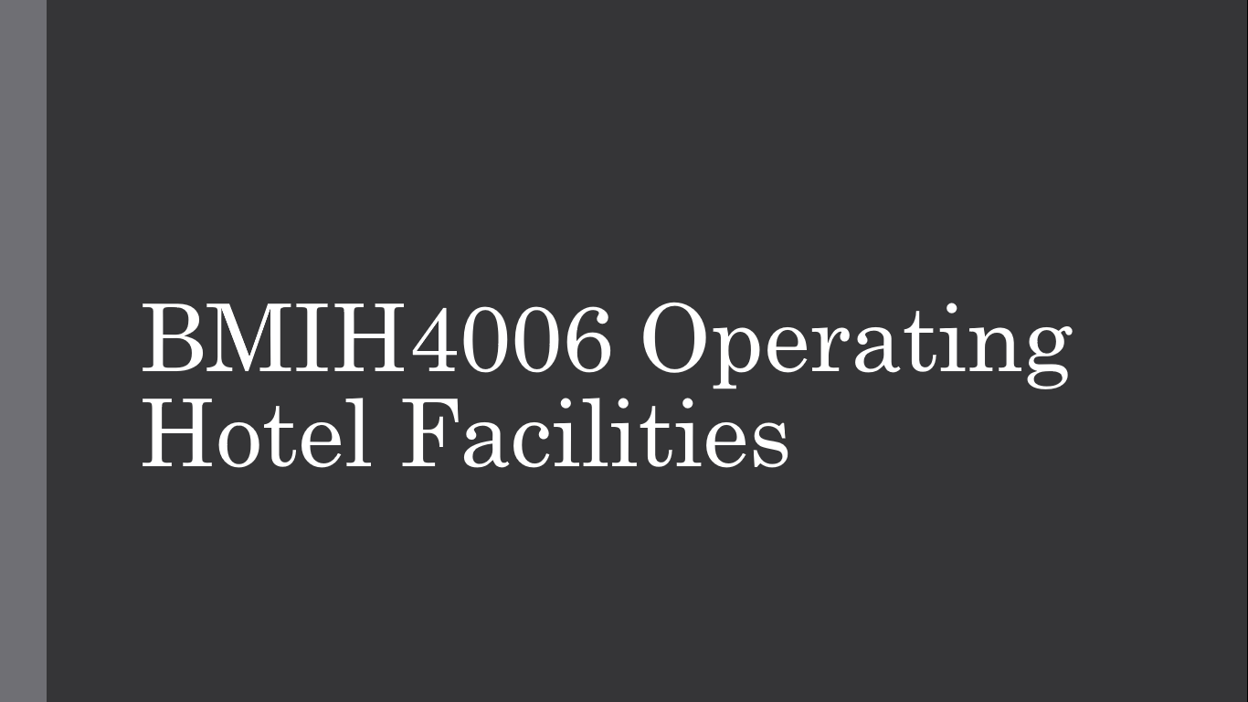

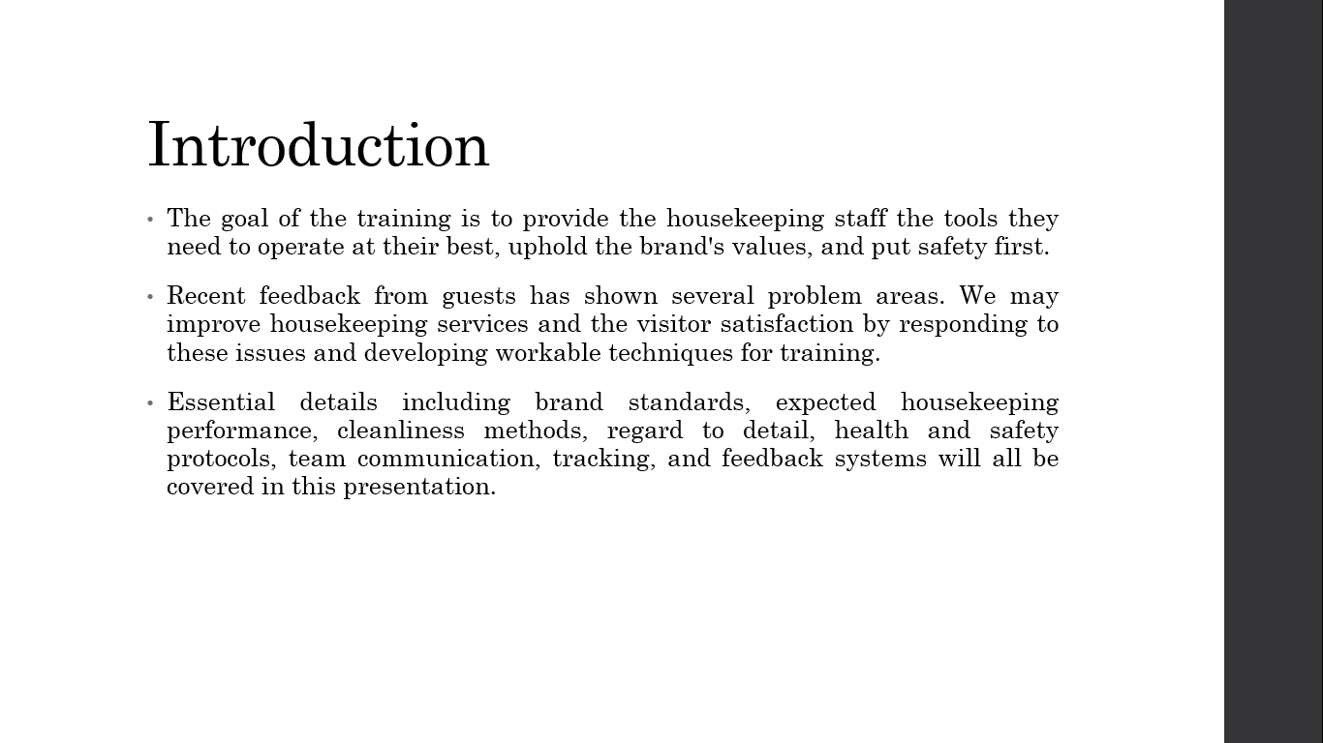As the floor housekeeping manager, I've heard a rise in visitor concerns about the quality of our cleaning, presentation, and care for the smallest details. It is essential that we take measures to guarantee that our guests are receiving the highest level of service possible, along with the high standards of our hotel's brand (Fiore and Jeoung, 2019). This presentation's goal is to provide us with the groundwork we need to perform better, meet brand standards consistently, and keep safety protocols inviolate. In this way, we can keep our excellent reputation and increase client happiness. In this course, we will go over a number of different things, such as brand standards, performance expectations, cleaning methods, paying attention to detail, safety procedures, ensuring quality, working as a team, and keeping tabs on progress. Together, we can improve housekeeping by putting into practise the ideas presented here and making a significant impact on the hotel's bottom line.

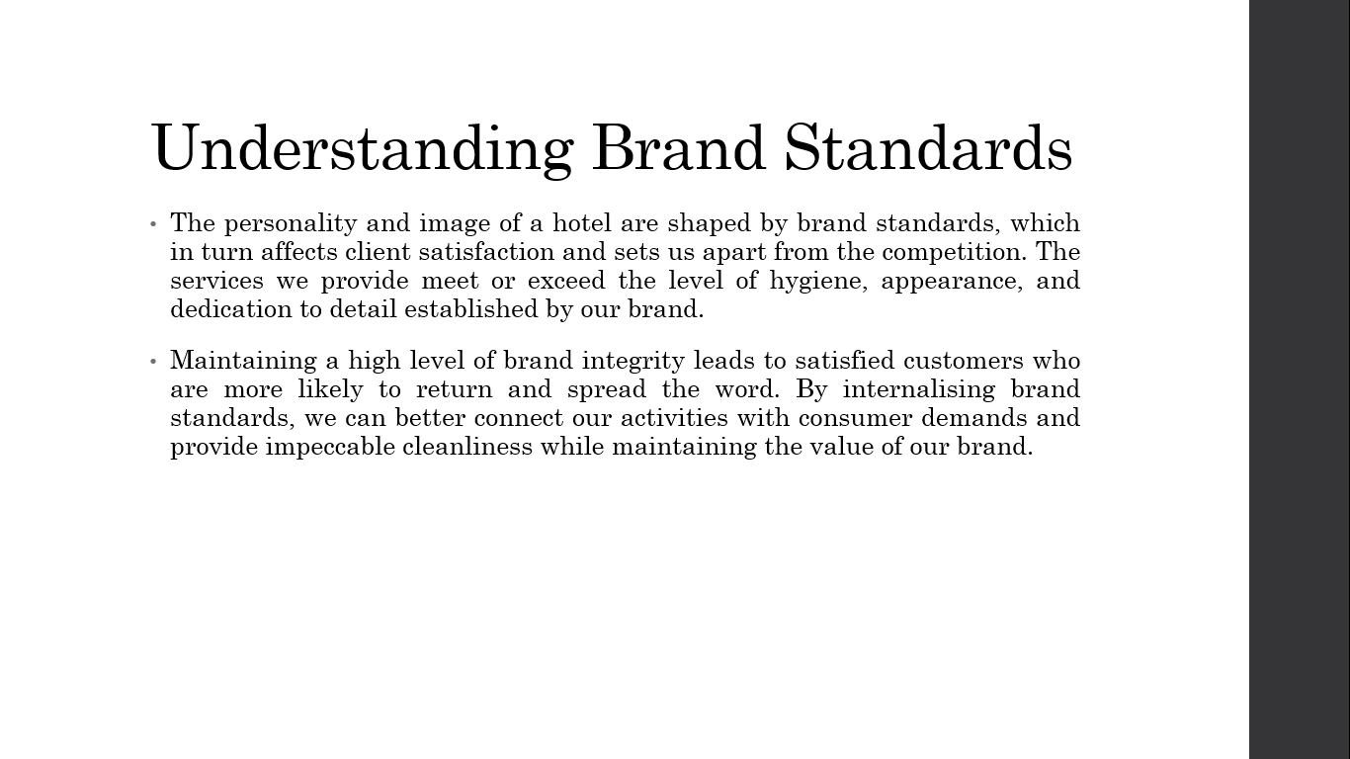
Our hotel's character and popularity have been shaped in large part by adhering to brand guidelines. Here, we'll discuss how adhering to brand guidelines may have a significant effect on customer satisfaction. By maintaining these criteria, we can provide our visitors with a constant experience and set ourselves apart from the competitors. Housekeeping-related aspects that contribute to brand consistency include tidiness, neatness, and meticulousness (Fiore and Jeoung, 2019). These norms represent the hotel's core beliefs and provide a positive public perception of our establishment. Instilling trust in our visitors by consistently surpassing brand standards generates loyalty and great word of mouth.
By absorbing and internalising these principles, we may adjust our conduct to conform to the ideals our brand represents. Let's work as a team to ensure that our cleaning services reflect well on our company and create a lasting impression on our customers.

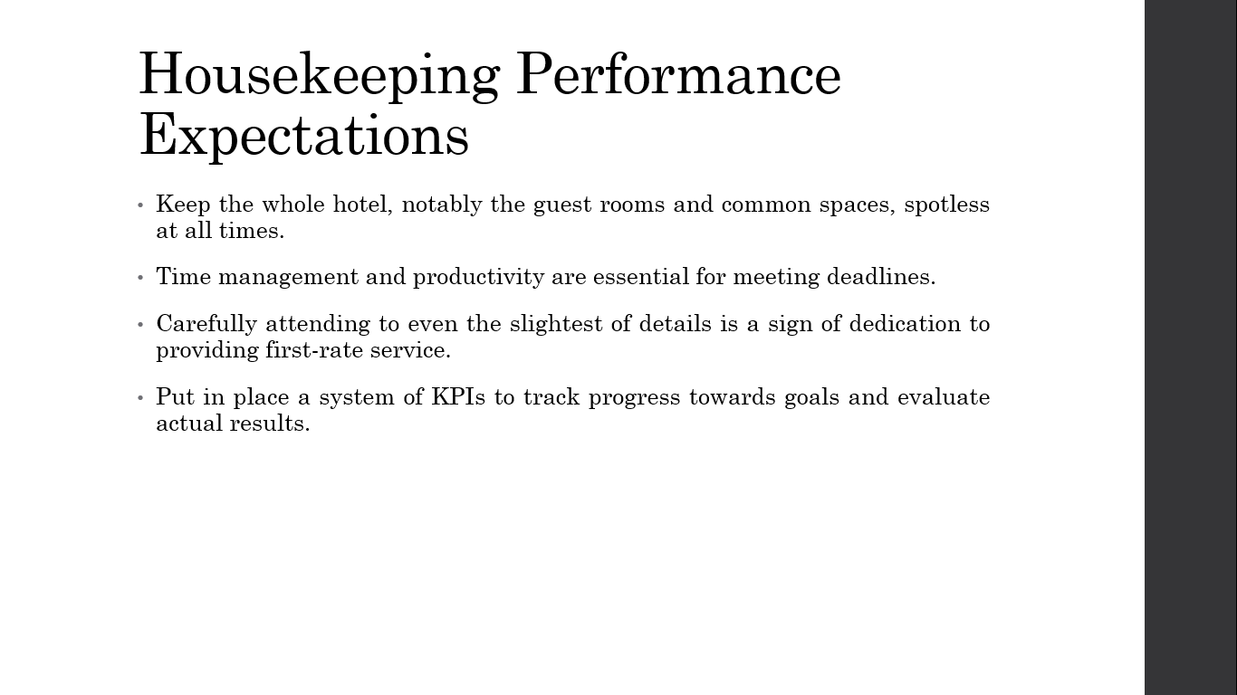
Establishing concrete performance standards is critical for our success as cleaning professionals. Following these standards will help ensure that our hotel continues to provide our guests with a memorable experience. This section will detail the particular objectives and benchmarks that we must meet.
- Our first priority should be to ensure that all parts of the hotel, from guest rooms to common spaces, are spotless at all times. Each room must be meticulously cleaned, sanitised, and arranged such that no signs of past occupants remain (Hartline and Jones, 2019). Every aspect of the room has to be cleaned, from dusting and vacuuming to changing the sheets and restocking of the amenities.
- Our success hinges on our ability to manage time effectively. As a team, we need to work quickly and efficiently to get everything done on time without sacrificing quality or cleanliness. Our productivity will increase if we take the time to plan out our work, set priorities, and streamline our processes.
- Our dedication to providing first-rate service is shown in the fact that we pay close attention to every detail. Every area of our job requires our undivided attention so that no detail is overlooked (Hartline and Jones, 2019). That includes things like making sure everything is in its place, aligning furniture, checking for maintenance concerns, and responding quickly to any requests from guests.
Key performance indicators (KPIs) will be set to track our development and motivate us to keep growing. Using these indicators, we may compare our results to those that have been set. By accepting and exceeding these performance objectives, we can provide superior cleaning services that benefit our guests and the hotel as a whole.

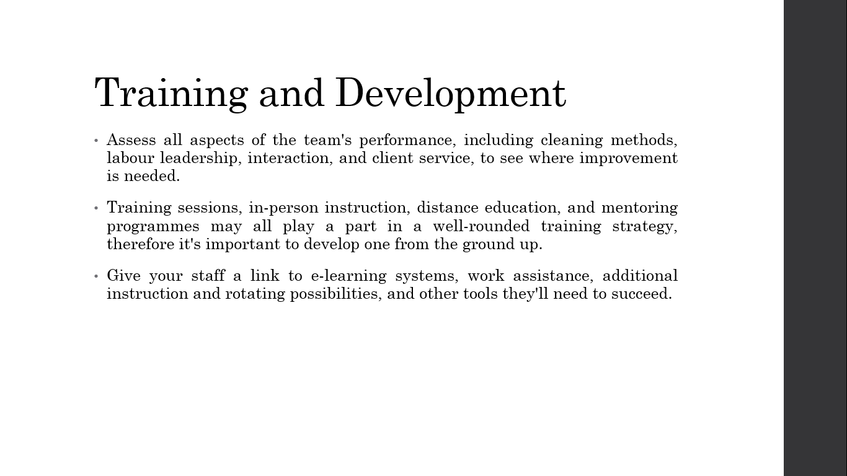
In order to raise productivity, reach brand requirements, and guarantee compliance with health and safety protocols, we must invest in the training and development of our housekeeping staff. In this article, we'll look at why regular training is so crucial, and we'll talk about ways to encourage continued education and development.
- To determine where in particular, our team members need training and development, we will perform an extensive examination. Improvements in cleaning methods, time management, communication, and customer service are all possible outcomes.
- We will create a customised training programme based on the requirements that have been established. The goals, curriculum, and delivery strategy for the training are all laid out here. Workshops, on-the-job instruction, virtual classes, and mentoring schemes are all possible components (Kuznietsova and Bidyuk, 2019).
- We'll make sure our staff has access to everything they need to grow and develop professionally. Opportunities for cross-training and work rotations are further examples of the kinds of training resources that might be provided.

- Our housekeeping staff will be immersed in an environment of constant training and development. This may be encouraged via frequent opportunities for employees to learn from one another and communicate their experiences and successes as a team (Hartline and Jones, 2019).
Training and development programmes help employees grow professionally, gain self-assurance, and provide customers with first-rate support. Let's work together to create a classroom that encourages development and helps us meet our performance objectives.

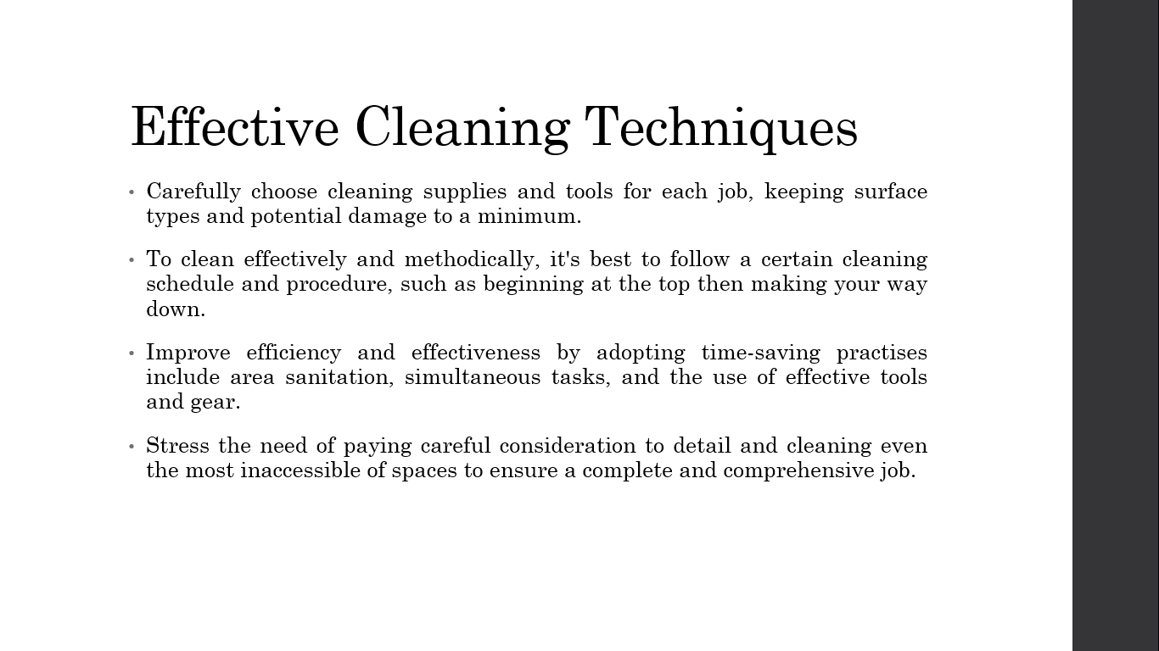
Delivering first-rate housekeeping services requires mastery of efficient and effective cleaning methods. Here, we'll examine some of the most important methods for cleaning, all of which may improve our procedures and provide better outcomes.
- We will talk about how crucial it is to clean using the proper supplies and tools for the job at hand. To clean thoroughly while reducing the possibility of harm, we need to know which solutions and equipment are most suited for certain surfaces and locations.
- We'll stress the value of developing a systematic approach to cleaning. When cleaning, it's best to start at the top and work your way down, carefully handling various areas and surfaces as you go.
- We'll learn how to clean faster and more thoroughly without sacrificing quality. Methods like zone cleansing, simultaneous tasking, and the deployment of suitable hardware and software are all possibilities here (Kuznietsova and Bidyuk, 2019).
- We will stress the value of meticulous attention to detail at every stage of the cleaning procedure. Cleaning thoroughly and completely requires paying attention to even the most inconspicuous of details.
Learning and using these efficient methods of cleaning will boost our efficiency, precision, and performance. By perfecting these methods, we can ensure that each and every one of our visitors has a pleasant and memorable stay.

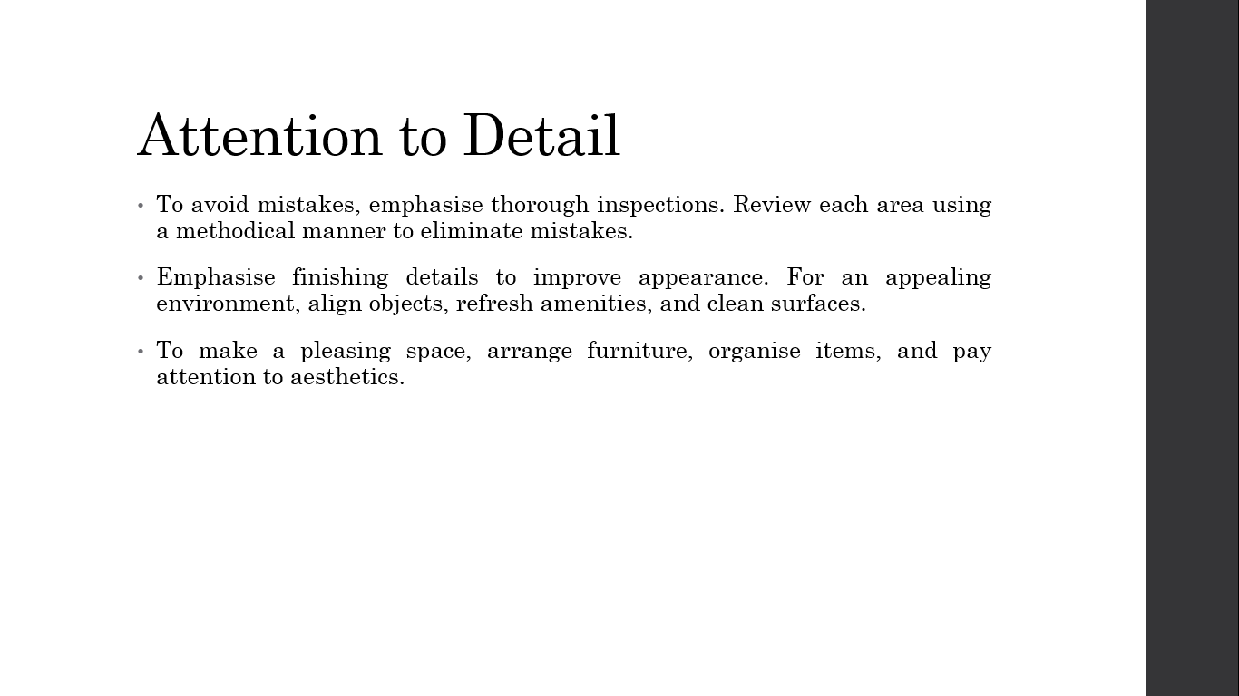
Providing first-rate cleaning services relies heavily on paying close attention to every little detail. The need for attention to detail will be emphasised here, along with methods for improving that attention.
Complete examinations: We will stress the need for comprehensive room and common area inspections. Promoting a methodical strategy for reviewing and double-checking each area guarantees that nothing is missed (Hassanien and Losekoot, 2021).
The last touches: We'll go through why it's so important to put in those last touches that really polish off a room. This involves straightening furniture, stocking up on refreshments, and wiping off counters and tables.
Standards for Presentations: We will stress the value of providing clean public spaces and guest rooms. A pleasant and comfortable atmosphere may be created by placing furniture in the right places, keeping clutter to a minimum, and paying attention to design details (Hassanien and Losekoot, 2021).
Innovative approaches to issues: We'll push for a proactive approach to finding and fixing sanitation problems. Teams can maintain high standards and respond quickly to maintenance problems and possible cleanliness concerns if they are encouraged to report them as soon as they are seen.
We show our dedication to quality and the happiness of our customers by encouraging a mindset of meticulousness. Our ability to provide an unforgettable experience for our visitors and go above and beyond their expectations is a direct result of our focus on the tiniest of details.

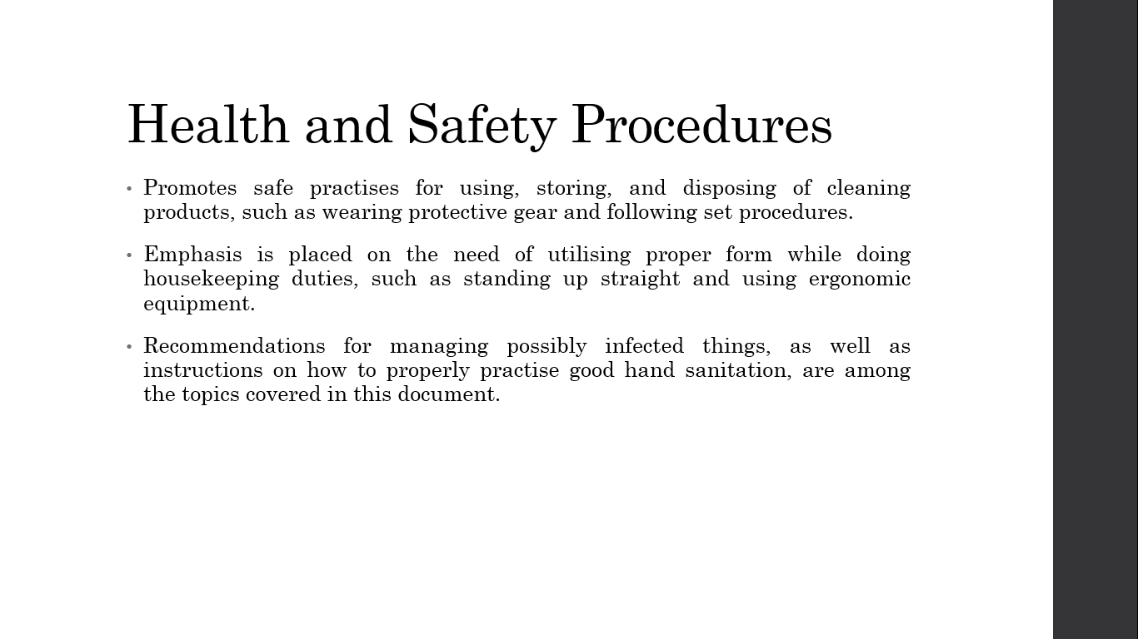
It is of the highest importance to us that our visitors and cleaning staff are safe and comfortable. Here, we'll go over some basic health and safety measures that must be taken to keep the workplace risk-free and secure.
- We will stress the need for safe practises for dealing with cleaning chemicals and other potentially dangerous substances. Personal protective equipment (PPE) should be used as directed by the manufacturer, and standard operating procedures should be followed (Fiore and Jeoung, 2019).
- We'll talk about why it's so crucial to take care of your body when cleaning. The risk of musculoskeletal injuries may be reduced by using safe lifting techniques, keeping a straight back, and making use of ergonomic tools and equipment.
- The procedures for controlling the spread of disease and keeping things clean will be covered. Rules for managing possibly tainted products, including adequate hand sanitation, maintenance, and decontamination, must be adhered to.
- The value of being ready for unexpected events will be emphasised. Included in this category are frequent training sessions on how to handle different critical circumstances as well as familiarity with evacuation plans, rescue routes, and security gear (Hassanien and Losekoot, 2021).
By following all safety regulations to the letter, we ensure the well-being of our customers and employees. The happiness of both employees and visitors may be improved by making health and safety a top priority.

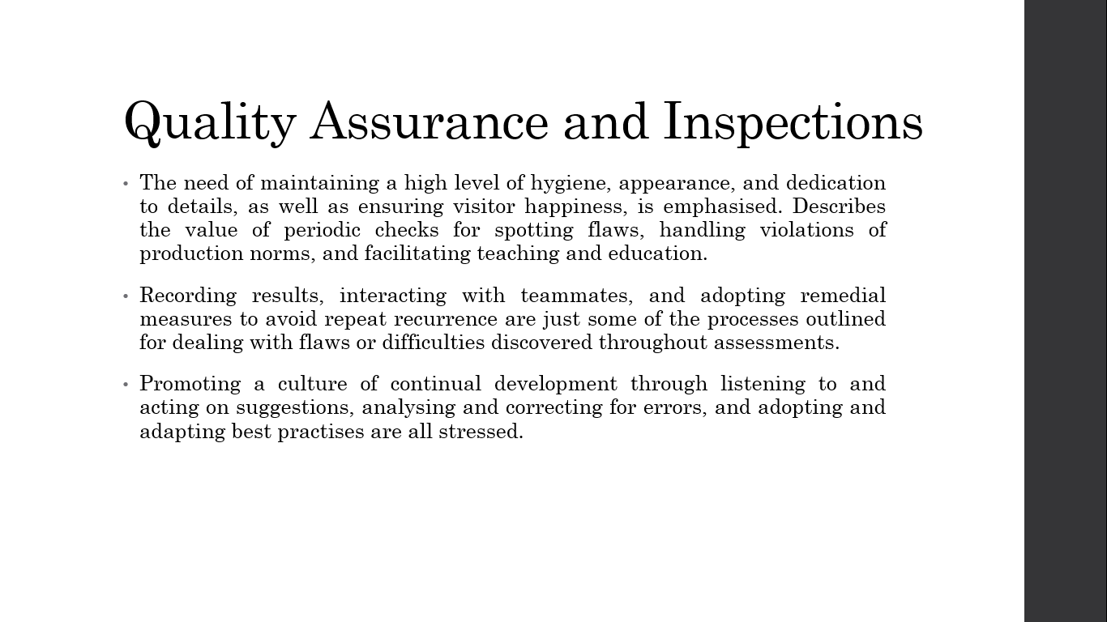
For our cleaning services to consistently meet or surpass brand standards and guest expectations, consistency is of the utmost importance. Here, we'll delve into quality control and the function of audits in guaranteeing top performance.
- We will stress how critical it is to meet all quality benchmarks. Standards for tidiness, attractiveness, specificity, and visitor contentment are all outlined here. Maintaining this level of quality ensures that our visitors have a pleasant and memorable stay.
- The inspection process and its goals will be discussed. Regular inspections are useful for seeing problem areas, correcting any lapses in quality, and spotting coaching and training openings (Fiore and Jeoung, 2019). Members of management, or those specifically tasked with the task, may conduct inspections.
- We'll lay out the procedure for fixing any problems found during inspections. In order to fix the problem and stop it from happening again, you must record your findings, share them with your team, and act on their suggestions.
- We will stress the value of always striving to do better. We are always improving our housekeeping services by encouraging feedback, analysing and correcting errors, and adopting best practises.
Consistently high-quality service delivery is only possible with the help of rigorous quality assurance methods and comprehensive inspections. Our performance may be constantly elevated, and guest expectations can be consistently surpassed via frequent monitoring, feedback, and improvement activities.

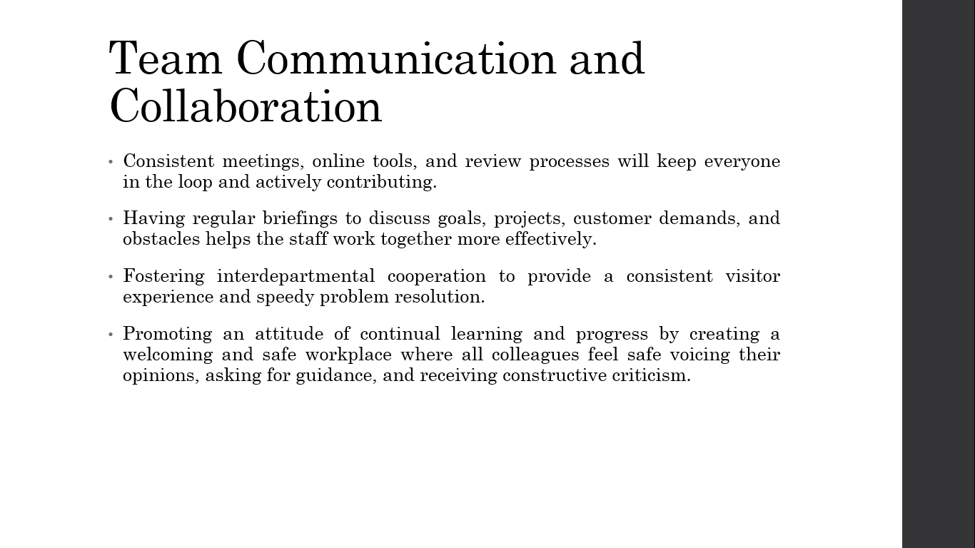
Seamless cleaning operations and great service can only be achieved via strong team communication and teamwork. Here, we'll talk about why it's crucial to encourage open lines of communication and teamwork in the workplace.
- We'll talk about why it's so important for your cleaning staff to have open lines of communication with each other. To make sure everyone is up-to-date and invested, we have frequent team meetings, use digital communication channels, and implement feedback systems.
- Daily briefings will be emphasised as a means of disseminating information about priorities, duties, and any unique issues or requests from guests (Penny, 2020). This facilitates communication, knowledge sharing, and effective work coordination between team members.
- We'll stress the need to work together with places like housekeeping and reception to better serve our guests. Facilitating open lines of communication and teamwork between staff members ensures that any problems encountered by guests are dealt with promptly.
- We will stress the value of cultivating a welcoming and safe workplace where everyone may feel safe voicing their opinions, asking for guidance, and receiving criticism (Riha and LeMay, 2021). This encourages a mindset of constant growth and development.
We can improve productivity, problem-solving, and teamwork as a whole by encouraging open dialogue and cooperation among team members. Let's work as a team to make sure our cleaning staff has all they need to succeed and provide first-rate service to our clients.

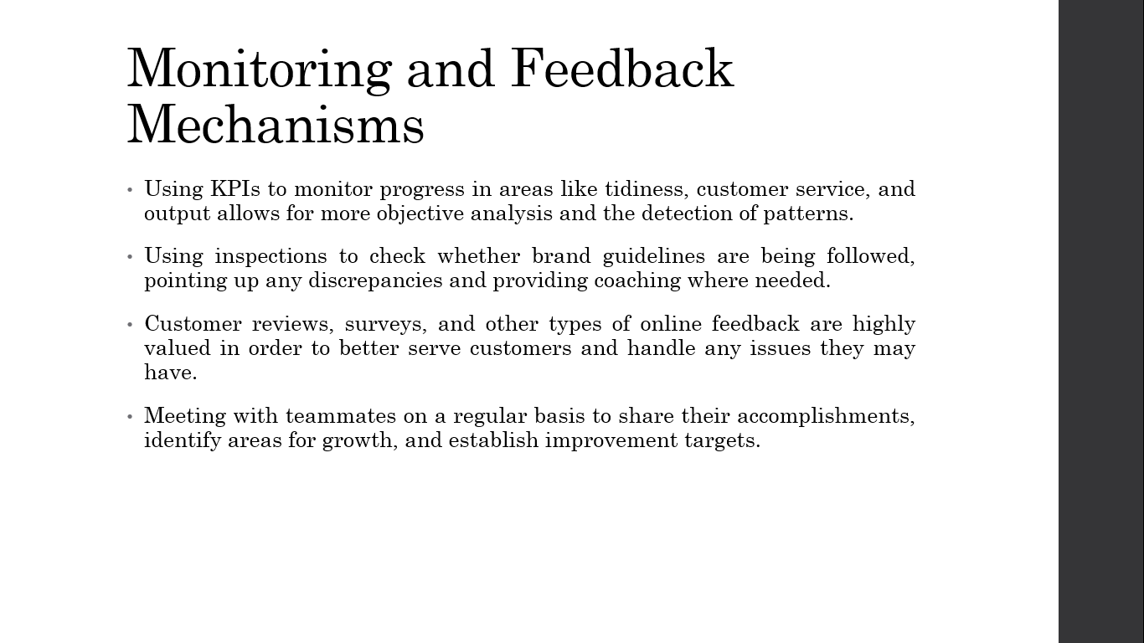
The success of our housekeeping operations depends on our ability to implement efficient monitoring and feedback processes for assessing performance, pinpointing problem areas, and maintaining high standards. Here, we'll get into why monitoring and feedback are so crucial and then talk about several ways to put those plans into action.
We will talk about how to utilise key performance indicators (KPIs) to monitor and improve housekeeping's efficiency, effectiveness, and other metrics. These quantitative measures may be used to dispassionately evaluate performance and spot patterns over time (Kuznietsova and Bidyuk, 2019).
The need for regular inspections to ensure that brand guidelines and quality standards are met will be emphasised. During inspections, problems may be spotted, and employees can get constructive criticism and guidance.
We want to investigate how useful customer comments may be for gauging our progress. We can better serve our customers and respond to any problems they may have if we solicit feedback from them in the form of reviews, surveys, and other online activities(Kuznietsova and Bidyuk, 2019).
We'll talk about how vital it is to periodically assess each team member's progress. Strengths, areas for growth, and targets for ongoing progress may all be discussed during these assessments.
The ability to proactively identify problem areas, receive and act on timely feedback, and drive continuous improvement in our housekeeping operations is dependent on comprehensive monitoring and feedback processes. Our hotel's guests will be happier, our staff will grow, and our business will thrive as a result.

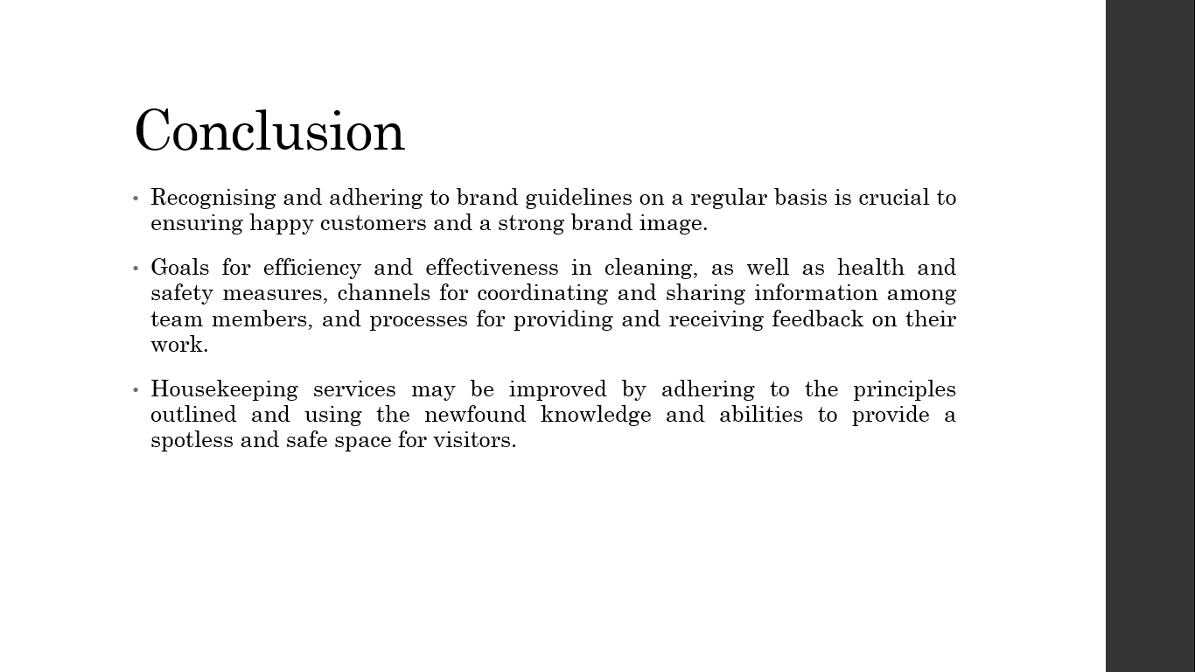

Guests' experiences, the hotel's reputation, and the bottom line all depend on the quality of our cleaning services being consistently excellent. Throughout this training session, we have covered a wide range of topics critical to the smooth functioning of a hotel. We have emphasised the importance of learning the brand's standards and acting in accordance with those standards at all times. Performance goals, efficient cleaning methods, attention to detail, health and safety protocols, channels of communication and cooperation within the team, and methods of monitoring and providing feedback have all been covered. Our cleaning services may be taken to a whole new level if we internalise these ideas and put into practise what we have learned in this course. We can guarantee that all of our visitors will enjoy the highest standards of tidiness, service, and security throughout their stay.

References

Fiore, A.M. and Jeoung, M. (2019). Measuring Experience Economy Concepts: Tourism Applications. Journal of Travel Research, 46(2), pp.119–132.
Hartline, M.D. and Jones, K.C. (2019). Employee performance cues in a hotel service environment: Influence on perceived service quality, value, and word-of-mouth intentions. Journal of Business Research, 35(3), pp.207–215.
Hassanien, A. and Losekoot, E. (2021). The application of facilities management expertise to the hotel renovation process. Facilities, 20(7/8), pp.230–238.
Kuznietsova, N. and Bidyuk, P. (2019). GENERALIZATION OF THE INFORMATION TECHNOLOGY STRUCTURE FOR FINANCIAL RISK MANAGEMENT. KPI Science News, 0(3), pp.33–43.
Penny, W. (2020). The use of environmental management as a facilities management tool in the Macao hotel sector. Facilities, 25(7/8), pp.286–295.
Riha, E.C. and LeMay, D. (2021). Saving students money with ebooks: A cross-departmental collaboration between interlibrary loan and course reserve. Technical Services Quarterly, 33(4), pp.386–408.

