 |  | Preparing for Professional  Police Practice
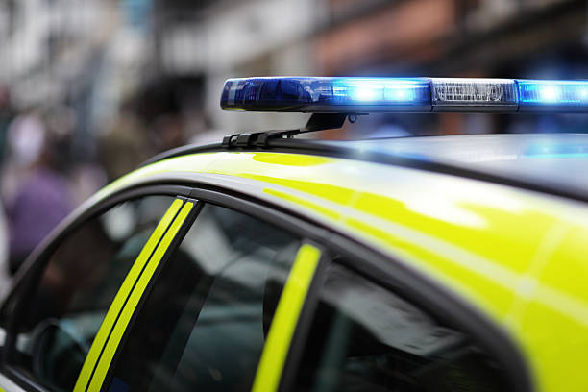

Assignment 2
Patrick Dalea | Kelly Andrews
Preparing for Professional Policing

Within this paper there is going to be different arguments talked about which are based on the topics of the necessity of maintaining Professional Standards in line with the Code of Ethics and the Standard of Professional Behaviour which will include the way of the ethical decision making in different police scenarios. It will be discussed about the way in which the police behave will be examined and the impact of standards of professional behaviour discussed. An analysis of their contractual obligations will also be included.
The necessity of maintaining those standards at these moments is going above level it was thought of being required, due to the contemporary era that we live in there are a lot of mistakes done by officers, civilians and so on, which are purely based on the mental state that person has. Mistakes are done, mistakes that could ruin somebody’s life and their future due to something that was not considered before, for example a case that happened on 2022 where Mr Benguit was arrested for murder and spent twenty years in prison due to police arresting him without checking his alibi, the alibi offered by Mr Benguit where he told officers he had nothing to do with the murder, after 20 years his alibi was rechecked due to the new regulations and his alibi now stands in court showing his innocence (Jon Robins, 2021), that’s why those codes of ethics, those standards of procedures were brought into the action. For example, the Code of Ethics of a Police Constable which include honesty, integrity and authority, respect and courtesy, equality and diversity (College of Policing, 2014). Each one of these groups of ethics are very important for day-to-day life for a Police Constable and above.
The Integrity and the Authority of a police Constable are very important due to the contact that they are having with the public in very different situation which can vary from controlled situations and uncontrolled situations. Being in contact with somebody that does not percept the fact that a Police Constable is there will make the scenarios uncontrolled, and some will take in the fact that a Police Constable is present and create the situation as controlled as possible. The way a Police Constable makes his entrance in civilian’s life will leave a mark, or a scar there depending on how their experience around the Police Constable was. An example would be the scenarios that happened to Ms Power an 85 year old woman that was left with bruises on her body after she was dragged by three police officers from a anti-fracking protest where she was sitting in her seat to support everyone despise the fact that she is and elderly woman, she will be there to support them, “Ms Power said she was left with bruises on her shoulders and was so angry that she has struggled to sleep since.” (Benjamin Kentish, 2017) . Every policeman should intake the fact that even though they are there to help, someone might see them as being there for a specific reason which may include their persona as well which can create difficulties while in contact or the future contact with the person, and overall situation can be discussed withing this subject which is the actions that the police took while the Black Lives Matter protests where the officers were seen “taking the knee” as a show of respect toward the community which was something very moving in that situation but became a problem after a while, making the public from other ethnic backgrounds thinking that they don’t matter as much and that the police is not so impartially thinking since the Black Lives Matter protest (Tom Gillespie, 2022). The code of ethics for the Police Constables covers most of the situations in one forcing their way of thinking, acting and behaving into a very well seen Officer which is there for the community and not to harm anyone. The authority that they have and the one that they putting into practice while on a call will leave a mark there for somebody that’s why every officer should have a different perception of the scenario where they should think about every single person involved and why could they be scared or why do they hate the police, there is no lie there not even one department is perfect, we are humans we make mistakes based on what we see and how it changed us as a person but those codes of ethics make the police see the world and the community with other eyes, eyes that will encourage the community to trust the police and not to be scared of them because of the past scenarios they had with other officers which weren’t as well trained as the ones that they are in contact now or the new generation of officers that come in with other perspectives. Thinking of the police as being a community every community that is around cannot be perfect, every single group, even a group of friends have their bad apples from someone’s point of view and it’s true, nothing can be perfect withing the Police Community because all the calls that the police is responding to are not the same, every call or every emergency that they are responding to will be different and there is nothing that can prepare them on all the situations and they will have to improvise to make everyone safe and so they could keep their job and those actions that are taken while improvising have different outcomes which can make other people see them as being bad officers. That does not mean there is no bad police, as it was said before every community and every group have their bad apples and it can be true, like somebody that does not do their job properly or they are not there for the public but for themselves, it does happen and it’s something that will keep on happening because it’s almost impossible to see right through somebody and their intentions before something bad happens (Newburn, 2015).
Respect and courtesy are something that everyone should think of and act on, nobody should not respect somebody for the way they look for they actions they took because they were in a bad place before. The courtesy that they have while trying to gather information about a case matter a lot especially with people that already had different encounters with the police, matters because of the way the civilians will behave around them, a police officer that will show his interest in their life, his interest in the problems that they had and the things they have been through leave a different kind of stamp behind him as being that policeman that is actually there for the community and is there because he knows there are people out there that cannot protect themselves, that don’t have a voice to speak with and he has to be there to offer that to them.
Equality and diversity are the last parts of the code of ethics, and it is important to maintain them within the code of ethics because of the diversity of people we have in the community, due to data analytics given by the government at the end of March 2020, 92.7% of police officers were White and 7.3% were from Asian, Black, Mixed and other ethnic backgrounds (Gov.UK, 2021). Everyone from the community should be equal there is no difference between humans everyone is the same but think different and has different goals that is the only thing that makes us apart from each other. It is true that people do feel safer to talk to someone that is much closer to their background then with someone that has no clue about what is actually true in their past and what isn’t. For example, it’s much easier as a victim of a burglary to connect with someone that already went through the same feeling this victim is going through right now because they know how you feel, therefore diversity is so important and this is why so many victim awareness support centres have opened, centres that have people who understands those victims due to previous victims that they helped, “General support for all victims and witnesses, as well as specialist support for victims of sexual violence and domestic abuse, is now available all under one roof” ( Lord Chancellor and Secretary of State for Justice, 2018).
In conclusion the Code of Ethics and the Standard of Professional Behaviour procedures are working but there is still a lot to learn from and a lot to teach to, there is never going to be a perfect Police Community that does not make any mistakes but that’s how everyone learns, from their mistakes.

References
Lord Chancellor and Secretary of State for Justice. (2018, September). Victims Strategy. Retrieved from HM Government.
Benjamin Kentish. (2017, October 11). Disabled 85-year-old woman dragged across busy road by police at fracking protest. Retrieved from independent: https://www.independent.co.uk/news/uk/home-news/fracking-protest-85-year-old-woman-green-party-anne-power-a7995611.html
College of Policing. (2014, July). Code of Ethics. Retrieved from college.police.uk: https://assets.college.police.uk/s3fs-public/2021-02/code_of_ethics.pdf
Gov.UK. (2021, January 29). Police Workforce. Retrieved from Gov UK: https://www.ethnicity-facts-figures.service.gov.uk/workforce-and-business/workforce-diversity/police-workforce/latest
Jon Robins. (2021, May 5). Miscarriages of Justice. Retrieved from the justice gap : https://www.thejusticegap.com/omar-benguit-all-i-ever-wanted-was-the-truth-to-come-out-i-am-innocent/
Newburn, P. T. (2015, January). Literature review - Police Integrity and Corruption . Retrieved from Justiceinspectorates: https://www.justiceinspectorates.gov.uk/hmicfrs/wp-content/uploads/pic-literature-review.pdf
Tom Gillespie. (2022, August 2022). British policing has 'lost its way' as public fears officers are too 'woke', report finds. Retrieved from Sky News: https://news.sky.com/story/british-policing-has-lost-its-way-as-public-fears-officers-are-too-woke-report-finds-12685861

