Marketing plan written for

_________________________ PREMIER INN BRIGHTON_________________________

Student Name

GERGANA NIKOLOVA
__________________________________________________

Student ID number
2213953
___________________

Marketing Essentials BMIH4005

Lecturer

CHRISTOPHER WILKINS
________________________________

Introduction
The following essay presents the marketing plan for Premier Inn Brighton. The scope of the marketing plan is to attract tourists during the winter period with promotional discount booking offers as not many attractions are available during winter time in the year like Festivals, parties and parades. This essay also includes Micro and macro analyses for the plan, marketing mix including 4’Ps strategies, smart targeting, competition between nearest hotels, target and segmentation (Jefferson, 2021). Communication plan is part of the essay before the conclusion where some recommendations are placed as a result of the plan.
Situation Analysis
-Company: Micro Marketing analysis – SWOT analyse:
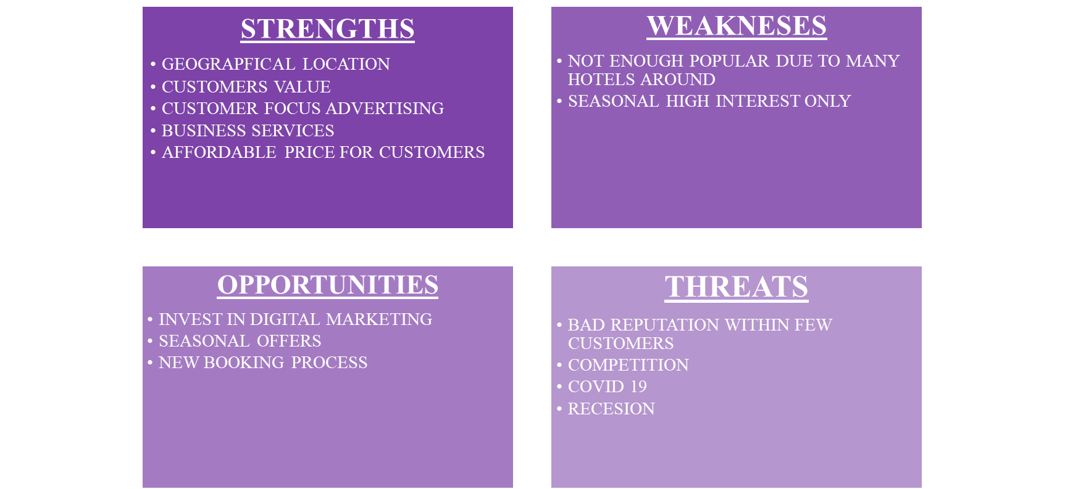

-Customers: Segmentation and Targeting/ Customer profile's.
The hotel is a good choice for young generation people who love parties, festivals and pride parades as Brighton is a very popular location on sea with many various attractions like word festivals. It is a very good choice for family weekend and holiday stay as the family rooms can be booked and special accommodation is provided (Premier Inn, 2022).

-Competitors: Porters five forces:
New entrant threats – There are four hotels close to the Premier Inn Brighton that offer comparable services and utilise different facilities. They offer paid Wi-Fi, TV, restaurants, coffee shops, sofa beds, and desk tables in each of their clients' rooms. According to that, Premier Inn offers its customers free Wi-Fi, discounts for reservations, and particular accommodations for families with children (Premier Inn, 2022).
Substitute threats – There are some indirect competitors here in terms of services like early check in and check out, longer and short stay and transport provided for the customers. Travelodge asking their customers to pay for Wi-Fi provided which in Premier Inn is free for their guests (Travelodge, 2022).
Hotel Du Vin offers only short stay including dinner or just luxury suit stay for two (Hotel Du Vin, 2022).
Premier Inn offer their guest with special accommodation and long stay for minimum 3 nights and get discount for the whole stay.
Customer bargaining power – Customers at Premier Inn can take advantage of a booking offer that entitles them to a larger discount on their third night's stay. In contrast to other hotels, their rates for guests' stays are always the same.
Supplier bargaining power – All of the rival hotels feature dining establishments or lobby bars, which poses a direct threat to Premier Inn. Premier Inn provides its customers with excellent customer service, delectable meals, and a wide selection of wine and spirits (Premier Inn). Unlike other hotels, which solely provide room service (TripAdvisor, 2022).
Industry rivalries – When it comes to booking deals for customers, the prices vary, but they are dependable and competitively priced for the service they offer. The threat in this situation is cheaper rates for one-night reservations, but there is no reduction and excellent lodging service (Bowie, 2013).

-Collaborators: Relationships, Partnerships, Franchises:
Premier Inn has a partnership with Whitbread and also some charity partnership program called GOSH children charity (Premier Inn). Booking can be done via mobile app, booking.com, TripAdvisor and Trustpilot.

-Climate: Macro marketing analysis – PESTEL analyse:
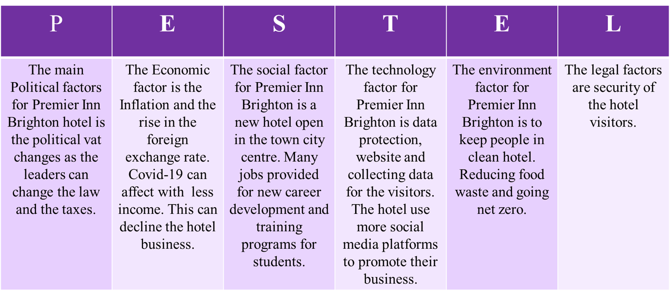

Objectives
-SMART target:
The promotion is in place during winter starting in December and finishes in February.
Promotional offer is available for unlimited number of customers in order to give the opportunity for more people to book and enjoy their stay.
Promotions include a minimum 3 nights booked with a 10 % discount for the first two and 20% discount for the third one.
The promotion will be advertised in November to the radio, TV, social media ( Facebook, Booking.com, Youtube), billboards, posters and collaboration with local businesses. Same as the website and the mobile app. For the existing customers emails will be send with the offer (Johansson, 2019).

Strategy
In terms of the Bowman’s strategy clock theory to positioning product based on the dimensions of price and perceived value using one of the eight models for Premier Inn hotel (Bowman, 2004).
With its vertically integrated business model, Premier Inn offers customers quality and value while generating profit for the steak holder.
The hotel has optimal hotel location, modern design and layout which control and fund development.
Equilibrated freehold/ leasehold with a big network, a lengthy lease, and renovation control.
Consistent consumer offerings under the own brand.
End-to-end operation: Consistently executing at minimal cost with high standards.
Less than 1% of travel was booked using internet agencies, which indicates low cost client acquisition (Whitbread, 2022).

Tactics
(350 Words)
Marketing mix:
Premier Inn Product Strategy – As per the location in Brighton the hotel provide single, double and accessible (wheelchair accesable) rooms to stay for a business meeting or events, Family rooms with king size bed and two pull out of sofa bed for long stay with your friends, parents and children.
Premier Inn Price/ Pricing Strategy – In terms of prices there are several ways for booking offers like Flex, Semi-Flex, Advance, Standard and Non-Flex rates (Premier Inn, 2022).
Premier Inn Place and Distribution Strategy – The hotel is allocated in 144 North Street, Brighton, East SussexBN1 1RE, (Premier Inn, 2022).
Premier Inn Promotion and Advertising Strategy - advertising the digital and social media, radio, outdoor, platforms (Facebook, Tweeter, Instagram, Trip advisor). Winter discount for new customers with 10% discount if you book 2 nights and 20% for the third one.
REACH – The promotion will be raised in November through the website and the mobile app on first place as an official information.
ACT – Accessing the website and wants to find out more about the promotional offer the customers can visit quick link YouTube video, Facebook page or Instagram.
CONVERT – The offer can be purchased via the mobile app or the official website meaning that customers have the opportunities to download the mobile app or just use the website.
ENGAGED – Quick survey how satisfied are the customers using the service with discount booking including questions like:
How often do you use this service?
How long do you usually stay when you book a hotel?
Are you looking for discount offer for your booking?

People – apprenticeships programme for young people and students who wants to develop in their carrier and to corporate social responsibility.
Process - simple booking process via website, mobile app or phone line.
Physical evidence – comfortable beds and pillows, TV and Wi-fi, desk table and sofa bed placed in the rooms.

Action
-Gannt chart of marketing activities: Preparation, Market research, Marketing channels schedule, Gathering feedback.
To act the marketing plan for the promotional offer in Premier Inn Brighton is more effectively to use the Gannt’s chart of marketing activities. This project management application allows users to visualise project timelines, progress, and deliverables. By employing visual lines or bars that highlight which activities have been completed and what has to be done, this can efficiently assign time and responsibilities (Gannt, 2015).
The Gannt chart for this promotion is about to advertising the offer in order to reach more new customers. In the table added to this essay it shows when the promotional offer will be advertising and for how long using TV, Radio, Facebook, Instagram, etc.
Some feedback needs to be taken from the customers in order to measure the success of the promotion.

Control
In order to control the promotional product, offer it is very important to focus on customers as their experience is one of the relevant propositions selling. However, the main part to control is to position on the hotel market in contrast with the competitors.
To control the plan for this promotion offer is also important to measure success using survey, taking feedback from customers and check reviews about the placed offer. Especially for the new customers to get more engaged with them there is some feedback tool provided for them in order to hear from them and improve the services in the future.

Conclusion
The above essay describes the marketing plan for Premier Inn Brighton where many analyses and plan have been placed. To summarise the Marketing plan for advertising discount booking offer for the winter period is good to say that the promotion offer is a good opportunity to attract new customers.
Finally, some recommendations for the above plan is to focus more on advertising and mostly on social media services and use more resources to satisfied the customers.

References

Beamish, K. and Ashford, R., 2006. The Official CIM Coursebook: Marketing Planning.
Premier Inn (2022) About us, available at: https://www.premierinn.com/gb/en/why.html (accessed 28 November 2022)
Whitbread (2022) About us, available at: https://www.whitbreadcareers.com/about-us/ (accessed 01 December 2022)
https://www.brighton-hove.gov.uk/news/2022/visitbrighton-plays-key-role-recovery-tourism-and-wider-economy (accessed 04 December 2022)
Travelodge (2022) About, available at: https://www.travelodge.co.uk/about/wifi/ (accessed 03 December 2022)
Jefferson, M. (2021) Premier Inn pins recovery hopes on marketing with ‘invest to win’ strategy, available at: https://www.marketingweek.com/premier-inn-recovery-marketing/ (accessed 30 November 2022)
Gantt, H., 2015. Gantt chart.
Bowman, K.S., 2011. Sustainable tourism certification and state capacity: Keep it local, simple, and fuzzy. International Journal of Culture, Tourism and Hospitality Research.
Bowie, D. and Buttle, F., 2013. Hospitality marketing. Routledge.
Jones, P., Hillier, D. and Comfort, D., 2014. Sustainability in the global hotel industry. International Journal of Contemporary Hospitality Management.
Bowie, D., Buttle, F., Brookes, M. and Mariussen, A., 2016. Hospitality marketing. Routledge.
George, R., 2021. Market Segmentation, Targeting, and Positioning. In Marketing Tourism and Hospitality (pp. 221-246). Palgrave Macmillan, Cham.
Phillips, P.A., 1999. Performance measurement systems and hotels: a new conceptual framework. International Journal of Hospitality Management, 18(2), pp.171-182.
Johansson, L., 2019. The social media platforms.
Percy, L., 2008. Strategic integrated marketing communications. Routledge.
Jones, P. and Ioannou, A., 1993. Measuring guest satisfaction in UK‐based international hotel chains: principles and practice. International Journal of Contemporary Hospitality Management.

Appendices

- 

