International Meetings Management for the Hotel Industry

BMIH6007

Presentation: Voices of Inclusion Storytelling Festival

Lecturer: Chris Wilkin

Student name:
Lucian Stefan Mihaita
2234126

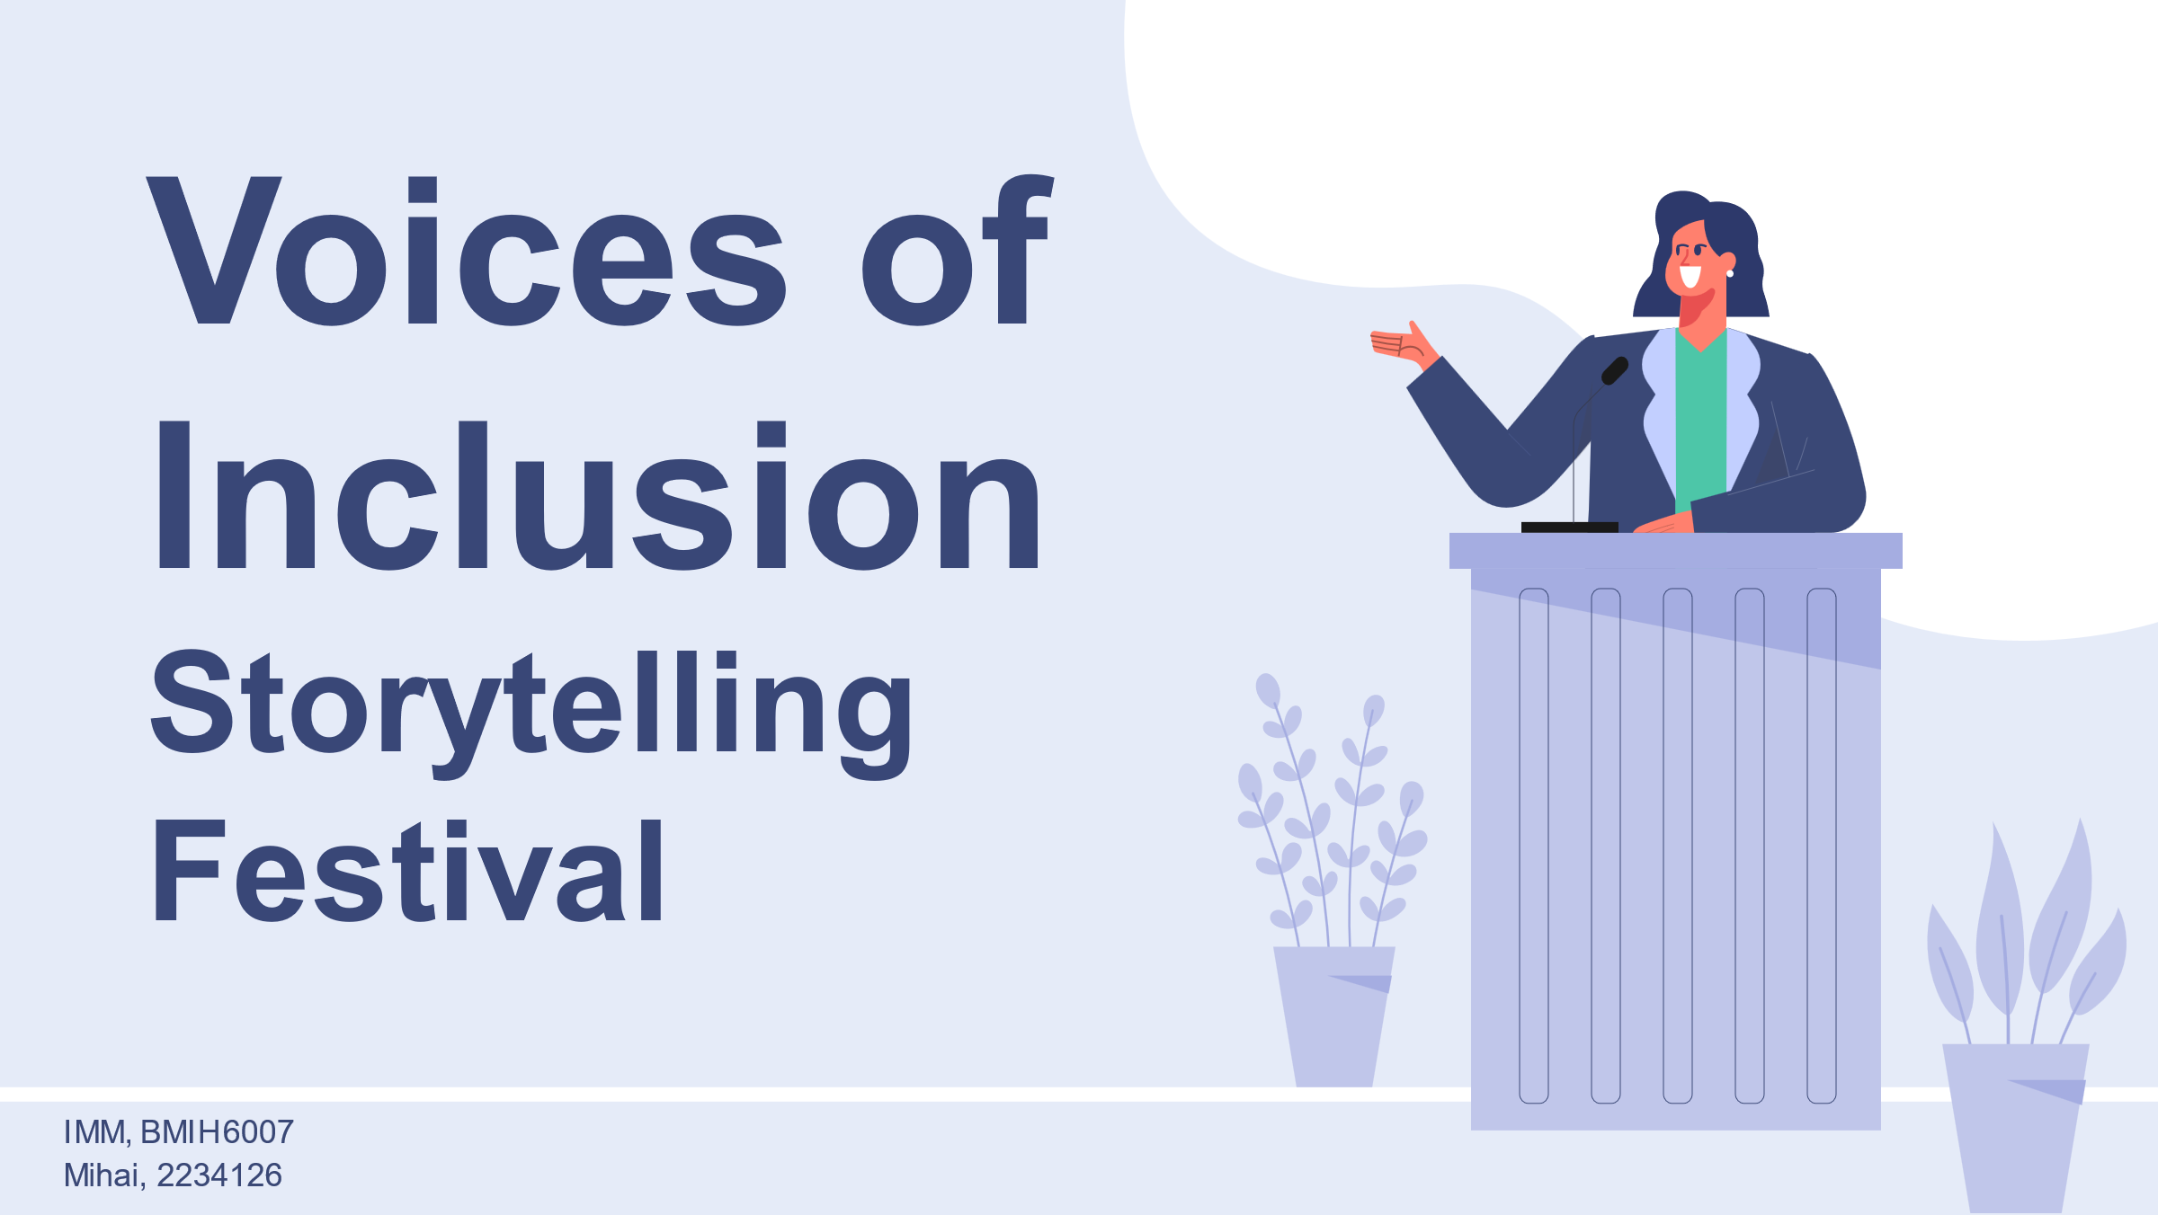
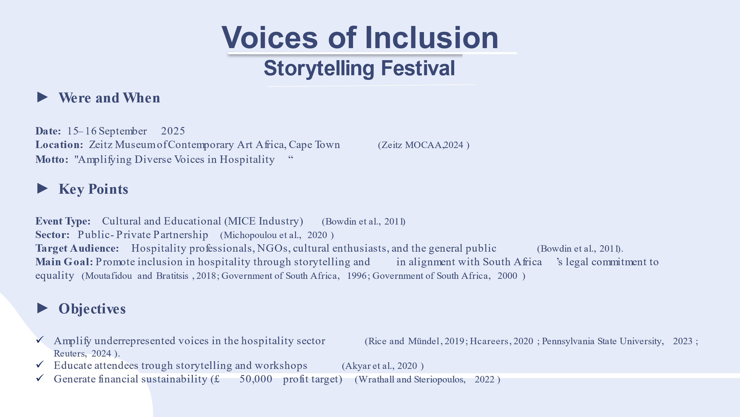
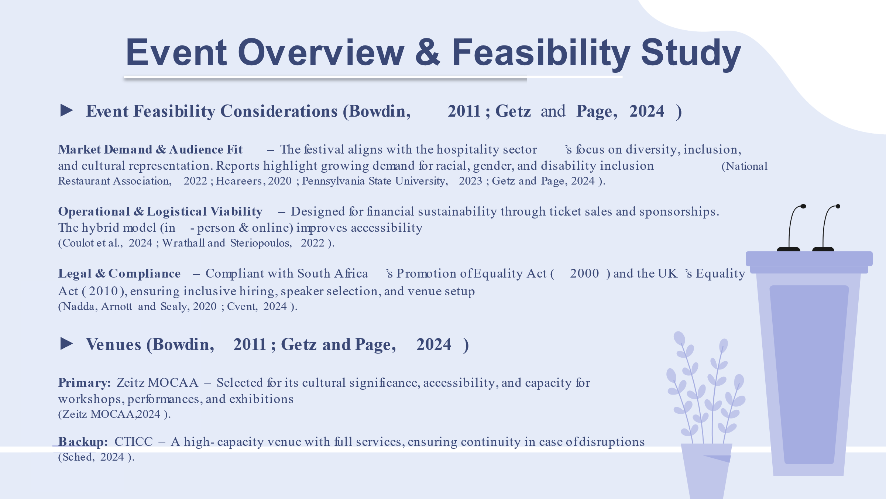
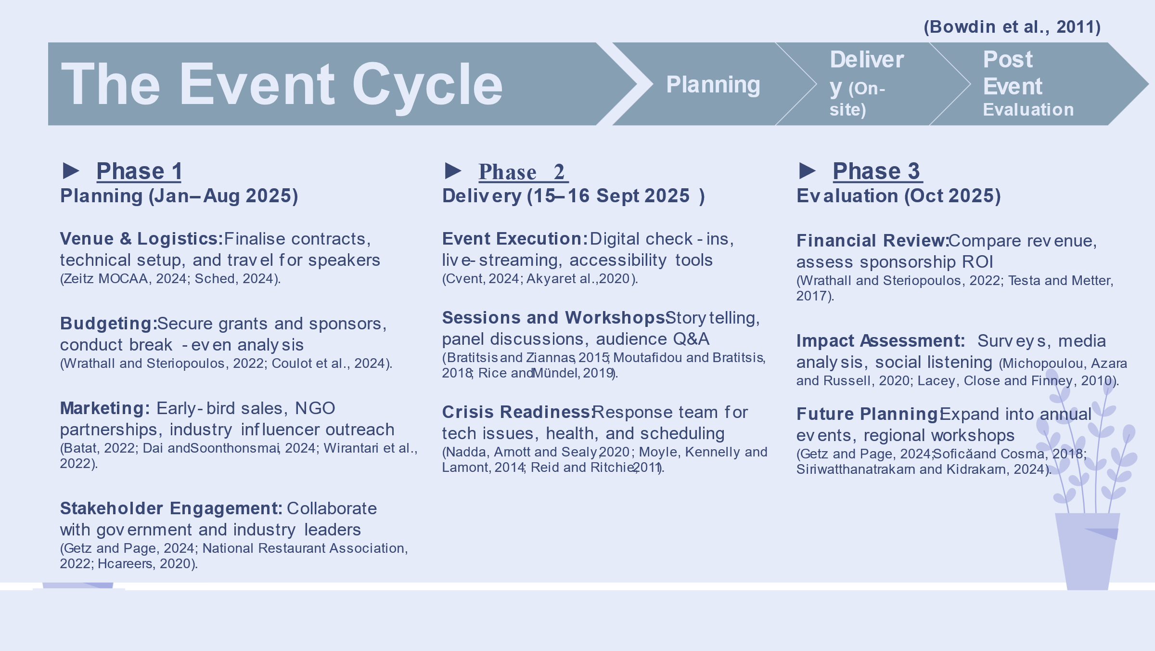

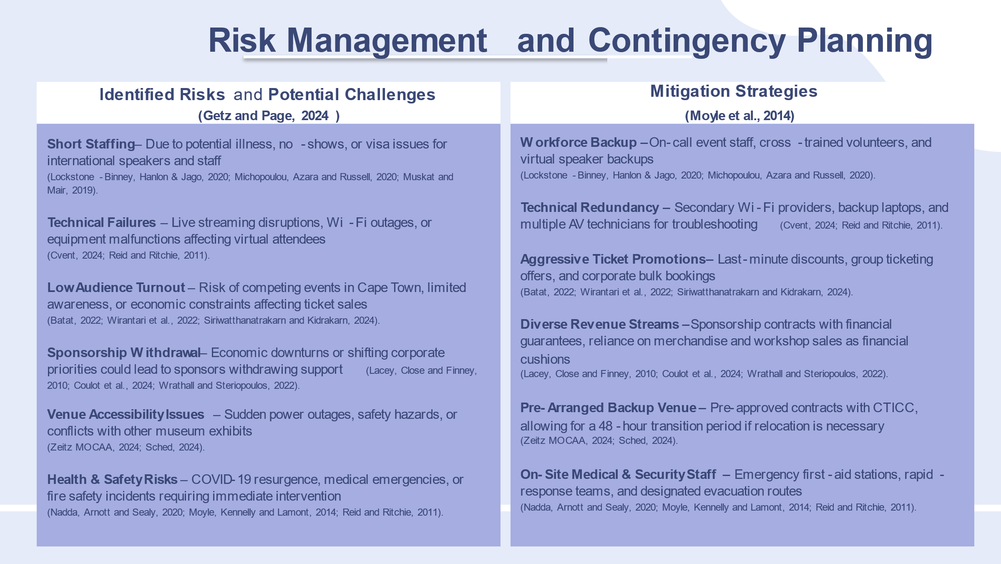
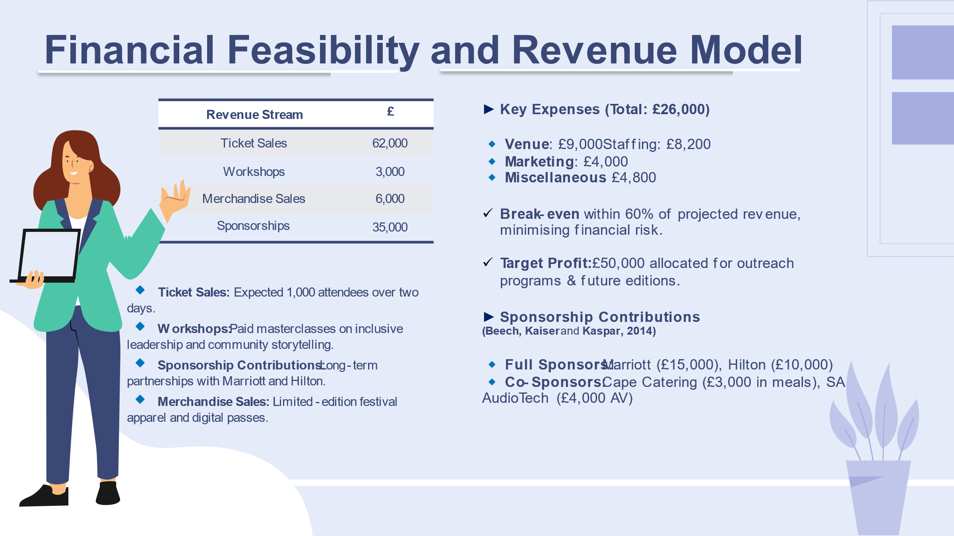
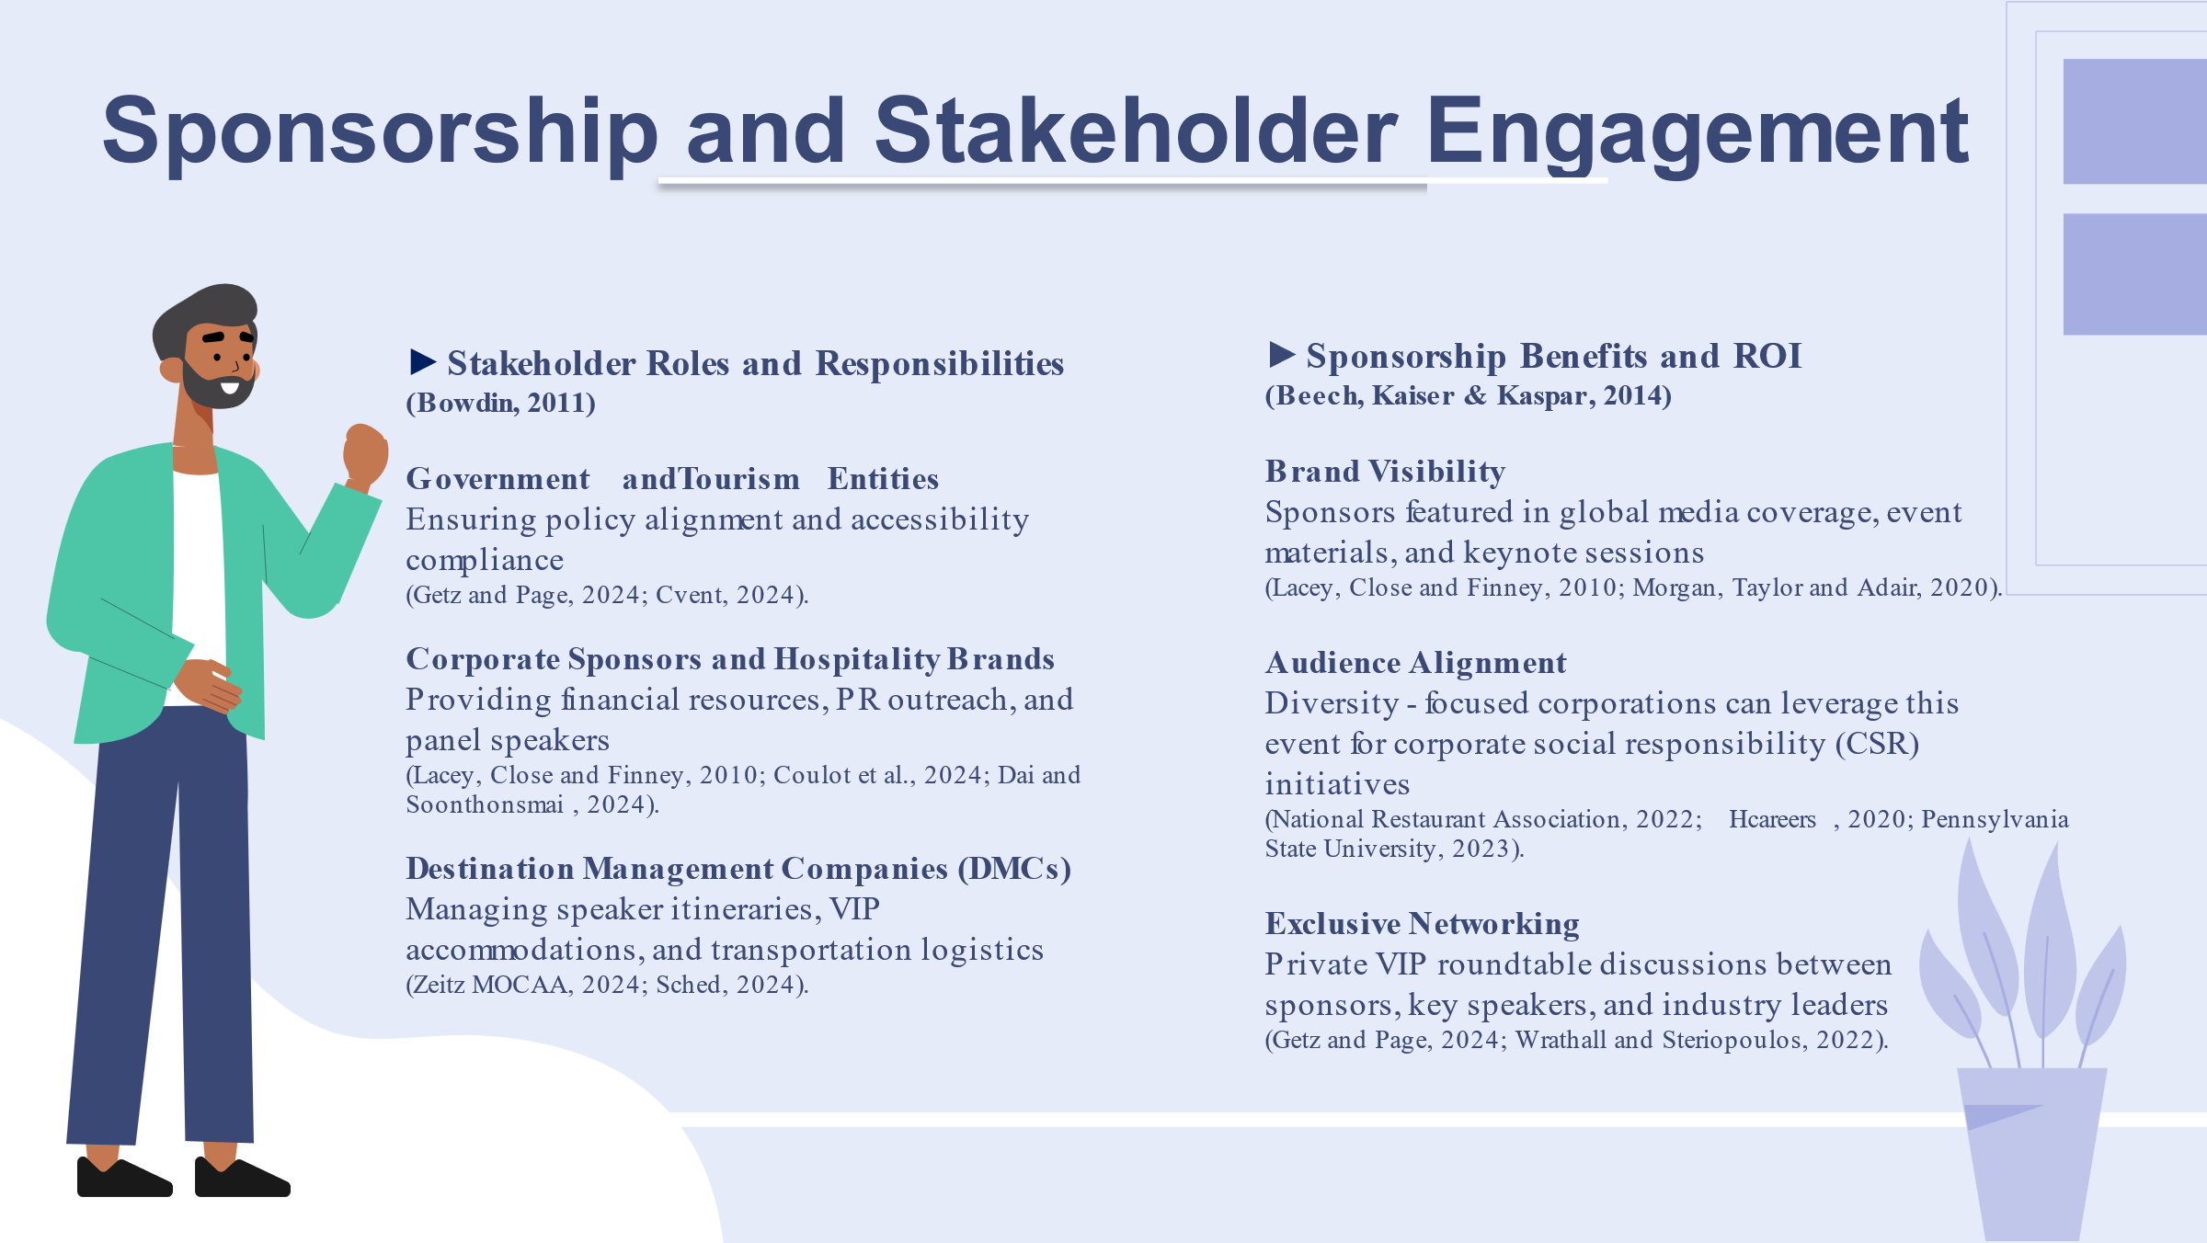
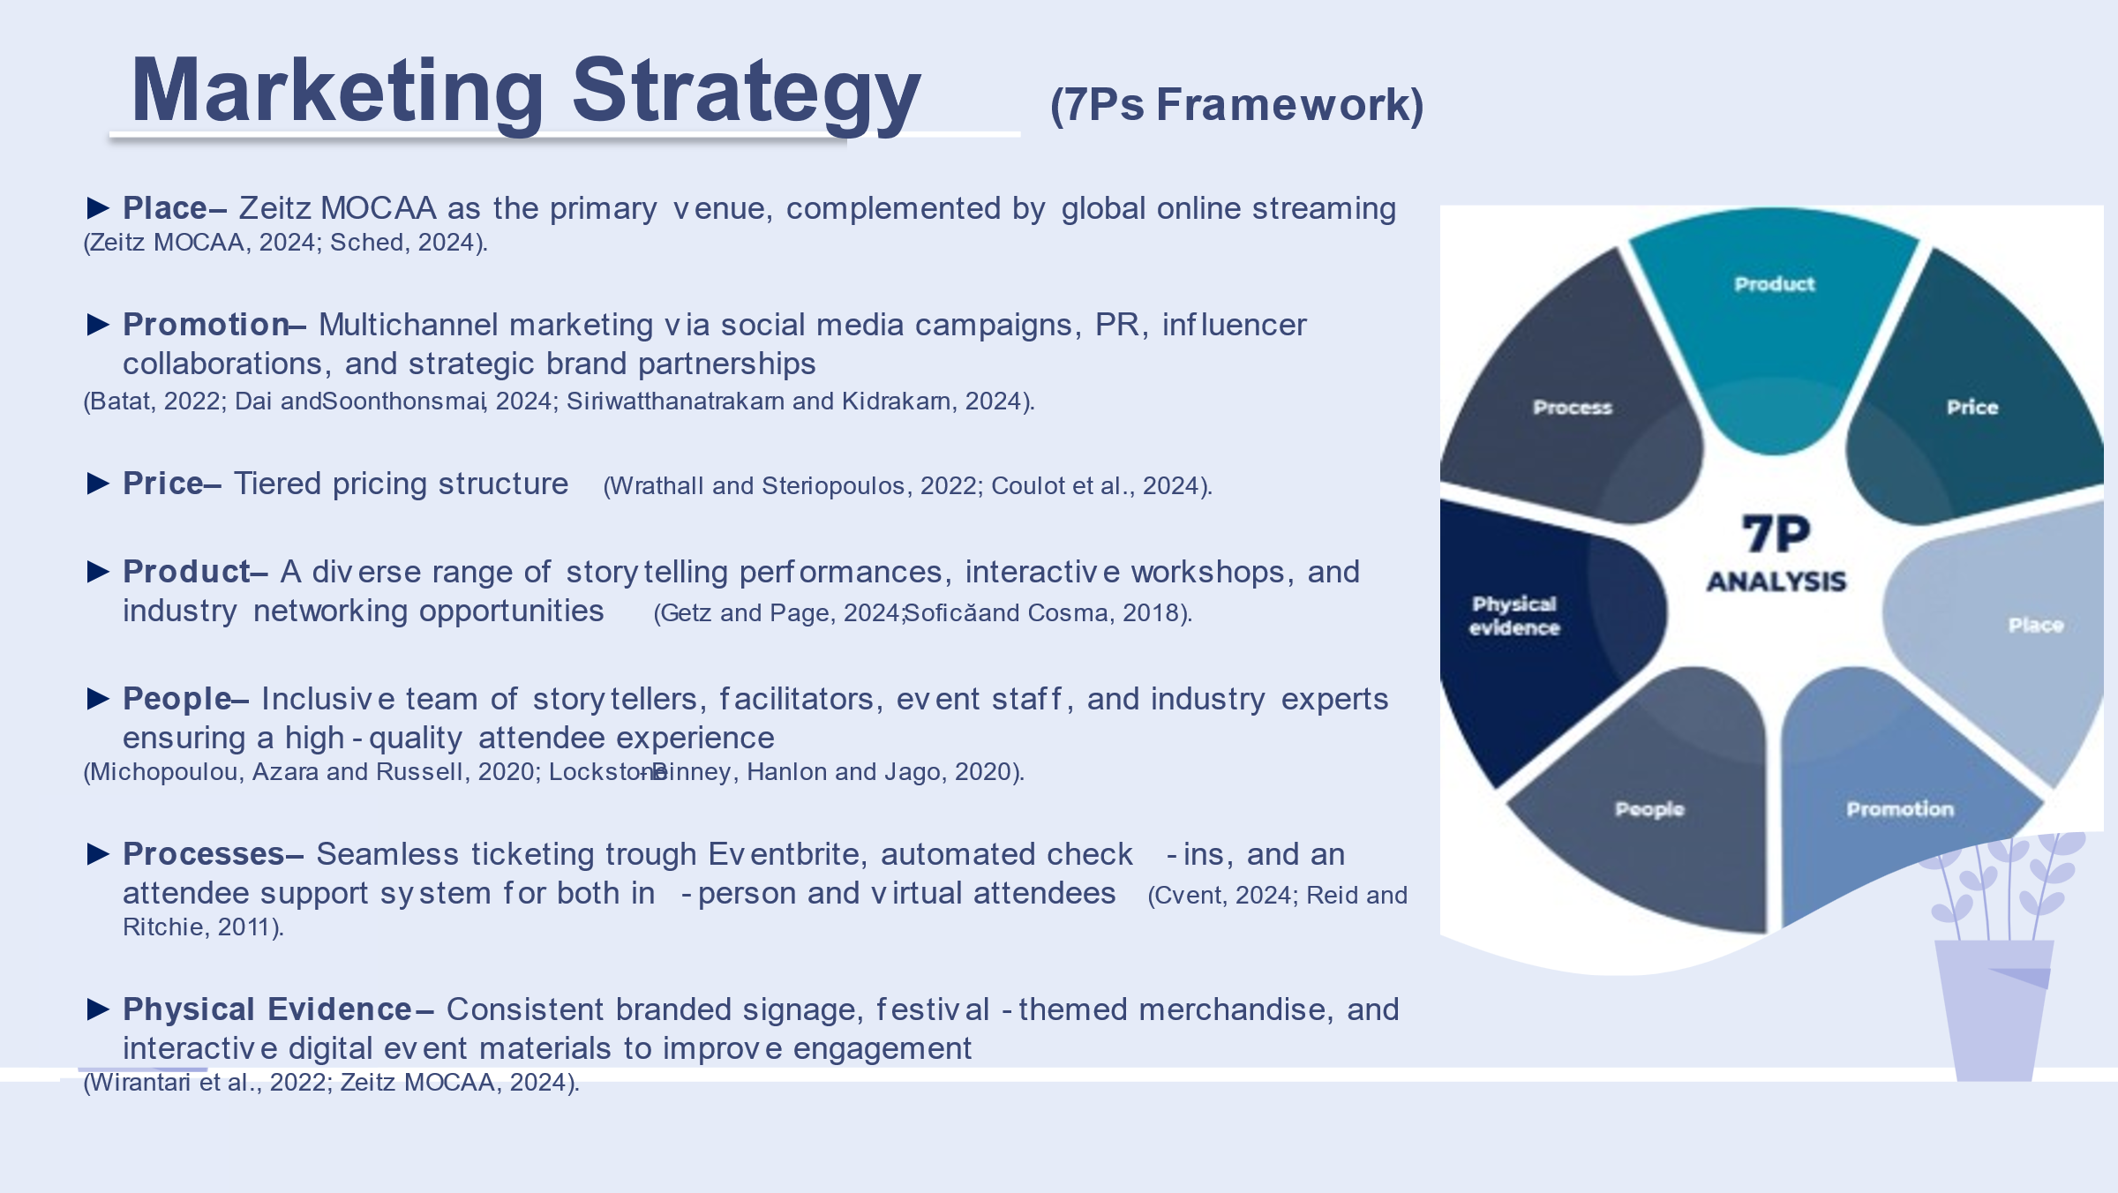
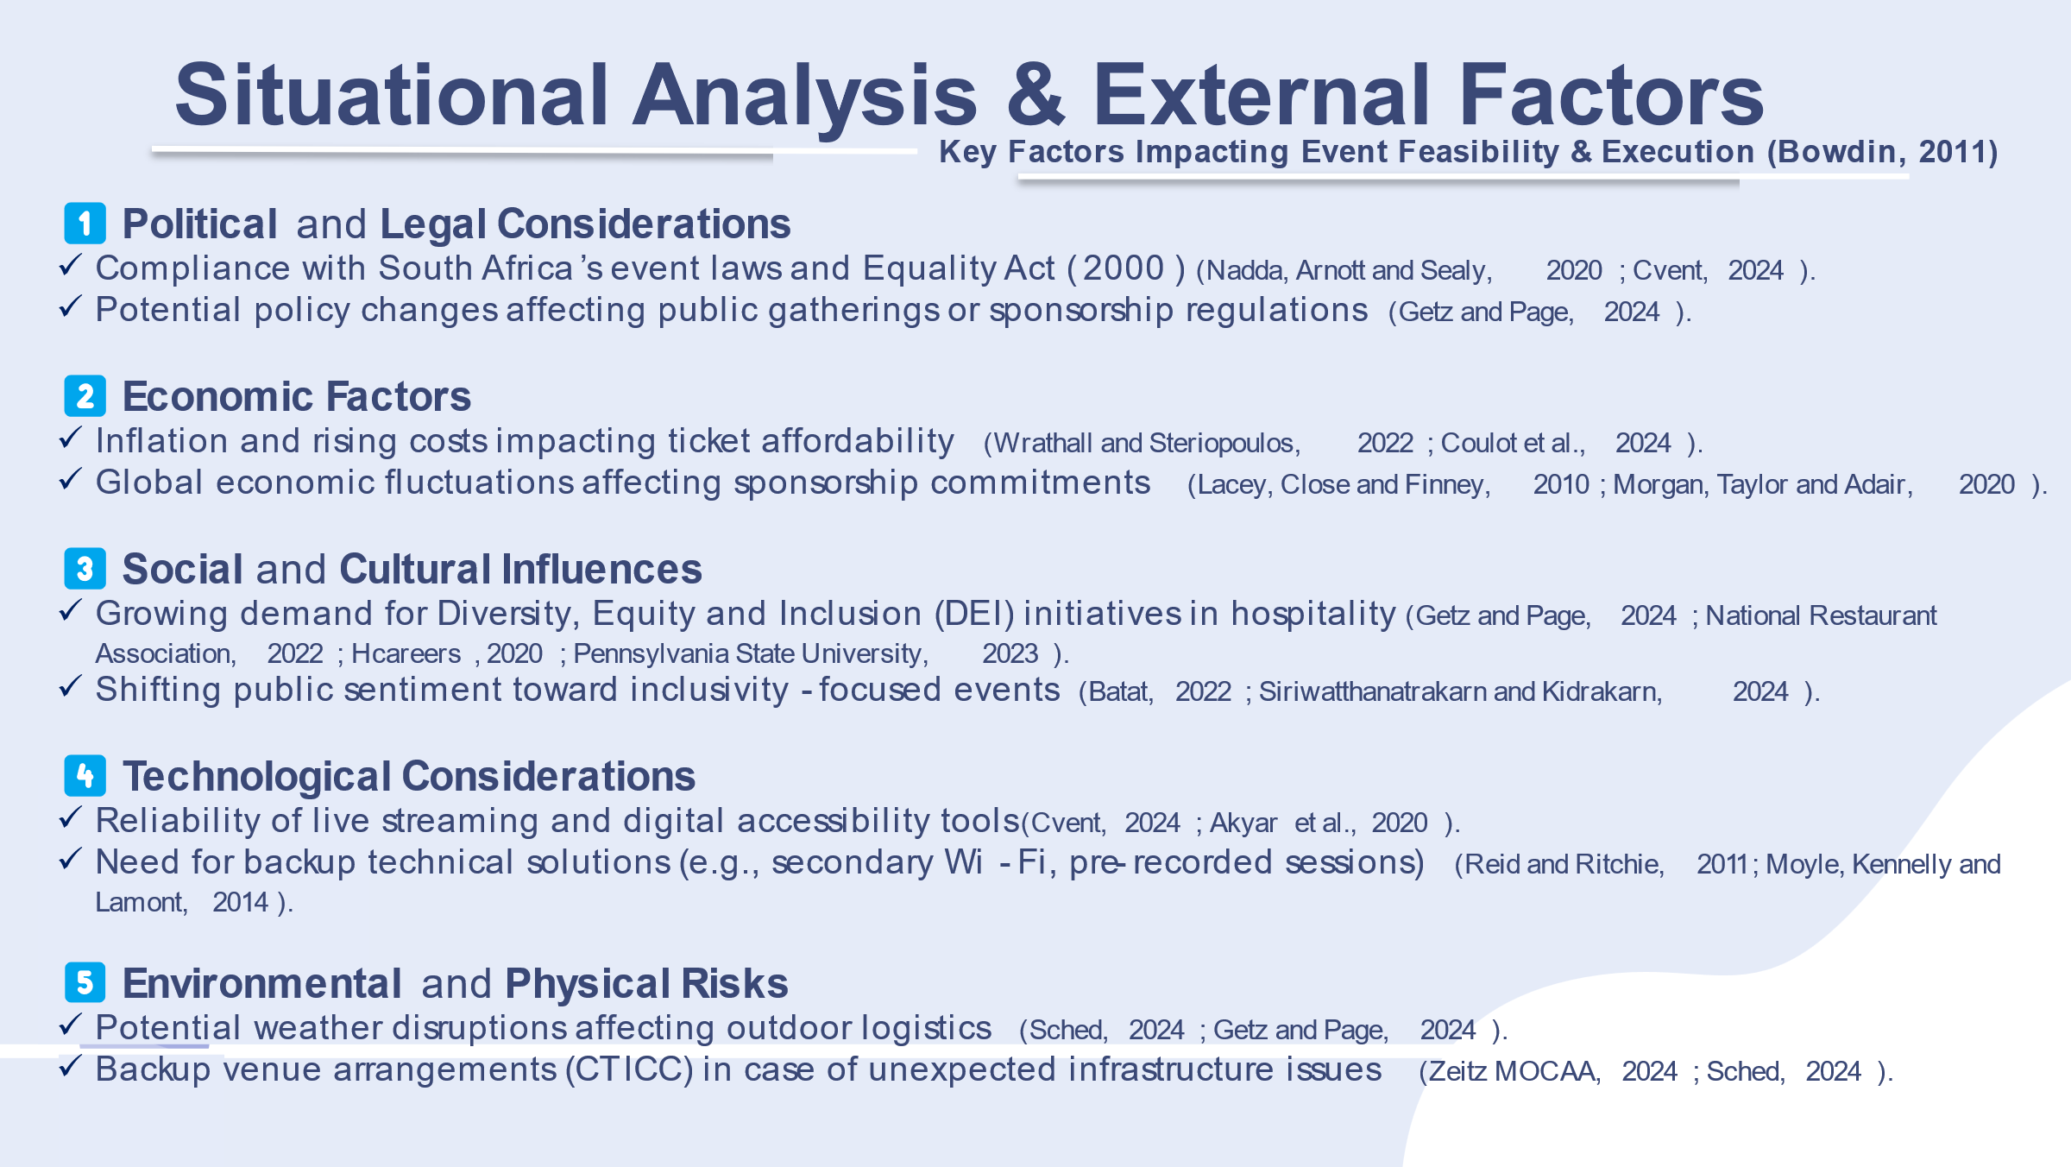
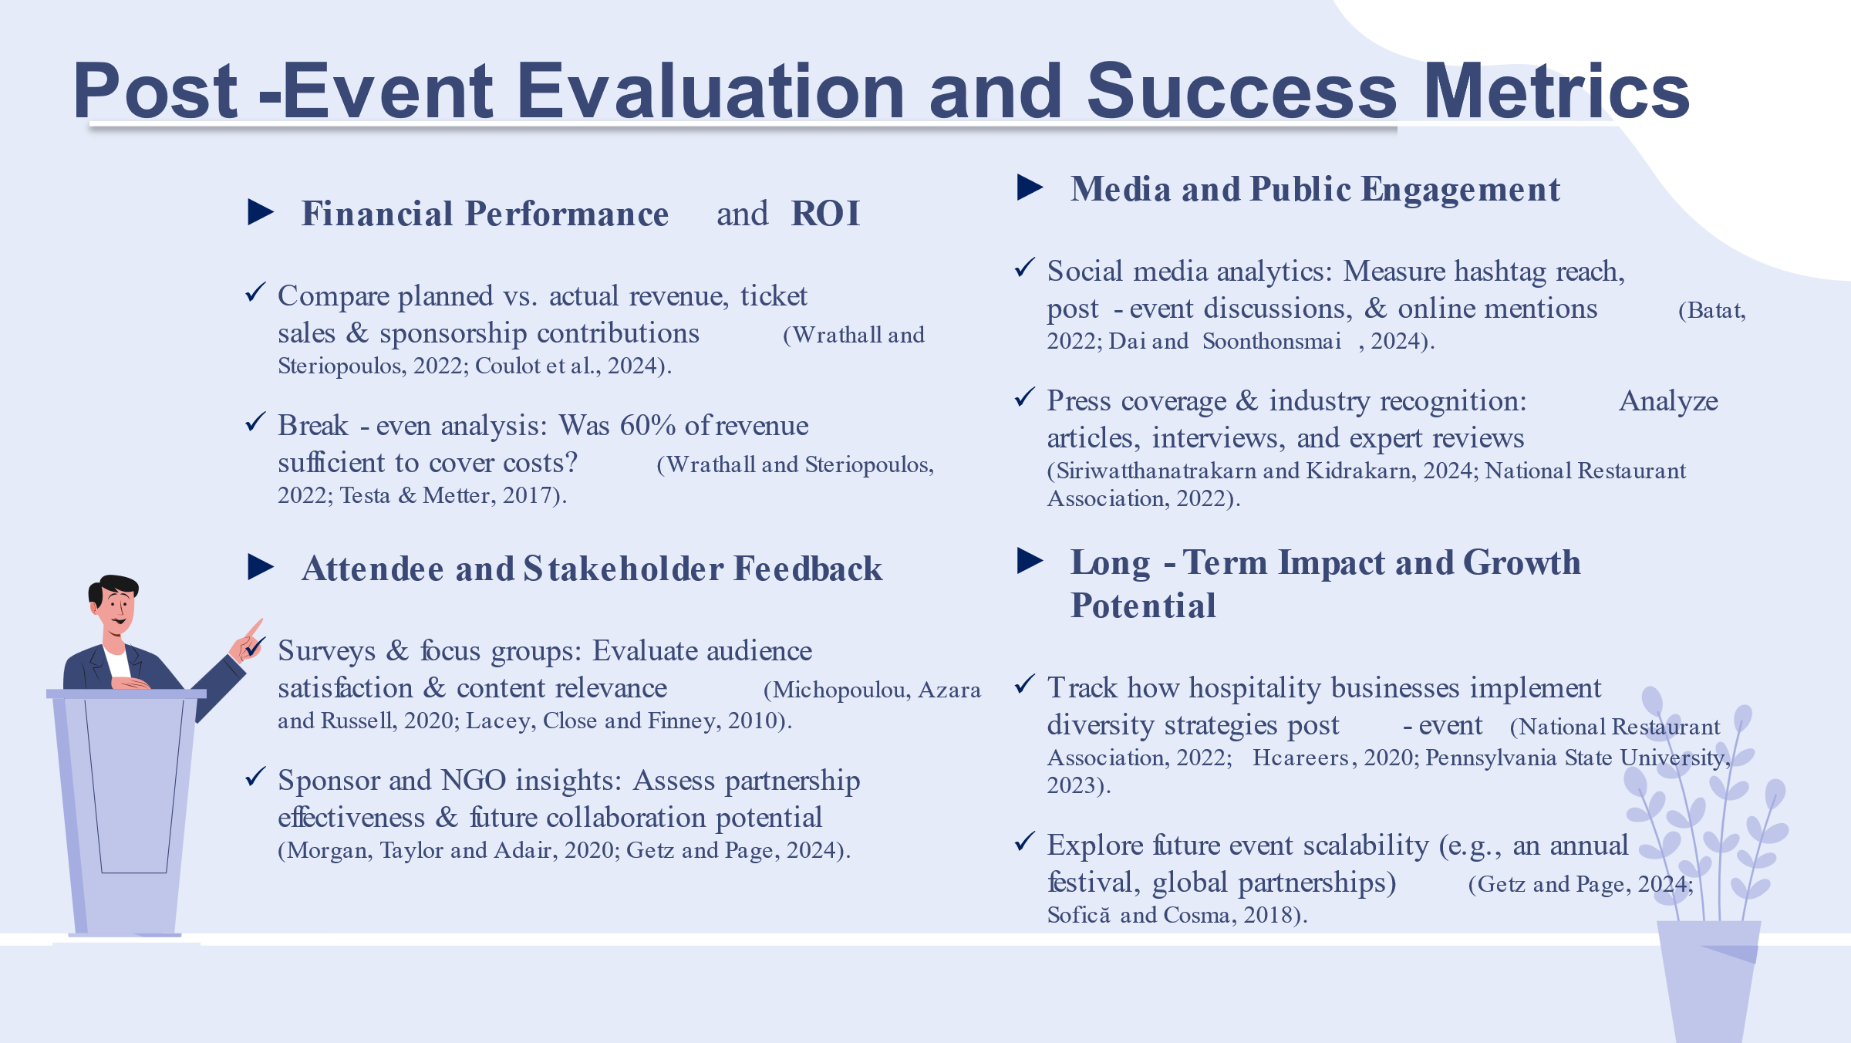

Reference

Akyar, Ö.Y., Demirhan, G., Oyelere, S., Flores, M. and Costas Jáuregui, V., 2020. Digital storytelling in teacher education for inclusion. https://www.proquest.com/scholarly-journals/special-education-teachers-professional/docview/2642951397/se-2?accountid=130472
Álvarez, D.C., Rodríguez, A.L. and Dono, J.A.M., 2018. Risk management and design of mitigation plans through discrete events simulation. https://www.academia.edu/download/100034591/ijscom.2018.09945620230319-1-q1f3re.pdf
Nadda, V., Arnott, I. and Sealy, W., 2020 Risk Managment in Events Management’, in Legal, Safety, and Environmental Challenges for Event Management. United States: IGI Global, pp. 1–20. Available at: https://doi.org/10.4018/978-1-7998-3230-0.ch001.
Batat, W., 2022. Why is the traditional marketing mix dead? Towards the “experiential marketing mix” (7E), a strategic framework for business experience design in the phygital age. Journal of Strategic Marketing, 32, pp. 101 - 113. https://doi.org/10.1080/0965254X.2022.2129745.
Bowdin, G., Allen, J., Harris, R., 2011. Events Management. [online] Available at: https://research-ebsco-com.ezproxy.uwtsd.ac.uk/linkprocessor/plink?id=0713b2d6-c559-3133-a063-9c460741a170
Bratitsis, T., and Ziannas, P., 2015. From Early Childhood to Special Education: Interactive Digital Storytelling as a Coaching Approach for Fostering Social Empathy. , pp. 231-240. https://doi.org/10.1016/j.procs.2015.09.267.
Chirieleison, C., and Montrone, A., 2013. Evaluating local government costs and revenues: The case of an Italian privately owned for-profit event. Tourism Management Perspectives, 8, pp. 90-97. https://doi.org/10.1016/J.TMP.2013.08.001.
Coulot, M., Pellerin, R., Yahia, E. and Harris, S., 2024. Predictive Methods for Event Revenues and Expenses to Support Convention Center Portfolio Management. Proceedings of the 12th IPMA Research Conference “Project Management in the Age of Artificial Intelligence”. https://doi.org/10.56889/drzt2050.
Cvent, 2024. Event Planning for Accessibility: Tips and Best Practices. [online] Available at: https://www.cvent.com/en/blog/events/event-planning-accessibility-tips-and-best-practices
Dai, H. and Soonthonsmai, V., 2024. The Effect of 7P Marketing Strategy and Lifestyle on Customer Loyalty at Shanghai Disneyland, China. KnE Social Sciences. https://doi.org/10.18502/kss.v9i29.17269.
DuHadway, S., Carnovale, S. and Hazen, B., 2019. Understanding risk management for intentional supply chain disruptions: risk detection, risk mitigation, and risk recovery. Annals of Operations Research, pp. 1-20. https://doi.org/10.1007/S10479-017-2452-0.
Getz, D. and Page, S., 2024. Event Studies: Theory and Management for Planned Events. 5th ed. London: Routledge.https://librarysearch.uwtsd.ac.uk/permalink/44WHELF_UWTSD/upgrip/alma99100647735602421
Hazira, M., Alagas, E., Amin, M., Zamzuri, N. and Zairul, M., 2021. The best practice of marketing strategies for the Malaysian business event industry from experts' perspective. Journal of Hospitality and Tourism Insights. https://www.proquest.com/scholarly-journals/best-practice-marketing-strategies-malaysian/docview/2646686874/se-2?accountid=130472
Ahmed, R., 2017. Risk mitigation strategies in innovative projects. In Key Issues for Management of Innovative Projects. IntechOpen. https://papers.ssrn.com/sol3/Delivery.cfm?abstractid=3884687
Kristiana, S., Oktavia, C., Magdalena, R. and Lilajati, M., 2020. Risk Mitigation Strategies on Supply Chain PT. X. IOP Conference Series: Materials Science and Engineering, 847. https://doi.org/10.1088/1757-899X/847/1/012052.
Lacey, R., Close, A., & Finney, Z., 2010. The Pivotal Roles of Product Knowledge and Corporate Social Responsibility in Event Sponsorship Effectiveness. Journal of Business Research. https://doi.org/10.1016/J.JBUSRES.2009.11.001.
Lockstone-Binney, L., Hanlon, C. and Jago, L., 2020. Staffing for successful events. The Routledge Handbook of Events. https://doi.org/10.4324/9780429280993-27.
Michopoulou, E., Azara, I. and Russell, A., 2020. Investigating the triangular relationship between temporary event workforce, event employment businesses and event organisers. International Journal of Contemporary Hospitality Management, 32, pp. 1247-1273. https://www.proquest.com/scholarly-journals/investigating-triangular-relationship-between/docview/2498996211/se-2?accountid=130472
Morgan, A., Taylor, T., & Adair, D., 2020. Sport event sponsorship management from the sponsee’s perspective. Sport Management Review. https://doi.org/10.1016/j.smr.2020.04.006.
Moutafidou, A., & Bratitsis, T., 2018. Digital storytelling: giving voice to socially excluded people in various contexts. Proceedings of the 8th International Conference on Software Development and Technologies for Enhancing Accessibility and Fighting Info-exclusion. https://doi.org/10.1145/3218585.3218684.
Moyle, B., Kennelly, M. and Lamont, M., 2014. Risk management and contingency planning in events: Participants’ reactions to the cancellation of Ironman New Zealand 2012. International Journal of Event Management Research, 8(1), pp.94-106. https://citeseerx.ist.psu.edu/document?repid=rep1&type=pdf&doi=2817eb1b745aaebc3e07b563cc2e7a72e90029b0
Muskat, B. and Mair, J., 2019. Knowledge Sharing and Power in the Event Workforce. https://www.proquest.com/scholarly-journals/knowledge-sharing-power-event-workforce/docview/2779511486/se-2?accountid=130472
Nam, C., 2017. The effects of digital storytelling on student achievement, social presence, and attitude in online collaborative learning environments. Interactive Learning Environments, 25, pp. 412 - 427. https://doi.org/10.1080/10494820.2015.1135173.
Quinn, B., 2013. Key Concepts in Event Management. London: SAGE Publications. https://sk.sagepub.com/books/key-concepts-in-event-management
Reid, S. and Ritchie, B., 2011. Risk Management: Event Managers' Attitudes, Beliefs, and Perceived Constraints. Event Management, 15(4), pp.329–341. https://www.proquest.com/scholarly-journals/risk-management-event-managers-attitudes-beliefs/docview/2779415463/se-2?accountid=130472
Rice, C., & Mündel, I., 2019. Multimedia Storytelling Methodology: Notes on Access and Inclusion in Neoliberal Times. Canadian Journal of Disability Studies. https://doi.org/10.15353/CJDS.V8I1.473.
Saavedra, J., Pérez, E., Crawford, P., & Arias, S., 2018. Recovery and creative practices in people with severe mental illness: evaluating well-being and social inclusion. Disability and Rehabilitation, 40, pp. 905 - 911. https://doi.org/10.1080/09638288.2017.1278797.
Sched, 2024. Event Venue Selection: 8 Factors to Consider & How to Choose. https://sched.com/blog/venue-selection/
Siriwatthanatrakarn, C., & Kidrakarn, K., 2024. The Development of Integrated Marketing Communication Strategies for Organizing International Running Events. Studies in Media and Communication. https://doi.org/10.11114/smc.v12i4.7009.
Sivasankaran, V., , B., Mahadik, S., Khair, M., Goel, O., & Jain, A., 2023. Effective Risk Mitigation Strategies in Digital Project Management. Innovative Research Thoughts. https://doi.org/10.36676/irt.v9.i1.1500.
Sofică, A., & Cosma, S., 2018. Extended Marketing Mix (7Ps) and HRM Recruiting. How to Sell a Job. Studia Universitatis Babeș-Bolyai Negotia. https://doi.org/10.24193/SUBBNEGOTIA.2018.3.01.
Testa, M.R. and Metter, M., 2017. Assessing economic impact as a means for event efficacy: A proposed model and case study. Event Management, 21, pp.61-70. https://www.proquest.com/scholarly-journals/assessing-economic-impact-as-means-event-efficacy/docview/2779500131/se-2?accountid=130472
Wirantari, K., Aryana, N., Sutama, K., Mudana, G., Ruki, M., & Mataram, G., 2022. Implementation of Marketing Mix to Increase Meeting Events. International Journal of Travel, Hospitality and Events. https://doi.org/10.56743/ijothe.v1i2.18.
Wrathall, J., & Steriopoulos, E., 2022. Event budgeting and financial health. Reimagining and Reshaping Events. https://doi.org/10.23912/9781911635871-4963.
Zeitz MOCAA, 2024. Zeitz Museum Event Hosting. [online] Available at: https://zeitzmocaa.museum/
National Restaurant Association, 2022. Diversity, Equity, and Inclusion in the Restaurant Industry. https://restaurant.org/research-and-media/research/research-reports/dei/
Hcareers (2020) ‘Survey Results: Diversity and Hospitality Upper Management’, Hcareers. Available at: https://www.hcareers.com/article/employer-articles/survey-results-diversity-and-hospitality-upper-management
Pennsylvania State University (PSU) (2023) ‘Hotel Industry Board Diversity Report 2023’, School of Hospitality Management, PSU. Available at: https://hhd.psu.edu/sites/default/files/hospitality-management-hm/shm/hospitality-management-hmshm-hotel-industry-board-diversity-report-2023.pdf
Reuters (2024) ‘Migrants are making their mark in Italy’s restaurant kitchens’, Reuters, 10 October. Available at: https://www.reuters.com/world/europe/migrants-are-making-their-mark-italys-restaurant-kitchens-2024-10-10/

I acknowledge the use of Grammarly App and Microsoft Word Editor on 07th February 2025 to check my grammar syntax.

I confirm that I have not presented an AI generated text as my own work.

I confirm I have copies of my draft, notes and other resources I used before and after the use of AI tools which I may be asked to provide in evidence.

