Component 2 - Research Report

Student name: Raquel Salmon
Student number: 2224841
Lecturer name: Daminabo Pokubo

LCHS4002_BIRM
Digital Skills and Research Methods

Contents page

- Introduction ……………………………………………………….page 3
1.1 Importance of Digital Skills
- Research Design ………………………………………………….page 4
2.1 Research Question
2.2 Methodology
2.3 Ethical Consideration
- Results ………………………………………………………………page 6-8
- Discussion ………………………………………………………….page 8
- Conclusion ………………………………………………………….page 9
- Reference List ……………………………………………………...page 10
- Appendix A – Blank copy questionnaire ………………………page 11

- Introduction
In this report we will look at and find out the importance of digital skills used for study and at the workplace. This report will examine data acquired from a questionnaire that was given to students at (UWTSD). As the focal point on digital competence continues to rise in approval in higher education studies and the workplace as both organisations require the bare minimum of digital skills. Digital skills have been put in place to be remarkably important in today’s creation of work and study. According to Lordache, Marien, and Baelden, (2017), “digital skills can be defined as having the capability to use digital tools productively to carry out various duties in the office or school environment effectively”. Nevertheless, Deursen and Dijk (2009), specified that there are numerous definitions of digital skills, providing a few more definitions will be much useful to this report.
Workers and Students can use a range of digital skills that will be applicable to their studies and work. Some examples of digital skills are mentioned below,
- Ability to use Microsoft applications, (report witing, presentations etc)
- Communicate and collaborate using Microsoft teams or outlook.
- Ability to share data and information appropriately.
- Transacting with online banking, transfers
- Problem solving, using digital skills and tools to come up with resolutions.
On the other hand, there are a long list of digital tools that can be accessed to do a wide range of things, from work, study and everyday life which can be,
- Microsoft word
- Microsoft teams
- Outlook
- Facebook
- Skype
- Moodle
- WhatsApp
- Microsoft OneDrive
Students and workers can make use of these tools to carry out appointed tasks successfully to meet an agreed level of standards. As technology advances each education institution and workplaces require a basic level of digital competency, even jobs that require no qualifications. Digital tools hold a solid significance in everyday life making communication instant and direct, being competent using digital tools also boosts confidence in work performance and in study performance. The next segment will high-point the importance of digital skills and tools to workers and students.
  - Importance of digital skills.

- Employees competent in digital skills are high in demand, due to high-tech changes in business and education, encouraging workers and students to obtain new digital skills.
- Knowing how to utilise digital tools and skills in the workplace can boost one’s confidence in executing different tasks.
- Compounded estimations can be carried out more sufficiently by making use of digital tools such as, Microsoft excel.
- Impediments can be fragmented by using digital tools.
- Digital skills in the workplace will allow you to work from home or a different location using online digital tools such as, skype, zoom, Microsoft teams and Facetime to communicate.
- Digital skills are essential for engaging in money transfers and online transactions.

- Research Design - This research carried out is primary research which aims to find out the importance of digital skills frequently used by students at UWTSD. A quantitative research approach was used to accomplish the aim and purpose of this research. Applying the quantitative research approach, a questionnaire was created and given out to students through email and barcode at UWTSD. In order to comprehend the research design for this research a clarification of primary research will be provided.
Moreover, primary research is known as original research where the researcher gathers immediate information being investigated (Ohgaki and Kleihues, 2019). This type of research design is completely different from secondary research. Some key differences to separate primary and secondary research are clarified in the table created below.
Primary research | Secondary research
Surveys | Published data
Interviews | Books
Clinical trials | Government reports
Data | Official statistics

  - Research Question - This analysis focuses to answer the research question below.
Which digital tools are most used by students at UWTSD?
Microsoft outlook is mostly used by students at UWTSD, Microsoft outlook is an essential part of every organisation, outlook enables students at UWTSD to correspond, network and collaborate with other students, send, and receive emails, access university online resources, contact student services and IT support for students experiencing any technical issues passwords etc.
  - Method
Quantitative research is a plan of action that uses data to test and trial products, investigate and observe trends. Quantitative research can be conducted in different ways such as, percentages and proportions. Quantitative research is different to qualitative research because quantitative research is used when you want to experiment, observe and evaluate something, whereas qualitative research is used if you want to comprehend things like theories, thoughts and knowledge from society. There are many ways to collect data in quantitative research by using questionnaires, interviews, surveys, observation and carrying out experiments. A questionnaire is a range of questions put out to the public. Google forms was used to conduct the questionnaire produced, four questions were asked using a combination of closed and open questions and was shared with students at UWTSD via barcode sent out through email.
  - Ethical Considerations - Lordache, Marien and Baelden, (2017), stated, ethical awareness and cultural awareness are highly important when carrying out quantitative research. Consent is the main factor of ethical consideration, according to Connelly, (2014), “Consent consists of the following: consent should be given freely (voluntary), subjects should understand what is being asked of them, and involved persons must be competent to consent. When carrying out primary research persons have the right to withdraw from the research at any time”. Ethics is important to protect participants from unlawful research. Not following approved protocol is an ethical issue and can be prevented by following approved guidelines when conducting primary research. According to Pierce, (1997), at times the boundary between a complex decision problem often requires some analytic intervention.

- Results
This segment will highlight the results taken from the data collected from all participants. In this report, results will be put forward using a combination of graphs and a pie chart sectioned below.

- Do you feel confident using Outlook?
Students were asked if they are confident using outlook.
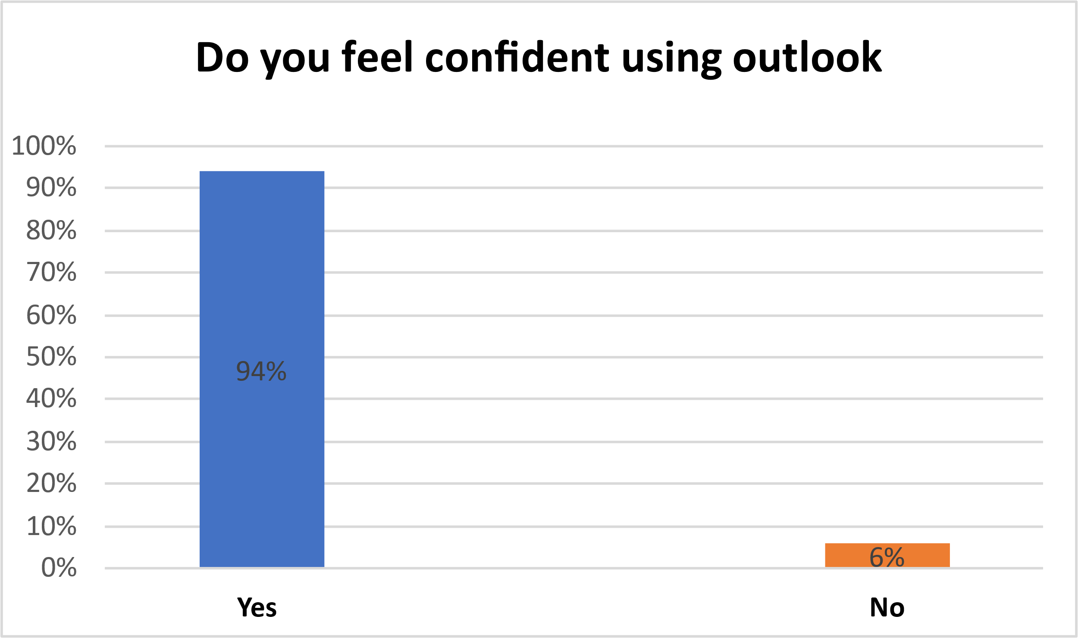
Fig 1 – Question on how you feel using Outlook.

- Do you think outlook is the most important digital tool?
Students were asked if they outlook is important.
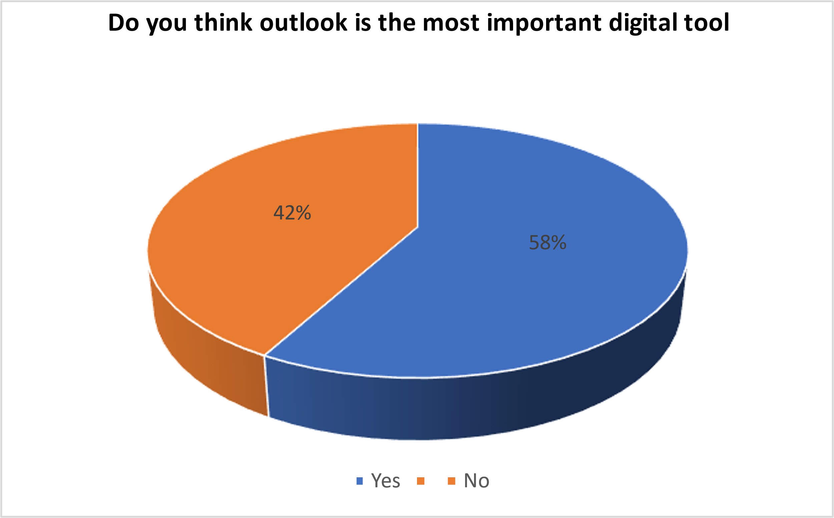
Fig2 – Question on is Outlook the most important digital tool.

- Do you think Moodle is a useful digital tool for students at UWTSD?
Students where asked what they think of Moodle.
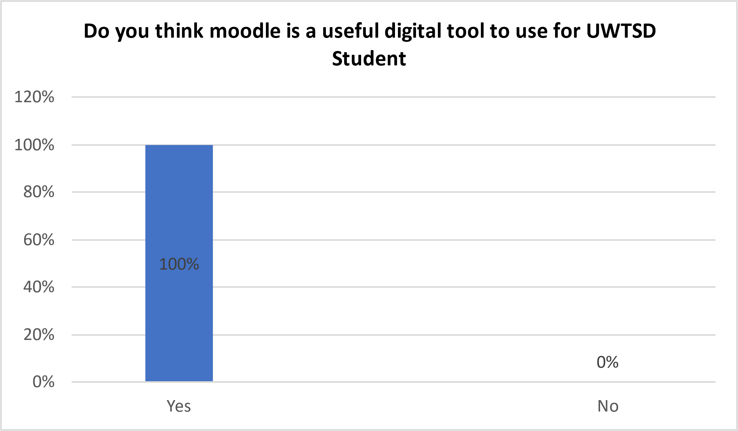
Fig 3 – Question on do you think Moodle is a useful digital tool.

- Have you ever avoided using digital technology to communicate?
Students were asked what they thought.

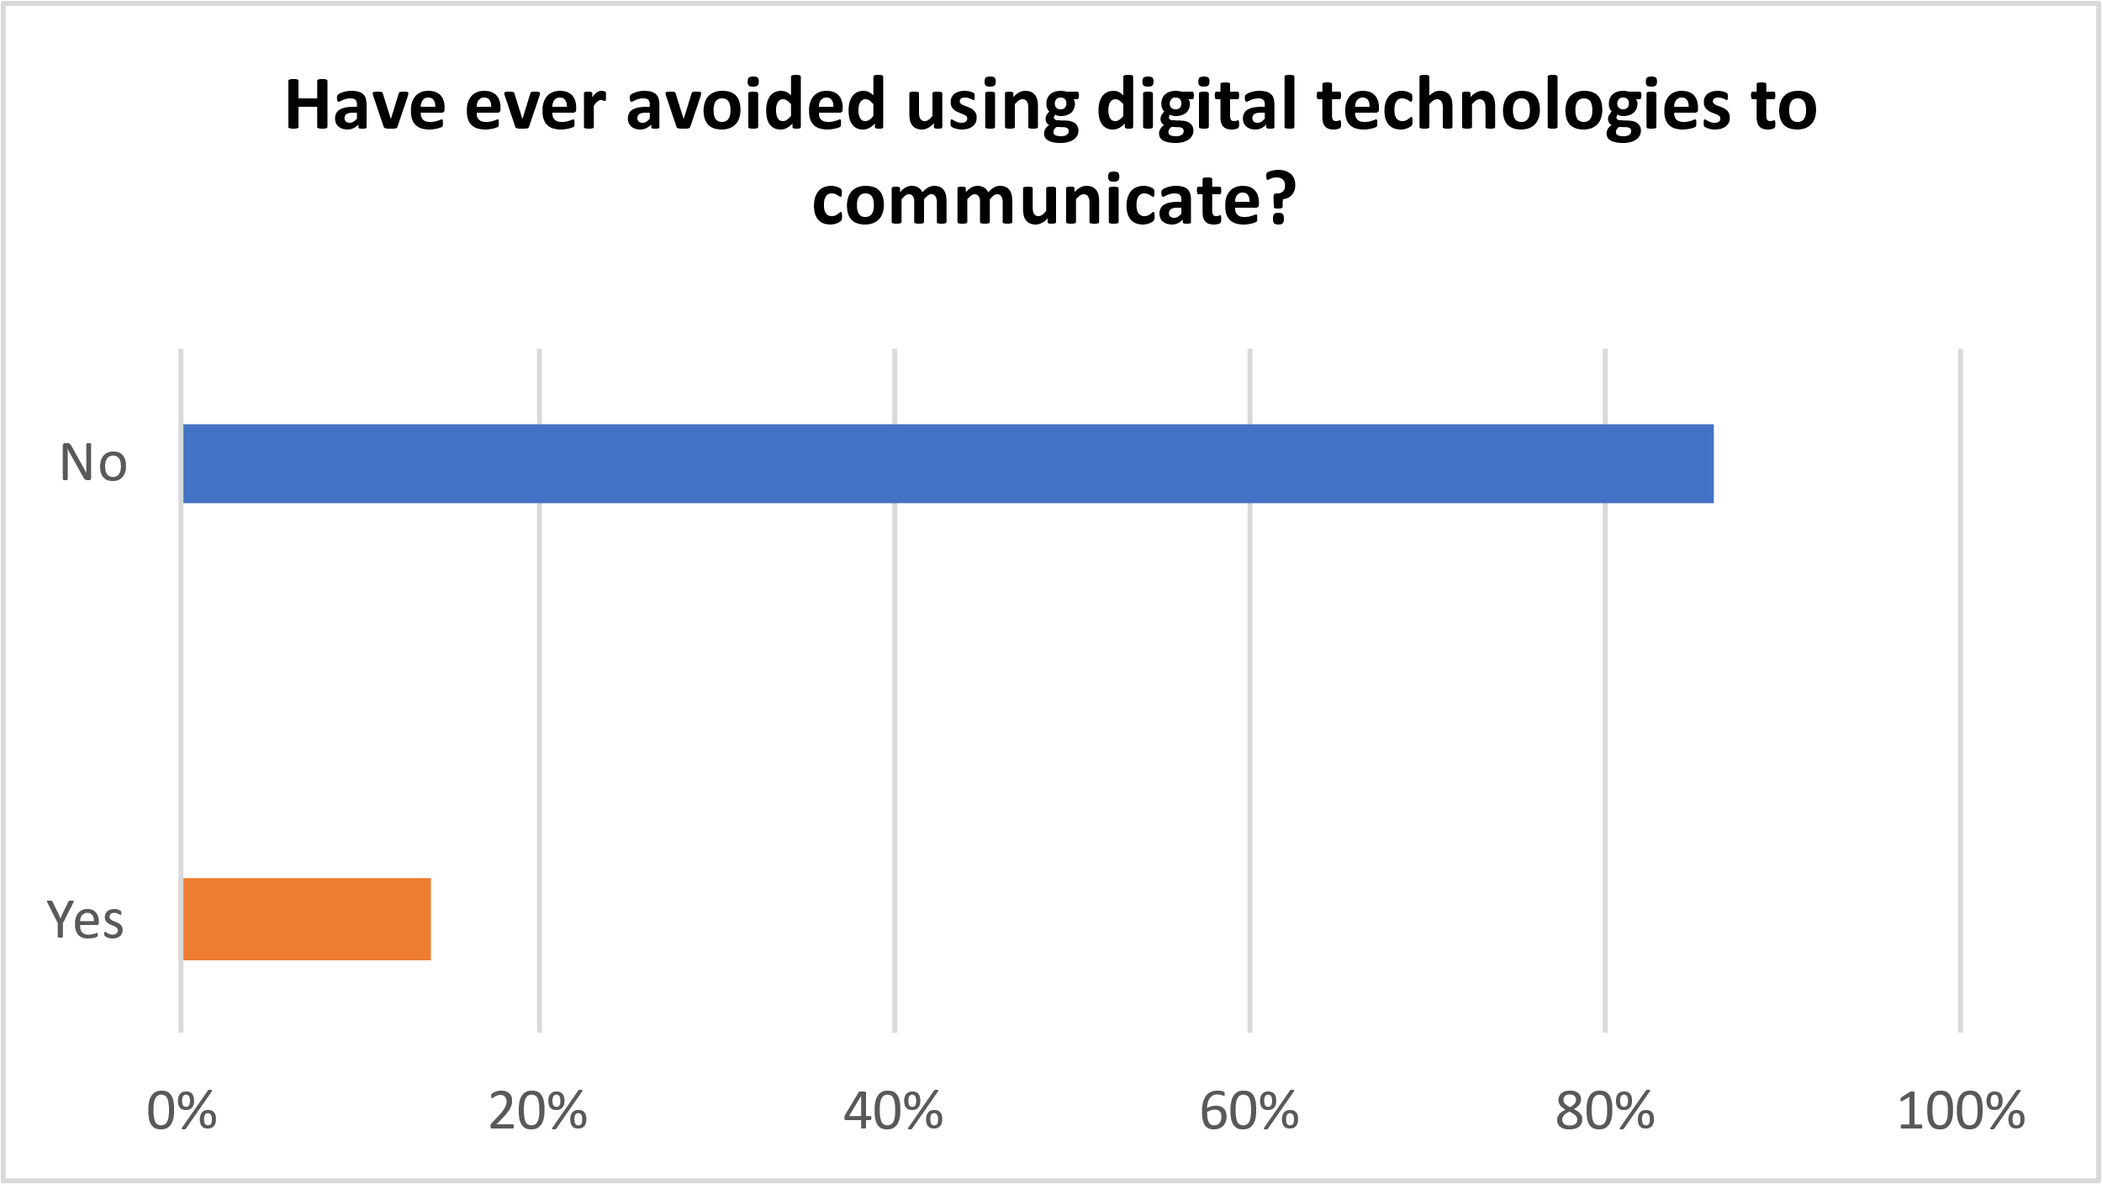
Fig 4 – Question on avoiding use of digital technologies to communicate.

- Rank in order which digital tool is used most by UWTSD Students.

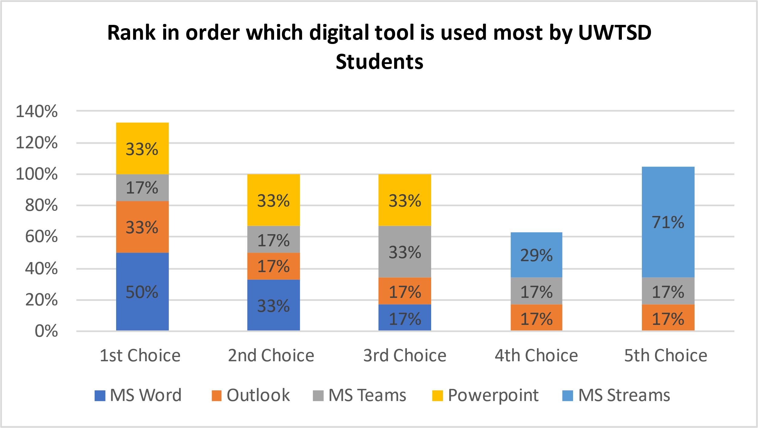
Fig 5 – Which digital tool is most used by UWTSD Students.

- Discussions - When asked if students are confident using outlook 94% participants said yes and 4% of participants said no. The reason this response is that every student would have been given a unique email to access every resource, communicate with other students and lecturers. When asked if students think that outlook the most important digital tool, 58% participants said yes and 42% participants said no. The reason for this response is because students cannot progress academically as a student without the use of Microsoft applications such as, OneDrive, Microsoft word processor, Microsoft teams and Microsoft excel. When asked if students think using Moodle is a useful digital tool, 100% of participants said yes and 0% of participants said no. The reason behind this response is that Moodle has a wide collection lecturer resource, slides and workshop activities that are needed to support students and engage with one another. When asked if students have ever avoided digital technology to communicate 86% of participants said yes and 14% of participants said no. The reason for this response is that the entire world runs of digital technology, with digital technology constantly advancing students must keep up with the program. When asked which digital tool students ranked as most used, 1st choice, 50% voted for MS word, 2nd choice, 33% voted for outlook, 3rd choice, 33% voted MS teams, 4th choice, 29% voted power-point and 5th choice 71% voted for MS streams. The reason for this rank in order is because MS word is needed to write up documents, essays, and reports etc, as a student one must always have access to their student outlook email and OneDrive to keep update with what is going on campus, communications with other students and lecturers.
- Conclusion - This report has covered the importance of digital skills and tools in higher education and in work. A range of digital skills were mentioned from having the ability to use digital skills and tools effectively, to using digital skills acquired and digital tools to break down, solve problems and come up with resolutions. In this report we identified some key differences to separate primary research from secondary research, and it were explained how quantitative research is different from qualitative research. The report identified the main factors of ethical consideration, and how they can be avoided when conducting research by always maintaining confidentiality and following protocol in primary research. Results from the questionnaire showed high competency in students’ relationship with using digital tools and the importance of digital skills. Digital skills and the understanding of digital tools are needed to be academically successful, without such skills persons become very limited when it comes to finding a course or jobs to suit your needs, as almost every organisation requires the use of digital skills. Lewia and McNicol (2015) had stated that “globalisation had made a huge impact on digital tools and the understanding of people in society. 21st century skills are vital to be successful in education and the workplace. Digital skills are needed to participate and evolve in this knowledge-based workforce”.

- Reference list

- Connelly, L.M., 2014. Ethical considerations in research studies. Medsurg Nursing, 23(1), pp.54-56.
- Lordache, C., Mariën, I. and Baelden, D., 2017. Developing digital skills and competences: A quick-scan analysis of 13 digital literacy models. Italian Journal of Sociology of Education, 9(1).
- Van Laar, E., Van Deursen, A.J., Van Dijk, J.A. and De Haan, J., 2019. Determinants of 21st-Century Digital Skills: A large-scale survey among working professionals. Computers in Human Behavior, 100, pp.93-104.
- Ohgaki, H. and Kleihues, P., 2013. The Definition of Primary and Secondary GlioblastomaDefinition of Primary and Secondary Glioblastomas. Clinical Cancer research, 19(4), pp. 764-772.
- Pierce, P.F., 1997. What is an ethical decision?. Critical Care Nursing Clinics of North America, 9(1), pp.1-11.

- Appendix A
Digital Skills and Research Methods Quiz

This questionnaire is a voluntary quiz, based on students experience using different digital tools. All information given will be stored on a password protected laptop to ensure confidentiality. Many thanks.

1.Do you feel confident in using Outlook? Required to answer. Single choice.
Yes
No
2.Do you think Outlook is the most important digital skill? Required to answer.
Single choice.
Option 1
Option 2
If yes, state why
3.Do you think Moodle is a useful digital tool for students at UWTSD? Required to answer. Single choice.
Yes
No
If yes, state why
4.Have you ever avoided using digital Technology to communicate? Required to answer. Single choice.
Yes
No
5.Rank in order which digital tool is used most by students at UWTSD. Required to answer.
MS Teams
MS Word
Outlook
PowerPoint
Streams

