Lecturer Name: David Oyebisi
Student Name: Corina-Florina Barbu
Student ID: 2332679
Module Name: Organisational Culture
Module Code: LCLM5005

Contents
1. Introduction 3
2. The Influence of Organisational Culture on Structure and Decision-Making 3
3. Identifying the Prevailing Organisational Culture at Tesco 5
4. How Tesco Leverages its Organisational Culture to Adapt to External Environmental Influences 8
5. Organisational Culture as an Enabler or Barrier to Effective Organisational Functioning 10
6. The Impact of Organisational Culture on Performance and Recommendations for Improvement 12
6.1 Recommendations for Improvement 14
7. Conclusion 16
Reference List 18

1. Introduction
Organisational culture plays an important role in shaping employee behaviour and influencing how organisations operate and achieve their objectives. Mullins and Christy (2016) explain that culture is based on shared values, beliefs and attitudes that define “how things are done around here”. These elements influence decision-making, organisational structure, motivation and job satisfaction. Similarly, Schein and Schein (2017) argue that culture provides shared assumptions that guide expected workplace behaviour.
This report focuses on Tesco PLC, one of the largest retailers in the UK. Tesco is a relevant example because its performance depends on employee collaboration, effective management and responsiveness to changing customer expectations. The report critically analyses how culture influences Tesco’s structure, decision-making, adaptation and performance. Schein’s Model and Handy’s Cultural Types are applied, supported by academic literature and Tesco’s corporate documentation.

2. The Influence of Organisational Culture on Structure and Decision-Making
Organisational culture influences how an organisation develops its structure and makes decisions. Mullins and Christy (2016) suggest that shared values and attitudes shape organisational processes and managerial behaviour. At Tesco, customer service, teamwork and operational efficiency influence both formal responsibilities and decisions at different management levels.
Tesco operates through a hierarchical structure with clear authority from senior management to store managers and frontline employees. For a large retailer, this supports control, coordination and consistent standards. Schein and Schein (2017) link culture closely with leadership because leaders reinforce acceptable behaviours and shared assumptions. Tesco’s emphasis on serving customers and collaboration therefore supports clearly defined responsibilities while encouraging teams to contribute to common objectives.
However, hierarchy can create decision-making challenges. Strategic investment and major organisational changes are primarily controlled by senior management. Centralisation can improve consistency and reduce risk, but multiple management levels may slow communication and limit frontline influence. This is significant because store employees interact directly with customers and may identify local needs and operational problems earlier than senior managers.
Tesco’s values also support employee and customer feedback. Its purpose and values guide relationships with customers, colleagues and communities (Tesco PLC, 2025). Store managers and teams can respond to local operational issues within wider corporate policies, suggesting a combination of centralised strategic control and some decentralised operational decision-making.
Critically, this combination is both a strength and a limitation. Centralisation maintains common standards and strategic direction, while participation can improve motivation and responsiveness. However, an overly controlling hierarchy may reduce employee influence, innovation and job satisfaction. Robbins and Judge (2019) argue that culture shapes employee attitudes and willingness to participate. Tesco must therefore balance clear authority with meaningful employee involvement.

3. Identifying the Prevailing Organisational Culture at Tesco
Organisational culture can be identified through frameworks that examine shared values, behaviours and assumptions. Schein’s Model and Handy’s Cultural Types are particularly useful for identifying Tesco’s prevailing cultural characteristics.
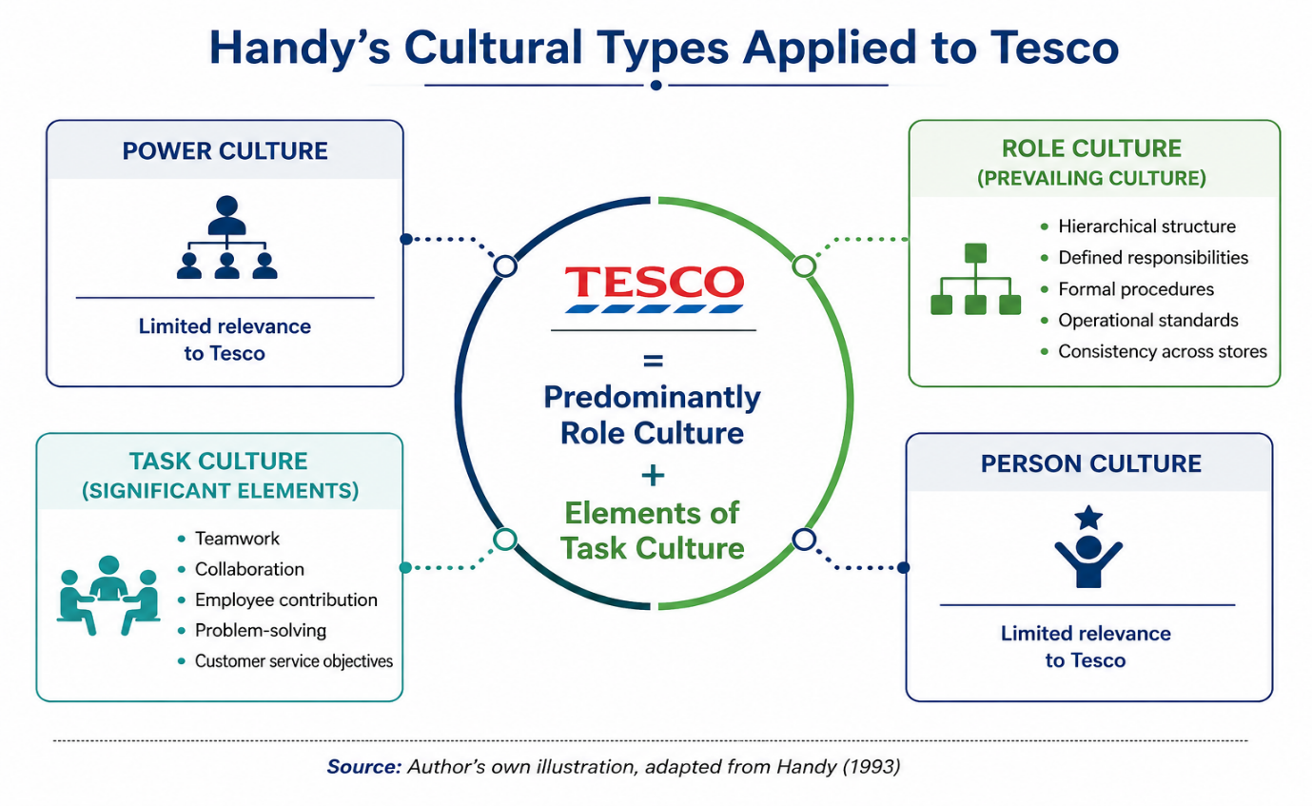

Figure 1: Schein's Model of Organisational Culture Applied to Tesco
Source: Author's own illustration, adapted from Schein and Schein (2017).
As illustrated in Figure 1, Schein’s Model divides culture into artefacts, espoused values and basic underlying assumptions (Schein and Schein, 2017). Artefacts are visible aspects of culture. At Tesco, these include customer-focused practices, teamwork, a consistent brand and the “Every Voice Matters” employee survey (Tesco PLC, 2024). These practices suggest that customers and colleagues are visible cultural priorities.

Espoused values are the principles formally communicated by an organisation. Tesco’s values emphasise trying harder for customers, treating people as they want to be treated and recognising that every contribution can make a difference (Tesco PLC, 2025). These values provide behavioural guidance and can create consistency. However, their effectiveness depends on managers applying them in everyday practice across stores and departments.
Basic underlying assumptions are deeply embedded beliefs that employees may accept without consciously questioning them. At Tesco, customer satisfaction appears to be a central assumption because understanding customers and improving what matters to them are embedded in the organisation’s approach. Schein’s Model therefore identifies Tesco as strongly customer-oriented and people-focused.
Handy’s Cultural Types provide a second framework. Handy (1993) identifies power, role, task and person cultures, which can be used to assess authority, responsibilities and teamwork within Tesco.
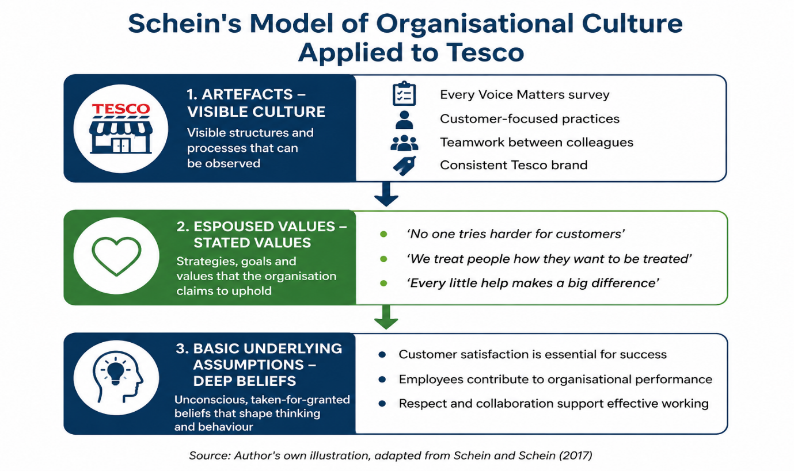
Figure 2: Handy's Cultural Types Applied to Tesco

Source: Author's own illustration, adapted from Handy (1993).
As illustrated in Figure 2, role culture appears to be Tesco’s prevailing culture. Role culture is associated with hierarchical structures, procedures and clearly defined responsibilities (Handy, 1993). Tesco requires operational standards and specialised functions to maintain consistency across a large retail network.
Nevertheless, Tesco also demonstrates task culture through teamwork and collaboration. Employees and specialist teams cooperate to achieve objectives and solve operational problems. This can improve customer service and organisational performance. Critically, role culture provides stability and control but may reduce autonomy if hierarchy becomes excessive. Task culture can increase flexibility and employee involvement. Tesco is therefore best described as predominantly role-based, with significant elements of task culture.
An important limitation of applying Schein’s model is that visible practices and official values do not automatically prove that all employees share the same assumptions. Tesco operates across numerous stores and functions, and local leadership may influence how colleagues experience the culture. Consequently, the model is useful for distinguishing between what Tesco communicates and what may become embedded in daily behaviour, but employee experience should also be considered when assessing the strength of the culture.

4. How Tesco Leverages its Organisational Culture to Adapt to External Environmental Influences

Organisations must adapt to economic, technological, social and environmental pressures. Culture can support adaptation by influencing how employees and managers interpret and respond to change. Tesco uses its customer-focused and collaborative culture to respond to developments in the competitive retail environment.
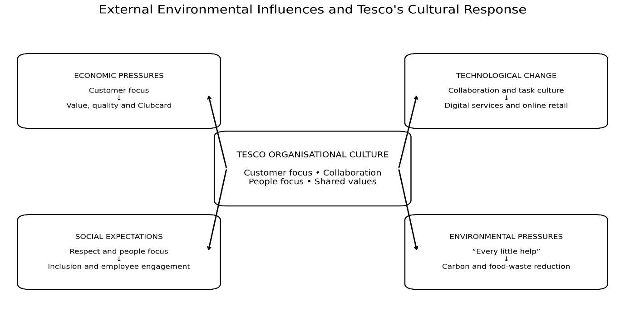
Figure 3: External Environmental Influences and Tesco's Cultural Response
Source: Author's own illustration based on Mullins and Christy (2016) and Tesco PLC (2025).

Economic pressures, including inflation and cost-of-living concerns, have increased customer sensitivity to price. Tesco’s customer-oriented culture supports a focus on value, quality and convenience. Its Clubcard strategy provides targeted value and strengthens customer loyalty (Tesco PLC, 2025). This demonstrates how a shared focus on customers can influence pricing and service decisions in response to economic conditions.
Technological change has also altered customer expectations. Consumers increasingly expect digital services, personalised offers and flexible shopping. Tesco has developed online retail and Clubcard capabilities, requiring collaboration between digital, operational and customer-facing teams (Tesco PLC, 2025). This reflects task-culture characteristics. A collaborative culture can support the acceptance of new systems, although Tesco’s formal hierarchy may slow implementation if procedures become too rigid.
Social expectations concerning fairness, inclusion and responsible employment also influence Tesco. Its value of treating people as they want to be treated provides a cultural basis for employee engagement and inclusion. From Schein’s perspective, embedded assumptions of respect and collaboration may encourage participation in change (Schein and Schein, 2017). However, these values must be consistently demonstrated by local managers to remain credible.

Environmental pressure from governments, customers and stakeholders requires retailers to reduce their impact. Tesco has included carbon and food-waste reduction within its sustainability priorities (Tesco PLC, 2025). The value “Every little help makes a big difference” can connect everyday employee actions with wider sustainability objectives. Overall, Tesco’s culture enables adaptation by providing a shared customer and people focus, but the organisation must balance the stability of role culture with the flexibility of task culture.

The relationship between culture and external adaptation is particularly important in retail because customer expectations can change rapidly. A culture centred on customers gives Tesco a reference point for interpreting external pressures: managers can assess whether a proposed response improves value, convenience or service. This reduces ambiguity and can support strategic alignment. Nevertheless, customer focus must be supported by accurate market information; shared values alone cannot predict economic or technological change.

Tesco’s response to external influences also demonstrates the interaction between cultural stability and flexibility. The organisation needs common standards to protect its brand and coordinate large-scale operations, yet it must allow specialist and operational teams to respond to new conditions. In cultural terms, role culture supports reliability, whereas task culture supports problem-solving. Combining these characteristics is therefore a potential source of organisational resilience rather than simply a compromise between two cultural types.

5. Organisational Culture as an Enabler or Barrier to Effective Organisational Functioning
Organisational culture can be both an enabler and a barrier. A strong culture may create consistency, guide behaviour and improve cooperation, but it can also reinforce established practices and resistance to change. At Tesco, culture acts primarily as an enabler, although its hierarchical characteristics create limitations.
Tesco’s values provide employees with a shared direction focused on customers, respect and individual contribution (Tesco PLC, 2025). According to Schein and Schein (2017), shared assumptions help employees understand acceptable behaviour. A strong customer focus can therefore align employee actions with service quality and wider organisational objectives.

Culture also enables teamwork and employee involvement. Tesco’s task-culture elements encourage collaboration between store colleagues, managers and specialist teams. Frontline employees possess direct knowledge of customer needs and operational problems, so their contribution can improve responsiveness. Employee involvement may also support motivation and job satisfaction (Robbins and Judge, 2019).
However, Tesco’s role culture may become a barrier when hierarchy and formal procedures reduce flexibility. Lower-level employees may have limited influence over decisions despite valuable operational knowledge. Communication can become slower and opportunities for innovation may be missed. Furthermore, Schein and Schein (2017) argue that deeply embedded assumptions can be difficult to challenge. Established practices that previously supported success may therefore create resistance to new technology or working methods.
A further risk is a gap between Tesco’s stated values and actual employee experience. Respect and involvement are positive espoused values, but management practices may vary across a large store network. If employees believe their views are ignored, trust and job satisfaction may decline. Consequently, positive corporate statements alone do not guarantee a positive culture.
Overall, Tesco’s culture is primarily an enabler because customer focus and collaboration support consistent behaviour, service and responsiveness. Nevertheless, hierarchy can become a barrier if it restricts employee voice or change. The enabling effects outweigh the limitations, provided Tesco maintains flexibility and meaningful employee participation.
The effectiveness of culture should also be judged against Tesco’s organisational context. In a smaller or highly creative business, a formal role culture might be a significant barrier. For Tesco, however, clear procedures are necessary to coordinate stores, supply chains and large numbers of employees. The issue is not whether hierarchy exists, but whether it is used proportionately. Where procedures protect consistency and accountability, culture enables functioning; where approval processes prevent timely responses or discourage constructive challenge, the same culture becomes restrictive.
This distinction shows why strong culture is not automatically positive. Cultural strength can increase alignment because employees understand organisational priorities, but it can also increase conformity. If colleagues assume that established approaches should not be questioned, Tesco may lose useful operational knowledge. Effective functioning therefore requires managers to reinforce company values while creating opportunities for disagreement, feedback and local problem-solving. Tesco’s culture is an enabler only when leadership prevents role culture from becoming excessively rigid.

6. The Impact of Organisational Culture on Performance and Recommendations for Improvement

Organisational culture affects performance through employee behaviour, customer service, engagement and innovation. Mullins and Christy (2016) argue that shared values influence motivation, job satisfaction and management control. Tesco’s customer-focused culture generally supports performance by aligning employees with strategic priorities, although its role-based characteristics may restrict flexibility.
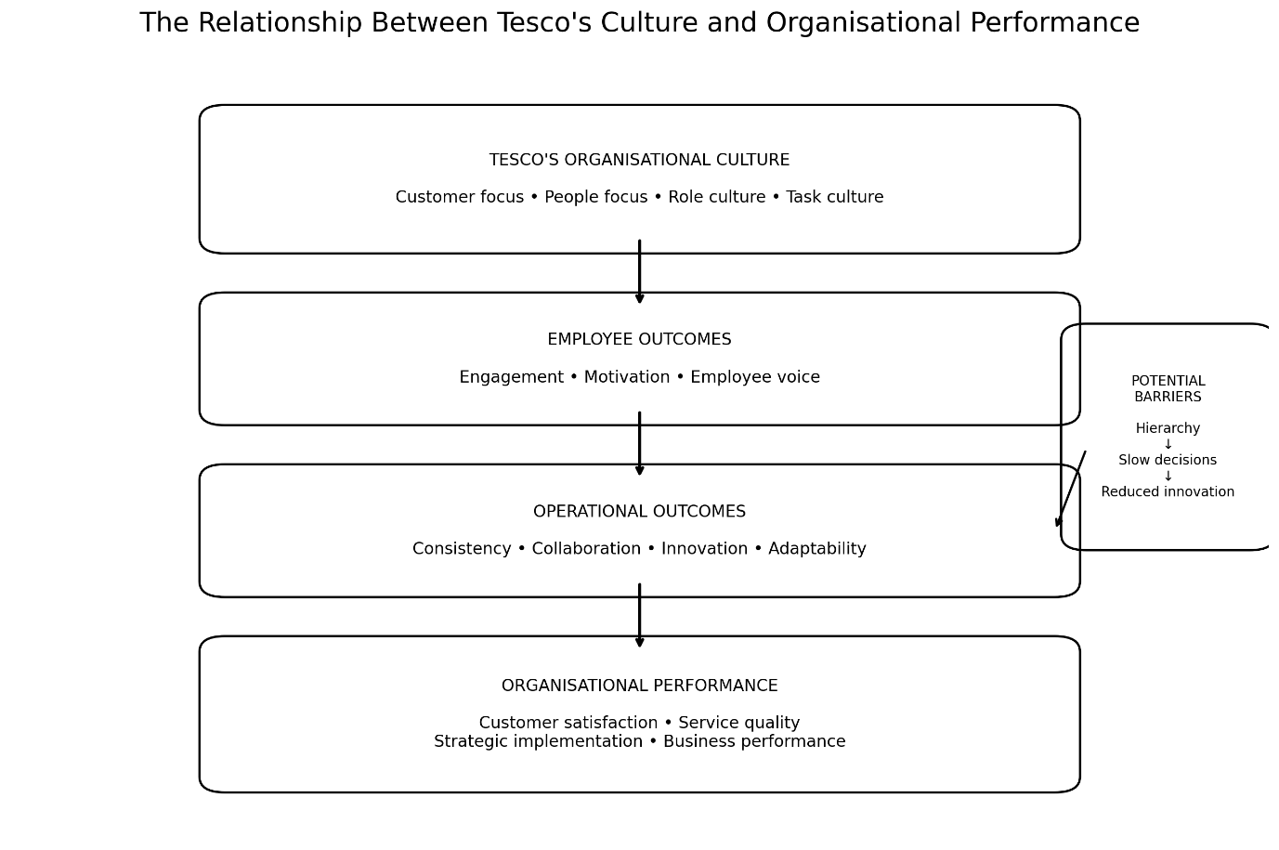
Figure 4: The Relationship Between Tesco's Culture and Organisational Performance
Source: Author's own illustration based on Mullins and Christy (2016), Schein and Schein (2017) and Handy (1993).

Tesco’s emphasis on value, quality and service provides employees and managers with clear performance expectations. Tesco reported that investment in these areas supported customer satisfaction and business performance during 2025/26 (Tesco PLC, 2026). Financial results cannot be attributed entirely to culture, but customer-focused values can support consistent implementation of commercial strategy.
Culture also affects performance through engagement. Tesco’s “Every Voice Matters” survey measures colleague experience, and 85% of colleagues reported that they would recommend Tesco as a great place to work in 2024/25 (Tesco PLC, 2025). Engagement can support motivation, cooperation and service. However, Tesco’s large workforce means employee experiences may differ between locations, creating possible gaps between stated values and daily management practice.
Innovation is another performance issue. Task-culture elements support cooperation around digital services and operational improvements, while role culture may slow ideas through multiple levels of authority. Employee voice can contribute to innovative behaviour when psychological safety allows individuals to express ideas without fear of negative consequences (Miao et al., 2020).
The impact of culture on performance is indirect and should not be overstated. Sales, profitability and market position are also affected by competition, inflation, supply-chain conditions and strategic investment. Nevertheless, culture can influence how consistently strategy is implemented. When colleagues understand the importance of customer value and service, daily behaviours may support strategic priorities across locations. Culture can therefore be considered an organisational capability that contributes to performance rather than a single direct cause of financial results.
There is also a relationship between cultural consistency and service performance. Customers may expect similar standards when using different Tesco stores or channels. Role culture supports this through procedures and defined responsibilities. However, customer needs are not identical in every location. Greater local discretion, supported by clear organisational values, could allow employees to respond to specific problems without weakening the Tesco brand. This reinforces the need for controlled autonomy rather than complete decentralisation.

6.1 Recommendations for Improvement

First, Tesco should strengthen employee voice and psychological safety at store level. Edmondson’s psychological safety theory suggests that employees contribute more openly when they feel safe to question practices and report problems. Tesco should combine Every Voice Matters survey with regular team discussions and visible management responses to suggestions. Evidence reviews associate psychological safety and trust with positive team behaviour and employee attitudes (CIPD, 2024).

Second, Tesco should create a stronger balance between role and task culture. Standard procedures should remain in safety, financial control and product quality, but store teams should have greater autonomy to address local customer needs. Cross-functional teams involving frontline, digital and supply-chain employees could test improvements before wider implementation.
Third, managers should be evaluated on how consistently they demonstrate Tesco’s values. Based on Schein’s model, leaders translate espoused values into daily behaviour. Performance evaluation should therefore consider employee engagement, development and responses to colleague feedback alongside financial and operational results.
Finally, Tesco should use a cultural performance scorecard combining customer satisfaction, engagement, retention, internal promotion and implemented employee suggestions. This reflects the Balanced Scorecard approach by connecting financial and non-financial measures. Comparing indicators across stores could help identify where organisational values are not consistently applied.
Overall, Tesco’s culture positively influences performance through customer focus, consistency and collaboration. The recommended improvements would preserve the stability of role culture while strengthening employee voice, local flexibility and leadership accountability.
These recommendations should be implemented gradually and evaluated through measurable outcomes. Tesco could pilot enhanced employee-voice meetings and cross-functional teams in selected stores before wider adoption. Engagement, implemented suggestions, customer feedback and operational performance could then be compared with previous results. This evidence-based approach would allow Tesco to identify whether greater participation produces meaningful improvements rather than assuming that cultural change is automatically beneficial.
Leadership development is particularly important because employees often experience organisational culture through their immediate manager. Tesco should provide store and department managers with practical training in listening, inclusive decision-making and constructive responses to employee concerns. Senior leaders should also communicate examples where colleague feedback has changed a process. This would reinforce, through visible leadership behaviour, the underlying assumption that employee contribution is valued and could narrow the gap between espoused values and everyday practice.
A further performance consideration is cultural integration across functions. Tesco’s customer proposition depends on coordination between stores, distribution, technology and commercial teams. Shared values can provide a common language across these specialist areas, while task-based collaboration can reduce functional separation. However, if departments focus narrowly on formal responsibilities, role culture may create organisational silos. Cross-functional problem-solving is therefore important for converting shared customer values into coordinated performance.

7. Conclusion

In conclusion, organisational culture has a significant influence on Tesco’s structure, decision-making, adaptability and performance. Schein’s Model identifies a customer-oriented and people-focused culture expressed through visible practices, stated values and underlying assumptions. Handy’s Cultural Types indicate that Tesco is predominantly characterised by role culture, supported by important elements of task culture. This combination provides the control and consistency required by a large retailer while also encouraging teamwork and collaboration.

The analysis concludes that Tesco’s culture acts mainly as an enabler of effective organisational functioning. Its customer focus supports strategic responses to economic and technological change, while shared values can strengthen employee alignment and service performance. However, hierarchy and formal procedures may become barriers when they restrict employee voice, local flexibility or innovation. Tesco should therefore strengthen psychological safety, operational participation and leadership accountability while retaining necessary organisational controls. A better balance between role and task culture would help Tesco maintain a coherent identity and respond more effectively to future external pressures.

More broadly, the case of Tesco demonstrates Mullins and Christy’s (2016) argument that culture has a pervasive influence across organisational processes. Culture is connected not only to employee attitudes but also to structural control, managerial decisions and the organisation’s ability to interpret external pressures. Tesco’s future effectiveness will therefore depend on treating culture as an active management issue rather than assuming that published values are automatically embedded throughout the business.

Reference List
Chartered Institute of Personnel and Development (CIPD) (2024) Trust and psychological safety: An evidence review. London: CIPD. Available at: CIPD Trust and Psychological Safety evidence review .
Edmondson, A.C. (1999) ‘Psychological safety and learning behavior in work teams’, Administrative Science Quarterly, 44(2), pp. 350–383.
Handy, C. (1993) Understanding Organizations. 4th edn. London: Penguin Books.
Kaplan, R.S. and Norton, D.P. (1992) ‘The balanced scorecard—measures that drive performance’, Harvard Business Review, 70(1), pp. 71–79.
Miao, R., Lu, L., Cao, Y. and Du, Q. (2020) ‘The high-performance work system, employee voice, and innovative behavior: The moderating role of psychological safety’, International Journal of Environmental Research and Public Health, 17(4), article 1150.
Mullins, L.J. and Christy, G. (2016) Management and Organisational Behaviour. 11th edn. Harlow: Pearson Education Limited.
Robbins, S.P. and Judge, T.A. (2019) Organizational Behavior. 18th edn. Harlow: Pearson Education Limited.
Schein, E.H. and Schein, P.A. (2017) Organizational Culture and Leadership. 5th edn. Hoboken, NJ: John Wiley & Sons.
Tesco PLC (2024) Annual Report and Financial Statements 2024. Welwyn Garden City: Tesco PLC.
Tesco PLC (2025) Annual Report and Financial Statements 2025. Welwyn Garden City: Tesco PLC. Available at: Tesco Annual Report and Financial Statements 2025 .
Tesco PLC (2026) Preliminary Results 2025/26. Welwyn Garden City: Tesco PLC. Available at: Tesco Preliminary Results 2025/26.

