
Applied Leadership and Management in the Workplace
Module Assignment Submission
Student Name: | Zoltan Balog
Student Number: | 2028534
Module No: | BMSK5009
Module Title: | Developing a High-Performance Culture

Table of Contents
INTRODUCTION 2
MAIN FINDINGS 3
What is Culture? 3
Context of organisational culture. 10
The ‘why’ of different cultures 17
CONCLUSION 20
REFERENCE LIST 20
APPENDICES 24

INTRODUCTION
Establishing and preserving a high-performance culture is essential for businesses looking to succeed over the long run and expand steadily. A high-performance culture fosters innovation, employee engagement, and customer satisfaction in addition to improving operational efficiency. This study examines the effective development of a high-performance culture by businesses, especially Amazon. This research identifies important tactics that can promote an excellence culture by analysing Amazon's distinctive organisational practices, values, and leadership principles. In order to gain a deeper understanding of the mechanics underlying Amazon's success in creating a high-performance environment, we will also examine the ways in which different theoretical frameworks and models might be used. Also look at the importance of employees' ethics, their behaviour, beliefs and their value in an organisation culture.

MAIN FINDINGS

What is Culture?
According to Pappas and McKelvie (2022), culture is a complex notion that includes the ideas, practices, conventions, and tangible characteristics of a specific group or community. Amazon's culture is frequently characterised as competitive, high-performing, and customer-focused (Cuofano, 2022). Furthermore, Spencer- Oatey (2012), suggests that culture is a group of people, whether in a society, organisation, or community, use their common values, beliefs, conventions, practices, behaviours, and symbols to communicate with each other and the outside world. This touches upon the notion of culture.
A pioneer in the field of organisational behaviour and management, Charles Handy created a ground-breaking model that identified four main organisational cultures: People, Role, Task, and Power.
According to Fraraccio (2023), each culture, which is characterised by distinct traits and governance styles, is an essential instrument for identifying organisational problems and developing plans to improve productivity and increase employee satisfaction.
Despite being distinct and incorporating several components, Amazon's culture shares similarities with Handy's four categories of organisational culture.
Amazon’s POWER culture determines strategic direction, its top-down influence and leadership-driven decision-making, where senior executives decide the strategic direction. Since culture can affect how teams work together and how change is executed, it is crucial for managers and leaders to understand it (Chartered Management Institute, 2015).
But, in Amazon ‘ROLE’ culture, power is tied to roles rather than individuals. Employees have specific, well-defined tasks (e.g., picking, packing, and sorting), with clear responsibilities and performance expectations. This structure ensures that each part of the fulfilment process is streamlined and efficient.
Decision-making is frequently centralised in role cultures, where managers or supervisors oversee daily activities in accordance with corporate directives. This guarantees uniformity, which is particularly important in a big company like Amazon where repeatable, predictable procedures are essential.
According to Gërguri (2023), another illustration Organisations can better understand how cultural differences impact management, communication, and behaviour in the workplace by using Trompenaars' Seven Dimensions of Culture framework.
Amazon's organisational culture and cross-cultural operations can be examined using Trompenaars' model of cultural dimensions.
- Universalism vs. Particularism
Amazon, as a global company, likely leans towards universalism in its core policies and practices. This universalist strategy helps Amazon be more productive and efficient, particularly in logistics and warehousing, where operational excellence depends on standards compliance.
- Individualism vs. Communitarianism
Amazon frequently places a strong emphasis on individual success, paying staff members according to their own performance indicators. Nonetheless, communitarianism is also present because accomplishing Amazon's extensive operational objectives requires collaboration and teamwork.
- Specific vs. Diffuse
Task-oriented interactions characterise the "specific" culture in which Amazon operates. Particularly in warehouses and business settings, employees are required to concentrate on their designated responsibilities and performance goals.
- Neutral vs. Emotional
Amazon usually takes a neutral position, preferring a focused and professional workplace. Its data-driven, high-performance culture, where judgements are frequently made using reasoning and analysis rather than feelings, is consistent with this objectivity.
- Achievement vs. Ascription
Amazon values results and merit and is very achievement oriented. A competitive and high-performance culture is supported by the frequent promotion of employees based on their contributions and performance.
- Sequential vs. Synchronic
Amazon places a high importance on efficiency, deadlines, and stringent schedules. With a focus on efficient supply chain management and delivery, its logistical operations are extremely time sensitive.

- Internal vs. External Control
With a strong emphasis on internal management, Amazon seeks to influence its surroundings through innovation, data, and technology. Amazon regularly improves its systems and logistics in an effort to forecast and influence customer behaviour.
According to Bonifacio (2023), another excellent framework by the cultural web model was created in 1992 by Kevan Scholes and Gerry Johnson as a way to examine the various components of a business, and how these factors can influence how individuals work for them (or how customers purchase from them).
An organization's paradigm, or the lived experience of its employees, is defined by the ‘Cultural Web’ model (Hoyas, 2021). It looks at the interrelated components—such as symbols, rituals, power dynamics, and more—that go into forming an organization's culture. The high-performance, customer-focused paradigm is reinforced by every aspect of the web, but it also highlights drawbacks. As Amazon expands, striking a balance between this culture, worker welfare, and long-term viability is essential.
Amazon Cultural web model:
1. Storie: Strong focus on customer obsession and innovation.
2. Symbol: Amazon's smiling logo, which stands for satisfied customers.
3. Power Structure: Power is concentrated at the top, reflecting a hierarchical approach. The CEO and executive team hold most of the power, and the management structure below them is not very transparent.
4. Organizational Structure: Flat organisational structures and small, independent teams that share knowledge and collaborate across functional boundaries.
5. Control System: Extensive documentation and writing for decision-making, as well as ongoing performance evaluation.
6. Ritual and Routine: Frequent all-hands meetings, ongoing process optimisation, and reinvention. "Day 1" mindset to preserve startup-like flexibility (Razzetti, 2021).
Amazon's basic values are operationalised through routines, controls, and symbols, resulting in a concrete high-performance culture, as the Cultural Web demonstrates. It also reveals restrictions on workplace flexibility and employee input, though.
A framework for interpreting the subtleties of cultural artefacts, professed beliefs, and underlying presumptions in a workplace is offered by Schein's Model of Organisational Culture (Mulder, 2022).
Three levels of culture are examined by Schein's model:
Artifacts
Artefacts would include observable components such as Amazon's open workplace designs, relaxed dress code, and customer-focused taglines.
Espoused Values
Characteristics like as "Customer Obsession" and "Bias for Action" are reflected in Amazon's 14 Leadership Principles (Razzetti, 2021). Everyone at Amazon is expected to adhere to the company's Leadership Principles, from upper management to warehouse employees.
Comprehending the intricacies of an organization's culture is crucial for proficient leadership and management.
Basic Underlying Assumptions
Among Amazon's most fundamental presumptions are probably the notions that performance is driven by fierce employee competition and that constant innovation and efficiency are essential to success.
Understanding how Amazon's high standards are ingrained in company culture and drive for excellence at the potential sacrifice of employee well-being is made easier with Schein's approach.
Combining knowledge from the two models yields a thorough understanding: Amazon's culture places a strong focus on customer happiness and excellent performance, which makes the workplace efficient and streamlined but may come at the expense of employee flexibility and well-being. The balance between accomplishing business objectives and preserving a sustainable workplace culture is demonstrated by this synthesis, which emphasises the connections between the fundamental presumptions (Schein) and useful components (Cultural Web).

McKinsey’s 7 element
Originally presented in the 1970s, McKinsey's 7-S Framework charted the intersections of seven elements that affect an organization's capacity for change and adaptation (Malik, 2022). The framework considers both "hard" and "soft" elements and is particularly useful for aligning departments, restructuring, or implementing change.
Hard Elements
Strategy: A well-crafted business plan that enables the organisation to create a plan of action to attain a long-term competitive advantage and is supported by the mission and values of the company is referred to as a strategy (Talerico, 2022).
Structure: These are the company's roles, responsibilities, and organisational structure.
System: Workflows and other operational procedures that enable the organisation to run smoothly and effectively are examples of systems, which are processes and procedures that support operations and decision-making (Kenton, 2022).
Soft Elements
Shared Values: According to The Strategy Institute (2024), shared values serve as a direction for organisational culture and staff behaviour and are frequently seen as the company's goal or vision.
Style: Organisational culture and employee morale are greatly impacted by the leadership approach and management style of the organisation, which includes how leaders communicate, make decisions, and deal with difficulties (admin, 2021).
Skills: According to Jurevicius (2023), skills refer to the core competencies and capabilities of the organization and its employees.
Staff: Employees examine the individuals in the company, paying particular attention to their qualifications, aptitudes, and distribution among various roles. Strategies for hiring, retaining, training, and development are also taken into account in this component.

According to Ehsanfar (2019), an organisation functions can all be impacted by a company's culture, encompassing both internal and external elements such as employee morale, productivity, operational objectives and leadership style, as well as external elements like market demands, competition, and industry dynamics. However, when referring to organisational culture, Wong (2023) states the set of common beliefs, customs, and objectives that determine how work is carried out and how staff members engage with one another and clients.
Promotions are determined by performance and merit, and employees are expected to accept responsibility for their job. Although Amazon is renowned for its difficult work environment, it also promotes competition internally (e.g., aggressive deadlines, performance tracking) to push success. Crucially, however, the culture of high pressure has been blamed for causing stress, burnout, and discontent among workers, particularly in warehouses with high operational intensity (Dudovskiy, 2022).
Future success for Amazon is on striking a balance between sustainability, employee well-being, and its high-performance culture.
A person's behaviour and decision-making in their professional life are influenced by their work ethic, which is a collection of values, beliefs, and principles (Pantelakis, 2023).
By prioritizing ethics, values, and beliefs, organizations can cultivate a culture that promotes trust, integrity, and long-term sustainability.
According to Paredes (2024), the moral standards and ideals that direct conduct and decision-making in a corporate setting are referred to as business ethics. It entails making sure that companies conduct themselves morally and responsibly, taking into account how their decisions may affect their workers, clients, suppliers, the community, and the environment.
According to Stoyanchev (2024), company's dedication to conducting business in a way that maximises its positive effects on the economy, society, and environment while ensuring long-term prosperity is known as organisational sustainability. However, to create value for shareholders as well as other stakeholders including employees, communities, and the environment, it entails striking a balance between economic performance, social responsibility, and environmental stewardship (Kumari & Singh, 2023).
By satisfying the demands of consumers, workers, and investors who place a greater value on ethical and sustainable business practices, sustainability initiatives assist organisations in becoming more resilient, improving their reputation, and being more competitive.
According to Milanesi (2023), organisational sustainability for Amazon might entail methods for lowering carbon emissions (for example, through packaging and renewable energy projects), strengthening community impact, and improving working conditions. However, because of Amazon's size, sustainability initiatives can have a significant impact on society and the environment, enhancing the company's long-term sustainability and competitiveness.
According to Amazon (2022), this is in line with other programs meant to promote sustainable habits, such as Amazon's pledge to achieve net-zero carbon emissions by 2040.

Context of organisational culture.
Amazon's organizational culture has been a key factor in the company's remarkable growth and success since its founding in 1994.
According to Pereira (2023), the goal of Amazon is "to be the most customer-centric company on Earth." The emphasis on customer happiness in the retail, internet service, and IT industries is implied by this mission statement.
According to the research Dudovskiy (2020), Amazon's business model is built on three key pillars: reasonable pricing, a wide selection, and quick delivery.
For instance, one element that draws customers to the business's website and mobile app is the extensive product variety. Additionally, ease is emphasised in Amazon's mission statement, even when it comes to using the Internet to access the company's items. This feature is a reaction to consumers using "convenience" as a criterion to assess the calibre and appeal of online retail goods. One of the most well-known and reliable brands in the world is Amazon (Teachers, 2023). Consumer trust in the technological company and its products is maintained by the strong brand.
Amazon company focus on workplace security and employee relations, this vision statement highlights the goal of being the greatest e-commerce company in the world. According to Meyer (2017), Amazon views its employees as one of the most significant stakeholders in the online retail industry, as evidenced by the organization's employee-centered strategic statement.
A work atmosphere where individuals aspire to perform at their highest level is fostered by Amazon's values, which include efficiency, delivering results, and high standards. These principles also guarantee that Amazon's business strategy stays in line with its customer-focused mission.
Amazon's organisational culture makes it possible for the company to react to e-commerce industry opportunities. The customs and values that shape employees' actions are established by an organization's corporate culture (Scott, 2020).
For instance, Amazon's corporate culture encourages staff members to think creatively and unconventionally in order to come up with innovative ideas and solutions. Amazon must, however, strengthen its organisational culture to influence human resource development for sustained competitive advantage in order to retain a competent staff.
Amazon's culture and background are entwined with its focus on innovation, its goal of becoming the best customer-centric firm, and its global domination in e-commerce (Gerguri, 2023). The culture, which places a high value on efficiency, innovation, and data-driven decision-making, is present throughout all international activities, from corporate offices to fulfilment centres. This customer-centric approach drives innovation and decision-making throughout the company. According to (Functionly Staff, 2023), Amazon's organisational structure is renowned for being team-based and hierarchical.
Cost leadership is the business strategy that Amazon follows (Smithson, 2023).
For instance, Amazon maximises operational efficiency through the use of cutting-edge computing and networking technology, resulting in reduced expenses. The business is able to reduce the expense of its web-based shopping and other services because to the advantages of this competitive approach.
According To Teachers (2023), Amazon's primary business areas include digital services, cloud computing (AWS), e-commerce, and logistics, each of which has its own set of standards.
Amazon's culture has been formed and sustained in large part by Jeff Bezos, the company's founder, and his leadership style and attitude (Boogaard, 2021).
The company's Leadership Principles, which direct employees in their daily activities and decisions, are closely connected with Amazon's work ethics. High standards of ethics and responsibility are emphasised by Amazon's culture of customer devotion, ownership, and predisposition for action (carly, 2018).
According to Meier (2022), Amazon's management culture is based on its 16 Leadership Principles. Important ideas:
Customer Obsession: Leaders put the needs of their customers before those of rivals or immediate profits.
Ownership: Managers are urged to behave for the firm, not simply their team, and to have a long-term perspective.
Bias for Action: A fast-paced setting that values speed and exploration.
Gain Trust: Leaders must be able to listen, communicate openly, and own up to their mistakes.
Performance is tracked and evaluated rigorously, creating a results-oriented culture.
A work atmosphere where individuals aspire to perform at their highest level is fostered by Amazon's values, which include efficiency, delivering results, and high standards. These principles also guarantee that Amazon's business strategy stays in line with its customer-focused mission.
Although they have played a significant role in Amazon's success, these principles have also contributed to some of its difficulties. Although it promotes growth, the focus on operational excellence and high standards has been linked to a stressful workplace. Despite encouraging efficiency, the idea of frugal living has come under fire for perhaps resulting in cost-cutting practices that have an adverse effect on working conditions.
Employees' contributions to business outcomes and Amazon's Leadership Principles are routinely assessed.
Employees are ranked according to their performance using a "stack ranking" method, which encourages competitiveness but also puts pressure on them (PerformYard, 2021).
Amazon runs a highly organised company with discrete divisions for different purposes like marketing, IT, finance, operations, and human resources.
Amazon has operations in numerous nations, each with its own set of rules. Policies pertaining to data privacy, taxes, and e-commerce differ greatly amongst jurisdictions. Amazon must abide by these rules in order to keep its business running effectively. Since Amazon is an online business that manages vast volumes of consumer data, data privacy regulations in several nations are essential to its operations.
Amazon benefits from government backing for cybersecurity and e-commerce's seamless operation. Furthermore, Amazon benefits from the political stability of wealthy nations. According to Greenspan (2023), government support has contributed to the rise in popularity of the internet retail industry. However, Amazon may face fierce competition from major firms, particularly international businesses venturing into the online retail space, in this expanding sector of online commerce.
Political issues affecting Amazon's operations are the cause of the increase in the minimum wage for all Amazon workers. Amazon's HR policies may be impacted by several regulations, especially those pertaining to minimum pay, working hours, and working conditions.
Amazon was compelled to alter the minimum salaries for its employees in the US and the UK due to political and economic pressure (Agile, 2024). In the United States and the majority of European nations, political stability and a reliant corporate strategy present an opportunity.
Despite its tremendous success, Amazon has come under fire for its culture, especially when it comes to work-life balance and employee welfare.
According to PEREIRA (2023), the majority of well-known global firms need a workforce that is healthy and educated, as well as complex supply chains and reliable legal and financial services. For such large organisations to operate effectively and fulfil their primary value proposition, all of these elements and more are required. An organization's values, beliefs, attitudes, and practices that emphasise and support sustainability as a fundamental component of its operations and decision-making procedures are referred to as its sustainability culture (Griffon, 2024).
Amazon might not be able to properly handle outside pressures like regulatory scrutiny or employee discontent if its culture becomes too inflexible or unsustainable. The business must make sure that its high-performance culture doesn't compromise worker welfare, as this could have a detrimental impact on sustainability in the long run.
Additionally, a variety of economic factors, such as interest rates, fluctuations in currency exchange rates, inflationary pressures, and consumer spending patterns, have an effect on Amazon.
Amazon's norms and behaviours are significantly shaped by social and geographic factors. These elements have a major influence on Amazon's strategies, personnel dynamics, and corporate culture and are consistent with the cultural and contextual setting of the areas in which it operates.
Amazon employs people from all around the world and a variety of backgrounds. Although diversity can encourage creativity and innovation, it can also make it difficult to align behaviours and ideals.
A number of moral principles form the basis of Amazon's business practices. These guidelines guarantee that the firm runs ethically and fairly and are applicable to decision-making, business procedures, and employee behaviour.
A thorough code outlining required ethical behaviour for employees has been established by Amazon (Amazon, 2021). The company forbids discrimination based on several grounds including race, religion, gender, and sexual orientation. Amazon has policies in place to stop harassment at work. The business places a strong emphasis on following all relevant laws and rules. According to Amazon (2024), the business declares its support for basic human rights.
Although Amazon has set these moral guidelines, there have been concerns raised about how they have been applied and upheld. According to the research Spence (2022), the business has come under fire for its treatment of employees, aggressive tax evasion tactics, and environmental effects, which point to a discrepancy between its professed moral principles and real-world actions.
Beliefs such as customer obsession, long-term thinking, and data-driven decision-making reinforce Amazon’s focus on sustainable success and competitive differentiation. These beliefs ensure that employees remain aligned with Amazon’s ambitious goals while upholding ethical standards. However, the intense focus on customer obsession and frugality has sometimes come at the cost of employee well-being.
Amazon SWOT analysis
Strengths: Amazon's broad presence in cloud computing and e-commerce (AWS). Strong brand loyalty and user experience as a top priority. AI, advanced technology, and automated logistics.
Weaknesses: Reports of unhappiness among employees and significant levels of pressure. Profitability is impacted by a persistent emphasis on competitive pricing.
Opportunities: Entering new services and markets. Increasing interest in environmentally friendly methods.
Threats: Enquiries into antitrust and tax matters worldwide. Inflation and supply chain interruptions. Dangers to cybersecurity.

Amazon PESTLE analysis
Political: Because of its international operations, Amazon is subject to a variety of political environments and laws.
Economic: Opportunities arise from growing disposable incomes in developing nations and economic stability in developed markets.
Social: Amazon's business strategy benefits from shifting consumer preferences and growing online purchasing patterns.
Technological: Amazon's success is fuelled by ongoing innovation in cloud computing, e-commerce, and logistics.
Legal: Operations are impacted by evolving import/export regulations and growing product requirements.
Environmental: Reducing carbon emissions and putting more emphasis on sustainability.

Amazon McKinsey 7S Framework
Strategy: Innovation, operational excellence, and a focus on the customer. Focus on long-term growth while attending to social and environmental obligations is ensured by a well-defined plan supported by common principles.
Structure: Product line-based divisions (e.g., AWS, Prime, Alexa).
Encourages cooperation across divisions and fosters agility and responsibility through shared values.
Systems: Automated supply networks and data-driven decision-making. Shared values guarantee that ethical behaviour and customer-centricity are given top priority in efficient systems, which improve operational scalability.
Style: Innovation-focused and results-driven.
High performance is driven by leadership style; together with initiatives for sustainability and inclusivity, help to moderate the high-pressure atmosphere.
Staff: Varied, although there is a possibility of a high turnover rate.
Long-term organisational commitment is increased by making investments in talent development and coordinating staff goals with common values.
Skills: Proficiency in cloud services, artificial intelligence, and logistics.
Innovation and a competitive edge are guaranteed by constant skill development in line with common ideals.
Shared values include operational excellence, long-term planning, and customer focus.
In order to align strategy, structure, and systems with the overarching goal of generating value for customers and stakeholders, shared values serve as the bond.

Shared values form the foundation of Amazon's high-performance culture, which influences workforce alignment, technology adoption, and strategic choices.
Amazon's alignment across several dimensions is demonstrated by its capacity to adapt (PESTLE), implement strategy (7S), and capitalise on strengths and opportunities (SWOT).
By tackling major flaws and social/environmental issues, shared values are increasingly reflecting a trend towards sustainability and employee well-being.
Amazon can strengthen its standing as a leader in international trade and promote resilience in the face of threats by making sure that common values are ingrained in every facet of business operations.

The ‘why’ of different cultures
The common values, attitudes, and practices that influence how employees collaborate and interact inside a company are collectively referred to as work culture (Factorial, 2020).
According to BasuMallick (2023), numerous elements, including as organisational policies, employee conduct, workplace amenities, and leadership styles, have an impact on it. In essence, the attitudes and atmosphere that management creates and that all employees experience are reflected in the work culture.
The set of moral standards and ideals that direct a person's conduct and mindset towards their job is known as work ethics (Baker, 2023). This idea includes a number of characteristics that affect an individual's approach to their work duties and interactions with coworkers.
Personal growth is linked to a good work ethic because it motivates people to pursue excellence and self-improvement.
According to Tom (2023), strong work ethics enable employees to drive productivity, improve quality, and create a happy work environment, all of which have a huge positive impact on their organisations. Although some people undoubtedly have a stronger work ethic than others by nature, this does not imply that work ethic cannot be taught. To put it briefly, a strong work ethic is more about attitude and character, thus someone may need to shift their viewpoint in order to develop.
Both workers and companies need a strong work ethic since it affects output, job happiness, and workplace culture in general (Pantelakis, 2023).
Employees should have a strong work ethic for the following main reasons:
- Enhanced Reputation and Credibility
- Increased Productivity
- Improved Job Satisfaction
- Personal Growth and Development
- Greater Accountability
- Positive Workplace Culture
- Better Work-Life Balance
Together, these elements support organisational efficacy as well as individual achievement.
The following are important moral guidelines that workers should be follow:
Professional conduct: Workers should uphold the highest standards of professionalism, which include polite conversation and proper conduct in the office (Russell & Weeks, 2024).
Non-discrimination and anti-harassment: To stop sexual harassment and discrimination, policies should be in place.
Social media usage: Guidelines for proper social media platform use, particularly with regard to the business.
Confidentiality: Workers are expected to keep proprietary information private.
Observance of legal requirements: Compliance with applicable laws and regulations.
Conflicts of interest: A guide to recognising and averting conflicts between one's own interests and those of the firm.
Social and environmental responsibility: Employees are expected to support the company's social impact and sustainability objectives.
Misconduct reporting: Protocols that allow staff members to report moral transgressions without worrying about reprisals.
Honesty and integrity: Demands that all business interactions be conducted with honesty and morality.
Health and safety: Keeping a healthy workplace and adhering to safety protocols. Laws govern matters like recruiting practices and safety requirements for all firms. In order to comprehend these regulations, employees usually need formal training. Individual employees may be penalised for not adhering to policies, and noncompliance may cause legal problems for the business (Hayes, 2023).
According to Sheldon (2023), workers' opinions regarding workplace culture frequently mirror their views of the organization's priorities, methods of operation, and treatment of its employees.
Workers develop opinions on how approachable, open, and helpful leaders are. Trust and confidence in leadership are fostered by an environment of open communication (Tsai, 2011). Employee engagement may suffer in strict or hierarchical environments when workers feel their opinions aren't valued.
Workers assess if the company actually embodies its declared ideals (such as Amazon's Leadership Principles). Employees are more likely to think that
principles like ownership, innovation, and customer obsession are essential to success when they are continuously reinforced.

CONCLUSION
In summary, Amazon is a prime example of how a robust, high-performance culture can foster long-term growth and innovation. Organisational culture is a significant success factor. Amazon's basic values—operational excellence, customer focus, and a purposeful mindset—have a significant influence on the company's culture.

REFERENCE LIST
admin. (2021, November 29). The McKinsey 7S Model Explained With a Practical Example. Consultport. https://consultport.com/succeed-as-consultant/the-mckinsey-7s-model-explained-with-a-practical-example/
Agile, P. (2024). Amazon PESTEL Analysis | PDF Agile. Www.pdfagile.com. https://www.pdfagile.com/blog/amazon-pestel-analysis
Amazon. (2021). Code of business conduct and ethics. Ir.aboutamazon.com; Amazon. https://ir.aboutamazon.com/corporate-governance/documents-and-charters/code-of-business-conduct-and-ethics/default.aspx
Amazon. (2022). Sustainability - US. Amazon. https://sustainability.aboutamazon.com/
Amazon. (2024). Amazon Global Human Rights Principles. Sustainability (US). https://sustainability.aboutamazon.com/human-rights/principles
Anderson, L. (2021, July 2). Amazon PESTEL Analysis | EdrawMax Editable Templates. Www.edrawmax.com. https://www.edrawmax.com/templates/1005770/
Baker, C. (2023, October 25). The Importance of a Strong Work Ethic and 5 Ways to Improve Yours. Leaders.com. https://leaders.com/articles/personal-growth/work-ethic/
BasuMallick, C. (2023, August 25). What Is Work Culture? Definition, Components, Examples, and Best Practices. Spiceworks. https://www.spiceworks.com/hr/engagement-retention/articles/what-is-work-culture/
Bonifacio, R. (2023, September 25). The Cultural Web Model Explained - Shiftbase. Www.shiftbase.com. https://www.shiftbase.com/glossary/cultural-web-model
Boogaard, K. (2021, August 31). Is Jeff Bezos’ leadership style good or bad? It’s complicated. Getmarlee.com; Marlee. https://getmarlee.com/blog/jeff-bezos-leadership-style
carly. (2018, June 27). Amazon Work Ethic: Behind the Curtain. Macarta. https://www.macarta.com/amazon-work-ethic-behind-emerald-curtain/
Chakraborty, R., & Assistant, R. (2021). A Comparative Study of the Communication Strategy of Amazon.Inc: USA-India perspective. A Comparative Study of the Communication Strategy of Amazon.Inc: USA-India Perspective, 9(7), 2320–2882. https://ijcrt.org/papers/IJCRT2107430.pdf
Chartered Management Institute. (2015). Understanding Organisational Culture. https://www.managers.org.uk/~/media/Files/PDF/Checklists/CHK-232-Understanding-organisational-culture.pdf
Cuofano, G. (2022, September 4). Amazon Organizational Culture. FourWeekMBA. https://fourweekmba.com/amazon-organizational-culture/
Dudovskiy, J. (2020, April 3). Amazon McKinsey 7S Model. Research-Methodology. https://research-methodology.net/amazon-mckinsey-7s-model-2-2/
Dudovskiy, J. (2022, March 22). Amazon Organizational Culture: Harsh, but Effectively Contributing to the Bottom Line. Research-Methodology. https://research-methodology.net/amazon-organizational-culture-harsh-effectively-contributing-bottom-line-2/
Ehsanfar, M. (2019, July 28). Understanding and Defining the Organizational Context. Www.linkedin.com. https://www.linkedin.com/pulse/understanding-defining-organizational-context-mohsen-ehsanfar
Factorial. (2020, December 9). Work Culture Definition [download free ebook]. Factorial Blog. https://factorialhr.com/blog/work-culture-definition/
Fraraccio, M. (2023, September 21). Management Theory of Charles Handy. Business.com; business.com. https://www.business.com/articles/management-theory-of-charles-handy/
Functionly Staff. (2023). Amazon’s Corporate Structure: Exploring Hierarchy and Management Style. Www.functionly.com. https://www.functionly.com/orginometry/amazon-corprate-structure
Gerguri, F. (2023, May 16). The Company Culture at Amazon. Employee Experience Magazine. https://www.emexmag.com/the-company-culture-at-amazon/
Gërguri, F. (2023, September 14). Understanding Trompenaars Cultural Dimensions - A Complete Guide. Employee Experience Magazine. https://www.emexmag.com/understanding-trompenaars-cultural-dimensions-a-complete-guide/
Greenspan, R. (2023, June 26). Amazon.com Inc. PESTEL/PESTLE Analysis, Recommendations. Panmore Institute. https://panmore.com/amazon-com-inc-pestel-pestle-analysis-recommendations
Griffon, P. (2024, February 19). Sustainability Culture In Business - A Complete Guide. Purple Griffon. https://purplegriffon.com/blog/sustainability-culture-in-business
Hayes, A. (2023, June 27). Code of Ethics: Understanding Its Types, Uses Through Examples. Investopedia. https://www.investopedia.com/terms/c/code-of-ethics.asp
Hoyas, J. (2021, June 16). The Cultural Web Model: Creating a Corporate Culture Strategy - Factorial. Factorial Blog. https://factorialhr.co.uk/blog/cultural-web/
Jurevicius, O. (2023, December 3). McKinsey 7S Model: The 7S Framework Explained - SM Insight. Strategic Management Insight. https://strategicmanagementinsight.com/tools/mckinsey-7s-model-framework/
Kenton, W. (2022, December 30). McKinsey 7S Model. Investopedia. https://www.investopedia.com/terms/m/mckinsey-7s-model.asp
Kumari, A., & Singh, M. (2023). A journey of social sustainability in organization during MDG & SDG period: A bibliometric analysis. Socio-Economic Planning Sciences, 88(101668), 101668–101668. https://doi.org/10.1016/j.seps.2023.101668
Malik, P. (2022, February 17). The McKinsey 7-S Model Framework, Explained (2022) - Whatfix. The Whatfix Blog | Drive Digital Adoption. https://whatfix.com/blog/mckinsey-7s-model/
MBA Knowledge Base. (2017, May 24). Charles Handy’s Model of Organizational Culture. MBA Knowledge Base. https://www.mbaknol.com/management-principles/charles-handys-model-of-organizational-culture/
Meier, J. D. (2022, October 13). 16 Amazon Leadership Principles Explained. JD Meier. https://jdmeier.com/amazon-leadership-principles/
Meyer, P. (2017, February 12). Amazon.com Inc.’s Organizational Culture Characteristics (An Analysis). Panmore Institute. https://panmore.com/amazon-com-inc-organizational-culture-characteristics-analysis
Milanesi, C. (2023, July 26). Amazon’s Next Big Sustainability Push To Focus On Supply Chain. Forbes. https://www.forbes.com/sites/carolinamilanesi/2023/07/26/amazons-next-big-sustainability-push-to-focus-on-supply-chain/
Mulder, P. (2022, February 16). Organizational Culture Model by Edgar Schein | ToolsHero. ToolsHero. https://www.toolshero.com/leadership/organizational-culture-model-schein/
Pantelakis, A. (2023, July 28). What is work ethic and why is it important for success? Recruiting Resources: How to Recruit and Hire Better. https://resources.workable.com/hr-terms/what-is-work-ethic
Pappas, S., & McKelvie, C. (2022). What is culture? Live Science. https://www.livescience.com/21478-what-is-culture-definition-of-culture.html
Paredes, R. (2024, June 4). Principles & Benefits of Business Ethics. SafetyCulture. https://safetyculture.com/topics/business-ethics/
PEREIRA, D. (2023, April 14). Amazon PESTLE Analysis (2023). The Business Model Analyst. https://businessmodelanalyst.com/amazon-pestle-analysis/
Pereira, D. (2023, February 28). Amazon Mission and Vision Statement. Business Model Analyst. https://businessmodelanalyst.com/amazon-mission-and-vision-statement/?srsltid=AfmBOorcCS0w8zFqfuy9fiJL7zLC1nc9loFvZjRmXTGSn4JWFr9RKLTO
PerformYard. (2021, March 16). How does amazon do performance management? | performyard. Www.performyard.com. https://www.performyard.com/articles/how-does-amazon-do-performance-management
Razzetti, G. (2021, September 8). How Amazon Built a Culture of Innovation by Working Backwards | By Gustavo Razzetti. Fearlessculture.design. https://www.fearlessculture.design/blog-posts/how-amazon-built-a-culture-of-innovation-by-working-backwards
Russell, T., & Weeks, A. (2024, February 15). Ethics at work: an Employer’s Guide. CIPD. https://www.cipd.org/uk/knowledge/guides/ethics-work-guide/
Scott, M. (2020, October 28). Amazon Vision Statement - Everything You Should Know. SageMailer. https://sagemailer.com/blog/amazon-mission-statement-vision-and-core-values/
Shaw, A. A. (2024, January 5). McKinsey 7S Framework of Amazon. C Management. https://cmanagement.xyz/mckinsey-7s-framework-of-amazon/
Sheldon, R. (2023, May 31). Workplace culture and its impact on corporate reputation. Igniyte. https://www.igniyte.co.uk/blog/workplace-culture-and-its-impact-on-corporate-reputation/
Smithson, N. (2023, June 22). Amazon.com Inc.’s Generic Strategy, Intensive Growth Strategies. Panmore Institute. https://panmore.com/amazon-com-inc-generic-strategy-intensive-growth-strategies
Spence, G. (2022, April 3). How Ethical is Amazon’s Flywheel? Www.linkedin.com. https://www.linkedin.com/pulse/how-ethical-amazons-flywheel-gemma-spence
Spencer-Oatey, H. (2012). What Is Culture? https://warwick.ac.uk/fac/soc/al/globalpad-rip/openhouse/interculturalskills_old/core_concept_compilations/global_pad_-_what_is_culture.pdf
Stoyanchev, A. (2024, April 9). Leveraging Hybrid Work to Craft an Efficient Organizational Sustainability Strategy. OfficeRnD. https://www.officernd.com/blog/organizational-sustainability-strategy/
Swargam 2017, L. S., Satishkumar. (2017). McKinsey 7-S Model. Analyst Zone. https://analyst-zone.com/techniques/mckinsey-7-s-model
Talerico, A. (2022). McKinsey 7S Model. Corporate Finance Institute. https://corporatefinanceinstitute.com/resources/management/mckinsey-7s-model/
Teachers, T. (2023, July 3). Understanding SWOT Analysis: Leveraging Amazon’s Success. Two Teachers. https://www.twoteachers.co.uk/post/understanding-swot-analysis-leveraging-amazon-s-success
The Strategy Institute. (2024, May 17). The McKinsey 7-S Model for Organizational Alignment and Success. Www.thestrategyinstitute.org. https://www.thestrategyinstitute.org/insights/the-mckinsey-7-s-model-for-organizational-alignment-and-success
Tom, N. (2023, May 22). The Importance Of A Strong Work Ethic in Business. Real Business. https://realbusiness.co.uk/strong-work-ethic
Tsai, Y. (2011). Relationship between organizational culture, leadership behavior and job satisfaction. BMC Health Services Research, 11(1). BMC. https://doi.org/10.1186/1472-6963-11-98
Wong, K. (2023, June 28). Organizational Culture: Definition, Importance, and Development. Achievers. https://www.achievers.com/blog/organizational-culture-definition/

APPENDICES
Handy’s model
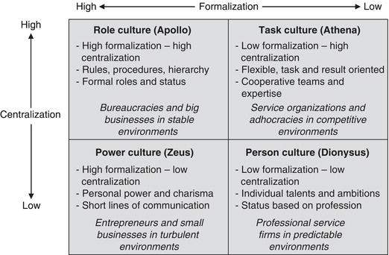
(MBA Knowledge Base, 2017)
Edgar Schein’s Organizational Culture triangle
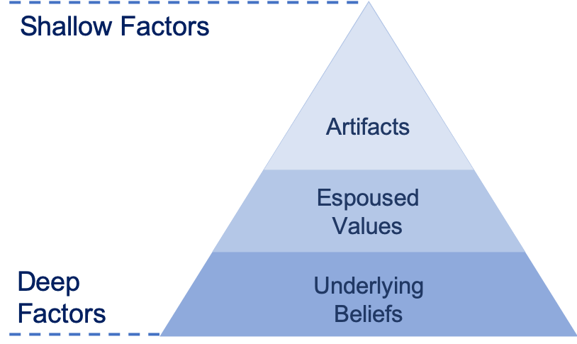
Trompenaar model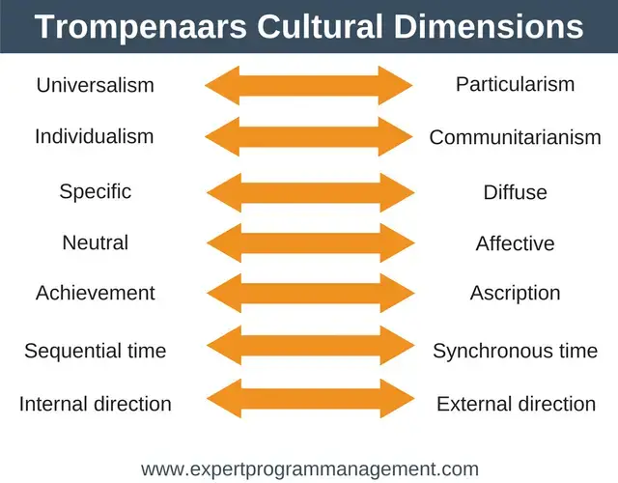

Cultural Web Model
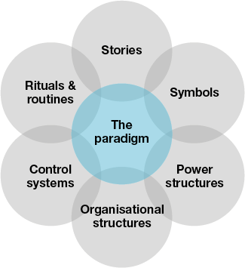
McKinse’s 7 Framework
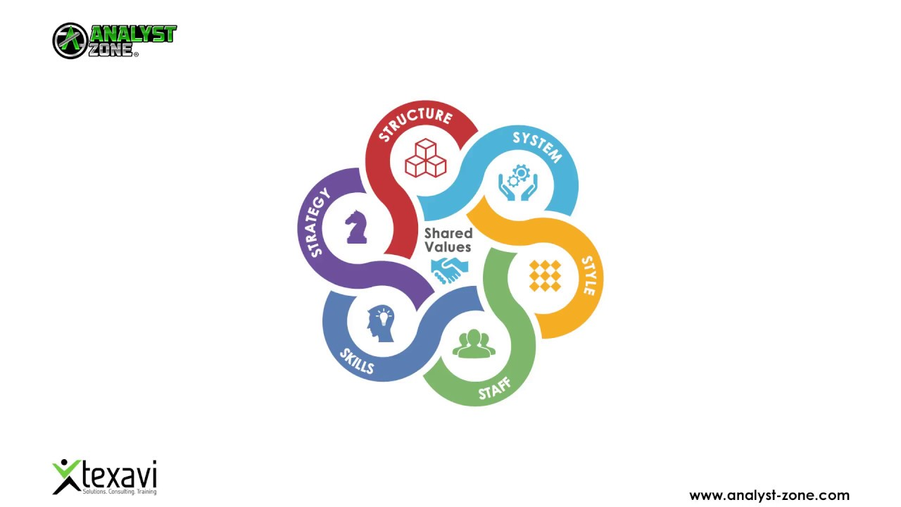
(Swargam 2017, 2017)

