Operating Systems Assignment
Student Name: Saidas Stankevicius
Student Number: 2533410
Programme: CertHE Computing Skills for Workplace
Module: Computer Architecture and Operating Systems
Module Code: ACCA4022

Table of Contents
Contents
Introduction 3
1. Key Functions of General Operating Systems 4
2. Use of Windows OS CLI Commands 6
3. Use of Linux OS CLI Commands 13
Conclusion 17
Reference List 18

Introduction

Operating systems are essential software that manage computer hardware and software resources while providing users with an interface to interact with a computer system. They perform a variety of important tasks, including managing memory, controlling processes, handling files, supporting networking, and maintaining system security. Modern operating systems such as Microsoft Windows and Linux are widely used in both personal and business environments due to their reliability, flexibility, and powerful command-line interfaces. [1], [2]
This report examines the key functions of operating systems and demonstrates the use of Windows PowerShell, Batch scripting, Linux command-line interface (CLI) and Bash scripting to perform common administrative tasks. Screenshots are provided throughout to demonstrate the execution of commands and scripts, while academic references are used to support the discussion. [1], [3]

Key Functions of General Operating Systems

An operating system (OS) is the core software that manages a computers hardware and software resources while providing a platform for users and applications to interact efficiently. It performs a range of essential functions, including process management, device management, security, and user interface management. Without an operating system, a computer would not be able to run applications or coordinate hardware resources effectively. The following sections explain these key functions and their importance in modern computing.[1], [4]

Process Management
Process management is one of the primary functions of an operating system. A process is a program that is currently running, and the operating system is responsible for creating, scheduling, executing, and terminating processes efficiently. It allocates processor time so that multiple applications can run simultaneously without interfering with one another. Modern operating systems use multitasking techniques to ensure that each process receives sufficient CPU time while maintaining overall system performance and responsiveness. Effective process management improves system stability, maximises hardware utilisation, and enables users to run several applications at the same time. [1], [5]

Memory Management
Memory management is another essential function of an operating system. It is responsible for allocating and managing the computers main memory (RAM) so that applications and processes can run efficiently. The operating system keeps track of which parts of memory are in use and which are available, preventing conflicts between programs. It also uses techniques such as virtual memory to allow larger applications to run even when physical memory is limited. Effective memory management improves system performance, prevents crashes, and ensures that multiple programs can operate smoothly at the same time.[1], [6]

File Management
File management is responsible for organising, storing, retrieving, and protecting data on storage devices such as hard drives and solid-state drive. The operating system creates a structured file system that allows users to save, rename, copy, move, and delete files and folders efficiently. It also controls file permissions to ensure that only authorised users can access or modify specific files. Effective file management helps maintain organised data, improves system efficiency, and reduces the risk of data loss.[1], [7]

Device Management
Device management enables the operating system to communicate with and control hardware devices such as printers, keyboard, monitors, storage devices, and network adapters. The operating system uses device drivers to ensure that hardware components function correctly and efficiently. It also manages the allocation of hardware resources and detects when new devices are connected or removed. Effective device management improves compatibility, reliability, and overall system performance while allowing users to use different hardware without needing to understand how each device operates internally.[1], [8]
Security and User Management
Security and user management help protect the operating system and the data stored on it. The operating system controls user accounts, passwords, and permissions to ensure that only authorised users can access files, applications, and system settings. Security features such as authentication, encryption, firewalls, and antivirus support help prevent unauthorised access and protect against malware and cyber threats. These functions are essential for maintaining data confidentiality, integrity, and availability in both personal and business environments.[1], [9]
User Interface Management
User interface management allows users to interact with the operating system through either a graphical user interface (GUI) or a command-line interface (CLI). A GUI uses windows, icons, menus, and pointers to make navigation simple and user- friendly, while a CLI allows users to type commands to perform tasks more efficiently. Both interfaces enable users to manage files, run applications, configure settings, and administer the system. Providing different interface options allows operating systems to meet the needs of both everyday users and IT professionals.[1], [2]

Use of Windows OS CLI Commands
The Windows command-lie interface (CLI), including Command Prompt and PowerShell, allow users and system administrators to perform a wide range of administrative tasks using text- based commands. CLI commands can often complete tasks more quickly than graphical tools and provide greater control over system management. This section demonstrates several commonly used windows CLI commands covering process management, file and directory management. Network testing and monitoring, user management, and task scheduling. Screenshots of both the command and their outputs are included to demonstrate their use. [2], [10]
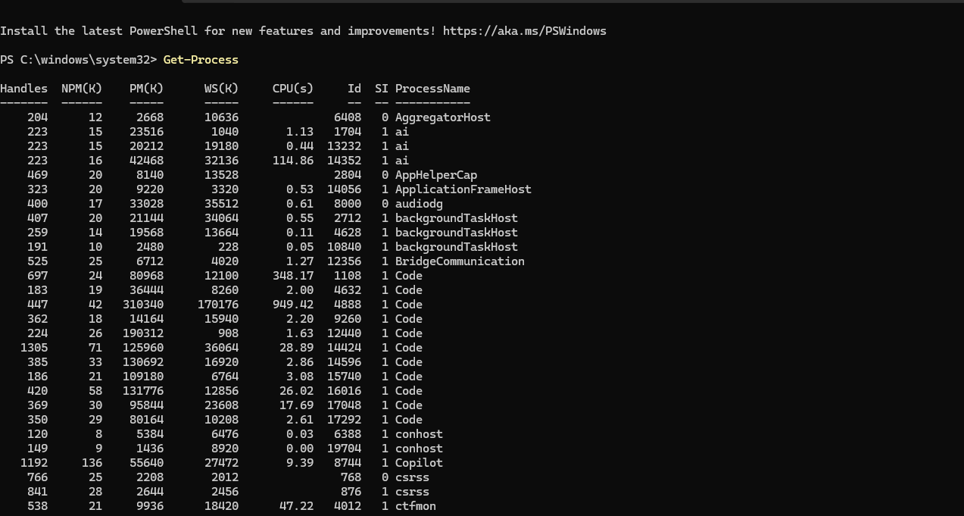
Command 1: Get-Process
Purpose: The Get-Process command displays all currently running processes on the computer. It provides information such as the process name, process ID, (PID), CPU usage, and memory usage. This command is commonly used to monitor system performance, troubleshoot running applications, and identify processes that may need to be stopped or investigated.[2], [10]
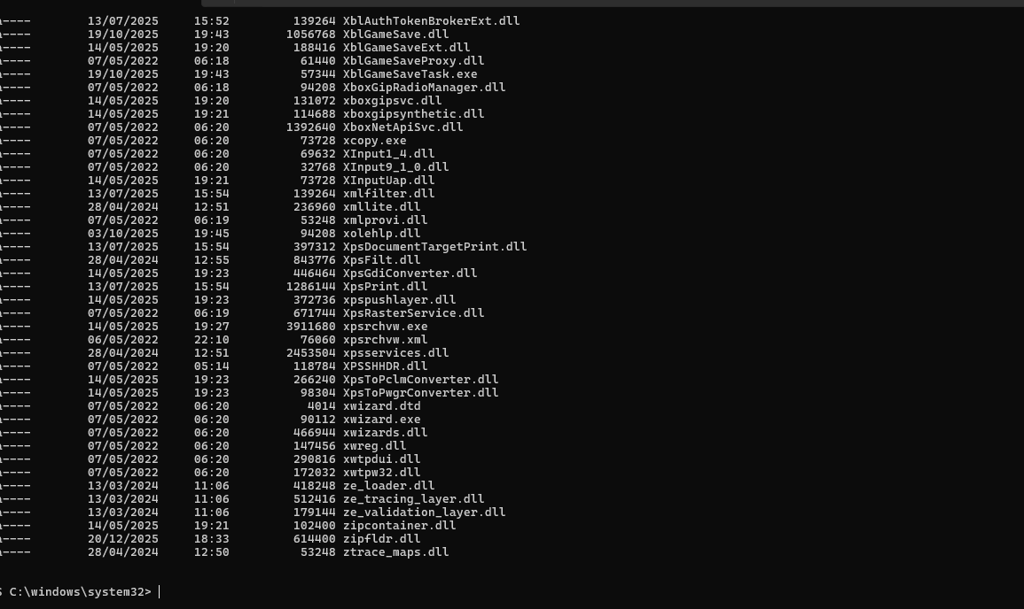
Command 2: Get-ChildItem
Purpose: The Get-ChildItem command displays the files and folders contained within a specified directory. It allows users to view the contents of a folder, check whether files exist, and navigate the file system. This command is commonly used for file and directory management and helps system administrators organise and locate files efficiently.[2], [7]
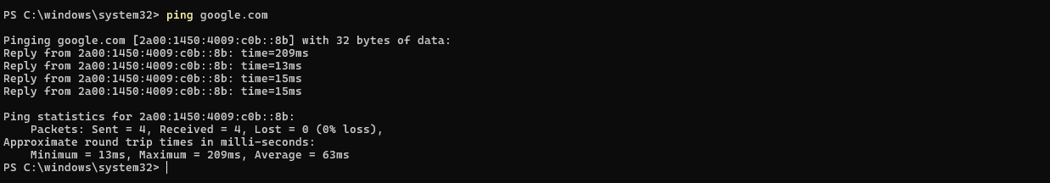
Command 3: ping google.com
Purpose: the ping command tests the network connection between the local computer and another device or website. It sends data packets to the destination and measures the response time. This command is commonly used to verify internet connectivity, troubleshoot network problems, and check whether a remote host is reachable.[2], [8]
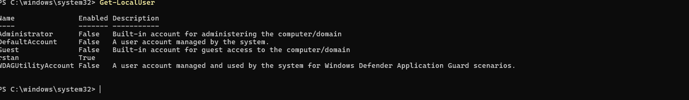
Command 4: Get-LocalUser
Purpose: The Get-LocalUser command displays all local user accounts configured on the computer. It provided information such as the account name, whether the account is enabled, and a brief description. System administrators use this command to manage user accounts, verify account status, and identify built-in or inactive accounts for security and administration purposes.[2], [9]

Command 5: Get-Date
Purpose: The Get-Date command displays the current system date and time. It is commonly used to verify the computers clock, record timestamps in scripts, and assist with system administration, logging, and troubleshooting. The command can also be used in PowerShell scripts for scheduling tasks and monitoring system events.[2], [10]
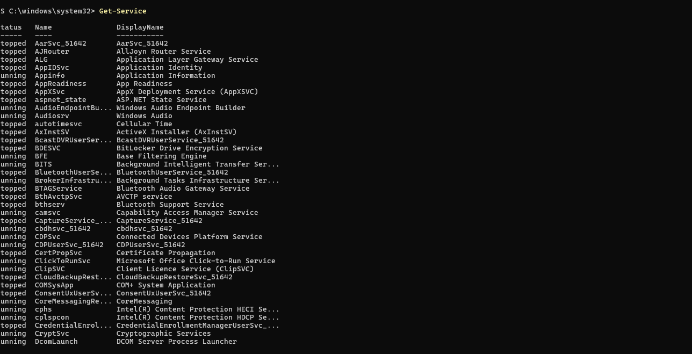
Command 6: Get-Service
Purpose: The Get-Service command displays all services installed on the computer together with their status, such as whether they are running or stopped. It is commonly used by system administrators to monitor system services, troubleshoot problems, and verify that essential windows services are operating correctly. This command helps maintain system stability and ensure important background service are functioning as expected.[2], [10]
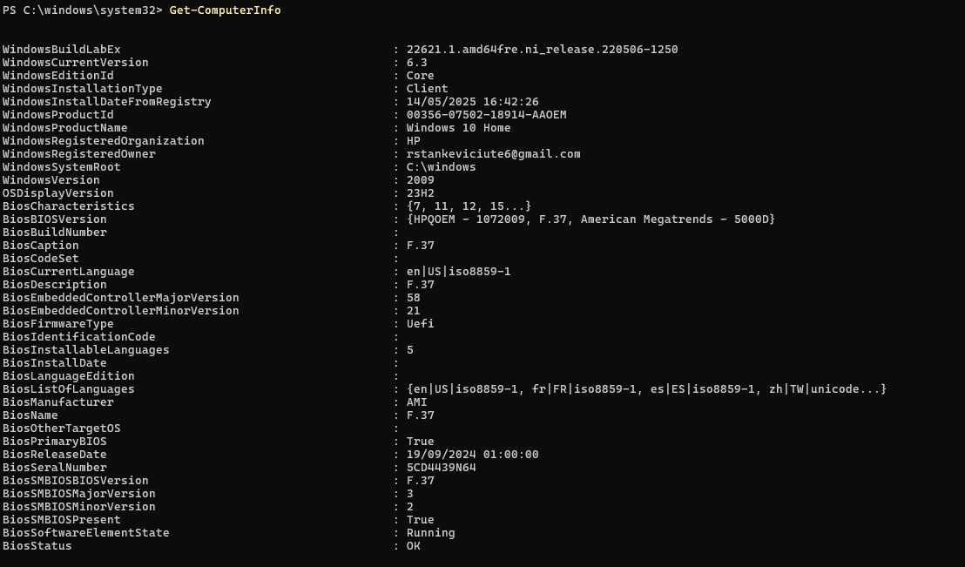
Command 7: Get-ComputerInfo
Purpose: The Get-ComputerInfo command displays detailed information about the computer and its operating system. It provides information such as the windows version, hardware details, BIOS version, system configuration, processor, memory, and other important system properties. This command is useful for troubleshooting, system auditing, and verifying computer specifications without opening multiple system settings.[2], [10]
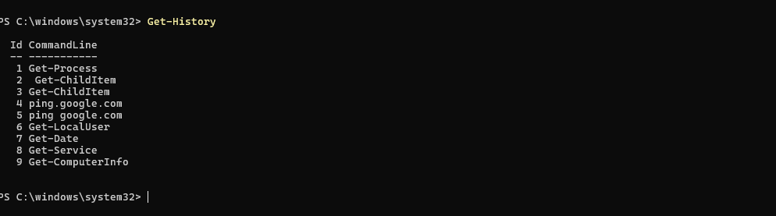
Command 8: Get-History
Purpose: The Get-History command displays a list of PowerShell commands that have been executed during the current session. It allows users to review previously entered commands, repeat commands without retyping them, and keep track of administrative tasks. This command is particularly useful for troubleshooting, scripting, and improving productivity by recalling command history.[2], [10]
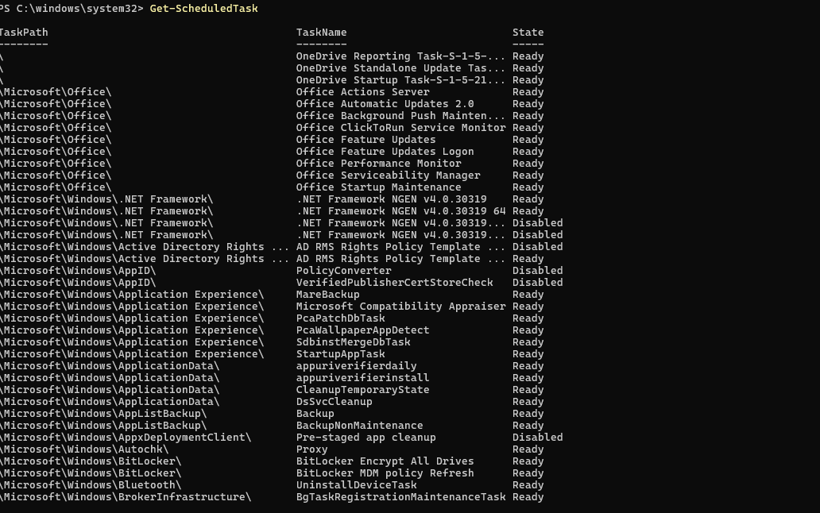
Command 9: Get-ScheduledTask
Purpose: The Get-ScheduledTask command displays all scheduled tasks configured in the computer. It provided information about tasks that are set to run automatically at specific times or in response to system events. System administrators use this command to monitor, manage, and troubleshoot automated maintenance and administrative tasks.[2], [10]
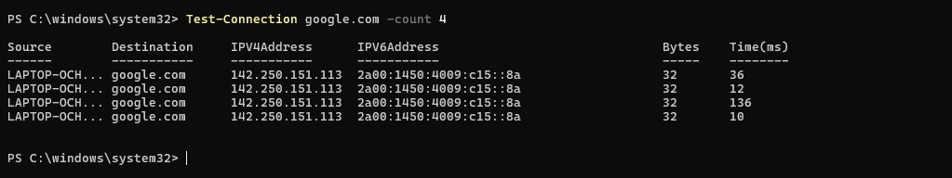
Command 10: Test-Connection google.com -Count 4
Purpose: The Test-Connection command checks network connectivity between the local computer and another device or website. In this example, the command sends four test packets to google.com and displays the response time, IP address, and whether the packets were successfully received. This helps administrators verify internet connectivity, troubleshoot network problems, and measure network performance. The successful replies shown in the output confirm that the computer has an active internet connection and can communicate with the remote host.[2], [7]

Use of Linux OS CLI Commands
The Linux command line interface (CLI) provides users with an efficient method of interacting with the operating system through text-based commands. Bash commands allow users to mange files and directories, monitor running processes, test network connectivity, administer user accounts and automate repetitive tasks. Compared with graphical interfaces, the CLI offers greater flexibility, faster execution of administrative tasks and improved automation capabilities. The following examples demonstrate common Linux bash commands used in everyday system administration.[2], [8]

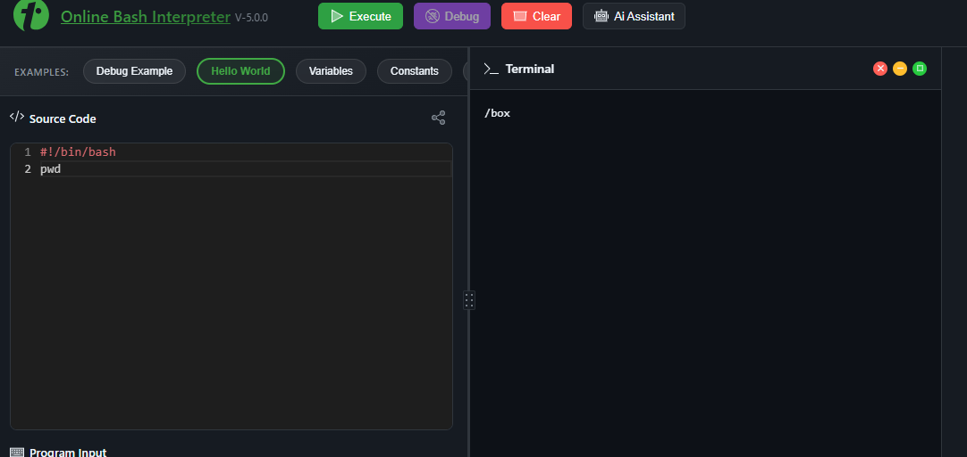
Command 1: pwd
Purpose: The pwd (print working directory) command displays the current working directory in the Linux file system. It helps users identify their present location before navigating or manging files. In this example, the output/ box shows the current working directory.[2], [8]
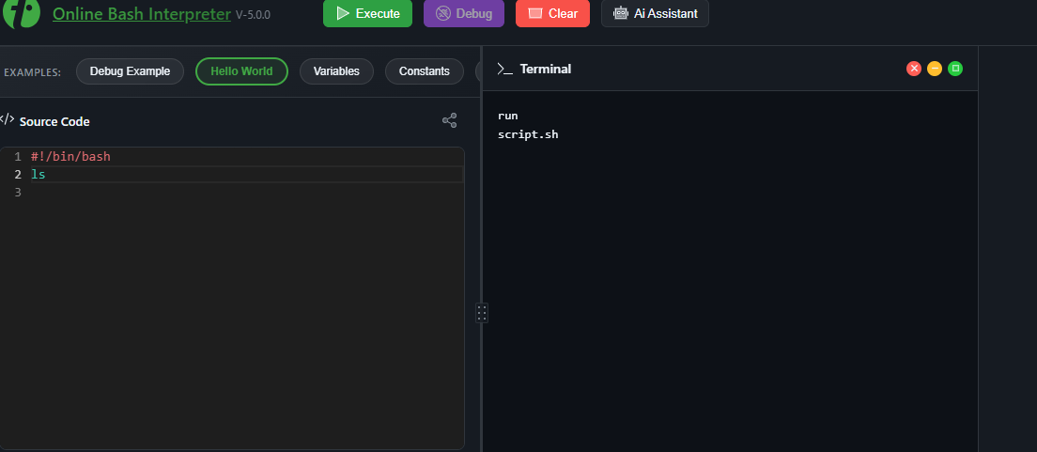
Command 2: ls
Purpose: The ls command lists the contents of the current directory. It is commonly used to display available files and folders before performing file management tasks. In this example, the command shows the files present in the working directory, including the script file created by the online bash environment.[2], [8]
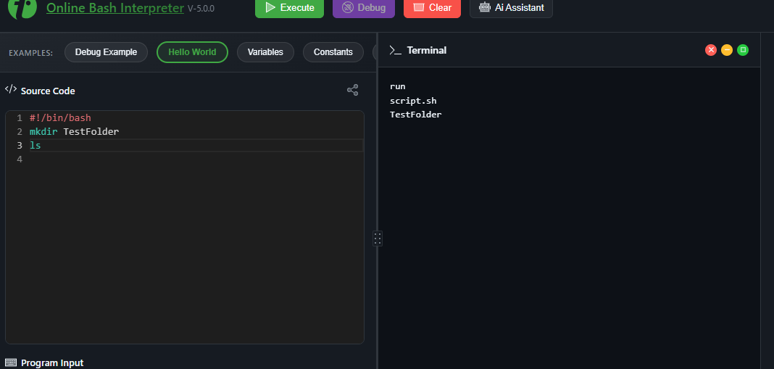
Command 3: mkdir TestFolder
Purpose: The mkdir (make directory) command creates a new directory within the current working location. It is commonly used to organise files into folders and structure the Linux file system. In this example, a folder name TestFolder is created successfully. The ls command is then used to verify that the new directory exists.[2], [8]
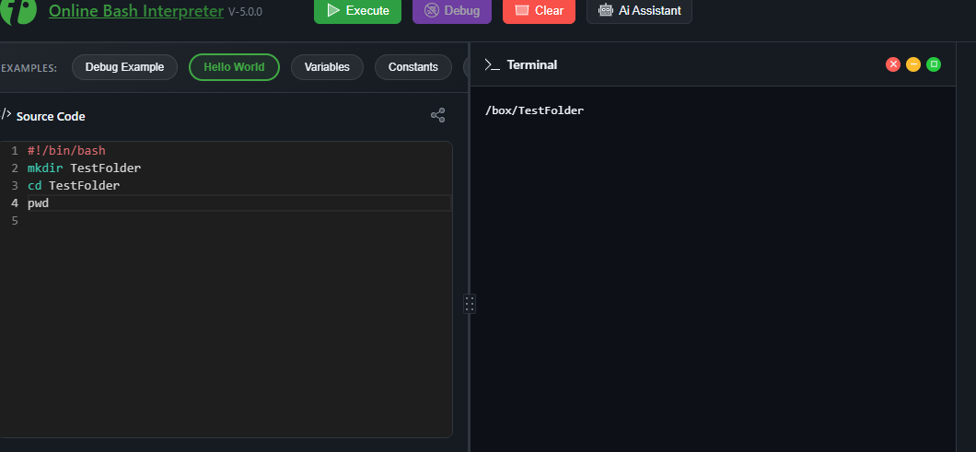
Command 4: cd TestFolder
Purpose: The cd (change directory) command is used to move between directories in the Linux file system. It allows users to navigate to different folders so that files can be accessed, managed or executed. In this example, the command changes into the TestFolder directory. The pwd command confirms that the current working directory has changed successfully to /box/ TestFolder.[2], [8]
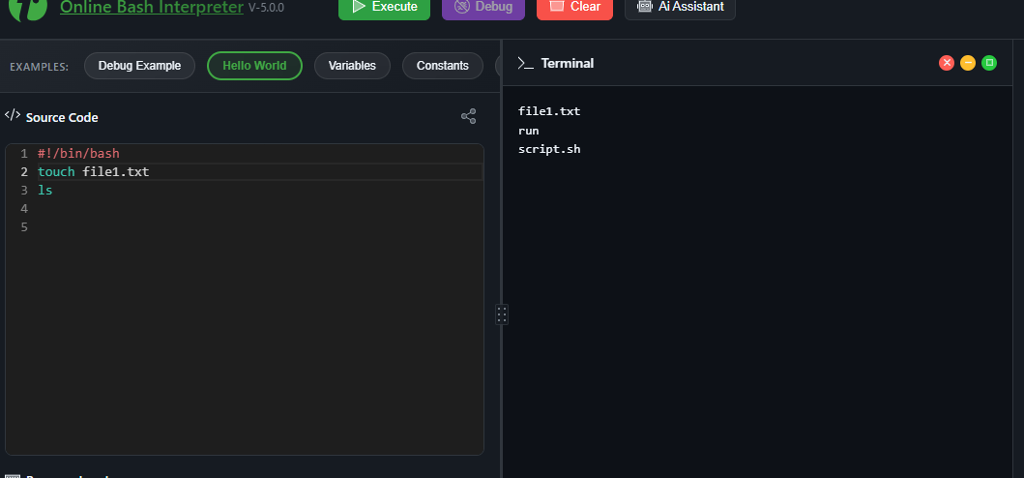
Command 5: touch file1. Txt
Purpose: The touch command is used to create a new empty file in Linux. It can also update the timestamp of an existing file. In this example the command creates a file called file1.txt. The ls command is then used to list the directory contents, confirming that file1.txt has been created successfully.[2], [8]
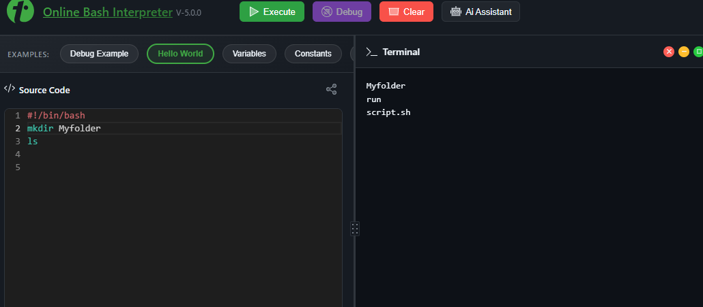
Command 6: mkdir My folder
Purpose: The mkdir (make directory) command is used to create a new directory in the Linux file system. Directories help organise files into separate locations, making file management easier. In this example, the command creates a new folder name My folder, and the ls command confirms that it has been created successfully.[2], [8]
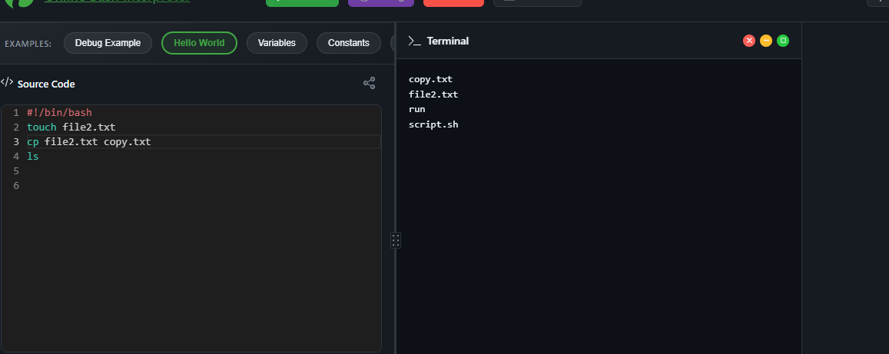
Command 7: cp file2.txt copy.txt
Purpose: The cp (copy) command is used to create a duplicate of a file or directory. It allows users to back up files or create additional copies without modifying the original, in this example, the command copies file2.txt to a new file called copy.txt. the ls command confirms that both files are present I the directory.[2], [8]

Conclusion
This report has demonstrated the importance of operating systems and the role in managing computer hardware, software and system resources. The report examined the key functions of operating systems and compared the use of graphical user interfaces with command-line interfaces. Practical activities using windows PowerShell and Linux Bash commands showed how command-line tools can be used to mange files and directories, monitor systems, test network connectivity and automate routine tasks. The windows batch and Linux bash scripts further demonstrated how scripting can improve efficiency, reduce manual work simplify repetitive administrative tasks. Overall, completing these practical exercises has improved my understand of operating system management and strengthened my ability to use command-line tools confidently. These skills are valuable for system administration and support the effective management of modern computer systems.[1], [2], [5], [8]

Reference List

[1] A. Silberschatz, P.B. Galvin and G. Gagne, Operating System Concepts, 10th ed. Hoboken, NK: John Wiley & Sons, 2018.

[2] Microsoft, Windows Commands. Available: https://learn.microsoft.com/windows-server/administration/windows-commands/

[3] The Linux Documentation Project Bash Guide for Beginners. Available: https://tldp.org/LDP/Bash-Beginners-Guide/html/

[4] Microsoft, PowerShell Documentation. Available: https://learn.microsoft.com/powershell/

[5] Microsoft, Get-Process (Microsoft. PowerShell. Management). Available:
https://learn.microsoft.com/powershell/module/microsoft.powershel.management/get-process

[6] Microsoft, Get-Service (Microsoft. PowerShell. Management) Available:
https://learn.microsoft.com/powershell/module/microsoft.powershell.managment/get-service

[7] Linux ma-pages project, Linux man pages online. Available: https://man7.org/linux/man-pages/

[8] GNU Project, Bash Reference Manual. Available: https://www.gnu.org/software/bash/manual/bash.html

[9] Microsoft, Get-Local User (Microsoft. PowerShell. Local Accounts). Available: https://learn.microsoft.com/powershell/module/microsoft.powershell.localaccounts/get-localuser

[10] Microsoft, PowerShell Documentation. Available: https://learn.microsoft.com/powershell/

