SJIE5006-Keeping Our Children Safe
Front of Leaflet

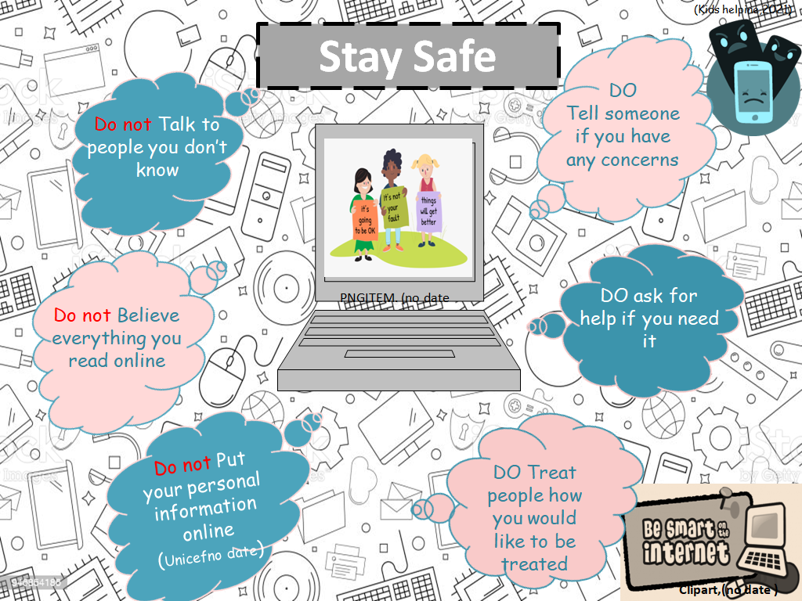

Back of leaflet

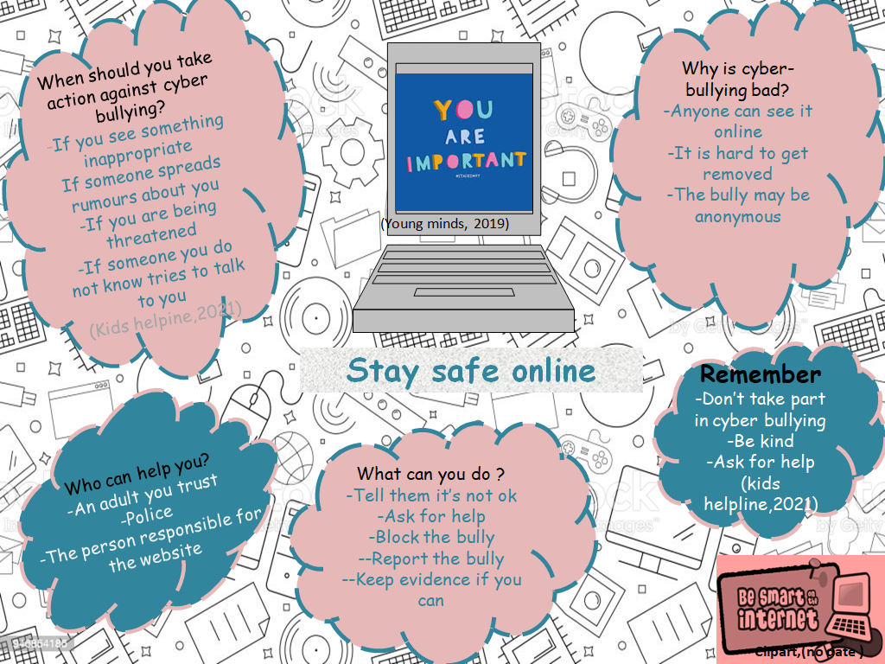

References for Leaflet

Clipart. (no date ). E-safety clipart. Available: http://clipart-library.com/clipart/n1622759.htm. Last accessed 25/3/2021.
Dovi.A. (2020). Cyber bullying . Available: https://kidshealth.org/en/parents/cyberbullying.html. Last accessed 25/3/2021.

Kids helpline. (2021). Cyber bullying how to protect yourself and get support. Available: https://kidshelpline.com.au/teens/issues/cyberbullying. Last accessed 25/3/2021.
National Bullying Helpline. (2019). Information and advice about all forms of bullying. Available: https://www.nationalbullyinghelpline.co.uk/. Last accessed 25/3/2021
PNGITEM. (no date ). Bullying is not ok kids helpline. Available: https://www.pngitem.com/middle/iiJbbhi_bullying-is-not-ok-kids-helpline-health-and/. Last accessed 25/3/2021.
Unicef. (no date ). Cyber bullying: What it is and how to stop it. Available: https://www.unicef.org/end-violence/how-to-stop-cyberbullying. Last accessed 25/3/2021.
Young minds. (2019). Bullying. Available: https://youngminds.org.uk/find-help/feelings-and-symptoms/bullying/. Last accessed 25/3/2021.

https://www.istockphoto.com/vector/vector-computer-pattern-computer-seamless-background-gm946854186-258552620

Rationale
During this document safeguarding and child protection will be discussed, considering policies and procedures from the past to present day and what the safeguarding of children includes. Focussing on multi agencies, schools and how they promote the welfare of young people and e-safety, cyber bullying and the importance of safety online.
Safeguarding and child protection often have the misconception that they are the same thing, although they work alongside each other they are in fact different. The (NSPCC, no date ) highlights that safeguarding is promoting the welfare of children and preventing and protecting them from harm, this includes any harm to their health or development ensuring that they are cared for and they are safe and protected from abuse and maltreatment. Actions taken are to allowed young people to have positive outcomes. Safeguarding is the action that is taken to promote the welfare of children and protect them from harm. Child protection is the intervention when a child is harmed or likely to be harmed significantly, so it is part of the safeguarding process. Child protection procedures which are used are to inform the reader what to do if they are worried about an individual child.
In 2000, there was a public enquiry into the death of a young girl, according to Hall.D,(2003) The investigation began after the child was neglected and killed by a family member, the Laming report requested a large list of changes that needed to be made, this included better information systems with focus on accurate written records and a suggestion for a commissioner for children. This would bring new roles to national and local authorities to hopefully improve the system, providing better supervision, co-ordination and someone who has the responsibility and accountability. The aim however was not to focus on who would be held accountable but how all these things put into place would aim to prevent another child abuse tragedy. (Hall.D, 2003) highlights that “Often the reasons lie in failures of systems rather than individual short comings. Within hospitals, changed working practices threaten continuity of are in clinical teams. Different boundaries between agencies, high staff turnover, workloads pressures and indifferent managerial support make it increasingly difficult for health professionals, social workers and police officers to train together and manage cases together.” Hall.D, (2003) suggests Other problems these create are things such as mutual trust and respect which are earnt through working alongside each other and understanding each other’s approaches and procedures, when this does not happen then problems would continue to arise. Lord laming was adamant in the importance of having the better education and training for staff so practitioners working alongside children have the knowledge and understanding to best provide their duty of care to the highest standard. Lord laming took evidence from local authorities including social services and the police and made a detailed report from this information and aimed to find out how the tragedy had happened. The findings suggested that certain individuals and departments not informing other agencies they were involved with about the severity of the situation and the conclude the report decided that moving forward local authorities would be held accountable for any cases of abuse of any children in their care. Over time policies are updated and re evaluated, According to (virtual college,2013) The protection of children : A progress report was published by Lord Laming 12th March 2009.This report had 58 recommendations on safeguarding children. This included child protection training, regular reviews, working together across multi organisations and many more.
On the 1st April 2008 GOV.UK(,2019) explains that All Wales Child Protection Procedures (AWCPP) were brought in, this was to replace previous procedures taking into consideration the new legislation of safeguarding amongst the local safeguarding children boards and implement the new procedures due to reports such as the Laming report. The AWCPP are responsible for addressing safeguarding situations such as on the internet, they act on this with the training they have received from research and legislation.
The Children’s Act 1989 is another law which was implemented to ensure the safeguarding of young people , (GOV.UK,1989 ) says it is “An Act to reform the law relating to children; to provide for local authority services for children in need and others; to amend the law with respect to children’s homes, community homes, voluntary homes and voluntary organisations; to make provision with respect to fostering, child minding and day care for young children and adoption; and for connected purposes.”The main focus of the Children Act is to focus on children in need of protection, Section 17 in the act says that every local authority have a duty to safeguard all children in their area who are ‘a child in need’ and to promote their welfare. A child in need is recognised as a young person who needs support or intervention from their local authority to be able to meet their potential. Gov.Uk,(1989) Section 47 of the Children Act states the responsibility of the local authority is to look into any young person’s circumstances if they have reason to believe that that child has experienced or is likely to experience significant harm. Then to take whatever action is necessary to safeguard that child or to ensure their welfare. Within the local authority they are expected to provide the young person with relevant support from whatever services they need to safeguard them and help their welfare. Any concerns or allegations that a child may suffer any abuse or neglect, is the local authorities’ job to investigate and prevent.

AbbysProjects, (2016) explains that more than two agencies working together with the same goal of supporting an individual’s needs is considered as multi agency. To be successful they need to communicate well, understand each other’s roles and responsibilities and the ability to work together well. As previously discussed there have been cases where devastating outcomes have happened that potentially could have been avoided if the multi agencies worked together effectively. However when multi agencies work together well they can use their knowledge and areas of expertise to deal with concerns and provide interventions early on , if the professionals are all able to work together individuals will receive the best possible interventions and support. When agencies work together the information shared gets reviewed multiple times, this makes it less likely for an individual being a risk of harm from mistakes being made. (AbbysProject, 2016) “Abuse, more often than not, occurs when a service user has been somewhat forgotten about and neglected. This occurs when agencies are not working effectively together, and so remain oblivious to a person’s care needs and situation. By using effective communication and information sharing systems (such as the common assessment framework), multi-agency work forces are being constantly reminded and updated of each person they support’s situation and of any changes in their requirements.” (GOV, 2013) suggests that when agencies were asked there were many barriers highlighted which caused problems such as IT systems and confidentiality of information including unsecure email systems.
Ni Direct, (no date) suggests that education settings are responsible for safeguarding their pupils and also teaching the pupils how to safeguard themselves. Every school should have safeguarding policies and procedures to follow, all staff should be aware of these. Annual training takes place for all staff members on safeguarding and also the safeguarding system that they have in place within their school. This enables them to know what to do if they have concerns about anyone in the setting. Everyone should be aware of the person responsible for child protection, a designated safeguarding officer and how to react to a disclosure or concern including how to report and record it. Another safeguarding aspect of school settings is that every staff member has to have a DBS check. According to ( Nidirect, no date) “The Disclosure and Barring Service (DBS) helps employers in England, Wales and Northern Ireland make safer recruitment decisions and prevent unsuitable people from working with vulnerable groups, including children. The DBS decides whether it is suitable for a person to be placed on or removed from a barred list.”
The writer believes it is important to highlight the subject of e-safety and cyber bullying, due to the ever rising amount of young people having access to the internet. The online world can be accessed on mobile phones , tablets, laptops and computers Most households have devices and internet access, according to ( Johnson.J ,2020) “ Following two consecutive years at 90 percent, the share of households with internet access in the United Kingdom (UK) further increased through 2019 and 2020, reaching 96 percent - the highest it has ever been.”. There are many things accessed online a large amount of which are positive such as online learning, especially through covid-19 - the use of educational apps has supported many children’s learning, there are also apps to develop skills and play games- the option of keeping in contact with friends and family. These are all important aspects of life that the internet supplies. However alongside these positives there are unfortunately negative aspects and risks such as cyber bullying, invasion of privacy, identity theft, inappropriate or offensive content and strangers posing as somebody else. The use of social media allows an online ‘community’, often young people can be pressured into using them by friends as it is a popular thing amongst them. According to (Unicef, no date) Cyber bullying can include spreading lies or embarrassing photos of another person on social media, sending threatening or unkind messages or pretending to making a fake profile and being abusive whilst impersonating them. Often cyber bullying happens as well as being bullied in person, however when it is online the person can keep a record which can help with evidence to stop the bully. Many young people have described cyber bullying as feeling like they cannot escape, it can affect people mentally, emotionally and physically, causing embarrassment, upset and impacting on their sleep and health such as feeling unwell due to worry.
(Unicef, no date) says “The feeling of being laughed at or harassed by others, can prevent people from speaking up or trying to deal with the problem. In extreme cases, cyber bullying can even lead to people taking their own lives. Cyber bullying can affect us in many ways. But these can be overcome and people can regain their confidence and health.”
This is why young people need to be taught about and aware of the dangers being online can bring. Reminding them not to post personal information such as where they live or go to school, to be in control of their privacy settings so they only have people they know. If anything offensive or upsetting did occur online the children should be reminded of the importance to speak to a trusted adult and to report the person on whichever platform they are using. Often young people have made new friends online, meeting up with someone they do not know should not be encouraged, if this is necessary then a responsible adult should accompany them to ensure they are who they say they are. According to (Safer internet, 2017 ) “Over half (56%) of young people aged 8-17 years said they have shared images or videos on a public social media profile, with almost a third (31%) saying that most of the photos they share are on a public profile that can be seen by anyone. Almost a quarter said they don’t know how to control who can see what they post on social media (23%). Only half of 8-17 year olds (51%) said they always think about what personal information they could be sharing before they post a photo or video online.” Parents and professionals such as teachers are all important parts in educating young people about these risks and supporting them to have a safe experience online and ensuring they understand what to do if they come across any of the negative situations that can happen online. Setting A, a comprehensive school celebrates anti bullying week and e-safety week annually. Throughout these weeks the pupils are educated on different problems and situations they may find themselves in online and ways they can react to remain safe, who they can ask for help, what to do and what not to do. How to report and block people and what information they should and should not be sharing online.
Young people should be encouraged to use their device in a room where an adult can see their screen and monitor. There are apps available for schools and parents to download which makes the search engines child friendly, this is important for extra precaution. Parents are often invited into their child’s educational setting to access e-safety training to help them understand how to keep their child(ren) safe online.
Safeguarding is everybody’s responsibility, multi agency professionals working together effectively and supporting and educating parents and young people on how to remain safe and secure will enable a better chance of success in keeping young people safe.

References
AbbysProjects. (2016). How does multi agency work decrease the risk of abuse and neglect?. Available: https://abbysprojects.wordpress.com/2016/03/07/how-does-multi-agency-working-decrease-the-risk-of-abuse-and-neglect/. Last accessed 25/3/2021.
Family Law. (2009). Lord Laming's report on child protection . Available: https://www.familylaw.co.uk/news_and_comment/lord-laming-s-report-on-child-protection. Last accessed 25/3/2021.
Hall.D. (2003). Recommendations will work only with professional and managerial commitment. Child protection—lessons from Victoria Climbié. 1 (.), 293-294.

GOV.UK. (2019). All Wales Child Protection Procedures. Available: https://www.torfaen.gov.uk/en/HealthSocialCare/Keeping-Children-and-Adults-Safe/Child-Protection/All-Wales-Child-Protection-Procedures.aspx. Last accessed 25/3/2021.
Gov.Uk. (1989). Children Act 1989. Available: https://www.legislation.gov.uk/ukpga/1989/41/introduction/enacted. Last accessed 25/3/2021.
Johnson.J. (2020). Household internet . Available: https://www.statista.com/statistics/275999/household-internet-penetration-in-great-britain/#:~:text=Household%20internet%20penetration%20in%20the%20United%20Kingdom%20(UK)%201998%2D2020&text=Following. Last accessed 25/3/2021.
NiDirect. (no date ). Disclosure and Barring . Available: https://www.nidirect.gov.uk/articles/disclosure-and-barring-protecting-children-and-vulnerable-adults. Last accessed 25/3/2021

Nidirect. (no date ). How schools can protect children from abuse. Available: https://www.nidirect.gov.uk/articles/how-schools-can-protect-children-from-abuse. Last accessed 25/3/2021.
NSPCC. (no date ). Safeguarding children and child protection . Available: https://learning.nspcc.org.uk/safeguarding-child-protection. Last accessed 25/3/2021.

Safer Internet. (2017). Key statistics from safer internet day . Available: https://www.saferinternet.org.uk/blog/key-statistics-safer-internet-day-2017-report. Last accessed 25/3/2021.

