

LEVEL 4

SEMESTER 2

MODULE CODE: SHSS4078
Adventure: A Risk worth Taking

aSSESSMENT TYPE: aSSIGNMENT
Assessment/Component: 1 (Part A)
COMPONENT WEIGHTING: 55 %
WORD COUNT: 2000 WORDS
MODULE TUTOR: Denise leonard

Assignment:

With reference to a critical incident case study that we have examined, identify one key contributing hazard. Evaluate your own personal logged experiences in different activities, of risk management in relation to this identified hazard.

You should include a logbook recording every activity session you complete during this module and a synopsis of the critical incident case study as appendices to this submission.

SUBMISSION DETAILS:

Deadline:
Date: 19th April 2019
Time: 3.00pm
Portal: Turnitin

School of Sport, Health & Outdoor Education

Assessment Feedback Sheet

Student No./Name:Elise Cox 1805509
Module: SHSS4078
Module Code: Adventure: A Risk Worth Taking

Personal Evaluation – to support your academic progress please complete the section below BEFORE submitting your work.
What do you consider to be the best aspects of this work? |  |  | The research
Which aspects do you consider could have been improved in this piece of work? |  |  | The reading
What have you found most satisfying whilst undertaking this submission? |  |  | Completing it
ASSESSMENT CRITERIA | Learning  Outcomes |  | GRADE
ASSESSMENT CRITERIA |  |  | Poor  0 – 25% | Unsatisfactory  26-39% |  | Satisfactory  40 – 49% | Good  50 – 59% | Very Good  60 – 69% | Excellent  70 – 85% |  | Exceptional  86– 100% | %
Complete logbook for each session | All |  |  |  |  |  |  |  |  |  |  | 15%
Provide a synopsis of a critical incident case study | All |  |  |  |  |  |  |  |  |  |  | 15%
Identify a specific significant hazard and the risk it poses to undertaking adventurous outdoor activities | 1,2,3,5 |  |  |  |  |  |  |  |  |  |  | 30%
Discuss a range of appropriate measures that might effectively control the identified hazard and consequent risks. | 1,2,3,5 |  |  |  |  |  |  |  |  |  |  | 30%
Appropriate references used and correctly formatted | All |  |  |  |  |  |  |  |  |  |  | 10%
It is expected that students will present work that is proof read, correctly referenced and adheres to the Assessment Checklist. Therefore a range of 0 – 10 marks will be deducted for non-completion of any of the points on the checklist below.
TUTOR COMMENTS:

Submission date:  via Turnitin |  | Return date:  (at least within 4 weeks) |  |  | Tutor: Denise Leonard |  |  |  |  | Mark:

Assignment Checklist

- Please complete the Personal Evaluation section of the Assessment Feedback sheet, add your name and details, and paste the whole of this assignment document into the front of your assignment

- Submission is a single word file, clearly labelled with your name and module code
- Font style - Times New Roman, size -12 for text and 14 for headings
- Ink colour – black only
- Line spacing – 1.5 line spacing and 2cm- 2.5cm page margins
- Quotations more than three lines to be indented 1 line spacing
- One line space between paragraphs, paragraphs must be left aligned
- Pagination (your assignment should have page numbers)
- All tables and figures are internally referenced and have a title
- Word count checked and written at end of text (before references and any appendix)
- Assignment is within 10% of the word limit (excluding references and any appendices)
- All references in the text are included in the reference list
- Correct referencing following the Harvard style, as described in the Palgrave study skills book ‘Cite them Right’.
- Correct spelling using UK English
- Correct use of punctuation
- Grammar and syntax correct- double check anything that has a green line under it
- I have read my assignment out loud to myself and it makes sense and is easy to read
- Somebody else has read my work and it makes sense to him or her!
- I have checked and I have not plagiarised
Failure to follow these guidelines will cost you marks!

This essay will analyse the Lyme Bay case study and discuss how the lack of personal protective equipment contributed as a hazard to this tragedy. Using personal experiences, appropriate measures will be identified that can be used to help preventing a similar tragedy. There will be a discussion of how having good knowledge and understanding of first aid and how to use personal protective equipment effectively can be essential to saving a life if an emergency should occur.

When looking at the case study of Lyme Bay (appendix 1) there were many factors that resulted in the deaths of the four students. This included poor organisation from not only the school, but St Albans Activity centre. The instructors were not experienced and did not have the appropriate qualifications, also, the students had poor personal protective equipment which was not suitable for the activity. It is apparent that the weather was not properly assessed before the activity took place. From the harbour the water seemed calm with north westerly winds and the visibility was good; however, if the staff had taken a full weather report they would have realised that further out to sea the winds would have changed direction and the sea would become choppier with low visibility. These conditions were not appropriate for taking a group of novice canoeists out, and without proper equipment this group would have been exposed to a high risk of hypothermia (Lyme Bay 1994).

Personal protective equipment plays a major role in keeping not only oneself safe, but also maintaining the safety of others. In the Lyme Bay incident, the students were wearing life jackets which were not inflated and only some of them had whistles. They were also not given proper instructions on how to inflate the life jacket if there was an emergency. Life jackets are usually deflated and only inflated when there is an emergency, whereas buoyancy aids will keep a person afloat at all times. Buoyancy aids also help to keep the body warm and are usually brightly coloured, which could help with being able to stay visible when in the water (Hutchinson 2018).

As well as buoyancy aids, other personal protective equipment is essential when taking a novice group out on the water. Wetsuits were only given to the students because they demanded them; however, other equipment such as cagoules or spray jackets could have been offered to help keep the wind off them (British Canoe Union, 2007). The British Canoe Union (2007) also recommend for beginner paddlers to wear helmets, and while in sea kayaking they might not necessarily be worn, when working with beginners it is advised as this reduces the risk of head injury from capsizing. It also makes that person more visible if they fall into the water. Spray decks fitted on to the kayak prevent water from entering the boat causing it to sink, and although spraydecks are not usually advised for novice paddlers, as they require unclipping if capsized, water entering the kayak can cause a first time paddler to panic, they are also essential when embarking with a kayak in choppy water. In discussing the Lyme Bay case, spray decks would have been essential and would have prevented the boats from sinking and also would have kept the students warm (Hutchinson 2018). It is apparent that the students were lacking in the correct personal protective equipment, equipment that could have potentially saved their lives. The correct equipment ensures safety in a potential accident or emergency (Ferrero 2006).

From my personal experience taking part in a different range of outdoor activities, I know that a first aid kit is essential when going out, not only alone, but in a group. When looking at the Lyme Bay case only Anthony Mann was carrying a first aid kit (Lyme Bay 1994). However, as he had been split up from his colleague (who was not carrying a first aid/ response kit) the group who had become stranded had no way of preserving their body heat or being able to contact anyone for help. No flares or radio devices were carried, so the group could not signal for help when they became stranded. Many different safety devices can be used such as a personal locator beacon (PLB), which has unlimited range and will immediately alert the coast guard. They could also use a handheld digital selective calling (DSC) devise which could contact all vessels and shore stations in range. Even simply carrying a mobile phone with a fully charged battery in a waterproof case will work and making sure to check that there will be a signal where the activity is taking place (RNLI 2019).

It is also important for people to know how to use first aid equipment. Without having a basic understanding of first aid, the equipment cannot be used as effectively. Its recommended to go on a first aid course if regularly taking part in outdoor adventurous activities (Wills 2013). You can also go on an outdoor first aid course which I took part in at the beginning of the university course. This specialises in accidents and emergencies that take place in the outdoors; for example, a basic first aid course will not teach you what do if you have a scenario where someone has injured themselves in places where it is hard for emergency services to reach. It is also a requirement for outdoor practitioners to have been on a first aid course that specialises in outdoor scenarios.

Before taking part on a hill walking trip to the Brecon Beacons (appendix 4), the night before I organised my personal protective equipment. I knew it would be cold and possibly raining so I made sure I packed waterproof trousers and jacket. I also packed food and drink to keep my energy levels up. I organised my own first aid kit which contained bandages and plasters, and medication such as Paracetamol and Ibuprofen and a survival bag. As I usually suffer from the cold I wore thermal layers, a fleece and a padded jacket underneath my waterproof coat and thermal leggings underneath my waterproof trousers. I believed that I was organised and I had packed enough equipment to sustain me for the day. However, upon arriving on the hills we discovered that it was snowing. Even with all of my protective equipment I had not come prepared for the snow. During our walk I became cold and because I had not prepared for snow I had not brought any spare warm layers or warm gloves and a hat. From this experience I have learnt that not only will I conduct a thorough weather forecast, but I will always bring extra clothing with me to prevent the early stages of hypothermia (Wills 2013).

Without proper personal protective equipment in cold environments or the water, there is a risk of putting yourself in danger of getting hypothermia (Graver 2003). Hypothermia is when the body temperature drops from a normal temperature of around 37C down to 35C and if not treated quickly will result in death. Early signs of hypothermia include shivering, fatigue, confusion, slurred speech and forgetfulness. To treat this, then extra layers of clothing can be put on to conserve the heat. A bothy bag or emergency shelter can be used to help preserve heat for the person who is hypothermic, and the more bodies there are in the group shelter also helps keep the surrounding temperature up. Simply huddling around the hypothermic individual could save their lives and also prevents the rest of the group from standing around in the cold and also becoming hypothermic. Food and a hot drink also helps bring up the core body temperature (NHS 2013). If the body temperature does not rise then it will lead to severe hypothermia, this is when the body temperature drops to below 32C; signs of this include unconsciousness or a very low response, the shivering stops and a pulse becomes undetectable. In response to severe hypothermia, emergency services must be called (NHS 2013).

While on a coasteering trip I experienced very early signs of hypothermia and to prevent this from happening again I make sure I have the correct personal protective equipment. When it is particularly cold I wear two wetsuits. I find this works well for me, however, wearing two wetsuits can feel uncomfortable. I am in the process of purchasing my own wetsuit which is a correct fit and will be a winter weight wetsuit so it is thicker than the ones we borrow from the stores in university. Also, extra clothing such as wetsuit socks and gloves also prevent me from being at risk from hypothermia. When on a trip to Llandysul Paddlers (appendix 2), I had not yet purchased my personal wetsuit and this led me to being fearful of getting in the water and getting cold. I chose to not take part in this activity as I did not want to be bring the morale of the group down and chose to help the group by recording their paddling from land so they could use it to reflect upon after the activity was over.

It is important to ensure that all personal protective equipment is safe and so equipment needs to be thoroughly checked before and after use in order to prevent accidents (DeBrun 2017). Rock climbing equipment, such as harnesses and ropes, should be checked for snags and tears and making sure all belaying devices and carabineers are not eroded and are fit for purpose. While at Three Cliffs Bay on a rock climbing activity (appendix 3) we checked all the equipment that we took from the stores, even though all the equipment is logged onto a system that prevents damaged equipment from being used. Personally checking the equipment ensures that it is definitely fit for purpose and is safe to use (DeBrun 2017). Most outdoor activity centre provide the basic centre harness; this is simple to use and avoids the possibility of people putting it on incorrectly. Helmets are used in outdoor rock climbing venues in order to prevent rocks from falling and causing head injuries, they can also be use with younger groups on high ropes courses and indoor climbing centres.

To conclude, personal protective equipment is essential when taking part in outdoor adventurous activities. First aid equipment and communication devices such as mobile phones should be carried when going to remote places, for example, Three Cliffs Bay is not an easy walk back to the car park if an accident or an emergency should occur. It is good practice to carry a personal first aid pack and to become aware of what to look for when checking personal protective equipment. When discussing the Lyme Bay tragedy, it was apparent that personal protective equipment had not been carefully managed. It is important to not only have the proper protective equipment, but it is good practice to have an emergency plan, letting someone know where you are going and what time you are expected to be back can make a difference if an emergency were to occur (Ferrero 2006).

Word count- 1852

References

British Canoe Union, (2007) The British Canoe Union coaching book. Caernarfon: Pesda Press.
Debrun, G., (2017) Work-at-Height Standards in the Climbing Wall Industry. Association of Outdoor Recreation & Education Conference Proceedings, pp. 32-34.
Ferrero, F., (2006) White water safety and rescue. 2nd ed. Caernarfon: Pesda Press.
Graver, D., (2003) Aquatic rescue and safety. Champaign, Ill; Leeds: Human Kinetics.
Hutchinson, D.C., (2018) The complete book of sea kayaking, sixth edition. 6th ed. Falcon Guides.
‘Lyme Bay Tragedy’ (1994) The Lyme Bay Canoeing Tragedy, 1, pp. 1-29.
National Health Service. (2013). Hypothermia. http://www.nhs.uk/conditions/Hypothermia/Pages/Introduction.aspx Accessed on 15th April 2019
RNLI. 2019. Rnli.org. [Online]. [18 April 2019]. Available from: https://rnli.org/safety/how-to-call-for-help-at-sea
Wills, K., (2013) Outdoor first aid : a practical manual: essential knowledge for outdoor enthusiasts. Caernarfon: Pesda.

Appendix 1- Synopsis of Lyme Bay Tragedy

On Sunday 21st of March 1993, 23 students and two teachers arrived at St Albans Activity Centre. The students, aged 16-17, were not experienced in sea kayaking. Upon arrival the students split into three groups and practiced dry land paddling training and capsize drills in the centre’s swimming pool. However, they did not practice techniques of re-entering the canoe.

March 22nd 1993, the group was divided into three different groups of eight pupils, one teacher and two instructors. They met down in the harbour at 10am with the intention to kayak 3km from Lyme Bay to Charmouth. They were told it would take 45 minutes to get there and an hour to get back. The weather conditions were not a cause of concern, with north westerly winds, the sea was slightly to moderately choppy and the visibility was good. However, further out to sea the conditions were rougher and the wind direction had changed. Because of this the other group, who were out on dinghies, returned early to the centre and did not see the kayaking group on their return.

The two instructors were not fully experienced and were not qualified to take people out. Anthony Mann, the more experienced instructor, held a 1 star BCU qualification and Karen Gardner the junior instructor also held a BCU 1 star. Just 14 days prior to the incident both Mann and Gardner took part in a two-day training course given by Steven Gynes. Gynes was a BCU qualified senior instructor for inland and trainee senior instructor on sea. He had been employed by the centre to help train staff. Gynes described Mann as being over confident in his abilities. He describes Gardner as lacking confidence in her abilities.

The instructor and the teacher (Norman Pointer) all took out canoes that were less stable than the canoes that the eight students took out; none of the students’ canoes had the correct buoyancy and were not fitted with spray decks. The instructors were equipped with buoyancy aids, cagoules and their canoes were fitted with spray decks, both had whistles and Mann had a first aid kit and a tow line. The pupils had poorly inflated lifejackets, but not all were equipped with whistles and they all had wetsuits which were only supplied on the demand of the students. On top of all this flares were not carried. Pointer was a novice canoeist and used a canoe that was inappropriate for his abilities.

As they set off one of the students, Simon Dunne, capsized his canoe, however, the water was shallow enough for him to get back in with assistance from Mann and they re-joined the group. The group had not been told how to organise themselves. Due to Pointer’s boat not being appropriate for his abilities this led him to capsize three times. This exhausted him and he was sick in the water; because of this he suggested that he went back to shore as he did not want to be a burden on the rest of the group. However, Mann thought it was important to remain with the rest of the group. As this was happening the rest of the group rafted up. Due to the canoes not being fitted with deck lines, the group had to cling on to keep the canoes rafted together. Due to the wind shifting and becoming a stronger off-shore wind, the rafted canoes drifted further and further out to sea. Eventually Mann and Pointer were unable to see the rest of the group and could not re-join.

While rafted up, the two outer canoes began to fill with water, and before long the two outer canoes were abandoned and the two boys who were in those canoes laid across the remaining ones. Gardner had in fact made a technically appropriate decision, however, the added weight caused the canoes to sink and one by one each canoe was abandoned until one remained. eight canoeists attempted to cling-on to the remain canoe, however this became an impossible task due to the slippery surface of the canoe. This caused everyone to become more tired and cold.

The times of these events are unclear, but it could have been as early as 11am. At 2.43pm the fishing vessel Spanish Eyes found a capsized canoe and radioed this information to HM Coastguard. As it was not unusual for small boats to be found, this did not cause any concern for the coastguard. At 2.58pm the harbourmaster reported the possibility of missing canoeists, and the centre’s manager Joe Stoddart had gone to Charmmouth to see if they had reached the shore. By 4.08pm the Portland helicopter was now out accompanying the search and an inshore lifeboat had been launched, which by 5.30pm had found the teacher, Norman Pointer, and the instructor Anthony Mann and rescued them and took them back to shore. By 6.04pm seven people had been rescued with just one remaining lost. It was around four hours after the first report of the missing canoeists, the last student was found. As a result of this tragedy, four students lost their lives. One student passed away in the water while the other three passed away in hospital.

This incident could have been avoided, however, St Albans Activity Centre had no emergency procedures in place and when they found out that the group was late, action was not taken straight away. Students had inappropriate clothing and their life jackets were not in inflated properly. The instructors lacked experience and the correct qualifications to be able to lead a group, they also had no means of communication with the centre and no flares were carried, therefore they were unable to contact anyone for help. The school failed to follow guidelines and recommendations set by the county council and appeared to be very disorganised when organising the trip. This resulted in the need for national regulation and registration of outdoor activity centres. This led to the Adventure Activities Licensing Authority (AALA) being established in 1996.

Appendix 2-Llandysul Paddling, 12th February 2019 kayaking

Examine the generic risk assessment
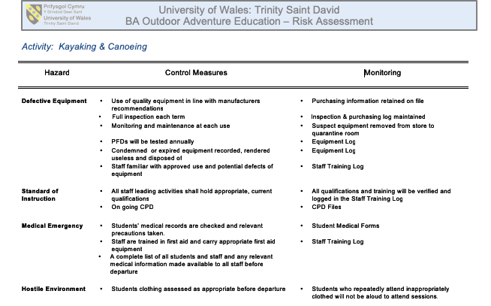
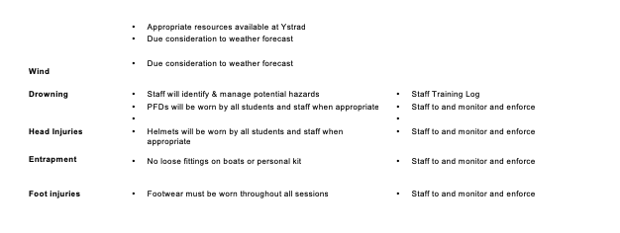

Make notes towards or write a site-specific risk assessment
Due to recent flooding there could be unknown objects under the water that we are unaware of. To avoid this keep feet raised if fall in water.
Car park- be aware of moving vehicles.
River banks could be slippery due to rain in the previous days.
The weather: SW wind, 9°c, cloudy
Be familiar with relevant legislation
SWAOPG
AALA
Environmental Agency

Understand the relevant NGB awards and their remits
BCU
First aid
White water safety

Have understood key technical terms (words and phrases) when given
CLAP- Communication, line of sight, Avoidance, position of most usefulness.
Eddy- an area of water that is slow moving, and can be used to stop paddling
Stopper- a wave caused by an obstacle.

Have identified key activity specific skills to be developed (knot tying, weather, nature, etc)
How to throw a throwline, learning about rising river levels, learn about weather and how it can affect your day on the water.
Be aware of issues relating to access and conservation/ environmental sustainability relating to the venue
Code of conduct- do not leave rubbish on site, be conscious of other people using the site, use exit and entry sites that are approved by the land owner,

Be able to outline the potential benefits of each session
Could potentially gain confidence in a river setting. Could learn new kayaking skills.

Inspect relevant kit in accordance with the guidelines provided
All kit is checked in stores, and we check it personally before we set off. Wetsuits, helmets, river knifes, buoyancy aids, and throwlines were taken on this trip

Maintain a record of dynamic risk assessments/ considerations
It was a cold day so was wary of people getting hypothermia.
There had been recent flooding and rain, so kept an eye out for unexpected objects.
Reflect on their own and others’ preparation for the activity
I did not actually enter the water due to recent sickness and a fear of getting cold, due to adverse effect on my body. Instead I observed from the side and took video footage of my classmates so they could reflect on their experience.
I still wore a buoyancy aid, helmet, throwline and river knife for my own protection and in case someone needed help.

Record any near misses or accidents
There were no near misses or accidents.

Appendix 3-Three Cliffs Bay 19th February 2019 Climbing

Examine the generic risk assessment
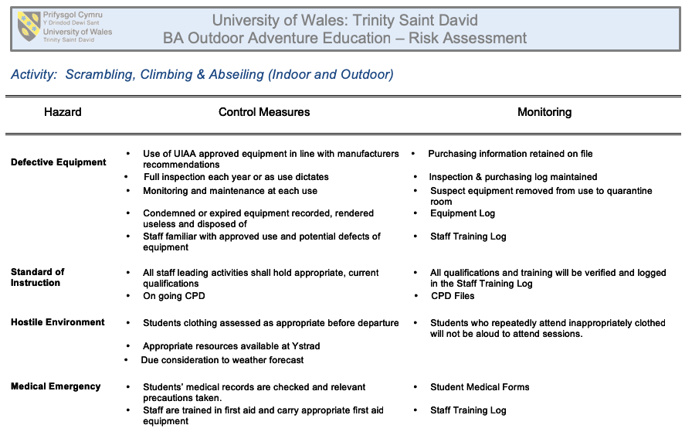
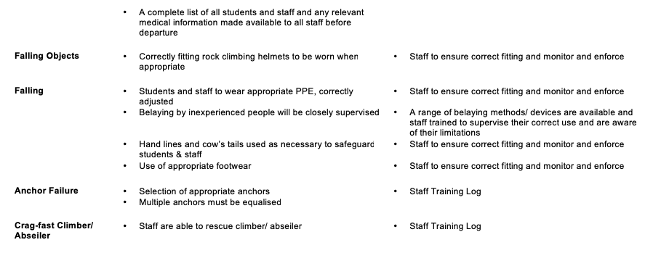

Make notes towards or write a site-specific risk assessment
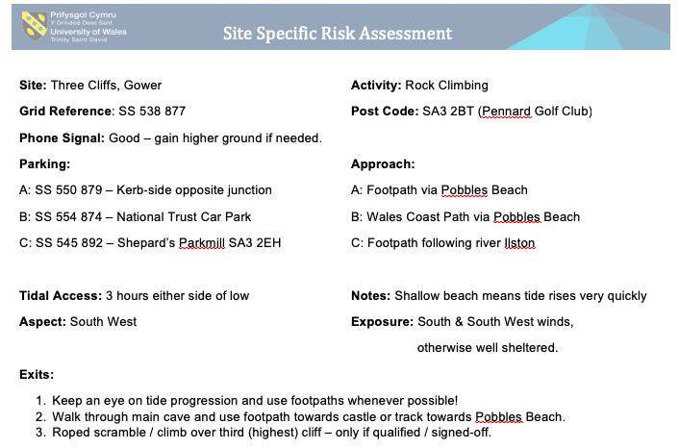
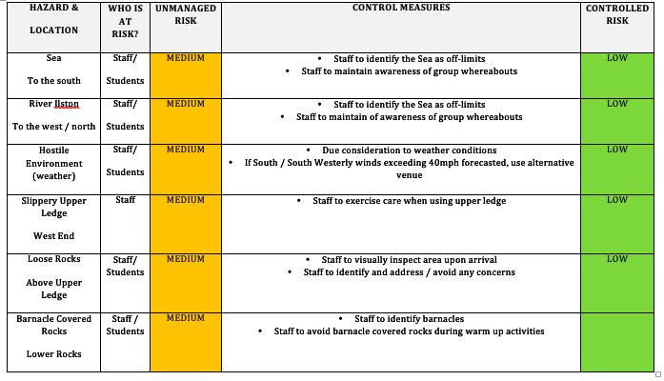
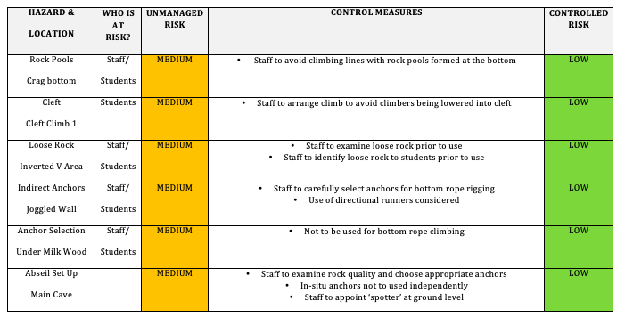
Low tide- 12.06pm, high tide- 18.23pm. safe to climb between 9am and 3pm. Possible rain forecast for 4pm

Be familiar with relevant legislation
AALA
Have permission from landowners
Check for wildlife on the rocks so that they will not be disturbed

Understand the relevant NGB awards and their remits

BMC- Rock Climbing Instructor
First aid

Have understood key technical terms (words and phrases) when given
Half Hitch- a type of knot
Grade- to describe the difficulty of the route when climbing or bouldering
Tidal Range- height difference between low and high tide
Belay- secure the person to an anchor, whether that is a solid anchor or a person at the top or the bottom.

Have identified key activity specific skills to be developed (knot tying, weather, nature, etc)
Belaying, knot tying, tidal times.

Be aware of issues relating to access and conservation/ environmental sustainability relating to the venue
Always pick up rubbish. Do not disturb other people using the site. Follow the Countryside Code when getting to the site (close gates behind you).

Be able to outline the potential benefits of each session
Learn new skills from being in a coastal environment. Potential to gain confidence and team work skills.

Inspect relevant kit in accordance with the guidelines provided
All PPE is checked in stores and checked personally on the day of use

Maintain a record of dynamic risk assessments/ considerations
13mph steady wind SSW
While other people were climbing we collected rubbish that was on the beach.

Reflect on their own and others’ preparation for the activity
Brought lots of food and water to keep energy levels up, I did bring climbing shoes but felt they were not necessary.

Record any near misses or accidents
There were no near misses or accidents

Appendix 4-Brecon Beacons 12th March Hill walking
Examine the generic risk assessment
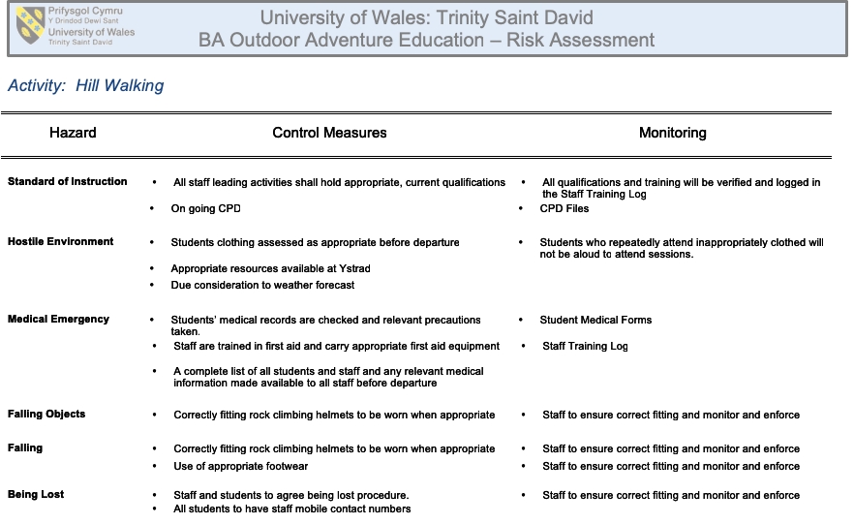

Make notes towards or write a site-specific risk assessment
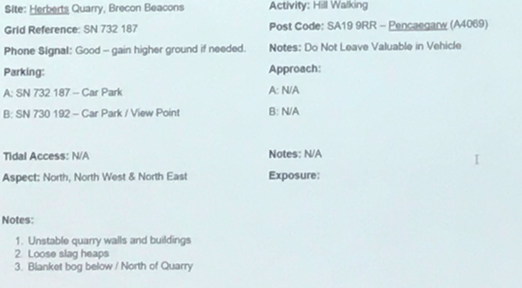

Be familiar with relevant legislation
AALA
Country side code

Understand the relevant NGB awards and their remits
Mountain leader
First aid

Have understood key technical terms (words and phrases) when given
Wind chill- the lowering of the actual temperature on the body caused by the wind.

Contour Line- a guide showing how steep the land is
Temperature Inversion - layer of cool air at the surface is overlain by a layer of warmer air

Have identified key activity specific skills to be developed (knot tying, weather, nature, etc)
How to walk in snow, map reading, navigation and compass skills.

Be aware of issues relating to access and conservation/ environmental sustainability relating to the venue
Do not leave rubbish behind, be aware of other walkers

Be able to outline the potential benefits of each session
Good form of exercise. Team building skills. Learning map reading and navigation skills.

Inspect relevant kit in accordance with the guidelines provided
First aid kit, waterproof, survival bag, food, water. All packed the night before and checked once more in the morning.

Maintain a record of dynamic risk assessments/ considerations
We all looked at weather forecast before we set off, however, having arrived at our destination we noticed snow. We then had to assess whether it was safe for us to continue the walk. All of us had warm clothing and we had a dynamic risk assessment throughout the walk to decide if we should continue. We didn’t have snow equipment such as crampons and one of the member of our group did not have water proof trousers so we were conscious of him getting cold.

Reflect on their own and others’ preparation for the activity
I was not cold starting off the walk, however, once we reached the top of the mountain and we stopped for lunch I became cold and irritable. In the future I will always pack extra clothing, including gloves, as well as a warm drink in case I get too cold. I will also check a more in-depth weather forecast. For example I will look at Mountain weather information service for a more accurate weather forecast.

Record any near misses or accidents
There were no near misses or accidents

