Emma-Sian Davies (1502478)

An insight through evidence of how use of Google Ad Words can help The Primporium improve its customer base

Digital Marketing Campaign using Ad Words and Ad Sense for The Primporium Beauty Salon & Tanning Centre

Contents
Executive summary 2
Introduction 3
Organisation profile 4
Current Marketing Analysis: Primporium 5
Market Analysis 6
Google Ad Sense 6
Google Ad Words 6
Google Display Network 7
Personal case study 7
PT Wahana Indonesia Transport Case Study 7
Google Search Network 7
Future of The Primporium 9
Goals 9
Investment 9
Predicted Results 9
Conclusion 10
References 11
Appendices 12
Appendix 1 12
Appendix 2 13
Appendix 3 14
Appendix 4 15
Appendix 5 16
Appendix 6 17
Appendix 7 18

Executive summary

This report will focus on the detailed analysis on how the use of Google Ad Sense and/or Google Ad Words can have a positive impact on a small, rural organisation offering complementary and beauty treatments. It will critically evaluate the benefits and limitations of both Google Ad Sense and Google Ad Words within the industry and its specific use in drawing customers to the organisation; it will better inform the organisation of its digital marketing needs for future success.

Introduction

Following on from a previous digital marketing analysis of The Primporium, the decision to continue with this organisation and not another was a simple one. With very limited marketing strategies in place, the organisation, once the sole trader in a rural market town has come up against a growing number of organisations offering similar treatments and packages; thus creating increasing competition. By carrying out a detailed analysis of both Google Ad Sense and Google Ad Words, we will better understand the digital marketing platform in an attempt to help The Primporium boost its social media presence and digital marketing profile.
To apprise the reader of the organisation, there will be a summarised company profile, showing what products are offered and how the organisation is conducted. From there a current marketing analysis will show how the organisation trades in comparison to other local organisations in this industry, and how other organisations make use of digital marketing.
With these details available, it will then be possible to analyse how Google Ad Sense and Google Ad Words can help show that, with the use of digital marketing the future potential of the organisation can be improved.

Organisation profile

To better understand the organisation, the following profile gives a brief indication of who The Primporium are, what they offer and how they currently market themselves.
- Organisation name: The Primporium Beauty Salon and Tanning Centre

- Location: Rural Market Town in West Wales

- Number of employees: 5
  - Owner / Part-Time Therapist: Trudie Peters
  - Manager / Therapist: Zoe Hancox
  - Therapist: Rebecca
  - Therapist: Claire
  - Receptionist: June Davies

- Goods and services offered: Various treatments offered including, but not limited to:
  - Occasion Make-up
  - Tanning – booths and spray tanning
  - Complementary therapies – massage, facials etc...
  - Weight-loss treatment
  - Nails – shaping, painting and extensions
  - Electrolysis
  - Sale of branded products e.g. Elemis and St Tropez

- Key online and website management personnel: Trudie Peters

- Age of company: 20 years (approximate)

- URL: No website

- Social media: Facebook

- Sales online: None – all sales done within the establishment

- Customer base: Relies on returning, ongoing custom and seasonal trade

Current Marketing Analysis: Primporium

Through research and analysis, it was determined that The Primporium was not reaching its full potential and, with the increase in competition and dwindling custom, the possibility of going in to administration has become a true threat if changes are not made.
The Primporium currently has no web page and only uses word of mouth and Facebook as marketing. The benefits of word of mouth is that people go there because of a good verbal review from an acquaintance, this has proven to be successful for the organisation to date. In a World where technology has vastly changed the way we interpret information, word of mouth still has a strong hold on the decisions made by people on a daily basis. Research carried out by The Nielsen Company in 2013 suggests that a high number of people will trust the recommendation of a close family or friend above other forms of marketing. From the table in ‘Appendix 1’, we can see that between 2007 and 2013 there was a rise of 6% in the number of global consumers relying on word of mouth, a staggering 84% of consumers surveyed. This is primarily the only way The Primporium attracted new and returning custom until it launched its Facebook page in 2013. Details obtained from plumplot.co.uk ‘Appendix 2’ shows that with a population of 4,513 in the SA38 area alone (location specific to organisations establishment) (plumplot.co.uk, 2016) and only 495 people following their social media presence, the numbers suggests there could be significant improvement.
Fierce competition over the years has come from a similar organisation, ‘Beauty & Reflexology’. This is a sole trader and she works from her private residence. With 749 members in the organistaion group, Beauty & Reflexology does appear to be more popular. Of course with both, the number of people who follow the organisation does not necessarily in turn result in actual custom.
The organisation works solely from its establishment and therefore customers must visit them for any treatments. The increase in mobile beauty and complementary therapists means that consumers have more choice and can opt to have an organisation come to their residence, freeing them from the trouble of travelling to the establishment and the stresses that come with it. In order for The Primporium to supersede all competition and increase its popularity, suggestions were made to them to consider selling their branded products and gift vouchers online as well as in the salon.

Market Analysis

Product marketing can be daunting for any organisations. How to begin and what to market and costs can easily and quickly spiral out of control. The effects of digital marketing on the macro-environment means there is huge competition in every field of industry. Over time the internet has become an integral part of daily life for many people and with the speed with which social media has grown, it is no wonder so many organisations take full advantage of digital marketing strategies. We can see from ‘Appendix 3’ the speed with which the social media site Facebook grew in the space of 9 month; 100 million followers (Tuten & Solomon, 2017).
Many companies may decide to outsource their marketing to a designated marketing organisation, with the introduction of Google Ad Sense and Google Ad Words, developed and owned by Google; marketing has become a simple step by step process which enables an organisation to keep costs at a minimum and decide for themselves how much is spent and for what period of time the adverts are required. This keeps all marketing in-house and eliminates any external, additional costs.

Google Ad Sense
Google Ad Sense is a Display Network platform with which an organisation can publish Google Ads to their own website and becoming part of an affiliate marketing strategy (Google, 2018). The adverts are subject specific and once a consumer clicks on the advert link, the web owner is paid a percentage fee for allowing Google to advertise on their site. With this platform your organisation is not marketing itself but other organisations. To market your organisation the better platform here would be Google Ad Words.

Google Ad Words
Google Ad Words is the platform used by an organisation when advertising their own brand or products (Google, 2018). In this instance there are different ways of using the platform; using Google search results pages and partnered websites or Google Display Network, thus becoming part of a paid marketing strategy. Adverts can be placed in a variety of mediums that are specific to your needs such as:
- Organisation website(s)
- Online games
- Social media
- YouTube
- Mobile phone apps
- Magazine websites
- Blogs
With such variety and such ease of use, Google are allowing organisation’s to have more control over their digital marketing.

Google Display Network
The difference with Display Network is that an organisation can choose to use adverts in the form of banners, text ads or video adverts which pop up within other websites. One example of this is Facebook and, with The Primporium only having one digital media presence, could be beneficial to increasing popularity.

Personal case study
To test Google Ad Words, a recent search on a personal laptop for clothing and broadband suppliers was undertaken to see what results would appear on Facebook (Facebook, 2018). As we can see from the results shown ‘Appendix 3’, Google uses recent search engine searches and cookies to provide the page user with adverts that may interest them.

PT Wahana Indonesia Transport Case Study
A small car rental organisation in Indonesia faced strong competition from other similar organisations and to stand out from the crowd they introduced Google Ad Words. Their website presence has increased dramatically and received a 50% increase in sales and 100% increase in site traffic. They have been able to expand their organisation and advertise in other countries (Digital Training Academy, 2018).

Google Search Network
In this day and age it is no surprise that when we use a search engine to find something we are presented with adverts. By typing just a few key words in to a search engine, Google for example; you are presented with a list of websites relating to the words searched and the top two or three listings are adverts, as seen in ‘Appendix 4’. These are paid adverts from organisations and appear above other sites to attract the attention of potential consumers.
Research shows that internet searches using search engines were as high as 80% in a 2001 survey (Fisher, 2001). In a survey carried out by the Search Engine journal in 2016 the percentage was at a staggering 93%, an insightful glimpse of how much we rely on a search engine to support our browsing needs:
“93% of online experiences begin with a search engine” (Siu, 2017).
If an organisation such as The Primporium were to set aside a budget for digital marketing through Google Ad Words they could in theory reach the fundamental 5 S’s goal in internet marketing (Chaffey & Ellis-Chadwick, 2012):
- Sell: Increase sales on branded products and treatments
- Serve: Adding value to the organisation by offering consumers online deals
- Speak: By opening lines of online communication with existing and future consumers they have a more personal experience.
- Save: By using Google Ad Words, the organisation saves money marketing themselves rather than outsourcing to a marketing firm.
- Sizzle: With consumer feedback the organisation can determine if changes can be made to different products offered, if one product is more popular than another and gain consumer feedback to better improve the organisation.
Statistics show that on average, Google Search Network is more successful than Google Display Network but only be a small margin. With both becoming increasingly popular the click through rate and average conversion (to sales) rate in different industry sectors is steadily increasing, as we ca see from ‘Appendix 6 and 7) (Mangles, 2018).

Future of The Primporium

With the research and evidence presented to the owner and manager of The Primporium, they have concluded that a revised marketing approach would improve sales and increase return custom. Specific goals, investment and projected results have been complied with the intention to review in two months. The Google Ad Words campaign will run between April 24th 2018 and June 24th 2018 with a budget of £310.

Goals
- To increase awareness and social presence of organisation within 50 miles of the establishment.
- Show why potential clients should choose The Primporium, and encourage them to purchase products online and/or make an appointment.
- Drive more new business through online advertising using Google Ad Words and a more planned and co-ordinated approach.
- Reach a long-term goal of opening another establishment within the 50 mile radius to expand the organisation.

Investment
- Created an AdWords campaign with a budget of just £5 per day.
- Introduced banner ads with a click-to-call option, with discounted offers so customers can book appointments immediately.
- Used AdWords’ reporting tool to track clicks and calls to actual bookings.

Predicted Results
- Increased Facebook page traffic by 100%
- Increased online product sales 25%
- Increased return custom 40%
- Ability to expand (based on results after 1 year)
Though they have decided not to create a website at this time, they will look at the possibility of creating one in the future if business improves and they are able to expand the organisation. Then they will contemplate making use of Google Ad Sense to increase funds further.

Conclusion

Both Ad Words and Ad Sense are excellent tools an organisation can use to promote products and treatment services offered online and can also help the organisation make money. Using Ad Words in this case is the most effective way to advertise the organisation to a distinct target audience. By going through the steps one by one, The Primporium will be able to develop a personalised digital marketing strategy enabling current and future consumers to access their Facebook site easily to view what other products and treatments are offered and what deals they have. Optimistically, it is hoped that The Primporium will be able to meet the goals set and provide a secure and satisfying future for all staff and consumers.

References
Chaffey, D. & Ellis-Chadwick, F., 2012. Digital Marketing - Stratergy, Implementation and Practice. 5th ed. Essex: Pearson.
Digital Training Academy, 2018. Search case study: Luxury car rental boosts sales leads with AdWords. [Online]
Available at: http://www.digitaltrainingacademy.com/casestudies/2015/03/search_case_study_luxury_car_rental_boosts_sales_leads_with_adwords.php
[Accessed 10th April 2018].
Facebook, 2018. Amme Nais. [Online]
Available at: https://www.facebook.com/
[Accessed 10th April 2018].
Fisher, J. G., 2001. E-Business for the Small Business. 1st ed. London: Kogan Page Ltd.
Google, 2018. Google Ad Sense. [Online]
Available at: https://www.google.co.uk/adsense/start/#/?modal_active=none
[Accessed 5th April 2018].
Google, 2018. Google Ad Words. [Online]
Available at: https://adwords.google.com/intl/en_uk/home/
[Accessed 4th April 2018].
Mangles, C., 2018. Search Engine Statistics 2018. [Online]
Available at: https://www.smartinsights.com/search-engine-marketing/search-engine-statistics/
[Accessed 10th April 2018].
plumplot.co.uk, 2016. Population. [Online]
Available at: http://a.plumplot.co.uk/?tab=maps6&pc=34
[Accessed 8 April 2018].
Siu, E., 2017. 24 Eye-popping SEO statistices. [Online]
Available at: https://www.searchenginejournal.com/24-eye-popping-seo-statistics/42665/
[Accessed 12th April 2017].
Tuten, T. L. & Solomon, M. R., 2017. Social Media Marketing. 1st ed. London: Sage.

Appendices

Appendix 1
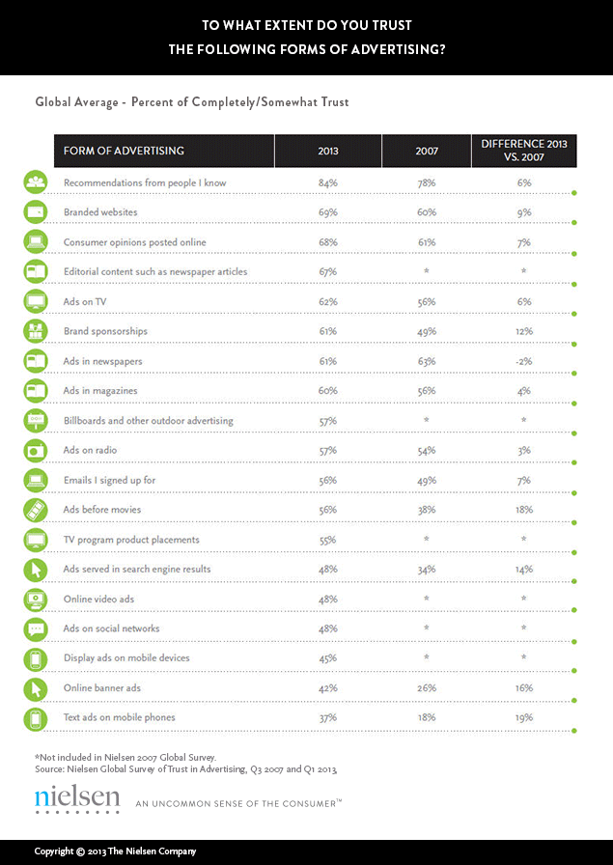

Appendix 2
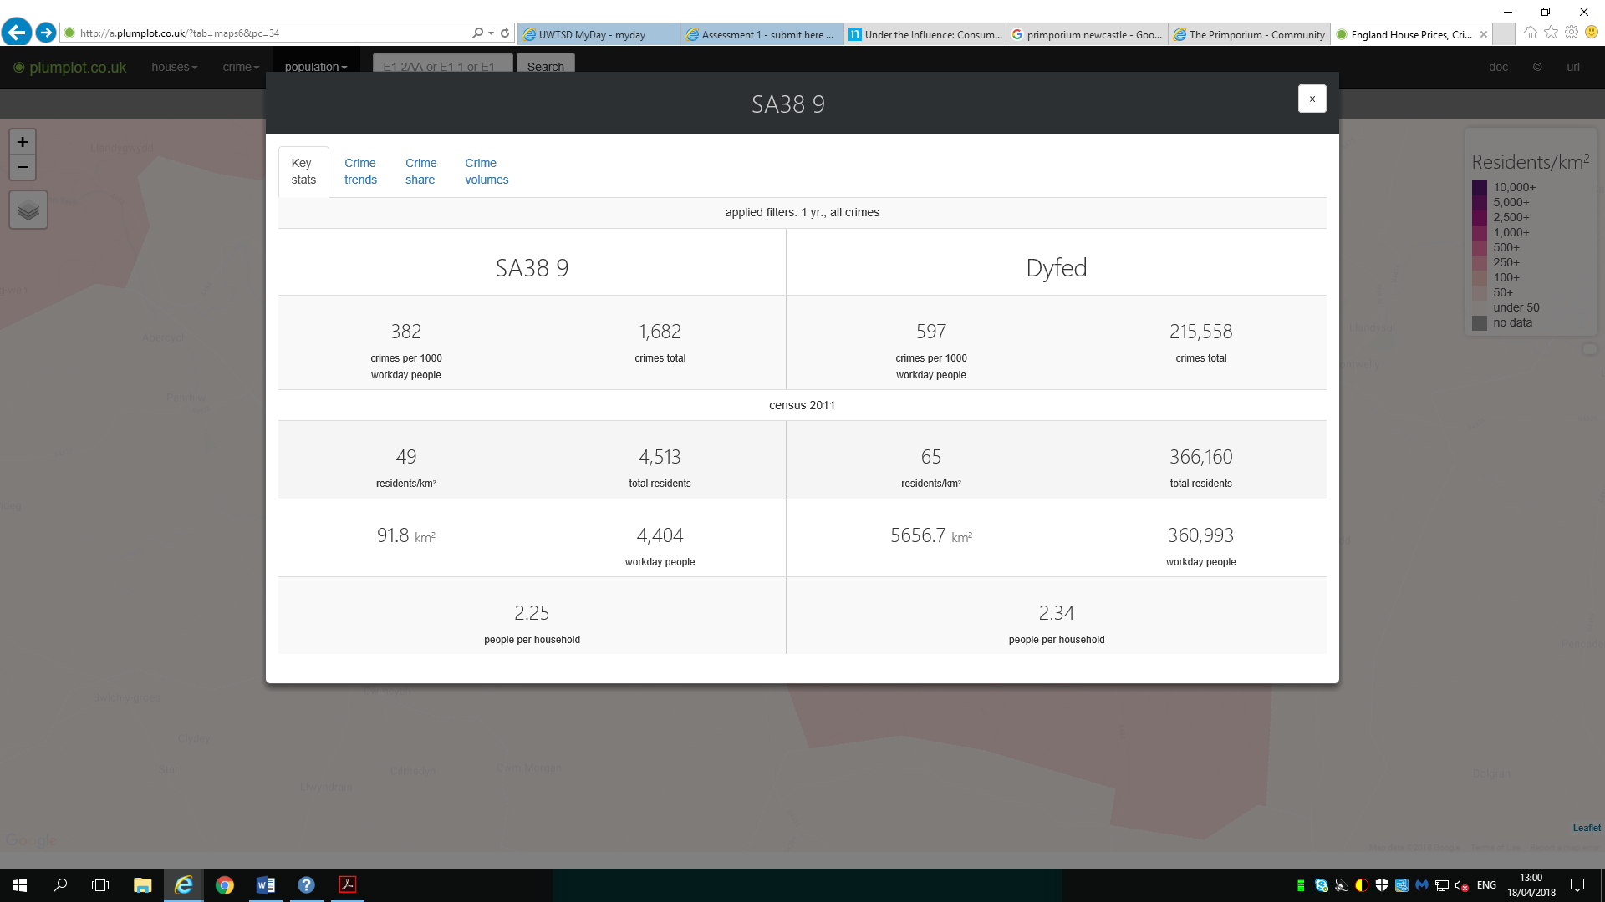

Appendix 3

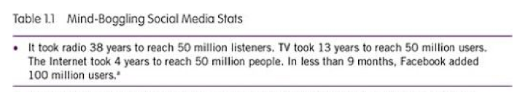

Appendix 4

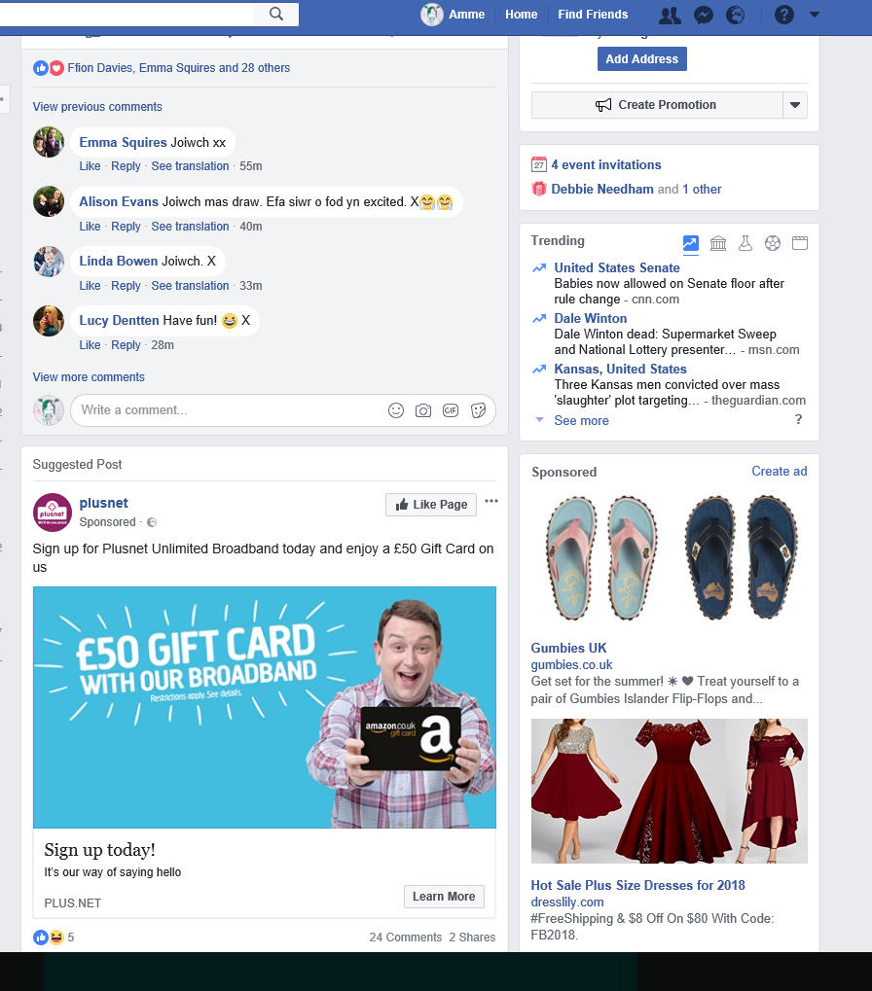

Appendix 5
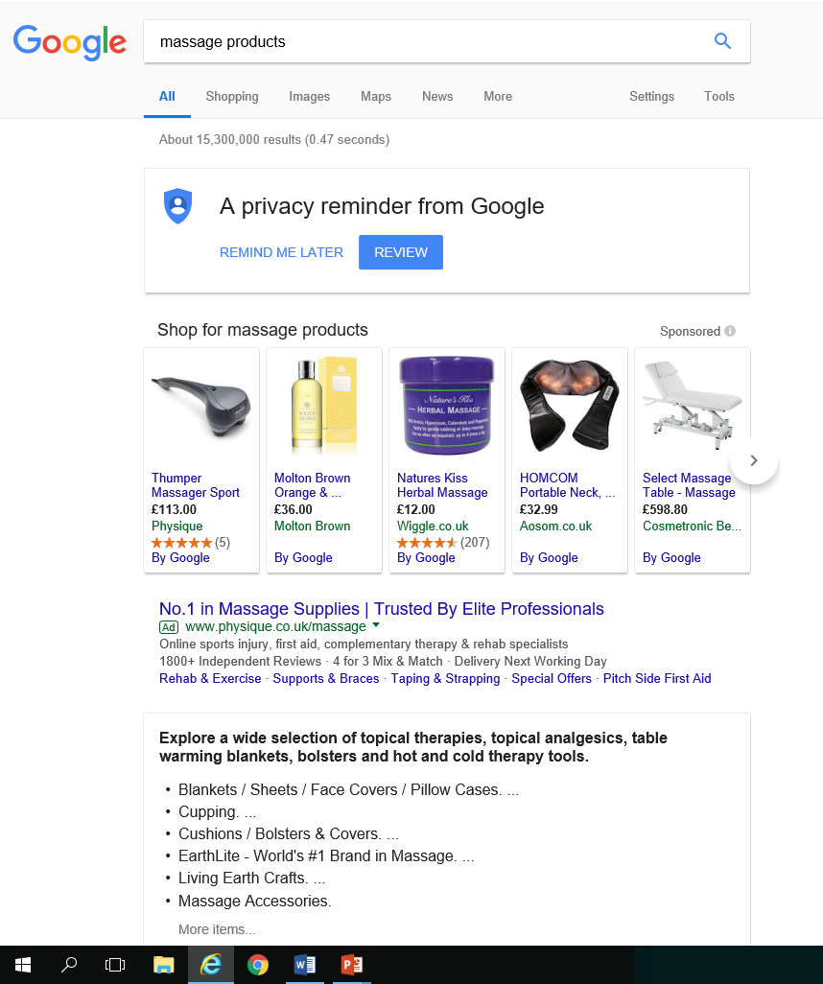

Appendix 6

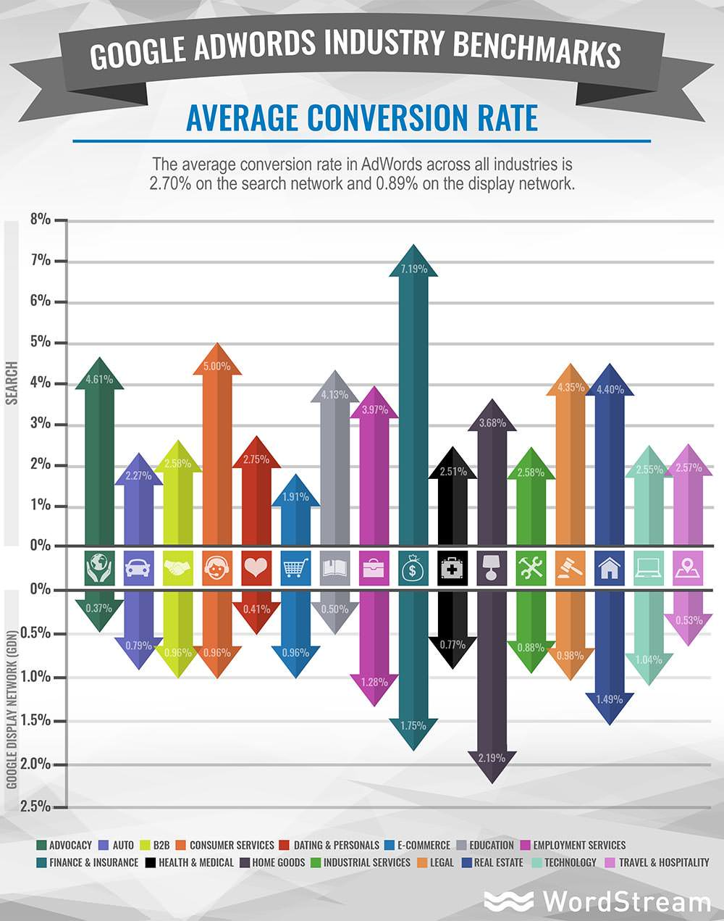

Appendix 7

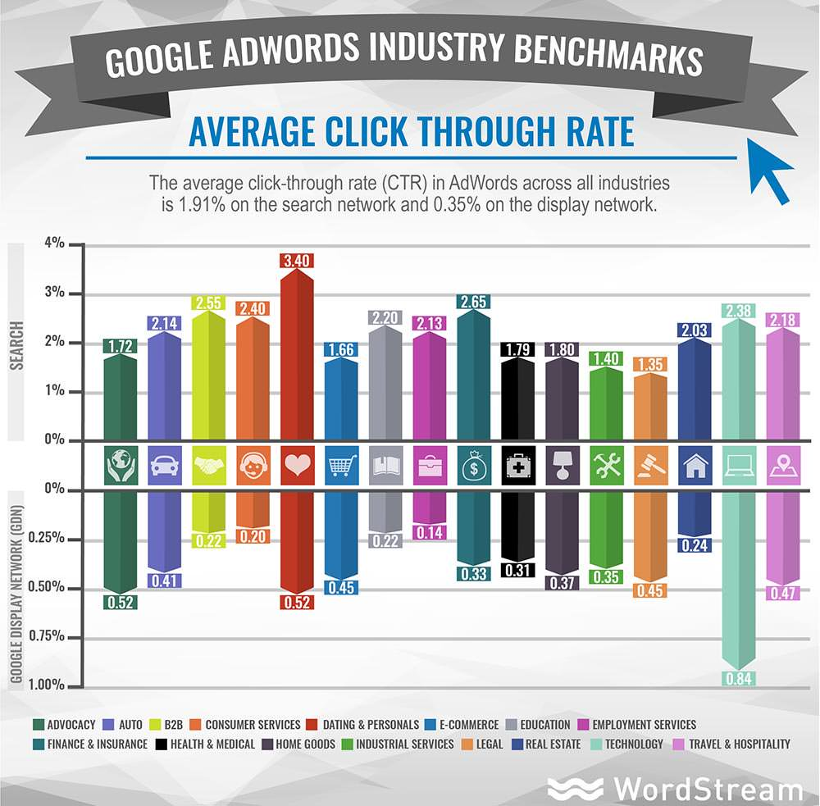

Figures obtained were taken from the 2011 Census and estimated in 2016 by plumplot.co.uk

