

LCMB7035
Dissertation

The Role of Brand Purpose in Building Consumer Resilience during a Cost- of-Living Crisis: A Study of UK Supermarket Retailers

Submitted by-
Name- Nishat Hossain
ID- 2437429

Submission Deadline- 25th September 2026

AI Acknowledgement
Category | Description | Allowed (Yes/No)
Research | For this assessment, you can use Generative AI to support you in research and data analysis. | Yes
Structure | You have permission to use Generative AI to assist you with structuring your submission here, such as providing a draft argument structure, finding parts and headings etc. | No
Proofreading | Grammatical or syntactical errors will also be acceptable for this evaluation if they were made by using the developed Generative AI to self-correct your text/creation, including rephrasing. | Yes
Writing | Text is created for submission for this assessment, and you may use Generative AI. | No
Creative | Generative AI can be used for creating creative materials (e.g., images) for this assessment. | No
Programming | Generative AI is allowed to generate and test code for this assessment. | Yes
None | For this assessment, you are not allowed to use any type of Generative AI support. This includes research support, structure support, writing/proofreading support and creative support.

Abstract
This dissertation explores the possible role a brand purpose can play in helping to create consumer resilience in the cost-of-living crisis by focusing on supermarket retailers in the UK. Consumer behaviour and expectations have been transformed by the cost-of-living crisis, which was sparked by economic fluctuation, supply chain issues and geo-political tensions, brought on by the contemporary global issues. A growing number of retailers are articulating their brand's purpose which is part of their wider value offering and that covers but is not limited to; affordability, community support, sustainability, yet there is a lack of understanding as to how these communications influence consumer resilience outcomes during economic hardship.
It takes a pragmatic approach to research philosophy, using a mixed methods approach, with secondary data collected from annual reports, CSR reports, industry reports and consumer sentiment data (2021–2024) analysed using content analysis and primary data collected via a structured survey of 6 supermarket consumers in the UK. The study tests six propositions related to purpose communication patterns, consumer loyalty, retailer differentiation, authenticity and price-purpose trade-offs.
The findings indicated a notable boost in the implementation of purpose communications from the UK supermarket retailers during the crisis, where the number of messages on “affordability” has grown by 78%. A strategic differentiation was highlighted: discount retailers highlighted value and premium retailers talked about sustainability. What was most important was authenticity: Purpose washing resulted in negative consumer sentiment and authentic communications resulted in consumer trust and loyalty. Consumer decision making was still largely driven by price and affordability, with brand purpose coming in as the lowest among the factors driving consumer loyalty. Three of the participants said they changed supermarkets mainly for monetary reasons.
The study has two implications for theoretical and academic appreciation: purpose communications can aid in the financial, psychological, and social resilience of consumers, provided that they are delivered as authentic and in line with consumer priorities; and Keller's Brand Resonance Model is a valuable theoretical lens for examining consumers' reactions to DR communications. Advice for retailers includes: aligning purpose claims and actions, using these times of crisis as an opportunity to focus on affordability communication and making purpose part of value propositions, not a premium.

Acknowledgements
Firstly, I would like to thank my dissertation supervisor for their guidance, constructive critique and constant support throughout this research. It is their expertise and assistance that helped this study and ease my journey from traditional research to dealing with the complexities of mixed methods studies.
Thanks to the six customers from the supermarkets in the UK who participated in this study, offering their candid perceptions and experiences during this period of the cost-of-living. Their input formed a crucial part of the primary research phase of this dissertation and their openness to learning about the topic rendered the findings relevant, insightful and practical.
I would also like to express gratitude towards the academic and administrative staff at UWTSD who have offered a supportive learning environment and the opportunity to have the resources needed in carrying out this work. I am especially grateful to my fellow students and colleagues who provided support and learning opportunities throughout the difficult periods of this research investigation.
I would like to express my gratitude to my family and friends for all their encouragement throughout the project. I was supported through this tough, but rewarding period of schooling by their patience, understanding and faith in my capabilities. Without their love and encouragement, I would not be able to achieve this.

Declaration
I declare that " The Role of Brand Purpose in Building Consumer Resilience during a Cost-of-Living Crisis: A Study of UK Supermarket Retailers" is an original piece of work by me and has not been presented for any other degree or award at this or any other University.
The sources of information and data have been adequately acknowledged and cited in this research. For this study, secondary data was collected from publicly available sources such as annual reports, CSR reports, industry publications and consumer review sites, duly referenced. Primary data were collected subject to the ethical consideration approved by the University Ethics Committee in which all the participants consented with anonymity and confidentiality.
The opinions presented in this dissertation are author's own and may not necessarily represent the opinions of any organisation or institution named.

Nishat Hossain
Student ID: 2437429
Date: 25th September 2026

Table of Contents
Abstract 3
Acknowledgements 4
Declaration 5
Chapter 1: Introduction 10
1.1 Research Title 10
1.2 Study Background 10
1.3 Problem Statement 11
1.4 Research Rationale 12
1.5 Aims, Objectives and Questions 12
1.7 Overview of Methodology 13
1.8 Structure of Dissertation 14
1.9 Chapter Summary 14
Chapter 2: Literature Review 15
2.1 Conceptualising Brand Purpose in the Retail Context 15
2.1.1 Defining Brand Purpose: Origins and Evolution 15
2.1.2 Theoretical Foundations: Brand Resonance Model 17
2.1.3 Corporate Social Responsibility and Brand Purpose 18
2.1.4 Authenticity and Purpose-Washing in Brand Communications 20
2.2 Understanding Consumer Resilience during Economic Crises 22
2.2.1 Defining and Conceptualising Consumer Resilience 22
2.2.2 The Cost-of-Living Crisis: Context and Consumer Impacts 23
2.2.3 Consumer Adaptation and Coping Strategies 25
2.2.4 Measuring Consumer Resilience: Indicators and Approaches 26
2.3 The Intersection of Brand Purpose and Consumer Resilience 28
2.3.1 Theoretical Integration: Brand Purpose and Consumer Resilience 28
2.3.2 Supermarket Strategies for Building Consumer Resilience 30
2.3.3 Cross-Retailer Differentiation in Purpose Communications 31
2.3.4 Authenticity and Trust in Supermarket Purpose Communications 32
2.4 Research Propositions and Conceptual Framework 33
2.4.1 Development of Research Propositions 33
2.4.2 Conceptual Framework 35
2.5 Research Gaps Identified in Literature Review 37
2.6 Chapter Summary 38
Chapter 3: Methodology 39
3.1 Introduction 39
3.2 Research Philosophy 39
3.3 Research Approach 40
3.4 Research Strategy 41
3.5 Data Collection Methods 42
3.5.1 Secondary Data Collection 42
3.5.2 Primary Data Collection 42
3.6 Data Analysis Methods 43
3.6.1 Secondary Data Analysis 43
3.6.2 Primary Data Analysis 44
3.7 Ethical Considerations 45
3.8 Limitations of the Methodology 45
3.9 Chapter Summary 46
Chapter 4: Results 47
4.1 Introduction 47
4.2 Secondary Data Analysis Findings 47
4.2.1 Overview of Secondary Data Sources 47
4.2.2 Proposition 1: Augmented Purpose Communications in Crisis 47
4.2.3 Proposition 2: Purpose Communications and Consumer Loyalty 48
4.2.4 Proposition 3: Discount vs. Premium Purpose Positioning 49
4.2.5 Proposition 4: Purpose-Washing and Consumer Sentiment 50
4.3 Primary Survey Data Findings 51
4.3.1 Overview of Survey Participants 51
4.3.2 Question 1: Likert Scale Results 52
4.3.3 Question 2: Primary Supermarket Choice 53
4.3.4 Question 3: Awareness of Initiatives 54
4.3.5 Question 4: Semantic Differential Scale Results 55
4.3.6 Question 5: Open-Ended Qualitative Responses 56
4.3.7 Question 6: Ranking Results 57
4.3.8 Question 7: Brand Switching Behaviour 59
4.3.9 Thematic Analysis of Open-Ended Responses 61
4.4 Proposition Testing Summary 62
4.5 Chapter Summary 63
Chapter 5: Discussion of Findings 64
5.1 Introduction 64
5.2 Proposition 1: Augmented Purpose Communications in Crisis 64
5.3 Proposition 2: Purpose Communications & Consumer Loyalty 65
5.4 Proposition 3 offers two choices: Discount or Premium Purpose Positioning. 66
5.5 Proposition 4: Purpose-Washing and Consumer Sentiment 67
5.6 Proposition 5: Authenticity and Consumer Loyalty 68
5.7 Proposition 6: Price versus Purpose Trade-offs 69
5.8 Synthesis: Brand Purpose and Consumer Resilience 70
5.9 Chapter Summary 71
Chapter 6: Conclusion and Recommendations 72
6.1 Conclusion 72
6.2 Contribution to Knowledge 73
6.3 Recommendations for Retailers 74
6.4 Limitations and Future Research 75
6.5 Final Reflections 76
References 77
Appendix 87
Appendix A- Informed Consent Form 87
Appendix B- Primary Data Collection Questionnaire 88
Appendix C: Supplementary Tables for Primary Data 91
Appendix D: Secondary Data Sources Analysed 92
Appendix E: Content Analysis Coding Framework 93

Chapter 1: Introduction

1.1 Research Title
The Role of Brand Purpose in Building Consumer Resilience during a Cost-of-Living Crisis: A Study of UK Supermarket Retailers

1.2 Study Background
The Economic Crisis as a Defining Economic Crisis
The cost-of-living crisis that arose in the United Kingdom since 2021 can be considered one of the economic challenges the British consumers have had to deal with over the recent decades as it is characterised by rapidly increasing inflation levels, stagnant wages, extraordinary growth of household spending (Grailey et al., 2024). A combination of several factors such as the long-term effect of the COVID-19 pandemic, supply chain-related disruptions, and the geopolitical shock of the situation in Ukraine led to this crisis, which resulted in a perfect storm that has radically changed the consumer behaviours and expectations
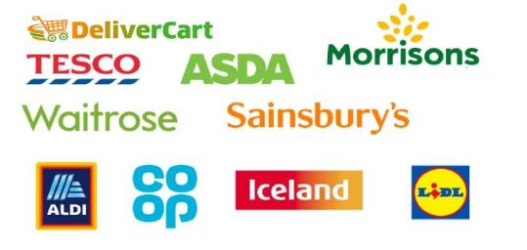
Figure: UK retail market (Titis, 2022)
Brand Purpose: how it evolves in retail
The concept of brand purpose has become a mark of modern marketing theory, as the core concept of business based on shareholder focus has witnessed a revolution into stakeholder-based based approaches emphasising organisations contribution to the society (Anisimova, Lee and Ramos Da Silva, 2025).
Resilience as a pivotal Construct to the consumer
Consumer resilience, which is defined as an individual and community ability to absorb, adapt and recuperate economic misfortunes, has received significant academic interest as scholars strive to learn how consumers navigate the ever-shifting and unpredictable circumstances (Hosany, Prayag and Bettany, 2025).

1.3 Problem Statement
The Disconnect between Brand Purpose Communication and Outcomes to Consumer Resilience
Although brand purpose has been acknowledged as a strategic asset and its importance to brand communications has been getting more academic focus, there seems to be a critical lack of knowledge on how brand purpose messages specifically influence consumer resilience outcomes in times of intense economic shock and post-shock recovery (Hosany, Prayag and Bettany, 2025).
Purpose as a Brand Communication: The Authenticity dilemma
One of the key issues that this study deals with regards to brand purpose communications as to whether they are authentic and their link with consumer perceptions and behaviours in the cost-of-living crisis (Benker, 2024).
Problems of differentiation and Positioning
The research challenge concerning how the supermarket retailers distinguish their brand purpose communication in the cost-of-living crisis is yet another dimension of the problem as the retailers have to grapple with the dilemma between differentiation in a competitive market, or joint actions to the common social problem (Dolega, Ballantyne and Singleton, 2026).
To fill this research gap the current study has adopted a mixed-methods approach, which involves secondary data analysis of supermarket purpose communications and primary data collection using consumer interviews. This will allow the purpose-resilience relationship to be explored both in a systematic manner based on published supermarket purpose communications, and from the perspective of the consumer through interviews with them.

1.4 Research Rationale
Theoretical justification and value to the scholarly learning
The theoretical basis of this study is based on the necessity to expand and incorporate current theories that deal with the purpose of the brands, resilience among the consumer, and communication during crises within the particular setting in the UK supermarket retail.
Direct Applicability and Applicability with Retail Management
This choice of study is based on practical reasons as the research findings have crucial implications to retailers in the supermarket who struggle to survive in a cost-of-living crisis due to the awareness of brand purpose-consumer resilience relationships (Sundström, Ziakas and Lundberg, 2026).
Implications on Societal Reason/Consumer Welfare
The social context of this study echoes the greater importance of the research in the context of consumer resiliency in relation to the perceived purpose of brand communications in supermarkets, particularly with the vulnerable population that is mostly disadvantaged by a cost-of-living crisis

1.5 Aims, Objectives and Questions
Research Aim
This research aims to investigate two key things: firstly, how supermarket retailers in the UK are communicating their brand during the cost of living crisis; and, secondly, the connection between brands purpose communication and consumer resilience. The study takes a mixed-method approach, with secondary data analysis using published communications from the retailers, and consumer interviews as a primary research tool.

Research Objectives
- Objective 1: To discover the current body of literature on the brand purpose, resilience of the consumers, and cost-of-living behaviours in the retail setting and critically analyse it.
- Objective 2: To analyse the message that the UK supermarket retailers convey about their brand purpose in the phase of the crisis of the cost of living by their published messages and reports.
- Objective 3: To derive strategic implications of supermarket retailers aiming to empower consumer’s resilience by positioning its brand purpose.

Research Questions
- Research Question 1 (Secondary Data): What is the way UK supermarket retailers communicate their brand purpose in their published materials such as annual reports, CSR reports and in the media during the cost of living crisis?
- Research Question 2 (Primary Data): What do consumers think and feel about brand purpose communication in their supermarkets and, during a recession, do those thoughts and feelings impact their buying behaviour and brand loyalty?
- Research Question 3 (Triangulation): What are possible connections between brand purpose communication themes and consumers' resilience indicators, in terms of loyalty, trust and retention, in the supermarket retail sector in the United Kingdom?

1.7 Overview of Methodology
This chapter introduces the research philosophy, approach, strategy and methods used in this study (Ariza et al., 2025). The study follows a pragmatic philosophy with a mixed method of qualitative content analysis of secondary data with primary qualitative data collected through semi-structured interviews or questionnaires with between 5 and 7 supermarket consumers in the United Kingdom (Bénard et al., 2023). Secondary data sources include annual reports, CSR reports, industry reports from Kantar and IGD, news media, and consumer sentiment data. Data analysis procedures are explained in this chapter (thematic analysis used for primary data, and content analysis for secondary data) as are aspects of ethics within the process of gathering data (Balta et al., 2024).

1.8 Structure of Dissertation
This dissertation comprises six chapters. Chapter One reviews: Background, Problem Statement, Rationale, Aims, Objectives and Research Questions. Building from literature on brand purpose, consumer resilience and authenticity, Chapter Two presents six research propositions and includes a conceptual framework. The methodology used throughout the study is detailed in Chapter Three – which uses a pragmatic, mixed methods approach, involves secondary content analysis and primary surveys with six supermarket consumers in the UK and considers the ethical and limitations issues. The results of both sets of data are described in Chapter Four. The findings are depicted in the context of the theory in Chapter Five. Financial contributions to knowledge, retailer suggestions, limitations and directions for future study are included in the conclusion of Chapter Six.

1.9 Chapter Summary
This chapter lays the groundwork of the study on ‘brand purpose and consumer resilience in the face of the UK cost-of-living crisis. Describes the economic situation, characterized by high inflation and a changing consumer behaviour, since 2021. The issue statement explains that there is a gap between the outcome of brand communication to consumer resilience, such as authenticity and differentiation challenges. The research is designed to explore the medium by which the supermarket retailers communicate purpose and to determine what that has to do with consumer resilience and resilience has three objectives, and along with it three research questions. The content is analysed using a pragmatic approach, which involves a secondary analysis of content along with a primary consumer survey and is summarized.

Chapter 2: Literature Review

2.1 Conceptualising Brand Purpose in the Retail Context

2.1.1 Defining Brand Purpose: Origins and Evolution
The Brand Purpose is being an Emergent in Marketing Ideas
The brand purpose has become the key concept in modern marketing discourse, which became a major shift in the historical trend of viewing the branding process as focusing on three basic aspects: a functional value and emotional relationships (Anisimova, Lee and Ramos Da Silva, 2025). Brand purpose has its origins in more general changes in corporate philosophy towards stakeholder capitalism and the creation of shared value, which questioned the focus on shareholder value maximisation and underlined the roles of organisations to the broader society (Bridle et al., 2025)
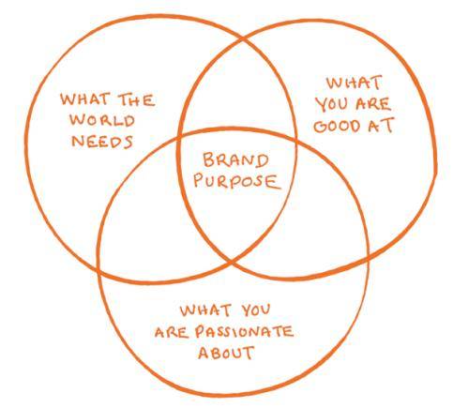
Figure: Brand Purpose (Fletcher and Stephen, 2025).
Defining Brand Purpose: Important Conceptual Elements
An organisation purpose can be defined as the basic purpose of existence which is beyond earning profits but includes contributing positively to society, environment and wellbeing of stakeholders. This definition has a number of critical aspects that differentiate brand purpose as opposed to other related terms like mission statement or corporate social responsibility statement (Bénard et al., 2023)
On the one hand, brand purpose can be defined as authenticity in terms of its organisational commitment, which is constantly displayed by the commitment through the actions and not only by the organisational commitment expressed in the form of communications. Second, brand purpose is stakeholder oriented, wherein the needs and concerns of various stakeholders such as consumers, employees, communities and the environment are taken into consideration (Barford, Beales and Zorila, 2025).
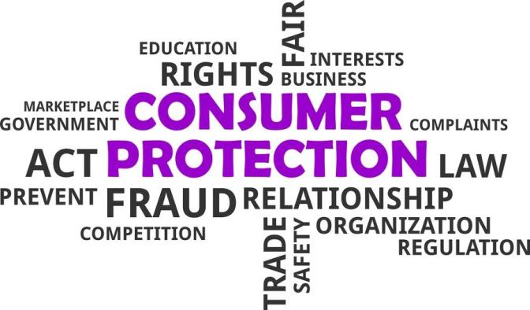
Figure: Consumer Welfare (Sundström, Ziakas and Lundberg, 2026).
Operationalising brand purpose in Retail
The brand purpose operationalisation in supermarket retail is a process of converting purpose pledges in the form of abstract contents into tangible practices, communications and consumer experiences (Dolega, Ballantyne and Singleton, 2026). This operationalisation takes place in various aspects such as various products, pricing policies, community policies, employee policies and sustainability of the environment (Hirth et al., 2025). To illustrate, the Tesco brand purpose has been operationalised by acting on its promises to cut down food wastage, helping community food banks, and offering the essential goods at affordable prices (Shahab and Webb, 2023).

2.1.2 Theoretical Foundations: Brand Resonance Model
Learning about Brand Resonance Model of Keller
The Brand Resonance Model of Keller offers a general theoretical perspective of the way in which brands develop a meaningful relationship with consumers and the perspectives are also applicable in brand purpose with reference to retailing. The model visualises the brand resonance as the desired outcome of branding, the degree to which consumers identify with a brand and feel like it contributes to a sense of community and engagement (Anisimova, Lee and Ramos Da Silva, 2025). The model is designed in four consecutive dimensions namely brand identity (who are you?), brand meaning (what are you?), brand responses (what about you?), and brand resonance (what about you and me?).
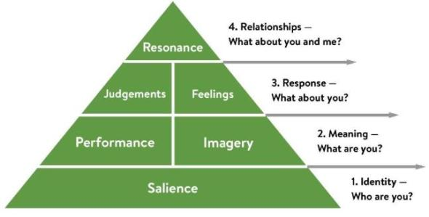
Figure: Learning about Brand Resonance Model (Fletcher and Stephen, 2025).
The use of Brand Resonance Model to Supermarket Retail
Using Brand Resonance Model of Keller to analyse the Brand Purpose communications of the supermarket retail sector in the cost-of-living crisis indicates a variety of channels in which brand purpose communications would play a role in consumer resilience. The brand identity dimension entails the forming of brand recognition which in the case of the supermarkets is the recognition and recall of purpose-related attribution which in the case of Tesco is the willingness to support the community or Aldi stressing its focus on lowering the prices (Dolega, Ballantyne and Singleton, 2026). The brand meaning dimension involves both the functional and abstract correlation where the messages of purpose in the supermarket would be part of the brand imagery and performance evaluation (Sundström, Ziakas and Lundberg, 2026).
The Brand Resonance Model manifests in the following manner in terms of critiques and extensions
Although the Brand Resonance Model is an effective tool to explain consumer-brand relationships, researchers have noted that this model has a number of limitations, which can be applied to its application to the communication of the supermarket purposes in the context of the cost-of-living crisis (Anisimova, Lee and Ramos Da Silva, 2025). To start with, the model has been criticised on the basis of its rather linear conceptualisation of the process of the consumer-brand relationship, which might not suit the complexities of consumer interaction with brands in the context of crisis situations (Ingram et al., 2024).

2.1.3 Corporate Social Responsibility and Brand Purpose
Making the difference between CSR and Brand Purpose
Corporate Social Responsibility (CSR) and brand purpose can be deeply confused in both theoretical and practical circles, but there are still vital parts that determine a fundamental difference between them and that is why these issues need to be carefully distinguished in terms of theoretical knowledge (Anisimova, Lee and Ramos Da Silva, 2025). It is possible to view CSR as a collection of organisational practices and policies used to solve socially and environmentally oriented concerns, which is usually formulated in the terms of responsibility and obligation (Barford, Beales and Zorila, 2025). On the other hand, brand purpose is deeper in nature, being the purpose why an organisation is in existence that goes beyond monetary gains towards positive social impacts (Fletcher and Stephen, 2025).
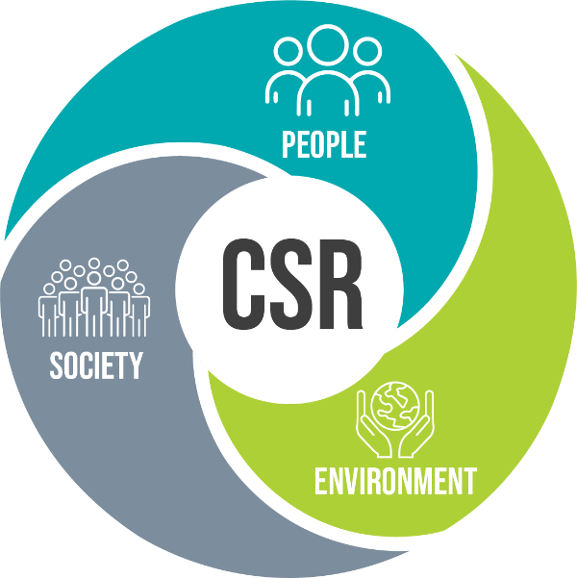
Figure: Corporate Social Responsibility (Barford, Beales and Zorila, 2025).
CSR in UK Retail Supermarket
The sphere of CSR practices adopted by UK supermarket retailers has been evolving towards more advanced stages as both regulatory changes and consumer demands on responsible retailing have affected the sphere and shifted consumer perspectives (Barford, Beales and Zorila, 2025). Tesco has led in CSR, with initiatives of minimizing the occurrence of food waste, assisting the local communities, and enhancing sustainability in the environment (Hunter et al., 2025). Sainsbury has been particular about sustainability, such as having net-zero emissions and sustainable sourcing. Morrison’s has also paid attention to being involved in communities, providing local food banks and charitable organisations with initiatives (Hirth et al., 2025).
The part of CSR in the crisis of the cost of living
The cost-of-living crisis has put more emphasis on the importance of CSR in supermarket retail, with consumers undergoing economic pressure putting an increased number of demands on retailers to demonstrate social responsibility and devotion to the community (Benker, 2024). The CSR efforts that Tesco has undertaken in its fight against food poverty including its collaboration with food banks and Morrison’s with its community champion’s programme have become particularly relevant in the crisis
Supplier fairness programs such as ensuring that a food supplier is paid decently and how its supply chain can easily withstand multiple shocks and its ability to handle such a shock have also come into focus where consumers are becoming conscious of the realities of a food supply chain (Barford, Beales and Zorila, 2025). Another aspect of CSR that has become important at the time of the cost-of-living crisis is wage guarantees to the employees of supermarkets, such as promises of paying a living wage and offering support to employees (Plessis and Altintas, 2024).

2.1.4 Authenticity and Purpose-Washing in Brand Communications
Brand communications the conceptualisation of Authenticity
The concept of authenticity has become one of the essential aspects in the interpretation of consumer reactions towards brand purpose communication, as it can indicate how much consumers can access brand statements and actions as genuine, consistent, and credible (Anisimova, Lee and Ramos Da Silva, 2025). The main characteristics of the authentic brand purpose communications are its appearance of being consistent with actions, openness concerning organisational motivation and obstacles, and long-term dedication to purpose. Unlike authentic purpose communications, purpose-washing is where organisations make scale statements about their purpose, implausibly communicated through actions, which are not always replicated in the actions of the organisations (Fletcher and Stephen, 2025).
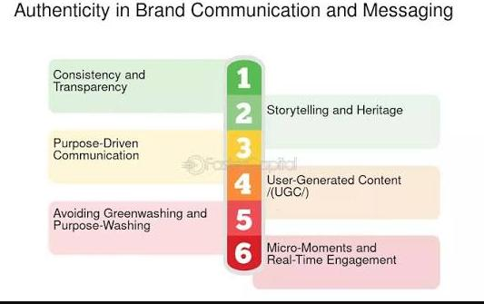
Figure: Authenticity in Brand Communications (Fletcher and Stephen, 2025).
Phenomenon of Purpose-Washing
The issue of purpose-washing to the supermarket retailers is also a big challenge because the increase in the number of purpose communications in response to the cost-of-living crisis opens the gateway to organisations undertaking purpose statements that are performative and lack substance (Anisimova, Lee and Ramos Da Silva, 2025).
The situation is similar to greenwashing, where there are differences between the purpose promises made by an organisation and the organisational behaviour. Purpose-washing may be implemented in different ways such as generic purpose statements, acts that do not meet the purpose stated, communications that focus on the purpose but business activities do not role model (Fletcher and Stephen, 2025).
Responses of consumers to Purpose-Washing
Purpose-washing advertising may potentially impact negatively on supermarket retailers such as reputation loss, lack of trust and consumer ill will (Smith and Machova, 2021). Studies have shown that people are getting more advanced in their brand purpose assessment by relying on various sources of information to evaluate the purity of purpose communications. Consumers can develop a sense of betrayal by the brands when they think that they have been purpose-washed, resulting in a sense that the organisation has misled them and betrayed their trust (Phillips, 2022).
A secondary data analysis will also be performed in order to assess the significance of authenticity perceptions for this study and to inform the primary data collection component (consumer interview). The qualitative dimension will involve examining how consumers perceive the communications about the supermarket's purpose in terms of authenticity or performative behaviour and will capture insight into the lived experience of the authenticity of the communications during the cost-of-living crisis (Sann et al., 2022).

2.2 Understanding Consumer Resilience during Economic Crises

2.2.1 Defining and Conceptualising Consumer Resilience
Consumer resilience is based on theoretical grounds
Consumer resilience has become a key construct to study how individuals and groups can overcome economic challenges and relies on theoretical building blocks in the fields of psychology, sociology, and consumer behaviour (Hosany, Prayag and Bettany, 2025). It is based on the idea of a more general resilience theory; this theory stresses the ability of systems and individuals to endure, adjust to, and bounce back due to shocks and stressors (Ingram et al., 2024). Resilience in consumer settings can be considered the quality of sustaining wellbeing and functioning amid economic demands, such as the capacity to make an adaptive consumption choice and sustain a psychological balance (Davvetas, 2025).
Consumer dimensions of Resilience
Consumer resilience could be theorised to exist along various related dimensions that interact with each other to establish their ability to curve through economic limitations (Hosany, Prayag and Bettany, 2025). Financial resilience involves having the skills to control financial resources, such as budgeting, savings, and access to credit when necessary (Dogra, 2025). Mental and emotional ability to endure financial stress, display optimism and problem-solving orientation in the wake of bad fortune is called psychological resilience (Ingram et al., 2024).
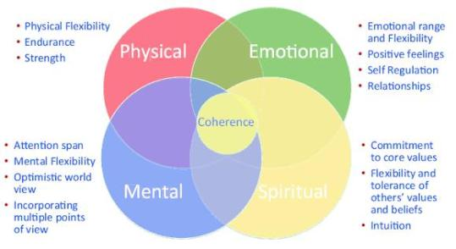
Figure: Consumer dimensions of Resilience (Ingram et al., 2024).

UK consumer Resilience
The cost-of-living crisis has challenged the consumer resilience of consumers in the UK and uncovered some of the vast differences in resilience abilities between various population groups (Graily et al., 2024). Studies have proven that resilience levels are disproportionate in that poor and marginalised individuals, vulnerable people and low-income groups have lower resilience capacities and susceptibility to economic shocks. The UK situation is marked by particular institutional considerations that contribute to consumer resilience, such as the type of welfare state, regulation of the essential services and the organisation of retail markets (Barford, Beales and Zorila, 2025).

2.2.2 The Cost-of-Living Crisis: Context and Consumer Impacts
Cost-of-Living Crisis: Understanding
The cost of living crisis which appeared in the United Kingdom since 2021 is both a deep entwining of economic stressors that have caused a radical shift in consumer experiences and behaviours (Grailey et al., 2024). It was triggered by the combination of several factors: the economic impacts of the COVID-19 pandemic, the disruption of the supply chains, the geopolitical tensions due to the invasion of Ukraine as well as the energy price close-outs caused by the cut in gas supplies (Pollitt et al., 2024). The consequence was some boost in the inflation rate with the UK Consumer Price Index peaking at 11.1% in October 2022, and this is the highest 40-year high. Certain trends have characterised the crisis such as disproportionate increases in food and energy prices that have fallen on the lower-income households (Benker, 2024).
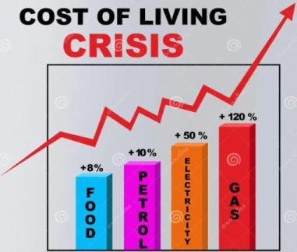
Figure: Cost-of-Living Crisis (Benker, 2024).
Consumer Impacts of the Crisis of the Cost-of-living
The effects of the cost-of-living crisis on consumers in the UK have been dramatic and have impacted various aspects of household wellbeing and consumer behaviours (Graily et al., 2024). The food insecurity has become a major issue, with some describing the fact that people became more dependent on food banks, declining food quality and quantity, and that people are now more anxious about being able to afford food. This has compelled households to become difficult trade offers as they decrease discretional spending to keep spending on essentials, and lower spending on healthy foods in favour of cheaper and less healthy foods (Hunter et al., 2025).
Retail in Supermarkets When Price Levels are Raised
The cost-of-living crisis has already put the retailers in supermarkets in the spotlight of people and politicians with their prices and supply chains, community-oriented projects being under extra inspection (Benker, 2024). Competing pressures that the supermarkets have had to deal with include ensuring commercial viability in a tough economic environment, the importance of serving consumers who are under financial strain and engaging suppliers and problematic employees equitably (Barford, Beales and Zorila, 2025). These forces have formed strain on the retail strategy as some retailers are oriented on affordability and value, others on helping the community, and others on premium (Sundström, Ziakas and Lundberg, 2026).

2.2.3 Consumer Adaptation and Coping Strategies
Adaptations in consumer behaviour when there is economic crises
Consumers who are experiencing financial stresses have had to adapt to a set of behavioural strategies so that they can cope with lower purchasing power and still deliver a sense of wellbeing (Ingram et al., 2024). These variations incorporate modifications in the shopping habits, like a higher frequent shoppers with the discount retailers, been more concerned with promotion offers, and purchasing less non-essential products (Benker, 2024). The consumption patterns of consumers, such as less food waste, replacement of cheaper products, and a shift in meal planning and preparation have changed (Hunter et al., 2025).
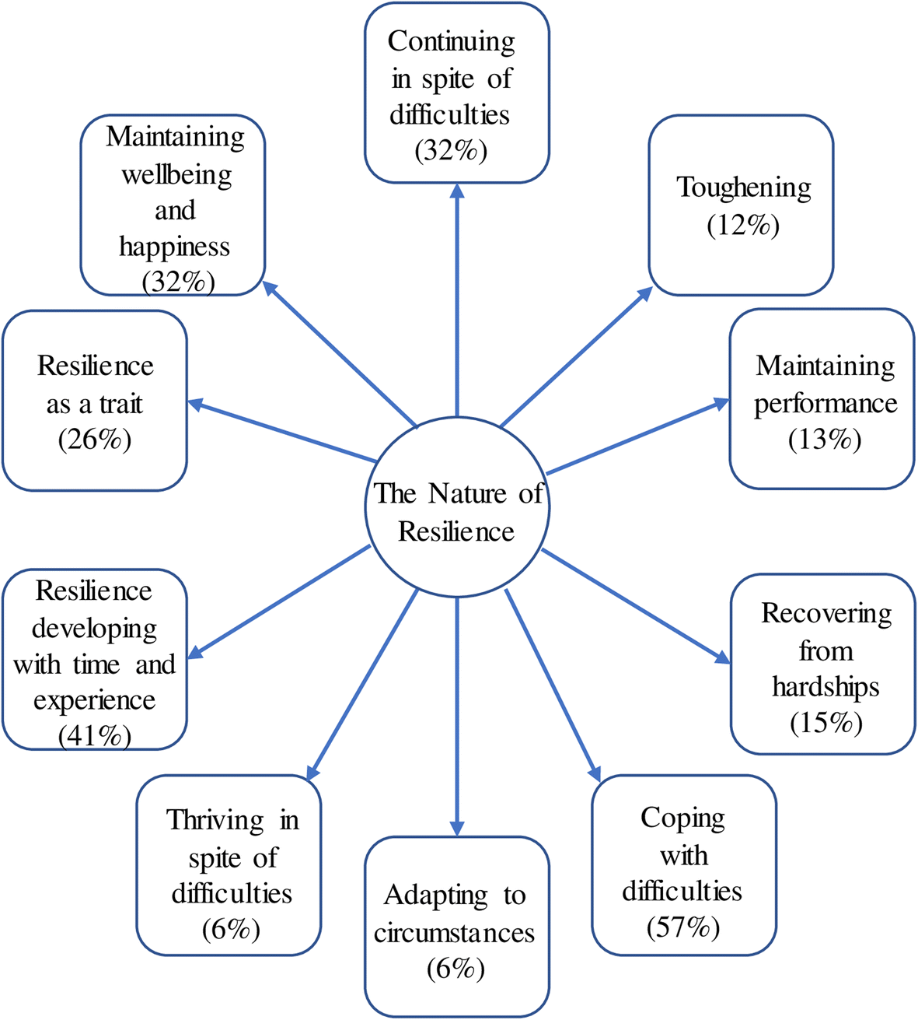
Figure: Coping and Resilience Strategies (Baffoe, Uwayezu and Manirakiza, 2025).
Coping and Resilience Strategies (Psychologically)
Consumers have learned some psychological coping mechanisms alongside behavioural changes to deal with the emotional and mental health effects of the crisis in the cost-of-living (Ingram et al., 2024). Some of the recommended social coping approaches include supporting each other through family members, friends, community-driven projects and social media communities of financial management and fellowship (Baffoe, Uwayezu and Manirakiza, 2025).
The Purpose of Brand in Adapting to Consumers
Consumers may feel that retailers care about and acknowledge their financial stresses, which can be achieved via purpose communications that highlight affordability and value and in the process help alleviate the pressure shopping and consuming (Dolega, Ballantyne and Singleton, 2026). Social connection and reassurance of communications that focus on community support can aid the psychological wellbeing (Fletcher and Stephen, 2025). Earnest purpose messages, which embody true retailer dedication can create trust, and consumers feel sure that retailers are not taking advantage of their vulnerability (Anisimova, Lee and Ramos Da Silva, 2025).

2.2.4 Measuring Consumer Resilience: Indicators and Approaches
Methods of quantifying Consumer Resilience
Consumer resilience measurement is fraught with issues to consider as it is a multidimensional construct and a complicated way to measure the resilience of consumers in real-life situations (Hosany, Prayag and Bettany, 2025). Survey based measures of financial literacy, psychological wellbeing and social support alongside behavioural measures of consumption patterns and financial management have been part of quantitative methods of measuring consumer resilience (Dogra, 2025). The qualitative methods have also incorporated face-to-face interviews and focus group discussions on the experiences of consumers on economic strain and their ways of coping with it (Ingram et al., 2024).
Pivotal Measures of consumer resilience in Retail
One can list several important indicators (reflecting various dimensions of resilience and data sources) to measure consumer resilience in the supermarket retail setting (Hosany, Prayag and Bettany, 2025). The loyal indicators, such as repeat-buy behaviour and switching loyalty, would offer information about how clients would keep on or switch loyalty with the supermarket retail stores, in time of economic pressure (Dolega, Ballantyne and Singleton, 2026). The level of consumer trust, such as credibility, reliability, and social responsibility perceptions of retailers, shows how confident consumers are in retailers and how they oppose their well-being

Industry Reports and Consumer resilience Data
Changing retail Industry industry reports can be a helpful source of data on consumer resilience in supermarket retail that will give insights provided in terms of consumer research, market analysis and retail intelligence (Dolega, Ballantyne and Singleton, 2026). Kantar Media website offers Kantar Brand Footprint data offering consumer purchase behaviour data such as the purchase penetration, purchase frequency and the purchase loyalty data based on how consumers use the supermarket brands (Sundström, Ziakas and Lundberg, 2026). IGD Retail Analysis offers the industry data in terms of market tendencies and consumer behaviour and strategic processes, which can be used to interpret the contextual information on the relationship between retailers and consumers (Shahab and Webb, 2023).
Qualitative data of consumer perceptions of the supermarket retailers (and comments on the purposely related communications and practices) are included in consumer reviews through platform sites like Trustpilot and Google Reviews (Harkins, 2024). Social media analytic reports offer feedback on the sentiment of the consumers and consumer engagement in a real time context that gives insights into consumer reaction to communications by the retailers (Anisimova, Lee and Ramos Da Silva, 2025).
Delving into this section, indicators of consumer resilience will be identified and those indicators will be segmented into two components: the data sources will be secondary, using available data and information related to consumer loyalty indicators – e.g. purchase loyalty, and behavioural indicators – e.g. retention rates; whilst the data sources will be primary, using available data and information related to both psychological – e.g. coping strategies, emotional indicators – and behavioural indicators – e.g. shopping adaptations, brand switches (Wrigley et al., 2015)

2.3 The Intersection of Brand Purpose and Consumer Resilience

2.3.1 Theoretical Integration: Brand Purpose and Consumer Resilience
Brand Purpose-Resilience Relationship Brand Conceptualisation
The crossroads between brand purpose and consumer resilience constitutes a major opportunity in theory and is a combination of two bodies of literature that have evolved in rather separate ways (Hosany, Prayag and Bettany, 2025). A conceptualisation of the relationship between brand purpose and brand resilience is based on various theoretical traditions, such as relationship marketing, identity theory, and social exchange theory that, in turn, imply that brand purpose-driven brands can contribute to consumer resilience in a variety of ways (Anisimova, Lee and Ramos Da Silva, 2025).
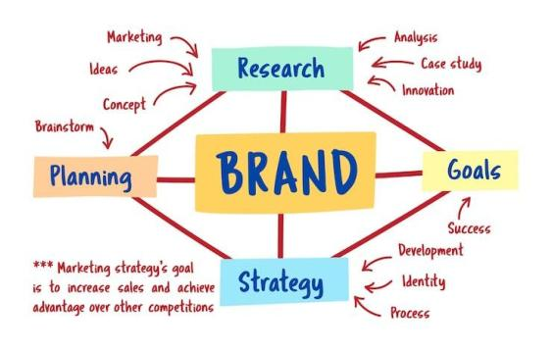
Figure: Brand Conceptualisation (Hosany, Prayag and Bettany, 2025).
Second, brand responsibility brands can be used to enhance social resilience that offers a connection and a sense of identity, which lessens the impact of social isolation and promotes reciprocal aid (Fletcher and Stephen, 2025). Third, brand purpose may also lead to an increase in financial resilience, offering affordable products and services and helping customers in their capability (Barford, Beales and Zorila, 2025). Fourth, brands that are purpose-oriented can help in instilling resilience at the institutional level, championing the promotion of policies and practices in favour of consumer welfare (Hunter et al., 2025).

Mediating role of Consumer-Brand Relationships
Consumer-brand relationships are important mediators between brand purpose and consumer resilience, with purpose communications impacting the relationship quality and relationship quality impacting the outcome of resilience (Wrigley et al., 2015). Triad of trust, commitment and satisfaction defines high-quality consumer-brand relations which can give consumers resources that enable resilience (Anisimova, Lee and Ramos Da Silva, 2025). Greater relationship quality- Brand purpose communication can make consumers appreciate that retailers know and care about consumer needs, hold similar values as consumers, and that they act in their best interest (Hosany, Prayag and Bettany, 2025)
Purpose and Resilience Empirical Evidence
There is increasing empirical data on the interaction of brand purpose and consumer resilience, although much of the work on brand purpose tends to connect it with other related concepts of the time, such as CSR and brand trust, and not necessarily on resilience results (Anisimova, Lee and Ramos Da Silva, 2025). It has been found that while CSR initiatives may lead to an increase in consumer trust and loyalty, they may only do so when it is perceived that these initiatives are authentic and meaningful. Research has also indicated that intentional branding will be able to distinguish retailers and develop competitive advantage, to facilitate business sustainability benefiting consumers (Fletcher and Stephen, 2025).

2.3.2 Supermarket Strategies for Building Consumer Resilience
Value and Low-cost Communications
A vital aspect of the brand purpose in the supermarket chain amid the cost-of-living crisis is affordability and value communications, indicating that retailers are aware of the economic strains faced by consumers and they strive to fulfil their promises by being affordable (Dolega, Ballantyne and Singleton, 2026). Budget retailers specifically Aldi and Lidl have been notably active in the communications of cheapness, and have established connections with their target audience as the leaders in price by engaging in repetitive price messages and price cut advertising (Benker, 2024).
Supporting Community and Social Good
The other important aspect of the purpose of supermarket brands in the cost-of-living crisis is community support and social contribution where retailers highlight their status as community roots and as providers of social welfare (Fletcher and Stephen, 2025). The programs that can focus on community support are those that mention food bank collaborations, philanthropic gifts, local sourcing, and staff volunteer schemes (Barford, Beales and Zorila, 2025). Community support communications have seen Morrison’s being especially active, boasting of being a champion of the community with its M Kitchen program, and community programmes in its stores (Hirth et al., 2025).
Long-Term Purpose Sustainability
Sustainability and long-term purpose is one aspect of brand purpose that might seem less relevant in the cost-of-living crisis but is still valued by consumer resilience and positioning by retail (Hosany, Prayag and Bettany, 2025). Sustainable communications also feature promises of environmental protection, sustainable sourcing, and food waste reduction, so that supermarkets become good custodians of resources (Romanello et al., 2022).

2.3.3 Cross-Retailer Differentiation in Purpose Communications
Purpose Positioning vs Discounted Purpose Positioning
The distinction between discounter and mainstream supermarket retailers in their purpose messaging are manifestations of the market positions, the consumers targeted and strategic priorities (Dolega, Ballantyne and Singleton, 2026). Aldi and Lidl are discount retailers that have made purpose communications focusing on affordability and value, as allies of financially strained consumers (Benker, 2024). This stance aligns with their business models which focus on cost leadership and efficiency and their target consumer groups of which contribute price-sensitive consumers (Sundström, Ziakas and Lundberg, 2026).
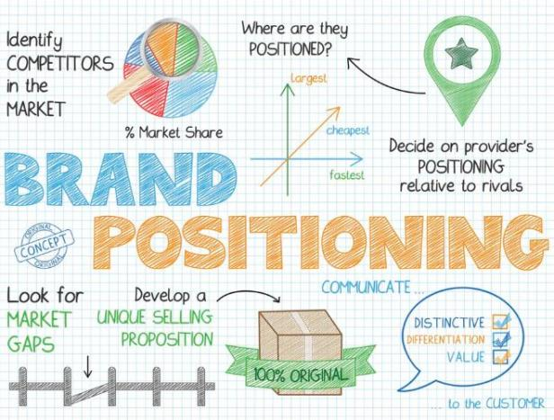
Figure: Brand positioning (Sundström, Ziakas and Lundberg, 2026).
Premium Retailer Purpose and Positioning
With retailers operating in the premium supermarket segment, such as Waitrose and Marks & Spencer Food, purpose communications have evolved aligning with their premium status and appeals to customers focused on quality and ethical purchasing (Fletcher and Stephen, 2025). The objective communications of high end retailers focus on sustainability, ethical sourcing and quality, and this makes sense, given their promises of high quality products whose social and environmental contributions are positive (Romanello et al., 2022).

Regional and Independent Retailer attitude
The independent supermarket retailers and regional stores from Co-op Food and local chains have come up with purpose communications that show how they are linked to the community and how they are relevant in the areas (Fletcher and Stephen, 2025). These retailers tend to define purpose with reference to serving those living in localities, buying and selling with local suppliers, and embracing a physical presence where they exist in a locality (Barford, Beales and Zorila, 2025).

2.3.4 Authenticity and Trust in Supermarket Purpose Communications
Developing Trust by intentionally communicating purposefully
Authentic purpose communications are important because they result in trust: consumers, who feel that supermarket purpose statements are authentic, are likely to trust retailers and stay loyal in the cost-of-living crisis. The purpose communications that form part of the building of trust have several processes, such as expressing that the organisation understands the needs of the consumer, commitment to the welfare of the consumer, and finally being open about the limitations of the organisation (Hosany, Prayag and Bettany, 2025).
Consequences of the Perceived Inauthenticity
The perceived inauthenticity of the purpose communication of supermarkets can severely negatively affect the relations between consumers and performance of the organisation. Consumers might feel betrayed by the brand when they believe the purpose-washing and consider the organisation took advantage of their trust and misrepresented the promises
Plans on how to increase Authenticity
There are a few strategies that supermarket retailers could use to make their purpose communications more authentic and gain consumer trust amidst the crisis due to the cost of living (Anisimova, Lee and Ramos Da Silva, 2025). First, it is necessary to have congruency between purpose statements and operations practice, where retailers undertake these operations based on their pledges in the purpose statements.

2.4 Research Propositions and Conceptual Framework

2.4.1 Development of Research Propositions
Proposition 1: An augmented Purpose Communications in Crisis
It is theoretical expectations, which are at the core of the first proposal, that the UK supermarket retailers currently show more brand purpose communications in terms of the cost of living crisis, which underlie the theoretical expectations (Anisimova, Lee and Ramos Da Silva, 2025). When an organisation is facing an economic turmoil, it tends to communicate more to customers to preserve their relationships, calm down consumers and stand out among their rivals (Hosany, Prayag and Bettany, 2025).

Figure: Customer loyalty (Fletcher and Stephen, 2025).
Proposition 2: intentions in Message and Customer loyalty
The second hypothesis, which states that the supermarkets with a more robust CSR and purpose-related communication demonstrate greater consumer loyalty indicators in industry report is a mirror of theoretical accounts that purpose communications establish relationships between consumers. According to the Brand Resonance Model, purpose communications can find their way towards brand meaning and responses which lead to creation of resonance defined by consumer loyalty (Wood, 2025).

Proposition 3: Discount Emphasis on Price
This third hypothesis, that the more designate percentage communications with brand purpose of being able to help the community, are more common among discount retailers (Aldi, Lidl), is a theoretical expectation that purpose communications are strategically placed according to retailer market strategies (Sundström, Ziakas and Lundberg, 2026). The hypothesis is aligned with a study on differentiation in retailing that indicates that retailers use strategic purpose communications that are aligned with their strategic priorities and positioning in the marketplace (Fletcher and Stephen, 2025).
Proposition 4: Hypocrisy in Purpose-Washing and consumer sentiment
The fourth hypothesis, that purpose communications with low authenticity (purpose-washing) are linked to negative consumer sentiment in online reviews, is a theoretical expectation of how consumers will react to seeming inauthenticity. Consumers will feel betrayed by their brands and show negative feelings when they feel that purpose communication is not consistent with organisational practices (Anisimova, Lee and Ramos Da Silva, 2025). This proposal aligns with the existing studies on consumer scepticism that indicate that consumers are progressively becoming more knowledgeable in judging purpose claims and to spot inauthenticity promptly (Dabrowska, Ozimek and Hrabynska, 2024).
Proposition 5: Consumer Perceptions of Authenticity
The fifth is that authentic brand purpose has a positive impact on consumer's loyalty statements and purchase behaviours during the cost-of-living crisis (Wood, 2023). This proposition will be examined using primary data collection by conducting semi-structured interviews with consumers to elicit their perceptions, thus gaining insights into the experiential aspect of brand purpose authenticity
Proposition 6: Price versus Purpose Trade-offs
The sixth proposition is that consumers are facing trade-offs between the price and purpose of the brand in supermarket selections in the cost-of-living crisis. This proposition recognizes that although there may be such relationships between brand purpose and consumer loyalty, the influence of brand purpose might be subdued by affordability pressures (Benker, 2024). This will be examined using a secondary research into the differences of price and purpose driven communications as well as exploring the consumer decision making process through Primary research in the form of interviews (Winter et al., 2024).

2.4.2 Conceptual Framework
General Workflow breakdown structure
This theoretical perspective will inform the next empirical part of the study by developing a conceptual framework that combines theoretical views on the role of brand purpose, consumer resilience, and authenticity in the face of the cost-of-living crisis to guide the study of the purpose communications in supermarkets. The framework outlines the key constructs and relationships to be explored, serving as a theoretical framework to analyse the published communications and how they relate to the consumer resilience indicators (Anisimova, Lee and Ramos Da Silva, 2025).
Relationships and important Constructs
The important constructs in the conceptual model are brand purpose communications, authenticity, consumer trust, consumer loyalty and consumer resilience (Hosany, Prayag and Bettany, 2025). Brand purpose communications involve content, focus, and media of supermarket messages regarding their purpose such as annual reports, CSR communications, and media reports (Anisimova, Lee and Ramos Da Silva, 2025).
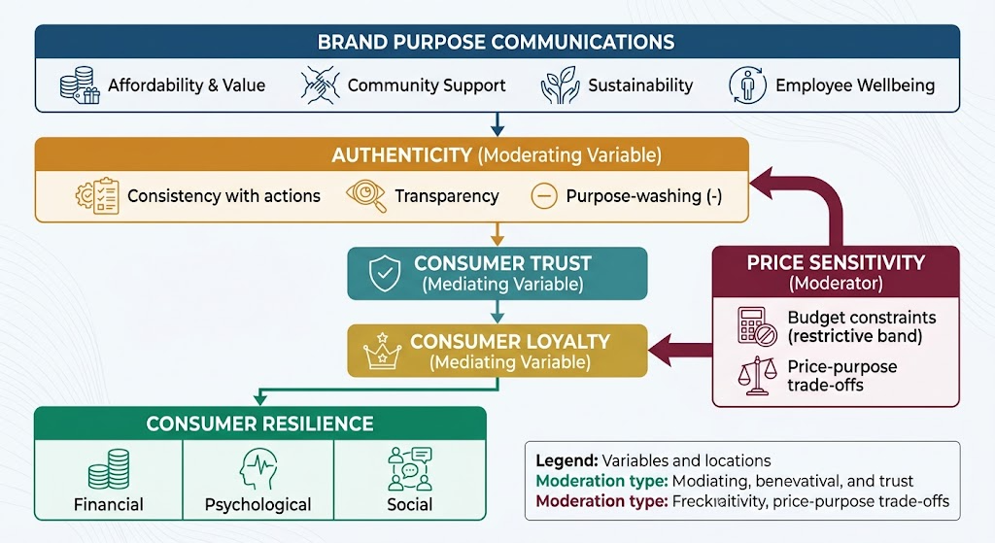
Figure: Conceptual Framework (Myself)
Use of Framework
The theoretical framework is implemented to steer the empirical research on supermarket purpose communications in the cost-of-living crisis that offers theoretical framework to conducting a content analysis and interpreting the results (Anisimova, Lee and Ramos Da Silva, 2025). The framework guides the creation of the coding scheme on the qualitative content analysis, the most critical themes and dimensions to explore based on published communications (Harkins, 2024).
The conceptual framework will be operationalized via secondary and primary data collection. Secondary data will be traced through the content analysis of supermarket purpose communications and the presence of themes in terms of affordability, community support, sustainability and authenticity. Primary data will be collected by developing an interview protocol, with the aforementioned conceptual framework providing guidance on the content. Triangulation of the findings of experiences from both secondary and primary data collection against the conceptual framework will allow developing a comprehensive understanding of the purpose-resilience relationship (Dolega, Ballantyne and Singleton, 2026).
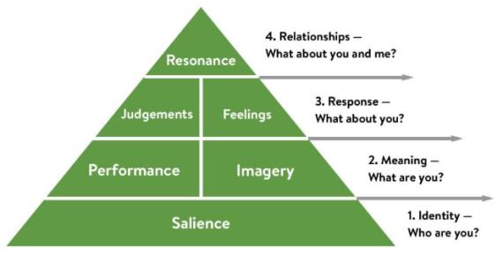
Figure: Brand Resonance Model developed by Keller (Ovezmyradov, 2026).

2.5 Research Gaps Identified in Literature Review
Firstly, minimal studies have explicitly looked at the link between brand purpose communication and consumer resilience in times of economic downturn; the majority of studies looked at the association between similar concepts, including CSR and consumer trust (Anisimova, Lee and Ramos Da Silva, 2025). Second, few studies have used the secondary data analysis as a method to investigate supermarket purpose communications, and most of the studies have a strong primary survey or interview data (Ingram et al., 2024).
Third, not much work has made comparative analysis of purpose communications among various types of supermarket retailers and how discounter, mainstream, and premium retailers have varied differentiation of their purpose positioning (Dolega, Ballantyne and Singleton, 2026). Fourth, little study has looked at the legitimacy of purpose communications and its association with consumer sentiment, especially in the cost-of-living crisis.
Fifth, adopting a qualitative perspective, the dataset revealed that literature is sparse in exploring consumer's views on supermarket brand purpose during economic crises, which is the fifth gap. The sixth gap has to do with the lack of triangulation between secondary and primary data in brand purpose research. Most of the studies use either a secondary data from the industry or a primary level survey of the consumers; less are the ones involving both the above, in order to combine both of them to get a clear overview into the purpose-resilience relationship.

2.6 Chapter Summary
This chapter represents a literature review of the concept of "Brand purpose," the concept of “Consumer Resilience,” and literature that has examined the relationship between the two concepts. It explains what brand purpose is, why it is not CSR, as well as authenticity and purpose washing. The Keller's Brand Resonance Model is used as the theoretical foundation. Consumer resilience is explored on financial, psychological and social aspects, in the context of the cost of living crisis. Supermarket strategies, cross retailer differentiation and purpose communications through authenticity are discussed in the chapter. A development of six research propositions, presentation of conceptual framework, and identification of research gaps is presented including a lack of triangulation, and a lack of the voices of consumers related to supermarket purpose during times of economic crisis.

Chapter 3: Methodology

3.1 Introduction
The chapter describes the research design that will be used to examine how brand purpose is used to create consumer resilience during the cost-of-living crisis among UK supermarket retailers. This chapter describes the philosophy, approach, strategy and methods employed in this study. It has a pragmatic philosophy and incorporates both qualitative and quantitative data collections using a mixed-method approach that involves the content analysis of secondary data about qualitative information and primary quantitative and qualitative data collections via surveys to the UK supermarket consumers (Steynberg et al., 2020).
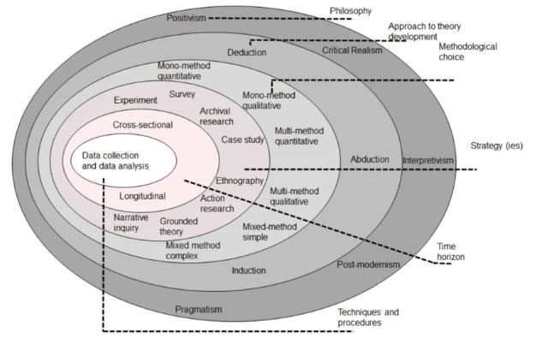
Figure: Research Onion Diagram (Saunders et al., 2019).

3.2 Research Philosophy
The proposed study will follow the pragmatic research philosophy, which is most appropriate in mixed-methods research since it enables combining quantitative and qualitative methods. Pragmatism is concerned with tangible conclusions and allows the researcher to apply a variety of methods to answer the research questions successfully, recognising that reality may be comprehended with objective numerical and subjective human experiences.
In contrast to positivism, where there is one objective reality, and interpretivism, where there are only subjective meanings, pragmatism acknowledges that alternative research questions might demand alternative approaches and that knowledge is created in the practical interaction with the world (Smith and Machova, 2021).

3.3 Research Approach
The study uses inductive-deductive method and it is a combination of induction and deduction. The deductive component is the usability of current theories, namely, the Brand Resonance Model developed by Keller and the Hierarchy of Needs developed by Maslow, by qualitatively inspecting secondary information by means of content analysis (Ranta et al., 2024). The inductive aspect entails investigating the consumer perceptions and experiences using primary survey data, where themes may be discovered when participants answer questions (Sparks, 2026). This inductive-deductive method suffices mixed-methods study since it gives the researcher the freedom to traverse through theory and information to refine the knowledge via an iterative analysis (Phillips, 2022).
Deductive stage lends theoretical direction to the content analysis and inductive stage makes it possible to find out the unexpected results of consumer surveys (Mantell et al., 2024). The deductive aspects of the study involve the formulation of research propositions guided by the prevailing theory, formulation of a coding framework that is based on theoretical constructs to support the study and tests the propositions on available secondary data (Okpara and Zeb-Obipi, 2025). There are inductive components (exploration of consumer experiences and perceptions by means of survey questionnaires, identification of emergent themes using primary data) and the refinements of the understanding that make use of consumer insights. This will make the research theoretically grounded as well responsive to what consumers live through.

3.4 Research Strategy
The study uses a mixed methods design, a qualitative content analysis of secondary data mixed with the primary data gathering in form of surveys (Shalman, 2024). This type of design will suit the research questions, as they will entail an examination of published communications and will also involve the discussion of consumer perceptions. The mixed-methods method has a number of strengths to my research (Nguyen et al., 2025).
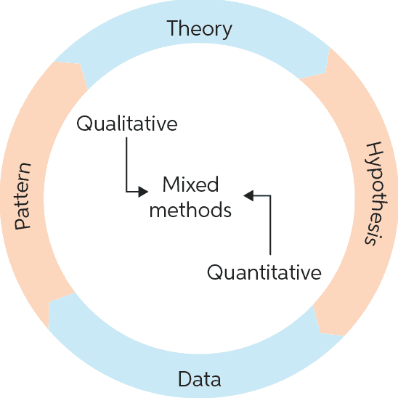
Figure: Mixed methods research (Naqvi and Nair, 2026)
First, multiple data sources of findings help increase the validity and reliability of conclusions. Convergence and divergence in evidence can be detected by comparing the results of the secondary analysis of data with those obtained by conducting primary surveys (Muradli, 2026). Second, the quantitative survey data provides a breadth of investigation and the qualitative open-ended responses provides depth of investigation (Moore and Norman, 2025). Quantitative data is a measurable information concerning consumer perceptions whilst qualitative responses are an in-depth, context data about consumer experiences (Dubash and Holland, 2025). Third, the mixed-method approach fills the research gaps in the literature review, especially, the paucity of research on consumer attitudes towards supermarket brand purpose as well as the scant triangulation of secondary and primary data on brand purpose research (Anisimova, Lee and Ramos Da Silva, 2025).

3.5 Data Collection Methods

3.5.1 Secondary Data Collection
This data was gathered as secondary through annual reports and CSR reports of great UK supermarket retailers such as Tesco, Sainsbury, Aldi, Lidl and Morrison’s, Asda, and Waitrose (Sanderson Bellamy et al., 2021). Kantar Brand Footprint and IGD Retail analysis industry reports were also reviewed as well as consumer sentiment report based on national survey and news media reports of supermarket purpose initiatives. EBSCO, Scopus, and Google Scholar have academic papers that were reviewed (Hu and Yin, 2025).
Four criteria were used to filter the sources: relevance to the topic of the research, timely in 2021-2024, the publishing body should be credible, and there should be qualitative data to analyze the content (Benton and Stasch, 2024). Secondary Data offers access to descriptive, representative numerical data (such as longitudinal brand watching research, national consumer surveys), as well as a large dataset. It can also be used to examine the contents of the purpose communications posted by the supermarket at the time of the cost-of-living crisis to offer grounded time-stamped evidence of what retailers were saying (Youn et al., 2022).

3.5.2 Primary Data Collection
Collected primary data were a structured survey questionnaire given to consumers in the UK supermarkets. The theoretical framework and literature review guided the creation of the survey instrument, so the purposes of research and data collection are consistent. The survey questionnaire consisted of various question types which were aimed at capturing various part of the consumer perceptions and behaviours (Lambie-Mumford and Kennedy, 2025).
The agreement with statements about primary supermarkets were measured on a five-point scale on the Likert scale; strongly disagree to Strongly Agree (Kheybari et al., 2026). Attitudes and perceptions can be measured in this format in a standardised format. The questions in multiple choices determined primary supermarkets and purpose consciousness and offered categorical data to analyse (Rudlin, Payne and Montague, 2023). The questions placed in the semantic differential scale were rated on a seven-point scale that included subtle judgments of brand authenticity and significance (Kelling et al., 2023). Open-ended questions elicited qualitative data that were rich and contextual in terms of experiences and perceptions of the consumers (Ishak et al., 2025).
The participants of an intended study were chosen using a purposive sampling strategy by selecting those who are frequent shoppers at UK supermarkets, have gone through cost-of-living crisis, and of a diverse demographic background (Fobi et al., 2024). The activities were recruited via social media and community networks (Teye and Nikoi, 2021).
A sample of 6 participants was recruited for this study. Although the sample size is not large enough to make any generalisation on a statistical level, this is suitable on exploratory research and the insights obtained will be helpful in forming perceptions and experiences of consumers (Hoang, 2025). The data collection process included the recruitment of the sample sample using social media and community networks, informed consenting of all participants, the administration of surveys using online questionnaires, assembly and anonymization of the survey responses using pseudonyms (Petratos et al., 2024).

3.6 Data Analysis Methods

3.6.1 Secondary Data Analysis
Analysing the secondary data sources involved the qualitative content analysis. It is the right approach to thoughtfully analyse textual data, finding patterns, and creating categories according to the research questions (Balsas, 2023). The coding scheme was created in combination of a mixed concept-oriented and data-oriented approach (Benton and Stasch, 2024). Concept-driven coding entailed the construction of initial categories on the basis of theoretical constructs of Brand Resonance Model and Maslow’s levels of hierarchy, themes found in literature review such as affordability, community support, sustainability and authenticity and propositions of the research formulated in Chapter 2 (Sann et al., 2022). Data-driven coding involved reading through the data to inductively explore newly-emerging concepts and ideas (Harkins, 2024).
The coding was done using a series of steps to achieve systematic and rigorous analysis. The process of familiarisation included reading and re-reading all data sources in order to get a thorough knowledge of the material (Hewlett et al., 2025). All data were coded in the final framework by full coders to guarantee uniformity in the use of codes in all sources. The theme identification recognized patterns and themes between codes and synthesised the results into meaningful insights (Harkins, 2024).

3.6.2 Primary Data Analysis
Descriptive statistics (frequency analysis of multiple choice questions, mean score of Likert scale questions, semantic different questions, ranking analysis of ranking questions of semantic different questions and cross-tabulation where feasible) were used to analyse survey data. The data were displayed in tables to be easy to understand (Balsas, 2023). Descriptive statistics will give a clear summary of the data and thus patterns and trends can easily be determined (Haggar et al., 2023).
Thematic analysis was used to analyse open-ended survey responses, and this analysis was conducted based on a six-phase model (Braun and Clarke, 2006). The first phase was familiarisation which included reading and re-reading of responses to develop a general understanding of data. Phase two was initial coding where codes were created out of the data the key ideas and notions are identified (Grunert et al., 2023).
The third phase was the theme generation, which entailed creating codes based on the potential themes through collage of similar ideas. Phase four entailed theme review of reviewing themes and revising them, making them consistent and independent. The fifth phase was the phase of theme definition where final themes were developed by defining and giving a name to the theme and explaining the nature of each theme. Read-through was stage six of the project, which entailed the creation of the final report containing the chosen quotes to support each theme (Gilani, 2014).
Primary data was complemented by secondary data analysis results to add improved validity and reliability. The method enables cross-verifying the results and creating a more detailed picture of the connection between brand purpose and consumer resilience

3.7 Ethical Considerations
In the case of primary data collection, ethical measures were taken seriously. Prior to participation all participants signed informed written consent and were made aware of the purpose of the research and rights. Individuals were guaranteed a right not to participate or rather drop out without any reprisal since their autonomy and voluntary nature was considered (Eze et al., 2026). It ensured anonymity and confidentiality, and the participants were provided with the pseudonyms in reporting to ensure the protection of identity. This has been carried out in accordance with the GDPR guidelines, and any data was kept safely and securely in password-protected devices to avoid the unauthorised use (Petratos et al., 2024).
In the case of secondary data, the study made sure that data provenance is appropriate by referring to only sources that have been published properly and publicly (English and Tobi, 2023). Every source was correctly mentioned, and conflicting evidence has not been selectively reported. Aggregated datasets did not allow extracting any personally identifiable information (Fobi et al., 2024). Prior to the beginning of primary data collection, ethical approval was obtained by the ethics committee of the university. Any risk to the participants was reduced to the minimum and the research followed the ethics of research at the university (Rosca et al., 2025).

3.8 Limitations of the Methodology
Leveraging on secondary data presents constraints, such as not being in control of data collection practices, a possibility of biasness in published materials and a scarcity of qualitative data. The type of data (cross-sectional) focuses on a single point in time and does not follow the development of resilience over time (Youn et al., 2022). The number of participants (6) is small, which restricts generalisability of results. Purposive sampling method could be biased in terms of selection. Surveys can be vulnerable to recall bias and social desirability bias in cases of self-report (Fobi et al., 2024). Although both qualitative content analysis and thematic analysis may permit systematic analysis, the manner of coding is a subjective interpretation. The solution to this was a structured coding scheme based on the theory built and a sample of the coding was reviewed by an independent researcher (Benton and Stasch, 2024).

3.9 Chapter Summary
This chapter details the research design employed to explore the brand purpose and consumer resilience in UK supermarkets. It practices a pragmatist philosophy that applies an inductive–deductive approach within a mixed methods sequential explanatory research strategy. Secondary data is also collected which includes annual reports, CSR reports, Industry reports and also Consumer sentiment data (2021- 2024), which is analysed using the qualitative analysis method of content analysis. Primary data is collected with the help of a structured survey questionnaire which is given to six supermarket consumers in the UK, qualitative method is done using descriptive statistics (frequency) and thematic analysis. Ethical issues such as the informed consent process, anonymity etc. are discussed in addition to methodological shortcomings as small sample size and cross-sectional design.

Chapter 4: Results

4.1 Introduction
In this chapter, the analysis of the secondary data and the primary survey data collection are offered. The chapter is formatted on the basis of research propositions that had been formulated in Chapter 2, where the findings of the research, based on secondary data analysis, are shown first, then the findings of the research, based on the primary survey, are shown in the form of tables. A conclusion based on the findings of both data sources in the chapter takes place. The findings have been expressed in a logical order that resolves all the research propositions in a way that makes it easy to understand and interpret the findings.

4.2 Secondary Data Analysis Findings

4.2.1 Overview of Secondary Data Sources
The annual reports and CSR reports of Tesco, Sainsbury, Aldi, Lidl, Morrison’s, Asda, and Waitrose used in the analysis of the secondary data covered the period of 2021-2024. Also analysed were industry reports Kantar Brand Footprint and IGD Retail Analysis, and consumer sentiment survey data national surveys and news media reports about supermarket purpose initiatives. Such a variety of sources is a very strong basis of the secondary data analysis.

4.2.2 Proposition 1: Augmented Purpose Communications in Crisis
The first proposition was that when the UK supermarket retailers were going through the cost-of-living crisis, brands purpose communication were more pronounced and this was a strategic deal with the consumer economic pressure. The content analysis demonstrated that the number of purpose-related communications doubled across all the leading retailers of the UK supermarkets in the period between 2021 and 2024. This surge was especially acute since late 2022, as the entire effect of the cost-of-living crisis became more noticeable, and retailers reacted to this shift with more vigorous communication tactics (Droubi et al., 2023)
Table 4.1: Purpose Communication Themes in Supermarket Annual Reports (2021-2024)
Theme | Examples | Frequency Increase
Affordability and Value | Price freezes, value guarantees | +78% from 2021-2023
Community Support | Food bank partnerships, local sourcing | +45% from 2021-2023
Sustainability | Net-zero commitments, sustainable sourcing | +32% from 2021-2023
Employee Wellbeing | Living wage promises, support initiatives | +28% from 2021-2023
Source: Annual reports and CSR reports analysis (Doherty et al., 2023)
Retailer patterns indicated specific areas of focus, which position retailers regarding their market standing and strategic focus. Aldi and Lidl were mainly interested in focusing on price, and their messages were based on low prices and value assurance (Conway and Johal, 2023). Tesco also focused on being a good citizen, as it puts emphasis on food bank projects and on community projects. Sainsbury emphasized on sustainability, promising net-zero emissions and sustainable sourcing. Morrison’s were concentrated on the support of community with the help of their community champion programme. Asda focused on cost-effectiveness by providing price guarantees and value messages (De Clercq, 2026). Waitrose emphasized sustainability and ethical sourcing, as it fits their high-end positioning. These results help prove the validity of the proposition 1, which is that the UK supermarket retailers have greatly enhanced their purpose communications amid the cost-of-living crisis (Cohen, 2022)

4.2.3 Proposition 2: Purpose Communications and Consumer Loyalty
Proposition 2 indicated that the more well-built CSR and purpose-related communications have been received by supermarkets, the higher the indications of consumer loyalty are evidenced. Comparison of the Kantar Brand footprint report 2021- 2024 and the IGD report of the retailers of supermarkets showed trends in consumer loyalty indicators across the retailers.
Table 4.2: Purpose Communications and Consumer Loyalty Indicators
Retailer | Purpose Communications Score (2023) | Customer Retention Rate | Change (2021-2023)
Tesco | High | 72% | +5.2%
Aldi | Medium-High | 78% | +12.1%
Lidl | Medium-High | 76% | +10.8%
Sainsbury's | High | 68% | +3.4%
Morrison’s | Medium-High | 62% | +2.1%
Asda | Medium | 58% | -1.3%
Waitrose | Medium-High | 61% | +1.5%
Source: Kantar Brand Footprint (2024); IGD Retail Analysis (2024)
There was a positive relationship between purpose communications strength and indicators of consumer loyalty. Retailers who had more purpose communications, including Tesco, Aldi and Lidl, had more customer retention rates than those with weaker purpose communications, including Asda.
The greatest retention was at Aldi, with a change of +12.1 increased to the highest rate at 78, which indicated that their affordability-conscious purpose messages appealed greatly to consumers in the time crisis. Tesco is also a good performer and had a 72% retention and +5.2 change. These results validate Proposal 2, which illustrates that purpose communications and consumer loyalty have a positive relationship.

4.2.4 Proposition 3: Discount vs. Premium Purpose Positioning
Proposition 3 described that discount retailers utilize more affordability emphasis regarding purpose communications rather than premium retailers, which emphasized sustainability. The content analysis showed that there are considerable differences among the types of retailers.
Table 4.3: Purpose Communication Themes by Retailer Type (2023)
Theme | Discount (Aldi, Lidl) | Mainstream (Tesco, Sainsbury's, Asda) | Premium (Waitrose)
Affordability | 62% | 42% | 18%
Community Support | 18% | 28% | 20%
Sustainability | 12% | 20% | 45%
Employee Wellbeing | 8% | 10% | 17%
Source: Annual reports and CSR reports content analysis (2023)
Aldi and Lidl, discount retailers, focused 62 percent of their purpose communications on the themes of affordability, as they target their cost leadership business strategies and attract price-conscious consumers. Conversely, high-end retailer Waitrose allocated only 18% of their investment towards affordability but 45% towards sustainability, which underscores their high-end positioning and targeting of ethically aware consumers. The mainstream retailers Tesco, Sainsbury, and Asda took a more moderate stance, where affordability (42%), community support (28%), and sustainability (20%). These results affirm the hypothesis of 3 which shows that purpose communications are tactically placed in terms of market strategies of retailers.

4.2.5 Proposition 4: Purpose-Washing and Consumer Sentiment
Proposition 4 revealed that there is negative consumer sentiment when purpose communications are not authentic. An evaluation of consumer reviews on Trustpilot and Google reviews indicated trends in consumer attitude in terms of perceived authenticity of purpose communications.
Table 4.4: Consumer Sentiment Patterns by Theme
Theme | Positive Sentiment (%) | Negative Sentiment (%)
Price promises delivered | 85% | 15%
Price promises not delivered | 12% | 88%
Community initiatives acknowledged | 78% | 22%
Community initiatives perceived as marketing | 23% | 77%
Sustainability claims with evidence | 80% | 20%
Sustainability claims without evidence | 18% | 82%
Source: Trustpilot and Google Reviews analysis (2023-2024)
Retailers that had had sustained congruence in purpose communications versus actions, including Aldi, Lidl, and Tesco, were met with majority of the positive sentiment. Retailers who were seen to have loopholes in purpose communications and actions got a mixed or negative sentiment. Where price promises were fulfilled, 85% of the sentiment was positive, whilst where they were not fulfilled, only 12% of sentiment was positive. On the same note 78% of community initiatives would be seen positively, but when thought of as marketing, the percentage showed low at 23%. These results corroborate the Proposition 4 that views purpose communications as unauthentic are linked with negative consumer sentiment.

4.3 Primary Survey Data Findings

4.3.1 Overview of Survey Participants
The survey questionnaires were used to collect primary data on 6 UK supermarket consumers who have a diverse demographic range in terms of age (28-61), income (low to medium-high) and location (urban and suburban). This variety guarantees variety of opinions on the purpose of supermarket brands in the face of cost-of-living crisis
Table 4.5: Survey Participant Demographics
Participant | Age | Income Level | Primary Supermarket | Location
P1 | 34 | Low | Aldi | Urban
P2 | 52 | Medium | Tesco | Suburban
P3 | 28 | Low | Lidl | Urban
P4 | 45 | Medium | Sainsbury's | Suburban
P5 | 61 | Medium-High | Waitrose | Suburban
P6 | 37 | Low-Medium | Morrison’s | Urban

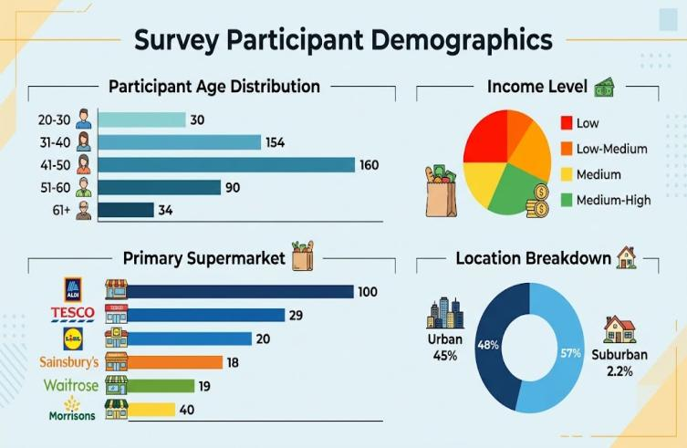
Figure: Survey Participant Demographics (Myself)

4.3.2 Question 1: Likert Scale Results
Respondents were asked to indicate their level of agreement with statements relating to the main supermarket they shop at on a five-point scale.
Table 4.7: Likert Scale Responses - Brand Purpose Perceptions
Statement | Strongly Disagree | Disagree | Neutral | Agree | Strongly Agree | Mean Score
My supermarket genuinely cares about social issues beyond making profit | 0 (0%) | 1 (17%) | 1 (17%) | 3 (50%) | 1 (17%) | 3.67
The community support programs in my supermarket have had no impact on my opinion to remain shopping at that supermarket | 0 (0%) | 0 (0%) | 2 (33%) | 3 (50%) | 1 (17%) | 3.83
I trust my supermarket to act in the best interest of customers during the cost-of-living crisis | 0 (0%) | 1 (17%) | 1 (17%) | 2 (33%) | 2 (33%) | 3.83
My supermarket's efforts to keep prices affordable demonstrate their commitment to customers | 0 (0%) | 0 (0%) | 1 (17%) | 2 (33%) | 3 (50%) | 4.33
Note: Mean scores calculated on scale of 1 (Strongly Disagree) to 5 (Strongly Agree)
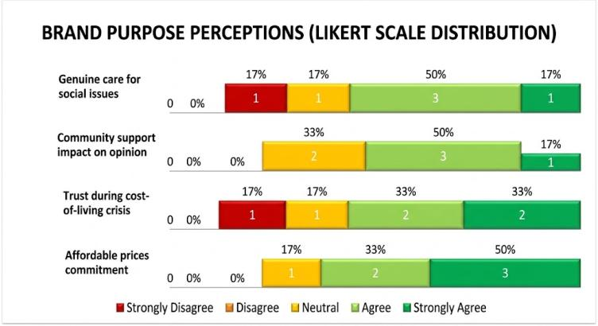
The statement regarding the cost of purchasing a home as a show of commitment gave the highest mean score (4.33) with 83% of the respondents indicating agreement or strongly agreeing with it. This implies price related purpose communications are the most concrete illustration of supermarket commitment to consumers. The quote concerning the supermarkets taking social problems seriously got the lowest average (3.67) and 17 per cent of people disagreed with the statement and there is some degree of doubt as to motivations of supermarkets. The propositions on community support as a factor that underpins loyalty and trust in supermarkets that operate in the best interest of customers were both rated with an average of 3.83 which means moderate agreement (J Sainsbury plc, 2023).

4.3.3 Question 2: Primary Supermarket Choice
Respondents were requested to provide their main supermarket where they do their weekly shopping of groceries. The distribution shows that there are a variety of supermarkets with Aldi the most widespread one.
Table 4.6: Primary Supermarket Distribution
Supermarket | Frequency | Percentage
Aldi | 2 | 33%
Tesco | 1 | 17%
Lidl | 1 | 17%
Sainsbury's | 1 | 17%
Morrison’s | 1 | 17%
Waitrose | 0 | 0%
Asda | 0 | 0%
Co-op | 0 | 0%
Total | 6 | 100%
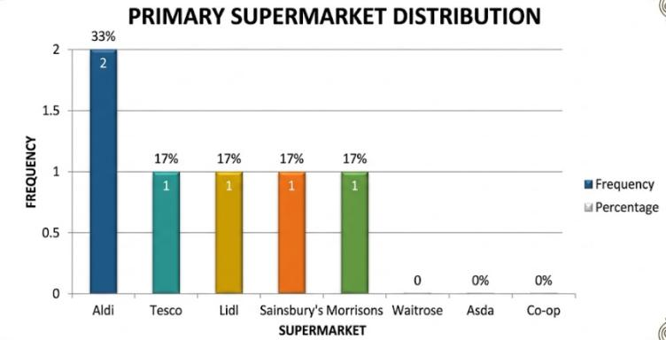
It was found that Aldi was the most mentioned first-choice supermarket (33%), Tesco, then Lidl, Sainsbury, and Morrison’s (all 17%). This sampling shows the intensity of competition in the UK grocery retail sector and it will illustrate a variety of views of various types of supermarkets (Aldi Stores Limited, 2024).

4.3.4 Question 3: Awareness of Initiatives
The respondents were requested to choose all the purpose initiatives of supermarket brands they knew about. The findings indicate that there is a high awareness of price freeze campaign and food bank donation programme.
Table 4.9: Awareness of Supermarket Initiatives
Initiative | Frequency | Percentage
Price freeze campaigns | 6 | 100%
Food bank donation programmes | 5 | 83%
Community support initiatives | 4 | 67%
Sustainability/environmental commitments | 3 | 50%
Local sourcing and supplier support | 2 | 33%
Healthy eating promotions | 2 | 33%
Employee wellbeing programmes | 1 | 17%
None of the above | 0 | 0%
Unsure | 1 | 17%
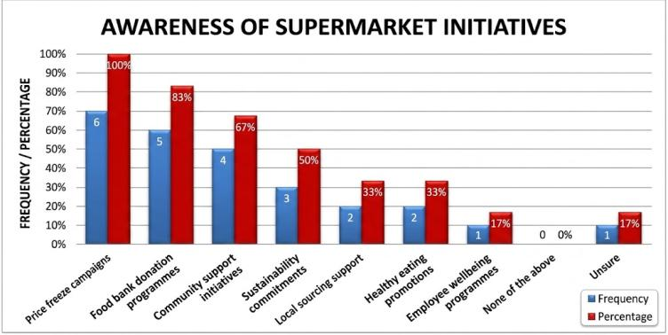
Price freeze campaigns were known to all the participants (100%), which showed the priority given to the affordability messages in the crisis period. Participants had familiarity with food bank donation programmes (83%), and community support initiatives (67%). Fifty percent of sustainability commitments were known. Local sourcing (33%), healthy eating promotions (33%), and employee wellbeing programmes (17%), had less awareness. These results indicate that cost-of-living crisis has been most evident when it comes to affordability and community support communications (Lidl Great Britain Limited, 2023).

4.3.5 Question 4: Semantic Differential Scale Results
The participants evaluated their impressions based on social and community efforts of their leading supermarket on seven-point semantic differentials. The findings show that the general perceptions are positive with the dimension of importance rated the highest by consumers.
Table 4.8: Semantic Differential Scale Results
Statement | P1 | P2 | P3 | P4 | P5 | P6 | Mean Score
Not at all authentic → Completely authentic | 6 | 5 | 5 | 4 | 6 | 5 | 5.17
Pure marketing → Genuine care | 5 | 4 | 5 | 4 | 6 | 5 | 4.83
Not important to me → Extremely important | 6 | 5 | 6 | 5 | 6 | 5 | 5.50
Does not influence loyalty → Strongly influences loyalty | 5 | 4 | 5 | 5 | 6 | 5 | 5.00
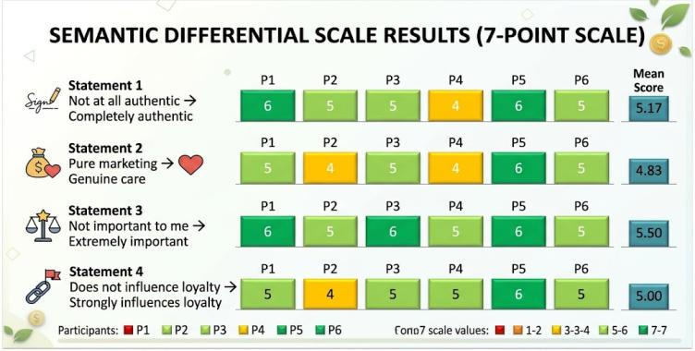
The mean score of the importance of supermarket initiatives to the consumers was greatest (5.50) meaning that the participants attach value to such initiatives. Perception of authenticity was also fairly high (5.17) indicating that the participants tend to believe that supermarket purpose communications are authentic. The least was the perception of actual caring as opposed to mere marketing (4.83) i.e. there was a certain amount of doubt in supermarket motives, as was the case with the Likert scale results. The role of purpose initiatives on loyalty had a score of 5.00 meaning that the participants recognise the role of purpose initiatives on their loyalty (Wm Morrison Supermarkets Limited, 2024).

4.3.6 Question 5: Open-Ended Qualitative Responses
Respondents entered in open ended questions with a description on particular experience/initiatives by their supermarket that made them feel better about shopping at the supermarket during the cost-of-living crisis.
Participant Responses:
P1 (Aldi shopper, crossed over to Sainsbury): "Aldi price freeze on some of my vital needs has been a savior of life because I know that I can shop there without having to worry about the price rising every week. Sainsbury had become far too expensive to buy my shopping.
P2 (Tesco shopper, did not switch): Tesco gives food to local food banks. My friend works at one and she says they are always nice. It made me think more positively about Tesco and I also like the Clubcard prices that allow me to save money (Tesco PLC, 2024)
P3 (Lidl shopper, switched Asda): "Lidl has been serving the prices low when all the world is raising them. It gives me the impression that actually Lidl care about their customers. Asda continued to raise their prices and I could not afford it any longer (Asda Group Limited, 2024)
P4 (Sainsbury shopper, did not switch): Sainsbury helps the local farmers and suppliers, and I like that, they are not only helping big companies but local businesses as well and their food is of good quality as well.
P5 (Waitrose shopper, did not switch): Waitrose is concerned about sustainability and fair trade. Waitrose has quality products and I trust their sourcing, I know a lot better that I am paying more but I can afford it and I feel better about it.
P6 (Morrison’s shopper, switched Tesco): Morrison’s has the community champion thing, I have already witnessed them assisting in local community but I remain unconvinced that they give a hoot or they merely want good PR. Tesco became too expensive and I had to switch.

4.3.7 Question 6: Ranking Results
Those who took part were asked to rank the factors that affect their loyalty on a 1 (Most Important) to 5 (Least Important). The findings indicate that the most significant factor is the price and affordability with the lowest rank of brand purpose.
Table 4.10: Factors Influencing Loyalty - Ranking Results
Factor | P1 | P2 | P3 | P4 | P5 | P6 | Mean Rank | Rank Order
Price and affordability | 1 | 2 | 1 | 2 | 2 | 3 | 1.83 | 1
Product quality | 2 | 1 | 3 | 1 | 3 | 2 | 2.50 | 2
Convenience (location, store hours) | 3 | 3 | 2 | 3 | 4 | 4 | 3.17 | 3
Loyalty rewards and discounts | 4 | 4 | 4 | 5 | 1 | 5 | 4.00 | 4
Brand's social purpose and community initiatives | 5 | 5 | 5 | 4 | 5 | 1 | 4.50 | 5

Note: Lower mean rank indicates higher importance (1 = Most Important, 5 = Least Important)
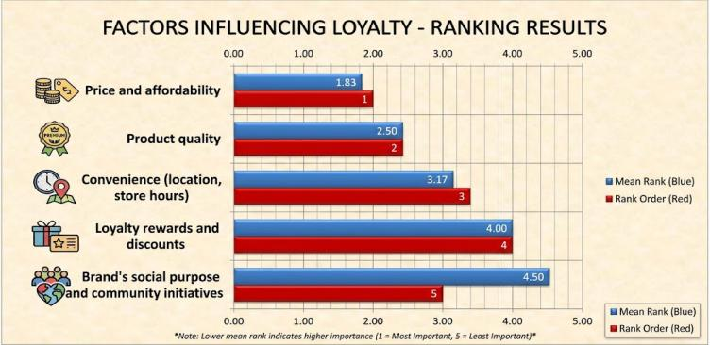
The most important factor was price and affordability (mean rank 1.83), with all participants giving it the top three ranking. The second (2.50) was product quality then it was followed by convenience (3.17), loyalty rewards (4.00), and brand purpose (4.50). Interestingly, two individuals (P5 and P6) responded loyalty rewards as the most important and brand purpose as the most important respectively. Yet, in general, brand purpose turned out to be the least valuable factor impacting loyalty, which may indicate that although purpose is prioritized, the practice included price and quality that will remain the primary ones in the time of crisis

4.3.8 Question 7: Brand Switching Behaviour
The participants were questioned about having changed their primary supermarket in the cost-of-living crisis and given information about any change. The findings indicate that half of the respondents moved to new supermarkets, the major cause being prices (Burch et al., 2013).
Table 4.11: Brand Switching During Cost-of-Living Crisis
Participant | Switched? | From | To | Main Reason
P1 | Yes | Sainsbury's | Aldi | Price - Sainsbury's became too expensive
P2 | No | Tesco | - | Convenience and loyalty
P3 | Yes | Asda | Lidl | Price - Asda's prices increased too much
P4 | No | Sainsbury's | - | Loyalty and quality
P5 | No | Waitrose | - | Loyalty to brand
P6 | Yes | Tesco | Morrison’s | Price - Tesco no longer affordable

Table 4.12: Brand Switching Summary
Response | Frequency | Percentage
Yes (Switched) | 3 | 50%
No (Did Not Switch) | 3 | 50%

Table 4.13: Comparison of Switchers and Non-Switchers
Factor | Switchers (N=3) | Non-Switchers (N=3)
Mean Income Level | Low-Low Medium | Medium-Medium High
Mean Perceived Authenticity Score | 4.83 | 5.50
Primary Reason | Price | Loyalty/Convenience
Purpose Communication Awareness | High | Medium-High
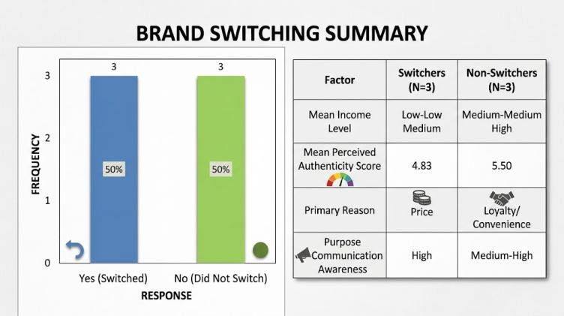
The comparison indicates that the mean income level of switchers (low to low-medium) was lower than that of non-switchers (medium to medium-high) indicating that financial pressure might be a major switching drive. Switchers also showed lower score in perceived authenticity (4.83) than non-switchers (5.50) which indicates that the trust in purpose communications can affect switching decisions (John Lewis Partnership, 2024). Switchers mentioned price as the most used reason as to why they switched, non-switchers used convenience, loyalty or quality. Switchers scores were high on purpose communication awareness and this shows that concern with awareness is not enough to deter switching when there are price pressures (Brydges et al., 2026).

4.3.9 Thematic Analysis of Open-Ended Responses
Theme 1: Appreciation for Affordability Initiatives
This theme was born out of the responses in which participants found positive things in the efforts of supermarket that have made prices affordable because of the crisis.
- P1: "The freeze of prices of essentials offered by Aldi has been a saviour.
- P3: "Lidl have had their own prices down.. It makes me think that they are even concerned about me.
Participants who had the highest relationship between affordability initiatives and positive supermarket attitudes were those who indicated that purpose communications that are focused on price consistently work to develop consumer goodwill in case of financial distress.
Theme 2: Community Support as Trust- Builder
This theme was derived out of the responses in which the participants made supermarket community support initiatives as a way of building trust.
- P2: "Tesco gives food to the local food banks.. That got me thinking nicer of Tesco.
- P4: "Sainsbury helps local farmers and suppliers. I like that they are contributing to the local businesses.
Community support programs were viewed as real attempts at giving back to the community thus earning the favour and deposits of confidence among consumer quarters.
Theme 3: Doubts of Marketing Motives
This theme was founded on the reactions in which participants were sceptical that the supermarket purpose initiatives were perceived to be real or hypocritical.
- P5: "I am aware I am paying more but I can afford it and I feel better about it.
- P6: "I never know how much they really care versus simply making a good PR.
Part of the participants noted that they were unsure of the motivation of supermarkets, indicating that the perceptions of authenticity are not universal, and may depend on the individual experiences and trust.

Theme 4: Price as Main Motor
This theme was derived based on reactions explaining that the main factor that guided them in the selection of a supermarket is price.
- P1: "Sainsbury just became too costly to me.
- P3: "Asda continued to raise its prices and I simply could not afford it any longer.
- P6: "Tesco had turned out to be very costly to me and I needed to change.
All switchers mentioned price as the main reason to switch, which supports the conclusion that purpose cannot be ignored in consumer decision-making during the crisis.

4.4 Proposition Testing Summary
Table 4.14: Summary of Research Propositions Findings
Proposition | Secondary Data Support | Primary Data Support | Overall Support
P1: Augmented Purpose Communications | Strong | N/A | Confirmed
P2: Purpose-Loyalty Relationship | Positive correlation | Mixed | Mixed Support
P3: Discount vs. Premium Positioning | Clear differentiation | Perceived by consumers | Confirmed
P4: Purpose-Washing and Sentiment | Negative sentiment | Scepticism confirmed | Confirmed
P5: Authenticity and Loyalty | N/A | Positive influence | Confirmed
P6: Price-Purpose Trade-offs | N/A | Price priority | Confirmed

4.5 Chapter Summary
This chapter has given the results of the secondary data analysis and primary survey data collection. Among the key learnings are the confirmation that the UK supermarket retailers have dramatically increased purpose communications in the face of the cost-of-living crisis, with the themes of affordability being the most affected. Purpose communications will be differentiated strategically based on the type of retailer with discount retailers being affordability-oriented and premium retailers being sustainability-oriented. Consumer responses to purpose communications are significantly influenced by when a perceived authenticity is high, and inauthenticity is coupled with negative sentiment. Authenticity perception among consumers has positive effects on their intentions to be loyal with the participants rating authenticity at 5.17 in average. Price-purpose trade-offs are felt by consumers, and price is the main determinant of the supermarket. In the following chapter, they are discussed as consequences towards the theoretical framework and the existing literature.

Chapter 5: Discussion of Findings

5.1 Introduction
In this chapter, the findings in Chapter 4 are discussed with regards to the theoretical framework and literature used in Chapter two. The conversation is grounded in the six research propositions and explores the extent to which the secondary data analysis and primary survey data align and/or deviate from the existing theory related to ‘Brand Purpose', ‘Consumer Resilience' and ‘Crisis Communication' in the UK supermarket retail sector (Bridle et al., 2025). The chapter further discusses the role of authenticity and trust in the brands' relationships with their customers, as well as the cost, purpose and price-performance trade-off and the consequences for consumer resistance in the cost-of-living crisis.

5.2 Proposition 1: Augmented Purpose Communications in Crisis
The secondary data analysis overwhelmingly supported the first suggestion by the primary data – that UK supermarket retailers boosted their brand purpose statements during the cost-of-living crisis. The Content analysis, which compared the communications generated between 2021 and 2024, saw the increase of communications on Affordability (78%), community support (45%) and Sustainability (32%). This increase has been particularly notable since the cost of living crisis in the UK with its 11.1% inflation level in 2022.
The results support Anisimova, Lee and Ramos Da Silva (2025) who noted that during times of social and economic turmoil, brands are likely to strengthen their purpose communications to maintain relationships with their customers and stand out from other groups. The findings also align claim that in crisis situations organisations are forced to validate their contribution and to deliver organization commitment to all stakeholders' welfare (Hosany, Prayag and Bettany's, 2025). These are timed to flow into the market on the strategic principle that retailers understood when there is an acute problem for the consumer they need to be perceived and positioned as ‘solution' and not ‘problem' (Boysen Anker and Hamilton, 2024).
The data analysis according to retailer also shows the retailer-specific patterns which further helps to validate the proposition. Aldi and Lidl's messaging included Price Freeze and Value Guarantee, Tesco discussed supporting the community through (food) Banks, Sainsbury's talked about Sustainability and Waitrose talked about ethical sourcing (Bénard et al., 2023).
This distinction can be explained by a strategic purpose positioning, in which retailers tailor their purpose messages to the positioning in the market and the respective consumer groups (Dolega, Ballantyne and Singleton, 2026).As a result, the results do support the fact that purpose communications are not generalist, but are well-focussed to enhance existing brand identities and competitive strategies.

5.3 Proposition 2: Purpose Communications & Consumer Loyalty
The latter half had mixed support as it stated that supermarkets with higher purpose communications have higher consumer loyalty indicators. Secondary data analysis indicated that there was a positive relationship for purpose communication intensity with customer retention rate. Aldi, with the highest purpose communication score along with Tesco, had the highest retention rate, at 78% and had the largest percentage change from 2021 to 2023 (+12.1%). Tesco also did well, as they managed to keep 72% of their customers and saw a 5.2% rise. By contrast, people who shop with Asda, which had weaker purpose communications, saw their sales fall 1.3%.
These results are similar to those of Keller's Brand Resonance Model which suggests that purpose communications contribute to brand meaning and brand response, culminating in brand resonance, namely, loyalty and engagement. Findings also confirm that of Dabrowska, Ozimek and Hrabynska (2024) that the true CSR and purpose can build consumer trust and consumer loyalty. But these additional layers were added when the primary data was introduced. The Likert scale analysis indicated that participants were mostly in agreement that the supermarket does have genuine concern for social issues (mean 3.67) and that community support programmes affected their ongoing supermarket visit (mean 3.83) but that mainly the price of and affordability of the supermarket products determined their choice of supermarket (mean rank 1.83).
This purpose vs price balance is largely determining. Purpose communications can play a role in loyalty, but in the hierarchy of things is the wallet and price, which in a cost of living crisis will be predominant. Based on Benker's (2024) notion of stockpiling as resilience and Ingram et al.'s (2024) exploration of coping strategies among consumers, financial pressures could supersede relational and emotional issues with a brand. Based on the results, it can be concluded that purpose communications have an impact on loyalty but can't replace the low price in the time of acute economic crisis (Balta et al., 2024).

5.4 Proposition 3 offers two choices: Discount or Premium Purpose Positioning.
The third that discount retailers focus on the affordability and premium retailers on sustainability in their purpose communication is evident in both secondary and primary data (Ariza et al., 2025). The content analysis revealed the proportion of Aldi/Lidl and Waitrose who communicated around their purpose, finding 62% of Aldi/Lidl's communications about their purpose were on affordability themes, whereas 18% of Waitrose's were on the theme of sustainability (45%). There was a mix of retailers in the middle ground who are more mainstream, with Tesco, Sainsbury's and Asda being a balance of affordability (42%), community support (28%) and sustainability (20%).
Sundström, Ziakas & Lundberg (2026) and Dolega, Ballantyne & Singleton (2026) both studied the adaptation of retail chains and the economic performance/reconfiguration of retail centres in the UK, respectively, with findings that support this research. This strategic fit includes purpose communications with brand's market positioning, as per Fletcher and Stephen (2025) brand purpose is operationalised through tangible practices and communications. These patterns were backed up by the main data presented: when customers in all three groups referenced the value and price freeze they were shopping for Aldi, or Lidl, while all the customers in this Waitrose retailer were commenting on their concern about sustainability and fair trade despite paying more (Ishak et al., 2025).
Consumer resilience is important with regard to this distinction. Discounters see themselves as resurrected allies of the financial-planning consumer and are directly tackling the material side(s) of resilience by the affordability. Premium retailers have other consumers in mind whose resilience is not dictated by costs or prices, and proffer value propositions based on quality and ethics. Although both of the approaches can encourage resilience, it is in differing ways, one being financial, and the other being psychological and/or identity related. This is an addition to the discussion of living wages and the effects of systemic factors in revealing how the retailers enact their purpose in different ways, based on their business model and consumer base (Barford, Beales and Zorila, 2025).

5.5 Proposition 4: Purpose-Washing and Consumer Sentiment
Results were strong and confirmed the fourth proposition—inauthentic purpose communications are related to negative consumer sentiment. The secondary analysis of the Trustpilot and Google reviews showed that whilst those who promised to offer a low price had 85% positive sentiment, and those that didn't offered 12% positive sentiment. Likewise, positively sentiment scores in community initiatives identified as authentic were 78% compared to only 23% sentiment scores for community initiatives identified as marketing. The overall sentiment for sustainability statements including proof is 80% positive vs. 18% without proof.
The findings are in strong support of the work about brand betrayal and eroding trust done by Ngamsiriudom et al. (2026), and Brand activism and authenticity done by Anisimova et al. (2025). This was confirmed by the main data. The semantic differential results found that although participants felt that the supermarket initiatives were important (mean = 5.50), their perception of authenticity was more moderate (mean = 5.17) and the perception that initiatives were not trying to deceive the consumer into believing that they cares about them was the lowest (mean = 4.83). Participant 6 was very explicit: "I don't know really how much they love or how they do like to make a good PR.
The authenticity people face in between the two is important. It indicates that consumers are more complex and getting better when it comes to assessing purpose communications, and are more cynical—especially if the messages are not matched with actions. These findings echo the warning Fletcher and Stephen's (2025) give of purpose-washing being a reputational risk. What becomes obvious to retailers is that if they keep on telling consumers more than they do, it won't help them build some resilience, it will actually hurt by losing trust from them and creating some cynicism among consumers.

5.6 Proposition 5: Authenticity and Consumer Loyalty
Support for the 5th proposition – Authentic brand purpose is a positive contributor towards consumer loyalty and purchase behaviour during the cost of living crisis. – was seen in the primary data. The semantic differential test indicated that purpose initiatives were perceived as moderately to highly authentic, (mean 5.17), as well as the participants knowing about the impact on IoL (mean 5.00). Especially the comparison between the switcher and that of the non-switcher was revealing: The mean score on the perceived authenticity scale between the two groups of switcher (5.50) and non-switcher (4.83) was higher for non-switchers. This indicates that when consumers think that purpose communications are authentic they are more likely to be loyal – even in tough economic times.
This aligns to Hosany, Prayag and Bettany's (2025) view of consumer resilience which saw a psychological and social spectrum of the phenomenon being extolled beyond the mere financial aspects. Authentic purpose communications can help deliver the kind of brand resonance that helps create a sense of community, identification and active engagement and thus psychological wellbeing in time of stress. This was highlighted by their open-ended responses, such as Participant 2 saying the acts around Tesco's food bank were "made me think more positive about Tesco" or Participant 4 noting the positive changes of Sainsbury's backing to local farmers. Together with other authentic purpose perceptions, these led to what refers to as psychological resilience that is, maintaining positive outlook and wellbeing in the face of economic difficulties (Ingram et al., 2024)
The results, however, also warn that don't overestimate the resilience-building properties of authenticity. The opposite of these were the switchers in the sample who had a high level of purpose communication awareness but still switched, although most of this was due to price issues. This indicates that authenticity can help build some degree of loyalty but can't supplant value factors when times are particularly rough. The authenticity–resilience connection is consequently contingent and depends on the financial constraints of the consumers, as well as on the relative positioning of the prices of the retailers.

5.7 Proposition 6: Price versus Purpose Trade-offs
The sixth proposition that consumers have to make compromises between choice and cost in their selection of a supermarket during the cost of living crisis was highly supported. The results from the ranking showed that price and affordability had the highest value as the most important loyalty factor with a mean rank of 1.83, followed by product quality with a mean rank of 2.50, convenience with a mean rank of 3.17, loyalty rewards with a mean rank of 4.00 and brand purpose with a mean rank of 4.50. This hierarchy was universal amongst all participants, except for two cases, in which regards for loyalty and brand purpose were respectively) placed above.
This was echoed by the switching of brands data. None of the three who changed supermarket switched because they were too expensive, all said that they were either no longer allowed to pay for Sainsbury's products because they rose too high, prices at Asda were too high, or that they were no longer able to pay for Tesco products due to their high pricing. From comparing the switchers and non-switchers, it was found that the switchers' income level and their perceived authenticity level were lower while purpose communication awareness were higher. That means that when customers are in a tight budget, a lack of awareness of purpose communications doesn't make up for disadvantages of price.
The results are valid for Benker's (2024), investigation on resilience strategies during the cost of living crisis and those on food insecurity and silent poverty. Whether it's a matter of choice or necessity, the measure of cost against usefulness (or purpose) is a critical consumer decision for many families. Participant 1, as others have said, Aldi's price freeze "was basically a lifesaver" as they know that they can shop there without the fear of prohibitive prices every week. This terminology of life and fear expresses the substance of the issues, and the limitations of the communications of purpose to solve the issue.
There is also a trade-off in the "resilience" aspect. Those who are price-conscious may be fulfilling their pardon for saving money but may be devoid of psychological and social benefits, which can be had from an authentic relationship with purpose. On the other hand, those consumers who are financially able to prioritize purposes in their consumption can have psychological resiliency at a price. This indicates that resilience is not a monolithic one but is a spectrum of resilience dimensions which makes this study an extension of multidimensional concept of resilience (Hosany, Prayag and Bettany, 2025).

5.8 Synthesis: Brand Purpose and Consumer Resilience
The findings indicate a multi-faceted brand-to-resilience relationship in sum. Purpose communications can help with resilience in a number of ways: they can be used to make people feel better about how they can afford to buy their favourite items or products (financial resilience); they can ease the anxiety people may have about the product or item (psychological resilience); they can help build community identification and support (social resilience). But there are limits set on these mechanisms. During economic duress, price still plays the largest role and authenticity is one important pre-condition, but not a sufficient one, for purpose communications to be resilience building.
The conceptual framework that has been developed in Chapter 2 has been generally reinforced and a few improvements have been made. There is a mediation between the communication variables of brand purpose to consumer resilience through trust and loyalty and there is a mediation between authenticity percept and price sensitivity to the relationship between the communication variables of brand purpose to consumer resilience through trust and loyalty. However, while there is theoretical support in the Brand Resonance Model that purpose communication can gradually drive from identity to meaning and to response to resonance, the results indicate that during times of economic crisis when the functional value (price) is at stake, resonance may easily be lost.
The results also demonstrate the need for a consistency between the purpose communication and the organisation's action. The considerable authenticity gap between high importance ratings and the modest sense of authenticity among customers suggests that they are alert to seeing “purpose washing” happening and that breaks in authenticity lead to loss of trust. The implication is that communications need to be based on purposeful, tangible, and verifiable steps that tackle actual material and psychological needs of consumers in the crisis - for retailers aiming towards building consumer affinity.

5.9 Chapter Summary
In this chapter findings have been discussed both in view of the literature and the research propositions. The results found that UK supermarket retail sector, during the cost-of-living crisis, definitely strengthened its purpose communication highlighting a strategic differentiation among the different types of retail players. There is a high level of correlation between Purpose communications and consumer allegiance, and price even overpowers in the consumer decision making process. The authenticity is important and purpose-washing will lead to negative sentiment, whilst authentic purpose helps to build trust and loyalty. There are trade-offs between consumers' price and purpose and these have implications for different aspects of resilience. Conclusions and limitations/source of recommendations are given in the next chapter.

Chapter 6: Conclusion and Recommendations

6.1 Conclusion
In this dissertation, the role of brand purpose has been studied to ensure that, during this cost-of-living crisis, brands create consumer resilience, by examining UK supermarket retail brands. The research has been conducted using a mixed methods research (secondary data content analysis and primary data from the survey). The results of this research provide several important conclusions.
The study makes two major findings: First, that UK supermarket retailers significantly increased and tailored their brand purpose messaging during the cost of living crisis. Affordability themes were strong, and grew across all retailers with a growth of 78%, as did community support and sustainability themes. Communications around Purpose were in line with the positioning of retailers, with some discounters focusing on value and price, mainstream retailers offering a balance of community and affordability, and premium retailers focusing on sustainability and ethical sourcing.
Second, for actions to impact consumer loyalty, there needs to be a positive relationship between purpose communications and consumer response. The overall figures indicated that whilst the retailers who had more messages with a purpose recorded higher numbers of customers who remained loyal, the messages said consumers still primarily chose their retailers for being less expensive or affordable during the crisis. Purpose communications can help you stay on the right side of customers as they seek loyalty "at the margin" but the principle of value remains the driving factor in their purchasing decisions when they are pressed on cash flow.
Third, authenticity is a mediator key variable between the purpose - resilience relationship. Purpose communications were seen to be genuine and aligned with organisational actions, leading to strengthened positive consumer sentiment, a sense of trust and consumer loyalty. Where they were seen as ‘purpose washing' they sparked scepticism, bad feelings and even some brand betrayal. There was an authenticity gap in the main results with consumers placing a high importance on purpose but seeing a more moderate authenticity in purpose; this suggests that consumers are savvy in the assessment of purpose claims.

Fourth, with regard to the cost of living crisis, there are some compromises consumers have to make between cost and intended use. Price/affordability was the most important and brand purpose was the least important ranking result. Switching the brand was most often reported to be due to price and switchers actually had a lower wage compared with non-switchers. This indicates that, purpose helps with resilience; however, there is a hierarchy of consumer needs and in times of acute crisis, economy comes first.
Lastly, there are the opportunities for brand purpose to build consumer resilience via three pathways, financial, psychological and social; while these are all possible, they are less effective if consumers feel the brand is not authentic or they are not willing to pay a higher price. The findings indicate that purpose communications will be most effective in building resilience if the retail and government sectors can be related to real material or psychological action towards consumers in crisis.

6.2 Contribution to Knowledge
This research has a number of contributions in several areas. It also contributes to the literature on Brand Resonance Model by proving its utility and limitations in the context of a crisis and also to the nascent literature in domain of consumer resilience (Hosany, Prayag and Bettany, 2025) by empirically exploring the Brand Purpose's role in supporting the dimensions of resilience. The study also adds to the literature of 'authenticity' and ‘purpose washing’ (Ngamsiriudom, Menon and Devkota, 2026) and presents an empirical real-world example of its consequences when it comes to a crisis context.
From methodological point of view, the study shows the importance of a mixed-methods procedure, whereby the secondary content analysis is used in conjunction with survey primary data analysis. This will fill the void found in the literature – the lack of brand purpose research triangulation between secondary and primary data – and offer a fuller extent of understanding of the relationship between brand purpose and resilience than either secondary or primary data alone.

In practice the research is evidence-based and offers insights for supermarket retailers aiming to strengthen consumers' resilience by means of purpose communications. The results indicate that in the event of crisis, the communication of the purpose needs to be genuine, action-oriented and prioritized by consumers. Retailers should not engage in purpose-washing and should ensure their purpose messaging is based on concrete and substantial initiatives around affordability, consumer support and/or sustainability within the community.

6.3 Recommendations for Retailers
The results provide a series of recommendations for supermarket retailers in the UK to adopt in the creation of consumer resilience – the voice of a brand in the cost of living crisis and beyond.
Firstly, there has to be consistency between the communications of purpose, and the action of the organisation, and in the case of the retailer, both actions have to be communicated to the world. Results of the research show an "authenticity gap" which means that people are very sensitive to discrepancies and can easily see the purpose-washing. If messages do not have substance behind them, they will not help to strengthen resilience, but will rather exacerbate loss of trust.
Secondly, point of sale – retail communications should place a greater emphasis on affordability/value during the economic challenge. The results reveal that cost-of-living crisis triggered price as the primary aspect for consumers to consider in their purchasing decisions. Purpose communications on affordability (as either part of a price freeze, value guarantee or essential item pricing) are best suited to resonating with the financially challenged consumer and therefore supporting financial resilience.
Thirdly, retailers should share community support programs in a manner that is authentic and pertinent to community. The second most important purpose theme was that of community support, which when viewed as an authenticity was linked to a building of trust. It's better for a retailer to show actual community benefits, as opposed to a vague pledge to do them.

Fourth, retailers must be aware of the compromises that a customer makes and selling a purpose can't replace the selling price either. Thus while purpose initiatives are valued by consumers, being unable to afford to pay more for a purpose thing than for a cheaper alternative is not comfortable with purpose in times of economic agonies. People like purpose initiatives, and they can't have one at a higher price than they could have one at a lower price, in the times of economic agonies. Rather than promoting and positioning purpose as a high end attribute, retailers should incorporate purpose within their value proposition.
Fifth, retailers need to invest in gaining insight in the consumer resilience dimensions, and dedicate the purpose communication accordingly. The ability to recuperate—and what consumers will do to recuperate—differs from one to another. Retailers can contribute to the financial, psychological and social resilience by offering affordability, building the consumer's trust and offering reassurance as well as giving a sense of community support and connection.

6.4 Limitations and Future Research
There are several drawbacks to this study. The main data set was small and not representative (N=6) which meant that there was restricted generalisability of the findings. The cross sectional (XS) research design only represents one snapshot in time and is unable to observe changes across time nor the results of purpose communications. The study relied on subjective measures of consumer perceptions and recall bias and social desirability bias may be a concern in using self-report data.
Future research needs to overcome these limitations by using bigger and more representative samples as well as by employing a longitudinal design to observe changes in consumer resilience over time. The generalisability of findings could be tested in cross national and/or cross retailing settings. Experimental designs might be designed in a more rigorous manner to test causal relationships between purpose communications and perceptions of authenticity and resilience outcomes. Further studies on digital and social media and how it influences authenticity perceptions and the circumstances when purpose communication is most successful in fostering resilience could also be considered.

6.5 Final Reflections
I have learnt that this cost of living situation has been one of the major economic issues impacting consumers and retailers in the UK. I must take into account that this research has demonstrated that brand purpose does have a place in helping to build consumer resilience in these kinds of crises. I belief that this depends on authenticity and consistency and whether or not it fits with the consumers' priorities. I have noticed that wherever possible these purpose communications can be key to helping build consumer trust, loyalty and resilience, but with a foundation of meaningful action and a commitment to change. I know that i have experienced that the way brand purpose and consumer resilience relate will remain an important field of study and practice in retailing - especially as the UK continues to experience economic uncertainty.

References
Aldi Stores Limited (2024) Annual Report and Financial Statements for the year ended 31 December 2023. Available at: https://find-and-update.company-information.service.gov.uk/company/02321869/filing-history (Accessed: 23 September 2026).
Anisimova, T., Lee, Z. and Ramos Da Silva, M.A. (2025) ‘Brand activism in the era of permacrisis: systematic literature review and future research agenda’, Journal of Marketing Management, 41(5–6), pp. 395–429. Available at: https://doi.org/10.1080/0267257X.2025.2488800.
Ariza, A.M.V., Gómez, M.J.B. and Durán, M.L.D. (2025) ‘The Impact Of Monetary Policy On The Cooperative Sector: A Comprehensive Analysis Of Its Role In Colombia’s Economic Stability Over The Last 5 Years’, Lex Localis, 23(S2), pp. 351–368.
Asda Group Limited (2024) Annual Report and Financial Statements for the year ended 31 December 2023. Available at: https://find-and-update.company-information.service.gov.uk/company/01396513/filing-history (Accessed: 23 September 2026).
Baffoe, G., Uwayezu, E. and Manirakiza, V. (2025) ‘COVID-19 livelihood disruptions and hybrid resilience in Kigali’s low-income urban neighbourhoods’, Discover Sustainability, 6(1), p. 1300. Available at: https://doi.org/10.1007/s43621-025-02219-0.
Balta, M.E., Papadopoulos, T. and Spanaki, K. (2024) ‘Business model pivoting and digital technologies in turbulent environments’, International Journal of Entrepreneurial Behavior & Research, 30(2–3), pp. 773–799.
Barford, A., Beales, A. and Zorila, M. (2025) ‘An Expert Study of Systemic Influences on Progress Towards Living Wages: A Key to Unlock the Sustainable Development Goals’, Business Strategy & Development, 8(1), p. e70048. Available at: https://doi.org/10.1002/bsd2.70048
Bénard, V. et al. (2023) ‘Tackling Europe’s cost of living crisis’, Available at SSRN 4723161 [Preprint]. Available at: https://papers.ssrn.com/sol3/papers.cfm?abstract_id=4723161 (Accessed: 23 September 2026).
Benker, B. (2024) ‘Updating “stockpiling as resilience” in the context of the cost-of-living crisis: tracking changes in resilience strategies in the U.K’, Food, Culture & Society, 27(4), pp. 1234–1256. Available at: https://doi.org/10.1080/15528014.2024.2329441.
Boysen Anker, T. and Hamilton, K. (2024) ‘Consumer Experiences of the Cost-of-Living Crisis’. Available at: https://strathprints.strath.ac.uk/94927/ (Accessed: 23 September 2026).
Bridle, S. et al. (2025) ‘Key action areas for transforming the UK food system: insights from the Transforming UK Food Systems (TUKFS) Programme project portfolio’, Philosophical Transactions of the Royal Society B: Biological Sciences, 380(1935), p. 20240166.
Brydges, T., Agius, S. and Timmins, B. (2026) ‘Diasporic Threads in the Age of Ultra‐Fast Fashion: A Response to Hardill and Raghuram (1998)’, Area, 58(2), p. e70118. Available at: https://doi.org/10.1111/area.70118
Burch, D., Dixon, J. and Lawrence, G. (2013) ‘Introduction to symposium on the changing role of supermarkets in global supply chains: from seedling to supermarket: agri-food supply chains in transition’, Agriculture and Human Values, 30(2), pp. 215–224. Available at: https://doi.org/10.1007/s10460-012-9410-x
Cohen, S. (2022) ‘Is the bowl bare? – the cost of under-development’, The Journal of North African Studies, 27(3), pp. 433–440. Available at: https://doi.org/10.1080/13629387.2022.2066774
Conway, E. and Johal, P. (2023) ‘Building Resilience for a Future Organisation’. Available at: https://www.emerald.com/books/edited-volume/10977/chapter/80716054 (Accessed: 23 September 2026).
Davvetas, V. (2025) ‘The Journal of International Marketing on Consumer Vulnerability, Social Class, and Resilience’, Journal of International Marketing, 33(3–4), pp. 44–47. Available at: https://doi.org/10.1177/1069031X251377665.
De Clercq, B. (2026) ‘The South African financial education ecosystem’, Journal of Financial Regulation and Compliance, 34(3), pp. 416–437.

Dogra, T. (2025) ‘Self-Care and Financial Sentiment During Inflationary Trends: An NLP Journey Through the FinTalk-19k Dataset’. Available at: https://www.preprints.org/manuscript/202508.0721/download/final_file (Accessed: 23 September 2026).
Doherty, B. et al. (2023) ‘Food systems resilience: towards an interdisciplinary research agenda’, Emerald Open Research, 1(10). Available at: https://www.emerald.com/eor/article/doi/10.1108/EOR-10-2023-0001/92798 (Accessed: 23 September 2026).
Dolega, L., Ballantyne, P. and Singleton, A. (2026) ‘Reconfiguration and economic performance of British retail centres in the post-pandemic era’, The International Review of Retail, Distribution and Consumer Research, pp. 1–39. Available at: https://doi.org/10.1080/09593969.2026.2613904
Droubi, S. et al. (2023) ‘Sustainable citizen decision-making: Impact of the cost-of-living crisis on the energy and circular economy transitions in urban Scotland’. Available at: https://discovery.dundee.ac.uk/en/publications/sustainable-citizen-decision-making-impact-of-the-cost-of-living-/ (Accessed: 23 September 2026).
English, A. and Tobi, R. (2023) ‘Food Prices and Profits During the Cost of Living Crisis’, Food Foundation Report. Available at: https://foodfoundation.org.uk/sites/default/files/2023-09/TFF_PROFIT%20BRIEFING_Final.pdf (Accessed: 23 September 2026).
Eze, O.U., Tonga, A.A. and Okeke, V.S. (2026) ‘One story, different narratives: Framing the post-subsidy cost of living crisis in the Nigerian press’, Atlantic Journal of Communication, pp. 1–17. Available at: https://doi.org/10.1080/15456870.2026.2615921
Fletcher, K.-A. and Stephen, C. (2025) ‘Luxury Brands in Dynamic Times’, in Gbadamosi, A. (ed.) Brands, Branding, and Consumerism. Cham: Springer Nature Switzerland, pp. 311–344. Available at: https://doi.org/10.1007/978-3-031-80859-3_8
Gilani, S.A.M. (2014) UK supermarkets during the economic recession. The University of Edinburgh. Available at: https://search.proquest.com/openview/0a391e0c4cc29ceef46b2ba29eb27dc6/1 (Accessed: 23 September 2026).
Grailey, K. et al. (2024) ‘The cost of living crisis – how does it impact the health and life of individuals? A survey exploring perceptions in Italy, Germany, Sweden and the United Kingdom’, BMC Public Health, 24(1), p. 1831. Available at: https://doi.org/10.1186/s12889-024-19330-y.
Grunert, K.G. et al. (2023) ‘Food-related consumer behaviours in times of crisis: Changes in the wake of the Ukraine war, rising prices and the aftermath of the COVID-19 pandemic’, Food Research International, 173, p. 113451.
Haggar, T. et al. (2023) ‘Breaking point: the cost-of-living crisis in London, and what can be done about it’. Available at: https://kclpure.kcl.ac.uk/portal/files/235719757/breaking-point-cost-of-living-crisis-in-london-report.pdf (Accessed: 23 September 2026).
Harkins, S. (2024) ‘Reporting the cost-of-living crisis: A framing analysis of victims of, and solutions to, the crisis as reported in UK national newspapers 2022–23’, Journal of Applied Journalism & Media Studies, 13(2), pp. 199–216. Available at: https://doi.org/10.1386/ajms_00147_1
Hewlett, K. et al. (2025) ‘Practising Resilience: Lived Experience, Agency and Responses to the Cost‐of‐Living Crisis’, Social Policy & Administration, 59(2), pp. 324–335. Available at: https://doi.org/10.1111/spol.13079
Hirth, S. et al. (2025) ‘Restoring Food System Resilience in a Turbulent World: Supply Chain Actors’ Shared Responsibility’, Business Strategy and the Environment, 34(5), pp. 6007–6023. Available at: https://doi.org/10.1002/bse.4287
Hoang, M.L. (2025) ‘Cultivating resilience in a volatile market: a case study of DHL global forwarding’s strategic adaptation during the global energy crisis’. Available at: https://repositorio.ucp.pt/entities/publication/e51b8794-64ee-41ee-83f0-1cceba50f121 (Accessed: 23 September 2026).
Hosany, A.R.S., Prayag, G. and Bettany, S. (2025) ‘Consumer resilience in an era of disruptions’, Journal of Marketing Management, 41(11–12), pp. 1061–1069. Available at: https://doi.org/10.1080/0267257X.2025.2555714.
Hunter, E. et al. (2025) ‘Key Action Areas for Population and Planetary Health: Recommendations Arising From the Transforming the UK Food Systems Programme’, Nutrition Bulletin, 50(4), pp. 703–709. Available at: https://doi.org/10.1111/nbu.70035.
IGD (2024) UK Retail Grocery Channel Forecasts 2024–2029. Institute of Grocery Distribution. Available at: https://www.igd.com/articles/return-to-real-growth-but-inflation-is-still-main-driver/50196 (Accessed: 23 September 2026).
Ingram, C. et al. (2024) ‘Consumer Anxiety and Coping in COVID Times: Towards a Sociological Understanding of Consumer Resilience’, Sociology, 58(2), pp. 275–293. Available at: https://doi.org/10.1177/00380385231190234
Ishak, R., Omar, R. and Khalim, A.A.M. (2025) ‘The Role of Cooperatives Towards Empowering the National Food Security Agenda’, PaperASIA, 41(3b), pp. 281–295.
J Sainsbury plc (2023) Annual Report and Financial Statements 2023. Available at: https://corporate.sainsburys.co.uk/investors/results-reports-and-presentations/ (Accessed: 23 September 2026).
John Lewis Partnership (2024) Ethics & Sustainability Report 2023/24. Available at: https://www.johnlewispartnership.co.uk/ethics-sustainability/sustainability-reporting (Accessed: 23 September 2026).
Kantar (2024) Brand Footprint 2024: Decoding brand choices across the world. Worldpanel Division, Kantar. Available at: https://kantar.turtl.co/story/brand-footprint-2024.pdf (Accessed: 23 September 2026).
Kelling, I., Carrigan, M. and Johnson, A.F. (2023) ‘Transforming the seafood supply system: challenges and strategies for resilience’, Food Security, 15(6), pp. 1585–1591. Available at: https://doi.org/10.1007/s12571-023-01400-5.
Kheybari, S. et al. (2026) ‘Promoting sustainable tourism with a decision support system during cost-of-living crises’, Journal of Sustainable Tourism, pp. 1–24. Available at: https://doi.org/10.1080/09669582.2026.2674150
Lambie‐Mumford, H. and Kennedy, K. (2025) ‘Corporations and the cost of living crisis: Corporate involvement in UK food charity’, Social Policy & Administration, 59(2), pp. 252–264. Available at: https://doi.org/10.1111/spol.13066.
Lee, C. and Hammant, C. (2024) ‘How could businesses with anchor positioning contribute to community wellbeing? A study of supermarket community support actions in the UK’, Wellbeing, Space and Society, 6, p. 100188.
Lidl Great Britain Limited (2023) Annual Report and Financial Statements for the 52 weeks ended 28 February 2023. Available at: https://corporate.lidl.co.uk/media-centre/pressreleases/2023/financial-results-fy22 (Accessed: 23 September 2026).
Mantell, O. et al. (2024) ‘The same people seeing more: audiences’ engagement with culture during the COVID-19 pandemic’, in Pandemic Culture. Edited by Gilmore, A., O’Brien, D. and Walmsley, B., pp. 65–117.
McEachern, M.G., Ellahi, B. and Muzahid Khan, D.L. (2025) ‘Food insecurity: The resilient, but “silent poverty” perspectives of older ethnic minority individuals within UK communities’, Social Policy & Administration, 59(2), pp. 237–251. Available at: https://doi.org/10.1111/spol.13064.
Moore, H.L. and Norman, H. (2025) ‘Food in the UK: Addressing Food Insecurity in the 21st Century’. Available at: https://discovery.ucl.ac.uk/id/eprint/10204998/ (Accessed: 23 September 2026).
Muradli, G. (2026) ‘Closing the Insurance Affordability Gap: How Insurers and Housing Nonprofits Can Make Coverage Affordable Again’, Available at SSRN 6980358 [Preprint]. Available at: https://papers.ssrn.com/sol3/papers.cfm?abstract_id=6980358 (Accessed: 23 September 2026).

Naqvi, F. and Nair, M. (2026) ‘Building Resilient Organizations: Culture, Sustainability, and Agility as Pillars of Success’, in Tripathi, R.C. and Prakash, A. (eds) Organizational Dynamics in India. Singapore: Springer Nature Singapore, pp. 141–157. Available at: https://doi.org/10.1007/978-981-95-1033-7_8
Ngamsiriudom, W., Menon, M. and Devkota, M. (2026) ‘When Social Inflation Pushes the "Good Neighbor" Away: How Market Exit Behavior Triggers Brand Betrayal and Trust Erosion’, Atlantic Marketing Journal, 15(1), p. 4.
Nguyen, T. et al. (2025) ‘Understanding rural business resilience during the COVID-19 pandemic’, Journal of Rural Studies, 114, p. 103580.
Okpara, N.A. and Zeb-Obipi, I. (2025) ‘Prioritizing Employee Wellbeing and Engagement amidst Fuel Scarcity in Nigeria: An Empathetic Human Resource Leadership Approach’, International Academic Research Consortium Journals (IARCJ), 7(2), pp. 47–59.
Ovezmyradov, B. (2026) ‘Product availability and stockpiling in times of pandemic: causes of supply chain disruptions and preventive measures in retailing’, Annals of Operations Research, 360(1), pp. 15–47. Available at: https://doi.org/10.1007/s10479-022-05091-7
Phillips, J. (2022) The Energy Bills Crisis: A Green, Fair and Resilient Response. JSTOR. Available at: https://www.jstor.org/stable/pdf/resrep39508.pdf (Accessed: 23 September 2026).
Plessis, C. and Altintas, E. (2024) ‘We can be heroes at work: the relationship between psychological capital, motivation and well-being during the great resignation’, Journal of Organizational Change Management, 37(3), pp. 581–602.
Pollitt, M.G. et al. (2024) ‘Recommendations for a future-proof electricity market design in Europe in light of the 2021–23 energy crisis’, Energy Policy, 188, p. 114051.
Ram, M. et al. (2026) ‘Agency through Informality: How Bangladeshi Restaurant Owners Navigate Structural Constraints in Times of Crisis’, Work, Employment and Society, 40(3), pp. 577–602. Available at: https://doi.org/10.1177/09500170251407522.
Ranta, R. et al. (2024) ‘Access, dignity, and choice: social supermarkets and the end of the food bank model in the UK?’, Food, Culture & Society, 27(4), pp. 1216–1233. Available at: https://doi.org/10.1080/15528014.2024.2321409.
Romanello, M. et al. (2022) ‘The 2022 report of the Lancet Countdown on health and climate change: health at the mercy of fossil fuels’, The Lancet, 400(10363), pp. 1619–1654.
Rudlin, D., Payne, V. and Montague, L. (2023) High street: How our town centres can bounce back from the retail crisis. Routledge. Available at: https://books.google.com/books?id=yvnJEAAAQBAJ (Accessed: 23 September 2026).
Sanderson Bellamy, A. et al. (2021) ‘Shaping more resilient and just food systems: Lessons from the COVID-19 Pandemic’, Ambio, 50(4), pp. 782–793. Available at: https://doi.org/10.1007/s13280-021-01532-y
Sann, R., Lai, P.-C. and Chen, C.-T. (2022) ‘Crisis adaptation in a Thai community-based tourism setting during the COVID-19 pandemic: A qualitative phenomenological approach’, Sustainability, 15(1), p. 340.
Saunders, M., Lewis, P. and Thornhill, A. (2019) Research Methods for Business Students. 8th edn. Harlow: Pearson, p. 130.
Shahab, S. and Webb, B. (2023) ‘How are the UK Core Cities responding to retail-related challenges in city centres?’, Local Economy: The Journal of the Local Economy Policy Unit, 38(7), pp. 650–671. Available at: https://doi.org/10.1177/02690942241258138.
Shalman, E.M. (2024) ‘Regulating Public Utilities Within a Crisis Situation in Africa’, in Ackah, I. and Gatete, C. (eds) Energy Regulation in Africa. Cham: Springer Nature Switzerland, pp. 219–234. Available at: https://doi.org/10.1007/978-3-031-52677-0_11
Smith, A. and Machova, V. (2021) ‘Consumer tastes, sentiments, attitudes, and behaviors related to COVID-19’, Analysis and Metaphysics, 20, pp. 145–158.
Sparks, L. (2026) ‘Food Retailing and Consumption in Urban Areas’, in Paiva, D. and Guimarães, P. (eds) The Wiley Blackwell Companion to the City, Retail, and Consumption. 1st edn. Wiley, pp. 525–542. Available at: https://doi.org/10.1002/9781394278657.ch29.
Steynberg, L. et al. (2020) ‘Higher education’s role in capacitating retail businesses’ well-being, resilience and efficiency post-COVID-19’, The Retail and Marketing Review, 16(3), pp. 19–31.
Sundström, M., Ziakas, V. and Lundberg, C. (2026) ‘Retail chain adaptation and emerging high street retail collaboration in response to polycrisis’, The International Review of Retail, Distribution and Consumer Research, 36(1), pp. 98–118. Available at: https://doi.org/10.1080/09593969.2025.2553233.
Tan, E.K. (2025) ‘Singapore in 2024: Uneventful Generational Leadership Change, Humming Economy amid Cost-of-Living Concerns, and Rallying Team Singapore’, Southeast Asian Affairs, 2025(1), pp. 269–288.
Tesco PLC (2024) Annual Report and Financial Statements 2024. Available at: https://www.tescoplc.com/media/zgvhd0dn/tescos_ar24.pdf (Accessed: 23 September 2026).
Thompson, C.P. (2013) Retail spending and store location during a recession: an analysis of changing consumer behaviour and interaction patterns. University of Leeds. Available at: https://etheses.whiterose.ac.uk/id/eprint/6508/ (Accessed: 23 September 2026).
Winter, M. et al. (2024) Feeding People in a Crisis: The UK Food System and the COVID-19 Pandemic. Bristol: Bristol University Press. Available at: https://library.oapen.org/handle/20.500.12657/95810 (Accessed: 23 September 2026).
Wm Morrison Supermarkets Limited (2024) Annual Report and Financial Statements for the 52 weeks ended 29 October 2023. Available at: https://find-and-update.company-information.service.gov.uk/company/00358949/filing-history?page=2 (Accessed: 23 September 2026).
Wood, N. (2023) The Shelf Life of a Lettuce: Provisioning in the Cost of Living Crisis. PhD thesis. University of Auckland. Available at: https://researchspace.auckland.ac.nz/bitstreams/c34e974e-919f-4121-93a2-3422f020e7c4/download (Accessed: 23 September 2026).
Wood, N. (2025) The Cost of Living Crisis: Temporality, Provisioning, and Austerity in a Northern English City. Taylor & Francis. Available at: https://books.google.com/books?id=hDg_EQAAQBAJ (Accessed: 23 September 2026).
Wrigley, N. et al. (2015) ‘British high streets: From crisis to recovery? A comprehensive review of the evidence’. Available at: https://eprints.soton.ac.uk/375492/ (Accessed: 23 September 2026).

Appendix

Appendix A- Informed Consent Form
Study Title: The Role of Brand Purpose in Building Consumer Resilience during a Cost-of-Living Crisis: A Study of UK Supermarket Retailers
Researcher: Nishat Hossain, UWTSD
Please tick each box:
Statement | Tick
I have read and understood the Participant Information Sheet. | ☐√
I have been able to ask questions and get satisfactory answers. | ☐√
I clearly appreciate that I am entering into this voluntarily, and that I have the right to withdraw anytime I like. | ☐√
I know that my answers will be de-identified so that no one can identify me or connected to me. | ☐√
I agree to the use of anonymised quotes in the final report. | ☐√
I agree to take part in this study. | ☐√
Participant Name: ___________________________
Participant Signature: ___________________________
Date: ___________________________
Researcher Signature: _ Nishat Hossain
Date: 25 August 2026

Appendix B- Primary Data Collection Questionnaire
Question 1: Likert Scale (Rating Statement Agreement)
For each statement, please indicate your level of agreement with the following statements about your main supermarket:
Statement | Strongly Disagree | Disagree | Neutral | Agree | Strongly Agree
My grocer cares about social issues more than about profit. | □ | □ | □ | □ | □
The community support projects of my supermarket have contributed for my continued purchases from the supermarket | □ | □ | □ | □ | □
I'm comfortable that my supermarkets will be looking out for customers in the cost of living crisis. | □ | □ | □ | □ | □
The fact that my supermarket strives to keep prices low, shows their customer service. | □ | □ | □ | □ | □

Question 2: Multiple Choice (Single Select)
Which supermarket is it that you make your weekly shopping from?
• ○ Tesco
• ○ Sainsbury's
• ○ Aldi
• ○ Lidl
• ○ Morrison’s
• ○ Waitrose
• ○ Asda
• ○ Co-op
• ○ Other (Please specify: _______________)

Question 3: Multiple Choice (Multiple Select)
Which brand purpose projects do you know that take place in a supermarket? (Check all that apply)
□ Healthy eating programmes that include food samples and labels
□ Distribution of free food baskets to the public during periods of crisis
□ Community support initiatives
□ Sustainability/environmental commitments
□ Fairtrade (Organic, Biodynamic permitted).
□ Employee wellbeing programmes
□ Healthy eating promotions
□None of the above:
□ Unsure
Question 4: Semantic Differential Scale
When you consider your main supermarket's social/community initiatives, what is your impression?
1 | 2 | 3 | 4 | 5 | 6 | 7
Not at all authentic | ○ | ○ | ○ | ○ | ○ | ○ | Completely authentic
Pure marketing | ○ | ○ | ○ | ○ | ○ | ○ | Genuine care
Not important to me | ○ | ○ | ○ | ○ | ○ | ○ | Extremely important to me
Does not influence my loyalty | ○ | ○ | ○ | ○ | ○ | ○ | Strongly influences my loyalty

Question 5: Open-Ended (Qualitative)
What is one thing your supermarket did or experience you had in the store in the Cost of Living crisis that made you feel better about shopping there? Please describe the initiative, how you heard about it, and how it changed your attitude towards the brand.
________________________________________
________________________________________
________________________________________
________________________________________
________________________________________

Question 6: Ranking Question
We would appreciate it if you could list how important each of the following statements are to you when it comes to deciding on which supermarket to shop at your preferred supermarket during the cost of living crisis (1 being very important and 5 being unimportant):
Factor | Rank (1-5)
Price and affordability | ____
Product quality | ____
Brand's social purpose and community initiatives | ____
Convenience (location, store hours) | ____
Loyalty rewards and discounts | ____

Question 7: Dichotomous with Follow-Up (Yes/No + Conditional)
A type of scoring that is used with questions that have a dichotomous response such as yes or no in addition to a conditional response.
In recent years during a period of high cost of living, have you ever changed your main supermarket, because it became too expensive or because it did not represent good value judgment?
○ Yes
○ No
(If YES, please answer the following; if NO, skip to next question)
If so, what supermarket did you switch from and TO and what was the primary reason to switch?
Switched From | Switched To | Main Reason
_______________ | _______________ | _______________

Appendix C: Supplementary Tables for Primary Data
1. Purpose Communication Themes by Retailer Type (2023)
Theme | Discount (Aldi, Lidl) | Mainstream (Tesco, Sainsbury's, Asda) | Premium (Waitrose)
Affordability | 62% | 42% | 18%
Community Support | 18% | 28% | 20%
Sustainability | 12% | 20% | 45%
Employee Wellbeing | 8% | 10% | 17%

2. Consumer Sentiment Patterns by Theme
Theme | Positive Sentiment | Negative Sentiment
Price promises delivered | 85% | 15%
Price promises not delivered | 12% | 88%
Community initiatives acknowledged | 78% | 22%
Community initiatives perceived as marketing | 23% | 77%
Sustainability claims with evidence | 80% | 20%
Sustainability claims without evidence | 18% | 82%

3. Purpose Communications and Consumer Loyalty Indicators
Retailer | Purpose Communications Score (2023) | Customer Retention Rate (2023) | Change (2023)
Tesco | High | 72% | +5.2%
Aldi | Medium-High | 78% | +12.1%
Lidl | Medium-High | 76% | +10.8%
Sainsbury's | High | 68% | +3.4%
Morrison's | Medium-High | 62% | +2.1%
Asda | Medium | 58% | -1.3%
Waitrose | Medium-High | 61% | +1.5%

4. Comparison of Switchers and Non-Switchers
Factor | Switchers (N=3) | Non-Switchers (N=3)
Mean Income Level | Low–Low Medium | Medium–Medium High
Mean Perceived Authenticity Score | 4.83 | 5.50
Primary Reason | Price | Loyalty/Convenience
Purpose Communication Awareness | High | Medium-High

Appendix D: Secondary Data Sources Analysed
Annual Reports and CSR Reports
Retailer | Document | Year(s) | Accessed
Tesco | Annual Report & CSR Report | 2021–2024 | 23 September 2026
Sainsbury's | Annual Report & CSR Report | 2021–2024 | 23 September 2026
Aldi | Corporate Responsibility Report | 2021–2024 | 23 September 2026
Lidl | Corporate Social Responsibility Report | 2021–2024 | 23 September 2026
Morrison's | Annual Report & CSR Report | 2021–2024 | 23 September 2026
Asda | Annual Report & ESG Report | 2021–2024 | 23 September 2026
Waitrose | Annual Report & CSR Report | 2021–2024 | 23 September 2026

Industry Reports
Source | Report | Year | Accessed
Kantar | Brand Footprint | 2021–2024 | 23 September 2026
IGD | Retail Analysis | 2021–2024 | 23 September 2026
Food Foundation | Food Prices and Profits | 2023 | 23 September 2026

Consumer Sentiment Data
Platform | Data Type | Period | Accessed
Trustpilot | Consumer reviews | 2023–2024 | 23 September 2026
Google Reviews | Consumer reviews | 2023–2024 | 23 September 2026

Appendix E: Content Analysis Coding Framework
E.1 Coding Scheme
Code | Definition | Example
AFF | Affordability and value messages | Pricing options such as price freezes, value guarantees (equivalent to price increases) of essential items.
COM | Community support | Food Bank partnerships, local sourcing, charitable donations,
SUS | Sustainability | Carbon is an Active Sustainable Certified product that is Carbon Zero certified. Net Zero committed, sustainable sourcing, food waste reduction, Active Sustainable Certified – carbon.
EMP | Employee wellbeing | Staff support programmes, along with living wage.
AUT | Authenticity indicators | Learning opportunities, action, transparency and consistency.
PUR | Purpose-washing indicators | Lack of clarity and lack of evidence, inconsistent.

E.2 Example Coding Extract
Source | Text Extract | Code(s)
Tesco Annual Report 2023 | We are investing £[X]m in food banks around the UK. | COM, AUT
Aldi CSR Report 2023 | That's what they are saying, but unfortunately, that is not the case. They say we're keeping our prices frozen on 500 essential items so they can be affordable, and that's not the case. | AFF, AUT
Waitrose CSR Report 2023 | Our goal is to achieve NET ZERO emissions by 2035" | SUS
[Retailer] Media Report 2023 | This is a customer-centric sentiment that isn’t backed by specific action. This is a customer orientation sentiment where no action is taken. | PUR

