Student ID number: | 221083
Programme: | MSc Digital Skills for the Health and Care Professions
Module: | Digital Technology in Health and Social Care
Module code: | BMDS7006 CW2
Assignment Title: | Programme Improvement Project | Word count (or equivalent): | 4,515

Table of Contents

1 Introduction 4
1.1 Legal & Risk Services 4
Fig 1 – Areas of Legal Advice Offered 4
Fig2 – NWSSP Legal & Risk Organisational Structure 5
1.2 SWOT Analysis 6
Fig 3 – SWOT Analysis (Shewan, 2022) 6
1.3 Virtual Cabinet 7
Fig 4 – VC Ribbon Options 7
Fig 5 – Dictation Process 8
Fig 6 – Start Task tool in VC 9
Fig 7 – Publishing to VC Portal 9
Fig 8 – Reports Tab 10
Fig 9 – MS Word VC Add-in 11
Fig 10 – MS Outlook VC Add-in 11
2 Methods 12
Fig 11 – FITT Framework (Ammenwerth et al., 2006) 13
Fig 12 – Modified FITTE Framework to include environmental factors 14
3 Results 14
Fig 13 – Number of items of post received 15
Fig 14 – No of Emails Filed 15
Fig 15 – No of emails filed automatically by the Email Capture Rule 16
Fig 16 – Document Template Usage 16
Fig 17 – Age of Staff not using Templates 17
Fig 18 – No of document published using VC Portal 18
4 Discussion 18
Fig 19 – INAS Assessment (da Silva Serapião Leal, G., Guédria, W., & Panetto, H., 2019) 21
Fig 20 – Individuals vs Task Matrix 22
Fig 21 – Technology vs Task Matrix 24
Fig 22 – Individual vs Technology Matrix 26
9 References 29
Rogers, E.M. (1996) ‘Diffusion of Innovations, (4th Edition)’. New York, The Free Press 29
10 Glossary 30

1 Introduction

This section outlines the service context and the purpose of the software product. In 2009, the National Assembly for Wales ordered a report to look at how NHS Services in Wales could be run more efficiently (NWSSP, 2022b). This was done by Bath University and the report was published in October 2009 (Lewis M et al, 2009). It recommended a shared services approach to non-clinical services across NHS Wales (Lewis M et al, 2009). As a result, in April 2011, NHS Wales Shared Services Partnership (NWSSP) was born.
This assignment focuses specifically on the implementation of an electronic document management system called Virtual Cabinet (VC) in NWSSP Legal & Risk Services (L&RS), who provide legal advice to Health Boards and GPs throughout Wales (NWSSP, 2022a).

1.1 Legal & Risk Services

The areas of legal advice offered are listed in Fig 1.

Fig 1 – Areas of Legal Advice Offered

The functional organisational structure of L&RS is as follows:

Fig2 – NWSSP Legal & Risk Organisational Structure

Each legal Team is made up of a Team Leader, senior solicitors, solicitors, legal executives, trainees, paralegals, and secretaries. Team size differs, the smallest Team being 5 staff and the largest 17. The Business Support Team consists of administrators who manage the mail and travel, IT support who support the software used by L&RS and media co-ordinators who publish newsletters and manage social media. The Welsh Risk Pool (WRP) is somewhat different from the rest of L&RS and is out of scope. At the time of the implementation of VC, there were 80 staff.
Most legal matters begin with an enquiry. L&RS will act on behalf of Health Boards/Trusts or GP’s, corresponding with both the client and the person raising the legal issue (the other side), or more commonly, their legal representative. Expert advice may be requested, and all parties may meet at a “round the table” meeting to negotiate the position. If these fail, the case may go to court or a tribunal for a judge to settle it.
The pre-existing digital infrastructure was made up of 3 components:
- A bespoke case management system, known as “the database”, which was built by an external contractor. This holds all data relating to the legal matters.
- A shared network drive where newly created documents could be stored. It did not hold incoming documents or emails.
- Use of Microsoft (MS) Outlook and MS Word for creation and sending of electronic documents.
Confidential documents could not be emailed, so the vast majority of correspondence was printed and posted. Copies of these documents and all emails were printed and placed in a paper file, along with any incoming correspondence. These files could become very large, making them heavy and difficult to carry.

1.2 SWOT Analysis

A SWOT analysis (Shewan, 2022) of L&RS shows the following Strengths, Weaknesses, Opportunities and Threats within the department:
Strengths | Weaknesses
Customer Care  Specialist Knowledge and Experience  Value for Money  Financial Stability  Government Regulation  LEXCEL Accreditation  CSE Accreditation | Government Regulation  Paper Based  Slowness  Limited Marketing
Opportunities | Threats
Expansion into other Public Sectors  Internal Communication  Digitisation | Private Sector Competition  Changes to the Law  Government Policy

Fig 3 – SWOT Analysis (Shewan, 2022)

Digitisation is listed as an opportunity, showing that investing in software would be beneficial. Legal case work is very document heavy, with a great deal of correspondence. It can be difficult to see the latest activity on a matter if the most recent email/letter hasn’t been printed and filed. Staff attending meetings or working from home must carry large volumes of paperwork, often in heavy suitcases, which can cause back problems. Because staff must be in the same physical location of the files in order to work on those matters, it can be difficult to deal with urgent, incoming work when away from the office.

1.3 Virtual Cabinet

VC was implemented in 2016 with the intention of digitising L&RS and reducing the reliance on paper documents. At it’s simplest, VC is designed to replace physical filing cabinets with virtual ones, so that staff can access documents online at any time. This would make documents available from any location and is consistent with the Environment (Wales) Act 2016 legislation to reduce carbon usage in the public sector (Welsh Government, 2021).
The application has 4 main options on it’s ribbon:
Option | Function
In-tray | where incoming tasks and documents are accessed
Search | where all saved documents can be found and actioned
Messages | where messages relating to shared documents can be reviewed
Reports | where information about document activities can be accessed

Fig 4 – VC Ribbon Options

This simple ribbon makes navigating VC easy but due to the availability of add-ins and integration with the Legal & Risk Database, is infrequently used.
Within the in-tray, users can create tasks. This enables one user to ask another user to do some work on a document. Task delegation is common and L&RS use the following tasks:
- Bill and Close
- Dictation
- Generic Task
- Incoming Post
- Outgoing Approval
- Urgent Work

These tasks have workflows to ensure that the task is completed. For example, the Dictation process flow is used by solicitors to request that secretaries complete some dictation for them. They will send it to a secretary, who will draft the document and return it to the solicitor for approval. If the solicitor is happy, they will return it to the secretary to send out and mark the task as complete.

Fig 5 – Dictation Process

Initiating a task is simple. Users select the Task and who they would like to assign it to.
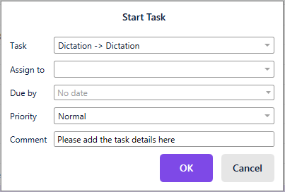

Fig 6 – Start Task tool in VC

Users can also send documents via a fully integrated secure file sharing portal to anyone with an email address. This is particularly useful for sending documents to claimant’s solicitors, as normal email is not suitable for sending patient information or sensitive data relating to a claim. Recipients can reply to these documents and these replies are accessible through the messages tab. Recipients can also send documents back to L&RS users via this Portal.
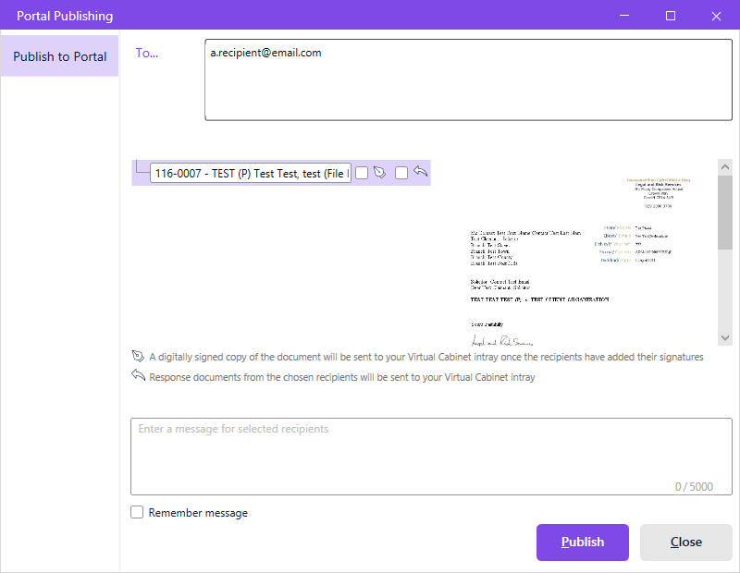

Fig 7 – Publishing to VC Portal

The reports tab enables users to access a full audit of activities they, or other users have done within VC, as well as viewing the status of tasks they have assigned to others and documents they have published to the Portal.
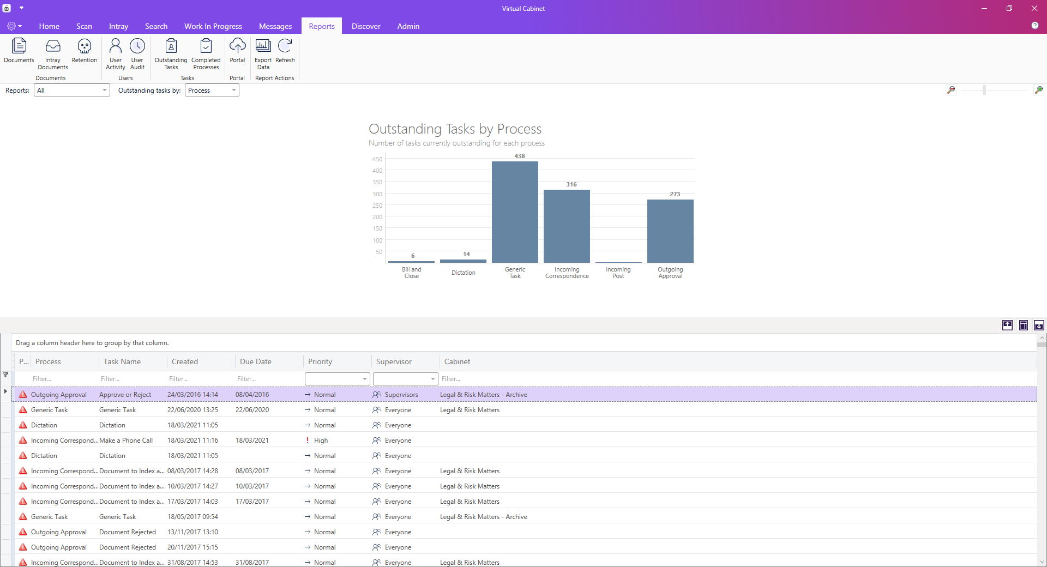

Fig 8 – Reports Tab

VC has a facility to create documents from templates. However, this went out of use within 2 years of the go-live. Instead, integrations with the L&RS database are used to create documents from templates and automatically file them within VC.
VC allows users to group documents into “Packs”, enabling users to group important documents together for easy access.
VC also allows users to extract documents, either individually, or into “VC Portable”, which is a simpler version of the full application, making navigating large numbers of documents much easier than a filing system.
VC has integrations with MS Outlook and MS Word. In Fig 7, the VC Word Add-in shows that the document is not stored in VC and offers options to create new documents, open existing documents, store in the users Intray, send to another users In-tray or file in VC, which is known as indexing, add a hyperlink to a document in VC or adjust the user options.
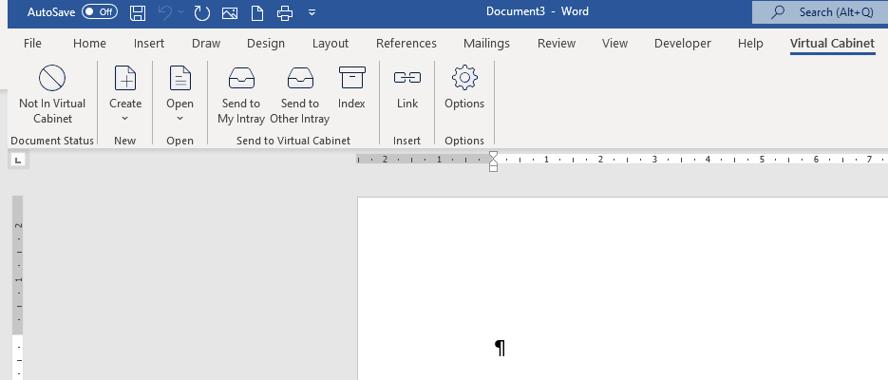

Fig 9 – MS Word VC Add-in

The Outlook Add-in allows users to assign a “capture rule” to incoming or outgoing emails. This files the email into VC and ensures all future incoming and outgoing replies are also automatically filed using the same indexing criteria.
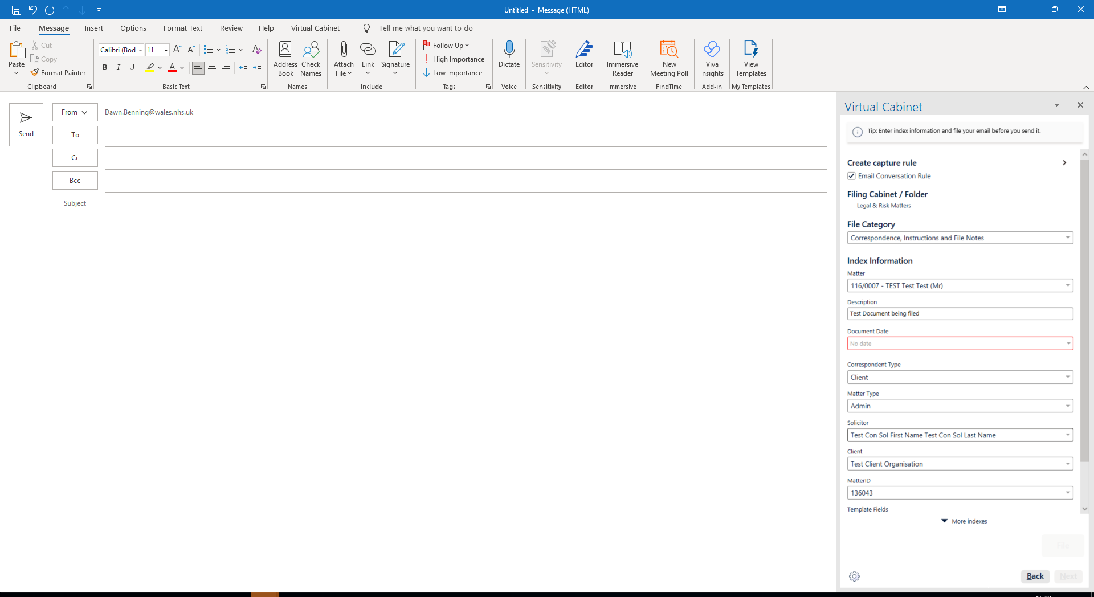

Fig 10 – MS Outlook VC Add-in

VC is a fully comprehensive document management solution with a comprehensive audit trail, ensuring good document governance. In addition, integrations are available, which enable creation of documents, filing of documents and emails as well as portal publishing from other applications, thus offering unlimited interoperability. On top of this VC introduces availability of data relating to document production, handling and workload activity that was previously unavailable. This data would help with service planning, monitoring and managing.

2 Methods

This assignment uses the FITT Framework (Ammenwerth et al., 2006) to measure the effectiveness of the implementation. An alternative framework is the Technology Acceptance Model (TAM) (Davis, D., 1989) but this only considers the perceived usefulness and perceived ease of use. These elements only relate to how a user is able to interact with the product. It does not consider other aspects, such as the suitability of the product beyond it’s usability e.g. does it comply with cyber security and information governance standards or the culture of the users organisation and digital receptiveness of the users, the immediate environment or the wider environment. Rogers, E.M. , et al (1996) describes a diffusion model that takes into account the innovation, communication channels, time and staff. Again, this model does not consider wider compliance standards, or the wider environment.
The FITT Framework considers the relationship between people (individuals), what they are trying to do (task) and the products that are being introduced (technology). It is the interaction between the 3 items that is used to measure the success of the implementation of an IT solution. This is abbreviated to:
Fit between Individuals, Task and Technology

Fig 11 – FITT Framework (Ammenwerth et al., 2006)

The FITT Framework is limited because it only considers factors within the environment where the technology is being implemented. The individual is limited to users or groups of users. In addition, whilst Ammenwerth et al. (2006) does mention some organisational factors, such as changes in hospital strategy, new legal requirements, new software standards and new technological achievements, they are incorporated into the individual or the task. However, many wider external factors that might influence the success of a project, such as stakeholders, government policy or global events are not considered. Crucially, the FITT framework does not consider that the project management team might have influence over the external environment that might influence the project. This assignment proposes that the Project Team may have influence of the environment and uses a modified FITT framework that also includes the environment (FITTE):

Fig 12 – Modified FITTE Framework to include environmental factors

The Environment includes both the organisation within which the change is being implemented and the wider environment within which it sits. Attributes for the Environment would vary by project but might include:
- Organisational Factors
- Governance Requirements
- Socioeconomic status
- Government policy
- Public opinion
- Competition
- Social Media/Media
- Other technological developments
- Regional/Global events
Management may or may not have influence over some of these attributes but it is essential to be aware of them and the extent to which they can be influenced when considering interventions relating to individuals, tasks or technology.
In this assignment, data has been gathered from VC to assess the usage and therefore, uptake of VC to measure it’s success, along with personal experience and conversations with users.

3 Results

Use of VC was mandatory. However, printers were not completely removed so staff could choose to continue to use paper, if they wished. There was also potential for staff to choose to store files on their laptops rather than in VC. Therefore, use of VC was not entirely enforceable but peer pressure did promote compliance. As paper was purchased centrally, there was no means to measure the number of outgoing items of post before or after the implementation of VC. However, it was possible to measure the number of incoming items of post being scanned into VC, once implemented. This showed a gradual decline in incoming post, indicating that use of VC not only impacted staff using it but also influenced the behaviours of people outside the organisation that staff interacted with. In March, 2020, the global Covid pandemic caused many people to start working from home and there is a big and sustained dip in number of incoming items from this date.
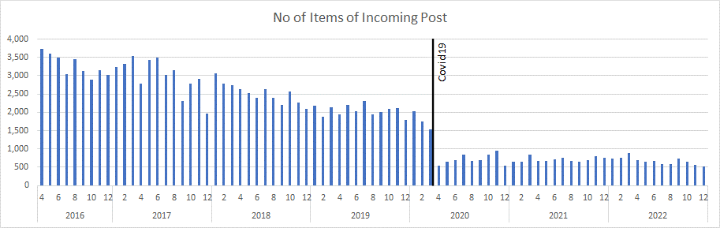
Fig 13 – Number of items of post received

The number of emails filed within virtual cabinet was also measured.
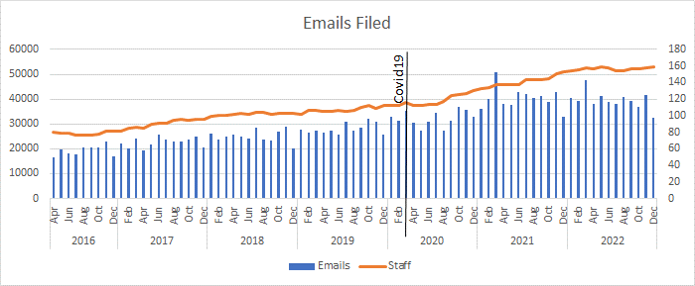

Fig 14 – No of Emails Filed

This showed that the number of emails being filed proportionately increased with the number of staff. However, there does appear to have been a dip during 2022.
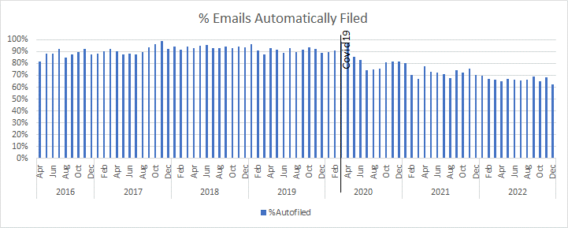

Fig 15 – No of emails filed automatically by the Email Capture Rule

This shows that the vast majority of emails were filed automatically. However, from the onset of the global Covid 19 pandemic in March, 2020, there is a reduction in the number of emails being automatically filed. The email capture rule was mandatory. However, when staff worked from home, they could avoid using it by not logging in to their VPN. As all staff worked from home from March 2020 onwards, there is around a 10% reduction in files being automatically filed. Although, this could reflect shorter email conversations, the most likely cause is staff choosing to avoid using the capture rule.
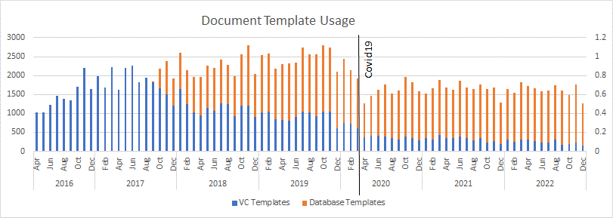
Fig 16 – Document Template Usage
Template usage increased by 215% in the first year, from just over 1,032 documents per month in April to 2225 documents per month by the following March. Templates were initially created through VC but problems with the technology meant that they were moved into the L&RS database. Template usage increased consistently with time until March 2020, when covid 19 resulted in all staff working from home. It also resulted in the majority of those L&RS staff corresponded with working from home too. This led to a change in legal working culture from formal template letters to a greater acceptance of email correspondence. Therefore, a reduction is seen in template usage from March 2020.
This increase continued until March 2020, when staff moved away from templated documents to direct emailing.
24 staff were identified as not using templates. 6 of these were temporary staff on short term contracts. 4 were identified where it was not part of their role. 3 left the department shortly after the implementation, having given notice prior to the implementation, leaving 11 staff where there was no known practical reason for them not to use the templates. The age profile of these staff at the implementation of VC is as follows:
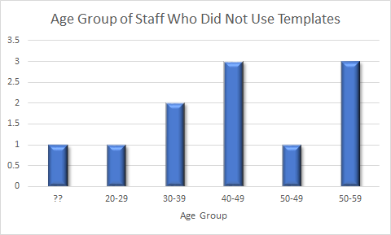

Fig 17 – Age of Staff not using Templates

In their paper, considering acceptance of mandated technology amongst engineering professionals, Keane, R., Cormican, K. and Flynn, P. (2020) report that social influence is stronger for those aged mid 40 – 50’s compared to under 35’s. This suggests that age might have been a factor in the uptake of templates. However, discussions with those remaining in the department in 2023 identified that the main reasons for not using templates were that they were not applicable to their role eg solicitors who asked secretaries to generate templates on their behalf, or that they were not applicable to their work eg the property solicitors work closely with the Estates Department, know the staff well and have no need for formal templates. Also, the Land Registry has on-line registration.

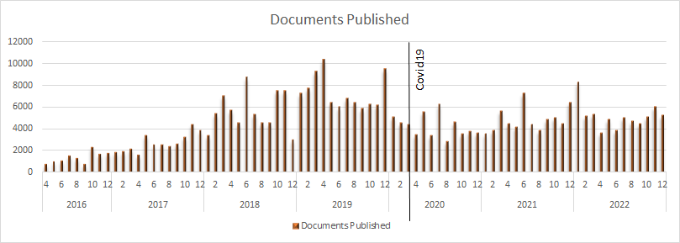

Fig 18 – No of document published using VC Portal

Unlike other aspects of VC, it was some time before VC Portal was in large volume usage. This was partly because electronic document sharing was new in the legal world and staff reported that many recipients resisted receiving documents this way, instead insisting that they were sent via the post. This changed over time as other users started to use their own Portal. However, it declined from 2020. Staff report that is due to correspondents becoming willing to accept email correspondence as a consequence of the Covid 19 pandemic.

4 Discussion

The results show that since April 2016, almost 4.5 million documents and emails have been filed and 371,000 documents have been published, suggesting that VC was successfully adopted and the project was a success. The average number of documents and emails filed per employee per week is 400 and the average number of documents published is 40. Using a modified FITTE Framework to consider why this was, in this assignment, the people are the staff in L&RS and the technology is Virtual Cabinet, both described in the introduction.
Firstly, considering the staff:
Ammenwerth et al., (2006) states that the attributes on an individual level are:
- IT knowledge
- Motivation and interest in the task to be completed
- Flexibility and openness to new ways of working
- Team culture
- Organisational context
- Cooperation within a Team
- Politics within an organisation
Within L&RS, at the time of implementation, there were 80 staff, with a range of IT competencies. All staff knew how to use the basic functions within Outlook and Word. Staff had also been trained on the Legal & Risk database and Big Hand dictation software. Use of technology was therefore already embedded in the workplace. Some staff had advanced skills in Word, Outlook and Excel, others did not. Some staff typed using only their index fingers. Staff ages varied from 28 to 77.
The implementation of the project was preceded by a business case and procurement process. This gave a long lead-in time for education and communication about the project, in order to prepare staff for VC. Change management was achieved by identifying the Director as project sponsor. The IT lead acted as a change agent, ensuring that staff were given demonstrations and regular updates as the project progressed. The purpose of these was to generate interest in the project, allay fears and build excitement around the project. The change manager also selected a group of 15 staff who were from differing Teams and staff grades were involved in the user acceptance testing. These staff were carefully selected, ensuring that those who might be most resistant were included, as well as some who were keen to engage. These staff were then assigned “super-user” status during the roll-out, which meant that they could offer support to any users having difficulty.
Because the department was made up of a mixture of qualified and unqualified staff, there was already prevailed a culture of learning and supporting each other, along with routine delegation of tasks and collaborative working. This made staff more receptive to change with an interdependency on universal compliance. Group training sessions, one-to-one, videos, presentations and written training materials were provided, along with user acceptance testing, addressing all for aspects of Kolb’s learning cycle (Kolb, D. A., 2015). Staff appeared to have passed the shock, denial, anger/blame, bargaining and confusion/depression phases of the Kubler-Ross (1969) Model of the emotional response to change before the implementation and were in the accepting or problem solving phases at go-live.
Ammenwerth et al., (2006) also states that the attributes on a task level are:
- Organisation of the tasks to be completed
- Activities and their interdependence
- Complexity of tasks
The tasks affected by this solution were:
- Filing emails
- Filing documents
- Creating documents
- Assigning tasks to colleagues
- Securely sending documents to correspondents
This all became electronic and was faster. It also gave staff access to documents and emails that other members of staff had dealt with. It streamlined asking staff to do work for others and provided an audit trail so that solicitors could easily evidence actions taken, should this become relevant to the case e.g. the other side alleging that documents had not been sent. There was some resistance to filing documents initially, with staff having differing views as to who’s responsibility this was. This was addressed through Team meetings where it was reinforced that it was everyone’s responsibility.
Ammenwerth et al., (2006) also states that the attributes on a technology level are:
- Stability
- Usability
- Costs
- Functionality
- Available Technical infrastructure
- Integration of tools
- Availability of tools
VC was a stable product, although it was a new concept for users, much care was put into the design of the filing cabinets, to ensure that it was logical and easy to use. The costs are not relevant to this assignment because funding was provided by Welsh Government. New servers were purchased to host the software, ensuring that the technical infrastructure was suitable. VC included add-ins integrated into MS Outlook and MS Word, making it easy for staff to file their documents and emails. VC was available for staff working in the office. A small number of staff had permission to work from home up to 3 days per week and a terminal server was provided for them to connect to whilst working remotely. A limitation of the product was that it would run maintenance scripts each night and therefore was not available between 12-2am. However, staff ordinarily worked office hours, so this was not considered to be an issue. An interoperability assessment (INAS) (da Silva Serapião Leal, G., Guédria, W., & Panetto, H., 2019) shows that VC has good interoperability:

 |  | Interoperability Layers/Barriers
 |  | Conceptual | Technological | Organisational
Enterprise Interoperability Concerns | Business | None | None | None
Enterprise Interoperability Concerns | Process | Processes were understood | Processes were supported | Processes were discrete for the Service
Enterprise Interoperability Concerns | Service | None | None | None
Enterprise Interoperability Concerns | Data | New data | New data | New data

Fig 19 – INAS Assessment (da Silva Serapião Leal, G., Guédria, W., & Panetto, H., 2019)

Using the FITT framework, the project was successful because:
Fit between the individual and the task:
 |  | Task
 |  | Organisation of the tasks to be completed | Activities and their interdependence | Complexity of tasks
Individual | IT knowledge | Staff were offered extensive training on a discrete product. | All interactions with documents relied on usage on VC. | The product was intuitive and staff were able to understand it easily
Individual | Motivation and interest in the task to be completed | Staff wanted better access to documents | Better access to documents relied on all staff filing their documents. | The product was intuitive and staff were able to understand it easily
Individual | Flexibility and openness to new ways of working | Staff's autonomy around case management was not impacted, so they were willing to try working differently. | Staff worked in Teams, any single member not willing to change would adversely affect the rest of the Team, leading to corporate willingness to change.
Individual | Team culture | Staff worked in Teams, any single member not willing to change would adversely affect the rest of the Team, leading to corporate willingness to change.
Individual | Organisational context | Fits with the core values of working together and innovating | Fits with the core values of working together and innovating | Fits with NWSSP core values of working together and innovating
Individual | Cooperation within a Team | Staff worked in Teams, any single member not willing to change would adversely affect the rest of the Team, leading to corporate willingness to change.
Individual | Politics within an organisation | Compliant with the carbon reduction strategy of NWSSP

Fig 20 – Individuals vs Task Matrix

This was a strong fit. Staff need tight document control during the lifecycle of the claims that they manage. They need to be able to evidence what document was created, when, by who and where it was sent. This was a key part of their role and being able to carry it out was essential. Being able to access all documents at all times meant that staff could look up anything they needed during a court or tribunal hearing. Prior to VC, if a document had been forgotten, a courier would be needed to urgently send the document from the office to the court. If this was in London, or further afield, the case might be compromised. The introduction of VC eliminated this risk, improving the service provision.

Fit between the task and the technology:
 |  | Task
 |  | Organisation of the tasks to be completed | Activities and their interdependence | Complexity of tasks
Technology | Stability | The Outlook and Word Add-in were frequently disabled, preventing staff from auto-filing emails and documents | Emails and documents could be filed manually if the Add-ins were disabled. | A variety of simple filing mechanisms were available
Technology | Usability | A variety of simple filing mechanisms were available. | A variety of simple filing mechanisms were available and tasks were not interdependent | A variety of simple filing mechanisms were available.
Technology | Costs | A robust procurement process ensured this was the best value for money solution for the task.
Technology | Functionality | Use of Outlook and Word Add-ins made the functionality accessible for the relevant tasks | The functionality supported completion of discrete tasks. | Tasks were simple and could be completed in a variety of ways.
Technology | Available Technical infrastructure | The use of a Terminal Server gave staff full access when working from home/at meetings/at court | The infrastructure improved access to documents, making it easier for staff to review and action them and keep up to date with cases. | The structure
Technology | Integration of tools | Use of Outlook and Word Add-ins made the functionality accessible for the relevant tasks | Integrations enabled staff to move between the database and VC easily. | The database integration made access to documents and document creation simple
Technology | Availability of tools | Tools were available when staff were working from the office or connected via VPN, meeting the needs of users with regards to task organisation. | Only a small number of staff had VPNs. This affected access to VC during court. However, normally, at least 1 member of the team in court would have a VPN.

Fig 21 – Technology vs Task Matrix

VC markets itself as a product for accountants, so it was not an obvious choice for legal case management. However, as described in the table above, the functionality closely matched what legal staff need to do in order to manage their documents. It provided the benefit of doing it electronically, giving on-line access to documents and reducing use of paper. There were 3 weaknesses in this area:
- Robustness of Office Add-in
- Home working
- Out of hours activity
The VC Outlook Add-in and Word Add-in regularly became disabled. This made it difficult for users to file emails and documents from within the proprietary applications. This was addressed by ensuring enough staff knew how to re-enable them, such that help was always on hand for staff affected by this weakness.
When working from home, the performance of the application was greatly reduced. This was addressed by providing a terminal server for staff to work from. However, this limited staff to 1 screen. As 2 screens came into routine use (around 2018) this limitation made the Terminal Server unpopular with home workers, who preferred to tolerate the slowness in order to continue to use 2 screens. As time progressed, VC was updated to improve it’s performance for remote workers, thus improving the fit between the task and the technology.
When VC was first introduced, out of hours working was rare. However, as the Court of Protection Team grew, a need for a 24 hour service came about. VC was offline each night for several hours and this proved inconvenient to the Court of Protection Team, who would sometimes be involved in emergency court orders that might take place at night. This issue remains unresolved and the Court of Protection Team have to file their documents after the event, the following day. Although inconvenient, this is manageable.

Fit between technology and individual:
 |  | Technology
 |  | Stability | Usability | Costs | Functionality | Available Technical infrastructure | Integration of tools | Availability of tools
Individual | IT knowledge | The VC Add-ins frequently became disabled but the IT Team and IT Champions knew how to help users with this. | The majority of users reported that they understood how to use VC and wanted to use it. | N/A | The majority of staff reported that they understood the functionality and wanted to use it. | All staff understood the infrastructure available and wanted to use it. | Staff reported that they understood the integration tools and wanted to use them. | Staff reported that they were aware of how to access VC and the need for VPN outside the office and wanted to use them.
Individual | Motivation and interest in the task to be completed | The VC add-ins disabling did not significantly impact staff motivation as alternative ways of working were availability.
Individual | Flexibility and openness to new ways of working | Staff were open to working differently and were not deterred by the add-ins becoming disabled
Individual | Team culture | Staff were receptive to change but expected a robust and easy to use product, which VC was. |  | N/A | Team interdependence ensured use of the functionality | Staff were used to using technology and understood the infrastructure | Team expected integration with the Legal & Risk database, which was part of the development | Staff expected the technology to be available in office hours, which it was.
Individual | Organisational context | NWSSP was able to support stable, usable software |  | N/A | The organisation valued good functionality, integration and availability.
Individual | Cooperation within a Team | Staff would help each other if they encountered technology issues |  | N/A | Staff would help each other if they encountered technology issues
Individual | Politics within an organisation | The organisation supported technological innovation and carbon reduction projects |  | N/A | The organisation supported technological innovation and carbon reduction projects

Fig 22 – Individual vs Technology Matrix

Staff were aware of the carbon reducing policies of Welsh Government, they had sufficient IT experience to be able to understand the new functionality and were keen to embrace the benefits of the change. The attributes of the technology met their expectations and they were mostly keen to embrace it.

Considering the staff, Keane, R., Cormican, K. and Flynn, P. (2020) report that social influence is stronger for those aged mid 40 – 50’s compared to under 35’s. Although the professional field is different, the results are relevant to the VC implementation which was mandated for legal professionals. The Director of L&RS was approaching retirement at the time of implementation and spent much time drumming up enthusiasm for the product ahead of it’s go-live and influencing users to embrace VC. With 49 staff who were over 35 and 31 staff under, this interaction was crucial in developing a positive mindset in more mature staff. With Keane, R., Cormican, K. and Flynn, P. (2020) reporting that under 35’s expecting the software to be easy to use, the usability of the software was an important factor in the uptake. After go-live, there were just 3 members of staff who reported finding the software difficult to use. These staff were in the over 35 group and had declined to engage with training opportunities, reporting workload pressures as the main factor. These staff were likely still in the denial phase of Kubler-Ross’s (1969) Model. Further training was offered but again, workload pressures was given as the reason for not engaging. Prior to implementation, just one member of staff expressed that they could see no benefits to using a paperless system but this user accepted the change. Many expressed concern about the loss of the tactile experience of handling papers. However, this was quickly accepted as staff realised that they no longer needed to carry large bundles of documents home, when working from home, to meetings or to court. This was seen as a great benefit. The other key benefit was being able to see all documents in one place, without having to wait for someone else to file them. There was a lot of informal feedback that staff found this to be highly beneficial.

A key external development that had a major impact on the uptake of VC was the global covid pandemic in 2020. This resulted in all staff working from home full time. This would not have been possible prior to the implementation of VC. Whilst VC usage was high, some users persisted in printing out bundles of documents when attending court or tribunals. They reported that this was because it was required from the other side. With all staff at home, they no longer had access to printers and the department finally became truly paperless. The technology, people and task had not achieved this on their own and it was the external factor of the pandemic, which is not part of the FITT framework, that delivered complete uptake.

The FITT framework also does not consider the fit between the technology and stakeholders. This proved to be a significant factor in the success of the project. One of the functions of the project was a portal for sharing documents securely. Whilst there was a good fit between staff, the technology and the task, there was resistance from recipients, who were not used to this technology. The project plan included writing to all correspondents to make them aware that this product was being brought into use. However, there was still resistance to receiving documents via this medium. The level of resistance experienced had not been predicted ahead of the project. It resulted in Legal & Risk staff giving IT guidance to recipients to try to foster adoption. More could have been done ahead of the launch to influence document recipients, such as a publicity campaign, raising awareness ahead of implementation.

The modified FITTE Framework proposed is somewhat similar to the Technology, People, Organizations, and Macroenvironmental factors (TPOM) framework developed by Cresswell, K., Williams, R., and Sheikh, Aziz (2020) which does take into account the organisation and the wider environment. However, the TPOM framework does not consider the role of the task, which was demonstrably important in this analysis.
In consideration of seamless care, management of legal cases is a discrete activity. However, learning from clinical negligence and personal injury claims can be used to improve patient safety. VC makes it easier to provide all documentation in relation to claims to the Client and to the Welsh Risk Pool, who require learning from events as part of the re-imbursement process.

To conclude, the implementation of VC was an effective change due to the tight fit between the staff, the technology, the task and the environment and a solid change management process. It enhanced staff’s ability to seamlessly manage their legal caseload from inception to closure, including court and tribunal attendance by making documents more accessible in more locations.

9 References

Ammenwerth, E., Iller, C. & Mahler, C. (2006) ‘IT-adoption and the interaction of task, technology and individuals: a fit framework and a case study.’ BMC Med Inform Decision Making 6, 3. Available at: https://doi.org/10.1186/1472-6947-6-3 (Accessed 17/04/2023)
Colb, D. A. (2015) Experiential Learning Experience as the Source of Learning and Development 2nd Edition. Available at: https://r2.vlereader.com/EpubReader?ean=1780133892505 (Accessed 26/4/2023)
Cresswell, K., Williams, R. and Sheikh, A. (2020) ‘Developing and Applying a Formative Evaluation Framework for Health Information Technology Implementations: Qualitative Investigation’, Journal of medical Internet research, 22(6), pp. e15068–e15068. Available at: https://doi.org/10.2196/15068.
da Silva Serapião Leal, G., Guédria, W., & Panetto, H. (2019). ‘Interoperability assessment: A systematic literature review. Computers in Industry’, 106, 111-132. Available at: https://doi.org/10.1016/j.compind.2019.01.002 (Accessed 20/4/2023)
Davis, F.D. (1989) ‘Perceived Usefulness, Perceived Ease of Use, and User Acceptance of Information Technology’, MIS quarterly, 13(3), pp. 319–340. Available at: https://doi.org/10.2307/249008. (Accessed 18/4/2023)
Keane, R., Cormican, K. and Flynn, P. (2020) ‘User acceptance of mandated technology: An analysis of the role of moderating factors’, Procedia Computer Science [Preprint]. Available at: https://doi.org/10.1016/j.procs.2019.12.156.
Kubler-Ross, E. (1969). On death and dying. New York: Simon and Schuster/Touchtone/Scrib
Lewis, M., Carey, S., Phillips, W. (2009) ‘Taking Forward Shared Services in NHS Wales’ NWSSP. Unpublished
Neves, B.B., Amaro, F. and Fonseca, J.R.S. (2013) ‘Coming of (Old) Age in the Digital Age: ICT Usage and Non-Usage among Older Adults’, Sociological research online, 18(2), pp. 1–14. Available at: https://doi.org/10.5153/sro.2998.
NWSSP (2022a) Legal and Risk Services. NWSSP. Unpublished.

Rogers, E.M. (1996) ‘Diffusion of Innovations, (4th Edition)’. New York, The Free Press

Shewan, D (2022) How to Do a SWOT Analysis (With Examples & Free Template!) Available at https://www.wordstream.com/blog/ws/2017/12/20/swot-analysis (Accessed 10/04/2023)
Welsh Government (2021) Climate Change Targets and Carbon Budgets. Available at: https://www.gov.wales/climate-change-targets-and-carbon-budgets#:~:text=Net%20zero%20means%20balancing%20the,of%205%2Dyear%20carbon%20budgets. (Accessed: 17/04/2023)

10 Glossary

Indexing – The act of filing a document in Virtual Cabinet
L&RS – Legal & Risk Services
Terminal Server – An on-site computer that users can connect to when working remotely, in order to carry out tasks that they couldn’t otherwise do.
WRP – Welsh Risk Pool
VC – Virtual Cabinet electronic document management system
VPN – Virtual Private Network

