
School of Engineering
Real World Powertrain Analysis
Xilong Song
1904076
Autimotive Engineering B Eng
02/11/2019
Pwoertrain Sustainability M6X01206

CONTENT
Introduction 2
1. The raw data files compiling and processing 3
2. The different vehicle types comparison 12
3. 2016 Toyota Aygo VVT-i X-Pression 5dr Hatchback analysis 17
4. 2028 Toyota Aygo design 19
Conclusion 22
Reference 22

Introduction
Alternative energy refers to new energy that can replace traditional petroleum fuels as vehicle power. At present, the commonly used alternative energy sources are electricity, natural gas, liquefied petroleum gas, alcohols, hydrogen, etc. New energy vehicles include pure electric vehicles, extended range electric vehicles, hybrid vehicles, fuel cell electric vehicles, hydrogen engine vehicles, and so on. In this report, author demonstrate the knowledge of alternative energy and analyse the given three vehicles about their various performances. In the drive circle, author show the comparison about their performance of fuel economy and the efficiency. In the last author assume the electric vehicle, hydrogen engine and the hybrid car.

The raw data files compiling and processing
The data from the three different vehicles are complex and numerous, then author compile and process these data files and demonstrated the validity of the calculations and removing the unnecessary data.
Here the tested data will be imported to ScanXL professional to analyse and output a list of data with maximum, average and minimum value of all performance.
2016 Toyota Aygo
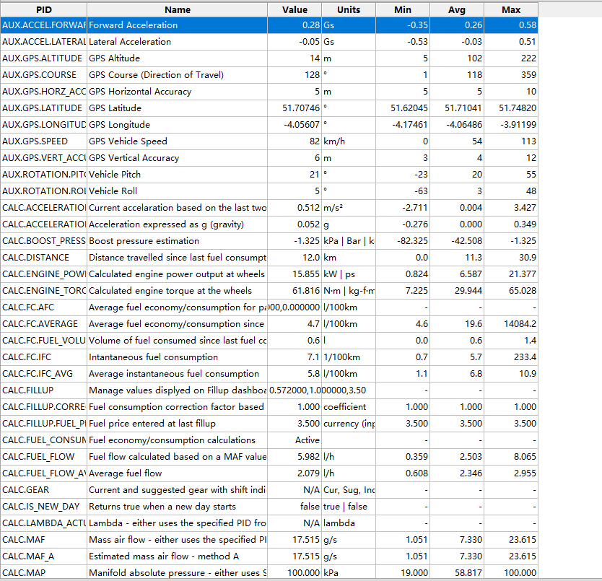
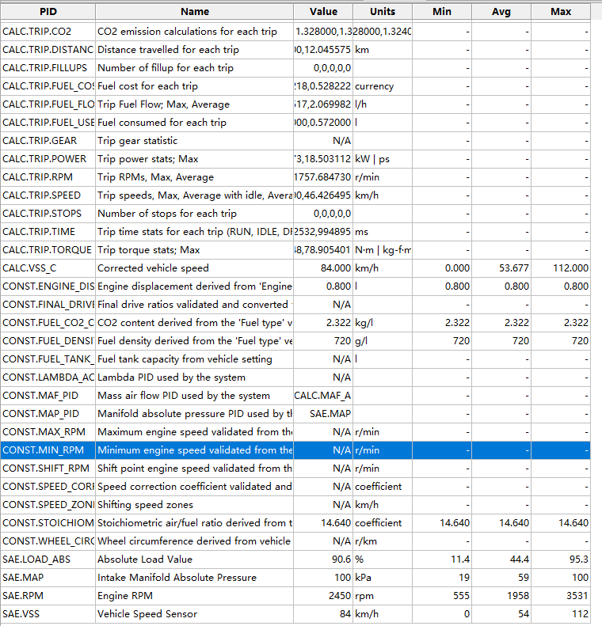

2016 Volvo V40 Cross Country
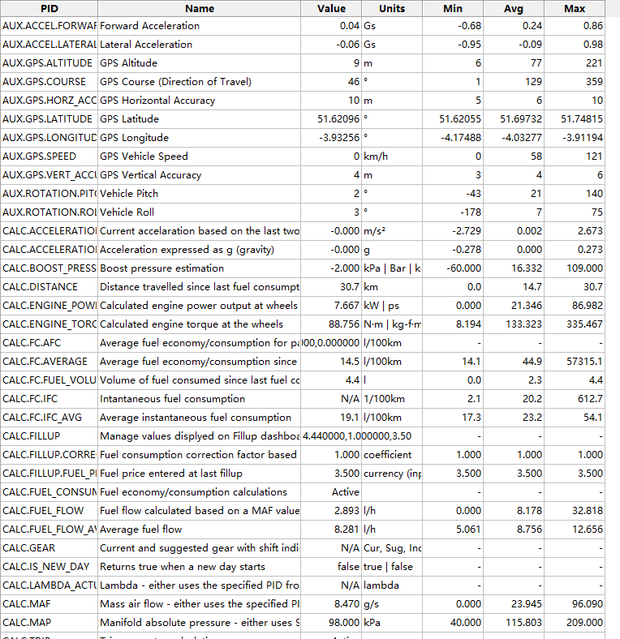
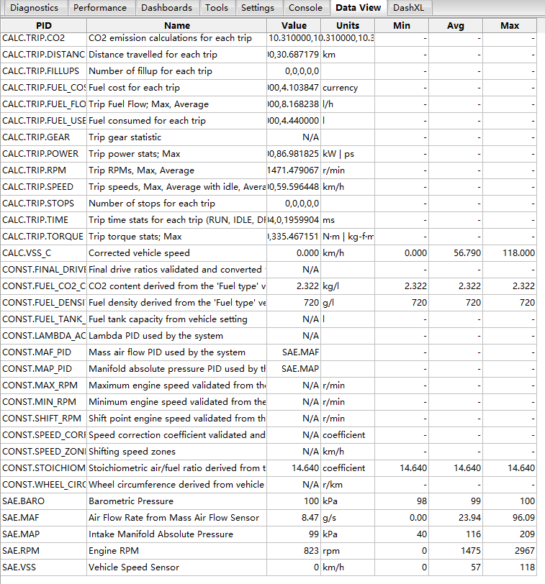
2011 Triumph Tiger 800XC
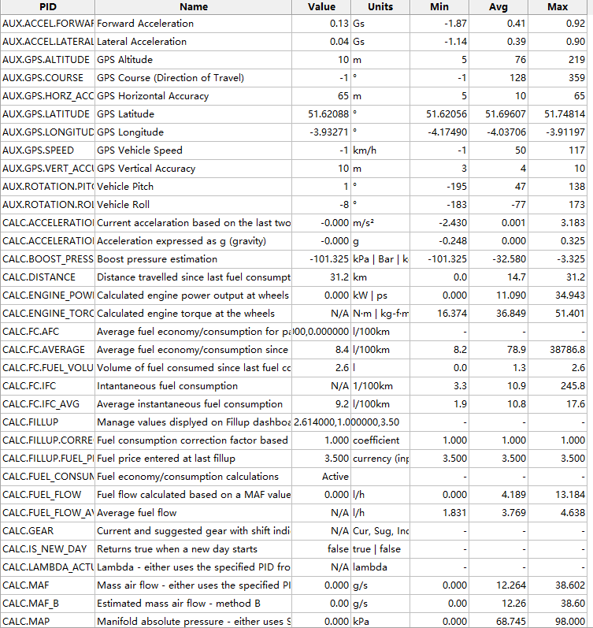
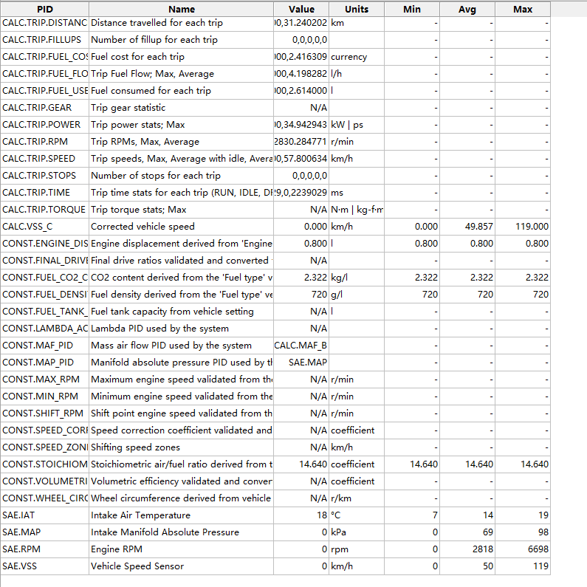
Here author would compare the given data about engine capacity of the three different engines. The engine capacity of 2016 Toyota Aygo is 998cc which data is in the datafiles, and it of the 2016 Volvo V40 is 1969 $cm^{3}$ ( $cm^{3}=cc$). The engine capacity of the Triumph Tiger is the smallest which is 799cc.
The top speed with different units should be calculated to one unit. The top speed of Volvo is 190km/h but the units of the others is miles per hours. Then they are calculated to 159.25km/h and 196.3km/h. Besides them the unit 1 $lb∙ft$ of torque is 1.355818$N∙m$, the unit 1 horse power of power is 746W. At last these data is processed with EXCEL below.

The different vehicle types comparison
Obviously, the three vehicle types are totally different, the Triumph Tiger is motorbike and the other two are different with engine, suspension and so on. Here author would like to compare how they differ in terms of engine load, drivability, efficiency and performance. The engine load can be calculated by torque and rotating speed.
  - The difference in engine load
The engine load basically determines the ability to generate power. Each engine is designed for a specific load, which is called the rated load or the maximum load at a specific speed. When the load on the engine get increasing, the engine speed decreasing. Triumph Tiger: The maximum engine rotating speed is 6698RPM and the average engine rotating speed is 2818RPM. The maximum calculated engine toque output is 51.401$N∙m$ and the average calculated engine toque output is 36.849$N∙m$. Then the maximum and average engine load of the Triumph Tiger are$\frac{6698×51.401}{9550}=36.05$ and$\frac{2818×36.849}{9550}=10.873$
Volvo V40: The maximum engine rotating speed is 2967RPM and the average engine rotating speed is 1475RPM. The maximum calculated engine toque output is 335.467$N∙m$ and the average calculated engine toque output is 133.323$N∙m$. Then the maximum and average engine load of the Volvo V40 are$\frac{2967×335.467}{9550}=100.033$ and$\frac{1475×133.323}{9550}=20.592$
Toyota Aygo: The maximum engine rotating speed is 3531RPM and the average engine rotating speed is 1958RPM. The maximum calculated engine toque output is 65.028$N∙m$ and the average calculated engine toque output is 25.944$N∙m$. Then the maximum and average engine load of the Toyota Aygo are$\frac{3531×65.028}{9550}=24.043$ and$\frac{1958×25.944}{9550}=5.105$
Then the maximum engine load is the Volvo V40 cross country
Engine load characteristics: When the engine speed is constant, its performance index changes with the load. The speed must be kept constant when measuring the load characteristics.
Because the engine speed is constantly changing, it is necessary to determine the load characteristics of the engine at different speeds in order to fully evaluate the fuel economy of the engine at different speeds and loads. The reading of the engine load characteristics was performed on a test bench. Take a gasoline engine as an example. After starting the engine, gradually open the throttle valve to the maximum. At the same time, adjust the load to keep the engine running at a certain speed and determine the engine output power and fuel consumption under this operating condition. Then close the small throttle, adjust the load to keep the engine speed unchanged, and then measure. This is continued in sequence until the minimum throttle opening of the engine can maintain stable operation, and the fuel consumption under different loads and speeds is obtained. The trend of the engine load characteristic curve changes at different speeds is similar, but the specific values are different.
The load characteristics of diesel engines are basically the same as those of gasoline engines. But comparing the two, the load characteristic curve of the diesel engine is relatively flat, which is why the diesel engine is more important than the gasoline engine.

  - The difference in drivability
The drivability is the vehicle in the X direction, the vehicle's forward direction, all dynamic changes, the main calculation and evaluation index is the change in the acceleration in the X direction.
According to the tested data graph output by ScanXL, author compares the forward acceleration and lateral acceleration of the three vehicles.
Toyota Aygo: the maximum forward acceleration is 0.58Gs and the minimum is -0.35Gs. The maximum lateral forward acceleration is 0.51Gs and the minimum is -0.53Gs.
Triumph Tiger: the maximum forward acceleration is 0.92Gs and the minimum is -1.87Gs. The maximum lateral forward acceleration is 0.90Gs and the minimum is -1.14Gs.
Volvo V40: the maximum forward acceleration is0.86Gs and the minimum is -0.68Gs. The maximum lateral forward acceleration is 0.95Gs and the minimum is -0.98Gs.
As a result, Triumph Tiger has the best drivability.
  - The difference in efficiency
According to the data of the three vehicles, firstly author compare their aerodynamics and weight reductions. The Triumph Tiger is 214.5kg which is the best and the air resistance is the smallest. Then the drive train efficiency is determined to find how differ the other two cars.
The Toyota Aygo engine is (EESI description, n.d.) Variable Valve Timing and Lift, which valves control the flow of fuel and air into, and the flow of exhaust out of the cylinders in the engine. This technique allows the distance the valves travel to change in accordance with the speed of the engine.
The Volvo V40 is (EESI description, n.d.) Direct Fuel Injection, which fuel is injected directly into the cylinder barrel, providing more efficient combustion than when fuel and air are mixed outside the cylinder. But it is also Turbodiesel, powered by engine exhaust and the engine – force compressed air into the cylinders, allowing more fuel to be burned per piston stroke, producing more power and using less total fuel.
  - The difference in performance
Commonly used to evaluate the performance indicators of the car are: power, fuel economy, braking, correction stability, ride comfort and pass ability. Under certain conditions of use, the ability of a car to work at its highest efficiency is called car performance. It is a structural characteristic index that determines the efficiency and convenience of automobile utilization. Here author demonstrate the data to compare their performance of acceleration and top speed, the fuel economy.
Toyota Aygo: its acceleration from 0km/h to 100km/h needs 14.2 second, and its top speed is 159.325km/h. Its fuel economy is 3.414l/100km.
Volvo V40: its acceleration from 0km/h to 100km/h needs 10.6 second, and its top speed is 190km/h. Its fuel economy is 3.7l/100km.
Triumph Tiger: its acceleration standing 0.25 miles is 12.2 second, and its top speed is 196km/h. Its fuel economy is 5.3l/100km.
As a result, the acceleration performance of Triumph Tiger is the best, and the fuel economy of Toyota Aygo is the best.

2016 Toyota Aygo VVT-i X-Pression 5dr Hatchback analysis
According to the initial analysis above, the fuel consumption of Toyota Aygo is1.495l/100km which is the “ideal” vehicle for 60km daily commute. Based on the GPS data of the Toyota Aygo drive circle, author look at the application and analyse it. As the GPS data analysis about Toyota Aygo by ScanXL shown below,
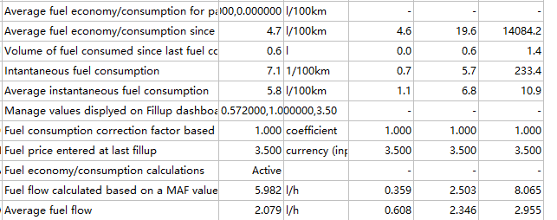
The average value of average instantaneous fuel consumption is 6.8 l/100km and the other two are 10.9 l/100km and 23.2 l/100km. Then the “ideal” vehicle is verified.
  - 3.1 Hybrid powertrain
According to the news Toyota Aygo will use hybrid powertrain.
(Hampel, 2019) Toyota has decided that the Aygo small car will have a successor. According to Johan Van Zyl, CEO of Toyota Europe, a purely electric version may also be offered, but this decision is still pending.
(Karkafiris, 2020) Next Toyota Aygo Might Use Hybrid Powertrain As Full Electric Isn’t Viable For Its Size
The decision to keep the Aygo alive for a third generation shows that Toyota isn’t facing the same pressure with other manufacturers to improve their fleet average CO2 emissions, thanks to its already established hybrid model.
  - 3.2 Stop-Start system
The start-stop technology can automatically stop the engine when the vehicle is temporarily stopped, thereby reducing fuel consumption and emissions. Especially in large cities with heavy traffic, using this technology has a good effect on energy conservation and emission reduction.
For a daily commute, Start Stop technology is very helpfully and improve the efficiency much and produce less carbon dioxide.
  - 3.3 Kinetic Energy Recovery Systems
KERS is an acronym for Kinetic Energy Recovery Systems. The basic principle is: to store the braking energy of the vehicle body through technical means, and use it as auxiliary power during the acceleration of the car! The specific use method may be implemented by imitating the acceleration button of A1. Now the Kinetic Energy Recovery Systems is not applied in the cars that used to daily commute.

2028 Toyota Aygo design
  - 4.1 The Toyota Aygo Electric design
As a “company technology director” besides thinking of the profits of the company, author also have the responsibility to protect the environment. Then the electric vehicles should be applied which reduce the NOx then the carbon dioxide. The mass adoption of electric vehicles (EVs) will bring significant benefits to society, including public health, environmental protection and economic growth. In 2028 the EV charge would be more applied in motorway and there will be more and more electric vehicles.
Here are the reasons why the electric Toyota Aygo is designed and should be manufactured.
- Electric vehicles use power battery packs and motors to drive power. It does not generate exhaust gas during operation and does not exhaust pollution. It is very beneficial to environmental protection and air cleanliness. It can be said to be almost "zero pollution" which the driver could take less tax.
- Electric cars do not make noise like transmission cars, and the noise it produces is almost negligible. Then drivers could enjoy the daily commuting time.
- Electric vehicles are cheap to use, only about one-fifth that of gasoline vehicles. In addition, the energy conversion efficiency is high. At the same time, the energy during braking and downhill can be recovered to improve the energy utilization efficiency. At night, the cheap "valley power" of the power grid is used for charging, which plays a role in stabilizing the peak and valley difference of the power grid.
- Electric vehicles are driven by electric motors and batteries, which eliminates the need for tedious maintenance items of traditional engines, such as changing oil, filter elements, and belts. Electric vehicles need only periodically check components such as motor batteries.
- For the daily commute, the energy sure can provide the power for 60km driving, and generally, the normal charging time is about 8 hours, and fast charging takes 1-2 hours.
  - 4.2 Toyota Aygo hydrogen fuel cell
(Williams) It’s far more sensible to use a hydrogen fuel cell, which converts the chemical energy stored in the hydrogen directly into electricity. That can give 60% efficiency or so once powering an electric motor. That means it will get around 85MJ of useable power – 31.6hp*h – from a kilo of hydrogen running through a fuel cell. A normal internal combustion engine, working at perhaps 30% efficiency, will give a little over 5hp*h from a litre of petrol. And no carbon dioxide produced.
  - 4.3 Toyota Aygo Hybrid Engine
The vehicle drive system is composed of two or more single drive systems that can run simultaneously. The driving power of the vehicle is provided by the single drive system separately or jointly according to the actual vehicle driving state. Due to the different components, layout and control strategies, a variety of classification forms have been formed. The energy-saving and low-emission characteristics of hybrid vehicles have aroused great attention from the automotive industry and become a focus of automotive research and development. The hybrid device not only exerts the advantages of long continuous working time and good power of the engine, but also the advantages of non-polluting and low noise of the motor. The two fight together side by side, complement each other, and the thermal efficiency of the car can be increased by more than 10%. Can be improved by more than 30%.

Conclusion
This report is divided to two parts, part one is the analysis and comparison about the 3 different vehicle types which are 2016 Toyota Aygo 1.0VVT, 2016 Volvo V40 Cross Country D2 and 2011 Triumph Tiger 800 XC. The data is determined by EXCEL, SCANXL. Besides them author also removing some unnecessary data and set a new graph. In the part two, based on the 60km daily commute drive circle, the electric and hybrid, stop-start and KERS application is descripted. Electric vehicle, hydrogen engine and the hybrid engine is assumed to design the Toyota Aygo and author also explained why these technologies are applied.

Reference
EESI description. (n.d.). Vehicle Efficiency. Retrieved from Enviromental and Energy Study Institute: https://www.eesi.org/topics/vehicle-efficiency/description
HampelCarrie. Toyota considering all-electric version of next Aygo. electrive: https://www.electrive.com/2019/12/11/toyota-considering-all-electric-next-gen-aygo/
KarkafirisMichael. CARSCOOPS. Next Toyota Aygo Might Use Hybrid Powertrain As Full Electric Isn’t Viable For Its Size: https://www.carscoops.com/2020/02/next-toyota-aygo-might-use-hybrid-powertrain-as-full-electric-isnt-viable-for-its-size/
Williams, O. (n.d.). Hydrogen fuel cells. Swansea, UK.

