ASSIGNMENT I
ACCB6006

1706594@student.uwtsd.ac.uk
Asgar Ali
School of Applied Computing
University of Wales Trinity Saint David
Supervisor: Michael Dacey
22nd February 2020
2500 Words

TABLE OF CONTENTS
ABSTRACT 4
1. INTRODUCTION 4
2. IMPLEMENTATION 4
2.1 NAVIGATION 4
2.1.1 Login 4
2.1.2 Signup 4
2.1.3 Logout 1
2.2 ADMIN 1
2.2.1 Creating movies 1
2.2.2 Updating a movie 1
2.2.3 Deleting a movie 2
2.2.4 Display movies 2
2.3 SEARCHING 2
2.4 STORING DATA 2
2.5 AUTHORISATION AND DISPLAYING USER LOG-INS 2
3. OBSERVER DESIGN PATTERN 3
3.1 Login Observer design pattern 4
3.2 Search Observer design pattern 6
4. AGILE USER STORIES 8
4.1 Software intangibility problem 8
4.1 Solution 8
5. VERSION CONTROL SYSTEMS 9
5.1 IMPORTANCE 9
5.2 GIT ARTEFACTS 10
6. CONCLUSION 11
6.1 Results 11
6.2 Known bugs / errors 11
6.3 Improvements 11
7. REFERENCES 11
8. APPENDIX A (GIT) 12
A.1 GitHub Repository 12
A.2 Git Logs 12
9. APPENDIX B (Website screenshots) 17
B.1 – Homepage 17
B.2 - Login 18
B.2 - Signup 19
B.3 – Movie listings 20
B.4 – Admin page 21
B.4 – Login user and time logs 21
B.5 – Editing/Saving movie 22
B.6 – Search filters 23
B.7 – Expanded movie image 23
B.8 User search logs page 24
10. APPENDIX C (CODE). 24
Autoloader.php 24
Header.php 25
Footer.php 27
Index.php 27
Login.php 30
Logout.php 32
Logs.php 32
Movie.php 33
Moviedb.sql 35
Searches.php 37
Signup.php 38
Config.php 41
C.1 Admin 41
Add.php 41
Delete.php 43
Edit.php 43
Index.php 45
C.2 OOP 48
Auth.php 48
Dbconnection.php 50
Failuremail.php 51
LoginSubject.php 52
Movie.php 53
SearchObserver.php 56
SearchSubject.php 57
Storage.php 58
C.3 Assets 59
Main.js 59
Main.css 59

Table of figures

Figure 1 – Folder structure of site in VS Code. 1
Figure 2 - Links once logged in. 1
Figure 3 - If Login type is not Admin, system will redirect user to the index page. 2
Figure 4 - Following code will execute once new movie added through this form. 2
Figure 5- Function called from movie file and image store via Storage file. 2
Figure 6 - Code will be executed when movie information has been changed and clicked for save. 2
Figure 7 – Public static function to check user sessions. 3
Figure 8 – Create and check authorisation object. Get log last log in details. 4
Figure 9 – Subject Class comments. 7
Figure 10 – An Observer Class was created by implementing the splObserver Interface. A Movie object is instantiated in order to write search data. 7
Figure 11 - A Subject Class with notify, update, detach, attach and search functions. 9
Figure 12 - End user story map example. 11
Figure 13 - Admin story map example. 11

Table of tables

Table 1 - User stories for Users. 9
Table 2 – User Stories for Admin. 10
Table 3 – Centralised vs Distributed VCSs. 11
Table 4 – The Git workflow and remote GitHub project address [10]. 11

ASSIGNMENT I

ABSTRACT

This report will discuss the authors CRUD implementation of an Object-oriented PHP7 web application, as well as the Observer software design pattern. Appropriate Agile user stories for the site have been detailed. The importance of Version Control Systems will also be discussed, and Appendix A.2 lists the Git log history for the project files that were pushed or amended to GitHub via a Bash terminal.

Keywords: Object Oriented PHP; Agile User stories; Git.

INTRODUCTION

An Object-Oriented PHP web application was developed along with the Observer design pattern – a multi-page movie site with a MySQL database. A local Apache server was configured using XAMPP. MySQL statements for the database were created using PhpMyAdmin. Bootstrap and CSS was used for styling, and jQuery for actions.

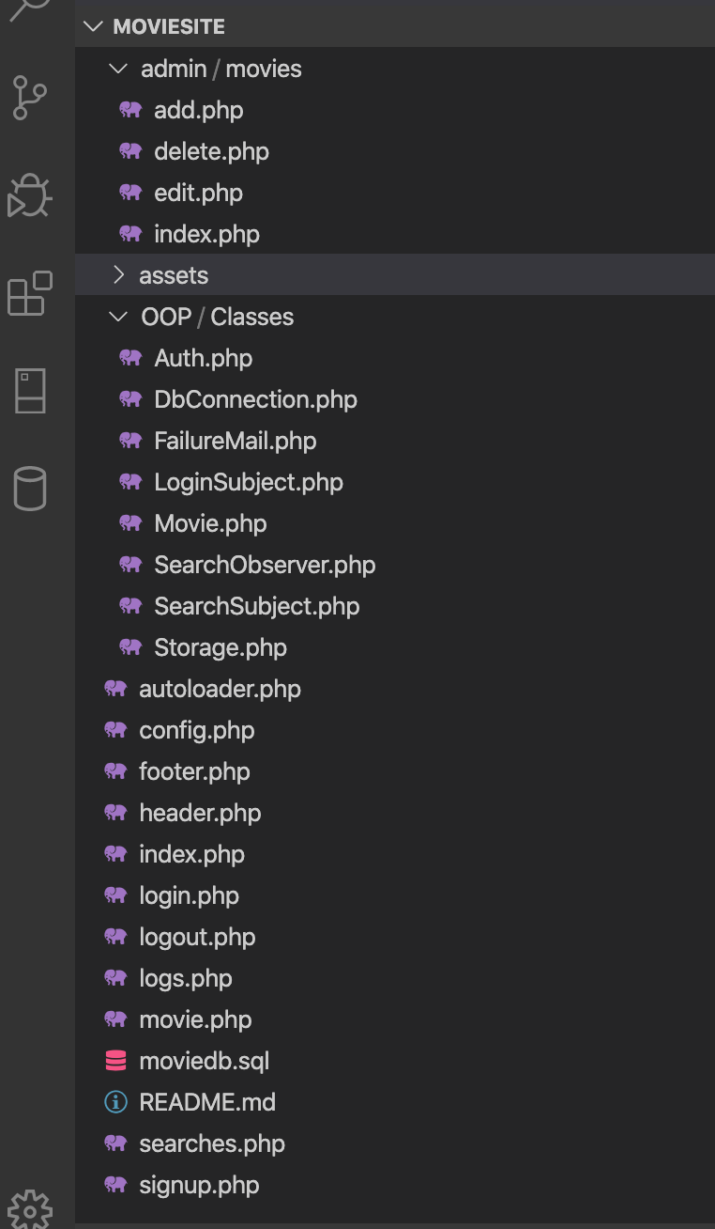

Figure 1 – Folder structure of site in VS Code.

IMPLEMENTATION

NAVIGATION

Users are able to navigate between pages by clicking on Bootstrap navbar links Login, Signup, Logout.

Login

Site users must log in to view content (Appendix B.1) – the username has been set as admin@gmail.com, and the password is 123456. Code from FailureMail and LoginSubject Classes are called from the login page. If login details are not matched to the database values, public function createUser ($email, $pass) from LoginSubject Class checks the details. If details are not matched, it sends the failure message notifying that the login attempt has failed.



Figure 2 - Links once logged in.

Signup

Users can also sign up to view movies (Appendix B.2). Before creating, is_email will check the list of registered users with the email id provided:

if($auth->is_email($email)) {
$errors['invalid_email'] = 'Email already exists.';
}

If there are no errors, new users will be registered:

if (0==count($errors)) {
$user = new Auth;
$user->signup ($name, $email, $password);

Check the login from Auth Class.

if (!$user->check_login($email, $password)) {
$errors['invalid_credentials'] = 'Invalid email or password';

Logout

When user logs out, the session must be cleared from the browser. Once session is cleared, user is redirected to Index page by using header ('location: index.php'). function Auth::logout(); is in Auth Class.

ADMIN

A folder named Admin contains 3 PHP files that are used by admin/movies for CRUD operations on the site when users click the Movie listings navbar link. They use the Auth and Movie Classes:

Creating movies

By clicking the ‘add movie button new movies can be created by movie name; uploading an image; writing a description and giving a rating between 1-5 (Appendix B.5).

Figure 3 - If Login type is not Admin, system will redirect user to the index page.

Figure 4 - Following code will execute once new movie added through this form.
Figure 5- Function called from movie file and image store via Storage file.

Updating a movie

Movies can be edited and saved by clicking the ‘Edit’ button in the Action column (Appendix B.5).

Figure 6 - Code will be executed when movie information has been changed and clicked for save.

Deleting a movie

By clicking the ‘Delete’ button in the Action column, the public function delete is invoked:

$movie->delete($_GET['id']);

Display movies

Movies are displayed on the homepage through an iteration:

if(count($movies)>0) {
foreach ($movies as $movie)

SEARCHING

To search for movie names or ratings, a drop-down filter was used (Appendix B.6) In header.php file, there is a search form. When a user searches, they will be redirect to the index page by adding the search parameters to the URL.

STORING DATA

Public Class Storage is used to store Movie images. When a new movie is created by the Admin, it will generate the image name with a combination of random characters and save to the movie image directory. A loop will be run 40 times and randomly chosen from the $character variable and once 40 characters are completed that value is used to give the image name.

Database connection settings are stored in the DbConnection Class which uses the PHP Data Objects (PDO) extension. It is the base Class for Movie and Auth. Private function getConnection – creates a new PDO object.

AUTHORISATION AND DISPLAYING USER LOG-INS

The class Auth, which inherits from the DbConnection Class, manages authorisation via the following functions:

- Check - checks whether users are logged into the site.
- isAdmin - checks if the user type is an admin.
- check_login - checks log in status of user with the database.
- Logout - clears session data when user logs out.
- Signup - inserts a new user to the database.
- is_email - checks if the email is already registered in the database.
- write_login – is used to save user log in information to the database.
- read_logins - returns log in history of the last 100 log ins.

Figure 7 – Public static function to check user sessions.

Figure 8 – Create and check authorisation object. Get log last log in details.

OBSERVER DESIGN PATTERN

Users of the website must login. A constraint of the project was to have a flexible log in implementation and to writing logs to the database and show an example of emailing failed login attempts to a website administrator. The Observer Design pattern was utilised to allow for this (see Appendix C.2). An object is used to maintain a list of observers that are automatically notified when the state of the object changes by applying a one-to-many dependency. PHP provides the SplObserver[1] and SplSubject[2] interfaces to implement the observer pattern as a template. SplObserver is an observer with an 'update' method, which will be called when its observed subjects call 'notify'. SplSubject is a subject with methods:

- Attach - add an observer.
- Detach - remove an observer.
- Notify - notify observers which are observing this subject (simply loop through the observers and call the 'update' method of each observer).

3.1 Login Observer design pattern

This Class was created to write a log for failed logins and to send an email for failed log in attempts.
FailureMail is an observer which observes LoginSubject. When a user is logging in ('createUser' of LoginSubject will be called), not matter success or failure, inside the 'createUser' method, 'notify' of LoginSubject will be called. Because FailureMail is an observer of LoginSubject, its 'update' method will be called (with a parameter $observable, which is an instance of the LoginSubject, so we will know login result of the user) when 'notify' method of LoginSubject is called.

CreateUser takes two parameters: $email and $pass. $auth->check_login ($email, $pass) searches in the database to find a user record with the email and password. it returns a user row if given info is validated or returns false if not. Calls notify to write login logs into database then returns the login result (true or false).

Figure 7 – Update function for failed login email.

Figure 9 – Subject Class comments.

Search Observer design pattern

First, SearchObserver observes SearchSubject (index.php line #21):
$searchSubject->attach (new SearchObserver()), then auth-users do searches (index.php line #24 and SearchSubject.php line #42): $movies = $searchSubject->search(...);
then $this->notify of $searchSubject will be called (SearchSubject.php line #56). It loops through the observers (here just the $searchObserver) and call 'update' of SearchObserver with one parameter ($observable, which means the $searchSubject), and finally write search logs (SearchSubject.php line #26 and SearchObserver.php line #12).

Figure 10 – An Observer Class was created by implementing the splObserver Interface. A Movie object is instantiated in order to write search data.

This Class is invoked when user searches for a movie and rating. The time, query type, movie rating and results count are noted when clicking on the requests page.
Figure 11 - A Subject Class with notify, update, detach, attach and search functions.

AGILE USER STORIES

Software intangibility problem

As software is intangible, development time cannot be predicted with tools such as PERT charts. Software requirements can be flawed due to communication problems and over-domination between stakeholders: users (who want the software) and developers (who build the software). Users may have new ideas and opinions and ask for many revisions along a project timeline. Some high-profile projects have failed due to these reasons [3].

Solution

To resolve these problems, decision making can be spread out across the project’s duration using user stories, which are user focused descriptions of software features [4]. They can be written by software users, or Agile software developers, who often use project management software to write the user stories. Stories can be prioritised based on their value. Releases are planned by placing stories into iterations [3]. User stories facilitate making sense of the software in order to deliver a Minimal Viable Product [5]. Wake (Extreme Programming explored) has suggested some attributes of good user stories [6]:
- Keep the stories small and independent of each other.
- Should be collaboration between the customers and developers.
- Making the users write the stories.
- Know how long it will take to develop a story with code.
- Story sub tasks should pass acceptance tests.
Acceptance tests are written before a programmer begins coding and describes the users’ usage and if the expectations have been met for a particular task. Tables 1 and 2 show the user stories for users and admins as well as the acceptance criteria. Red text is highlighted to show features that have not been implemented yet. They should also be ideally prioritised in order of importance [3].

Table 1 - User stories for End users.

Number | User Story | Acceptance Criteria

1 | As a User, I must be able to register in the system so that I will become a registered user. | 1.1) New User must register on the site by clicking the signup button.  1.2) New user must fill all the required fields and click submit button.  1.3) Email address verification should be sent after registering email.  1.4) New user must check the terms and condition box to register.
2 | As a User, I must be able to login in the system so that I can access the system. | 2.1) User can login with email & password on log in page. Admin will receive an email warning of all failed login attempts.  2.2) Forgot Password or username option link should be pressed if password forgotten.  2.3) User should be able to reset the password through the link via email message.
3 | As a User, I must be able to update my Profile Information so that all the information will be up to date. | 3.1) User must be able to view profile details by clicking a link to user admin section.  3.2) User must be able to add additional details like profile pic, DOB, Gender, and favourite genre by clicking a link to user admin section.  3.3) User must be able to edit all the profile details by clicking the link to go to the user admin section.
4 | As a User, I must be able to manage my account settings so that my account will be secure. | 4.1) User must be able to change the login password by clicking link to user admin section.  4.2) User must be able to turn on email notification about a new movie addition according to interests by clicking on radio buttons to turn on notifications.  4.3) User must be able to logout from the account by clicking logout link.
5 | As a User, I must be able to see movie ratings & reviews so that I will decide which movie to watch. | 5.1) User must be able to see the movies details, ratings & reviews by logging in and clicking on movie listings navbar link.  5.2) User must be able to rate the movies and give their reviews from admin page and click edit button under action column.  5.3) Only logged in users are allowed to rate & review by clicking edit button.  5.4) Users must be able to search the movies and ratings via search box and filter on movies page.

Table 2 – User Stories for Admin.

1 | As an Admin, I must be able to login in the system so that I can access the system. | 1.1) Admin must be able to login in the system by clicking the login page.
2 | As an Admin, I must be able to manage my account settings so that my account will be secure. | 2.1) Admin must be able to change the account password from admin page->account settings.  2.2) Admin must be able to logout from the account by clicking logout link.
3 | As an Admin, I can view my Dashboard so that I can see the crucial stats of users and movies. | 2.1) Admin must be able to view the user count & movie count by clicking on admin section.  2.2) Admin must be able to see a list of new users by clicking on logs page.  2.3) Admin must be able to see the top rated movies by clicking on admin page.  2.4) Admin must be able to see the movies search logs by users by clicking on search page link.  2.5) Admin must be able to see the active users list by clicking on admin page.
4 | As an Admin, I must be able to manage Users so that only the genuine user will be there on the system. | 4.1) Admin must be able to view the list of all users by clicking on admin page.  4.2) Admin must able to search the users according to name & email by clicking on admin page -> search name or search email.  4.3) Admin must be able to able to active/deactive users by going to admin section - > add or remove users.  4.4) Admin must be able to see the user details & edit them by going to admin section -> edit user.
5 | As an Admin, I must be able to manage the movies so that all the movies will be updated. | 5.1) Admin must be able to view the list of all movies by clicking on movie listings page.  5.2) Admin must be able to search the movies according to name via the search box.  5.3) Admin must be able to search for groups of movies according to ratings via the filter in the navbar.  5.4) Admin must be able to able to add, edit and delete movies by going the admin page.  5.5) Admin must be able to see the movie details & edit them from admin page.  5.6) Admin must be able to edit inappropriate reviews by going to the admin page and clicking the edit button.

When dealing with user stories in industry, they can be mapped using storyboard software by teams and organised into sprints, which are a short set period of time to complete a piece of work. Priorities and scheduled dates can be assigned to each story card [7] .

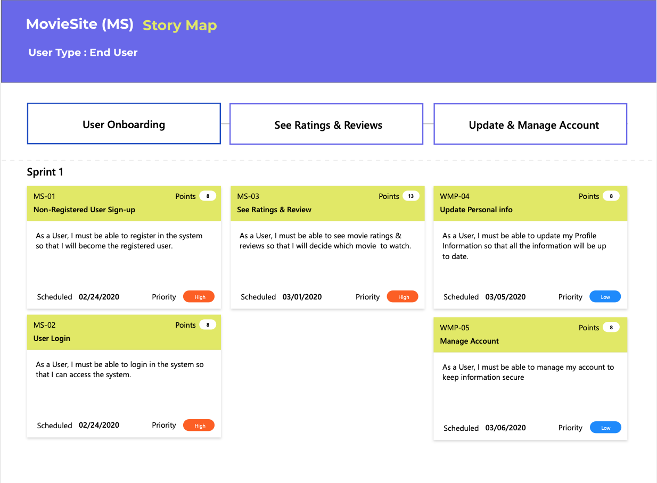

Figure 12 - End user story map sprint example.

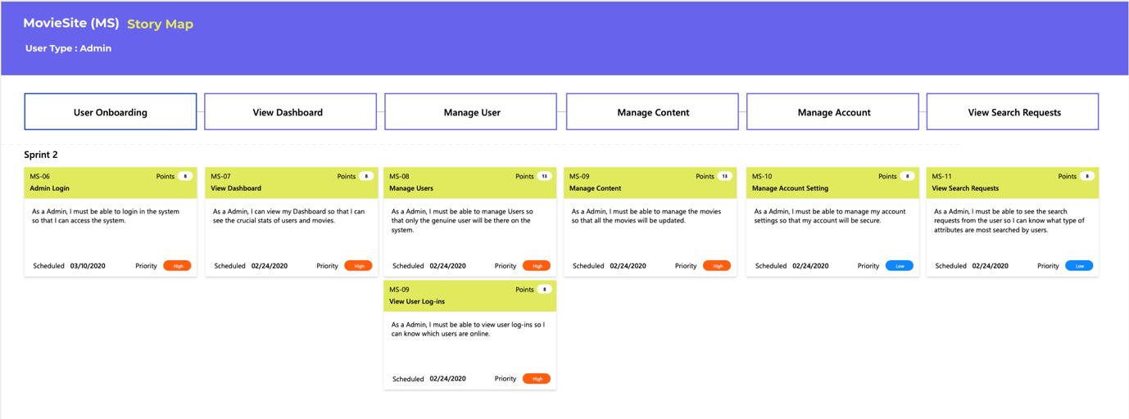

Figure 13 - Admin story map sprint example.

VERSION CONTROL SYSTEMS

IMPORTANCE

A version control system (VCS) is a system that tracks changes to files in a directory by recording the date, time, user that made a3change, and the differences between the file contents before and after that change. Files or content can get erased, corrupted or updated. It is useful for software users to have the ability to undo data changes, recover data or track changes [8]. VCSs support software engineering team collaboration by allowing developers to work affectively by managing, organising and co-ordinating versions of source code and files, which would otherwise be extremely challenging. Table 3 details the two approaches to VCSs, which are Centralised and Distributed [9]. Distributed VCS are more popular with developers today:
Table 3 – Centralised vs Distributed VCSs.
Version Control System | Centralised | Distributed
Software example | Subversion | Git, Mercurial.
Repository | One central. | Every user has individual local repository on computer.
Suitability | Several users on a single site. | Single or multiple users located in multiple sites.

GIT ARTEFACTS

The distributed VCS, GIT, was used by the author to push the project folder contents to the GitHub web service. Git organises a local workspace using three conceptual trees (or areas): working directory; Index and Local repository. Files or folders (artefacts) passed through these trees via GIT commands in a Bash terminal, before being pushed to GitHub (the master branch) (Table. 4) [10].

Files were modified in the working directory, staged in the index, then finally committed in the local repository:

- Modified – meaning files changes are not stored in the local repository.
- Staged – meaning a file has been tagged to be considered for the next commit.
- Committed – meaning data changes in a file become stored in the local repository.

The Working directory is a directory tree that holds the source files. A new Git artefact can be created here, and also initialise a new empty repository. The Index lists all files that are to be committed or ‘staged’ in the current branch. The Local repository is a pointer to the last commit in the current branch. Every commit will have a unique ID and comment. The Remote repository is the default (master) branch on GitHub (Appendix 8.1). All code was pushed to the remote server. Files can also be pulled from the remote server to the local repository. Git Logs of commit history can be viewed (Appendix 8.2) [10].

Table 4 – The Git workflow and remote GitHub project address with Git command examples [11].

Branch name | Working directory  (WORKSPACE) | Index  (STAGE) | Local repository  (HEAD) | GitHub repository  (MASTER)
Git Command | $git –-version  (Check git version)  $git config --global user.name / user. email  (setup the username and email).  $ mkdir (create a new directory).  $ cd (change into a new directory).  $git init –  (initialise a new repository).  $git rm (remove an added file). | $git add (stage a new artefact to the repository).  $git commit -m “message” (commit the artefact to the local repository).  git commit -am “commit message” (an express commit). | $git push origin master (push the artefacts to the remote repository).  $git add origin master (connect to remote server).  $git clone – (download a remote repository to the local repository).  $git fetch (fetch updated data from the remote repository).  $git log (print commit history).  $git checkout (undo changes)  $git reset head (unstage an artefact).  $git clean -xf (clean files).  $git clean - n (check what is being cleaned). | $git remote -v (view all connections).  git@github.com  :theasgarali  /Assignment-1.git -  (The address of the public project repository).

Files that should be ignored, such as those containing secure or sensitive data, should be added to a .gitignore file [10]. GitHub is a web-based repository hosting service that was used to push the artefacts from the local
repository using the origin master command.

CONCLUSION

Results

The author feels OOP was implemented appropriately by keeping all eight program Classes in a separate folder that other scripts utilised to create objects and inherit public methods from. The author also felt that the Observer design pattern was implemented correctly for both Log in errors and search items, although this did prove challenging. Function spl_autoload_register allowed for the classes and interfaces to be loaded if they were not currently defined with includes at the beginning of each script.

Known bugs / errors

Uploading a movie image can be a little temperamental and sometimes images do not upload, although the author believes this could be due to file permission issues on the operating system or the wrong path of the images.

Improvements

- The password was stored in the database in a readable format. A PHP hashing method can be used to encrypt and check the password in the database [12].
- For saving an image name, the time () function can be used to have a unique timestamp, instead of using $characters [13].
- Rename some files such as index.php, which appears twice, and to make files more descriptive
- Use underscores for all local and global variables.
- Composer can be used for loading libraries for functionality. Even better, using an Object-oriented PHP framework such as Laravel would be used for development in industry.
- Ideally, an MVC architecture should be implemented.

REFERENCES

[1] “PHP: SplObserver - Manual.” [Online]. Available: https://www.php.net/manual/en/class.splobserver.php. [Accessed: 27-Jan-2020].
[2] “PHP: SplSubject - Manual.” [Online]. Available: https://www.php.net/manual/en/class.splsubject.php. [Accessed: 27-Jan-2020].
[3] M. Cohn, User stories applied. Addison-Wesley Pub. Co, 2004.
[4] R. Jeffries, “Essential XP: Card, Conversation, Confirmation,” 2001.
[5] P. Ralph, “Software Engineering Process Theory: A Multi-Method Comparison of Sensemaking-CoevoIution-Implementation Theory and Function-Behavior-Structure Theory,” Jul. 2013.
[6] W. Wake, Extreme programming explored, 1st ed. Addison-Wesley Pub. Co, 2001.
[7] A. Alhazmi, “A Decision Support System for Sprint Planning in Scrum Practice,” IEEE xplore, 2018, doi: 10.1109/SECON.2018.8479063.
[8] K. Hinsen, Konrad, Laufer, “Essential Tools: Version Control Systems,” Comput. Sci. Eng., vol. 11, no. 6, pp. 84–91, 2009, doi: 10.1109.
[9] N. N. Zolkifli, A. Ngah, and A. Deraman, “Version Control System: A Review,” in Procedia Computer Science, 2018, vol. 135, pp. 408–415, doi: 10.1016/j.procs.2018.08.191.
[10] M. Loeliger, Jon, McCullough, Version Control with Git, Second. CA: O’Reilly, 2012.
[11] “Git - Reference.” [Online]. Available: https://git-scm.com/docs. [Accessed: 19-Feb-2020].
[12] “PHP: Introduction - Manual.” [Online]. Available: https://www.php.net/manual/en/intro.password.php. [Accessed: 11-Feb-2020].
[13] “PHP: time - Manual.” [Online]. Available: https://www.php.net/manual/en/function.time.php. [Accessed: 11-Feb-2020].

APPENDIX A (GIT)

A.1 GitHub repository

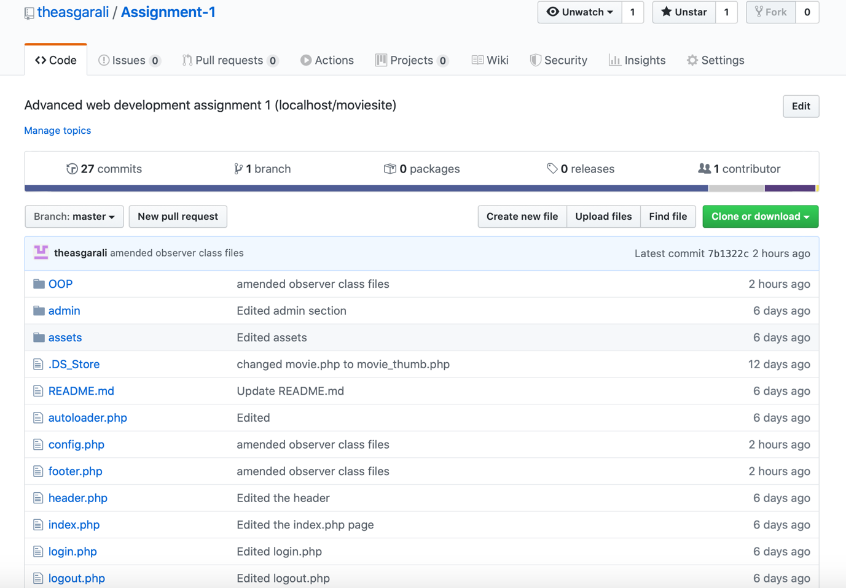

A.2 Git Logs

As-MacBook-Pro:Assignment 1 aali$ cd moviesite/
As-MacBook-Pro:moviesite aali$ git log
commit 7b1322cb3be0591403bbd16a0af3b0bb45288108 (HEAD -> master, origin/master, origin/HEAD)
Author: theasgarali <asgarali01@live.com>
Date: Sat Feb 22 14:40:44 2020 +0000

amended observer class files

commit f38716dab807cd48f7ee48b72e72df6377492c0e
Author: A. Ali <theasgarali@users.noreply.github.com>
Date: Wed Feb 19 11:19:19 2020 +0000

Add files via upload

commit 3b7dd7160c99a66f38ac9119e8046cefc091f4d1
Author: A. Ali <theasgarali@users.noreply.github.com>
Date: Sun Feb 16 15:42:15 2020 +0000

Delete movie_thumb.php

Not required

commit bc6c544ab3388577a1bd39c25e8476083a2d6702
Author: A. Ali <theasgarali@users.noreply.github.com>
As-MacBook-Pro:moviesite aali$ cd moviesite/gi
-bash: cd: moviesite/gi: No such file or directory
As-MacBook-Pro:moviesite aali$ git log
commit 7b1322cb3be0591403bbd16a0af3b0bb45288108 (HEAD -> master, origin/master, origin/HEAD)
Author: theasgarali <asgarali01@live.com>
Date: Sat Feb 22 14:40:44 2020 +0000

amended observer class files

commit f38716dab807cd48f7ee48b72e72df6377492c0e
Author: A. Ali <theasgarali@users.noreply.github.com>
Date: Wed Feb 19 11:19:19 2020 +0000

Add files via upload

commit 3b7dd7160c99a66f38ac9119e8046cefc091f4d1
Author: A. Ali <theasgarali@users.noreply.github.com>
Date: Sun Feb 16 15:42:15 2020 +0000

Delete movie_thumb.php

Not required

commit bc6c544ab3388577a1bd39c25e8476083a2d6702
Author: A. Ali <theasgarali@users.noreply.github.com>
Date: Sun Feb 16 15:41:36 2020 +0000
:...skipping...
commit 7b1322cb3be0591403bbd16a0af3b0bb45288108 (HEAD -> master, origin/master, origin/HEAD)
Author: theasgarali <asgarali01@live.com>
Date: Sat Feb 22 14:40:44 2020 +0000

amended observer class files

commit f38716dab807cd48f7ee48b72e72df6377492c0e
Author: A. Ali <theasgarali@users.noreply.github.com>
Date: Wed Feb 19 11:19:19 2020 +0000

Add files via upload

commit 3b7dd7160c99a66f38ac9119e8046cefc091f4d1
Author: A. Ali <theasgarali@users.noreply.github.com>
Date: Sun Feb 16 15:42:15 2020 +0000

Delete movie_thumb.php

Not required

commit bc6c544ab3388577a1bd39c25e8476083a2d6702
Author: A. Ali <theasgarali@users.noreply.github.com>
Date: Sun Feb 16 15:41:36 2020 +0000

:...skipping...
commit 7b1322cb3be0591403bbd16a0af3b0bb45288108 (HEAD -> master, origin/master, origin/HEAD)
Author: theasgarali <asgarali01@live.com>
Date: Sat Feb 22 14:40:44 2020 +0000

amended observer class files

commit f38716dab807cd48f7ee48b72e72df6377492c0e
Author: A. Ali <theasgarali@users.noreply.github.com>
Date: Wed Feb 19 11:19:19 2020 +0000

Add files via upload

commit 3b7dd7160c99a66f38ac9119e8046cefc091f4d1
Author: A. Ali <theasgarali@users.noreply.github.com>
Date: Sun Feb 16 15:42:15 2020 +0000

Delete movie_thumb.php

Not required

commit bc6c544ab3388577a1bd39c25e8476083a2d6702
Author: A. Ali <theasgarali@users.noreply.github.com>
Date: Sun Feb 16 15:41:36 2020 +0000

Edited

commit 1ca4794c4422aadda7a64341f15229c7e4951ce1
Author: A. Ali <theasgarali@users.noreply.github.com>
Date: Sun Feb 16 15:41:20 2020 +0000

Edited

commit 36b43451af1be7605e032d0e9f467d22bedc18c8
Author: A. Ali <theasgarali@users.noreply.github.com>
Date: Sun Feb 16 15:41:05 2020 +0000

Added file

commit 12280f7a90ade2e066e9518af77f2743f3874f41
Author: A. Ali <theasgarali@users.noreply.github.com>
Date: Sun Feb 16 15:40:46 2020 +0000

Added new Classes

Edited old classes and added new classes

commit 2470712b99f15c2a648881377a170d724011b542
Author: A. Ali <theasgarali@users.noreply.github.com>
Date: Sun Feb 16 15:40:03 2020 +0000

Added sql statements

commit 69ab9b666f34ccf5e189836bb88755cb8215a3b3
Author: A. Ali <theasgarali@users.noreply.github.com>
Date: Sun Feb 16 15:39:32 2020 +0000

added movie.php

commit 9f5b928e6389c559c574f4f92f105bc565c8911e
Author: A. Ali <theasgarali@users.noreply.github.com>
Date: Sun Feb 16 15:39:12 2020 +0000

commit 7b1322cb3be0591403bbd16a0af3b0bb45288108 (HEAD -> master, origin/master, origin/HEAD)
Author: theasgarali <asgarali01@live.com>
Date: Sat Feb 22 14:40:44 2020 +0000

amended observer class files

commit f38716dab807cd48f7ee48b72e72df6377492c0e
Author: A. Ali <theasgarali@users.noreply.github.com>
Date: Wed Feb 19 11:19:19 2020 +0000

Add files via upload

commit 3b7dd7160c99a66f38ac9119e8046cefc091f4d1
Author: A. Ali <theasgarali@users.noreply.github.com>
Date: Sun Feb 16 15:42:15 2020 +0000

Delete movie_thumb.php

Not required

commit bc6c544ab3388577a1bd39c25e8476083a2d6702
Author: A. Ali <theasgarali@users.noreply.github.com>
Date: Sun Feb 16 15:41:36 2020 +0000

Edited

commit 1ca4794c4422aadda7a64341f15229c7e4951ce1
Author: A. Ali <theasgarali@users.noreply.github.com>
Date: Sun Feb 16 15:41:20 2020 +0000

Edited

commit 36b43451af1be7605e032d0e9f467d22bedc18c8
Author: A. Ali <theasgarali@users.noreply.github.com>
Date: Sun Feb 16 15:41:05 2020 +0000

Added file

commit 12280f7a90ade2e066e9518af77f2743f3874f41
Author: A. Ali <theasgarali@users.noreply.github.com>
Date: Sun Feb 16 15:40:46 2020 +0000

Added new Classes

Edited old classes and added new classes

commit 2470712b99f15c2a648881377a170d724011b542
Author: A. Ali <theasgarali@users.noreply.github.com>
Date: Sun Feb 16 15:40:03 2020 +0000

Added sql statements

commit 69ab9b666f34ccf5e189836bb88755cb8215a3b3
Author: A. Ali <theasgarali@users.noreply.github.com>
Date: Sun Feb 16 15:39:32 2020 +0000

added movie.php

commit 9f5b928e6389c559c574f4f92f105bc565c8911e
Author: A. Ali <theasgarali@users.noreply.github.com>
Date: Sun Feb 16 15:39:12 2020 +0000
:

commit 7b1322cb3be0591403bbd16a0af3b0bb45288108 (HEAD -> master, origin/master, origin/HEAD)
Author: theasgarali <asgarali01@live.com>
Date: Sat Feb 22 14:40:44 2020 +0000

amended observer class files

commit f38716dab807cd48f7ee48b72e72df6377492c0e
Author: A. Ali <theasgarali@users.noreply.github.com>
Date: Wed Feb 19 11:19:19 2020 +0000

Add files via upload

commit 3b7dd7160c99a66f38ac9119e8046cefc091f4d1
Author: A. Ali <theasgarali@users.noreply.github.com>
Date: Sun Feb 16 15:42:15 2020 +0000

Delete movie_thumb.php

Not required

commit bc6c544ab3388577a1bd39c25e8476083a2d6702
Author: A. Ali <theasgarali@users.noreply.github.com>
Date: Sun Feb 16 15:41:36 2020 +0000
:

APPENDIX B (Website screenshots)

B.1 – Homepage

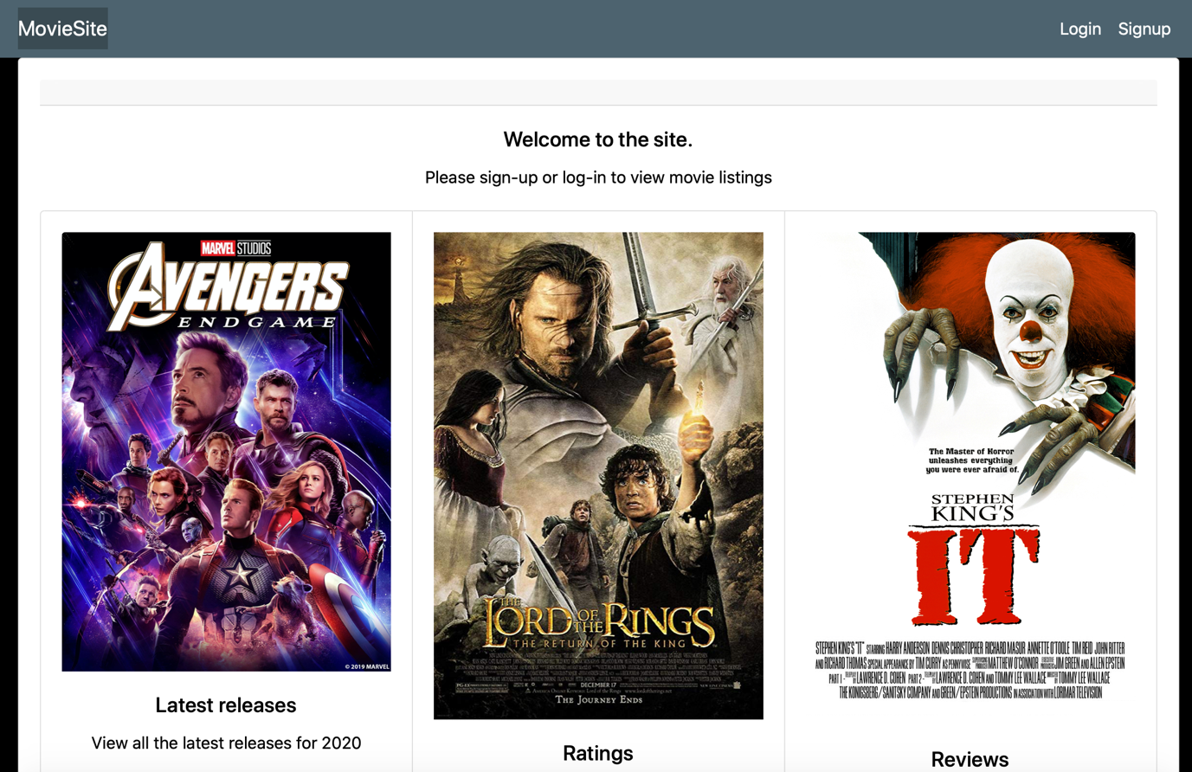

B.2 - Login

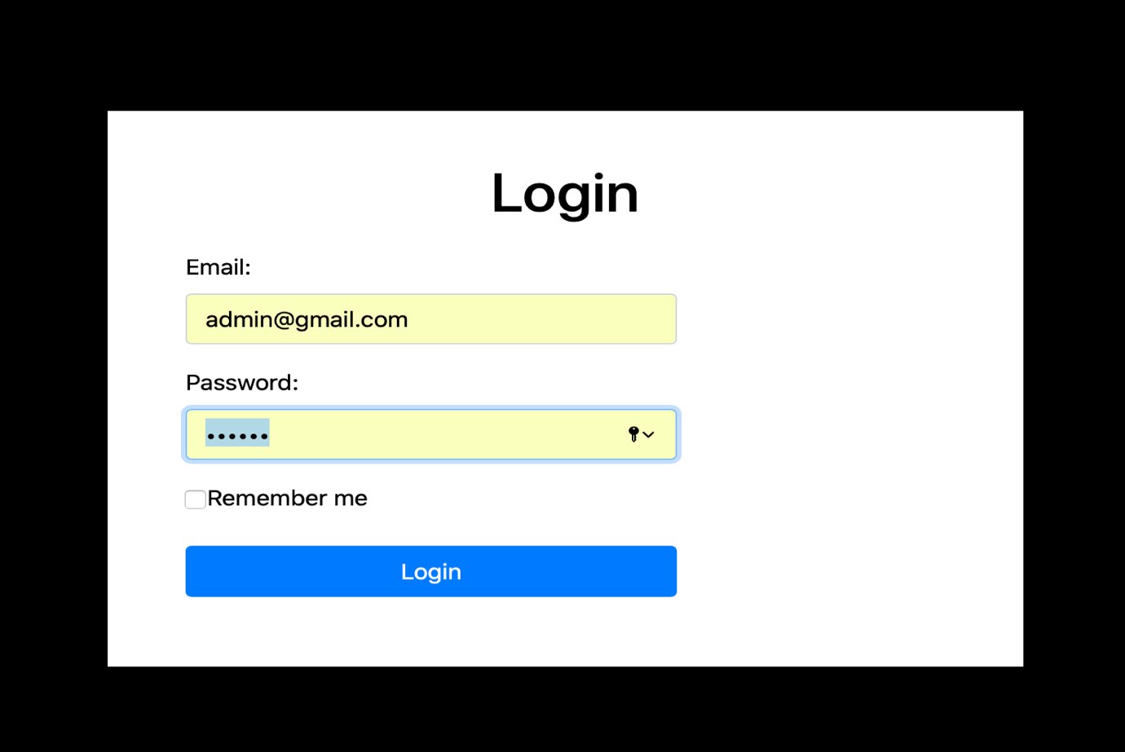

B.2 - Signup
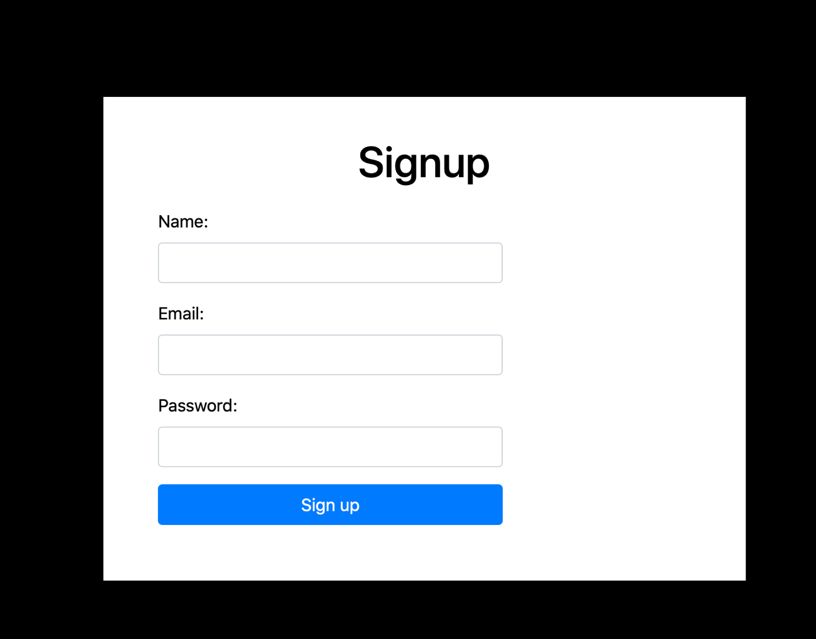

B.3 – Movie listings

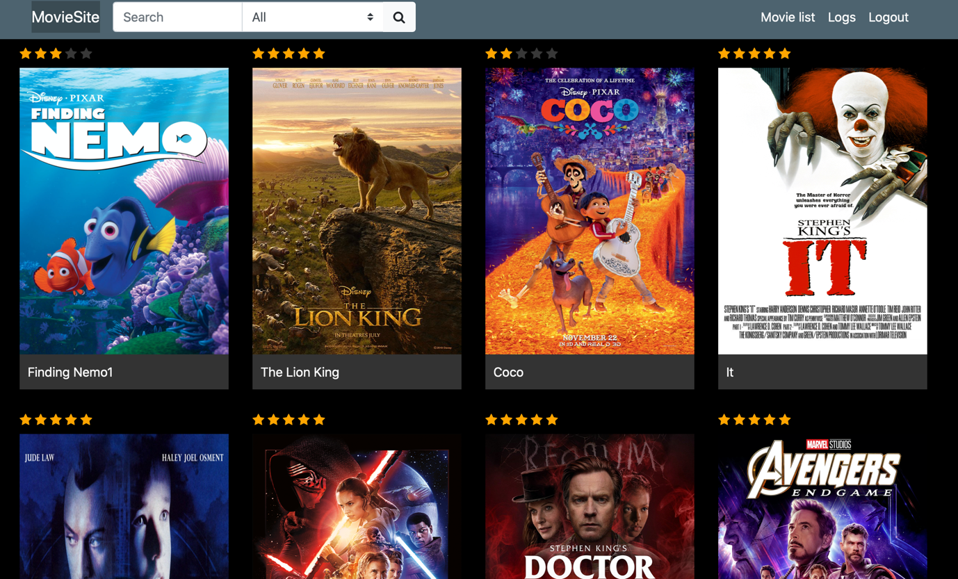

B.4 – Admin page

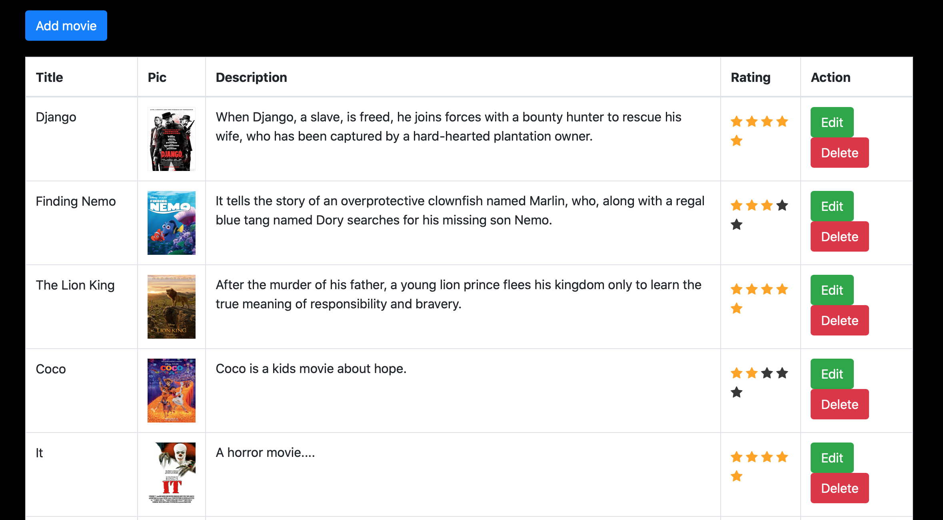

B.4 – Login user and time logs

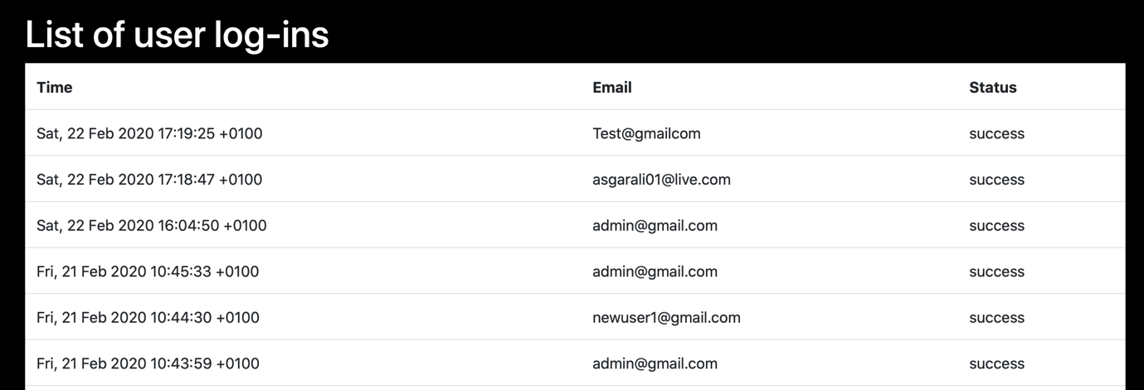

B.5 – Editing/Saving movie

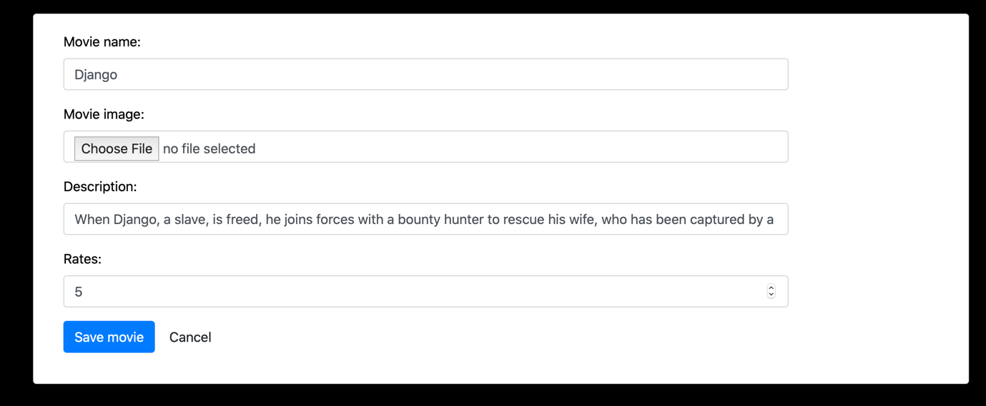

B.6 – Search filters
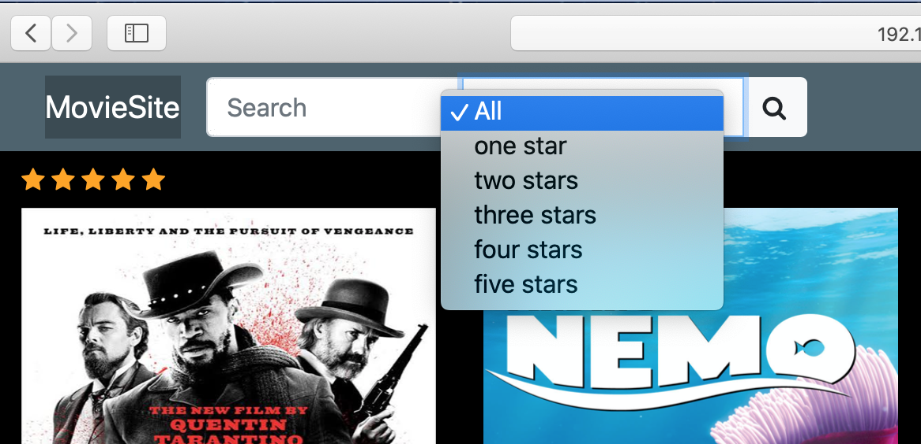

B.7 – Expanded movie image

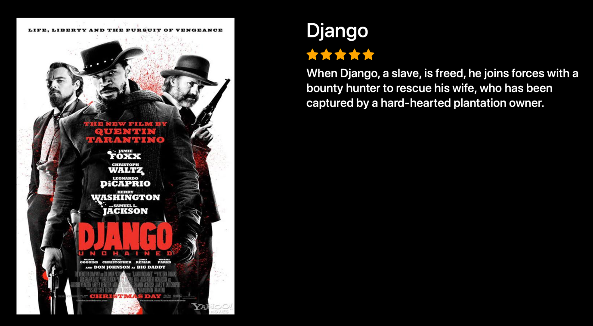

B.8 User search logs page

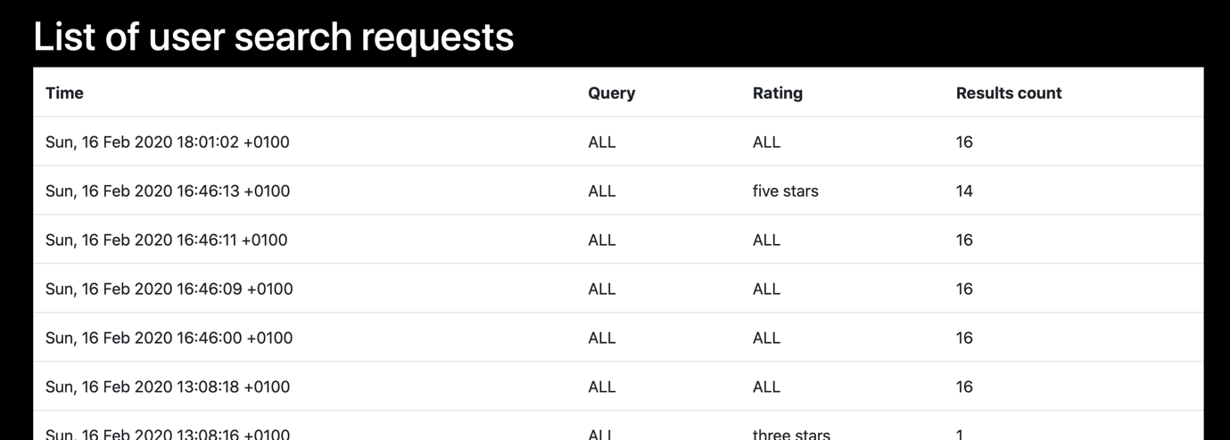

APPENDIX C (CODE).

Autoloader.php

<?php

session_start();

/* AUTOLOADING all classes from \Classes.
“PHP: Autoloading Classes - Manual.”
[Online]. Available: https://www.php.net/manual/en/language.oop5.autoload.php.
[Accessed: 08-Jan-2020].
*/

class Autoloader
{
public static function register()
{
spl_autoload_register(function ($class) {// registers autoloaders

$file = __DIR__.DIRECTORY_SEPARATOR.str_replace('\\', DIRECTORY_SEPARATOR, $class).'.php';
if (file_exists($file)) {
require $file;
return true;
}
return false;
});
}
}
Autoloader::register();

Header.php

<?php

//HEADER FILE

use OOP\Classes\Auth;

?>

<!DOCTYPE html >
<html>
<head>
<meta name="viewport" content="width=device-width, initial-scale=1">
<title>Movies</title>
<link rel="stylesheet" href="https://stackpath.bootstrapcdn.com/bootstrap/4.4.1/css/bootstrap.min.css" integrity="sha384-Vkoo8x4CGsO3+Hhxv8T/Q5PaXtkKtu6ug5TOeNV6gBiFeWPGFN9MuhOf23Q9Ifjh" crossorigin="anonymous">
<link rel="stylesheet" href="https://cdnjs.cloudflare.com/ajax/libs/font-awesome/4.7.0/css/font-awesome.min.css">
<link rel="stylesheet" href="<?php echo BASE_URL;?>/assets/css/main.css">

</head>
<body>
<nav class="navbar navbar-default navbar-expand-lg">
<div class="container">
<a class="navbar-brand" href="<?php echo BASE_URL;?>">MovieSite</a>
<button class="navbar-toggler" type="button" data-toggle="collapse" data-target="#navbarSupportedContent" aria-controls="navbarSupportedContent" aria-expanded="false" aria-label="Toggle navigation">
<span class="navbar-toggler-icon"></span>
</button>
<?php
if(Auth::check()){ // if user has already logged in,
?>
<form class="navbar-form mr-auto" method="get" action="<?php echo BASE_URL;?>">
<div class="input-group">
<input name="search" type="text" class="form-control" placeholder="Search" value="<?=(isset($_GET['search'])?addslashes($_GET['search']):'')?>">
<select class="custom-select" name="rating">
<option <?=(!isset($_GET['rating'])||0==$_GET['rating']?'selected':'')?> value="0">All</option>
<?php foreach (OOP\Classes\Movie::$ratings as $k=>$label): ?>
<option value="<?=$k?>" <?=(isset($_GET['rating'])&&$k==$_GET['rating']?'selected':'')?>><?=$label?></option>
<?php endforeach; ?>
</select>
<div class="input-group-append">
<button class="btn btn-light" type="submit">
<i class="fa fa-search"></i>
</button>
</div>
</div>
</form>
<div class="collapse navbar-collapse" id="navbarNav">
<ul class="navbar-nav ml-auto">
<?php if(Auth::isAdmin()): ?>
<li class="nav-item">
<a class="nav-link" href="<?php echo BASE_URL;?>/admin/movies">Movie list</a>
</li>
<?php endif; ?>
<li class="nav-item">
<a class="nav-link" href="<?php echo BASE_URL;?>/logs.php">Logs</a>
</li>
<li class="nav-item">
<a class="nav-link" href="<?php echo BASE_URL;?>/searches.php">Requests</a>
</li>
<li class="nav-item">
<a class="nav-link" href="<?php echo BASE_URL;?>/logout.php">Logout</a>
</li>
</ul>
</div>
<?php
}
else{
?>
<div class="collapse navbar-collapse" id="navbarNav">
<ul class="navbar-nav ml-auto">
<li class="nav-item">
<a class="nav-link" href="<?php echo BASE_URL;?>/login.php">Login</a>
</li>
<li class="nav-item">
<a class="nav-link" href="<?php echo BASE_URL;?>/signup.php">Signup</a>
</li>
</ul>
</div>
<?php
}
?>
</div>
</nav>

<div class="container">

Footer.php

</div>

<script src="https://code.jquery.com/jquery-3.4.1.slim.min.js" integrity="sha384-J6qa4849blE2+poT4WnyKhv5vZF5SrPo0iEjwBvKU7imGFAV0wwj1yYfoRSJoZ+n" crossorigin="anonymous"></script>
<script src="https://stackpath.bootstrapcdn.com/bootstrap/4.4.1/js/bootstrap.min.js" integrity="sha384-wfSDF2E50Y2D1uUdj0O3uMBJnjuUD4Ih7YwaYd1iqfktj0Uod8GCExl3Og8ifwB6" crossorigin="anonymous"></script>
<script src="<?php echo BASE_URL;?>/assets/js/main.js"></script>
<script>
$(document).ready(function(){
});
</script>
</body>
</html>

Index.php

<?php

//MAIN PAGE

//autoloader & config require
require(__DIR__.'/autoloader.php');
require(__DIR__.'/config.php');

// You can just get file included by using this 'use' expression.
use OOP\Classes\Auth;
use OOP\Classes\SearchObserver;
use OOP\Classes\SearchSubject;

// header.php file used to add the site links, search bar,etc for the user to navigate the site.
require __DIR__ . '/header.php'; // header is included

//show movies only for authorised users
if (Auth::check()) {

$searchSubject = new SearchSubject(); //$searchSubject object created from SearchSubject (SplSubject) Class.
$searchSubject->attach(new SearchObserver()); //Attach an SplObserver (SearchObserver Class) to $searchSubject object.

// calls search method of Movie Instance. If URL has the variable 'Search', system will list the movies based on search keywords and options.
$movies = $searchSubject->search(
isset($_GET['search'])?$_GET['search']:'',
isset($_GET['rating'])?$_GET['rating']:0
);
?>
<div class="movie-container row">
<?php
// If there are movies stored in database it'll display the list of movies.
if(count($movies)>0){
foreach($movies as $movie){
?>
<div class="col-sm-3">
<!-- Get the unique id of the movie to create a link and land to the movie page when user clicks on it -->
<a class="movie-link" href="<?php echo BASE_URL.'/movie.php?id='.$movie['id']; ?>">
<div class="movie-mask">
<div class="back-mask"></div>
</div>
<div class="movie-description">
<span><?php echo $movie['description'];?></span>
</div>
<div class="movie-content">
<div class="star-rating" data-rate="<?php echo $movie['rating'];?>">
<span class="fa fa-star"></span>
<span class="fa fa-star"></span>
<span class="fa fa-star"></span>
<span class="fa fa-star"></span>
<span class="fa fa-star"></span>
</div>
<img class="movie-thumb" src="<?php echo BASE_URL;?>/assets/<?php echo $movie['image'];?>">
<div class="movie-name"><?php echo $movie['name'];?></div>
</div>
</a>
</div>

<?php
}
}else{
// If no movies stored in table. It will show custom message as mentioned below.
?>
<div class="no-movie-result">
Sorry. No result for that keyword.
</div>
<?php
}
?>
</div>
<?php } else {?>
<div class="card text-center">
<div class="card-header">
</div>
<div class="card-body">
<h5 class="card-title">Welcome</h5>
<p class="card-text">Please Signup or Login to view movie listings</p>
</div>
<div class="card-group">
<div class="card">
<img src="assets/images/avengers.jpg" class="card-img-top" alt="...">
<div class="card-body">
<h5 class="card-title">Latest releases</h5>
<p class="card-text">View all the latest releases for 2020</p>
</div>
<div class="card-footer">
<small class="text-muted">Updated 3 days ago</small>
</div>
</div>
<div class="card">
<img src="assets/images/lord.jpg" class="card-img-top" alt="...">
<div class="card-body">
<h5 class="card-title">Ratings</h5>
<p class="card-text">View all ratings from viewers.</p>
</div>
<div class="card-footer">
<small class="text-muted">Updated 3 mins ago</small>
</div>
</div>
<div class="card">
<img src="assets/images/it.jpg" class="card-img-top" alt="...">
<div class="card-body">
<h5 class="card-title">Reviews</h5>
<p class="card-text">Read critical reviews from top movie critics</p>
</div>
<div class="card-footer">
<small class="text-muted">Updated 5 days ago</small>
</div>
</div>
</div>

<?php } ?>

<!-- footer section -->
<?php require __DIR__ . '/footer.php'; ?>

Login.php

<?php

/* LOGIN FILE.

If user is already logged, code will check the staus and send to the index.php file
else run the rest of the code of this page which contains the login form to be fill up by the user for authenticate and check the movies list.*/

//autoloader & config require
require(__DIR__.'/autoloader.php');
require(__DIR__.'/config.php');
require __DIR__ . '/header.php';

//import namespaces
use OOP\Classes\Auth;
use OOP\Classes\FailureMail;
use OOP\Classes\LoginSubject;

$login = new LoginSubject(); //$login object created from LoginSubject (SplSubject) Class.
$login->attach(new FailureMail()); //Attach an SplObserver (FailureMail Class) to $login object.

$errors = []; //array

if ($_SERVER['REQUEST_METHOD'] === 'POST') {
// if the request to call this file is post, you can find the method of the form in below HTML code 'form method="post"'.
// This method sends the form data to the browser in hidden mode instead of adding them to the URL like https://www.movies.com/login.php?email=user@gmail&pass=1457889....
if(!$login->createUser($_POST['email'], $_POST['password'])) { // Checking credential in the db. show error if credential doesn't exist
$errors['invalid_credentials'] = 'Invalid email or password';
}
else{ // if credential exist, redirect..
header('location:index.php');
}
}
elseif(Auth::check()) { // if user has already logged in, redirect to index page, user doesn't need to login again
header('location:index.php');
}
?>

<!DOCTYPE html >
<html>
<head>
<!-- head.php file contains the CSS, JS, third party code, etc for the site which are common for all pages. -->
<meta name="viewport" content="width=device-width, initial-scale=1">
<title>Movies</title>

<link rel="stylesheet" href="https://stackpath.bootstrapcdn.com/bootstrap/4.4.1/css/bootstrap.min.css" integrity="sha384-Vkoo8x4CGsO3+Hhxv8T/Q5PaXtkKtu6ug5TOeNV6gBiFeWPGFN9MuhOf23Q9Ifjh" crossorigin="anonymous">
<link rel="stylesheet" href="https://cdnjs.cloudflare.com/ajax/libs/font-awesome/4.7.0/css/font-awesome.min.css">
<link rel="stylesheet" href="<?php echo BASE_URL;?>/assets/css/main.css">
</head>
<body>

<div class="container">
<div class="full-wrapper">
<div class="auth-form-container">
<h1 class="text-center" style="margin: 0 0 20px;">Login</h1>
<form class="form-horizontal" method="post">
<div class="form-group">
<label class="col-sm-2 control-label" for="email">Email:</label>
<div class="col-sm-8">
<input name="email" class="form-control" id="email" type="email" required>
</div>
<?php // if error message exist, it is displayed
if(isset($errors['invalid_credentials'])){
?>
<div class="col-sm-9 col-sm-offset-2">
<div class="text-danger"><?php echo $errors['invalid_credentials']; ?></div>
</div>
<?php
}
?>
</div>
<div class="form-group">
<label class="col-sm-2 control-label" for="password">Password:</label>
<div class="col-sm-8">
<input name="password" class="form-control" id="password" type="password" required>
</div>
</div>
<div class="form-group">
<div class="col-sm-8 col-sm-offset-2">
<label class="checkbox-inline"><input type="checkbox" value="">Remember me</label>
</div>
</div>
<div class="form-group">
<div class="col-sm-8 col-sm-offset-2">
<button type="submit" class="btn btn-primary btn-block">Login</button>
</div>
</div>
</form>
</div>
</div>
</div>

</body>
</html>

Logout.php

<?php

//LOGOUT FILE

//autoloader & config require
require(__DIR__.'/autoloader.php');
require(__DIR__.'/config.php');

use OOP\Classes\Auth;

// When user logs out, we have to clear his session from the browser. And once session is cleared, we'll redirect customer to Index page by using header() method.
// You can find the function logout within src/app/Auth.php file
Auth::logout();

header('location:index.php');

Logs.php

<?php

//FILE FOR LOGGING ALL LOG IN ATTEMPTS

use OOP\Classes\Auth;

//autoloader & config require
require(__DIR__.'/autoloader.php');
require(__DIR__.'/config.php');

require __DIR__ . '/header.php';

//create an authorisation object.
$auth = new Auth();

//check authorisation, redirect to index if guest
if (!Auth::check())
header('location:index.php');

//Get the details of the user's last login with the site.
$attempts = $auth->read_logins();
?>
<div class="movie-container row pt-4">
<table class="table">
<h1>List of user log-ins</h1>
<tr>
<th>Time</th>
<th>Email</th>
<th>Status</th>
</tr>
<?php if (0==count($attempts)): ?>
<tr>
<td colspan="3" class="text-center">No attempts</td>
</tr>
<?php else: ?>
<?php foreach ($attempts as $attempt): ?>
<tr>
<td><?=date('r', $attempt['time'])?></td>
<td><?=htmlentities($attempt['email'])?></td>
<td><?=Auth::$statuses[$attempt['status']]?></td>
</tr>
<?php endforeach; ?>
<?php endif; ?>
</table>
</div>

<?php require __DIR__ . '/footer.php';

Movie.php

<?php

/* File shows a SINGLE MOVIE PAGE if the user is logged-in. If user is not logged-in, system will redirect to index.php file to do login.*/

//autoloader & config require
require(__DIR__.'/autoloader.php');
require(__DIR__.'/config.php');

use OOP\Classes\Auth;
use OOP\Classes\Movie;

/*Check for the user session. If the user is not logged in, system will redirect the customer to the index page.
Auth: means you have to check the Auth.php file and "Check()" is the function name.*/

if(!Auth::check()){
header('location:index.php');
}

/*This code is to get the individual movie information. $_GET['id'] is used to get the movie ID from the URL.
So if movie id is passed through the URL, this ID is used to send the code to get the movie details.*/

$movie_data = new Movie;
$movie = $movie_data->find($_GET['id']);

require __DIR__ . '/header.php';

?>

<div class="movie-container row" style="margin-top: 40px;">
<div class="col-sm-6">
<img class="movie-detail-thumb" src="<?php echo BASE_URL.'assets/'.$movie['image'];?>">
</div>
<div class="col-sm-6">
<h1><?php echo $movie['name'];?></h1>
<div class="star-rating star-rating-large" data-rate="<?php echo $movie['rating'];?>">
<span class="fa fa-star"></span>
<span class="fa fa-star"></span>
<span class="fa fa-star"></span>
<span class="fa fa-star"></span>
<span class="fa fa-star"></span>
</div>
<h4 class="movie-detail-description"><?php echo $movie['description'];?></h4>
</div>

</div>

<?php

// footer section
require __DIR__ . '/footer.php';

?>

Moviedb.sql

CREATE TABLE `keywords` (
`id` int(11) NOT NULL AUTO_INCREMENT,
`user_id` int(11) NOT NULL,
`keyword` varchar(255) NOT NULL,
PRIMARY KEY (`id`)
) ENGINE=InnoDB AUTO_INCREMENT=4 DEFAULT CHARSET=utf8;

/*Data for the table `keywords` */

insert into `keywords`(`id`,`user_id`,`keyword`) values
(2,1,'fghj'),
(3,1,'32');

/*Table structure for table `movies` */

CREATE TABLE `movies` (
`id` int(11) NOT NULL AUTO_INCREMENT,
`name` varchar(255) DEFAULT NULL,
`image` varchar(500) DEFAULT NULL,
`description` text,
`rating` varchar(255) DEFAULT NULL,
PRIMARY KEY (`id`)
) ENGINE=InnoDB AUTO_INCREMENT=32 DEFAULT CHARSET=utf8;

/*Data for the table `movies` */

insert into `movies`(`id`,`name`,`image`,`description`,`rating`) values
(1,'Django','images/django.jpg','When Django, a slave, is freed, he joins forces with a bounty hunter to rescue his wife, who has been captured by a hard-hearted plantation owner.','5'),
(2,'Finding Nemo','images/nemo.jpg','It tells the story of an overprotective clownfish named Marlin, who, along with a regal blue tang named Dory searches for his missing son Nemo.','3'),
(3,'The Lion King','images/lionking.jpg','After the murder of his father, a young lion prince flees his kingdom only to learn the true meaning of responsibility and bravery.','5'),
(4,'Coco','images/coco.jpg','Coco is a kids movie about hope.','2'),
(5,'It','images/it.jpg','A horror movie....','5'),
(6,'AI','images/ai.jpg','A horror movie....','5'),
(7,'Star Wars','images/starwars.jpg','Star Wars is an American epic space-opera media franchise.','5'),
(8,'Dr Sleep','images/drsleep.jpg','Struggling with alcoholism, Dan Torrance remains traumatized by the sinister events that occurred at the Overlook Hotel when he was a child.','5'),
(9,'Avengers','images/avengers.jpg','After Thanos, an intergalactic warlord, disintegrates half of the universe, the Avengers must reunite and assemble again to reinvigorate their trounced allies and restore balance.','5'),
(10,'SkyFall','images/skyfall.jpg','','5'),
(11,'Lord of the Rings','images/lord.jpg','Edit here...','5'),
(12,'X Men','images/xmen.jpg','Edit here....','5'),
(13,'Dark Knight','images/darkknight.jpg','Edit here....','5'),
(14,'Paddington','images/paddington2.jpg','Edit here....','5'),
(15,'Planet of the Apes','images/planetoftheapes.jpg','Edit here....','5'),
(16,'Kingdom','images/kingdom.jpg','Edit here....','5');

/*Table structure for table `users` */

CREATE TABLE `users` (
`id` int(11) NOT NULL AUTO_INCREMENT,
`name` varchar(255) DEFAULT NULL,
`email` varchar(255) NOT NULL,
`password` varchar(255) NOT NULL,
`type` varchar(255) NOT NULL,
PRIMARY KEY (`id`)
) ENGINE=InnoDB AUTO_INCREMENT=13 DEFAULT CHARSET=utf8;

/*Data for the table `users` */

insert into `users`(`id`,`name`,`email`,`password`,`type`) values
(1,'Main Admin','admin@gmail.com','123456','admin'),
(10,'Normal User','user@user.com','password',''),
(11,'Jason','jason@gmail.com','password','user'),
(12,'Jason','jason@outlook.com','password','user');

/*Data for the table `auth_history` */

CREATE TABLE `auth_history` (
`id` int(11) NOT NULL AUTO_INCREMENT,
`email` varchar(255) NOT NULL,
`time` int(11) NOT NULL,
`status` tinyint(4) NOT NULL,
PRIMARY KEY (`id`)
) ENGINE=InnoDB DEFAULT CHARSET=utf8;

CREATE TABLE `search_history` (
`id` int(11) NOT NULL AUTO_INCREMENT,
`query` varchar(255) NOT NULL,
`time` int(11) NOT NULL,
`rating` tinyint(4) NOT NULL,
`count` int(11) NOT NULL,
PRIMARY KEY (`id`)
) ENGINE=InnoDB DEFAULT CHARSET=utf8;

Searches.php

<?php

//FILE FOR LOGGING ALL SEARCH ATTEMPTS

use OOP\Classes\Auth;
use OOP\Classes\Movie;

//autoloader & config require
require(__DIR__.'/autoloader.php');
require(__DIR__.'/config.php');

require __DIR__ . '/header.php';

//create an movie object.
$movieObject = new Movie();

//check authorisation, redirect to index if guest
if (!Auth::check())
header('location:index.php');

//Get the details of the user's last searches with the site.
$attempts = $movieObject->read_searches();
?>
<div class="movie-container row pt-4">
<table class="table">
<h1>List of user search requests</h1>
<tr>
<th>Time</th>
<th>Query</th>
<th>Rating</th>
<th>Results count</th>
</tr>
<?php if (0==count($attempts)): ?>
<tr>
<td colspan="4" class="text-center">No attempts</td>
</tr>
<?php else: ?>
<?php foreach ($attempts as $attempt): ?>
<tr>
<td><?=date('r', $attempt['time'])?></td>
<td><?=htmlentities($attempt['query'])?></td>
<td><?=(0==$attempt['rating']?'ALL':Movie::$ratings[$attempt['rating']])?></td>
<td><?=$attempt['count']?></td>
</tr>
<?php endforeach; ?>
<?php endif; ?>
</table>
</div>

<?php require __DIR__ . '/footer.php';

Signup.php

<?php

/*This file is used to SIGNUP. If user is already logged-in and visits this page, system will redirect him to the index page.*/

//autoloader & config require
require(__DIR__.'/autoloader.php');
require(__DIR__.'/config.php');
require __DIR__ . '/header.php';

use OOP\Classes\Auth;
use OOP\Classes\FailureMail;
use OOP\Classes\LoginSubject;

$errors = [];

if ($_SERVER['REQUEST_METHOD'] === 'POST') {
$name = $_POST['name'];
$email = $_POST['email'];
$password = $_POST['password'];

$auth = new Auth;

// If name is less than 3 characters - error.
if(strlen($name)<3){
$errors['invalid_name'] = 'Name must be more that 3 characters.';
}
// If the password is less than 6 characters - error.
if(strlen($password)<6){
$errors['invalid_password'] = 'Password must be more that 6 characters.';
}
// Before creating an account, system will check the list of registered users with the email id provided.
if($auth->is_email($email)){
$errors['invalid_email'] = 'Email already exists.';
}

//register new user if no errors
if (0==count($errors)) {

$login = new LoginSubject(); //$login object created from LoginSubject (SplSubject) Class.
$login->attach(new FailureMail()); //Attach an SplObserver (FailureMail Class) to $login object.

$user = new Auth;
$user->signup($name, $email, $password);

if ($login->createUser($email, $password)) {
header('location:index.php');
exit;
}

$errors['invalid_credentials'] = 'Invalid email or password';
}
}
//If user is already logged-in, system will redirect him to the site main page.
elseif(Auth::check()){
header('location:index.php');
exit;
}
?>

<!DOCTYPE html >
<html>
<head>
<meta name="viewport" content="width=device-width, initial-scale=1">
<title>Movies</title>

<link rel="stylesheet" href="https://stackpath.bootstrapcdn.com/bootstrap/4.4.1/css/bootstrap.min.css" integrity="sha384-Vkoo8x4CGsO3+Hhxv8T/Q5PaXtkKtu6ug5TOeNV6gBiFeWPGFN9MuhOf23Q9Ifjh" crossorigin="anonymous">
<link rel="stylesheet" href="https://cdnjs.cloudflare.com/ajax/libs/font-awesome/4.7.0/css/font-awesome.min.css">
<link rel="stylesheet" href="<?php echo BASE_URL;?>/assets/css/main.css">
</head>

<body style="background-color: #000000; color: #FFF ">

<div class="container">
<div class="full-wrapper">
<div class="auth-form-container">
<h1 class="text-center" style="margin: 0 0 20px;">Signup</h1>
<form class="form-horizontal" method="post" action="#">
<div class="form-group">
<label class="col-sm-2 control-label" for="name">Name:</label>
<div class="col-sm-8">
<input name="name" class="form-control" id="name" type="name" required>
</div>
<?php
if(isset($errors['invalid_name'])){
?>
<div class="col-sm-9 col-sm-offset-2">
<div class="text-danger"><?php echo $errors['invalid_name']; ?></div>
</div>
<?php
}
?>
</div>
<div class="form-group">
<label class="col-sm-2 control-label" for="email">Email:</label>
<div class="col-sm-8">
<input name="email" class="form-control" id="email" type="email" required>
</div>
<?php
if(isset($errors['invalid_email'])){
?>
<div class="col-sm-9 col-sm-offset-2">
<div class="text-danger"><?php echo $errors['invalid_email']; ?></div>
</div>
<?php
}
?>
</div>
<div class="form-group">
<label class="col-sm-2 control-label" for="password">Password:</label>
<div class="col-sm-8">
<input name="password" class="form-control" id="password" type="password" required>
</div>
<?php
if(isset($errors['invalid_password'])){
?>
<div class="col-sm-9 col-sm-offset-2">
<div class="text-danger"><?php echo $errors['invalid_password']; ?></div>
</div>
<?php
}
?>
</div>
<div class="form-group">
<div class="col-sm-8 col-sm-offset-2">
<button type="submit" class="btn btn-primary btn-block">Sign up</button>
</div>
</div>
</form>
</div>
</div>
</div>

</body>
</html>

Config.php

<?php

// CONFIGURATION details can be amended here.

define('BASE_URL', 'http://192.168.64.2/moviesite/'); // XAMPP URL of the site
define('DB_HOST', 'localhost'); // Database Host Name.
define('DB_PORT', '3306'); //Port number
define('DB_USERNAME', 'root'); // User permission to access the database.
define('DB_PASSWORD', ''); //leave blank.
define('DB_DATABASE', 'moviedb'); //database name where all data will be save and fetched for the site.

define('STORAGE_PATH', 'assets'); // Path of the CSS, JS, Images

define('ADMIN_EMAIL', 'noreply@moviesite.com'); //admin email added

C.1 Admin

Add.php

<?php

//ADD MOVIE FILE

require_once(__DIR__ . '/../../autoloader.php');
require_once(__DIR__ . '/../../config.php');

use OOP\Classes\Auth;
use OOP\Classes\Movie;

$movie = new Movie;

//If Login type is not Admin, system will redirect user to the index page.
if(!Auth::isAdmin()){
header('location:index.php');
exit;
}

//Following code will execute once new move added through this form:
if ($_SERVER['REQUEST_METHOD'] === 'POST') {
$name = $_POST['name'];
$image = $_FILES['image'];
$description = $_POST['description'];
$rates = $_POST['rating'];
//Function called from movie.php and image store via Storage.php
$movie->create($name, $image, $description, $rates);

header('location:index.php');
}

require __DIR__ . '/../../header.php';

?>

<div class="form-container">
<div class="card">
<form class="form-horizontal" method="post" action="#" enctype="multipart/form-data">
<div class="form-group">
<label class="col-sm-2 control-label" for="name">Movie name:</label>
<div class="col-sm-10">
<input name="name" class="form-control" id="name" type="text" required>
</div>
</div>
<div class="form-group">
<label class="col-sm-2 control-label" for="image">Movie image:</label>
<div class="col-sm-10">
<input name="image" class="form-control" id="image" type="file" required>
</div>
</div>
<div class="form-group">
<label class="col-sm-2 control-label" for="description">Description:</label>
<div class="col-sm-10">
<input name="description" class="form-control" id="description" type="text" required>
</div>
</div>
<div class="form-group">
<label class="col-sm-2 control-label" for="rating">rating:</label>
<div class="col-sm-10">
<input name="rating" class="form-control" id="rating" type="number" min="1" max="5" required>
</div>
</div>
<div class="form-group">
<div class="col-sm-10 col-sm-offset-2">
<button type="submit" class="btn btn-primary">Save movie</button>
<button type="button" class="btn btn-default" onclick="history.back(1);">Cancel</button>
</div>
</div>
</form>
</div>
</div>

<?php require __DIR__ . '/../../footer.php'; ?>

Delete.php

<?php

//DELETE MOVIE FILE

require_once(__DIR__ . '/../../autoloader.php');
require_once(__DIR__ . '/../../config.php');

use OOP\Classes\Auth;
use OOP\Classes\Movie;

$movie = new Movie;

//If Login type is not Admin, system will redirect user to the index page.

if(!Auth::isAdmin()){
header('location:index.php');
exit;
}

//If Login type is Admin and movie ID found in the URL, following code executes to delete the respective movie information.
$movie->delete($_GET['id']);

header('location:index.php');

Edit.php

<?php

//EDIT MOVIE FILE

require_once(__DIR__ . '/../../autoloader.php');
require_once(__DIR__ . '/../../config.php');

use OOP\Classes\Auth;
use OOP\Classes\Movie;

$movie_data = new Movie;
$movie = $movie_data->find($_GET['id']);

//If Login type is not Admin, system will redirect user to the index page.

if(!Auth::isAdmin()){
header('location:index.php');
exit;
}

//Following code will execute when movie information has been change and clicked for save.
if ($_SERVER['REQUEST_METHOD'] === 'POST') {
$id = $_GET['id'];
$name = $_POST['name'];
$image = $_FILES['image'];
$description = $_POST['description'];
$rates = $_POST['rating'];

$movie_data->update($id, $name, $image, $description, $rates);

header('location:index.php');
}

require __DIR__ . '/../../header.php';

?>

<div class="form-container">
<div class="card">
<form class="form-horizontal" method="post" action="#" enctype="multipart/form-data">
<div class="form-group">
<label class="col-sm-2 control-label" for="name">Movie name:</label>
<div class="col-sm-10">
<input name="name" class="form-control" id="name" type="text" value="<?php echo $movie['name'];?>" required>
</div>
</div>
<div class="form-group">
<label class="col-sm-2 control-label" for="image">Movie image:</label>
<div class="col-sm-10">
<input name="image" class="form-control" id="image" type="file">
</div>
</div>
<div class="form-group">
<label class="col-sm-2 control-label" for="description">Description:</label>
<div class="col-sm-10">
<input name="description" class="form-control" id="description" type="text" value="<?php echo $movie['description'];?>" required>
</div>
</div>
<div class="form-group">
<label class="col-sm-2 control-label" for="rating">rating:</label>
<div class="col-sm-10">
<input name="rating" class="form-control" id="rating" type="number" min="1" max="5" value="<?php echo $movie['rating'];?>" required>
</div>
</div>
<div class="form-group">
<div class="col-sm-10 col-sm-offset-2">
<button type="submit" class="btn btn-primary">Save movie</button>
<button type="button" class="btn btn-default" onclick="history.back(1);">Cancel</button>
</div>
</div>
</form>
</div>
</div>

<?php

require __DIR__ . '/../../footer.php';

Index.php

<?php

//MAIN PAGE

//autoloader & config require
require(__DIR__.'/autoloader.php');
require(__DIR__.'/config.php');

// You can just get file included by using this 'use' expression.
use OOP\Classes\Auth;
use OOP\Classes\SearchObserver;
use OOP\Classes\SearchSubject;

// header.php file used to add the site links, search bar,etc for the user to navigate the site.
require __DIR__ . '/header.php'; // header is included

//show movies only for authorised users
if (Auth::check()) {

$searchSubject = new SearchSubject(); //$searchSubject object created from SearchSubject (SplSubject) Class.
$searchSubject->attach(new SearchObserver()); //Attach an SplObserver (SearchObserver Class) to $searchSubject object.

// calls search method of Movie Instance. If URL has the variable 'Search', system will list the movies based on search keywords and options.
$movies = $searchSubject->search(
isset($_GET['search'])?$_GET['search']:'',
isset($_GET['rating'])?$_GET['rating']:0
);
?>
<div class="movie-container row">
<?php
// If there are movies stored in database it'll display the list of movies.
if(count($movies)>0){
foreach($movies as $movie){
?>
<div class="col-sm-3">
<!-- Get the unique id of the movie to create a link and land to the movie page when user clicks on it -->
<a class="movie-link" href="<?php echo BASE_URL.'/movie.php?id='.$movie['id']; ?>">
<div class="movie-mask">
<div class="back-mask"></div>
</div>
<div class="movie-description">
<span><?php echo $movie['description'];?></span>
</div>
<div class="movie-content">
<div class="star-rating" data-rate="<?php echo $movie['rating'];?>">
<span class="fa fa-star"></span>
<span class="fa fa-star"></span>
<span class="fa fa-star"></span>
<span class="fa fa-star"></span>
<span class="fa fa-star"></span>
</div>
<img class="movie-thumb" src="<?php echo BASE_URL;?>/assets/<?php echo $movie['image'];?>">
<div class="movie-name"><?php echo $movie['name'];?></div>
</div>
</a>
</div>

<?php
}
}else{
// If no movies stored in table. It will show custom message as mentioned below.
?>
<div class="no-movie-result">
Sorry. No result for that keyword.
</div>
<?php
}
?>
</div>
<?php } else {?>
<div class="card text-center">
<div class="card-header">
</div>
<div class="card-body">
<h5 class="card-title">Welcome</h5>
<p class="card-text">Please Signup or Login to view movie listings</p>
</div>
<div class="card-group">
<div class="card">
<img src="assets/images/avengers.jpg" class="card-img-top" alt="...">
<div class="card-body">
<h5 class="card-title">Latest releases</h5>
<p class="card-text">View all the latest releases for 2020</p>
</div>
<div class="card-footer">
<small class="text-muted">Updated 3 days ago</small>
</div>
</div>
<div class="card">
<img src="assets/images/lord.jpg" class="card-img-top" alt="...">
<div class="card-body">
<h5 class="card-title">Ratings</h5>
<p class="card-text">View all ratings from viewers.</p>
</div>
<div class="card-footer">
<small class="text-muted">Updated 3 mins ago</small>
</div>
</div>
<div class="card">
<img src="assets/images/it.jpg" class="card-img-top" alt="...">
<div class="card-body">
<h5 class="card-title">Reviews</h5>
<p class="card-text">Read critical reviews from top movie critics</p>
</div>
<div class="card-footer">
<small class="text-muted">Updated 5 days ago</small>
</div>
</div>
</div>

<?php } ?>

<!-- footer section -->
<?php require __DIR__ . '/footer.php'; ?>

C.2 OOP

Auth.php

<?php

namespace OOP\Classes;

// Authorisation (Auth) of users of the site. All classes that operates with db inherite DbConnection BASE class.
class Auth extends DbConnection
{
const STATUS_SUCCESS = 1;
const STATUS_FAIL = 2;

//status description
public static $statuses = [
self:: STATUS_SUCCESS => 'success',
self:: STATUS_FAIL => 'fail',
];

// This function checks the User status - whether logged in or not.
public static function check(){
if (isset($_SESSION['user'])) {
return true;
}
return false;
}

// This function checks the User Type if User type is Admin, it returns true else return false.
public static function isAdmin(){
if (isset($_SESSION['user']) && $_SESSION['type'] == 'admin') {
return true;
}

return false;
}

//This function checks the login details of the user with the database data. If system found user data in database, it returns true else return false.
public function check_login($email, $password) {

//get row
$row = $this->findOne(
"Select * from users where email=:email and password=:password",
['email'=>$email, 'password'=>$password]
);

if ($row) {
$_SESSION['user'] = $row['id'];
$_SESSION['type'] = $row['type'];

return $row;
} else {
return false;
}
}

// This function is used to clear user session while logging out.
public static function logout() {
$_SESSION['user'] = false;
session_destroy();
}

// This function is used to insert new user data to database. This function is called when new user registers with the site to save data.
public function signup($name, $email, $password){

//inset user data
$this->execute(
"INSERT INTO users (name, email, password, type) VALUES (:name, :email, :password, 'user')",
['name'=>$name, 'email'=>$email, 'password'=>$password]
);
}

// Check the email within database. If provided email is already in database, it returns true, else returns false.
public function is_email($email){

//return user data, if it exists
return $this->findOne(
"Select * from users where email=:email",
['email'=>$email]
);
}

//Each time user successfully logs in, system will save login information to database.
public function write_login($email, $status)
{
$this->execute(
"INSERT INTO `auth_history` (`email`, `time`, `status`) VALUES (:email, :time, :status)",
['email'=>$email, 'time'=>time(), 'status'=>$status]
);
}

public function read_logins($limit=100) {

//return history
return $this->findAll(
"SELECT * FROM `auth_history` ORDER BY `id` DESC LIMIT $limit"
);
}
}

Dbconnection.php

<?php

namespace OOP\Classes;

use PDO; //PHP Data Objects (PDO) extension.
use PDOException;//Class that represents an error raised by PDO.

class DbConnection{ // Database connection class that will be used as base class in other classes.

private $connection;

private function getConnection() {

//try to open connection if it is empty
if (!isset($this->connection)) {
try {
//create new PDO object
$this->connection = new PDO('mysql:host=' . DB_HOST . ';port=' . DB_PORT . ';dbname=' . DB_DATABASE, DB_USERNAME, DB_PASSWORD);
} catch (PDOException $e) {
//die if we catch PDO exception
echo "Failed Connection:" . $e->getMessage();
die();
}
}

return $this->connection;
}

protected function findOne($sql, $params=[]) {
//prepare statement
$sth = $this->getConnection()->prepare($sql);

//execute statement
$sth->execute($params);

//return results
return $sth->fetch();
}

protected function findAll($sql, $params=[]) {
//prepare statement
$sth = $this->getConnection()->prepare($sql);

//execute statement
$sth->execute($params);

//return results
return $sth->fetchAll();
}

protected function execute($sql, $params=[]) {

//prepare the statement
$sth = $this->getConnection()->prepare($sql);

//echo "Sql: ".$sql;
//echo "<pre>";
//print_r($params);
//exit;

//execute statement
$sth->execute($params);
}
}

Failuremail.php

<?php

namespace OOP\Classes;

// Observer pattern - splObserver. If login fails, send an email to the admin email.

class FailureMail implements \SplObserver{

public function update($observable) // means the LoginSubject
{
$user = $observable->user; //assigned at line 47 and line 59 of LoginSubject.php

$auth = new Auth(); // initialise a Auth(see Auth.php) instance, to write the login logs(write to database)

if(isset($user['fail'])){
//write failure auth logs to the database.
$auth->write_login($user['failure email'], Auth:: STATUS_FAIL);

//send an email alert to the admin of the site as log in has failed.
$to_email = 'moviesite@outlook.com';
$subject = 'Checking user log ins';
$message = 'Log in has failed';
$headers = 'From: '.ADMIN_EMAIL;
mail($to_email,$subject,$message,$headers);
}
else {
//write success auth log to the database.
$auth->write_login($user['email'], Auth:: STATUS_SUCCESS);
}
}
}

LoginSubject.php

<?php

/*If login details are not matched to the database values, the class "createUser" is checking the details.
If details are not matched it sends the failure message notifying that login attempted has failed.
If a user logs in, relative observers are invoked.*/

namespace OOP\Classes;

class LoginSubject implements \SplSubject
{
// variable to save observers
private $observers = array();

//a variable to save user state
public $_user;

//if user state is changed, It notify to observers and let them update.
public function notify()
{
foreach( $this->observers as $observer )
$observer->update( $this );

}

//detach a observer from subject.
public function detach( $observer )
{
$this->observers []= $observer; // an an observer to the observer subject.
}

//attach a observer from subject.
public function attach( $observer )
{
$this->observers []= $observer;
}

//This is the IMPORTANT part where we change user state ie login event. subject notify to observer.
public function createUser($email, $pass)
{
// create auth instance
$auth = new Auth();

//try to check login
if ($user = $auth->check_login($email, $pass)) {
//it is OK, store user
$this->user = $user;

//notify state change to observers.
$this->notify();

return true;
}
else {
//Here if there is no in database, change user state.
$user['fail'] = 1;
$user['failemail'] = $email;
$user['failpassword'] = $pass;
$this->user = $user;

//notify state change to observers.
$this->notify();

return false;
}
}
}

Movie.php

<?php

//MOVIES FILE

namespace OOP\Classes;

class Movie extends DbConnection { // All class that operates with db is supposed to inherite the DbConnection class.

//rating constant variables.
const RATING_ONE = 1;
const RATING_TWO = 2;
const RATING_THREE = 3;
const RATING_FOUR = 4;
const RATING_FIVE = 5;

//Scope Resolution operators, for ratings in dropdown menu, used to call
public static $ratings = [
self:: RATING_ONE => 'one star',
self:: RATING_TWO => 'two stars',
self:: RATING_THREE => 'three stars',
self:: RATING_FOUR => 'four stars',
self:: RATING_FIVE => 'five stars',
];

public function search($search='', $rating=0) {
//base query
$sql = "SELECT * FROM movies";

$conditions=[];
$params = [];

//if we have filters - apply it
if ($search!='' || $rating!= 0) {

//we have search query? apply
if ($search!='') {
$conditions[] = 'CONCAT(NAME, description) LIKE :search';
$params['search'] = '%'.$search.'%';
}

//we have rating filter? apply
if ($rating!=0) {
$conditions[] = 'rating = :rating';
$params['rating'] = $rating;
}

//implode conditions
$sql .= ' WHERE '.implode(' AND ', $conditions);
}

//return results
return $this->findAll($sql, $params);
}

public function find($id){

//return results
return $this->findOne(
"SELECT * FROM movies WHERE id=:id",
['id'=>$id]
);
}

public function create($name, $image, $description, $rating){

$image_path = Storage::save($image, 'images');

//execute query with params
$this->execute(
"INSERT INTO movies (name, image, description, rating) VALUES (:name, :image, :description, :rating)",
[
'name'=>$name,
'image'=>$image_path,
'description'=>$description,
'rating'=>$rating
]
);
}

public function update($id, $name, $image, $description, $rating){

if($image["error"] != 0){
//update row without image, if error
$this->execute(
"UPDATE movies SET name=:name, description=:description, rating=:rating WHERE id=:id",
['id'=>$id, 'name'=>$name, 'description'=>$description, 'rating'=>$rating]
);

}else{
$old_data = $this->find($id);
$old_image = $old_data['image'];

Storage::delete($old_image);

$image_path = Storage::save($image, 'images');

//update image, if successfully uploaded
$this->execute(
"UPDATE movies SET name=:name, image=:image, description=:description, rating=:rating WHERE id=:id",
['id'=>$id, 'name'=>$name, 'image'=>$image_path, 'description'=>$description, 'rating'=>$rating]
);
}
}

public function delete($id){
$old_data = $this->find($id);
$old_image = $old_data['image'];

Storage::delete($old_image);

//delete movie
$this->execute("DELETE FROM movies WHERE id=:id", ['id'=>$id]);
}

//save search request to database
public function write_search($query, $rating, $count)
{
$this->execute(
"INSERT INTO `search_history` (`query`, `rating`, `time`, `count`) VALUES (:query, :rating, :time, :count)",
['query'=>$query, 'time'=>time(), 'rating'=>$rating, 'count'=>$count]
);
}

public function read_searches($limit=100) {

//return history
return $this->findAll(
"SELECT * FROM `search_history` ORDER BY `id` DESC LIMIT $limit"
);
}
}

SearchObserver.php

<?php

namespace OOP\Classes;

// Observer pattern - splObserver. Logs all search requests

class SearchObserver implements \SplObserver{

public function update($observable)
{
//create Movie object
$movieObject = new Movie();

//write search data
$movieObject->write_search($observable->query, $observable->rating, $observable->count);
}
}

SearchSubject.php

<?php

/*If a user sends a search request, relative observers are invoked.*/

namespace OOP\Classes;

class SearchSubject implements \SplSubject
{
// this is variable to save observers
private $observers = array();

//a variable to save query
public $query;

//a variable to save rating
public $rating;

//variable for results count
public $count;

//new search happens, It notify to observers and let them update.
public function notify()
{
foreach( $this->observers as $observer )
$observer->update( $this );
}

//detach a observer from subject.
public function detach( $observer )
{
$this->observers []= $observer;
}

//attach a observer from subject.
public function attach( $observer )
{
$this->observers []= $observer;
}

//Try to find movies and notify observers
public function search($query, $rating)
{
// create Movie instance
$movieObject = new Movie();

//search for movies
$movies = $movieObject->search($query, $rating);

//save search params & results count
$this->query = (''==$query?'ALL':$query);
$this->rating = $rating;
$this->count = count($movies);

//notify observers
$this->notify();

return $movies;
}
}

Storage.php

<?php

//This file is called from add.php to STORE the Movie images.

namespace OOP\Classes;

class Storage{
public function __construct(){
}

public static function save($file, $subPath){

//Loop for 40 times and get one number randomly from $character variable to give the image name.
$n=40;
$characters = '0123456789abcdefghijklmnopqrstuvwxyzABCDEFGHIJKLMNOPQRSTUVWXYZ';
$randomString = '';

for ($i = 0; $i < $n; $i++) {
$index = rand(0, strlen($characters) - 1);
$randomString .= $characters[$index];
}
$errors = [];
$currentDir = getcwd();
$uploadDirectory = "/../../".STORAGE_PATH."/".$subPath;
$fileName = $file['name'];
$fileSize = $file['size'];
$fileTmpName = $file['tmp_name'];
$fileType = $file['type'];
$name_exploded = explode(".", $fileName);
$fileExtension = end($name_exploded);
$save_fileName = $randomString . '.' .$fileExtension;
$uploadPath = $currentDir . $uploadDirectory . '/' . $save_fileName;
$didUpload = move_uploaded_file($fileTmpName, $uploadPath);

return $subPath . '/' . $save_fileName;
}

// Delete function is used to delete the Movie image.
public static function delete($path){
$currentDir = getcwd();
$storageSubPath = "/../../".STORAGE_PATH;
$file = $currentDir . $storageSubPath . '/' . $path;

unlink($file);
}
}

C.3 Assets

Main.js

//jQuery for searching ratings
$('.star-rating').each(function(){
var $this = $(this);
var rating = $this.data('rate');

for(i=0; i <= rating; i++){
$this.find('span:nth-child(' + i + ')').addClass('checked');
}
});

Main.css

/*---------------------------------------------------Body-------------------------------------------------*/
body{
margin: 0;
padding: 0;
box-sizing: border-box;
background-color: #000;
}

a{
text-decoration: none !important;
}

/*---------------------------------------------------Navbar-------------------------------------------------*/
.navbar{
background-color: #4d636f;
border: none;
border-radius: 0 !important;
}

.navbar-brand{
color: #fff !important;
background-color: #3a4b53 !important;
}

.navbar-nav{
float: right;
}

.navbar-nav li a{
display: block;
color: #fff !important;
}

.navbar-nav li a:hover{
background-color:#fff !important;
color:#000 !important;
}

.navbar-search input[type=text]{
border-radius: 0;
}

.navbar-search button[type=submit]{
border-radius: 0;
}

/*---------------------------------------------------Movies-------------------------------------------------*/

.card {
background-color: #fff;
padding: 20px;
color: #000;
}

.full-wrapper{
height: 100vh;
display: flex;
justify-content: center;
align-items: center;
}

.invalid-feedback{
color: #f00;
}

.movie-container{
color: #fff;
margin-left: -30px;
margin-right: -30px;
}

.movie-thumb{
width: 100%;
height: 360px;
}

.movie-name{
background-color: #333;
color: #fff;
padding: 10px;
}

.movie-mask{
position: absolute;
width: 100%;
height: calc( 100% - 72px );
left: 0;
top: 32px;
}

.movie-mask .back-mask{
position: absolute;
width: 100%;
height: 100%;
left: 0;
top: 0;
background-color: #000;
transition: .5s;
opacity: 0;
}

.movie-link{
display: block;
position: relative;
margin-bottom: 20px;
}

.movie-link:hover .back-mask{
opacity: .7;
}

.movie-description{
position: absolute;
display: flex;
align-items: center;
width: 100%;
height: 100%;
left: 0;
top: 0;
color: #fff;
padding: 32px 30px 40px;
opacity: 0;
transition: .5s;
word-break: break-all;
}

.movie-link:hover .movie-description{
opacity: 1;
}

.movie-detail-description{
line-height: 30px;
}

.movie-detail-thumb{
width: 440px;
height: 600px;
}

table{
background-color: #fff;
}

table .movie-thumb-small{
width: 60px;
height: 80px;
}

table .movie-table-description > div{
overflow: hidden;
text-overflow: ellipsis;
display: -webkit-box;
-webkit-box-orient: vertical;
-webkit-line-clamp: 3;
}

.form-container{
margin-top: 20px;
}

/*---------------------------------------------------Star ratings-------------------------------------------------*/

.star-rating{
padding: 6px 0;
}

.fa-star {
color: rgba(56, 56, 56);
}

.fa-star.checked {
color: orange;
}

.no-movie-result{
padding: 30px;
color: #fff;
font-size: 16px;
}

.star-rating-large span{
font-size: 26px;
}

/*---------------------------------------------------form-------------------------------------------------*/

.auth-form-container{
min-width: 600px;
background-color: #fff;
color: #000;
padding: 36px;
}

