Developing Relationships and Workplace Achievement.

Shajan Ali

student ID: 1814853

lecturer: Sujewaa Herath

Contents
Introduction 1
Methodology 2
Three development vehicles to the development need of individuals and organizations. 3
Employee Motivation 3
Employee Engagement 5
Performance Management 6
Development Vehicles in the Workplace: Organizational Example 8
Company Profile 8
Advantages of Employee Motivation 8
Advantages of Employee Engagement 9
Advantages of Performance Management 10
Ways of Meeting the Development Needs from Individual’s Expectation 11
SWOT Analysis 11
Personal Development Plan 12
Conclusion 14
References 15

List of Figures
Figure 1: Major Vehicles of Development Needs 2
Figure 2: Maslow's Need Theory 3
Figure 3: Two Factor Theory 4

Introduction
The improved performance of an organization depends on the skills of the employees that it holds. When the employees are efficient enough and skilled to take any corrective decision, the company can foster in the long run (Buchanan and Huczynski, 2020). So, it is required for the organizations that they make concern on the context of developing skill and career for their every individual employee. This report has made based on the individual employee development context of the business organization and for doing so different development vehicles have been analyzed in the context of British Consumer goods company Unilever. After that, a detailed personal development plan has been analyzed which can be used by the organization to meet the development needs of their potential employees.

Methodology
This report has made by collecting data from secondary sources. The data related to the organizational development aspect has collected from the management journals and books. Also, different websites got visited to collect the different views of different authors related to the development drivers of the organization. The books related to organizational behavior and management has been analyzed to find out the approaches that get taken by the organizational authorities or managers to develop their employees’ skill and the initiatives to fill the ability gaps of the organizational employees. The personal development plan of the potential candidate of the multinational organization has analyzed to draw out the conclusion about the company’s initiative to develop workforce skills.

Three development vehicles to the development need of individuals and organizations.
Development vehicles are the important determinates of organizational growth because they play a significant role in shaping the employee's drive, skill, and abilities for attending the organizational jobs with much efficiency (Allen and Bryant, 2012). So, there is a need to develop the organizational development vehicles proficiently so that the overall motivation of the employees gets increased to gain the overall organizational goals as well as the departmental goals (Singhvi et al., 2018). The improvement of the development vehicles in the organization includes employee motivation, engagement, performance management, reward system, hierarchical learning, etc. The important drivers of change from the organizational improvement context in today’s world can be shown as:

Figure 1: Major Vehicles of Development Needs
Source: (John, 2010).

Employee Motivation
The ways of making the employees energetic, committed, and creative for attainting organizational goals by fulfilling other related tasks is known as the employee motivational tool. In times of economic expansion or downturn, there is always a need for finding ways to make the employees motivated (Joseph LePla, 2013). So, there is a need for adapting the motivational incentives or employee involvement for making the employees motivated. The large corporation tends to have a separate business department called human resource department for overseeing the motivation of the employees so the low effort from this department cannot be expected that’s why they follow some guidance or the motivational theories that have been suggested by the management scholars for making their employees motivated towards the organization. So, the employees’ motivation can be driven by providing the regular feedback which is slightly visible, and the motivated workforce tends to emphasize their work-life more importantly, also emotional and the tangible motivation makes the current employees emotional bonding to the organization as well as make the possibility to the attainment of the potential skilled candidate (Lussier and Hendon, 2013). The following of emotional drivers make the organization generate a creative workplace which helps to make a difference in the organizational performance. The managements inspiration for giving employees motivation can be driven from:
Maslow’s Hierarchy of Needs
According to Maslow man is a demanding animal that’s why the needs can’t be fully satisfied and he has divided human needs into 5 basic stages (Cervai et al., 2014). Man always tends to want more and more things that are related to the things that he already possesses. So, the managers try to fulfill the employees' needs in different stages which can be shown as
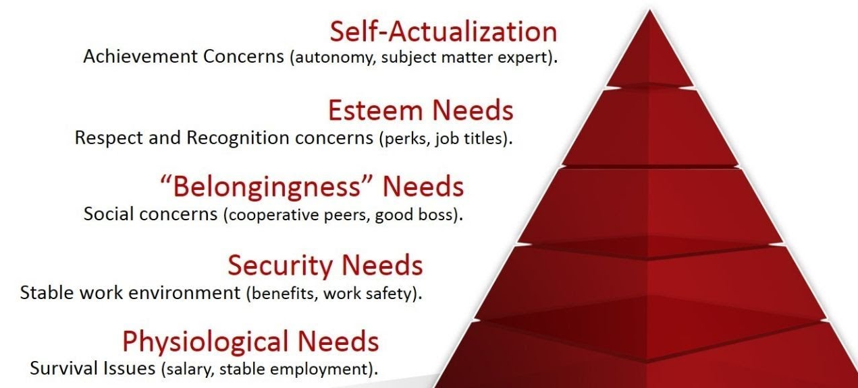
Figure 2: Maslow's Need Theory
Source: (Saad, 2018)
Herzberg’s Theory of Motivation
This theory helps the managers to get better performance from the work team by portraying two motivational factors (Lussier and Hendon, 2013). One is motivating factors and another is the hygiene factors. The motivating factors make the employees work herders which exists in the actual job and the absence of effective Hygiene Factors makes the employees perform less. Which can be shown as
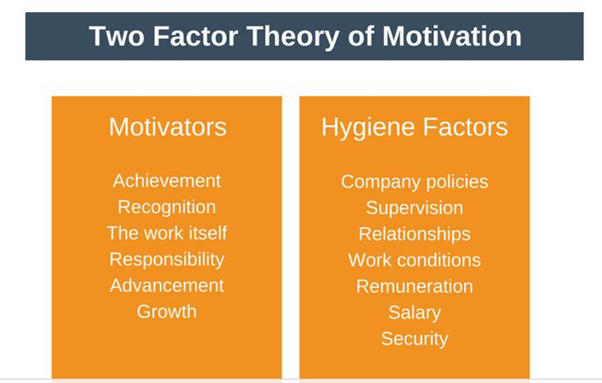
Source: (Lussier and Hendon, 2013)
Figure 3: Two Factor Theory

Employee Engagement
Employee engagement plays the role of measurement which can assume the employees’ context of felling belongingness to the job that they are doing, their commitment to the organizational, and the efficient effort to accomplish the related tasks (Cervai, Kekäle, and Claxton, 2014). When the organizations take incentives to improve the satisfaction of the employees they try to make employees feel positive to the organization and its overall management. The initiatives differ from employees to employees because the employee engagement incentives differ from people’s psychology tp psychology.
Employee engagement is considered one of the biggest drivers of the success in the organization which helps to enhance the employee performance because the employees who are engaged to the organization they understand the whole structure of the company, the purpose and it leads the employees to make the better decisions related to works (Eby and Allen, 2012). Employee engagement can be enhanced by encouraging flexibility in the work structure, providing brakes in the long term shifts, hold regular gatherings which can be formal or informal both which makes the employees know the organization, management and can lead to the generation of a trustworthy relationship. Employee engagement plays the key role of differentiation when it comes to promoting innovation and growth to the internal environment of the organization.
But in today’s work environment or the work morale of employees has been changed because the employees’ expectation towards their work has been changed because the employees tend to prefer the mobile careers than a job for life. So, the companies which have the initiatives and flexible environment for making the workforce engaged likely to have top performers in the current workforce as well as retention of new talents.

Performance Management
Performance management is considered as one of the controlling tools of management that aid the team leaders to oversee and assess the performance of the workforces (Joseph LePla, 2013). The main goal of performance management is to promote an environment where the performance of the teams can be directed in an efficient direction where the best abilities of them can be used to produce high quality of work with the maximum level of efficiency.
Performance management is important from the organizational aspect because it helps the managers and workforce to oversee the goals expectation and the career development of them along with the individual work according to the company’s pre-determined goals. Performance management helps to evaluate the individual performance from the overall workforce and the standard of the overall performance can be set easily.
Performance management can be done by using traditional tools like the generation and assessing the goals objectives and milestones of different departments. This can also help the managers to understand the effective performance and their actual features and developing improved tools to measure the overall performance of the employees (S. Pyngavil and Jindal, 2012). Along with the traditional measures of performance modern it based solution of measuring employee performance which can measure performance with every interaction. Performance management can be used to generalize the flow of the works, taking the corrective actions for improving performance and recommending new actions for making the employees understand to take corrective actions (Allen and Bryant, 2012). So the final result of employee engagement is to make the company drive towards the attainment of goals and ensures the performance optimally. In the performance management system, the managers guide the employees targeted volume of numbers and relayed guidance for ensuring success at the accurate level of inputs.

Development Vehicles in the Workplace: Organizational Example
In this portion, the focal point of the discussion will remain on the affiliation of the development vehicles relevant to the organizational context so that the improvement of the organization can be measured with the help of properly used examples. For making relevancy Unilever has chosen because of the company’s diversified initiatives to develop and maintain a skilled employee base.

Company Profile
Unilever is a British Dutch multinational company which has established in the UK almost 90 years ago at the year of 1929. The company is headquartered in London, United Kingdom, and Rotterdam, Netherlands (Unilever global company website, 2020). The company has operations in almost every countries world and it is successful in maintaining 1,55,000 employees worldwide by an efficient HR department.

Advantages of Employee Motivation
The advantages of employee motivation as a major driver of organizational success can be shown as:
To organization: In a general sense the employee motivation engages the organizational managers to oversee the overall condition of the employees (Armstrong and Landers, 2018). Unilever has a great concern on employee motivation because it helps the organization to foster by gaining a satisfactory amount of profit. After all, the organization and employee relationship get developed because of physical and emotional incentives (Unilever Apprenticeships, 2020). Unilever has become successful to gain a sufficient amount of profitability because the organization has launched many initiatives to foster the organizational innovation by making a flexible environment of working and that leads the employees to share their ideas freely because of the establishment of a win-win environment between the employees and environment.
To the individual: The individual can be get benefited from the motivational context of the organization because the employee development can be ensured by the motivational aspect of the organization because they tend to prioritize the employees’ development first (Hallier, 2009). The individuals within the Unilever’s environment also realize their efficiency on their working progress because the maximum efficiency has been ensured by the organization by adapting employee motivational aspect by taking the employee development initiatives like various types of training and development session, so the individual outcomes can be developed according to the pre-determined criteria. The individual performance of the Unilever’s employees gets monitored by the departmental managers so by measuring their outcomes and performance the managers can decide that what types of motivational incentives can be taken to raise the performance of the employees so that the individuals can realize their performance (Unilever Apprenticeships, 2020). The leader plays the role of an associate, not a boss so the communication gets easier and the employees can make complaints and this communication plays the role of a strong motivator in Unilever’s context.

Advantages of Employee Engagement
With the employee engagement initiatives, employees feel an emotional attachment towards the organization which generates the feeling of belongingness (Harrison, 2011). The advantages of employee engagement can be shown as
To the Organization
Organizations can make the employees feel belonging when they get engaged with the organization (John, 2010). So, the employees of Unilever get loyal to the organization because it tried to make a proper valuation of their emotional attachment and the employees tried to do best for the organization even at the time of economic downturn (Unilever Apprenticeships, 2020). The loyal employee base makes the lower absenteeism rate and organizational productivity get maintained with employee engagement as well as the attachment. In Unilever, they tend to though a success party in different departments when they get to achieve any milestones which makes the employees hold a good feeling towards the organization because they can be able to build a trustworthy relationship with the other members and an environment of trust get created among them.
To the Individual
The main benefits of employee engagement are to hold the felling of employee satisfaction. Employees of Unilever get engaged in the organization and they also feel the self-worth because they think that they are doing a great job with an efficient organization that values their performance and always works for their benefit. Unilever always tries to make its employees feel special because they value their potential, by email and different greeting cards they make grateful messages to their employees (Unilever Apprenticeships, 2020). The individual feels their potential and this psychological empowerment helps the individual to foster in their respective fields.

Advantages of Performance Management
Performance management is another driver of organizational development that tends to measure the outcomes of the individuals and generates benefits for the individual in many ways.
Advantage to Organization
The first advantages possess by performance management is to create an environment of accountability in the internal environment of the organization (Slattery and Anderson, 2008). Because Unilever’s departmental managers possess the flow of clear communication to the employees about the standard, the goals which need to be achieved, and the outcomes that they are expecting from the employees (Unilever Apprenticeships, 2020). That leads the employees to show greater accountability because they have stated with clear responsibilities. That eventually leads to the cost reduction of the organization. In Unilever, the project manager always keeps communication with the subordinates and they always keep a note about the progress of the work and how much resources are getting used in that context so this record-keeping aspect helps the organization to make the best use of available resources.
Advantages to Individuals
The first individual advantages of performance management are the customized development sessions which get designed by identifying the time and needed skills for the particular individuals (Reid and Barrington, 2012). Continuous improvement gets possible because the managers always engaged with the record-keeping activities with the individuals and the corrective actions can be taken in the shortest possible time. In the context of Unilever, there always remains a software-based communication with the managers and subordinates and the managers continuously keep the records of every individual and make them benefited from their needed training for building up the skills and the resources for developing the individuals’ attributes.

Ways of Meeting the Development Needs from Individual’s Expectation
Personal development used in the organizational aspect for increasing the skills of the employees for making them more productive in the company’s operational aspect and lead to the organization towards a greater environment of proficiency. So, the organizations are mainly liable for making the developed opportunity to the employees so that they can be able to attract more employees and by making the potential and current employees motivated and productive in different aspects of the organization (Milton,2015). The overall success of the employees depends on regular skill development and making the managers aware of the needs of the employees. By taking motivation from the managers and leaders the organizational employees get interested to keep them productive at the workplace and get intersected to develop their skills.

SWOT Analysis
SWOT-analysis helps a person to identify his/her skills and the gaps which can be considered while working in the current business world. As a University student, I have observed the personal attributes of some peers to make a SWOT analysis for identifying the strength and gaps of the personal attributes.
Strength  1.Written Communication  2.Reliability  3.Creativity | Weakness  1.Oral Communication  2.Mental Strength  3.Listening Skills
Opportunities  1.Networking  2.Internships | Threat  1. Intense Competition  2.Economic Downturn

Strength: The university students have to be very efficient in written communication because there is a general tendency to communicate with different authorities with the help of written letters. So, the potential candidate who is willing to be the employee of Unilever, me, and my peers possess strong written communication skills along with the creativity and reliability which can be evaluated from the self-assessment tests.
Weakness: The main weakness remains in the current students is the industrial languages that must be used in the business world while communicating with others which have not been practically practiced by me and my peers. Also, the mental strength required for situational handling and listening skills after attending every seminars and session has not been developed yet that can be the weakness for handling any business situation.
Opportunities: There is a chance of the business graduates or the undergrad students to work in Unilever as interns which can be an opportunity to foster in a permanent job position with that company. Also, the references and networks from that program can help to gain a permanent position.
Threat: The environment of the job market is getting complex day by day because of the complex job environment, intense competition is getting created between the job seekers (Cervai et al., 2014). Also, the economic downturn is making problems for organizations to retain highly skilled employees and arranging sessions for the employees' skilled development. So, a harder situation is getting introduced in the job market.

Personal Development Plan
This section has made a brief on the personal development plan of an individual who is interested to work on Unilever. This plan has relevance with the skill development programs that are been taken by Unilever’s HR department and the line managers. So, the intention, career development needs and the interested candidates required knowledge has been given in that plan
Required Skill | Objective | The Development  Procedure | Required Time
Communication | To make the employees skilled at verbal communication. | The sessions will be arranged from the Unilever’s HR authority to make the new requited skilled to communicate efficiently in the business world | 3 Weeks
Situation Handling Skill | To make the employees able to generate efficient decisions it the time of crisis. | The employees will be given some real-world cases related to crisis management and the Unilever authority will check whether they can make good decisions or not. | 4 Weeks
Analytical Ability | The ability to solve the problem related to critical reasoning. | The employees will be divided into groups and given real situations to apply the critical reasoning skills which will be monitored by the managers. | 7 Weeks
Technical Ability | In the complex job environment employees will be able to use technological platforms for better decision making | Employees will be allowed to join workshops and online training sessions for developing their skills. | 7 Weeks
Group Works | In the practical business situation, employees will use the group power to achieve desired outcomes. | The groups will be formed in a different department and the employees will use the power of democracy by valuing and listening to others’ opinions. | 16 Weeks
Inspiration Incentives | Employees will make motivated and engaged in their organization so that they earn efficiency at their work. | Tangible and intangible incentive strategies will be taken to keep employees motivated towards developing the career of themselves. | 16 Weeks

Conclusion
A business organization can gain success if the organization becomes able to spread improvement to the whole workforce, in other words among every individual of the business. So, it can be said that the overall development of the organization depends on how the organization can skillfully use its workforce. Unilever always remains concerned with the fact that they must develop a flexible organizational culture for promoting motivation, engagement, and performance management approach to their employees so that every employee goes through the development process. The company also keeps a continuous process for the employees’ development so that the recruit as well as the current employees remained concerned about their needed skills and try to fill the gap by contacting the managers.

References
Allen, D., and Bryant, P., (2012). Managing Employee Turnover. New York: Business Expert Press.
Armstrong, M., and Landers, R. (2018). Gratification of employee training and development. International Journal of Training and Development, 22(2), pp.162-169.
Baker, H. (2008). Employee training. Chandni Chowk, Delhi: Global Media.
Buchanan, D., and Huczynski, A., (2020). Organizational Behaviour. New York: Pearson Education Limited.
Cervai, S., Kekäle, T., and Claxton, J., (2014). Employee Engagement. Bradford: Emerald Group Publishing Limited.
Eby, L., and Allen, T., (2012). Personal Relationships. New York: Routledge Academic.
Hallier, J. (2009). Employers’ discovery of training: self‐development, employability and the rhetoric of partnership. Employee Relations, 21(1), pp.80-95.
Harrison, R. (2011). Employee development. London: Chartered Institute of Personnel and Development.
John, J. (2010). Relevance of Employee Development Plans in Employee Performance Management. SSRN Electronic Journal.
Joseph LePla, F., (2013). The Impact of Internal Branding on Employee Motivation and Competitive Advantage. Employment Relations Today, 40(1), pp.19-24.
Li, P., (2016). The impact of the top management teams’ knowledge and experience on strategic decisions and performance. Journal of Management & Organization, 23(4), pp.504-523.
Lussier, R., and Hendon, J., (2013). Human Resource Management. Thousand Oaks: SAGE Publications.
Milton (2015). Employee Development versus Compensation: Analysis of Employee Retention Strategies on Organizational Productivity. IJARKE Business & Management Journal, 1(3).
Reid, M., and Barrington, H. (2012). Training interventions. New Delhi: Jaico Publishing.
S. Pyngavil, R., and Jindal, S., (2012). A Study on Performance Management and its Impact on Employee Motivation. Effulgence-A Management Journal, 10(2), p.19.
Saad, D., (2018). Impact of Employee Motivation on Work Performance. International Journal of Scientific and Research Publications (IJSRP), 8(3).
Singhvi, P., Dhage, N. and Sharma, P., (2018). Compensation and Its Impact on Motivation Employee‟s Satisfaction and Employee‟s Performance. International Academic Journal of Organizational Behavior and Human Resource Management, 05(02), pp.1-43.
Slattery, J., and Anderson, J. (2008). Influences of new employee development practices on temporary employee work-related attitudes. Human Resource Development Quarterly, 17(3), pp.279-303.
Unilever Apprenticeships, 2020. Human Resources. [online] Unilever UK & Ireland. Available at: <https://www.unilever.co.uk/careers/apprenticeships/business-and-technology-apprenticeships/human-resources/> [Accessed 30 June 2020].
Unilever global company website. 2020. Unilever Global Company Website. [online] Available at: <https://www.unilever.com/> [Accessed 30 June 2020].

