

EXAMINATION PAPER
MARKS AND COMMENTS SHEET

PROGRAMME | OME Degree Apprenticeship
LEVEL | 4
MODULE | ACDB4011 Chemistry
STUDENT I.D. | 2416858
EXAMINER | Ewa Kazimierska | INTERNAL VERIFIER
Once completed marks only should be transferred onto the front of the examination paper (no comments other than ticks or crosses on the examination paper)

Question  Number | Comments | Marks available | Marks awarded | 2nd marker (sample) | 3rd marker (where necessary)
1 | 6/10 True/False answers correct. Solid grasp of redox and bonding concepts, though some confusion remains around structure and catalysts | 15 | 9
2 | Basic structure of Bohr model shown, but particle numbers and charges missing. Incorrect charge, flawed Lewis diagram, and no OME bond relevance discussed. | 11 | 5
3 | Excellent overall understanding of photon energy, electron structure, and emission phenomena. | 10 | 10
4 | Reaction was not balanced. Part b calculations contained errors, and part c lacked alternative method. Part d unanswered. | 15 | 8
5 | OB concept and applications mostly correct. One part not attempted, but reaction, equation, and enthalpy discussion were well done. | 16 | 11
6 | Reaction profile and explanation of activation energy were correctly handled. | 7 | 7
7 | Good interpretation of phase behaviour and diagrams. Only minor omission of naming phase transitions. | 11 | 10
8 | Incorrect formula used in titration, and no net ionic equation given. | 5 | 0
9 | No attempt made on calorimetry calculation. | 5 | 0
10 | No attempt made on either part of the redox question | 5 | 0
 |  |  | 60

1st Marker Name | Ewa Kazimierska | 1st Marker Signature | 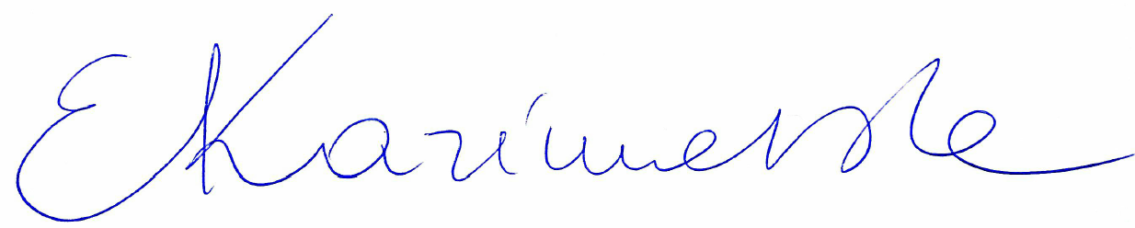
2nd Marker Name |  | 2nd Marker Signature
3rd Marker Name |  | 3rd Marker Signature
Reasons for awarding the final mark where there is more than one marker
Notes:
- The 3rd marker may be used where there is more than a 10 percentage point difference (in the TOTAL mark) between markers 1 and 2 OR when it is not possible to get agreement between markers 1 and 2. Reasons must be given where an agreed mark is given.
- This form is for internal use only and is NOT to be returned to the student. The final agreed marks must be transferred to the student feedback sheet in the assignment specification.
- The external examiner MUST be shown this form.

